Host: 10.10.10.6

Recon:

Using Nmap we can see that port 22 and port 80 are open.

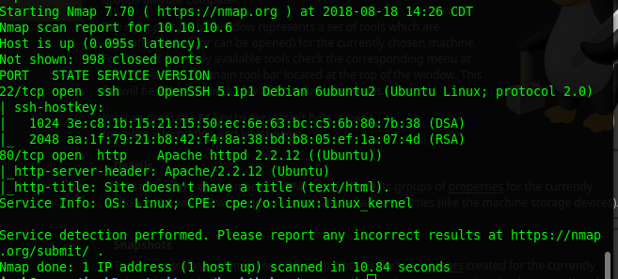
Running dirb on 10.10.10.6 shows a directory 10.10.10.6/torrent/ and other sub folders.

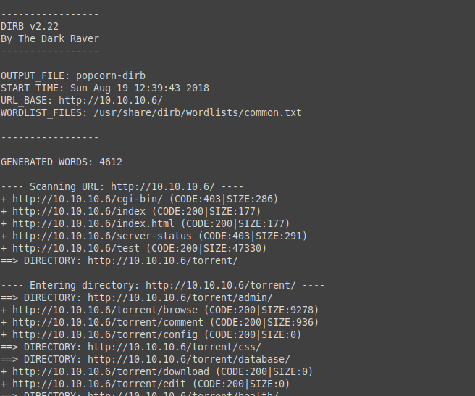

Register a login and login to upload
we can see that we can upload torrent file.
Upload any torrent file
once done you will get an option to add a screenshot for the image

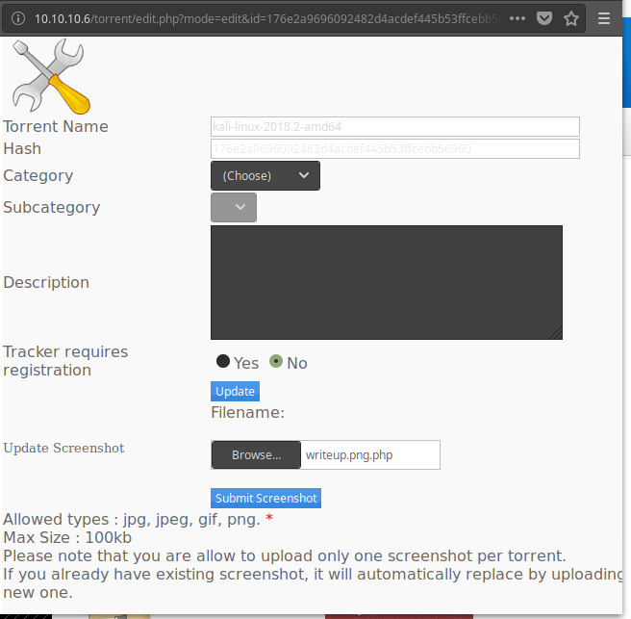
here we will upload out php upload exploit script to execute commands on the remote system.

Open burp and intercept the traffic before submitting.

In burp change Content-Type: application/x-php to Content-Type: image/png
because the server expects a png file
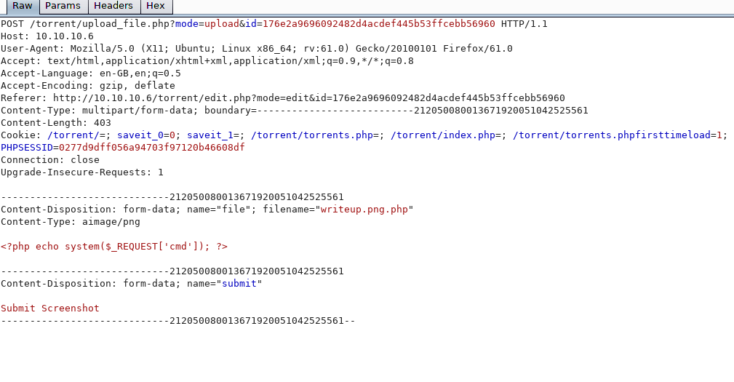

goto 10.10.10.6/torrent/upload/ and you can see the file renamed

now by appending command to the php file you can run commands on the server as below.

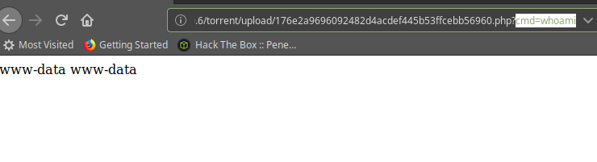
Now we should be able to run any commands on the machine

we will now use netcat to get a shell from the machine

run a net cat listener on your localmachine
run a netcat connect from server using burp
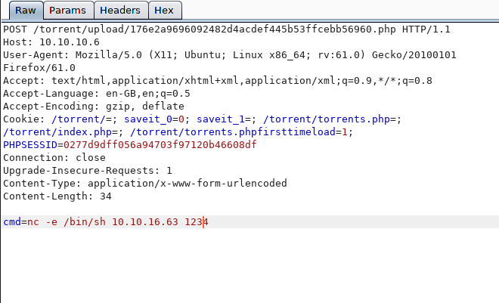
now you should be able to run commands from the shell

going to home/george will give you user hash

./176e2a9696092482d4acdef445b53ffcebb56960.sh

