在Rc等于3kohm下的实验数据





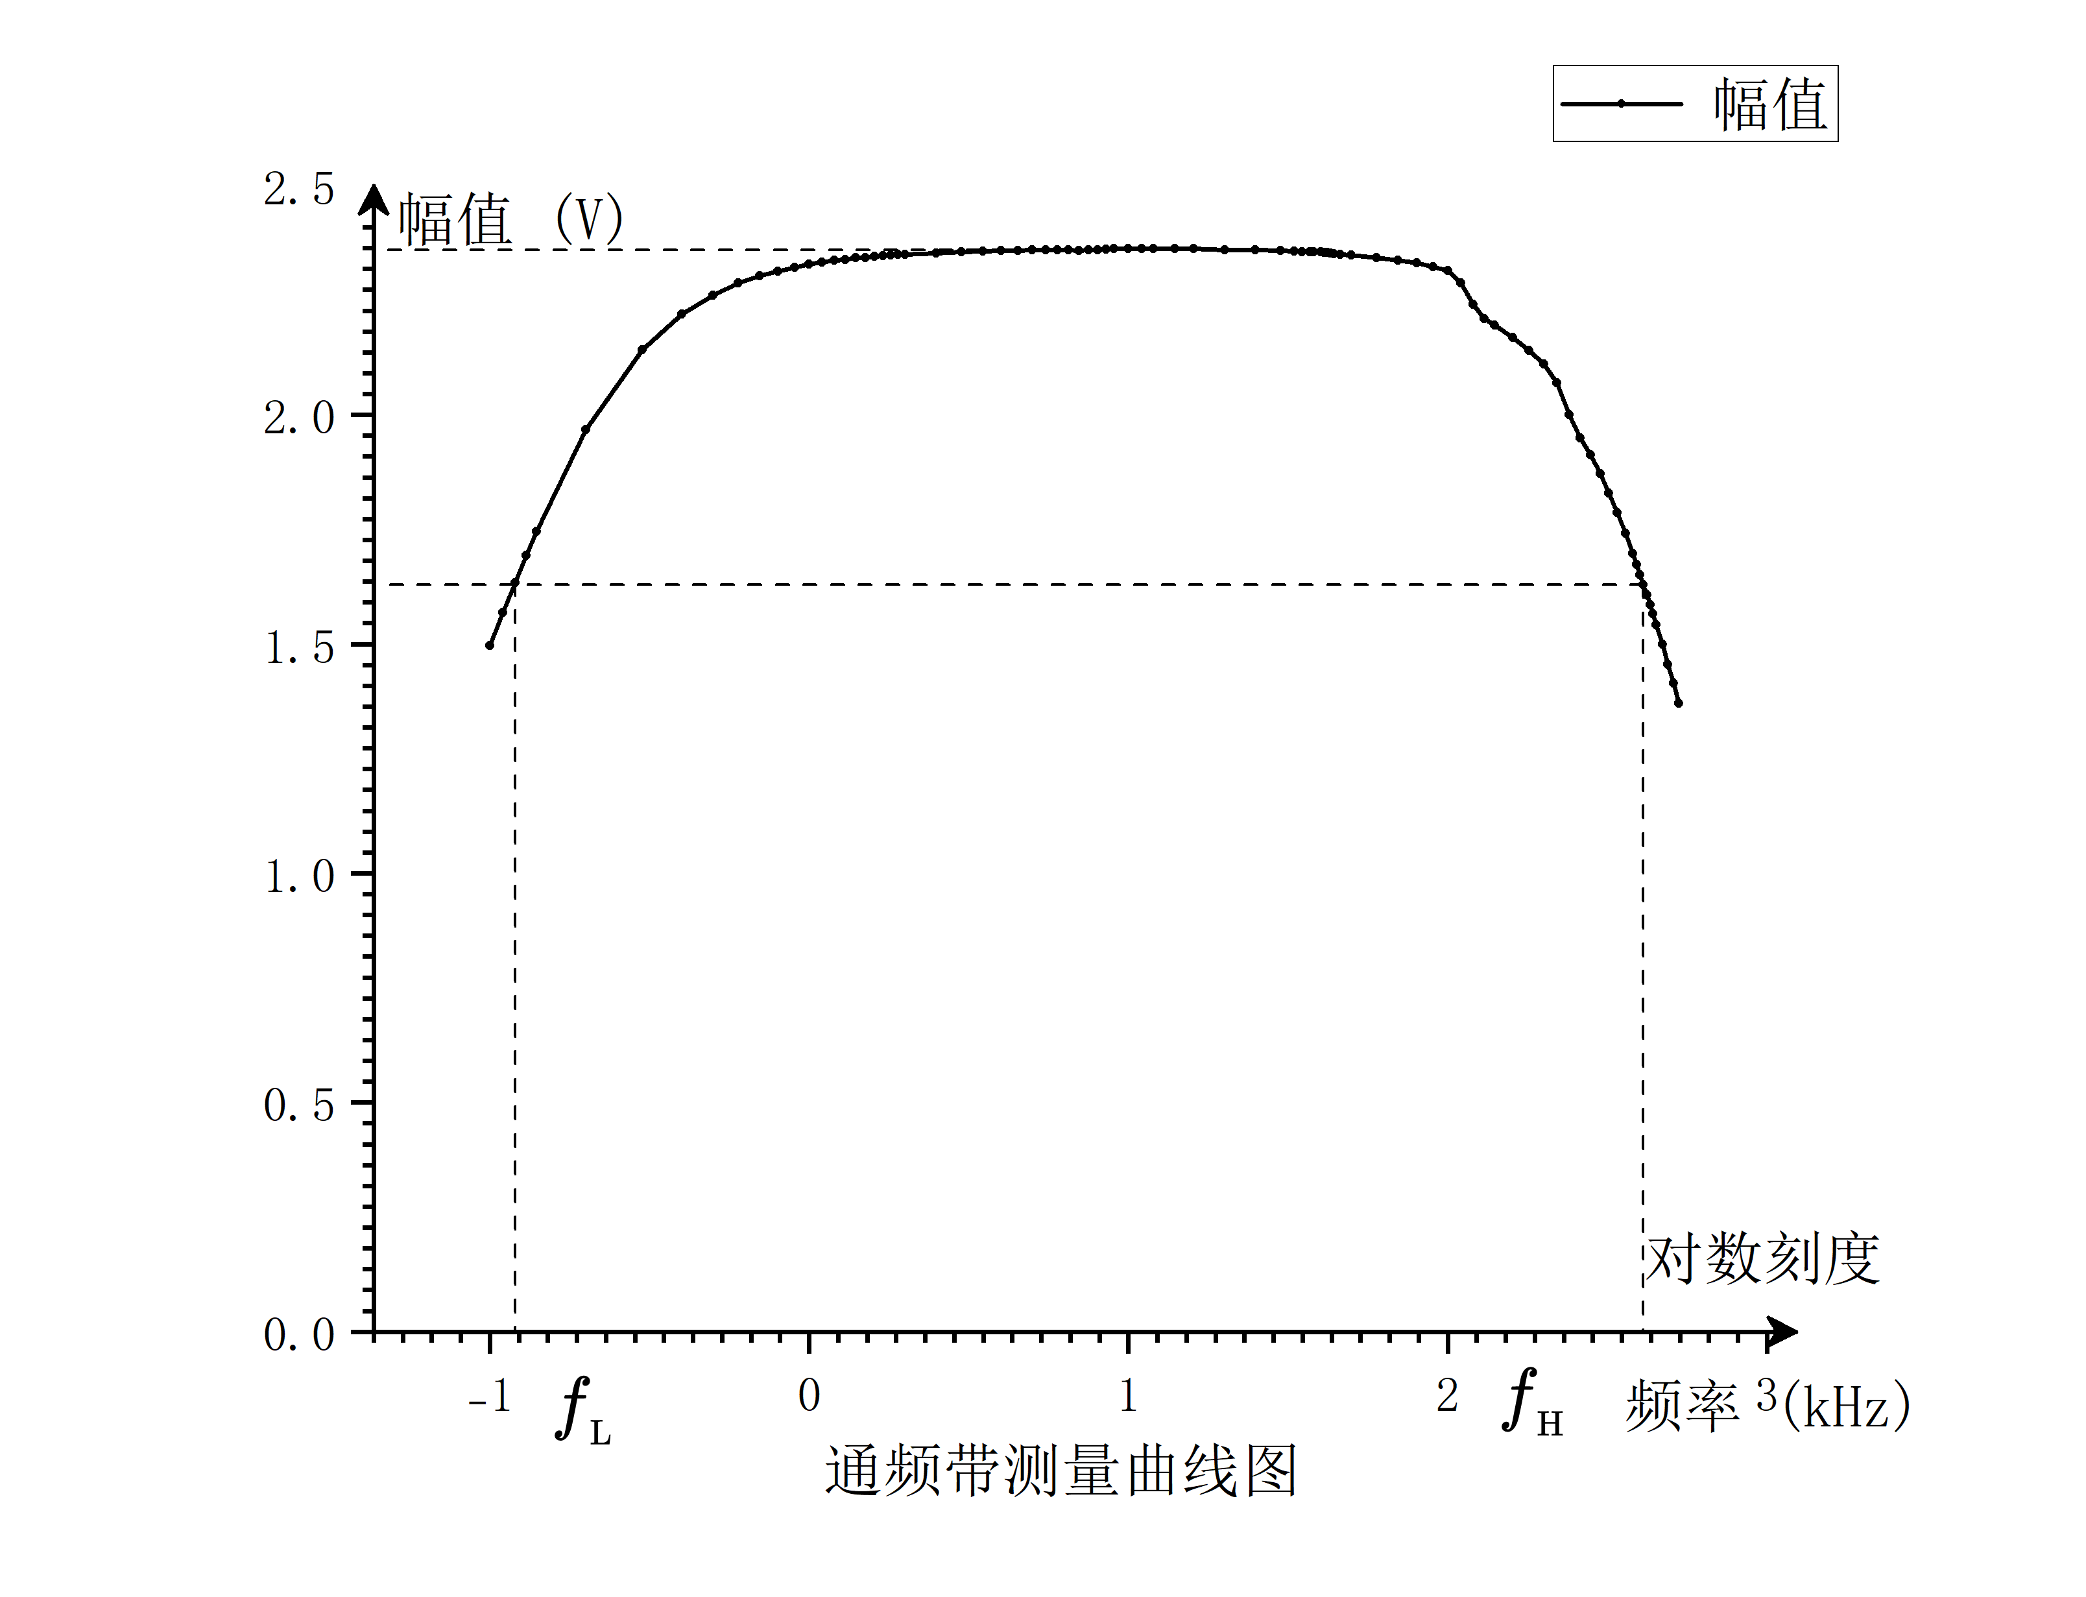

在Rc等于1kohm下的实验数据



|  |  |  |  |  |  |  |  |
| --- | --- | --- | --- | --- | --- | --- | --- |
| 输入电阻输出电阻的测量 | | | | | | | |
| 测输入电阻 | | | | 测输出电阻 | | | |
| R1(kohm) | Us(mV) | Ui(mV) | Ri(kohm) | RL(kohm) | Uo∞ | Uo | Ro(kohm) |
| 2 | 14.4 | 0.978 | 1.96 | 2 | 0.977 | 0.647 | 1 |

|  |  |  |
| --- | --- | --- |
| 测通频带 | | |
| fL(kHz) | fH(kHz) | BW |
| 0.15 | 332 | 331.85 |