**Assignment 1B: AirTnT Normalisation**

**Form 1: AirTnT Activity Sheet**

**UNF**

CHECK-IN(cust_id, cust_fname, cust_lname, checkin_initdate, checkin_inittime, guide_name, guide_id, (activity_code, activity_name, requested_guidename, requested_guideid, performed_guideid, performed_guidename, prescription_date, prescription_time , activity_charge, activity_itemchr, (item_code, item_desc, item_quant, item_charge))

**1NF**

CHECK-IN (cust_id, checkin_initdate, checkin_inittime, cust_fname, cust_lname, guide_name, guide_id)

* 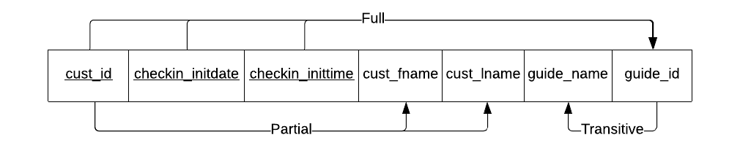

PRESCRIPTION (cust_id, prescription_date, prescription_time, activity_code, activity_name, requested_guidename, requested_guideid, performed_guidename, performed_guideid, activity_charge, activity_itemchr)

* 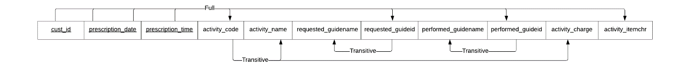

ITEM-LINE (cust_id, prescription_date, prescription_time, item_code, item_desc, item_quant, item_tcharge)

* 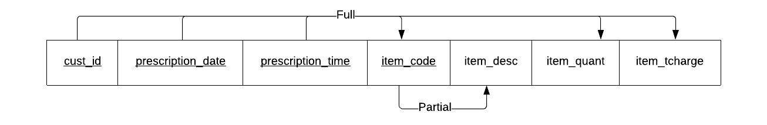

**2NF**

CHECK-IN (*cust_id*, checkin_initdate, checkin_inittime, guide_name, guide_id)

* guide_id → guide_name (TRANSITIVE)

CUSTOMER (cust_id, cust_fname, cust_lname)

* cust_id → cust_fname, cust_lname (FULL)

PRESCRIPTION (cust_id, prescription_date, prescription_time, activity_code, activity_name, requested_guidename, requested_guideid, performed_guidename, performed_guideid, activity_charge, activity_itemchr)

* activity_code → activity_name, activity_charge (TRANSITIVE)
* requested_guideid → requested_guidename (TRANSITIVE)
* performed_guideid → performed_guidename (TRANSITIVE)

ITEM-LINE (cust_id, prescription_date, prescription_time, *item_code*, item_quant, item_tcharge)

ITEM (item_code, item_desc)

* item_code → item_desc (FULL)

**3NF**

CHECK-IN (*cust_id*, checkin_initdate, checkin_inittime, *guide_id*)

GUIDE (guide_id, guide_name)

* guide_id → guide_name (FULL)

CUSTOMER (cust_id, cust_fname, cust_lname)

PRESCRIPTION (cust_id, prescription_date, prescription_time, *activity_code*, *requested_guideid, performed_guideid*, activity_itemchr)

* **Note:** requested_guideid and performed_guideid references a guide_id from GUIDE. No new entities need to be created from the transitive dependencies from 2NF for PRESCRIPTION.

ACTIVITY (activity_code, activity_name, activity_charge)

* activity_code → activity_name, activity_charge (FULL)

ITEM-LINE (cust_id, prescription_date, prescription_time, *item_code*, item_quant, item_tcharge)

ITEM (item_code, item_desc)

**Form 2: AirTnT Housekeeper Assignment Details**

**Initial Assumption**

* A housekeeper cannot be assigned to two unique houses in one day.
  + e.g. A housekeeper with ID = 1234 **cannot** be assigned to a house (ID = 001) on 1/1/2019, then proceed to be reassigned to a house (ID = 002) on the same date.

**UNF**

HOUSEKEEPER (housekeeper_id, housekeeper_fname, housekeeper_lname, housekeeper_phone, housekeeper_plcert, housekeeper_bkcheck, (house_code, house_name, assignment_initdate, assignment_enddate))

**1NF**

HOUSEKEEPER (housekeeper_id, housekeeper_fname, housekeeper_lname, housekeeper_phone, housekeeper_plcert, housekeeper_bkcheck)

* 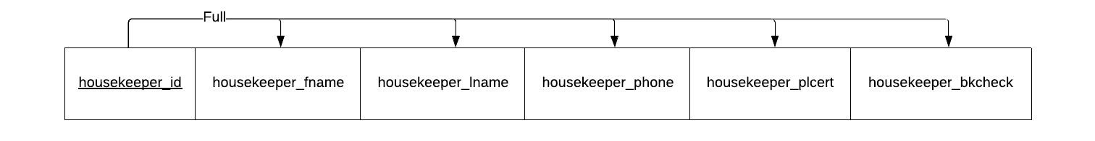 I am assuming that the contact phone may be a house phone and so may be shared by multiple housekeepers (that live in the same house). Hence, there is no transitive dependency of say (housekeeper_fname, housekeeper_lname) → housekeeper_phone.

ASSIGNMENT (housekeeper_id, assignment_initdate, house_code, house_name, assignment_enddate))

* 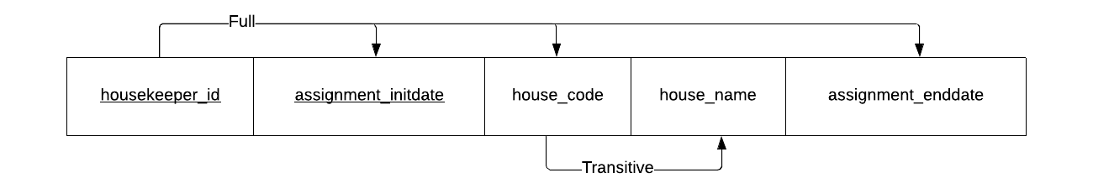

**2NF**

HOUSEKEEPER (housekeeper_id, housekeeper_fname, housekeeper_lname, housekeeper_phone, housekeeper_plcert, housekeeper_bkcheck)

ASSIGNMENT (housekeeper_id, assignment_initdate, *house_code*, assignment_enddate))

HOUSE (house_code, house_name)

* house_code → house_name (FULL)

**3NF**

HOUSEKEEPER (housekeeper_id, housekeeper_fname, housekeeper_lname, housekeeper_phone, housekeeper_plcert, housekeeper_bkcheck)

ASSIGNMENT (housekeeper_id, assignment_initdate, *house_code*, assignment_enddate))

HOUSE (house_code, house_name)