Test server: jdbens.mooo.com

This is currently acting as a dummy server. REST API is implemented and returns JSON data. But there is no connection to the garden: data is meaningless right now.

To return current state of garden in json format:

<http://jdbens.mooo.com/garden>

Returns:

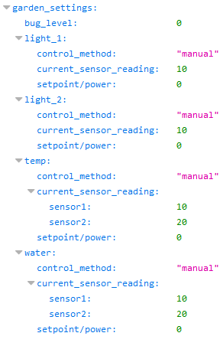

To set a parameter:

<http://jdbens.mooo.com/garden/temp/auto/35>

This will change the temperature to automatic control and set the setpoint to 35:

