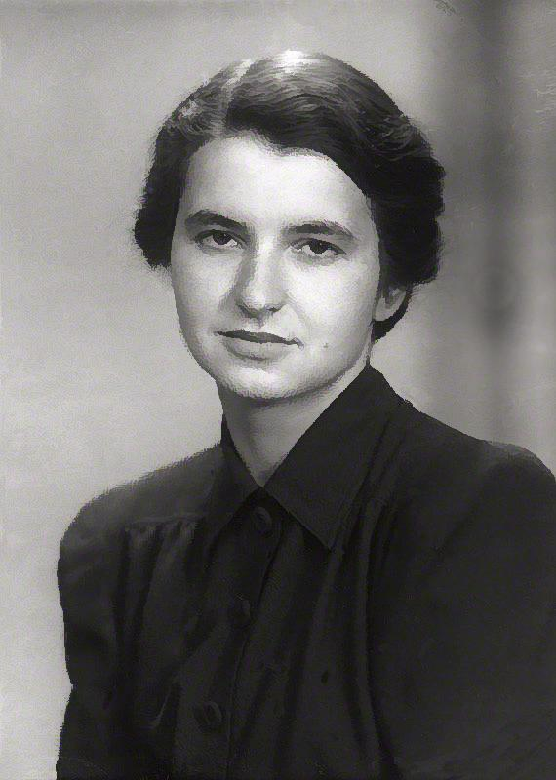
https://www.scienceall.com/brd/board/390/L/menu/317?brdType=R&thisPage=1&bbsSn=117563&brdCodeValue=



https://www.forbes.com/sites/johncumbers/2019/11/21/the-woman-who-first-showed-us-the-double-helix-a-personal-look-at-rosalind-franklin/

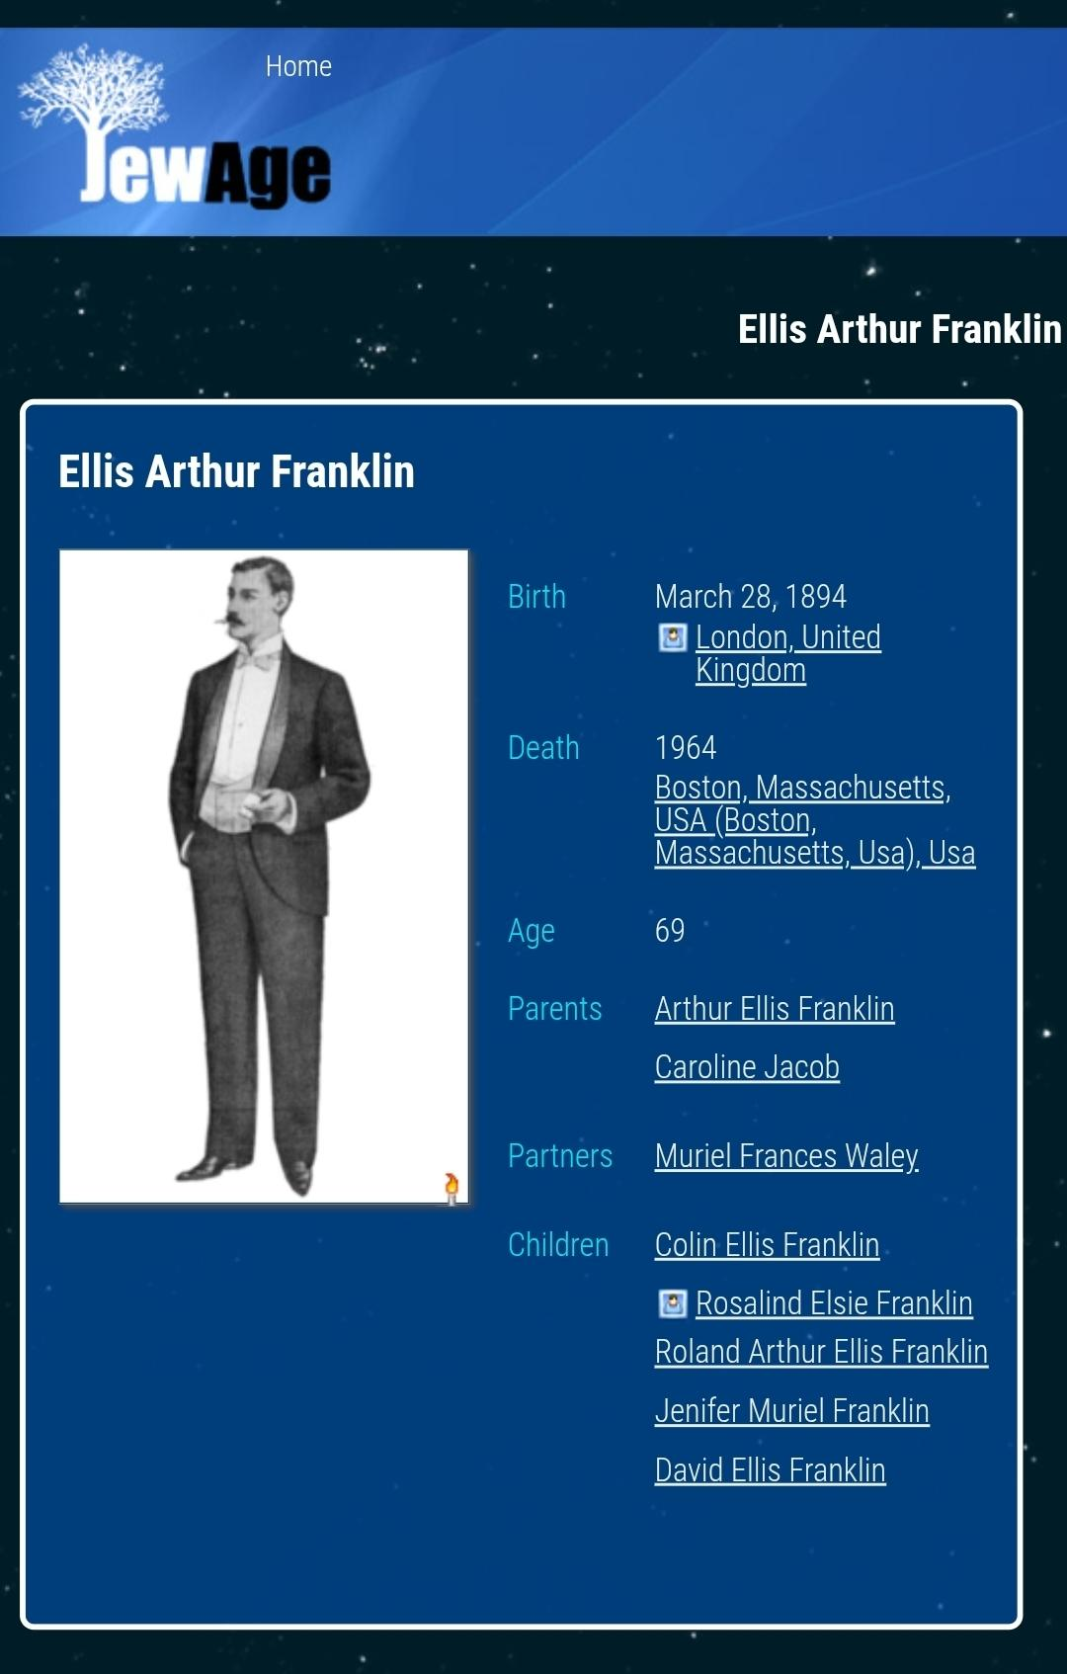
https://www.jewage.org/wiki/en/Profile:P1529595639

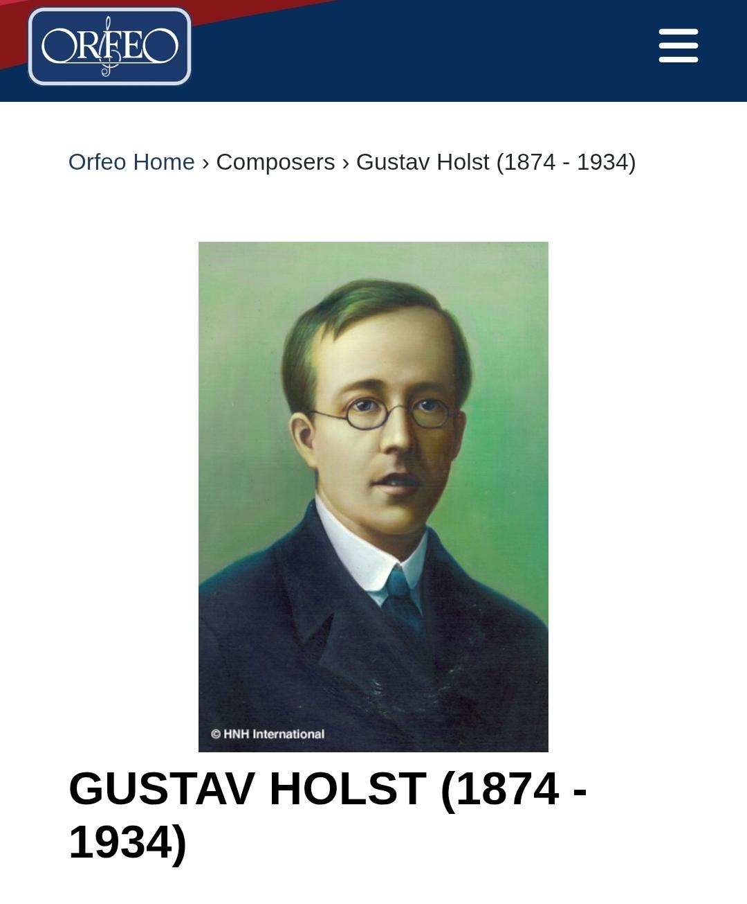

https://www.orfeomusic.de/Composer/Detail/24507

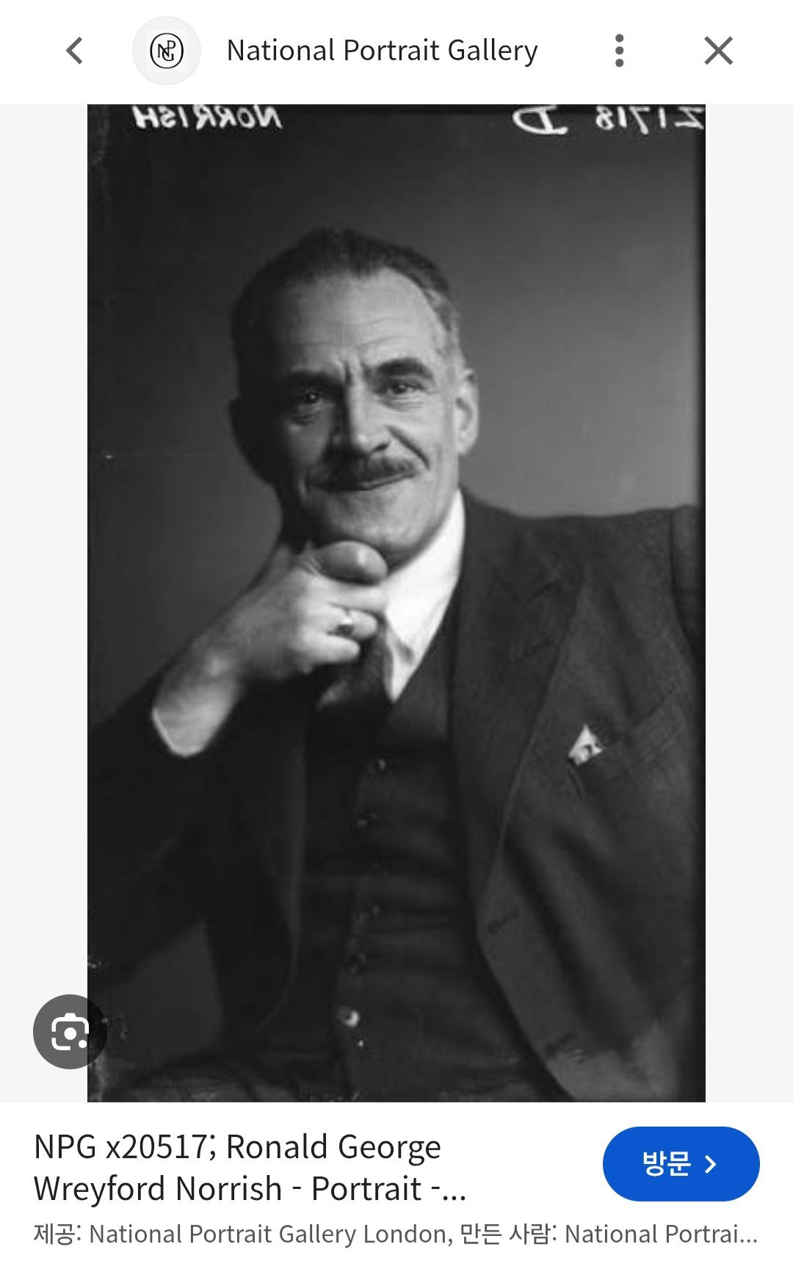
https://www.npg.org.uk/collections/search/portrait/mw163881/Ronald-George-Wreyford-Norrish

