Quick-Start Documentation:

Overview:
This device aims to trigger motor movement every instance of an individual’s heartbeat. For further verification, an LED on both the circuit board and microcontroller will flash when a heartbeat is registered by the microcontroller. An image of the assembled device can be found in Figure 1.
Figure 1: Assembled Device
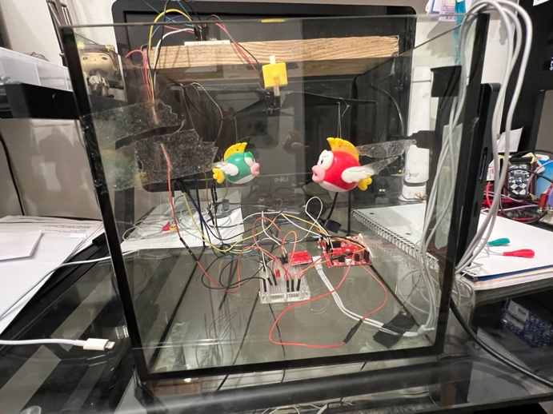
Figure 1: Assembled Device. Leads shown to the right of the device. Oscilloscope connection on back of device.

Installation or Setup Instructions:
- Hook up ECG Leads to User:
  - Red (R) Lead: Place on the right forearm.
  - Yellow (L) Lead: Place on the left forearm.
  - Green (G) Lead: Place elsewhere on the body, preferably the left or right leg.
    - Note: These leads can also be connected to a synthetic heart simulator using the same leads.

Figure 2: Proper Lead Placement for ECG
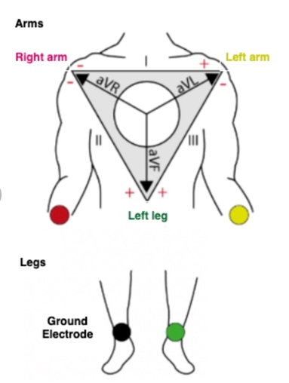
Figure 2: Proper lead placement for ECG. Ground electrode can be placed anywhere on the lower body [1].
- Plug in ECG Lead Wires into the ECG Module if Removed:
  - Shown in Figure 3 Below:
Figure 3: ECG Connection Input to ECG Module
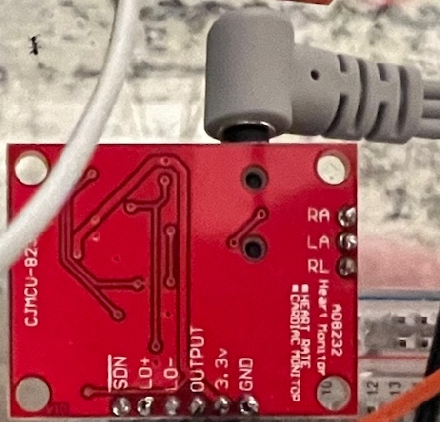
Figure 3: ECG Module. Lead connection circled in green.
- Plug MSP430 into Computer USB Port to Power the Device.
  - The device should begin working approximately 3 seconds after being plugged in.
- Ensure User Sits Still:
  - It's important for the user to remain still to reduce noise, allowing the ECG module to accurately read heart cycles.

Troubleshooting Tips:
- Motor is moving Sporadically/LED is Flashing too much:
  - Problem:
    - Excess movement can lead to noisy signal and sporadic motor movement.
  - Solution:
    - Make sure that ECG leads are properly hooked up and that the user is sitting still.
- Microcontroller appears to register two successive beats for every heart cycle.
  - Problem:
    - This is caused by the microcontroller ADC_Result threshold being lower than the T-wave peak electro potential, registering the T-wave as an additional heartbeat.
  - Solutions:
    - Access the microcontrollers code and increase the threshold value to register only the QRS complex. This may take some Trial and error; however, it is important to use a hexadecimal representation of the threshold value.

Additional Resources:
- Sparkfun Resources:
  - ECG Module: www.sparkfun.com/products/12650
  - Motor Driver: www.sparkfun.com/products/14451

- *See project report and documentation if additional information is needed for Device.

