Geometry 21 Unit 2: Polygons Name: _____________________________________
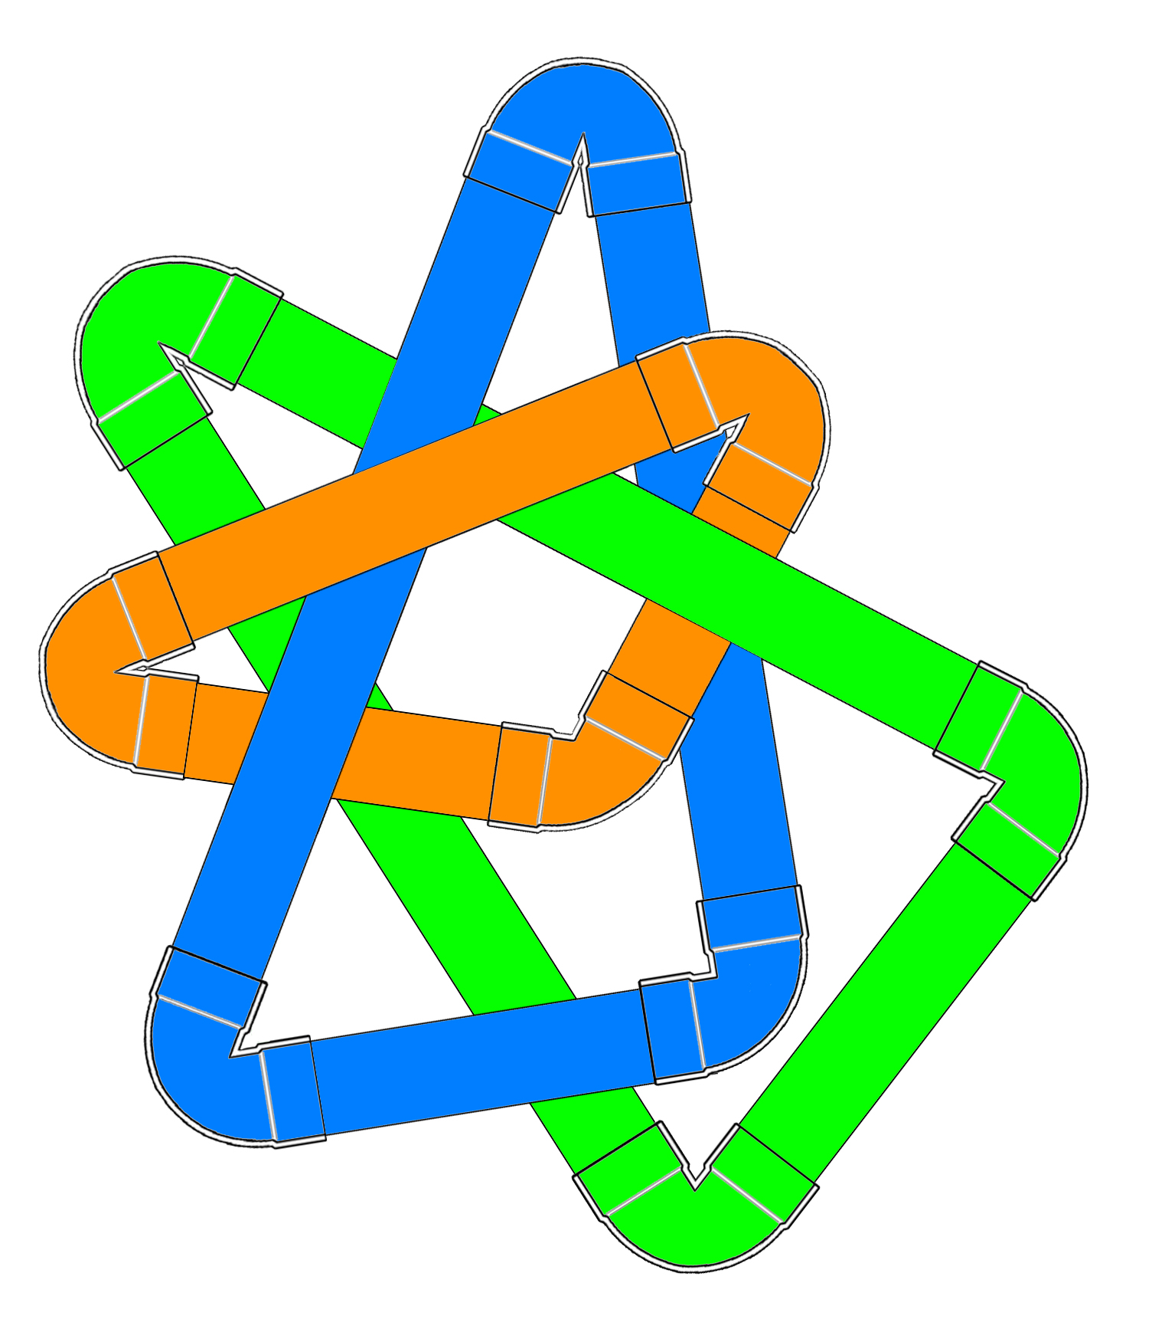
2.1.0 Get Ready – Pipe Art Date: _______________________ Period: _______

Louisa is making modern art from PVC pipe and fittings. Here is part of one of of her pieces:

She has custom-made corners that join the straight pieces, in angle measures from 30° to 150°. Some of the straight pipe is cut already, and some she can cut to any length she needs.

Before she begins, she makes a pattern for each triangle. Cut out the pipe pattern pieces that your teacher gave you. Cut along the “ends” of each pipe elbow.

Make some triangles with the pieces, adjusting the length of each pipe as needed.

Sketch the triangles you make. Record everything you notice about them.

Geometry 21 Unit 2: Polygons Name: _____________________________________
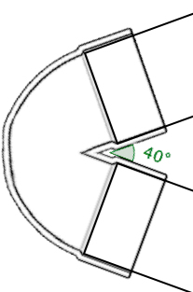
2.1.1 How many triangles? Date: _______________________ Period: _______

Louisa is curious about how many different triangles she could make if she starts with some specific pieces.

With a partner, try the following investigations. Each partner should start with the same pieces, in the same order. Then try to make as many different triangles as you can. Try to align the pipe in the fitting as shown to the right.
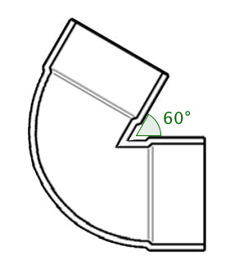
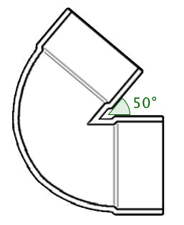
6 inches
1. 60° elbow, 6 inch pipe, 50° elbow

Sketches:

2. 3.4 inch pipe, 100° elbow, 5.2 inch pipe (in that order)

Sketches:
3. 40° elbow, 5.9 inch pipe, 3.6 inch pipe (in that order)

Sketches:

4. 7.2 inch pipe, 3.4 inch pipe, 5.2 inch pipe (in any order)

Sketches:

Geometry 21 Unit 2: Polygons Name: _____________________________________
2.1.2 How many DIFFERENT triangles? Date: _______________________ Period: _______
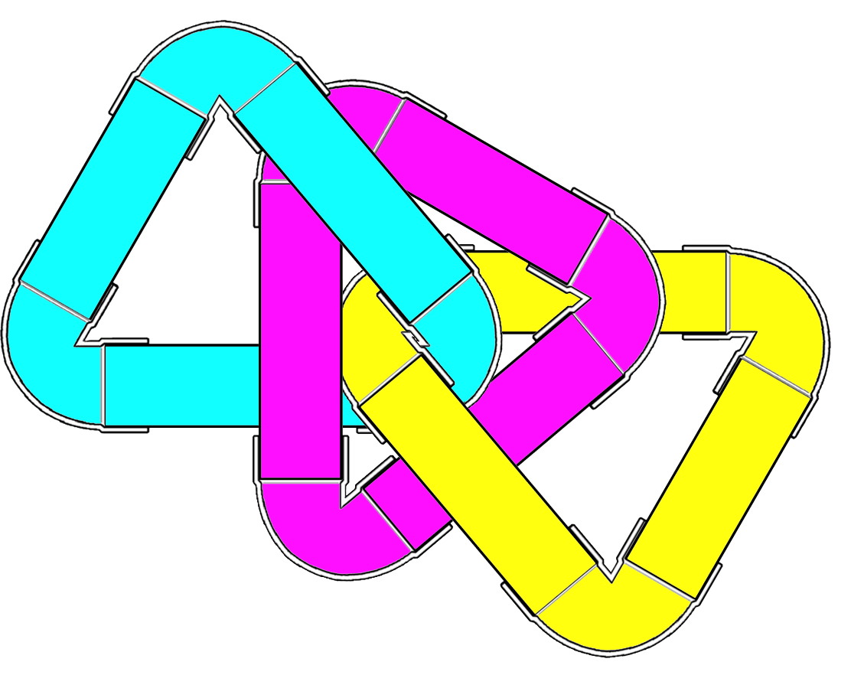
With your classmates, you created triangles from Louisa’s pipe parts. Below, Identify whether or not the samples given are created by isometries of one another. If they are, you’ve made two versions of the same triangle.

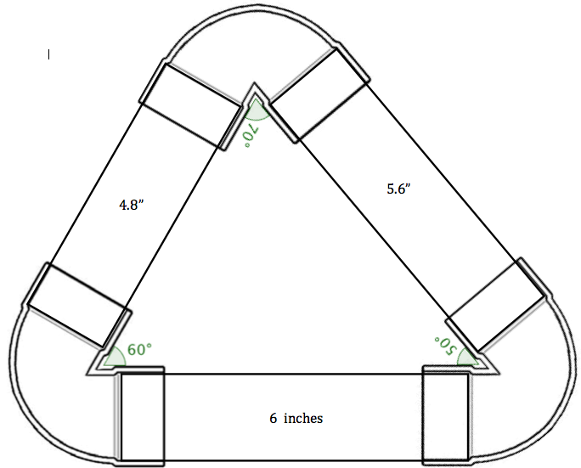
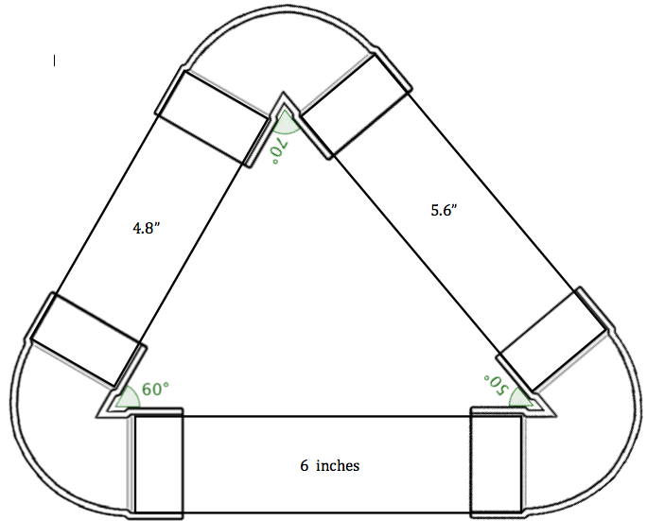
1. 60° elbow, 6 inch pipe, 50° elbow

Are they isometric? _______ If so, what transformation(s) would map the first image onto the second?

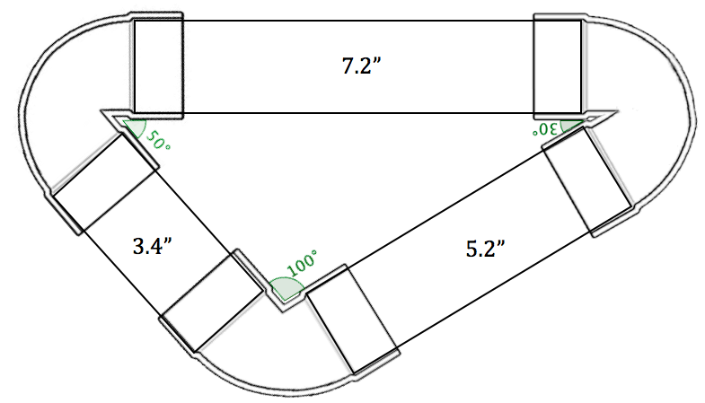
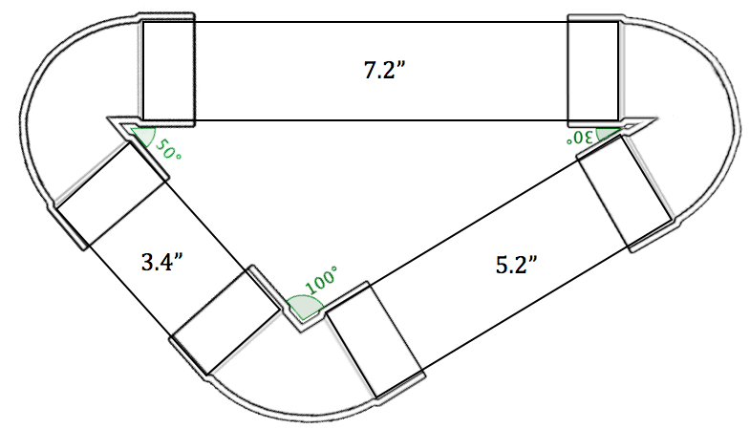
2. 3.4 inch pipe, 100° elbow, 5.2 inch pipe (in that order)

Are they isometric? _______ If so, what transformation(s) would map the first image onto the second?
3. 40° elbow, 5.9 inch pipe, 3.6 inch pipe (in that order)
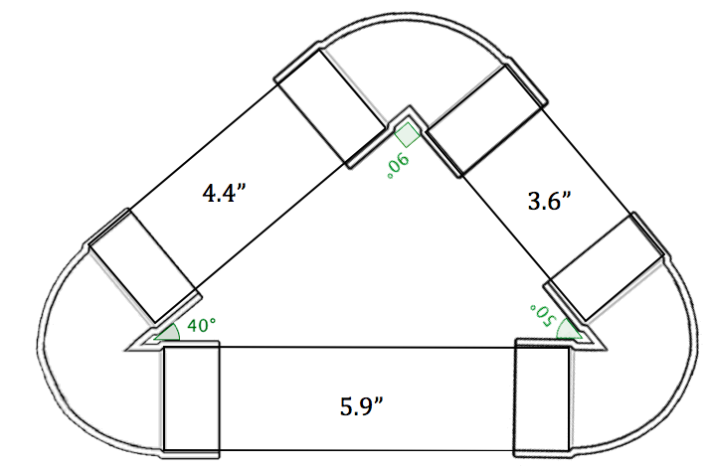
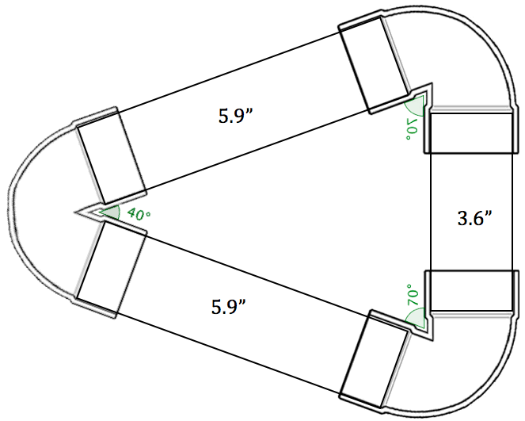
Sketches:

Are they isometric? _______ If so, what transformation(s) would map the first image onto the second?

4. 7.2 inch pipe, 3.4 inch pipe, 5.2 inch pipe (in any order)

Sketches:

Are they isometric? _______ If so, what transformation(s) would map the first image onto the second?

Geometry 21 Unit 2: Polygons Name: _____________________________________
2.1.3 Proving Triangles Congruent (Part 1) Date: _______________________ Period: _______

Recall that two figures are congruent if they are the same size and shape. They are also called isometric. For two triangles to be congruent, all three pairs of corresponding angles and all three pairs of corresponding sides must be congruent. (Corresponding just means in the same relative position.)

Identify the parts of ΔDEF that correspond to the parts of ΔABC. Note the symbols used to name angles and segments; be sure to name yours properly.

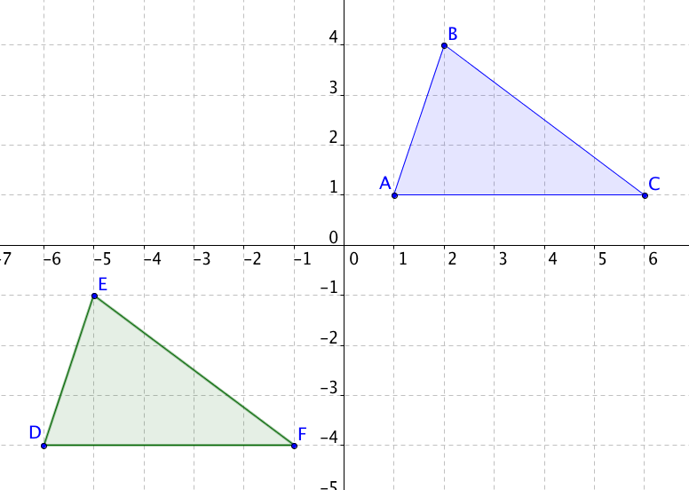
1. Angles:
___________ corresponds to ∠A
___________ corresponds to ∠B
___________ corresponds to ∠C
Sides:
__
___________ corresponds to AB

__
___________ corresponds to BC

__
___________ corresponds to CA

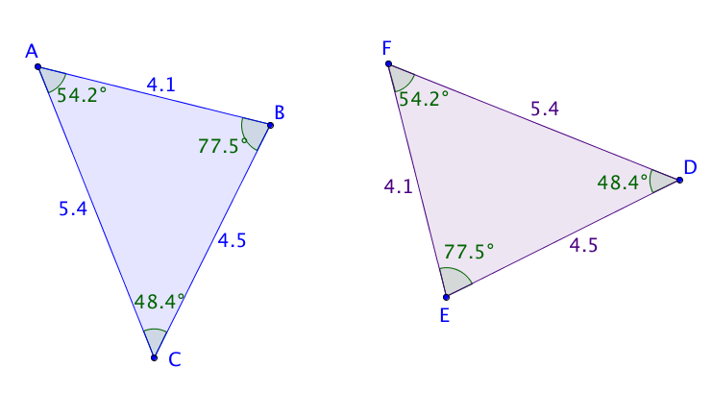
2. Angles:
___________ corresponds to ∠A
___________ corresponds to ∠B
___________ corresponds to ∠C
Sides:
__
___________ corresponds to AB

__
___________ corresponds to BC

__
___________ corresponds to CA

The symbol means “is congruent to.” We can use the congruence symbol to compare angles that have the same measure or segments that have the same length. From the last example, we know the following:

, ,  and , 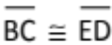, 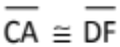

Since these are all pairs of corresponding parts, we can conclude that .

Question: Is it necessary to show that all six pairs of corresponding sides and angles are congruent to conclude that the triangles are congruent?

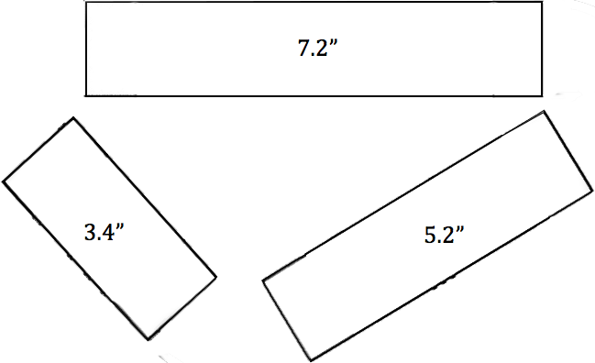
Think about the pipe pieces. When you started with each of the following sets of parts, you and your partner could only make one triangle. These combinations of parts are often referred to by the kind of part they are and the order in which they appear as shown below.
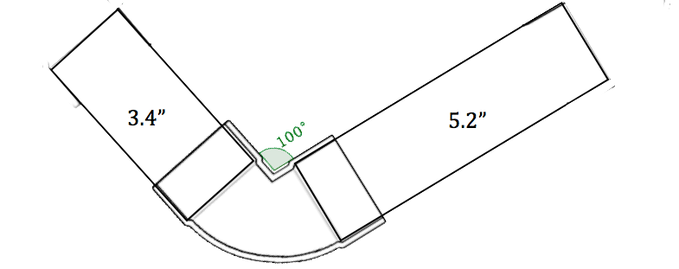
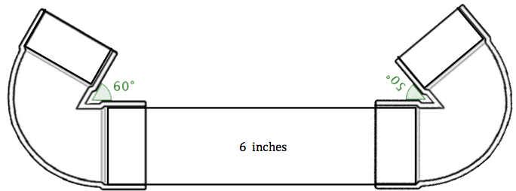

angle-side-angle (ASA) side-angle-side (SAS) side-side-side (SSS)

Can we extend this idea to proving that two triangles are congruent? What if we knew about these combinations of parts in two triangles? Would that be enough to determine that the triangles are congruent? Share your thoughts below – draw some examples.

Geometry 21 Unit 2: Polygons Name: _____________________________________
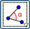
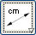
2.1.4 Proving Triangles Congruent (GeoGebra) Date: _______________________ Period: _______
Complete the following. Verify using the following measurement tools.

1. Open the GeoGebra file Proving Triangles Congruent, Part 1. You should see a screen like this:

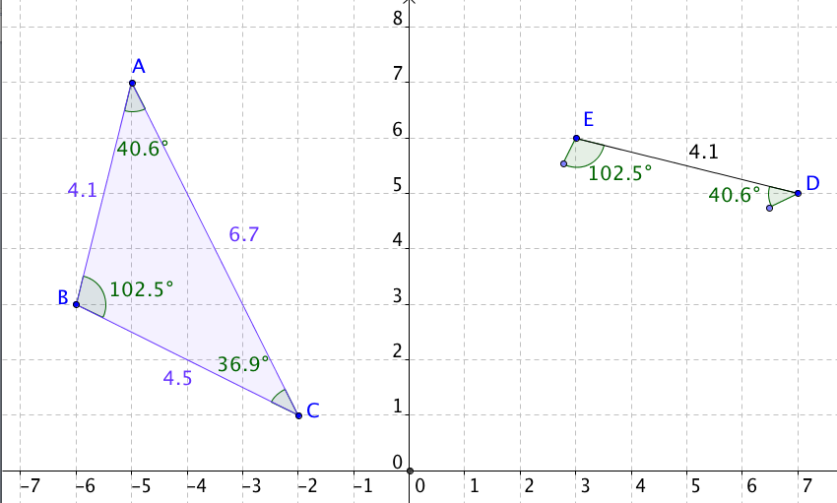

a. Use the Draw Ray tool to complete .

b. Sketch on the grid at right.


c. Use one of the transformation tools to map  onto .

Write a mapping rule and state, in words, which transformation(s) you used.

d. 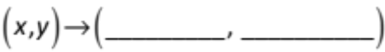 e. Transformation(s):

f. Which combination of triangle parts (SSS, SAS, ASA, or SSA) were we given? _____________________

g. Can we conclude that ? Answer and explain.

2. Open the GeoGebra file, Proving Triangles Congruent, Part 2.

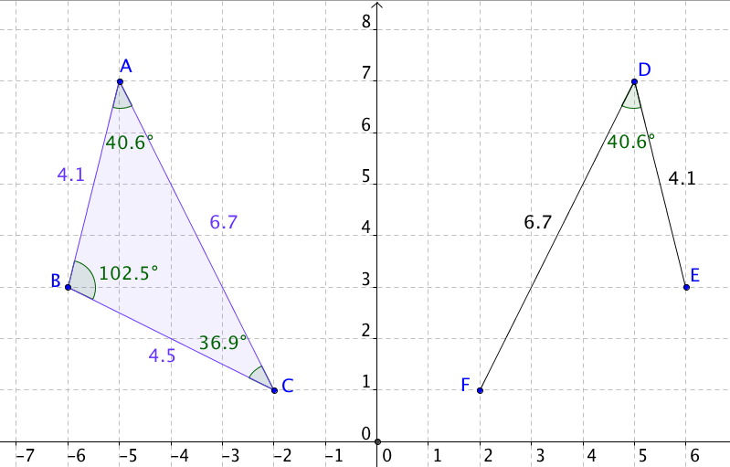
a. Complete and sketch on the grid.

b. Use one of the transformation tools to map onto .

c.

e. Transformation(s):

f. Which combination of triangle parts (SSS, SAS, ASA, or SSA) were we given? ________ _____________________

g. Can we conclude that ? Answer and explain.

3. Open the GeoGebra file, Proving Triangles Congruent, Part 3. Note that  is fixed in place.
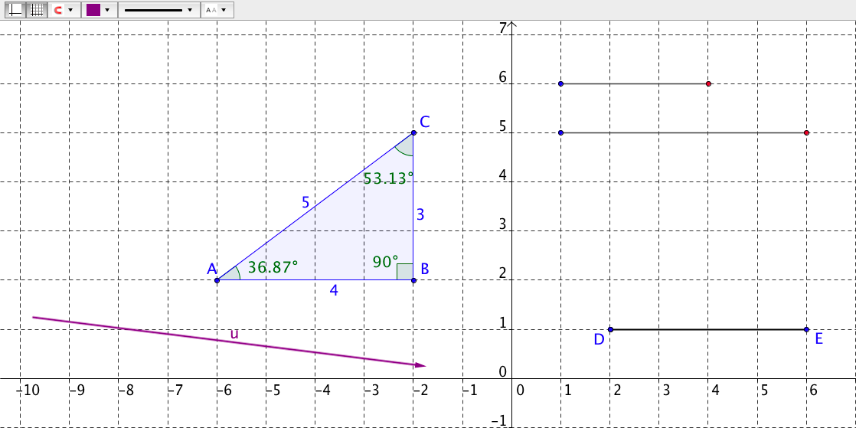
a. Drag the endpoints (blue ones first) of the two free segments into place to complete and sketch it on the grid.

b. Use one of the transformation tools to map onto .

c.

e. Transformation(s):

f. Which combination of triangle parts were we given? ________

g. Can we conclude that ? Answer and explain.

4. Open the GeoGebra file, Proving Triangles Congruent, Part 4.

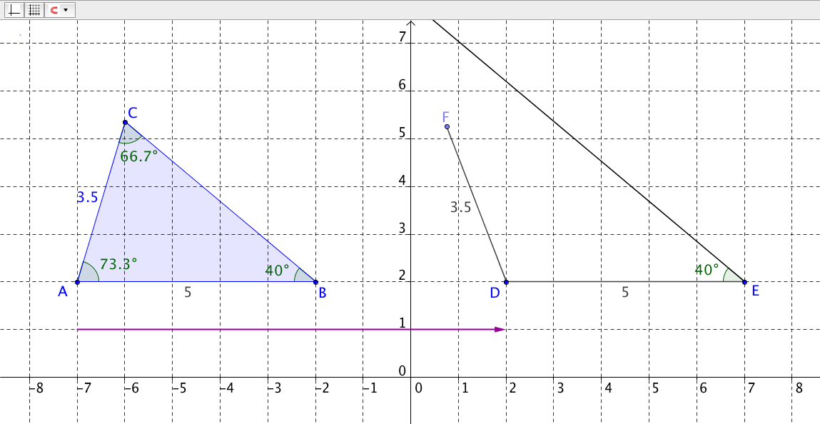
a. Grab point F and swing it around to complete the triangle. Sketch it.

b. Find another way to make a triangle. Sketch it.

c. Which combination of triangle parts were we given? ________ _____________________

d. Can we conclude that if we are only given the following?

Answer and explain.

5. Summarize what you’ve learned.

