Algebra 1 Unit 4: Linear Functions Name: _____________________________________
4.1.1 Motion Detector Class Introduction Date: _________________ Group: ______________

Sketch the distance-time graphs for the following situations:

- You start far away from the motion detector and 2. You are sitting still about 30 cm from the
walk toward the motion detector at a steady rate. motion detector and don’t move.

Distance in meters
Time in seconds

Distance in cm
Time in seconds

3. _____________________________________ 4. _____________________________________

_____________________________________ _____________________________________

Distance in meters
Time in seconds

Distance in meters
Time in seconds

5. _____________________________________ 6. _____________________________________

_____________________________________ _____________________________________

Distance in meters
Time in seconds

Distance in meters
Time in seconds

7. You start close to the detector and take 8. You start close to the detector and move
a big step away once every 1 second. away slowly at first, then quickly.
Distance in meters
Time in seconds

Distance in meters
Time in seconds

Is this function linear? ___________ Is this function linear? ___________

9. You start 6 m from the detector, and for each 10. You start at the detector and move
second that passes, you move 1 meter closer. away at a rate of 3 meters per second.
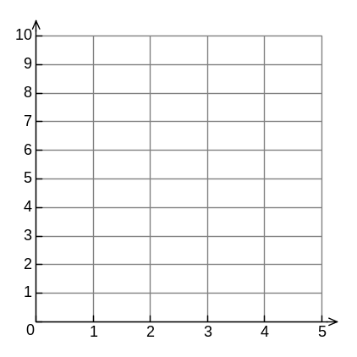
Distance in meters
Time in seconds
Distance in meters
Time in seconds

11. How did we make a horizontal line? 12. Can we make a vertical line? _____ Why?

_____________________________________ _____________________________________

13. Fill in the blanks:

a. A straight line is made by a person walking ________________________________________

b. A curved line is made by a person walking ________________________________________

c. A decreasing line is made by a person walking ________________________________________

d. An increasing line is made by a person walking ________________________________________

e. A steep line is made by a person walking _________________________________________

f. A shallow line is made by a person walking _________________________________________

g. A horizontal line is made by a person who _________________________________________

