Algebra 1 Unit 4: Linear Functions Name: _____________________________
4.1.2 Motion Detector Group Activity Date: _________________ Period:______

Group Members names: ______________________________________________________________

1. Draw an accurate graph for each situation by hand first. Then:

2. Hold the CBR motion detector in one hand, and your graphing calculator in the other. Aim the sensor directly at a wall. (Hint: The minimum distance it can detect is 6 in., the maximum is 20 ft.)

3. Press the purple “APPS” key. Run the “EasyData” application.

4. From the Setup menu choose 1: Distance, and go to the units tab. Select Feet ( ft ).

5. How did you do? Did you start too close/ not far enough? Walk too fast/ too slow?

a) Tony started 3 feet from the CBR. He walked b) Marie started 9 feet from the CBR

away from the detector at a rate of 3 feet per she walked toward it at a rate of 3 feet

second. per second.

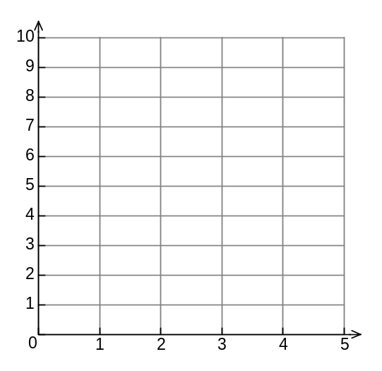
Distance in feet
Time in seconds
Distance in feet
Time in seconds

How did you do? How did you do?

______________________________________ ______________________________________

______________________________________ ______________________________________

______________________________________ ______________________________________

c) Billy started 10 feet from the CBR. He walked d) Julie started 5 feet from the CBR

toward from the detector at a rate of 2 feet she walked toward it at a rate of 1 foot

per second. per second.

Distance in feet
Time in seconds
Distance in feet
Time in seconds

How did you do? How did you do?

______________________________________ ______________________________________

Compare graphs b, c, and d. In which one was the student walking the fastest? ________________

How does the graph tell you this? _____________________________________________________

In which graph did the student reach the detector first? ___________________________________

How did you know? ________________________________________________________________

e) Pam started 7 feet from the detector. She f) Margaux started at the CBR. She walk-

stood still for 2 seconds, then walked toward the ed away at a rate of 4 feet per second

detector at 2 feet per second. for 2 seconds, then stood still.
Distance in feet
Time in seconds
Distance in feet
Time in seconds

g) Bobby started 10 feet from the CBR. He walked h) Darnell started at the motion detector.

toward it at a rate of 3 feet per second for three He walked away at 1 foot per second for

seconds, then walked away from it at 3 feet per 3 seconds, then walked away at 3 feet

second. per second.

Distance in feet
Time in seconds
Distance in feet
Time in seconds

i) Sara started 10 feet from the CBR. She walked j) Johnny sat 5 feet in front of the

toward the detector for 2 seconds at two feet detector and rocked slightly back and

per second, stopped for one second, then forth. walked away at 3 feet per second.

Distance in feet
Time in seconds
Distance in feet
Time in seconds

