Algebra 1: Unit 4: Linear Functions Name: _________________________________________
4.1.4 Matching Motion Representations Date: ___________ Partners: _______________________

1. Caroline started 5 feet from the motion detector and walked away at a constant rate of 1 foot per second.

Graph: Function: Table:

Rate ___________________

Start Distance _____________

2. Kevin started 5 feet from the motion detector and walked toward it at a constant rate of 1 foot every 2 seconds.

Graph: Function: Table:

Rate ___________________

Start Distance _____________

4.1.4 Matching Motion Representations Names: _________________________________________
Page 2

3. Carlos started in front of the motion detector and walked away at a constant rate of 5 feet per second.

Graph: Function: Table:

Rate ___________________

Start Distance _____________

4. Kendra started 5 feet from the motion detector and didn’t move.

Graph: Function: Table:

Rate ___________________

Start Distance _____________

4.1.4 Matching Motion Representations Names: _________________________________________
Page 3

5. Kenny started 20 feet from the motion detector and walked toward it at a constant rate of 5 feet per sec.

Graph: Function: Table:

Rate ___________________

Start Distance _____________

6. Karen started 1 foot from the motion detector and walked away from it at a constant 3 feet per second.

Graph: Function: Table:

Rate ___________________

Start Distance _____________

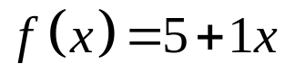  x is time in seconds  f(x) is distance in feet |  | 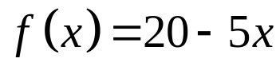  x is time in seconds  f(x) is distance in feet |  | 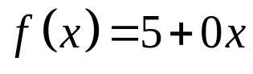  x is time in seconds  f(x) is distance in feet
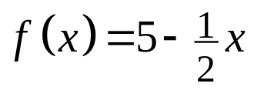  x is time in seconds  f(x) is distance in feet |  | 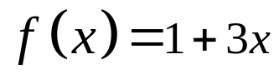  x is time in seconds  f(x) is distance in feet |  | 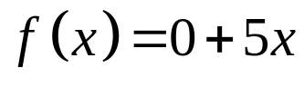  x is time in seconds  f(x) is distance in feet

x is time in seconds  f(x) is distance in feet |  | x is time in seconds  f(x) is distance in feet |  | x is time in seconds  f(x) is distance in feet
x is time in seconds  f(x) is distance in feet |  | x is time in seconds  f(x) is distance in feet |  | x is time in seconds  f(x) is distance in feet

  x, in sec | f(x), in ft
  0 | 5
  1 | 6
  2 | 7
  3 | 8
  4 | 9
  x, in sec | f(x), in ft
  0 | 5
  1 | 4.5
  2 | 4
  3 | 3.5
  4 | 3
  x, in sec | f(x), in ft
  0 | 0
  1 | 5
  2 | 10
  3 | 15
  4 | 20
  x, in sec | f(x), in ft
  0 | 5
  1 | 5
  2 | 5
  3 | 5
  4 | 5
  x, in sec | f(x), in ft
  0 | 20
  1 | 15
  2 | 10
  3 | 5
  4 | 0
  x, in sec | f(x), in ft
  0 | 1
  1 | 4
  2 | 7
  3 | 10
  4 | 13

  x, in sec | f(x), in ft
  0 | 5
  1 | 6
  2 | 7
  3 | 8
  4 | 9
  x, in sec | f(x), in ft
  0 | 5
  1 | 4.5
  2 | 4
  3 | 3.5
  4 | 3
  x, in sec | f(x), in ft
  0 | 0
  1 | 5
  2 | 10
  3 | 15
  4 | 20
  x, in sec | f(x), in ft
  0 | 5
  1 | 5
  2 | 5
  3 | 5
  4 | 5
  x, in sec | f(x), in ft
  0 | 20
  1 | 15
  2 | 10
  3 | 5
  4 | 0
  x, in sec | f(x), in ft
  0 | 1
  1 | 4
  2 | 7
  3 | 10
  4 | 13
