Algebra 1 Unit 1: Patterns Name: _____________________________________
1.1.1 Structure of Hydrocarbons Date: _________________ Group: ______________
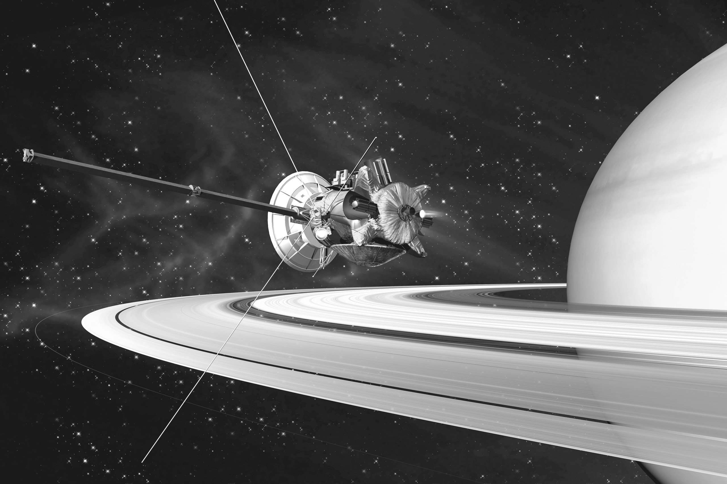
Artist’s concept of the Cassini orbiter saturn.jpl.nasa.gov

On June 30, 2004, NASA’s Cassini spacecraft entered orbit around Saturn to begin the first in-depth, up-close study of the ringed planet and its domain. As expected, the Saturn System has provided an incredible wealth of opportunities for exploration and discovery. Cassini has revealed that one of Saturn’s moons, Titan, has a surface shaped by rivers and lakes of liquid hydrocarbons ethane and methane (used as fuels), which form clouds and occasionally rain from the sky as water does on Earth.
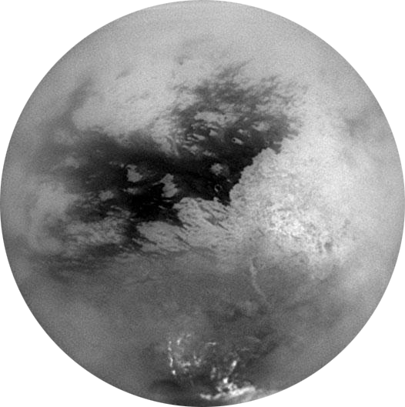
Saturn’s Moon, Titan
saturn.jpl.nasa.gov

Learn about hydrocarbons at: http://bit.ly/NJeugZ Learn about Titan at: http://1.usa.gov/qZn6E

You are chosen to travel to Titan in the year 2022 to get the fuel and return it to the Earth.
In order to identify the hydrocarbons, you will build some models and look for a common
pattern. An example of the simplest hydrocarbon, methane, is shown here. In every simple hydrocarbon molecule, each carbon atom has four bonds (links to other atoms) and each hydrogen atom has one bond.

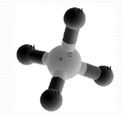
- Build models of ethane, propane, and butane and complete the table below.

Hydrocarbon Molecules
Hydrocarbon | Carbon Atoms | Hydrogen Atoms
Methane | 1
Ethane | 2
Propane | 3
Butane | 4
2. Make a graph that shows the relationship between the number of carbon atoms and the number of hydrogen atoms in the hydrocarbons listed in the table.

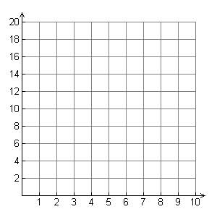
Number of Hydrogen Atoms
Number of Carbon Atoms
Hydrocarbon Structure

3. Does the number of hydrogen atoms follow
a pattern? Write a description of the pattern.

4a. Use the graph to predict the number of hydrogen atoms in a hydrocarbon with 5 carbon atoms. _______

b. Use the graph to predict the number of hydrogen atoms in a hydrocarbon with 8 carbon atoms. _______
5. Sketch the four simple hydrocarbon molecules you built. You can use H’s and C’s or circles for the atoms.

methane | ethane
propane | butane

Chemical Symbols can be used to represent hydrocarbon molecules. For example, ethane can be represented as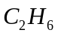, because ethane has 2 carbon atoms and 6 hydrogen atoms.

- Octane has eight carbon atoms; how many hydrogen atoms does it have? ________ What is its chemical symbol?

- Suppose a simple hydrocarbon has 22 hydrogen atoms. Work backwards to determine how many carbon atoms it has ____________ and then write its chemical symbol. ________________________________

- Can a simple hydrocarbon have 25 hydrogen atoms? ____________ Explain your answer.

- In this problem, you have examined many different representations of patterns. You made a table of values, you wrote a verbal description, and you examined a graph.

a. Which representation do you find most useful? Why?

b. Which is the most difficult for you to understand? Why?

