Algebra 1 Unit 1: Patterns Name: _____________________________________
1.1.2 Burning Hydrocarbons Date: _________________ Group: ______________
When hydrocarbons are burned, they create energy. The table below shows approximately how much energy (kJ/mole) is released from completely burning a fixed amount of each hydrocarbon.
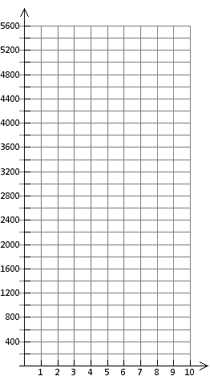
Energy (kJ/mole)
Energy Released by
Burning Hydrocarbons

Number of Carbon Atoms

Simple  Hydrocarbon | Number of Carbon Atoms | Energy Released from combustion (kJ/mole)
Methane | 1 | 920
Ethane | 2 | 1560
Propane | 3 | 2200
Butane | 4 | 2840
Pentane | 5
Hexane | 6
Heptane | 7
Octane | 8
Energy (kJ/mole)

- Look for the pattern and complete the table above.

- Describe the pattern in your table.

- Make a graph to show how much energy is released
(kJ/mole) from the combustion of hydrocarbons.

- Describe the pattern in your graph.

- Based on the data from the table and graph, which hydrocarbons do you think might be the best to bring back from Titan? _____________________________________________ Explain your answer.

