Gravel Count Program Manual

Table of Contents

1 Installation 2

1.1 Dependency 2

1.1.1 Matlab Runtime 2

1.1.2 R 2

1.1.3 GDAL 3

1.2 Main Program 4

2 Generate zero contour Images from DSM 5

3 Sieve through Gravel 7

# Installation

## Dependency

### Matlab Runtime

* + - 1. Download Matlab Runtime Installer from the link below  
         Matlab Runtime Installer : <https://drive.google.com/file/d/1AM-gQMwe66ClW6BzuNx_CHVNxmIi1Gte/view?usp=sharing>
      2. Unzip MatlabRuntime.zip, and start the installer in ./MatlabRuntime/for_redistribution/MyAppInstaller_web.exe
      3. Follow the step from the installer and accept the terms of agreement.

### R

* + - 1. Download R 3.6.3 installer from the link below  
         R 3.6.3 installer: <https://cran.r-project.org/bin/windows/base/old/3.6.3/R-3.6.3-win.exe>  
         ## Different version of R may not have the require library.

Only R 3.6.1 and R 3.6.3 has been tested

* + - 1. Follow the step from the installer to install R
      2. Add C:\Program Files\R\R-3.6.6\bin to PATH system enviroment
      3. Open a terminal and run R Console by typing R and press enter.  
         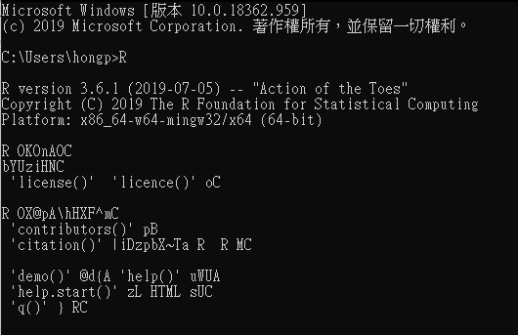
      4. Install gstat and sp packages by running the following command in R console.  
         install.packages(“gstat”)  
         install.packages(“sp”)
      5. Type in yes if personal library is required
      6. Select the mirror server for where to download the packages. The Default server to use is 0-Cloud.  
         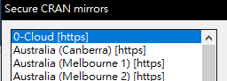
      7. Check the library is correctly install by running the following command in R console:  
         library(“gstat”)  
         library(“sp”)  
         If no error is shown means the library has successfully install.

### GDAL

* + - 1. Download OSGeo4W from the link below  
         OSGeo4W: <http://download.osgeo.org/osgeo4w/osgeo4w-setup-x86_64.exe>
      2. Choose Express Desktop Install and press Next
      3. Make Sure GDAL is selected when prompt what to install.

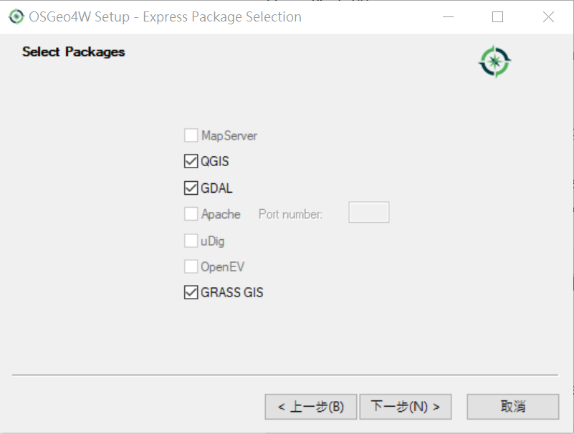

* + - 1. Choose a Download Sites, and press Next. The default site is <http://osgeo4w-oslandia.com>  
         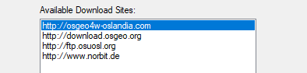
      2. Search for “gdal: The GDAL/ORG library and command line tools“ and Click on “Skip” if it is not selected to install gdal.  
         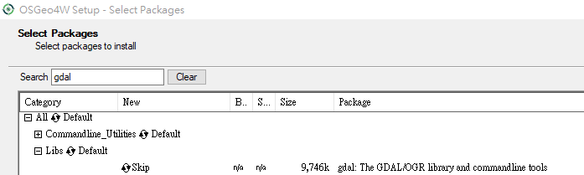  
         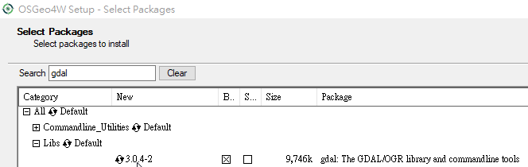
      3. Press Next and agree to all license term to start the install process.
      4. Add <Install path>/bin to PATH system environment.

## Main Program

* + 1. Download the program from the link below: <https://github.com/hongping1224/Dummy-Project/releases/download/v2.0-alpha/Release.zip>
    2. Unzip the downloaded package.
    3. Run the program by launching StoneCount.exe

# Generate zero contour Images from DSM

Generate zero contour Image by go to Extra -> zero-contour  
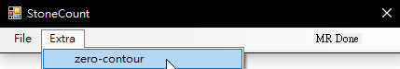

Select a DSM File

**Beware: space within the full path will result in error

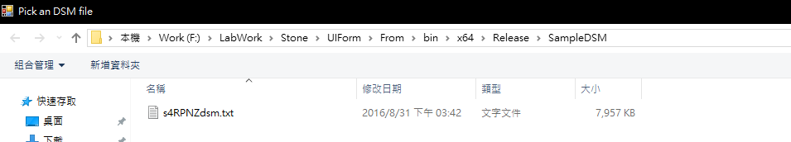

Select a location and input a filename to save result’s contour image.  
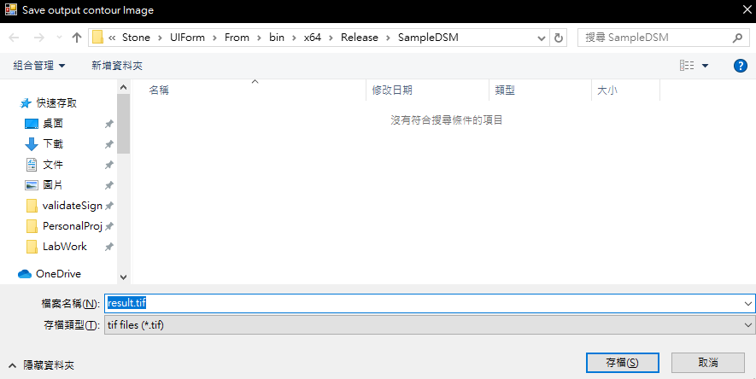

Wait until all process finished and showed the , the whole process can takes up to 35minutes. When all process is done, a zero contour image will appear.

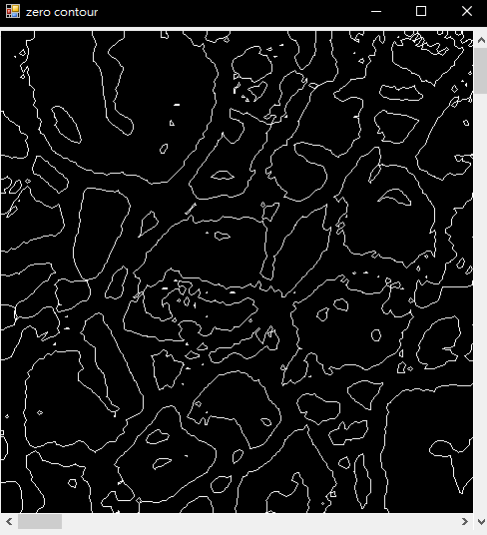

# Sieve through Gravel

Start a new project

File -> Start Project

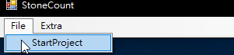

Preprocessing

Click Preprocess and Select a zero contour image. The Processing Window is shown below. The operations include Inverse, Fill, Opening, Closing, Erosion and Dilation. All operations are working with a binary image. Where white is to 1 and black is zero.

Each step will be show in the Logs panel. The logs can be save as a log file and can later be reapply to the images.

For comparison purpose, left clicking on the image will show the original image. Or by setting the Transparency of the result image is useful.

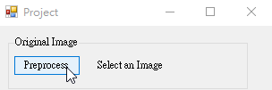

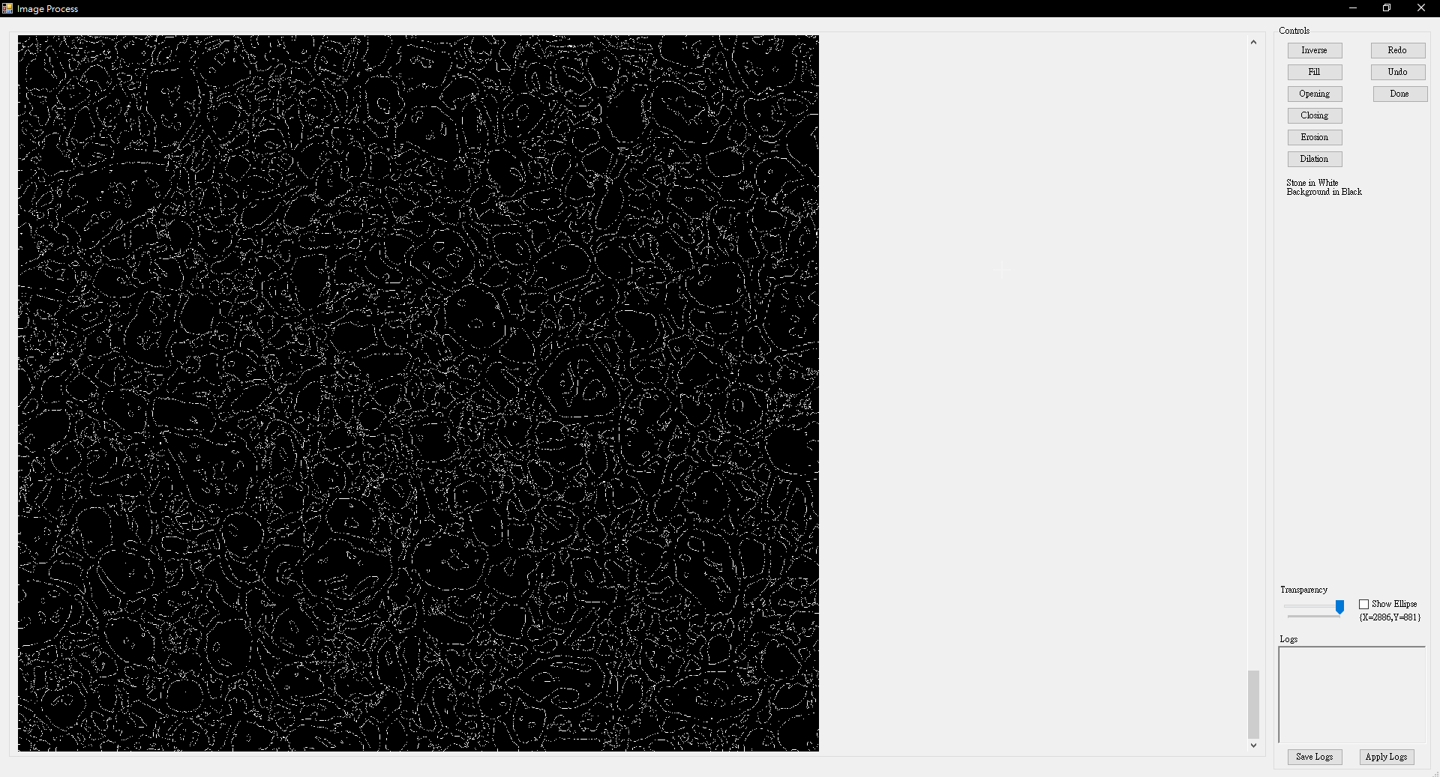

Preprocess the zero contour image.

This step is use to first fill in the gravel to get a solid gravel from its contour. Then end result of preprocessing background should be black and the gravel contour should be white. Press done after getting a satisfied result.

The example below shows the original contour image and the result of preprocessing by going through these 5 steps.

1. Fill → Fill Coordinate at x=1,y=1

* (x,y) should indicate a location of background.

1. Inverse
2. Fill → Fill Holes

* After executing Step 2, some contour lines may exist inside larger contour lines, which should be treated as noise. Step 3 eliminates this kind of noise.

1. Closing with a square filter with filter size equal to 7
2. Opening with a square filter with filter size equal to 7

Note that Step 4 and Step 5 are used to remove other kinds of noise and the parameters are only suitable in our example. When using other image, users should design their own morphological operations to eliminate the noise. The morphological operations implemented in StoneCount are based on Matlab. Reference of these morphological operations can be found in [Matlab’s document](https://www.mathworks.com/help/images/morphological-filtering.html?s_tid=CRUX_lftnav).

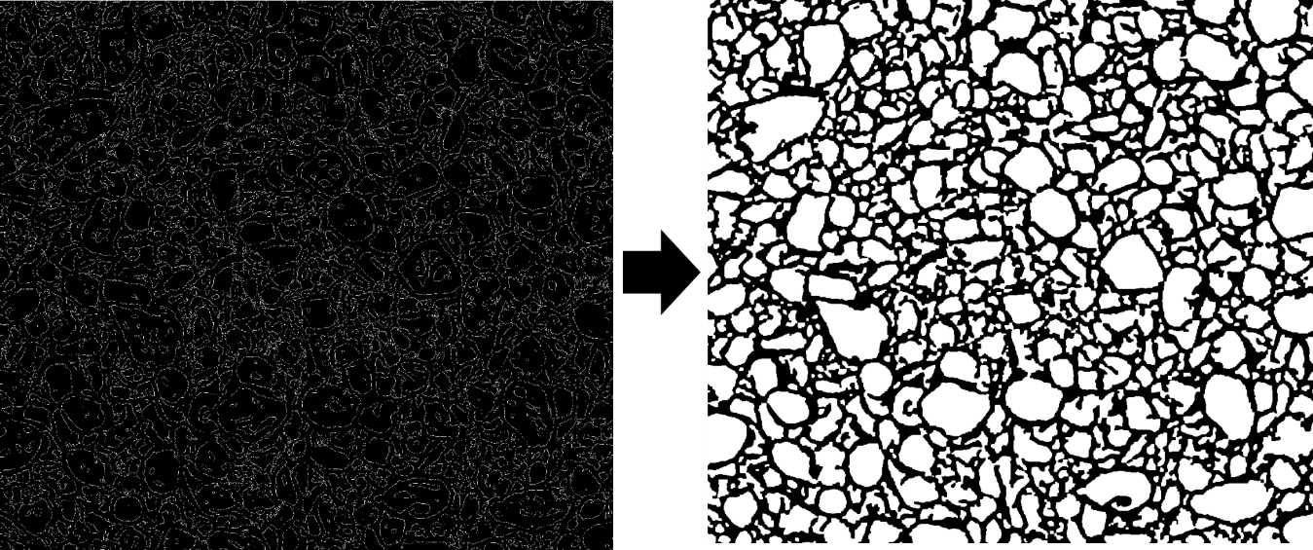

Start Sieving Process

The First Sieve will be available after the preprocessing process.

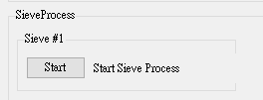

The sieving process is divided in 2 steps. The first step is to sieve out the gravel size larger than the threshold. The threshold can be change by adjusting the scroll bar or by typing in to the input box and press enter. Only the gravel of size larger than the threshold will remain. Press done to go to the next step when getting a satisfied result.

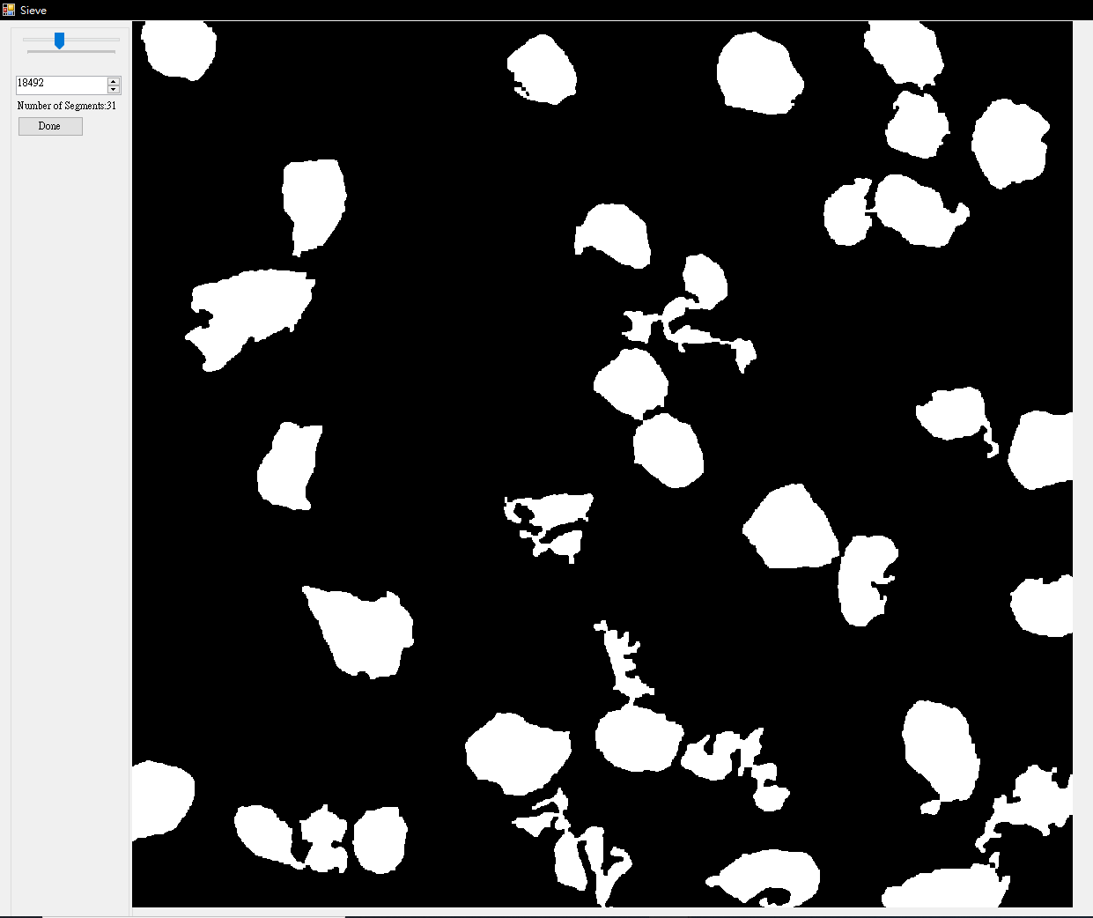

The second step of sieving is to process the sieved gravel from last step. The purpose of this step is to separate gravel which are merged together. The example below is done by an Opening operation. After getting a satisfied result, press done.

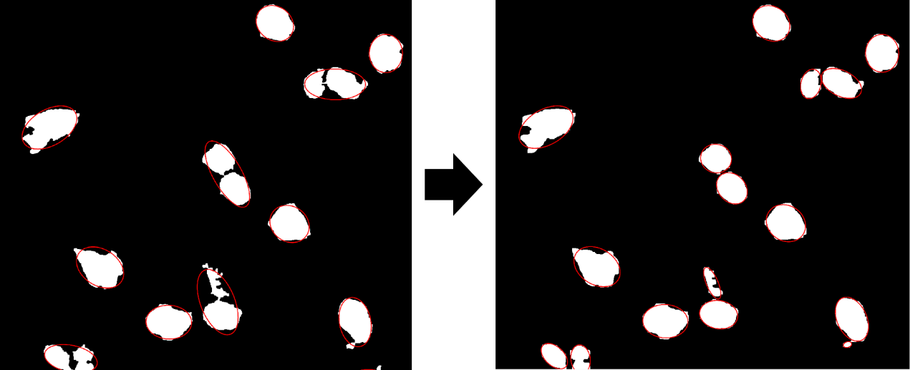

Repeat the Sieving Process

After a sieving process is done, The Next sieve will be available. Repeat step 3.4 until reaching a satisfied result.

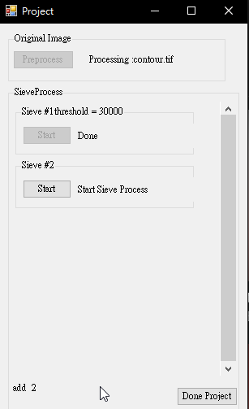

Press Done project to save the result. The result will include 2 shp file, result.shp is the boundary of each gravel and result_ellipse.shp is the fit ellipse of each gravel. In the table of both shp file are the x y coordinate of the ellipse center, the semi-major, semi-minor axis of the ellipse and the tilt of the ellipse. 