
PROBLEM SOLVING USING PROGRAMMING (JAVA) · 26SC1101E
Campus Smart-Locker and
Parcel Management System
Detailed Application Design
DESIGN BASELINE Transforms approved requirements into implementable Java structures while remaining entirely inside the PSPJ syllabus.

Predecessor | Task 1 · Application Specification and CO Matrix
Design target | Java SE console application
JDK baseline | Java 21 LTS; Java 17-compatible syntax where practical
Version | 1.0 · Implementation-ready design
Prepared by | Dr. N. Chaitanya Kumar  Professor in CSE & Coordinator, Freshman Engineering Department

1. Design decisions frozen in this version
This design resolves the open implementation choices from Task 1. Any later change must update the linked requirement, acceptance criterion and CO evidence.
Decision | Area | Approved design
DD-01 | Runtime | Java 21 LTS, using Java SE APIs and syntax that remains practical on JDK 17.
DD-02 | Interface | Single-user console application; no GUI, database, network or external framework.
DD-03 | Locker capacity | Twelve lockers represented as Locker[3][4]: four each of S, M and L.
DD-04 | Source of truth | parcels.csv stores parcel state; locker occupancy is reconstructed from waiting parcel records.
DD-05 | Parcel states | RECEIVED and PICKED_UP only.
DD-06 | Fee | S/M/L base fees of 10/20/30 plus 2.50 per kilogram.
DD-07 | Pickup code | Four-digit body plus one recursive checksum digit; teaching aid, not a security system.
DD-08 | Time data | Operator supplies receivedHour as an integer 0–23; advanced date/time APIs are unnecessary.
DD-09 | Notification | A NotificationChannel interface formats and prints a simulated message.
DD-10 | Testing | Manual acceptance scripts, trace tables and small Java verification routines; no external test framework.

2. Architecture
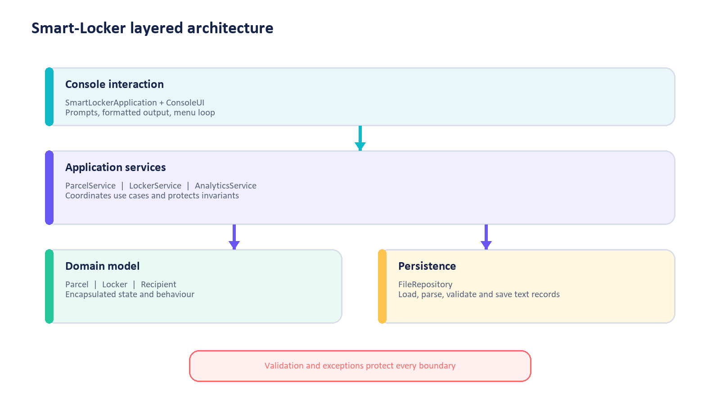
Figure 1. Layered application architecture
Dependencies point inward toward domain concepts. Console code does not manipulate files directly, and persistence code does not decide business rules.
Layer | Classes | Responsibility | CO
Console | SmartLockerApplication, ConsoleUI | Own the menu loop, prompts, typed retry and formatted output. | CO1, CO2
Services | ParcelService, LockerService, AnalyticsService | Coordinate use cases, validate state transitions and protect invariants. | CO2, CO3, CO6
Domain | Parcel, Locker, Recipient | Represent state and behaviour with encapsulation and composition. | CO4
Persistence | FileRepository | Load, parse and save delimited text using Path/Files. | CO5
Cross-cutting | InputValidator, custom exceptions, NotificationChannel | Validate boundaries, fail safely and demonstrate an interface. | CO4

2.1 End-to-end control flow
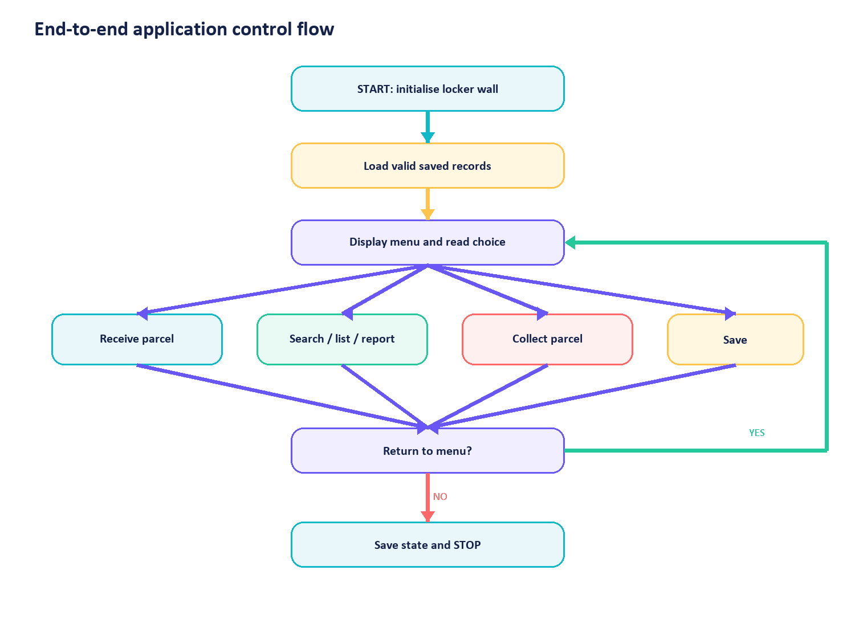
Figure 2. Main program control flow

3. Domain and class model
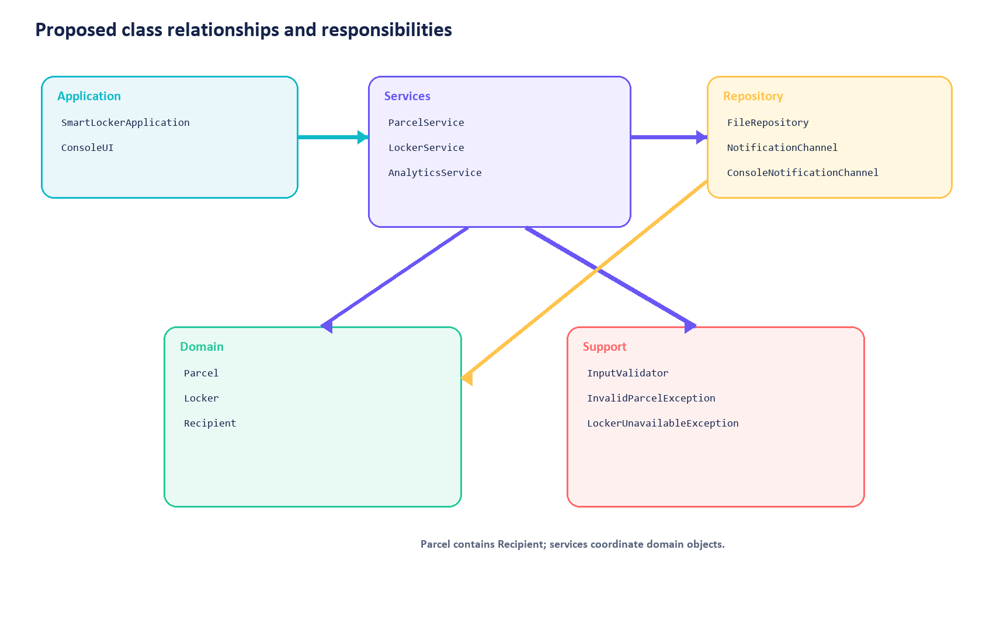
Figure 3. Proposed class model
The design uses classes only where they model a responsibility that can be explained at PSPJ level. Deep inheritance, advanced patterns and dependency frameworks are deliberately excluded.
Class/interface | Responsibility | Key operations | Invariant/boundary
SmartLockerApplication | Entry point and object assembly | main, run | Menu loop terminates only on 0
ConsoleUI | Prompting and formatted display | readMenuChoice, readParcelDraft, printReceipt, printError | Never changes domain state
Parcel | Parcel lifecycle data | constructor, getters, markPickedUp, toString | Required values valid; status known
Locker | One storage position | assign, release, canFit, isOccupied | At most one waiting parcel
Recipient | Recipient identity | constructor, getters, toString | ID and name non-blank
ParcelService | Receive, search and collect use cases | receiveParcel, collectParcel, findById, list/sort/filter | Parcel/map/list indexes agree
LockerService | Locker-wall allocation | findSmallestAvailable, assign, release, occupancy | Compatibility and occupancy preserved
AnalyticsService | Counts and reports | summariseBySize, busiestHour, topRecipients | Results derived; no state mutation
FileRepository | Delimited persistence | loadParcels, saveParcels, parseLine, formatLine | Invalid rows do not corrupt valid rows
InputValidator | Reusable field rules | requireText, parseWeight, validateSize, validateHour | Either valid value or clear exception
NotificationChannel | Interface for simulated notification | formatNotification | Returns displayable message
ConsoleNotificationChannel | Console implementation | formatNotification | No external messaging

3.1 Composition and interface use
- Parcel has one Recipient value and a lockerId after successful assignment.
- ParcelService has a LockerService, FileRepository and NotificationChannel.
- LockerService owns the Locker[][] wall.
- ConsoleNotificationChannel implements NotificationChannel; the service is programmed to the interface.
- AnalyticsService receives parcel collections for read-only processing.

4. Data structures

4.1 Locker wall and arrays
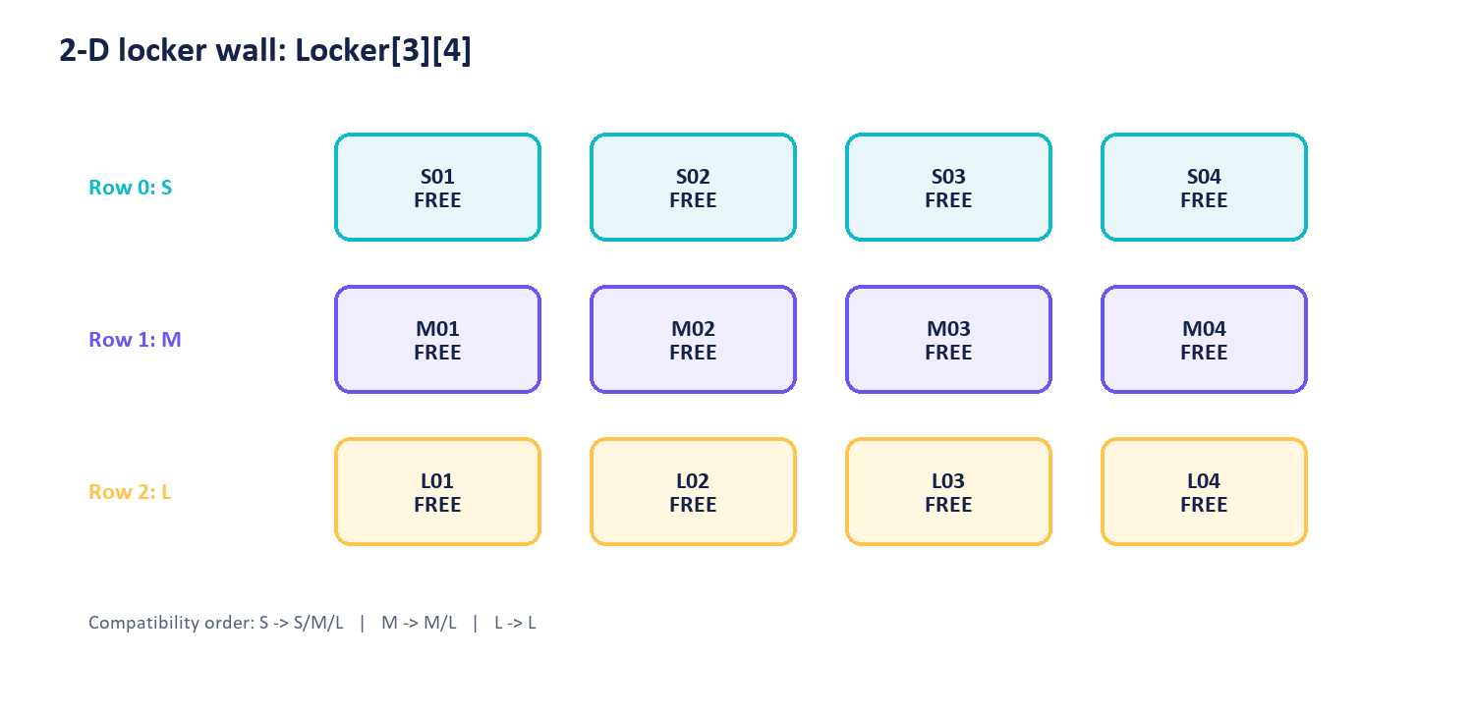
Figure 4. Two-dimensional locker wall
The row index represents size tier: 0=S, 1=M, 2=L. The column index represents locker number 1–4. Allocation scans from the parcel's required tier toward larger tiers, and within a tier from the lowest column upward.
Conceptual array mapping
SIZE_ORDER = {"S", "M", "L"}
BASE_FEES = {10.00, 20.00, 30.00}
Locker[][] lockerWall = new Locker[3][4]
S parcel scans rows 0, 1, 2
M parcel scans rows 1, 2
L parcel scans row 2 only

4.2 Collections and indexes
Structure | Purpose | Teaching reason
List<Parcel> | Master ordered collection | Append parcels, iterate, sort views and create streams.
Map<String, Parcel> | Parcel-ID index | Fast, readable lookup and duplicate detection using normalised ID keys.
Set<String> | Used pickup codes | Prevent duplicate generated codes and demonstrate uniqueness.
Optional<Parcel> | Search result | Represent “found or not found” without returning null.

NO INTERNAL DSA ANALYSIS Students choose collection APIs by behaviour. Implementation internals and Big-O remain outside this course.

5. Core algorithms

5.1 Receive parcel
ALGORITHM ReceiveParcel
1 READ parcelId, recipientId, recipientName, size, weightKg, receivedHour
2 VALIDATE every field
3 IF parcelId already exists THEN reject
4 locker = FIND smallest compatible free locker
5 IF no locker exists THEN throw LockerUnavailableException
6 fee = baseFee(size) + weightKg * 2.50
7 pickupCode = GENERATE unique code with recursive checksum
8 CREATE Recipient and Parcel
9 ASSIGN parcel to locker
10 ADD parcel to list, ID map and code set
11 DISPLAY receipt and simulated notification
12 RETURN accepted parcel

Commit point: steps 9–10 happen only after every validation and calculation succeeds. Earlier failure must leave all collections and lockers unchanged.

5.2 Locker assignment
ALGORITHM FindSmallestAvailable(size)
1 startRow = rowIndex(size)
2 FOR row FROM startRow TO 2
3 FOR column FROM 0 TO 3
4 locker = lockerWall[row][column]
5 IF locker is free THEN RETURN locker
6 RETURN no result

Termination is guaranteed because both loops have fixed finite bounds. The first returned locker is the lowest-numbered locker in the smallest compatible tier.

5.3 Pickup
ALGORITHM CollectParcel(code)
1 VALIDATE code shape and recursive checksum
2 FIND a RECEIVED parcel whose pickup code matches
3 IF none exists THEN reject without state change
4 RELEASE its locker
5 CHANGE parcel status to PICKED_UP
6 DISPLAY pickup confirmation

5.4 Recursive checksum
The code body is a four-digit value generated from an incrementing sequence. The fifth digit is digitSumRecursive(body) % 10.
FUNCTION digitSumRecursive(number)
1 IF number < 10 THEN RETURN number
2 RETURN number % 10 + digitSumRecursive(number / 10)
FUNCTION isValidPickupCode(code)
1 IF code is not exactly five digits THEN RETURN false
2 body = first four digits as integer
3 expected = digitSumRecursive(body) % 10
4 RETURN expected equals final digit

TEACHING BOUNDARY The deterministic code is suitable for recursion and validation practice, not for real security.

5.5 Fee calculation
Size | Base fee | Formula
S | 10.00 | 10.00 + weightKg × 2.50
M | 20.00 | 20.00 + weightKg × 2.50
L | 30.00 | 30.00 + weightKg × 2.50

The calculation retains double precision internally and applies %.2f only when displaying or writing the fee.

6. Method map and call hierarchy
Method | Owner | Calls/uses | Design purpose
main | SmartLockerApplication | run | Create dependencies, start application
run | SmartLockerApplication | load -> menu loop -> dispatch -> save | Own termination
handleReceive | SmartLockerApplication | ConsoleUI.readParcelDraft -> ParcelService.receiveParcel | UI/service boundary
receiveParcel | ParcelService | validators -> locker allocation -> fee/code -> commit | FR-04–08
collectParcel | ParcelService | code validation -> search -> release -> state change | FR-12
findSmallestAvailable | LockerService | rowIndex -> nested array scan | CO2/CO3
generatePickupCode | ParcelService | digitSumRecursive | CO3 recursion
loadParcels | FileRepository | Files.readAllLines -> parseLine | CO5
saveParcels | FileRepository | formatLine -> Files.write | CO5
buildReport | AnalyticsService | streams/collectors/StringBuilder | CO5/CO6

6.1 Method contracts
Method | Precondition | Postcondition
receiveParcel(draft) | Draft fields supplied; services initialised | Returns accepted Parcel or throws a specific domain exception; no partial change
findSmallestAvailable(size) | Size is S/M/L | Returns Optional containing first compatible free locker, otherwise empty
collectParcel(code) | Code text supplied | Exactly one waiting parcel changes state on success; none change on failure
parseLine(line, number) | Non-null text line | Returns valid Parcel or reports a malformed-line exception with line number
saveParcels(path, parcels) | Path and collection supplied | File contains header plus one line per valid parcel, or save failure is reported

7. Validation and exception design
Input/state | Validation | Failure mechanism
parcelId | trimmed, non-blank, unique ignoring case | InvalidParcelException / duplicate message
recipientId/name | trimmed and non-blank | InvalidParcelException
size | uppercase S, M or L | InvalidParcelException
weightKg | numeric; >0 and <=25 | NumberFormatException converted to clear validation result
receivedHour | integer 0–23 | NumberFormatException or InvalidParcelException
pickupCode | five digits; checksum valid | InvalidPickupCodeException
locker availability | compatible free position exists | LockerUnavailableException

7.1 Exception flow
- InputValidator detects field-level problems before service state changes.
- Service methods throw domain-specific exceptions when a business operation cannot complete.
- Console boundary catches expected exceptions and prints actionable messages.
- FileRepository catches or reports I/O and parsing failures with file/line context.
- Unexpected programming defects are not hidden behind a generic empty catch block.

7.2 State invariants
- Every RECEIVED parcel has exactly one occupied compatible locker.
- Every occupied locker references exactly one RECEIVED parcel.
- Every PICKED_UP parcel has no active occupied locker.
- Parcel IDs and pickup codes are unique in the in-memory collection.
- List and map contain the same Parcel objects.

8. Persistence design

8.1 Folder and file plan
SmartLockerReference/
src/edu/klh/pspj/smartlocker/...
data/parcels.csv
reports/analytics-report.txt
README.md

Only parcels.csv is authoritative. On load, the service creates a fresh locker wall and reassigns lockers recorded by valid RECEIVED rows. This avoids two files disagreeing about occupancy.

8.2 parcels.csv schema
Column | Java form | Rule
parcelId | String | Required, unique
recipientId | String | Required
recipientName | String | Required; comma rejected in course version
size | String | S/M/L
weightKg | double | 0 < value <= 25
lockerId | String | S01–L04 for RECEIVED; blank for PICKED_UP after save
pickupCode | String | Five digits and valid checksum
status | String | RECEIVED/PICKED_UP
receivedHour | int | 0–23
storageFee | double | Non-negative

Example records
parcelId,recipientId,recipientName,size,weightKg,lockerId,pickupCode,status,receivedHour,storageFee
P101,22004567,Asha Rao,M,2.50,M01,48260,RECEIVED,14,26.25
P102,22007112,Ravi K,L,8.00,,73512,PICKED_UP,10,50.00

8.3 Load algorithm
1 IF parcels.csv does not exist THEN start with empty collections
2 READ lines
3 CHECK header
4 FOR each remaining non-blank line
5 SPLIT with empty-field preservation
6 VALIDATE field count and values
7 CREATE Recipient and Parcel
8 IF RECEIVED THEN reserve recorded locker after compatibility checks
9 ADD valid parcel to list/map/code set
10 REPORT and skip malformed rows
11 CONTINUE until all rows are processed

8.4 Save algorithm
1 CREATE output lines and add the fixed header
2 FOR each parcel
3 FORMAT one delimited record
4 ADD record to output lines
5 WRITE all lines using Files.write
6 REPORT success only after write completes

9. Analytics and functional design
Report | Pipeline/pattern | Syllabus evidence
Total/waiting/picked up | count and filter/count | Predicate<Parcel>
Parcels by size | groupingBy(size, counting()) | Function<Parcel,String>
Locker occupancy | array traversal and percentage calculation | Imperative comparison
Busiest received hour | groupingBy(hour, counting()) then max | Comparator<Map.Entry<...>>
Top recipients | group by recipient, count, sort descending, limit | Streams + Collectors
Sorted parcel report | sorted(comparator) then collect/forEach | Comparator + method reference

Representative pipeline shape
parcels.stream()
.filter(parcel -> parcel.getStatus().equals("RECEIVED"))
.collect(groupingBy(Parcel::getSize, counting()))

The course will first produce equivalent results with loops, then rewrite selected aggregations as pipelines and compare readability and intent.

10. Complete test design

10.1 Unit-sized verification targets
Target | Required cases
InputValidator | Valid, missing, boundary and malformed text
Locker.canFit | All S/M/L compatibility combinations
LockerService allocation | Lowest compatible free locker; full tiers
Fee calculation | Each size and representative weights
Recursive checksum | Base case, multi-digit sum and corrupted final digit
Parcel state transition | RECEIVED to PICKED_UP once only
File parsing | Valid line, missing field, invalid number and unknown status
Analytics | Known sample dataset with independently calculated results

10.2 Integration scenarios
ID | Scenario | Expected result
IT-01 | Fresh start -> receive valid parcel -> save -> exit | File created; parcel RECEIVED; locker occupied
IT-02 | Restart from IT-01 -> list -> collect -> save | Parcel restored, then PICKED_UP; locker released
IT-03 | Fill all S lockers -> receive another S | Next compatible M locker used
IT-04 | Fill every compatible locker -> receive parcel | Controlled rejection; no partial record
IT-05 | Load file with valid-invalid-valid rows | Two valid rows load; invalid row reported
IT-06 | Run loop analytics and Stream analytics | Results match exactly

10.3 Sample oracle dataset
Parcel | Size | Status | Hour | Recipient
P101 | S | RECEIVED | 09 | Asha
P102 | M | RECEIVED | 09 | Ravi
P103 | L | PICKED_UP | 14 | Asha
P104 | S | RECEIVED | 09 | Meera
P105 | M | PICKED_UP | 14 | Asha

EXPECTED ANALYTICS Total 5; waiting 3; picked up 2; sizes S=2, M=2, L=1; busiest hour=09; top recipient=Asha with 3.

10.4 Acceptance trace
Acceptance | Design area | Verification
AC-01 | Startup/loading | IT-01; missing-file test
AC-02–03 | Allocation | LockerService matrix; IT-03
AC-04–07 | Validation/retry | InputValidator table
AC-08 | No capacity | IT-04
AC-09–10 | Pickup transition | IT-02; used/invalid code tests
AC-11 | List/search/sort | Comparator/search checks
AC-12–13 | Persistence | IT-02 and IT-05
AC-14 | Analytics | IT-06 and oracle dataset

11. Package and source-file design
src/edu/klh/pspj/smartlocker/
SmartLockerApplication.java
ui/ConsoleUI.java
model/Parcel.java
model/Locker.java
model/Recipient.java
service/ParcelService.java
service/LockerService.java
service/AnalyticsService.java
persistence/FileRepository.java
validation/InputValidator.java
notification/NotificationChannel.java
notification/ConsoleNotificationChannel.java
exception/InvalidParcelException.java
exception/InvalidPickupCodeException.java
exception/LockerUnavailableException.java

The full reference application may use packages. Student increments will introduce this structure only after classes and relationships are taught; early versions remain a single source file.

12. CO design evidence
CO | Design evidence | Student-facing explanation
CO1 | Parcel primitives, fee expression, Scanner contract, formatted receipt | IPO, pseudocode, expressions and console transcript
CO2 | Menu loop, validation retry, selection, nested allocation loops | Decision table, loop trace and termination reasoning
CO3 | Method contracts, recursive checksum, 1-D mappings and 2-D wall | Call map, recursion trace and array processing
CO4 | Domain objects, composition, interface and custom exceptions | Class model, invariants and exception flow
CO5 | Parsing, StringBuilder report, Comparator, library sort/search and Files | Schema, parser trace and restart evidence
CO6 | List/Map/Set, Optional, lambdas and Stream analytics | Collection rationale and imperative/functional comparison

13. Implementation sequence for Task 3
- Create the final project folders and model classes.
- Implement validation, locker wall and fee/checksum utilities.
- Implement ParcelService receive/search/collect operations.
- Implement FileRepository load/save and malformed-row recovery.
- Implement analytics in loop and Stream forms.
- Implement ConsoleUI and application menu.
- Create sample data and expected report.
- Compile with javac, run all verification scenarios and correct defects.
- Prepare a clean demonstration script and distributable ZIP.
NEXT TASK Task 3 will build and verify the complete instructor reference application from this design. Student installation documentation remains a later, separate deliverable.

14. Design review checklist
- ☐ Architecture uses only Java SE and approved syllabus concepts.
- ☐ Every class has one explainable responsibility.
- ☐ Every mutable state change protects the stated invariants.
- ☐ Locker assignment is deterministic and terminates.
- ☐ The recursion example has a visible application purpose.
- ☐ File state has one source of truth.
- ☐ Exceptions produce specific messages and no partial state.
- ☐ Collections are selected by behaviour, not internal complexity.
- ☐ Stream analytics can be checked against loop/manual results.
- ☐ AC-01 through AC-14 have a named verification route.
- ☐ CO1 through CO6 remain visible in design and student evidence.

15. References and version
Predecessor: PSPJ Smart-Locker Application Specification and CO Matrix, version 1.0.
Primary academic source: official PSPJ syllabus, Problem Solving Using Programming (Java), 26SC1101E.
Design version: 1.0. Any implementation deviation must be documented against a DD, FR, BR or AC identifier before the code is treated as the reference application.
END OF TASK 2 · IMPLEMENTATION-READY DESIGN

