**LOCAL PROFILE – ANNANDALE AND ESKDALE**

**Draft, 13/06/14**

**Contents**

**FOREWORD 1**

**PURPOSE, CONTEXT AND PROCESS 2**

**1. ABOUT ANNANDALE AND ESKDALE 3**

**2. POPULATION AND DEMOGRAPHY 8**

**3. DIVERSITY 12**

**4. ECONOMY 17**

**5. TOURISM AND LEISURE 24**

**6. DEPRIVATION, POVERTY AND INCOME 32**

**7. EDUCATION AND LIFELONG LEARNING 38**

**8. HEALTH 42**

**9. CARING 51**

**10. HOUSING 57**

**11. TRANSPORT 64**

**12. COMMUNITY SAFETY AND RESILIENCE 69**

**13. ENVIRONMENT 73**

# bears.jpgFOREWORD

# PURPOSE, CONTEXT AND PROCESS

# 1. ABOUT ANNANDALE AND ESKDALE

Annandale and Eskdale lies in the east of Dumfries and Galloway, , and is bordered by the Nithsdale area in the west, South Lanarkshire in the north, Scottish Borders in the east and Cumbria in the south. Most of its southern boundary is made up of the Solway Firth Coastline. Two main rivers, the Annan and the Esk run through the area draining into the Solway Firth. The Southern Uplands form the northern boundary. Covering 156,286 hectares, it accounts for around a quarter of the total area of Dumfries and Galloway.

**Urban-Rural Classification**

The Scottish Government produces an urban-rural classification, which is based on settlement size defined by the General Register Office for Scotland (GROS) and accessibility based on an analysis of the time taken to drive to larger settlements. Each data zone in Scotland is then classified under one of six categories:

* Large Urban Areas – Settlements of over 125,000 people.
* Other Urban Areas – Settlements of 10,000 to 125,000 people.
* Accessible Small Towns – Settlements of between 3,000 and 10,000 people and within 30 minutes’ drive of a settlement of 10,000 or more.
* Remote Small Towns – Settlements of between 3,000 and 10,000 people and with a drive time of over 30 minutes to a settlement of 10,000 or more.
* Accessible Rural – Settlements of less than 3,000 people and within 30 minutes’ drive of a settlement of 10,000 or more.
* Remote Rural – Settlements of less than 3,000 people and with a drive time of over 30 minutes to a settlement of 10,000 or more.

As illustrated below, over half of the population of Annandale and Eskdale live in rural areas. The remainder live in accessible small towns.

**Figure 1.1: % of Population by Urban/Rural Classification**

|  |  |  |  |  |  |  |
| --- | --- | --- | --- | --- | --- | --- |
|  | **Large Urban** | **Other Urban** | **Accessible Small Town** | **Remote Small Town** | **Accessible Rural** | **Remote Rural** |
| **Annandale and Eskdale** | **-** | **-** | **41** | **-** | **36** | **23** |
| **Nithsdale** | **-** | **55** | **-** | **9** | **22** | **13** |
| **Stewartry** | **-** | **-** | **19** | **29** | **12** | **40** |
| **Wigtown** | **-** | **36** |  | **14** | **23** | **27** |
| **Dumfries and Galloway** | **-** | **28** | **17** | **8** | **24** | **23** |
| **Scotland** | **39** | **30** | **9** | **4** | **12** | **7** |

Source: Scottish Neighbourhood Statistics

**Settlements**

Some details about the main towns and villages in Annandale and Eskdale are given below.[1]

**Annan**

Annan has a population of 8,960 and is identified as a District Centre in the Annan Housing Market Area. It is also forms part of the Gretna-Lockerbie-Annan regeneration corridor and is strategically located adjacent to the A75. The settlement contains a wide range of facilities including several primary schools, a secondary school, shops, police station, council offices, a train station and many other businesses.

Annan is an historic market town with many outstanding buildings as reflected by their listings and location within the Conservation Area.

**Canonbie**

Canonbie is located adjacent to the A7 between Langholm and Longtown/Carlisle. The settlement contains a number of facilities including a post office/shop, hall, primary school and a hotel. The settlement is identified as a Conservation Area and is characterised by the River Esk. Canonbie is identified as a Local Centre in the Eskdale Housing Market Area.

**Eaglesfield**

Eaglesfield has a population of 691 and is located adjacent to the A74(M) within the Gretna-Lockerbie- Annan regeneration corridor. It has a number of facilities including a post office/shop, hall and primary school, and is identified as a Local Centre within the Annan Housing Market Area.

**Eastriggs**

Eastriggs is a planned settlement that was original formed to support World War 1 efforts. It is a Local Centre within the Annan Housing Market Area and is located adjacent to the A75 within the Gretna-Lockerbie-Annan regeneration corridor. Eastriggs has a number of facilities including a post-office, primary school, shop and public houses. It has a population of 1,876.

**Ecclefechan**

Ecclefechan has a population of 841 and is identified as a Local Centre within the Annan Housing Market Area. It is located adjacent to the A74(M) and falls within the Gretna-Lockerbie-Annan regeneration corridor. The settlement has a number of facilities including a hall, shop, primary school and the house where Thomas Carlyle was born which is now a museum.

**Gretna Border**

The Gretna Border settlement includes Gretna, Gretna-Green and Springfield and is identified as a District Centre in the Annan Housing Market Area. Gretna Border forms part of the Gretna-Lockerbie-Annan regeneration corridor, and is strategically located adjacent to the A74(M) and A75, and on the Carlisle to Glasgow train route.

The majority of shops and facilities including post office, library and registry office are located along Central Avenue in Gretna. Gretna Border contains two primary schools, one in Gretna and the other in Springfield. Gretna is a planned village built in 1915 during the 1st World War to accommodate the workers of the munitions factories. The population of Gretna in 2011 was 3,147. Gretna-Green and Gretna Outlet village are major tourist attractions. Gretna-Green is historically famous as a wedding venue. Gretna outlet village has numerous shops and café/restaurants.

**Johnstonebridge**

Johnstonebridge is identified as a Local Centre in the Dumfries Housing Market Area and is strategically located adjacent to the A74(M) between Lockerbie and Moffat. The settlement contains a primary school and doctors surgery which operates part time.

**Langholm**

Langholm has a population of 2,227 and is defined as a District Centre in the Eskdale Housing Market Area and is strategically located on the A7. The settlement contains a number of facilities including a primary and secondary school, a small supermarket and a number of independent shops, public houses as well as other small businesses.

Langholm is characterised by the River Esk running through the settlement, the floodplain of which limits development potential along with the hills that surround the settlement. It is a Conservation Area and falls within the Langholm Hills Regional Scenic Area.

**Lochmaben**

Lochmaben is identified as a District Centre within Dumfries Housing Market Area. It is located on the A709 between Dumfries and Lockerbie. The settlement has a population of 1,942 and contains a number of facilities including a primary school, hall, shops, bank, and other small businesses. Lochmaben is characterised by its three Lochs and former castles.

**Lockerbie**

Lockerbie is an historic market town with a population of 4,287. it is identified as a District Centre in the Dumfries Housing Market Area and forms part of the Gretna-Lockerbie-Annan regeneration corridor. Lockerbie is strategically located adjacent to the A74(M) and west coast main line. The settlement contains a number of facilities including a primary and secondary school, a supermarket and a range of small independent shops, town hall, train station, ice rink, park and various small businesses.

**Moffat**

Moffat has a population of 2,582. The settlement contains a number of facilities including a primary and secondary school, hotels, parks, small supermarket, range of shops and other small businesses. Moffat has a Conservation Area and falls within the Moffat Hills Regional Scenic Area. It has well established links with tourism, originally as a spa town but more recently in terms of walking and toffee. It is identified as a District Centre in the Dumfries Housing Market Area and is strategically located near to the A74(M).

**Political Representation**

***Dumfries and Galloway Council***

There are 47 elected members of Dumfries and Galloway Council, with Annandale and Eskdale represented by:

* 4 members representing the ward of Annandale North
* 4 representing Annandale South
* 4 representing Annandale East and Eskdale

These elected members form the Annandale and Eskdale Area Committee, which provides the vision and leadership for the area, while the Area Manager is responsible for coordinating council services and delivering the priorities of the elected members on the Area Committee.

People in Annandale and Eskdale are also represented at a local level by 22 community councils.

***Scottish Parliament***

The Scottish Parliament has 129 members (MSPs):

* 73 of the above represent constituencies and are elected by the traditional first past the post system.
* a further 56 regional MSPs (seven for each of the regions used for European Parliament elections), elected using proportional representation.

Each resident of Annandale and Eskdale is, therefore, represented by one MSP representing the constituency of Dumfriesshire and seven MSPs representing the South of Scotland region.

***UK Parliament***

There are 650 constituencies in the UK, each represented at the UK parliament by one Member of Parliament (MP). Annandale and Eskdale is represented by the MP for the Dumfriesshire, Clydesdale and Tweedale constituency.

***European Parliament***

The European Parliament is made up of 766 Members (MEPs) elected in the 28 Member States of European Union. There are 6 MEPs representing the whole of Scotland.

**Note on Geographies**

As illustrated in the map on the following page, Annandale and Eskdale is one of four committee areas that make up Dumfries and Galloway. However, as many publicly available statistics and datasets are not produced specifically for these geographies, they must be built up from a series of lower level geographies. Throughout this document, Annandale and Eskdale is defined in a number of ways:

* Datazones – these are areas of around 350 households. Scotland is split into 6,505 datazones, and Annandale and Eskdale is made up of 49 of these areas.
* Intermediate Zones – these are groups of datazones and are the lowest level at which some data is available. These do not map exactly onto the defined boundaries of Annandale and Eskdale, so statistics based on IZs are calculated on a ‘best fit’ basis.
* Multi-member wards – as indicated above, there are three council wards wholly within Annandale and Eskdale.

**Figure 1.2: Areas within Dumfries and Galloway**

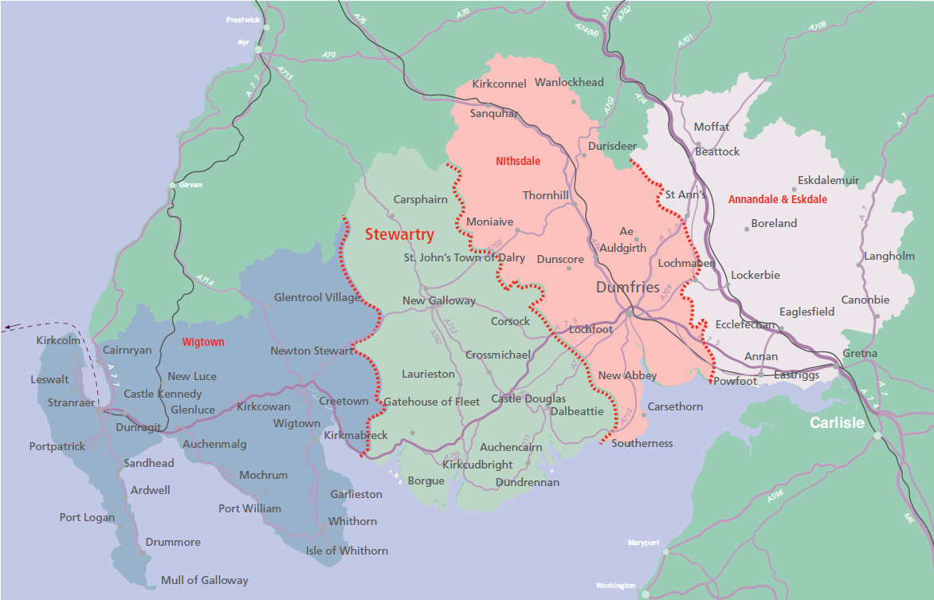

# 2. POPULATION AND DEMOGRAPHY

**Population**

The most accurate measure of population is the Census, which takes place every 10 years and was last conducted in 2011. With 38,521 inhabitants at the time of the last Census, Annandale and Eskdale has approximately 25% of the region’s population.

The Census figures indicate that there has been an increase of 4% in the population of Annandale and Eskdale since 2001 – this is a higher rate of population growth than the rest of the region, but slightly below the national average.

**Figure 2.1: Usual Resident Population**

|  |  |  |  |  |
| --- | --- | --- | --- | --- |
|  | **2001** | **2011** | **Change** | **% Change** |
| **Annandale and Eskdale** | 37,037 | 38,521 | 1,484 | 4.0 |
| **Nithsdale** | 57,373 | 59,452 | 2,079 | 3.6 |
| **Stewartry** | 23,832 | 24,022 | 190 | 0.8 |
| **Wigtown** | 29,251 | 29,329 | 78 | 0.3 |
| **Dumfries and Galloway** | 147,765 | 151,324 | 3,559 | 2.4 |
| **Scotland** | 5,062,011 | 5,295,403 | 233,392 | 4.6 |

Source: Census 2011

Looking at the age structure of the population, Annandale and Eskdale has the same demographic issues as Dumfries and Galloway as a whole, with a lower proportion of younger people (aged under 25) and a higher proportion of older people (aged over 65) than the Scottish average.

**Figure 2.2: Population by Age Group (%)**

|  |  |  |  |
| --- | --- | --- | --- |
|  | **Annandale and Eskdale** | **Dumfries and Galloway** | **Scotland** |
| **0-15** | 16.7 | 16.6 | 17.3 |
| **16-24** | 9.2 | 9.6 | 11.9 |
| **25-44** | 21.6 | 21.7 | 26.4 |
| **45-64** | 30.4 | 30.2 | 27.4 |
| **65+** | 22.1 | 21.8 | 16.8 |

Source: Census 2011

The average age of people in Annandale and Eskdale is 43.8, compared to 43.6 in Dumfries and Galloway and 40.4 for Scotland.[2]

**Births and Deaths**

In 2012 there were 330 births and 402 deaths in the area. The number of births has been consistently lower than the number of deaths – this can be attributed to the age profile of the population as outlined above. The number of births in Annandale and Eskdale has been steadily declining,

**Figure 2.3: Number of Births and Deaths in Annandale and Eskdale, 2008-2012**

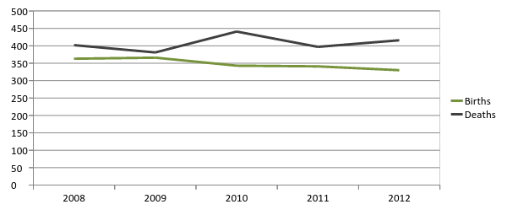

Source: Scottish Neighbourhood Statistics

**Migration**

There is a lack of reliable data on the level of migration into and out of small areas such as the Annandale and Eskdale – although there is data from the Census on the country of birth of the area’s residents (this will be presented in the section on Diversity).

Looking at the region as a whole, there are a significant number of people moving into and out of Dumfries and Galloway each year – in 2011/12, there were around 3,900 in-migrants to the region, and 4,080 out-migrants.[3]

In common with many rural areas Dumfries and Galloway experiences a disproportionate level of out-migration of young people (aged 16-20), while there is net in-migration of those in the older age groups. It is likely that this pattern is replicated in Annandale and Eskdale. It may be the case that this pattern is even more pronounced – which would explain the low proportion of young people as shown in Figure 2.1.

However, as Annandale and Eskdale has seen growth in its population while having more deaths than births, as illustrated in Figure 2.3, this implies that total net in-migration to the area has been positive over the past decade.

**Figure 2.4: Total Net Migration by Age, Dumfries and Galloway**

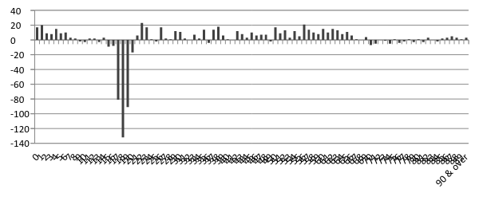

Source: GROS (2013) Total Migration To or From an Area

Note: Figures annual averages for 2009-11

**Population Projections**

Population projections are not produced for small areas such as Annandale and Eskdale. Population projections for Dumfries and Galloway as a whole show that the total population of the region is expected to fall very slightly (-0.6%) by 2020. However, within this small overall change there will be much larger changes amongst particular age groups. As the chart below illustrates, there will be:

* Significant declines in the number of younger and ‘prime’ working age people.
* A small increase in the number of older working age people.
* Significant increases in the number of people of retirement age.

**Figure 2.5: Projected % Change in Population by Age Group, 2010-2020, Dumfries and Galloway**

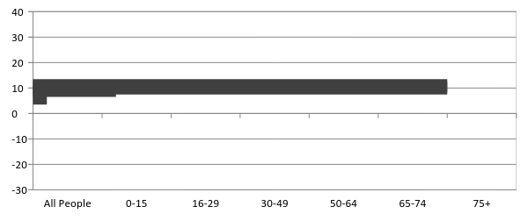

Source: GROS

Note: 2010-based projections

These changes will contribute to the ongoing shift in the age structure of the population. As illustrated in the chart below, there will be fall in the proportion of the population of working age, while people aged 65 and above will become a much larger part of the population.

**Figure 2.6: Projected Age Breakdown of Population, Dumfries and Galloway**

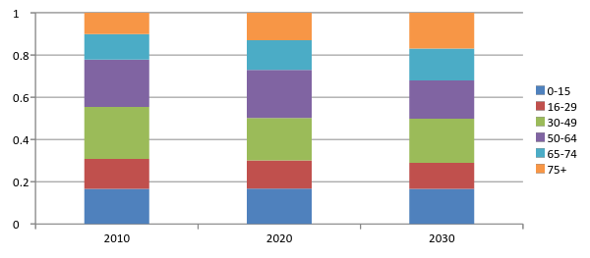Source: GROS

Note: 2010-based projections

Although population projections are not available for the four individual areas within Dumfries and Galloway, it could reasonably expected that demographic changes in Annandale and Eskdale will follow the same broad pattern, given the similarity of its age structure to the regional average as illustrated in Figure 2.2.

# 3. DIVERSITY

The Equalities Act 2010 sets out a duty for public bodies to have due regard to the need to:

* eliminate discrimination, harassment, victimisation and any other conduct that is prohibited by or under the Act
* advance equality of opportunity between persons who share a relevant protected characteristic and persons who do not share it
* foster good relations between persons who share a relevant protected characteristic and persons who do not share it.[4]

There are nine ‘protected characteristics’ under the Equalities Act. The available evidence on these groups in Annandale and Eskdale is set out below.

**Age**

***Young People***

There were 9,979 people aged under 25 living in Annandale and Eskdale in 2011. As illustrated in the Population section, in common with the rest of Dumfries and Galloway the area has a relatively low proportion of both children (aged under 16) and young people of working age (16-24), compared to Scotland as a whole.

**Figure 3.1: Young People in Annandale and Eskdale by Age Group, 2011**

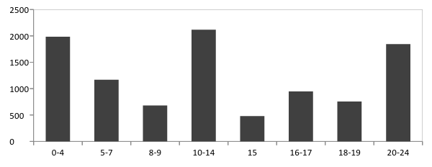

Source: Census 2011

***Older People***

As indicated in the population chapter, Dumfries and Galloway has a relatively large and growing population of older people. In Annandale and Eskdale, around 22% (in line with the regional average) of the population are aged over 65 – 8,522 people.[5]

**Figure 3.2: Older People in Annandale and Eskdale by Age Group, 2011**

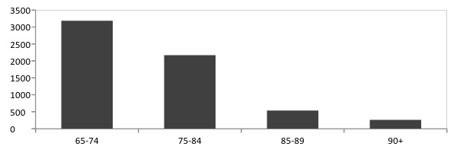

Source: Census 2011

The level of economic activity tends to decline amongst older age groups. Data from the Census[6] shows that 5,573 people in Annandale and Eskdale aged under 75 are economically inactive because they have retired.

**Disability**

Based on the 2011 Census, 8,115 people in Annandale and Eskdale describe themselves as having a long-term health problem or disability – just under half of these people said that they were ‘limited a lot’ by their condition. The proportion of the population with a long-term health problem or disability (21%) is slightly lower than the regional average, but higher than the Scottish average

**Figure 3.3: % of Population with Long-term Health Problem or Disability**

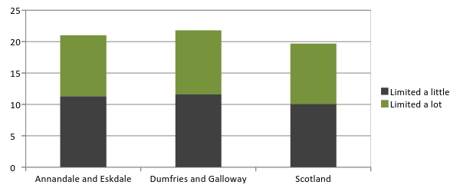

Source: Census 2011

**Sex/Gender**

In common with the gender split in both Dumfries and Galloway and Scotland as a whole, there are more women than men in the population of Annandale and Eskdale. This reflects the greater life expectancy amongst women.

**Figure 3.4: Population by Gender, 2011**

|  |  |  |  |
| --- | --- | --- | --- |
|  | **Annandale and Eskdale** | **Dumfries and Galloway** | **Scotland** |
| ***Male*** | | | |
| **Number** | 18,805 | 73,405 | 2,567,444 |
| **%** | 48.8 | 48.5 | 48.5 |
| ***Female*** | | | |
| **Number** | 19,716 | 77,919 | 2,727,959 |
| **%** | 51.2 | 51.5 | 51.5 |

Source: Census 2011

**Race and Ethnicity**

Dumfries and Galloway has a small but growing ethnic minority population. In 2011 people from ethnic minority (i.e. non-white) backgrounds represented 1.2% of the population, which is significantly lower than the Scottish average of 4.0%. However, this does represent an increase since 2001, when the figure was 0.7%.

Annandale and Eskdale has a slightly smaller ethnic minority population, accounting for only 0.9% of the population in 2011. Aside from White Scottish/British people, who account for 97% of the population, the largest ethnic groups are:

* White Polish – 343 people
* White Other – 300
* Asian – 198
* White Irish – 194[7]

Looking at people’s country of birth of people, Dumfries and Galloway as a whole has a high proportion of people born in England. As would be expected, with the area bordered to the south-east by Cumbria, this proportion is even higher in Annandale and Eskdale, accounting for 24% of the population.

**Figure 3.5: Country of Birth (%), 2011**

|  |  |  |  |
| --- | --- | --- | --- |
|  | **Annandale and Eskdale** | **Dumfries and Galloway** | **Scotland** |
| **Scotland** | 71.7 | 77.1 | 83.3 |
| **England** | 23.9 | 18.0 | 8.7 |
| **Northern Ireland** | 0.7 | 1.0 | 0.7 |
| **Wales** | 0.4 | 0.4 | 0.3 |
| **Republic of Ireland** | 0.2 | 0.3 | 0.4 |
| **EU (pre-2001 member)** | 0.7 | 0.7 | 1.1 |
| **EU (post-2001 member)** | 0.9 | 0.8 | 1.5 |
| **Other** | 1.5 | 1.7 | 4.0 |

Source: Census 2011

**Religion or Belief**

The 2011 Census included a question on religious belief. In common with Dumfries and Galloway and Scotland as a whole, the largest religious group in Annandale and Eskdale is Church of Scotland, accounting for 43% of the population. Those with no religion account for around 34%.

**Figure 3.6: Religion (%), 2011**

|  |  |  |  |
| --- | --- | --- | --- |
|  | **Annandale and Eskdale** | **Dumfries and Galloway** | **Scotland** |
| **Church of Scotland** | 43.0 | 43.1 | 32.4 |
| **Roman Catholic** | 5.7 | 6.5 | 15.9 |
| **Other Christian** | 7.9 | 6.7 | 5.5 |
| **Buddhist** | 0.4 | 0.3 | 0.2 |
| **Hindu** | 0.0 | 0.1 | 0.3 |
| **Jewish** | 0.0 | 0.0 | 0.1 |
| **Muslim** | 0.2 | 0.3 | 1.4 |
| **Sikh** | 0.1 | 0.1 | 0.2 |
| **Other religion** | 0.3 | 0.3 | 0.3 |
| **No religion** | 33.8 | 34.6 | 36.7 |
| **Religion not stated** | 8.5 | 8.1 | 7.0 |

Source: Census 2011

**Pregnancy and Maternity**

There were 330 births to mothers who were resident in Annandale and Eskdale in 2012, or around 8.6 per 1,000 people. This is compared to a rate of 9.2 per 1,000 people for Dumfries and Galloway as a whole.[8]

**Marriage and Civil Partnership**

52% of adults in Annandale and Eskdale are married or in a civil partnership, while 27% are single. This is close to the regional average.

**Figure 3.7: Relationship Status (% of adult population), 2011**

|  |  |  |  |
| --- | --- | --- | --- |
|  | **Annandale and Eskdale** | **Dumfries and Galloway** | **Scotland** |
| **Single (never married or in a civil partnership)** | 27.3 | 28.2 | 35.4 |
| **Married** | 52.4 | 51.3 | 45.2 |
| **In a registered same-sex civil partnership** | 0.1 | 0.2 | 0.2 |
| **Separated (but still legally married or in a civil partnership)** | 2.4 | 2.5 | 3.2 |
| **Divorced or formerly in a civil partnership which is now legally dissolved** | 8.8 | 8.7 | 8.2 |
| **Widowed or surviving partner from a civil partnership** | 9.0 | 9.1 | 7.8 |

Source: Census 2011

**Sexual Orientation**

There is a limited amount of evidence on the number of gay, lesbian or bisexual people, even at a national level, so it is difficult to make any estimate of the size of this group in Annandale and Eskdale. Findings from the Scottish Household Survey show that the sexual orientation of people in Dumfries and Galloway is close to the Scottish average, with around 99% of people identifying themselves as heterosexual or straight. As illustrated in the table above, only 0.1% of the adult population (40 people) in Annandale and Eskdale are in registered civil partnerships. However, it is felt that these figures are likely to under-report the percentage of lesbian, gay or bisexual people within society.[9]

**Figure 3.8: Sexual Orientation by Gender, 2012**

|  |  |  |  |
| --- | --- | --- | --- |
|  | **Male** | **Female** | **Total** |
| ***Dumfries and Galloway*** | | | |
| **Heterosexual/Straight** | 99 | 98 | 99 |
| **Gay/Lesbian** | 1 | - | 1 |
| **Bisexual** | - | 2 | 1 |
| **Other** | - | - | - |
| **Refused/Prefer not to say** | - | - | - |
| ***Scotland*** | | | |
| **Heterosexual/Straight** | 99 | 99 | 98 |
| **Gay/Lesbian** | 1 | 1 | 1 |
| **Bisexual** | - | - | - |
| **Other** | - | - | - |
| **Refused/Prefer not to say** | 1 | 1 | 1 |

Source: Scottish Household Survey 2012

**Gender Reassignment**

Due to the small number of people involved, and the way that data is collected, there is no specific data available on the number of people undergoing gender reassignment in Annandale and Eskdale or in Dumfries and Galloway.[10]

# 4. ECONOMY

**Employment**

Based on the Census, in 2011 there were around 17,700 residents of Annandale and Eskdale in employment.[11] This represents 63% of all people aged 16-74 – slightly higher than the overall employment rate for Dumfries and Galloway (61%). Looking at the types of jobs that they do, the Census also allows a breakdown of employment by industry. As illustrated in Figure ? below, this shows that the pattern of employment is broadly similar to the regional average. However:

* Health/social work and wholesale/retail account for the largest proportions of employment in the area, as they do across the region.
* Manufacturing also account for a significant proportion of total employment in Annandale and Eskdale (11%). This is a greater proportion than Dumfries and Galloway (8%).

**Figure 4.1: Employment by Industry, 2011**

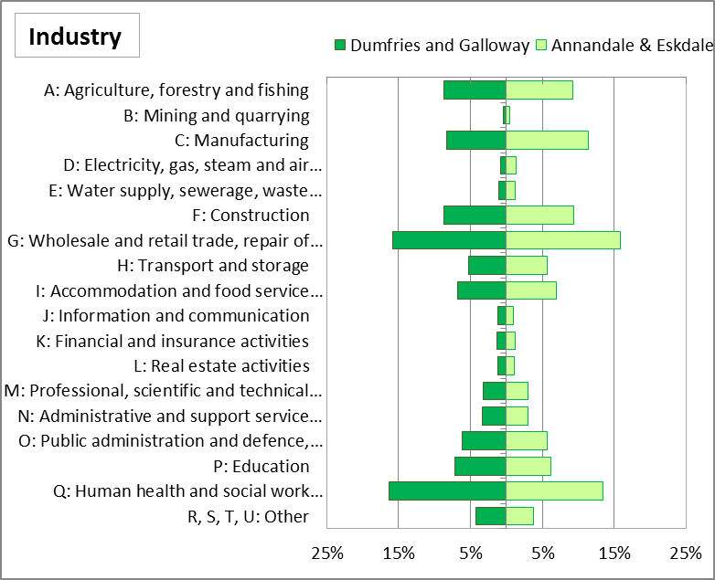

Source: Health Intelligence Unit, NHS Dumfries and Galloway

Census data can also be used to look at the occupational breakdown of those in employment. Skilled trades occupations are the largest group, accounting for around 18% of all employment in Annandale and Eskdale. There is a higher than average proportion of employment in process plant and machine occupations.

**Figure 4.2: Employment by Occupational Group, 2011**

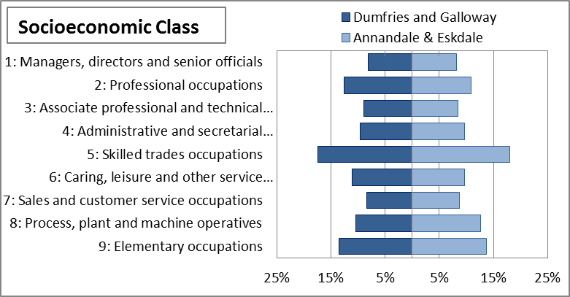

Source: Health Intelligence Unit, NHS Dumfries and Galloway

Looking at those people who are not in work, based on the 2011 Census there were around 1,110 people in Annandale and Eskdale who were unemployed (Figure ?) – that is they were not working but were available and looking for work. This represents 3.9% of all people aged 16-74, compared with a rate of 4.2% for Dumfries and Galloway.

The most up-to-date estimates of unemployment for Annandale and Eskdale come from the Claimant Count – this is the number of people who are claiming Jobseekers Allowance, so it does not include all of those people who are identified in the Census as ‘unemployed’ as some of these will not be eligible for JSA. As of December 2013, there were around 530 people in the area claiming JSA – after a significant increase after the onset of the recession in 2008, this has now fallen back, but is still above the pre-recession level.[12] However, as illustrated in the chart below, there are also significant seasonal fluctuations in unemployment.

**Figure 4.3: Claimant Count Unemployment, Annandale and Eskdale**

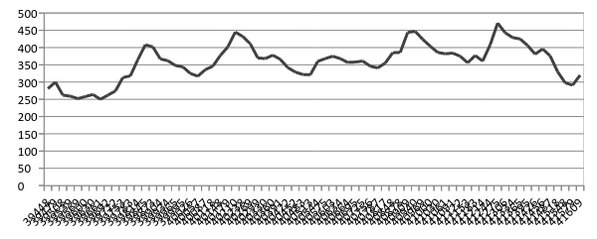

Source: NOMIS – Claimant Count

In addition to those people who are defined as unemployed, there were around an additional 8,860 people in Annandale and Eskdale in 2011 (31% of all those aged 16-74) who were economically inactive – that is they were neither in work or looking for work.[13] The majority of these (20% of people aged 16-74) were economically inactive because they had retired. A further 1,170 were inactive because they were long term sick or disabled.. In addition, a higher proportion of people in Annandale and Eskdale were in full-time employment.

**Figure 4.4: Economic Activity of People Aged 16-74, 2011**

|  |  |  |  |  |  |  |  |  |  |  |
| --- | --- | --- | --- | --- | --- | --- | --- | --- | --- | --- |
|  | | | **Annandale and Eskdale** | | | | | **Dumfries and Galloway** | | |
| **Number** | | **%** | | **Number** | | | **%** |
| ***Economically Active*** | **Part Time Employee** | 4,272 | | 15.1 | | 17,623 | | | 15.9 | |
| **Full Time Employee** | 10,326 | | 36.5 | | 38,387 | | | 34.5 | |
| **Self Employed** | 3,145 | | 11.1 | | 12,279 | | | 11.1 | |
| **Student – Economically Active** | 1,107 | | 3.9 | | 2,219 | | | 2.0 | |
| **Unemployed** | 549 | | 1.9 | | 4,681 | | | 4.2 | |
| ***Total Economically Active*** | *19,399* | | 68.6 | | *75,189* | | | *67.7* | |
| ***Economically Inactive*** | **Retired** | 5,573 | | 19.7 | | 21,678 | | | 19.5 | |
| **Student – Economically Inactive** | 801 | | 2.8 | | 3,531 | | | 3.2 | |
| **Looking after Home/Family** | 914 | | 3.2 | | 3,635 | | | 3.3 | |
| **Long Term Sick/Disabled** | 1,174 | | 4.2 | | 5,260 | | | 4.7 | |
| **Other** | 401 | | 1.4 | | 1,814 | | | 1.6 | |
| ***Total Economically Inactive*** | *8,863* | | 31.4 | | *35,918* | | | *32.3* | |
| **All people aged 16-74** | | | 28,262 | | 100.0 | | 111,107 | | | 100.0 |

Source: Census 2011

The Scottish Index of Multiple Deprivation[14] takes together a number of indicators to measure the level of ‘employment deprivation’ in each area. Based on the most recent SIMD data, there are around 2,290 employment deprived people in the area – this accounts for around 11% of the working age population, compared with 12% across Dumfries and Galloway as a whole. One of the 49 datazones in Annandale and Eskdale is within the 20% most employment deprived areas in Scotland based on this measure. A further 11 datazones are in the 2nd quintile of employment deprivation – i.e. the 20-40% most deprived in Scotland. Employment deprivation is concentrated in Annan North and Gretna and Eastriggs. The SIMD will be discussed further in Chapter 6.

**Figure 4.5: Most Employment Deprived Datazones in Annandale and Eskdale**

|  |  |  |  |  |  |  |
| --- | --- | --- | --- | --- | --- | --- |
| **Datazone** | **Area** | **Employment Deprivation** | | | **Overall Deprivation** | |
| **Rank** | **Quintile** | **Rank** | | **Quintile** |
| S01000965 | Annan North | 799 | 1 | 692 | | 1 |
| S01000967 | Annan North | 1536 | 2 | 1758 | | 2 |
| S01000963 | Gretna and Eastriggs | 1622 | 2 | 1785 | | 2 |
| S01000971 | Annan North | 1673 | 2 | 1505 | | 2 |
| S01000969 | Annan North | 1823 | 2 | 2184 | | 2 |
| S01000958 | Gretna and Eastriggs | 1833 | 2 | 1919 | | 2 |
| S01000970 | Gretna and Eastriggs | 2053 | 2 | 2321 | | 2 |
| S01000966 | Annan North | 2098 | 2 | 2306 | | 2 |
| S01000956 | Annan South | 2116 | 2 | 1954 | | 2 |
| S01001059 | Gretna and Eastriggs | 2429 | 2 | 2222 | | 2 |
| S01000962 | Annan South | 2445 | 2 | 2637 | | 3 |
| S01001054 | Lockerbie and Mid Annandale | 2516 | 2 | 2740 | | 3 |

Source: SIMD

**Businesss**

There are around 1,790 enterprises in the Annandale and Eskdale[15]. As is the situation across Dumfries and Galloway and Scotland, the vast majority are very small – only 10 employ more than 50 people. There are no enterprises in the area that employ more than 250 people.

**Figure 4.6: Enterprises by Size, 2013**

|  |  |  |  |  |  |  |
| --- | --- | --- | --- | --- | --- | --- |
|  | **Annandale and Eskdale** | | | **Dumfries and Galloway** | | **Scotland** |
| **Number** | **%** | **%** | | **%** | |
| **Micro (0-9)** | 1,620 | 90.5 | 88.9 | | 87.0 | |
| **Small (10-49)** | 160 | 8.9 | 9.9 | | 10.8 | |
| **Medium (50-249)** | 10 | 0.6 | 0.9 | | 1.7 | |
| **Large (250+)** | 0 | 0.0 | 0.2 | | 0.4 | |
| **Total** | 1,790 | 100.0 | 100.0 | | 100.0 | |

Source: NOMIS – Business Counts

Note: Annandale and Eskdale figure based on best fit of Intermediate Zones

The chart below illustrates how the number of enterprises in the area are distributed between broad industry sectors. Agriculture, forestry and fishing account for 38% of all enterprises in the area. Construction businesses account for 11% of the total.

**Figure 4.7: Enterprises by Sector (%), 2013**



Source: NOMIS – Business Counts

Note: Annandale and Eskdale figure based on best fit of Intermediate Zones

Data from the British Bankers Association shows the amount of lending provided to small and medium-sized enterprises by postcode, which can be used as an indicator of the level of business activity in each area. This shows that within the Annandale and Eskdale area, the majority (54%) of SME lending is in the DG11 postcode, which covers Lockerbie. The Annan postcode accounts for a further 20% of lending in the area.

**Figure 4.8: Value of Outstanding Lending to SMEs (£ Million) by Postcode**

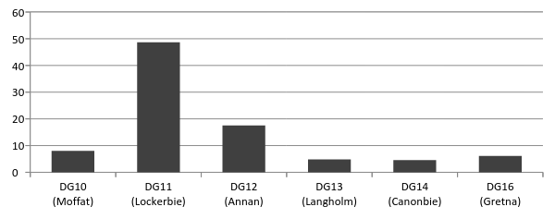

Source: BBA (2013) SME Lending by Postcode

**Business Support Services**

***Scottish Enterprise***

Scottish Enterprise has responsibility for supporting large and growth businesses across Lowland Scotland. In the period April-September 2013, it provided intensive support to 54 companies across Dumfries and Galloway through its account management process.[16]

***Business Gateway***

Business Gateway provides assistance and support to both people starting up their own businesses and existing firms who are looking to grow.

* 35 new start-up businesses were created in Annandale and Eskdale in the first six months of 2013/14, with the continuing challenging economy still affecting confidence of individuals seeking to start up in business.
* Start-up businesses are contacted by Business Gateway Advisers to ascertain any additional support required on a 3, 6 and 12 month basis. During the first half of 2013/14:
  + All 16 businesses contacted at 3 months were still trading
  + All 5 businesses contacted at 6 months were still trading
* A further 2 businesses in Annandale and Eskdale were given intensive specialist support through the local service element of the Business Gateway contract to help through difficult trading periods.
* The number of individuals attending Business Gateway workshops during this period was 156.[17]

***Young Entrepreneurs***

Over the first half of 2013/14, Over this period 11 Young Entrepreneurs were supported by our Young Entrepreneur Coordinator, to start up in businesses and Annandale and Eskdale. Starts covered a range of business areas:

* Construction and related trades – 4
* Pet care and Pet services -1
* Clothing design and manufacture – 2
* Personal services (hair and beauty) – 2
* Creative Arts (musician) – 1
* Personal Services (gym) -1.[18]

***Financial Assistance for Small Businesses***

Dumfries and Galloway Council’s Financial Assistance for Small Businesses scheme (FASB) provides a discretionary grant of up to £5,000 the purpose of which is to assist with the generation of employment and growth thus ensuring long term business sustainability. Eligible sectors are:

* Tourism
* Food and Drink
* Manufacturing
* Business to Business services
* Other businesses adding value to the local economy

4 businesses in the areas were supported by FASB during the first six months of 2013/14, with a total of £17,594 provided. This created 7 jobs and leveraged a further £41,294 of additional investment. In addition, a further 20 businesses were being supported by Business Gateway to develop applications to FASB.[19]

**Community Assets transfers**

Dumfries and Galloway Council is undertaking a community facilities review which aims to transferring the responsibility for managing a those facilities deemed surplus to requirements to a local management committee. This approach allows communities to become empowered, work together to develop the facility and work in partnership with other organisations to provide a hub for community activity for the benefit of those living within each community.

The following facilities in Annandale and Eskdale have been transferred to community control:

* St Mungos
* Annan Community Centre[20]

# 5. TOURISM AND LEISURE

**Tourism in the Economy**

Tourism is a key sector in the regional economy of Dumfries and Galloway. It is estimated that employment and Gross Value Added in sustainable tourism[21] in Dumfries and Galloway accounts for around 5,300 people and £79.1 million[22] respectively. The Scottish Tourism Economic Activity Monitor Report indicated, however, that nearly 6,000 jobs (full time equivalents) were supported by direct tourist expenditure in Dumfries and Galloway, and a further 1,358 jobs were supported by indirect revenue from tourism.

Employment in accommodation and food service activities, which is indicative of that in the tourism sector, was 1,266 in Annandale and Eskdale in 2011[23]. As shown below, the proportion of total employment in this sector in the area is slightly above the national average.

**Figure 5.1: Employment in accommodation and food service activities as % of total, 2011**

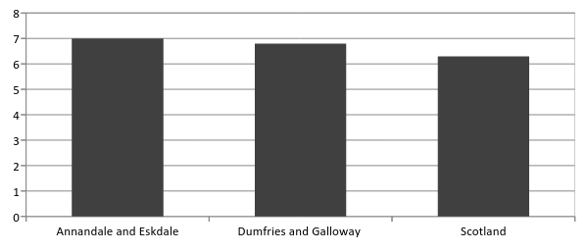

Source: Census 2011

Note: People aged 16-74

In 2012 Destination Dumfries and Galloway conducted a survey relating to economic development and business confidence of those involved in tourist industry[24]. Based on their sample, the study indicated that in 2012 just over 80% of operators assessed their performance either the same or better than the year before. The caravan/camping sector operators were at least happy with their economic performance. The hotel sector reported better trading in 2012 with 17% of operators reporting that their business did better in 2012 than in 2011. These are presented in Figure 5.2: below.

**Figure 5.2: Business performance in 2012 compared with 2011**

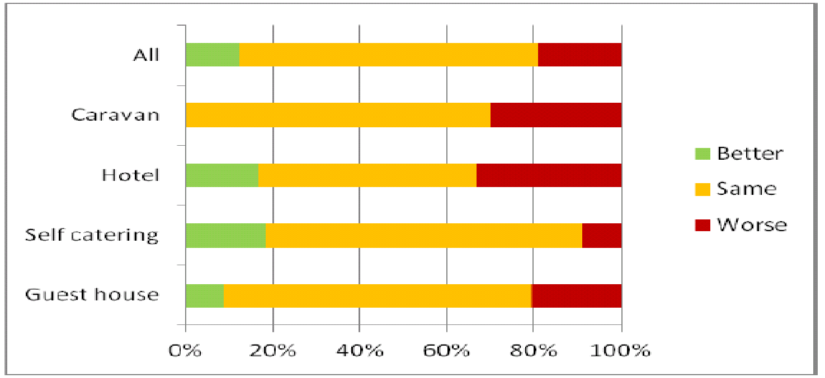

Source: DGC Tourism Business Confidence Monitor

Although these results cover tourism businesses across the whole of Dumfries and Galloway, it is likely that those in Annandale and Eskdale are affected by the same broad trends in tourism demand.

The table below indicates the overall amount of room spaces in Annandale and Eskdale, relative to Dumfries and Galloway. This illustrates the capacity of the area in terms of being able to accommodate tourists.

**Figure 5.3: Number of businesses and room spaces by type of accommodation**

|  |  |  |  |  |  |
| --- | --- | --- | --- | --- | --- |
|  | **No. of businesses** | | | **No. of bedrooms** | |
|  | **Dumfries and Galloway** | **Annandale and Eskdale** | **Dumfries and Galloway** | | **Annandale and Eskdale** |
| **Serviced Sector** |  |  |  | |  |
| Hotel | 93 | 26 | 1,537 | | 568 |
| Small Hotel | 26 | 12 | 275 | | 123 |
| Budget Hotel | 3 | 1 | 142 | | 42 |
| Country House Hotel | 7 | 1 | 104 | | 25 |
| Guest House | 30 | 14 | 146 | | 79 |
| B&B | 301 | 77 | 860 | | 219 |
| Inn | 19 | 5 | 149 | | 46 |
| RWR | 2 | 1 | 10 | | 3 |
| Serviced Sector Sub-Totals | 481 | 137 | 3,223 | | 1,105 |
| Serviced Sector % | 100% | 28.5% | 100% | | 34.3% |
| **Non-Serviced Sector** |  |  |  | |  |
| Self-Catering | 796 | 80 | 3,097 | | 271 |
| Hostel | 8 | 1 | 24 | | 13 |
| Exclusive Use | 3 | 1 | 31 | | 8 |
| Other | 1 | 1 | 30 | | 30 |
| Non-Serviced Sector Sub-Totals | 808 | 83 | 3,182 | | 322 |
| Non-Serviced Sector % | 100% | 10.3% | 100% | | 10.1% |
| Holiday / Touring Park | 97 | 17 | 9,483 | | 1,393 |
| OVERALL TOTALS | 1,386 | 237 | 15,888 | | 2,820 |
| OVERALL TOTAL % | 100% | 17.1% | 100% | | 17.7% |

Source: Destination Dumfries and Galloway (2011). *Audit of Tourism Accommodation Sector*

**Visitor Numbers**

To support tourism in Dumfries and Galloway, Tourist Information Centres are located across the region, including Gretna in Annandale and Eskdale. The numbers of customers using these centres are shown below.

**Figure: Visitor Information Centre foot-flow traffic: Dumfries and Galloway, 2012/13**

Source: Visit Scotland

In addition, in 2012/13 the Information Point in Partnership in Moffat (located within Moffat Mill) attracted 225,425 visitors.[25]

The Gretna Green Famous Blacksmiths Shop – located in Annandale and Eskdale – is by far the top visitor attraction in Dumfries and Galloway, attracting over 700,000 visitors in 2012.

**Figure 5.5: Top visitor attractions in Dumfries and Galloway in 2012[26]**

|  |  |
| --- | --- |
| **Attraction** | **Visitor Number** |
| **Gretna Green Famous Blacksmiths Shop** | 722,269 |
| **Mabie Forest, Dumfries** | 110,000 |
| **Mabie Farm Park, Dumfries** | 71,313 |
| **Cream o’ Galloway, Castle Douglas** | 61,500 |
| **Dalbeattie Forest** | 55,000 |

Source: Visit Scotland (2013) Tourism in Scotland’s Regions 2012

The majority of tourists in Dumfries and Galloway come from the UK. Nevertheless, and as presented in Table below, overseas tourism is also important and international tourists contribute to the development of the industry[27].

**Figure 5.6: Accommodation used by UK and overseas tourist nights (Thousands)**

|  |  |  |  |
| --- | --- | --- | --- |
|  | **UK tourist** | **Overseas tourist** | **Total** |
| **Hotel/guest house** | 488 | 35 | 523 |
| **Friends/relatives** | 538 | 128 | 666 |
| **B&B** | 269 | 12 | 281 |
| **Self-catering** | 555 | 0 | 555 |
| **Camping/caravanning** | 448 | 10 | 458 |
| **Other** | 135 | 21 | 156 |
| **Total** | 2,433 | 207 | 2640 |

Source: Visit Scotland

When comparing 2011 and 2012, the visitor numbers in Dumfries and Galloway were generally static with 71% of operators reporting that their visitor numbers remained unchanged; 10% reported an improvement whilst 19% said that their visitor numbers were down this year[28]. This is presented in Figure 5.7 below.

**Figure 5.7: Visitor numbers in 2012 compared with 2011**

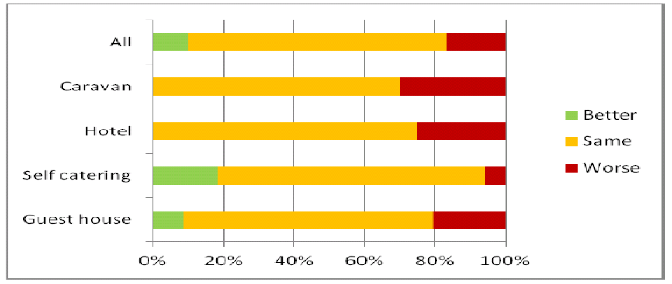

|  |  |  |
| --- | --- | --- |
| **Visitor Information Centre** | **Footfall** | **Bookings** |
| **Castle Douglas** | 15,945 | 85 |
| **Dumfries** | 38,208 | 309 |
| **Gretna** | 44,896 | 100 |
| **Kirkcudbright** | 46,199 | 150 |
| **Newton Stewart** | 2,468 | 30 |
| **Stranraer** | 15,961 | 73 |
| **Total** | 163,677 | 747 |

Source: DGC Tourism Business Confidence Monitor

In 2012 most operators were satisfied with their repeat custom and they felt that efforts to make visitors comfortable were paying off in terms of repeats visitors. Some felt that once a visitor had “discovered” the region they were likely to come back again especially if they had a positive accommodation experience[29].

**Figure** **5.8: Number of repeat visitors in 2012 compared with 2011**

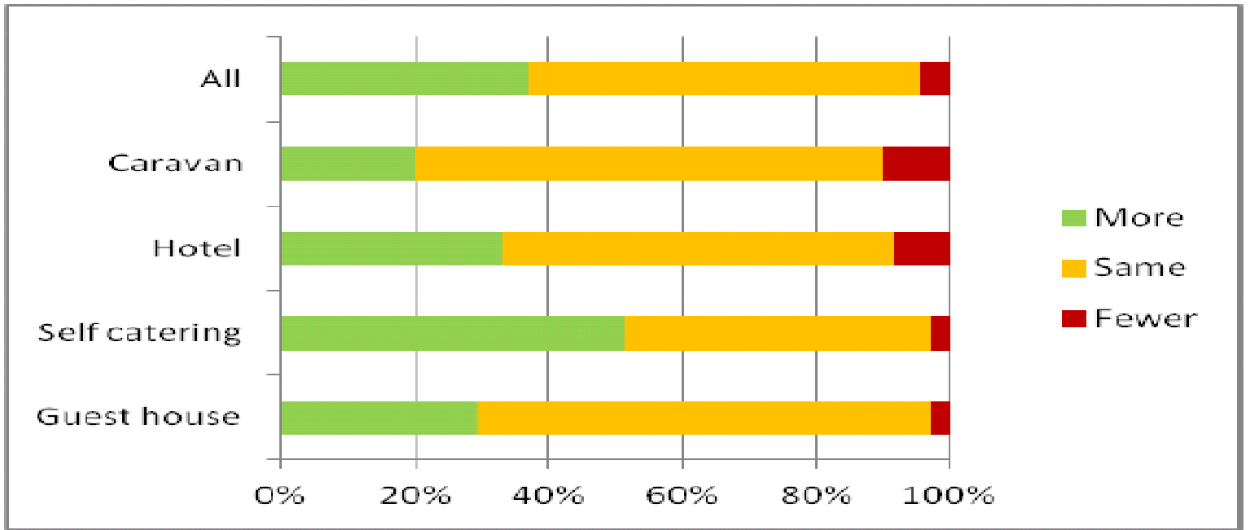

Source: DGC Tourism Business Confidence Monitor

It was noted that between 2011 and 2012 the visitor spend did not increase, staying static at best although equally likely to decrease. This spend relates not only to accommodation but also the opinion of the operators was sought on spend outwith their establishments[30] (see Figure 5.9 below).

**Figure 5.9:**  **Estimated visitor spending in 2012 compared with 2011**

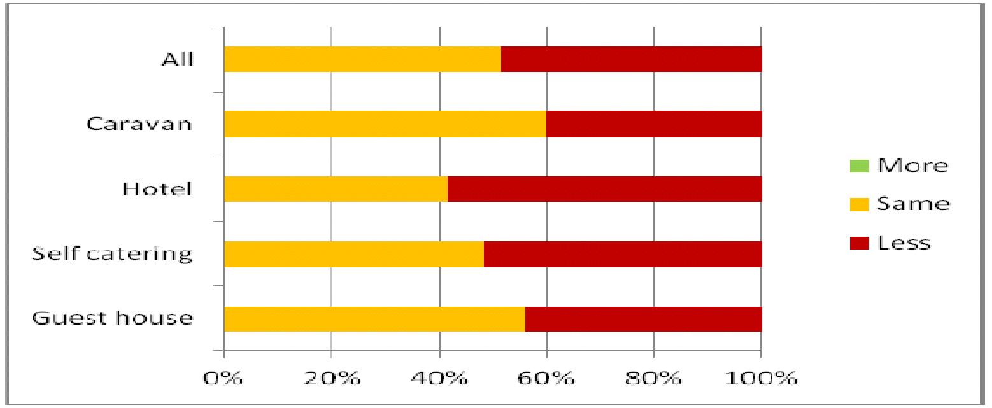

Source: DGC Tourism Business Confidence Monitor

This illustrates that many tourism businesses experienced a fall in spending, even though, as illustrated above, only a small proportion reported a fall in the number of visitors. Although these survey results cover the whole of Dumfries and Galloway, it could reasonably be expected that the trends experienced by operators are fairly similar across the four areas.

**Landscape**

The east of Dumfries & Galloway is home to a number of fascinating towns and villages. Lockerbie is a small agricultural town with excellent scenery and touring country roads. Nearby Lochmaben has three scenic lochs and the great outdoors with plenty of opportunities for sailing, fishing, cycling, and walking.

Annan reveals its historic sights, such as the 176-year-old bridge with its graceful arches, and Bridge House, considered one of the finest town houses in Scotland. Surrounded by four hills, Langholm is ideal for a walking or fishing trip. The River Esk, one of Scotland's greatest salmon rivers, flows right through the town.

At the border lies the town of Gretna and nearby Gretna Green with Famous Blacksmiths Shop. The small historical spa town of Moffat has a wide tree-lined high street, which retains much of its original characteristics. Moffat boasts the title of Scotland's first 'walkers are welcome town' and offers great access to the surrounding hills.[31]

**Cultural Opportunities**

Annandale & Eskdale has a number of attractions for visitors including scenic lochs, rivers and many outdoor attractions as well as historic sites. VisitScotland identifies 4 museums that visitors can enjoy while travelling across the region[32]. These are shown in Figure 5.10.

**Figure 5.10: Museums and galleries in Annandale and Eskdale**

|  |  |
| --- | --- |
| **Name of attractions** | **Location** |
| Annan Museum | Annan |
| Clan Armstrong Trust Museum | Langholm |
| The Clan Armstrong Centre | Langholm |
| Moffat Museum | Moffat |

Source: Visit Scotland

In the first half of 2013/14, there were 4,385 visits to Council-funded or part-funded museums in Annandale and Eskdale.[33]

In addition to these museums, VisitScotland identifies a number of historical attractions across Dumfries and Galloway, several of which can be found in Annandale and Eskdale (see Table below).[34]

**Figure 5.11: Historic sites including buildings and homes, churches, cathedrals and abbeys in Annandale and Eskdale**

|  |  |
| --- | --- |
| **Name of attractions** | **Location** |
| Thomas Carlyle's Birthplace | Annan |
| Kagyu Samye Ling Monastery and Tibetan Centre | Langholm |
| McDiarmid Memorial | Langholm |
| Westerkirk Library | Langholm |
| Churchyard Of St Kentigern | Lockerbie |
| Dryfesdale Lodge Visitors' Centre Trust | Lockerbie |
| Repentance Tower | Lockerbie |
| Ukrainian POW Chapel | Lockerbie |

Source: Visit Scotland

The region’s current events strategy [35] sets out a number of major festivals and events that are eligible for support. Those based in Annandale and Eskdale include:

* Eden Festival
* Lockerbie Jazz Festival

In addition there are a range of festivals that include events and activities spread across the region.

**Future Developments**

Annandale is a complex marketplace that plays host to a wide range of different markets – leisure and business-related. The diversity of its geography, bisected by the M74, sees the motorway corridor and the different settlements including Gretna having a significant influence on demand levels and patterns across the zone. An audit of the area’s tourism market[36] suggests a range of gaps and opportunities across the area:

* ***Moffat -*** Upgrade and maintain ‘county town’ character and profile of existing accommodation provision a degree of which needs to be improved / upgraded; Existing hotel to provide with leisure facilities / develop ‘spa’ and day spa operation; The move to provide ‘restaurant’ facilities; inn with food; boutique differentiated hotel properties again playing to market demands and helping the area improve its accommodation offering, and in parallel, food offering.
* ***Lockerbie -*** Upgrade existing hotel provision; Maintain existing level of stock.
* ***Annan -*** The Annan marketplace is linked to ‘Dumfries’ / Nithsdale in terms of its perceptions and offering.
* ***Langholm -*** Langholm to the east of the M74 – on the strategic A7 route through the Borders has seen a fall away in business-related demand sources in recent years. The leisure tourism markets are in evidence but the Town needs to maintain and upgrade current stock again paying attention to food and beverage.
* ***Gretna -*** Gretna, like Moffat, is different from some of the zone’s other settlements attributable to its location on the M74. In addition the settlement wedding credentials provide an added appeal in certain markets. This suggest that the ‘gaps’ in provision manifest themselves in different ways. The wider Annandale area already offers a range of serviced stock and some self-catering stock, the latter not performing at the levels of that further west. Gretna would benefit from an upgrade to its existing stock of serviced accommodation some of it quite poor and must not solely rely on the address to provide occupancy. The area would benefit from ‘boutique’ quality provision with much better food and beverage provision a significant gap in the settlement. The rich mix of markets in Gretna that included passing travellers, conference and meeting sector and the important wedding market linked to general leisure and coach tour demand important for the settlement and all offering opportunities in the future. However dangers exist if standards are not improved going forward.

# 6. DEPRIVATION, POVERTY AND INCOME

**Deprivation**

The Scottish Index of Multiple Deprivation incorporates several different aspects of deprivation. Indicators for income, access to services, education, housing, crime, employment and health are combined and weighted to produce a single measure. It divides Scotland into 6,505 small areas, called datazones, each containing around 350 households. The Index provides a relative ranking for each datazone in Scotland, from 1 (most deprived) to 6,505 (least deprived). 193 of these datazones are in Dumfries and Galloway, and 49 of these are in Annandale and Eskdale.[37]

As the table below shows, only one of the datazones in the area (S01000965, in Annan North) is in the 20% most deprived in Scotland, with a further 10 in the 20-40% most deprived. The majority of these datazones are in Annan North or Gretna and Eastriggs, clearly illustrating the concentration of deprivation in the area.

**Figure 6.1: Overall SIMD 2012 Most Deprived Datazones in Annandale and Eskdale**

|  |  |  |  |
| --- | --- | --- | --- |
| **Datazone Code** | **Area** | **SIMD Rank** | **Quintile** |
| S01000965 | Annan North | 692 | 1 |
| S01000971 | Annan North | 1505 | 2 |
| S01000967 | Annan North | 1758 |
| S01000963 | Gretna and Eastriggs | 1785 |
| S01000958 | Gretna and Eastriggs | 1919 |
| S01000956 | Annan South | 1954 |
| S01000969 | Annan North | 2184 |
| S01001059 | Gretna and Eastriggs | 2222 |
| S01000966 | Annan North | 2306 |
| S01000970 | Gretna and Eastriggs | 2321 |
| S01001081 | Moffat and Eskdalemuir | 2468 |

Source: SIMD 2012

There is more in-depth data looking at each of the individual ‘domains’ (health, education etc.) within the SIMD, and these are used throughout this document to develop the profile of the area.

**Income, poverty and debt**

Reliable and up-to-date information on income levels in small areas is limited. There is however evidence from the Annual Survey of Hours and Earnings that average wages in Dumfries and Galloway are significantly lower than the Scottish average – and that this gap has widened since the start of the recession in 2008.[38]

**Figure 6.2: Average Gross Weekly Pay (£), Full Time Workers**

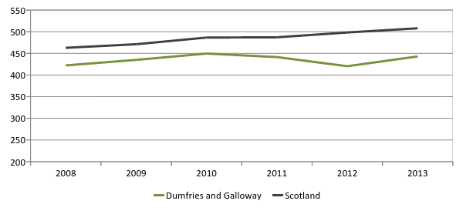

Source: NOMIS – Annual Survey of Hours and Earnings

Note: Residence based

At a more local level, estimates of average gross household income (for 2008/09) shows that income levels in Annandale and Eskdale (at around £404 per week) were slightly higher than the regional average (£393). This also shows that the proportion of low income households (19%) is slightly lower than the regional average (20%).[39]

Data from the Scottish Index of Multiple Deprivation suggests that 4,210 people in Annandale and Eskdale are ‘income deprived’, based on a range of indicators[40]. This accounts for around 11% of the population, compared with around 12% across Dumfries and Galloway as a whole. The pattern of income deprivation within the area is broadly similar to the pattern of overall deprivation illustrated in Figure ? – e.g. the most income deprived datazone is also the most deprived overall.

**Figure 6.3: Most Income Deprived Datazones in Annandale and Eskdale**

|  |  |  |  |  |  |  |
| --- | --- | --- | --- | --- | --- | --- |
| **Datazone** | **Area** | **Income Deprivation** | | | **Overall Deprivation** | |
| **Rank** | **Quintile** | **Rank** | | **Quintile** |
| S01000965 | Annan North | 895 | 1 | 692 | | 1 |
| S01000971 | Annan North | 914 | 2 | 1505 | | 2 |
| S01000963 | Gretna and Eastriggs | 1421 | 2 | 1785 | | 2 |
| S01001059 | Gretna and Eastriggs | 1857 | 2 | 2222 | | 2 |
| S01000956 | Annan South | 1887 | 2 | 1954 | | 2 |
| S01000969 | Annan North | 1938 | 2 | 2184 | | 2 |
| S01000967 | Annan North | 2036 | 2 | 1758 | | 2 |
| S01000970 | Gretna and Eastriggs | 2078 | 2 | 2321 | | 2 |
| S01001056 | Lockerbie and Mid Annandale | 2089 | 2 | 3244 | | 3 |
| S01000958 | Gretna and Eastriggs | 2159 | 2 | 1919 | | 2 |
| S01000994 | Boreland and Ecclefechan | 2361 | 2 | 2863 | | 3 |

Source: SIMD 2012

Another possible measure of income deprivation in localities is the level of provision of free school meals, which are available to children from low income families. The chart below shows the proportion of pupils in Annandale and Eskdale’s primary schools who are registered for free school meals (for those schools where this data is available). This shows that Beattock Primary has the highest level of free school meal provision, although as this is a small school this will represent a small number of pupils. The majority of school for which data is available have rates above the Scottish average.

**Figure 6.4: % of Pupils Registered for Free School Meals by Primary School**

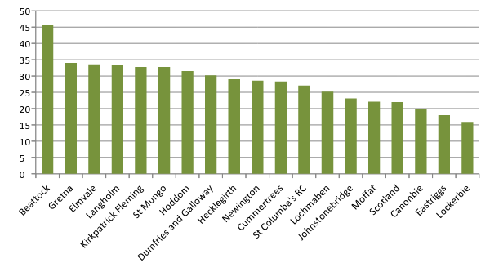

Source: Scottish Schools Online

Note: Figures not available for several of the smallest primary schools

More general information at a regional level on people’s financial circumstances is available from the Scottish Household Survey. This appears to show that fewer people in Dumfries and Galloway than the national average are struggling with their finances.

**Figure 6.5: Finances and Debt**

|  |  |  |
| --- | --- | --- |
|  | **Dumfries and Galloway** | **Scotland** |
| **% of population owing money to credit services** | 27 | 36 |
| **% of population with no access to savings** | 21 | 27 |
| **% of population with no access to basic bank or building society** | 4 | 6 |
| **% of population using credit unions** | 1 | 3 |
| **% of population not coping with their finances** | 6 | 12 |

Source: Dumfries and Galloway Council (2013) Financial Inclusion Strategy 2013-17

**Scottish Welfare Fund**

The Scottish Welfare Fund is a national scheme run by local authorities, and provides two types of grants[41]:

* Crisis Grants aim to help people, typically on benefits, who are in crisis because of a disaster or an emergency –for example, a fire or flood, needing to travel to visit a sick child or when money has been stolen.
* Community Care Grants aim to:
  + help people establish themselves in the community following a period of care, or remain in the community rather than going into care – where circumstances indicate that there is a risk of the person not being able to live independently without this help;
  + help people set up home in the community, as part of a planned resettlement programme, following an unsettled way of life;
  + help families facing exceptional pressures, with one-off items, like a cooker or a washing machine;
  + help people to care for a prisoner or young offender on release on temporary licence.

The number of applications and grants made in Annandale and Eskdale in 2013/14 are shown in the table below. While Crisis Grants account for the greatest number of awards, Community Care Grants are of greater value.

**Figure 6.6: Applications to the Scottish Welfare Fund, Annandale and Eskdale, 2013/14**

|  |  |  |  |  |
| --- | --- | --- | --- | --- |
|  | **Number of Applications** | **Number Successful** | **Success Rate** | **Value of Awards** |
| **Community Care Grants** | 227 | 103 | 45.3% | £80,536 |
| **Crisis Grants** | 452 | 301 | 66.6% | £15,864 |
| **Joint Applications** | 57 | 37 | 64.9% | £6,947 |

Source: Dumfries and Galloway Council

**Benefit claimants**

Data on the number of DWP benefit claimants in Annandale and Eskdale shows that there were 1,825 people of working age in the area claiming benefits in May 2013. This represents around 13% of the area’s working age population – a lower rate than across the region as a whole.

**Figure 6.7: DWP Benefit Claimants as % of Working Age Population, May 2013**

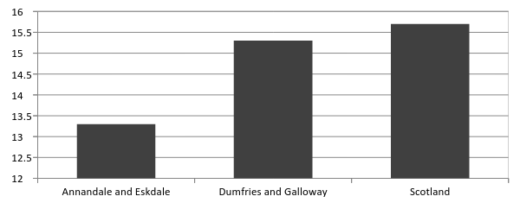

Source: NOMIS – DWP Benefits

As illustrated in the chart below, the largest group of benefit claimants in the area are those receiving Incapacity Benefit or its replacement, Employment Support Allowance. This is also the case regionally and nationally.

**Figure 6.8: Working Age Benefit Claimants in Annandale and Eskdale by Client Group, May 2013**

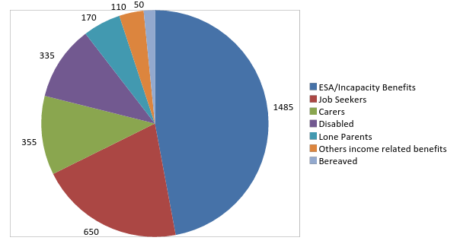

Source: NOMIS – DWP Benefits

The UK Government’s programme of welfare reform will have an impact on many people who currently claim benefits. It is estimated that the current package of reforms, which include changes to Housing Benefit, Child Benefit and Tax Credits, and the replacement of Disability Living Allowance (with Personal Independence Payments) and Incapacity Benefit (with Employment Support Allowance), will result in a total loss to Dumfries and Galloway of around £44million per annum, equivalent to £480 per working age adult.[42]

One of the most high profile elements of the UK Government’s welfare reforms has been the removal of the ‘spare room subsidy’, widely referred to as the ‘bedroom tax’. As of August 2013, 2013 there were 2,774 people in Annandale and Eskdale receiving Housing Benefit. 273 people of these were experiencing a reduction in their Housing Benefit as a result of the bedroom tax – around 10% of all Housing Benefit Claimants in the area.[43] The Scottish Government has allocated funding to mitigate the impacts of the bedroom tax through Discretionary Housing Payments - £756,200 worth of DHP awards were made in Dumfries and Galloway from April-November 2013, with an average value of £350.[44]

# 7. EDUCATION AND LIFELONG LEARNING

**Childcare**

The number of childcare providers and places (both local authority and private sector) in each locality within Annandale and Eskdale are shown in Figure 7.1 below.

**Figure 7.1: Childcare in Annandale and Eskdale**

|  |  |  |
| --- | --- | --- |
|  | **Providers** | **Places** |
| ***Local Authority Nurseries*** | | |
| **Amisfield** | 0 | 0 |
| **Beattock** | 1 | 60 |
| **Canonbie** | 1 | 40 |
| **Cummertrees** | 0 | 0 |
| **Eastriggs** | 1 | 40 |
| **Gretna** | 1 | 60 |
| **Annan** | 2 | 190 |
| **Langholm** | 1 | 60 |
| **Lockerbie** | 1 | 80 |
| **Moffat** | 1 | 60 |
| **Total** | **9** | **500** |
| ***Childcare providers*** | | |
| **Amisfield** | 2 | Unknown |
| **Beattock** | 0 | 0 |
| **Canonbie** | 1 | Unknown |
| **Cummertrees** | 1 | 6 |
| **Eastriggs** | 1 | 26 |
| **Gretna** | 2 | 82 |
| **Annan** | 13 | 152 |
| **Langholm** | 3 | 54 |
| **Lockerbie** | 4 | 98 |
| **Moffat** | 4 | 34 |
| **Total** | **31** | **452** |

Source: Dumfries and Galloway Council

Note: Total childcare places exclude those providers where the number of places are unknown

**School Pupils**

There are currently 4 secondary schools and 27 primary schools in Annandale and Eskdale, as shown below. Each primary school is listed under the secondary to which most of its pupils move – although in several schools pupils have a choice of more than one secondary school. Some smaller primary schools have been allocated to proposed ‘clusters’ – meaning that they will share head teachers.[45] These are listed together.

**Figure 7.2: Schools and Pupil Numbers in Annandale and Eskdale**

|  |  |
| --- | --- |
| **Annan Academy (913 pupils)** | **Langholm Academy (244)** |
| **Brydekirk (33)/Elmvale (116)**  **Carrutherstown (24)/ Cummertrees (48)**  **Eastriggs (146)**  **Gretna (243)**  **Hecklegirth (177)**  **Kirkpatrick Fleming (60)/Springfield (14)**  **Newington (383)**  **St Columba’s R.C. (50)** | **Canonbie (73)**  **Langholm Primary (174)** |
| **Lockerbie Academy (706)** | **Moffat Academy (271)** |
| **Applegarth (30)/Hutton (18)**  **Eaglesfield (60)/Hoddom (76)/Hottsbridge (27)**  **Hightae (10)/St Mungo (39)/Tundergarth (15)**  **Johnstonebridge (27)/Nethermill (30)**  **Lochmaben (243)**  **Lockerbie Primary (311)** | **Beattock (48)**  **Moffat Primary (246)** |

Source: Dumfries and Galloway Council (2012) and Scottish Schools Online

Note: School pupil numbers at September 2013

Education Scotland carries out around 240 school inspections each year. Each school inspection includes evaluations of three important quality indicators to keep track of how well all Scottish schools are doing. The headline results of the secondary schools in Annandale and Eskdale are shown in the table below. Results for Moffat Academy are not included as its most recent inspection (in 2005) was carried out before the current quality indicators were introduced, and may not be representative of the schools’ current performance.

**Figure 7.3: Quality Indicators for Annandale and Eskdale Secondary Schools**

|  |  |  |  |  |
| --- | --- | --- | --- | --- |
|  | **Improvements in Performance** | **Learners’ Experiences** | **Meeting Learners’ Needs** | **Date of Inspection** |
| **Annan** | Satisfactory | Good | Satisfactory | Jan 2009 |
| **Langholm** | Very Good | Good | Very Good | Jan 2010 |
| **Lockerbie** | Very Good | Good | Very Good | April 2011 |
| **Moffat** | - | - | - | Sep 2005 |

Source: Education Scotland

Note: Last inspection of Moffat Academy took place before the introduction of these three quality indicators

Average rates of absence (measured by the % of half-day absences) in the area’s secondary schools are generally close to the region’s average, although slightly lower in Langholm.

**Figure 7.4: Absence Rates in Annandale and Eskdale Secondary Schools, 2012/13**

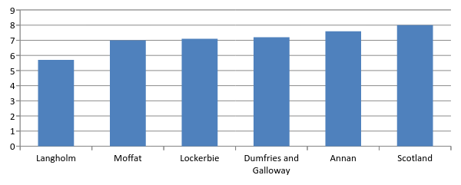

Source: Scottish Schools Online

Note: Rates are % of half-day authorised and unauthorised absences

Figures are S1-S5 averages

The proportion of pupils gaining qualifications in the area’s four schools is illustrated below compared to the regional and national averages.

**Figure 7.5: School Attainment in S4-S6, 2012/13**

|  |  |  |  |  |  |  |
| --- | --- | --- | --- | --- | --- | --- |
|  | **Annan** | **Langholm** | **Lockerbie** | **Moffat** | **Dumfries and Galloway** | **Scotland** |
| **% of Pupils with 5+ SG Credit in S4** | 45 | 42 | 42 | 53 | 43 | 38 |
| **% of Pupils with 3+ Highers in S5** | 16 | 26 | 28 | 52 | 27 | 28 |
| **% of Pupils with 3+ Highers in S6** | 38 | 43 | 42 | 53 | 39 | 38 |

Source: Scottish Schools Online

Note: % of original roll at S4

The Scottish School Leaver Destination Survey asks young people who left during the school year about their activity in the first week of October. These figures show that the proportions of pupils entering higher education, further education and employment vary widely across the area’s four schools.

**Figure 7.6: Destinations of School Leavers, 2012/13 (%)**

|  |  |  |  |  |  |  |
| --- | --- | --- | --- | --- | --- | --- |
|  | **Annan** | **Langholm** | **Lockerbie** | **Moffat** | **Dumfries and Galloway** | **Scotland** |
| **Higher Education** | 36 | 38 | 29 | 46 | 40 | 37 |
| **Further Education** | 40 | 43 | 26 | 26 | 29 | 28 |
| **Training** | 0 | 0 | 2 | 7 | 3 | 5 |
| **Employment** | 18 | 16 | 32 | 17 | 21 | 20 |
| **Voluntary Work** | 0 | 0 | 1 | 0 | 0 | 1 |
| **Activity Agreements** | 0 | 2 | 1 | 0 | 0 | 1 |
| **Unemployed – seeking** | 5 | 2 | 9 | 2 | 6 | 7 |
| **Unemployed – not seeking** | 1 | 0 | 0 | 0 | 1 | 1 |
| **Not Known** | 0 | 0 | 1 | 2 | 1 | 0 |

Source: Skill Development Scotland (2013)

Note: Totals may not sum due to rounding

**Students**

The only Further or Higher Education provision based in Annandale and Eskdale is the SRUC’s Barony Campus Further opportunities to study in Dumfries and Galloway are available at the University of Glasgow and the University of the West of Scotland, both of which have campuses in Dumfries, the SRUC’s Barony Campus and Dumfries and Galloway College, which has campuses in Dumfries and Stranraer, as well as the Open University. Those in the south of the area will also be able to access opportunities to study in Carlisle, at Carlisle College or the University of Cumbria.

The proportion of 17-21 year olds entering higher education is available at datazone level as one of the indicators used in the SIMD. This varies widely within the area, from below 5% in several datazones to over 26% in one datazones (in Langholm and Canonbie).[46]

**Qualifications**

Looking at the qualifications profile of the adult population in Annandale and Eskdale, data from the Census shows that the area has a lower proportion of people with at least Level 4 qualifications (equivalent to SVQ4/5 or degree level) and more no qualifications than the regional and Scottish averages.

**Figure 7.7: Level of Highest Qualification, Aged 16+ (%), 2011**

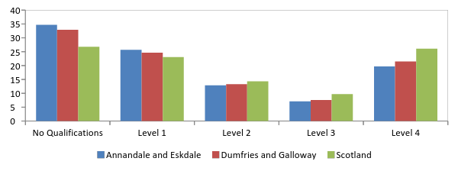

Source: Census

**Educational Deprivation**

Education is one of the ‘domains’ used in the Scottish Index of Multiple Deprivation, based on a combination of indicators. Annandale and Eskdale has five datazones in Scotland’s 20% most educationally deprived on this measure – these are found in Annan North, Annan South and Gretna and Eastriggs.

**Figure 7.8: Most Education Deprived Datazones in Annandale and Eskdale.**

|  |  |  |  |  |  |
| --- | --- | --- | --- | --- | --- |
| **Datazone** | **Area** | **Educational Deprivation** | | **Overall Deprivation** | |
| **Rank** | **Quintile** | **Rank** | **Quintile** |
| S01000965 | Annan North | 35 | 1 | 692 | 1 |
| S01000963 | Gretna and Eastriggs | 434 | 1 | 1785 | 2 |
| S01000967 | Annan North | 819 | 1 | 1758 | 2 |
| S01000970 | Gretna and Eastriggs | 974 | 1 | 2321 | 2 |
| S01000956 | Annan South | 1259 | 1 | 1954 | 2 |

Source: SIMD 2012

# 8. HEALTH

**Early Years**

Low birthweight is a major determinant of infant mortality and morbidity. It is used as an indicator of health status as it is associated with a variety of social and environmental factors, including maternal smoking, drug or alcohol use, being born to a younger or older mother and deprivation. [47]

The chart below show the proportion of babies with low birthweight (defined as lower than 2.5kg). The rate for Annandale and Eskdale is below the regional and national averages – however, it should be noted that this figure is based on a small number of births.

**Figure 8.1: % of Live Singleton Births with Low Birth Weight**

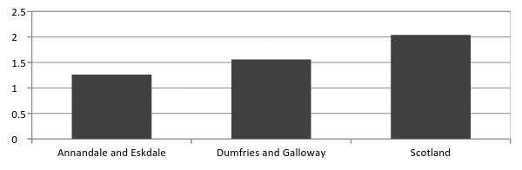

Source: Scottish Neighbourhood Statistics

Note: Data for 2010-12

There is evidence that breastfeeding in infancy has a protective effect against many childhood illnesses, and is likely to promote development. Deprivation is known to be strongly associated with the likelihood of breastfeeding.[48] As illustrated in the chart below, Annandale and Eskdale has a slightly lower rate of exclusive breastfeeding compared to the regional and national averages.

**Figure 8.2: % of Babies Exclusively Breastfed, 2011/12**

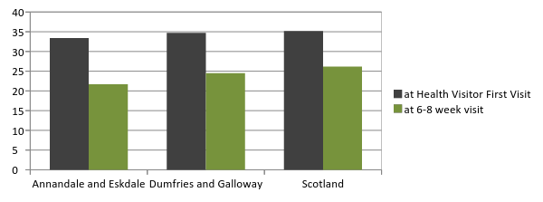

Source: Scottish Neighbourhood Statistics

**General Health**

The 2011 Census asked people to make an assessment of their general health. As illustrated below, the health profile of Annandale and Eskdale residents is broadly similar to that of the region as a whole.

**Figure 8.3: General Health of Population (%), 2011**

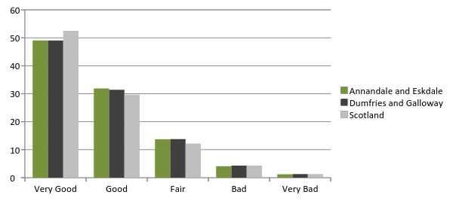Source: Health Intelligence Unit, NHS Dumfries & Galloway

As discussed in the section on Diversity, 8,100 people in Annandale and Eskdale describe themselves as having a long-term health problem or disability – 46% of these people said that they were ‘limited a lot’ by their condition. Only 3,500 of these people were aged 16-64, suggesting that many long-term health problems or disabilities are age-related.[49]

**Prevalence of Chronic Conditions**

The incidence of serious health problems is broadly similar in Annandale and Eskdale to that across Dumfries and Galloway as a whole. The only condition significantly more common in the area is hypertension.

**Figure 8.4: Number and % of Adults with Long-Term Conditions, 2012**

|  |  |  |  |  |  |
| --- | --- | --- | --- | --- | --- |
|  | **Annandale and Eskdale** | | | **Dumfries and Galloway** | |
| **Number** | **%** | **Number** | | **%** |
| **Cancer** | 970 | 3.0 | 3,577 | | 2.8 |
| **Chronic Obstructive Pulmonary Disease** | 1,133 | 3.5 | 3,998 | | 3.2 |
| **Coronary Heart Disease** | 2,223 | 6.9 | 8,209 | | 6.5 |
| **Dementia** | 370 | 1.2 | 1,455 | | 1.2 |
| **Diabetes** | 2,241 | 7.0 | 7,985 | | 6.3 |
| **Heart Failure** | 393 | 1.2 | 1,429 | | 1.1 |
| **Hypertension** | 7,405 | 23.1 | 24,659 | | 19.5 |
| **Stroke and TIA** | 1,080 | 3.4 | 3,872 | | 3.1 |

Source: Putting You First (2012)

Note: Figures are proportion of adult population from 2011 Census

Individuals may have more than one condition

**Life Expectancy and Mortality**

Life expectancy is an important measure of the health of the population. The latest available data for Annandale and Eskdale covers the five year period from 2003 to 2007. The chart below shows male and female life expectancy for the area and for those Intermediate Zones that lie at least partly within the are. With the exception of Annan North, both male and female life expectancy is higher than the national average across the area. Life expectancy is highest in Gretna and Eastriggs.

**Figure 8.5: Male and Female Life Expectancy**

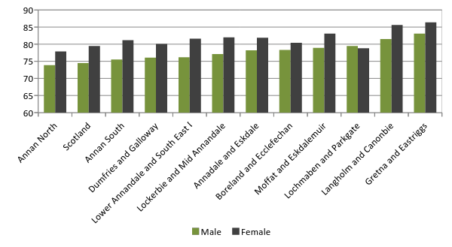

Source: SCOTPHO

Note: Data 5 year averages for 2003-07

Based on best fit of Intermediate Zones

There were 412 deaths in Annandale and Eskdale in 2012.[50] This equates to around 1.1 per 100 people – compared to a rate of 1.2 per 100 for Dumfries and Galloway.

Figures are also available specifically for early (i.e. under the age of 75) deaths from cancer. There are fewer early deaths from cancer in Annandale and Eskdale as a whole than the regional or national averages, but the rate is highest in Langholm and Canonbie.

**Figure 8.6: Early deaths from Cancer per 100,000 people**

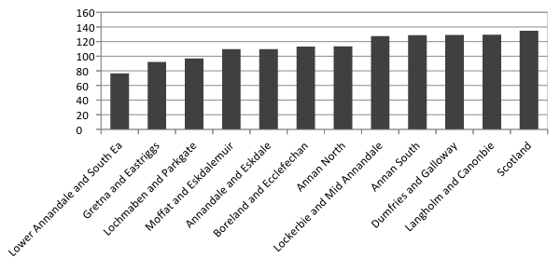

Source: SCOTPHO

Note: Deaths before the age of 75

Average data for 2007-09

Based on best fit of Intermediate Zones

**Substance Use**

***Alcohol***

Alcohol problems are a major concern for public health in Scotland, and excessive consumption can lead to a range of health and social problems. Dumfries and Galloway has a relatively high rate of alcohol-related hospital admissions relative to Scotland, and while the rate for Annandale and Eskdale as a whole is significantly lower, it is higher in Lockerbie and Mid Annandale and Annan North.

**Figure 8.7: Patients hospitalised with alcohol conditions per 100,000 people**

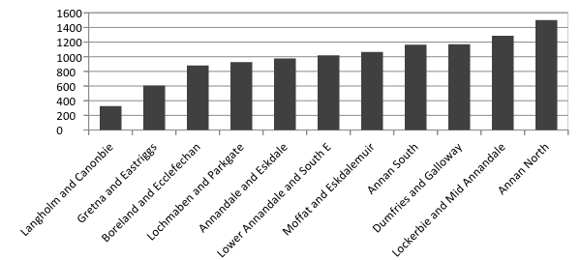

Source: SCOTPHO

Note: Average data for 2007-2009

Based on best fit of Intermediate Zones

While evidence on teenage alcohol consumption is not available below local authority level, 32% of 15 year olds in Dumfries and Galloway report usually drinking alcohol at least once a week. This is slightly higher than the Scottish average of 30%.[51]

***Smoking***

There is a lack of data at the sub-regional level on the prevalence of smoking. One of the best possible indicators for which data exists is the proportion of mothers smoking during pregnancy.

**Figure 8.8: % of Women Smoking During Pregnancy.**

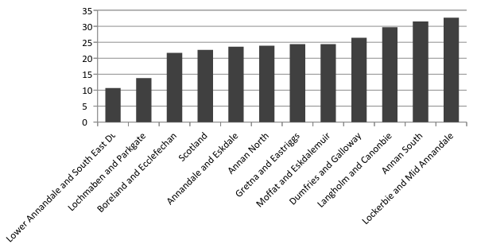

Source:ScotPHO

Note: Women recorded as ‘current smoker’ at antenatal booking appointment. Average for 2006-08

Looking at the prevalence of smoking amongst school pupils[52]:

* 3% of S2 pupils in Dumfries and Galloway are regular smokers (i.e. smoke at least one cigarette per week)
* 13% of S4 pupils are regular smokers. This has fallen from around 17% in 2006.
* Smoking was more common amongst boys (10%) than amongst girls (7%). This is in contrast with the Scotland-wide figures which show that girls are slightly more likely to be regular smokers.

***Drugs***

There is no available data on the number of drug users in Annandale and Eskdale. Evidence for Dumfries and Galloway as a whole shows that there were 152 drug-related hospital discharges in the region in 2011, a slightly higher rate than the national average.[53] 3.4% of 15 year olds report usually taking illegal drugs at least once a month. This is lower than the Scottish average of 6.8%.[54]

Figures from Police Scotland show that there were 22 offences for drugs supply, production or cultivation detected in Annandale and Eskdale in the period April-September 2013.[55]

**Mental Health**

Just over 8% of the population of Annandale and Eskdale are prescribed drugs for mental health problems. This slightly lower than the equivalent regional and national averages.

**Figure 8.9: % of Population Prescribed Drugs for Anxiety, Depression or Psychosis**

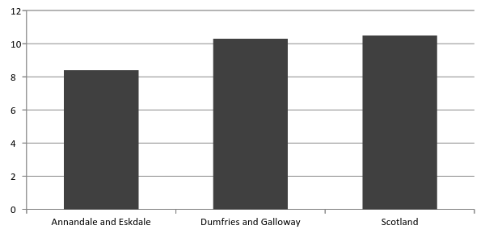Source: SIMD 2012

Note: Figures are for 2010

**Obesity and Physical Activity**

Child obesity in Dumfries and Galloway is slightly higher than the national average, with 10.9% (compared to 9.8%) of children in Primary 1 having a high BMI.[56]

Data from the 2007 Dumfries and Galloway Lifestyle Survey[57] found that only 29% of Annandale and Eskdale residents reported taking regular vigorous exercise – in line with the regional average. Across Dumfries and Galloway, 77.3% of adults participate in sporting activity, slightly higher than the national average of 74.2%.[58]

There are a range of public leisure facilities in the area[59]:

* Beechgrove Leisure Centre
* Lochmaben Leisure Centre
* Annan Swimming Pool and Games Hall
* Eskdale Sports Centre
* Everholm Sports Complex

The most recent numbers for attendance at indoor sports facilities in the area show that:

* There were 59,686 attendances at indoor swimming pools in Annandale and Eskdale during 2012/13.
* There were 157,658 attendances at indoor sport facilities.

**Health Deprivation**

Health is one of the ‘domains’ used in the Scottish Index of Multiple Deprivation, based on a combination of indicators including some of those examined above. Annandale performs relatively well on this measure, no datazones in the 20% most health deprived in Scotland.[60] There are 7 datazones in the 20-40% most health deprived – these are shown in the table below. This shows that the majority of the most health deprived areas are in Annan North.

**Figure 8.10: Most Health Deprived Datazones in Annandale and Eskdale**

|  |  |  |  |  |  |
| --- | --- | --- | --- | --- | --- |
| **Datazone** | **Area** | **Health Deprivation** | | **Overall Deprivation** | |
| **Rank** | **Quintile** | **Rank** | **Quintile** |
| S01000966 | Annan North | 1335 | 2 | 2306 | 2 |
| S01000956 | Annan South | 1719 | 2 | 1954 | 2 |
| S01000971 | Annan North | 2194 | 2 | 1505 | 2 |
| S01000965 | Annan North | 2248 | 2 | 692 | 1 |
| S01001059 | Lockerbie and Mid Annandale | 2333 | 2 | 2222 | 2 |
| S01000969 | Annan North | 2377 | 2 | 2184 | 2 |
| S01000967 | Annan North | 2449 | 2 | 1758 | 2 |

Source: SIMD 2012

**Health Services**

Health services in Annandale and Eskdale are provided by NHS Dumfries and Galloway. Services in the area are managed by the East Primary and Community Care Directorate.

There are four NHS hospitals in the area:

* Annan Hospital is a 24 bedded unit. The beds are accessible by local GPs and consultants from Dumfries & Galloway Royal Infirmary.
* Lochmaben Hospital consists of 28-bedded units:
  + The Clayson Wing provides short term care for people suffering from a variety of physical problems and requiring rehabilitation, palliative care etc.
  + The Shankland Wing provides ongoing care for people suffering from dementia and/or other mental health problems.
* Moffat Hospital is a 12 bedded unit. The beds are accessible by local GPs and consultants from Dumfries & Galloway Royal Infirmary.
* Thomas Hope Hospital, Langholm is a 12 bedded unit. The beds are accessible by local GPs, consultants from Dumfries & Galloway Royal Infirmary and Cumberland Infirmary, Carlisle.[61]

Accident and Emergency Services are located at Dumfries and Galloway Royal Infirmary, Dumfries (the main acute services hospital for the region).

In addition, the following NHS services are available in Annandale and Eskdale[62]:

* 12 GP surgeries
* 9 dentists
* 4 opticians
* 9 pharmacists

The chart below shows the results of two surveys that asked people about their views of NHS services. The area is split into North West and South East – in general, satisfaction is similar to the regional average.

**Figure 8.11: Satisfaction with NHS Services, July 2012 (Wave 2) and January 2013 (Wave 3)**

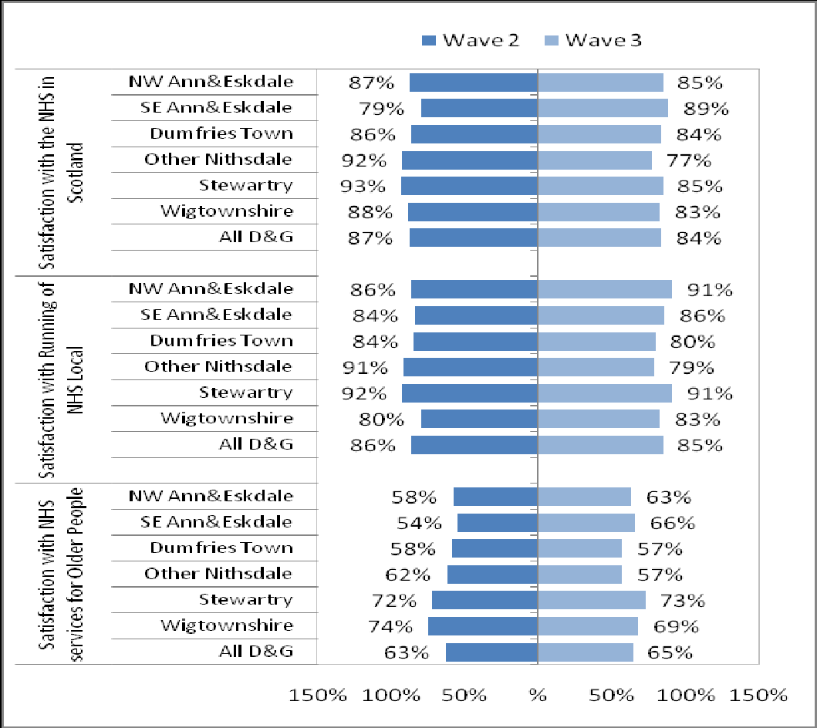

Source:NHS Dumfries and Galloway (2013). Public Perceptions of the NHS and Social Care in Dumfries and Galloway

**Putting You First**

Putting You First (PYF) is a five year change programme for Health, Care and Support services in Dumfries and Galloway. It seeks to identify and deliver new approaches with projects running across the region.

There are two Putting You First ‘pathfinder’ areas in Annandale and Eskdale.[63]

* The Annan pathfinder is developing a range of small tests of change, with a focus on building community capacity and forward looking care.
* Following community engagement work, the Esk Valley pathfinder has been focused on carers support, more services at Thomas Hope Hospital and transport.

# 9. CARING

There are many different types of ‘care’ including the services of professionals in residential and community settings in support of self-care, home care, long-term care, assisted living and other types of health and social care services.

Important in this context is the ageing population, as illustrated in Chapter 2. The rise in the number of older people – in particular the ‘oldest old’ – means that the overall number of people in the society with health or care needs has increased. In turn, this has altered the very nature of the health and care services, with older people now the biggest users. For example, there were 1,484 people diagnosed with dementia in Dumfries and Galloway in 2012/13 – this is around 1 in every 100 registered patients.[64] However, estimates by Alzheimers Scotland suggest that the figure is likely to be around 3,200.[65] Based on Annandale and Eskdale being home to around 26% of Dumfries and Galloway’s 65+ population, this would suggest that there are around 830 people with dementia living in the area. The ageing population and the increasing number of people with this type of condition holds new challenges for the NHS and social care in helping older people stay healthy, active and independent for as long as possible.

**Care Homes and Day Care**

Dumfries and Galloway has a 34 registered care homes for older people, of which 9 are located in Annandale and Eskdale[66]. All care home provision for older people is provided by the private and voluntary sector; there is no local authority provision. These facilities provide a mixture of short and long term residential and nursing care. The location of these care homes is shown below.

**Figure 9.1: Location of Care Homes for Older People, Dumfries and Galloway**

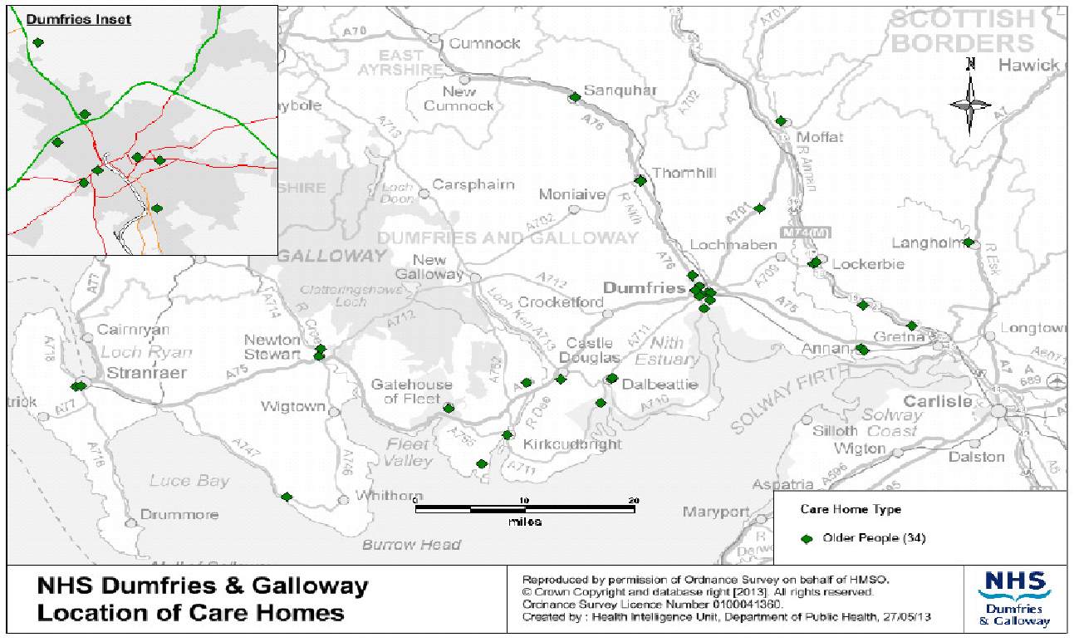

Source: Dumfries & Galloway Joint Strategic Plan for Older People 2012-2022

During 2011-2012 there were 485 new admissions to care homes in Dumfries and Galloway, and just under 120 of these were in Annandale and Eskdale. The Figure below shows that over half of new admissions in the area were adults aged 85 and over, followed by those aged 75 – 84 years.

**Figure 9.2: New Admissions to Care Homes, 2011-12**

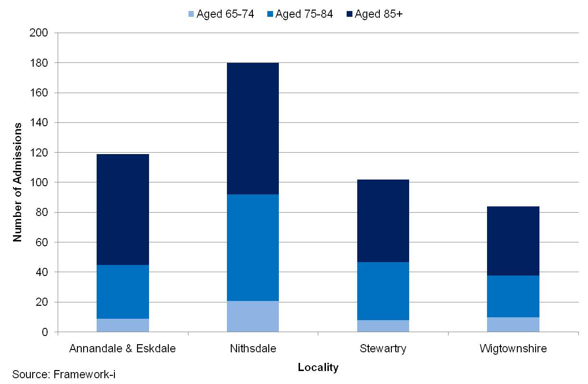

Source: Dumfries & Galloway Joint Strategic Plan for Older People 2012-2022

The length of stay for all care home placements in the area is shown in Figure below. The data from 2011-12 shows that 97 residents (29%) had a length of stay of under six months and 111 residents (26%) had a length of stay between 18 months and two years. A smaller proportion of residents (18%) had a length of stay of 2 years or more.

**Figure 9.3: Length of Stay for all Care Home placements, 2011-12**

|  |  |  |
| --- | --- | --- |
|  | **Annandale and Eskdale** | **Dumfries & Galloway** |
| **< 6 months** | 97 | 370 |
| **6 months < 1year** | 48 | 199 |
| **1 year < 18 months** | 47 | 224 |
| **18 months < 2 years** | 93 | 500 |
| **2 years plus** | 62 | 230 |
| **Total** | 347 | 1,523 |

Source: Dumfries & Galloway Joint Strategic Plan for Older People 2012-2022

The number of registered care home places has been declining over time. Figure 9.4 shows the trend in care home placements for older people in Dumfries & Galloway and Scotland. Between 2002 and 2012 Dumfries and Galloway has placed 2% fewer older people in care homes, per thousand people aged 65 and over. The rate across Scotland has declined by 14% over the same time period. On average, between 2010 and 2012, Dumfries and Galloway placed 21% fewer older people in care homes, per thousand people, compared to Scotland as a whole. However, growth in the numbers of older people means that there will still be increasing demand for care home placements across the region.

**Figure 9.4: Care Home Placements for people aged 65 and over, Dumfries and Galloway and Scotland, 2002-03 to 2011-12**

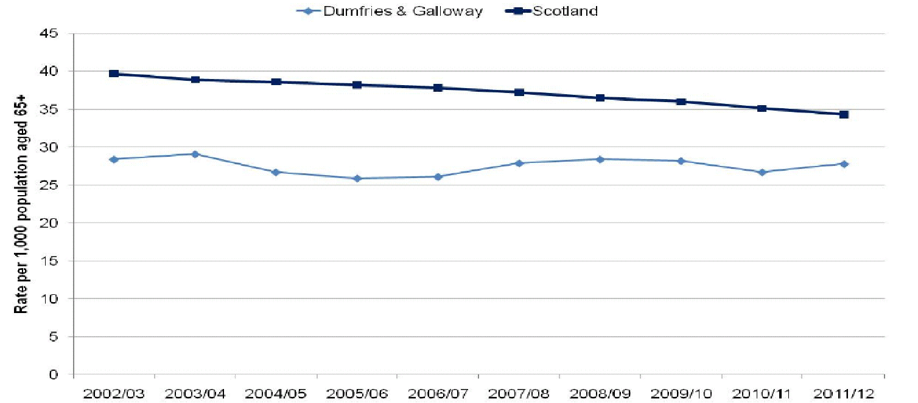

Source: Dumfries & Galloway Joint Strategic Plan for Older People 2012-2022

**Home Care Services**

In the last week of March 2012, there were 498 people aged 65 and over in receipt of a care at home service in Annandale and Eskdale. Around 43% of all clients in the area were in receipt of intensive home care, which is defined as 10 hours or more per week. A small number of clients (around 7%) require the support of two carers per home visit.

**Figure 9.5: Number of people aged 65+ receiving a care at home service by hours per week, 2011-12**

|  |  |  |
| --- | --- | --- |
|  | **Annandale and Eskdale** | **Dumfries & Galloway** |
| **Less than 10 hrs** | 285 | 1,014 |
| **10 - 20 hrs** | 173 | 761 |
| **21 - 30 hrs** | 16 | 98 |
| **31+ hrs** | 24 | 124 |
| **Total** | 498 | 1,997 |

Source: Dumfries & Galloway Joint Strategic Plan for Older People 2012-2022

Dumfries and Galloway has one of the highest rates of home care provision in Scotland. On average, it has provided almost 30% more hours of care at home per thousand population aged 65 years and over compared to Scotland as a whole. The percentage of older people with intensive needs who are cared for at home has increased from 40% in 2003 to 49% in 2012. These figures are consistently above the national average. It is expected that demographic change will see an increase in the number of older people requiring intensive home care in the future.[67]

The STARS re-ablement service was provided to more than 1,000 older people in Dumfries and Galloway during 2011-12 to make sure they had the best possible opportunities to regain their independence. Nearly 300 of these people were in Annandale and Eskdale. The majority of referrals were for people aged 75 – 84 years and over 85 years.

**Figure 9.6: Number of Referrals to STARS, Dumfries and Galloway, 2011-12**

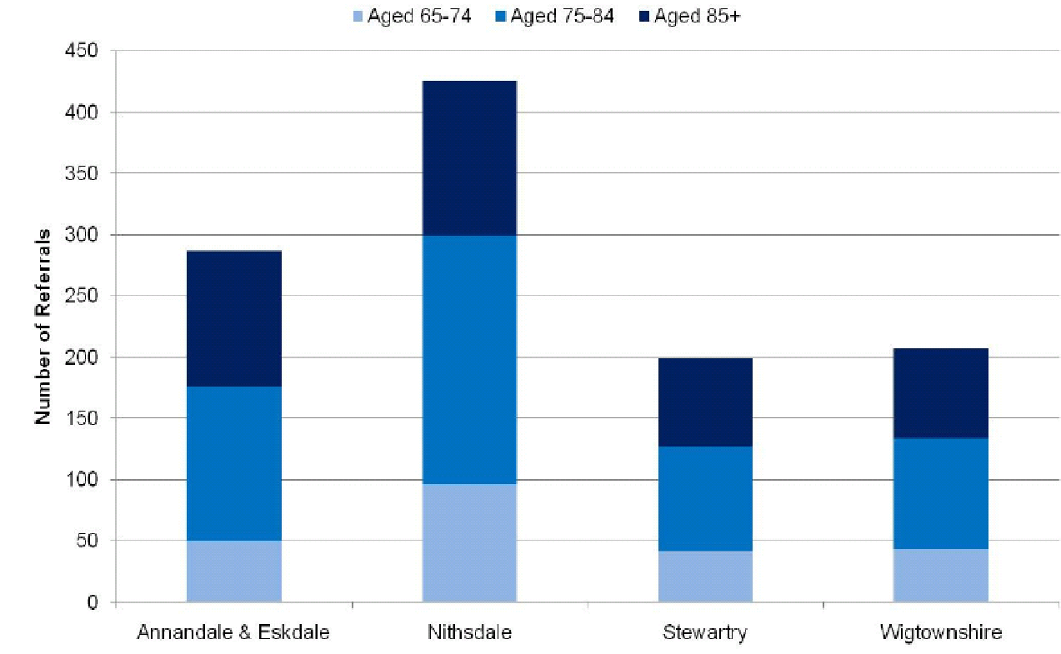

Source: Dumfries & Galloway Joint Strategic Plan for Older People 2012-2022

There were 2,159 older people receiving a community alarm service through Dumfries and Galloway social work department in 2011-2012. Approximately 460 clients also received a telecare equipment service during the year. Telecare is a term used to describe the remote or enhanced delivery of care services to people in their own home by utilising developing technology such as alarms, sensors and remote monitoring equipment. These are used to enable people to live with greater independence and safety in their own homes. Figure below shows the distribution of community alarm and telecare services across the four areas in Dumfries and Galloway during 2011-12. In Dumfries and Galloway 12.4% of people aged 75 and over had a telecare package in 2012. This is amongst the lowest of all local authorities in Scotland and less than the national average of 18.3%. Over 85% of clients in both categories were over the age of 75.

**Figure 9.7: Community Alarm and Telecare services for people aged 65 and over, Dumfries and Galloway, 2011-12**

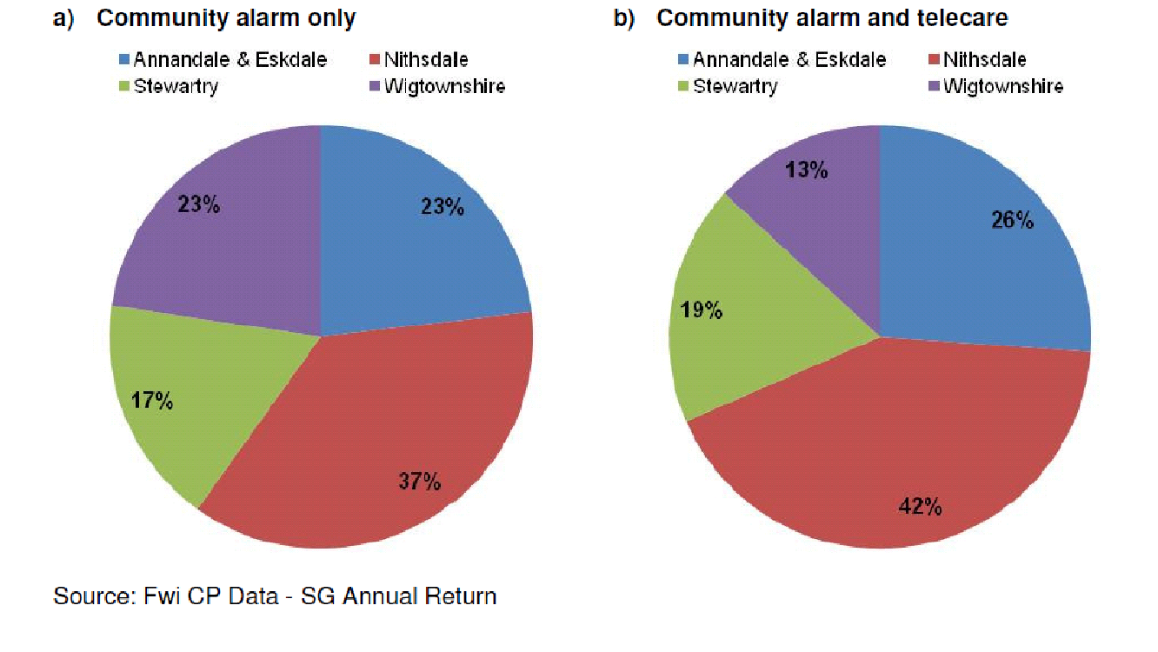

In 2011-2012, 292 people over the age of 65 across Dumfries and Galloway received a meal on wheels service. Annandale and Eskdale accounted for just under a quarter of these. A further 19 older people in the area received a frozen meals service.

**Figure 9.8: Proportion of Meals Service clients by locality, Dumfries and Galloway, 2011-12**

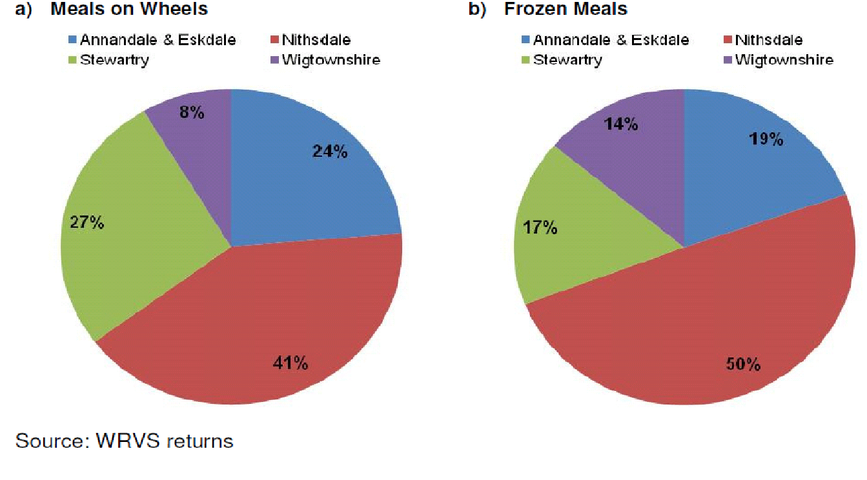

In 2011-2012 there were 593 people over the age of 65 in receipt of a shopping service from Food Train. Of these 154 also received a service from Food Train Extra, which provides help with practical household tasks. Older people in Annandale and Eskdale accounted for just under a fifth of these totals.

**Figure 9.9: Proportion of Food Train clients by locality, Dumfries and Galloway, 2011-12**

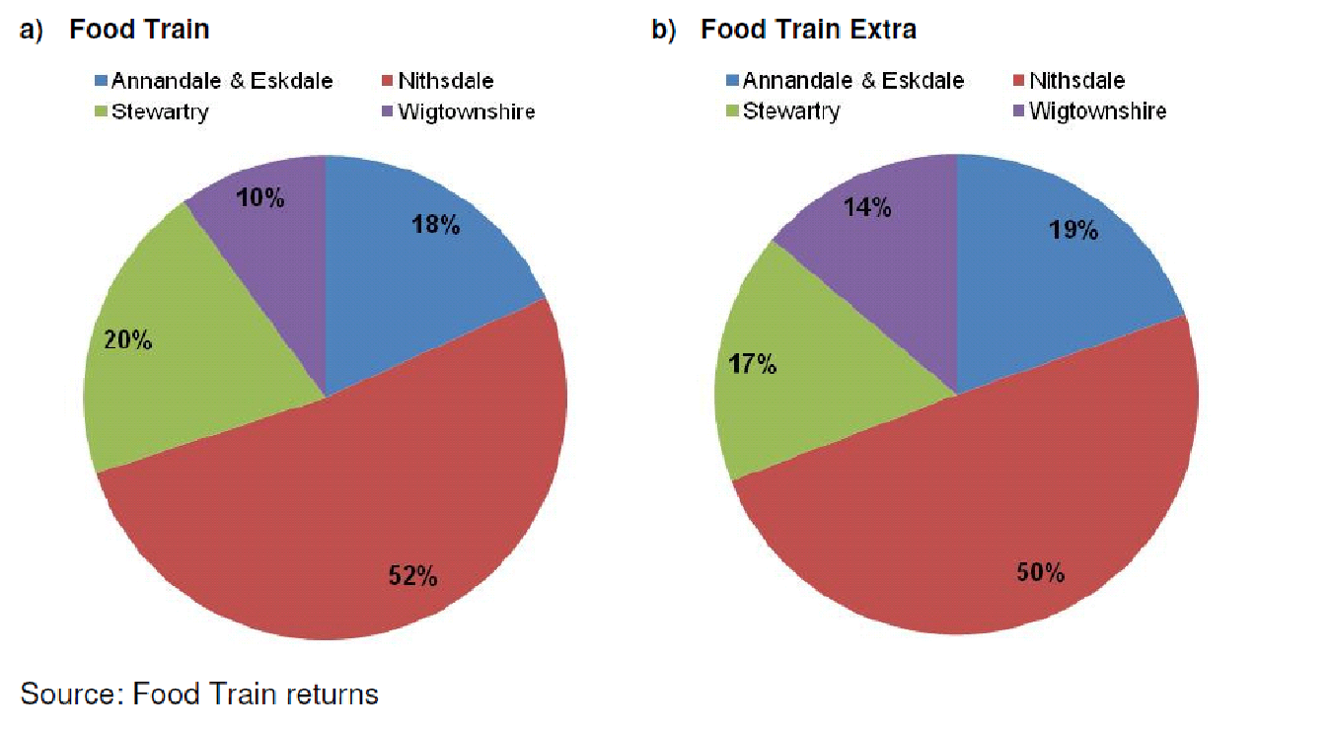

**Unpaid Carers**

The provision of unpaid care is defined as looking after, giving any help or support to family members, friends, neighbours or others because of a long-term physical or mental ill-health or disability or problems relating to old age. 3,750 people in Annandale and Eskdale provide some amount of unpaid care. At 9.7%, this is broadly in line with the average rate for the region.

**Figure 9.10: Provision of unpaid care**

|  |  |  |  |  |  |  |
| --- | --- | --- | --- | --- | --- | --- |
|  | **Annandale and Eskdale** | | | **Dumfries and Galloway (%)** | | **Scotland (%)** |
| Number | % |  | |  |
| **No unpaid care** | 34,771 | 90.3 | 90.1 | | 90.7 | |
| **1 to 19 hours a week** | 1,982 | 5.1 | 5.2 | | 5.2 | |
| **20 to 34 hours a week** | 383 | 1.0 | 1.0 | | 0.9 | |
| **35 to 49 hours a week** | 289 | 0.8 | 0.8 | | 0.8 | |
| **50 or more hours a week** | 1,096 | 2.8 | 2.9 | | 2.5 | |
| **All providing unpaid care** | 3,750 | 9.7 | 9.9 | | 9.3 | |

Source: Census 2011

# 10. HOUSING

**Housing in Annandale and Eskdale**

Housing belongs to one of the basic human needs as it represents a shelter, a space where families interact and it can be a source of health, rest and relaxation. Adequate housing is vitally important to the health of the local economies, communities and populations.

The table below presents all household spaces across Scotland and in Annandale and Eskdale. In Annandale and Eskdale, the proportion of vacant households is higher than the national average.

**Figure 10.1: All household spaces**

|  |  |  |
| --- | --- | --- |
|  | **Ananndale and Eskdale** | **Scotland** |
| Occupied | 95.2% | 95.9% |
| Unoccupied: Second residence/holiday accommodation | 1.1% | 1.5% |
| Unoccupied: Vacant | 3.7% | 2.6% |

Source: Census data 2011

The number of whole house or bungalow households in Annandale & Eskdale is 89.7% and is significantly higher than the national average (i.e. 63.4%). A as consequence, in the region there are fewer (than the national average) flats and apartments.

**Figure 10.2: Unshared dwelling**

|  |  |  |
| --- | --- | --- |
|  | **Annandale and Eskdale** | **Scotland** |
| **Whole house or bungalow** | 89.7% | 63.4% |
| -Whole house or bungalow: Detached | 36.8% | 21.9% |
| -Whole house or bungalow: Semi-detached | 26.3% | 22.8% |
| -Whole house or bungalow: Terraced | 26.6% | 18.6% |
| **Flat maisonette or apartment** | 9.8% | 36.4% |
| -Flat maisonette or apartment: Purpose-built block of flats or tenement | 7.9% | 34.2% |
| -Flat maisonette or apartment: Part of a converted or shared house (including bed-sits) | 1.3% | 1.8% |
| -Flat maisonette or apartment: In a commercial building | 0.7% | 0.5% |
| **Caravan or other mobile or temporary structure** | 0.5% | 0.2% |

Source: Census data 2011

Figure 10.3 reveals the ownership status of households in the area. Comparing to the Scottish average, Annandale & Eskdale has significantly higher proportion of owned outright households and lower proportion of owned with a mortgage or loan households. There are a lower proportion of people in rented accommodation, with no local authority housing provision.

**Figure 10.3: Household Ownership**

|  |  |  |
| --- | --- | --- |
| **Region Name** | **Annandale and Eskdale** | **Scotland** |
| **Owned: Owned outright** | 37.2% | 27.8% |
| **Owned: Owned with a mortgage or loan** | 27.3% | 33.7% |
| **Owned: Shared ownership (part owned and part rented)** | 0.3% | 0.4% |
| **Rented: Council (Local authority)** | 0.0% | 13.2% |
| **Rented: Other social rented** | 18.7% | 11.1% |
| **Rented: Private landlord or letting agency** | 12.5% | 11.1% |
| **Rented: Other** | 1.6% | 1.3% |
| **Living rent free** | 2.5% | 1.3% |

Source: Census data 2011

The table below indicates number of people living in a households and number of people living in a communal establishments (defined as an establishment providing managed residential accommodation). Proportionally, in Annandale & Eskdale the number of those who live in a communal establishment is slightly lower than Scottish average.

**Figure 10.4: Number of people living in households and those in communal establishments**

|  |  |  |
| --- | --- | --- |
|  | **Annandale and Eskdale** | **Scotland** |
| Lives in a household | 98.9 | 98.1% |
| Lives in a communal establishment | 1.1% | 1.9% |

Source: Census data 2011

**Properties by Council Tax Band**

Properties are banded for Council Tax based on their value in April 1991, with the highest valued properties in Band H. As illustrated in the table below, the spread of properties in Nithsdale is broadly the same as that across the whole region.

**Figure 10.5: Properties by Council Tax Band**

|  |  |  |  |  |  |
| --- | --- | --- | --- | --- | --- |
|  | **Annandale and Eskdale** | | | **Dumfries and Galloway** | |
|  | **Number** | **%** | **Number** | | **%** |
| **A** | 2,655 | 14.5 | 11,324 | | 15.3 |
| **B** | 5,693 | 31.1 | 22,785 | | 30.9 |
| **C** | 3,106 | 16.9 | 11,813 | | 16.0 |
| **D** | 2,318 | 12.6 | 9,867 | | 13.4 |
| **E** | 2,649 | 14.4 | 10,389 | | 14.1 |
| **F** | 1,338 | 7.3 | 5,059 | | 6.9 |
| **G** | 543 | 3.0 | 2,389 | | 3.2 |
| **H** | 31 | 0.2 | 159 | | 0.2 |
| **Total** | 18,333 | 100.0 | 73,785 | | 100.0 |

Source: Dumfries and Galloway Council

**Market Analysis**

Data on house prices is not available specifically for Annandale and Eskdale. Exceeding national trends, house price inflation in Dumfries and Galloway between 2003 and 2007 was 75%. This slowed to 5% in 2008 and since the beginning of the economic crisis the prices dropped down. In general, house prices in Dumfries and Galloway are significantly lower than average house prices in Scotland and this applies to all types of housing including detached, semi-detached, terrace and flats. The annual change in house price between 2012 and 2013 in Dumfries and Galloway was negative and accounted for -11.3%. This represents a significantly higher price drop comparing to the Scottish national average of -0.3%.

**Figure 10.6: Average house prices, April to June 2013**

|  |  |  |
| --- | --- | --- |
|  | **Dumfries and Galloway** | **Scotland** |
| **Average house price** | £126,087 | £153,102 |
| **Detached** | £181,409 | £225,193 |
| **Semi-detached** | £113,896 | £142,876 |
| **Terrace** | £90,537 | £123,206 |
| **Flat** | £65,864 | £117,517 |
| **Annual change in house price** | -11.3% | -0.3% |
| **Quarterly change** | -5.5% | +3.3% |

Source: Registers of Scotland Executive Agency

Note: All figures are simple averages based on all residential properties between £20,000 and £1,000,000 recorded in the four quarters of each year

**Demographic Factors**

As discussed in the Population chapter, older people are expected to make up a larger proportion of Dumfries and Galloway’s population than is currently the case. In addition to the number of older people increasing over time, the proportion of these living alone is also expected to dramatically increase. Estimates indicate that there are over 11,500 older people living alone in Dumfries and Galloway, of whom 2,200 are aged 85 and over. Many of these will be living in remote and rural areas of the region. Over the next ten years the number of older people living alone is expected to increase by 22% to over 14,000 people, with those aged 85 and over increasing to 3,500. By 2035 the number of people aged 85+ living alone is projected to be over 10,000 people, over two thirds of all people in that age group. [68]

**Figure 10.7: Projected Number of Single Adult Households by age, Dumfries and Galloway, 2010–2035**

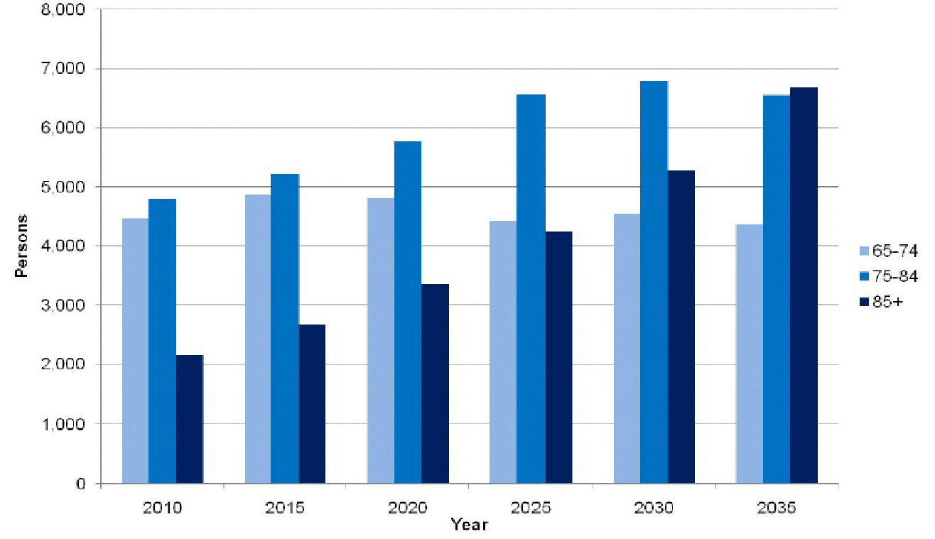

Source: Dumfries & Galloway Joint Strategic Plan for Older People 2012-2022

The Housing Needs and Demands Assessment carried out by Dumfries and Galloway Council in 2009 found that the proportion of older person households where at least one member is aged over 75 is expected to increase by 27% over the next ten years[69]. This increase in older person households is almost twice the national average. The change in number of older person households is likely to be sustained into the future, with projections indicating an 80% increase by 2035.

To accommodate the needs of an ageing population and other needs associated with housing, the area, has a range of retirement, sheltered and very sheltered housing available on a self-funded or housing support funded basis. In total there are just over 250 units in the area, providing a mix of accommodation in predominantly 1 person, 1 bedroom to 4 persons, 2 bedroom flats. These are presented in the Table below.

**Figure 10.8: Housing options for older people and those in need**

|  |  |  |
| --- | --- | --- |
|  | **Annandale and Eskdale** | **Dumfries & Galloway** |
| **Care homes** | 9 | 34 |
| **Retirement housing** | 45 | 429 |
| **Sheltered housing** | 200 | 783 |
| **Very sheltered housing** | 0 | 36 |

Source: Dumfries & Galloway Joint Strategic Plan for Older People 2012-2022

**Market Factors**

The economic climate in the UK has significant implications for the delivery of housing industry in Dumfries and Galloway. For instance, the recent down turn in the economy accompanied by extensive cuts in public spending at a national level have had a negative impact on the money made available through the Scottish Affordable Housing Investment Plan. Additionally, there are difficulties households currently face in securing mortgage finance because of a contraction in the lending markets is fuelling increasing demand in the private rented sector.

Affordability remains a significant challenge with only 56% of households able to access the private housing market at entry level. Increasing the supply of affordable housing is recognised as a priority within the South of Scotland Competitiveness Strategy which informs the Dumfries and Galloway Regional economic Strategy. This is in recognition of the need to retain and attract people of working age into the area to sustain our rural economy.[70]

Dumfries and Galloway’s Strategic Housing Investment Plan set targets for delivery of affordable housing. Housing Association Grant is the primary subsidy from the Scottish Government that enables Registered Social Landlords in Dumfries and Galloway to build new affordable houses. However, the Scottish Government’s view is that the current levels of subsidy are unsustainable. Over recent years the level of Housing Association Grant has been reduced and is likely to reduce further. The recent economic crisis had also negative impact on private finance contribution to overall housing development costs. This combination of factors means that new, and increasingly local, solutions will need to be developed if the delivery of housing is to meet existing need and demands.

**Meeting the Demand for Market Housing[71]**

Dumfries and Galloway is made up of approximately 68,900 households. Although the population has remained relatively static since 2001, the number of households has increased by 5%. The number of households is projected to increase by 10% due to the trend for smaller households, predominantly single and couple newly forming households. Over the shorter term, the total number of households in the region is projected to increase by 346 per annum up till 2016. This is substantially lower than the Scottish average. Considering the recent economic crisis, a banded forecast for household growth of 200 – 350 households per annum to 2016 might be anticipated.

Over the next 10 years the number of family households is projected to decrease by 26%. As noted above, the increase in the proportion of older person households is likely to be around twice the national average. Linked to this will be the predicted increase in numbers of over 75s living with a long term condition and frailty. The development of appropriate housing and care options will be a particularly key consideration in planning for the future.

In 2009 the Council undertook a Housing Need and Demand Assessment (HNDA) to assess the ability of the private housing market to meet housing need and demand. An estimate of need and demand for market housing per annum was matched to a profile of available properties based on recent sales activities in the market. The overall projections indicated:

* Imbalance in the availability of market housing at specific price points with an apparent under supply at the lower end of the market and an oversupply at the upper end of the market.
* Over time, increasing shortfalls at the lower end of the market are evident in all housing market areas.
* The evidence indicates that by 2019 there will be a shortfall of almost 6000 market dwellings throughout Dumfries and Galloway. In addition, given that the model assumes an annual new build supply of 200 units per year, the overall land requirement will be for just under 8000 market dwellings.

A detailed modelling exercise identified the extent and nature of unmet need for affordable housing in Dumfries & Galloway. The overall results of the projections indicated:

* Backlog Need: to the backlog need increases significantly from 2,057 in 2009 to 3,267 in 2018/19 (i.e. 59% increase over the 10 year period);
* Supply: the supply will remain fairly steady ending at 1,214 by 2018/19;
* Newly Arising Need: newly arising need remains fairly steady over the whole plan period (i.e. 1,319 in the baseline year and 1,321 by 2018/2019).

Unmet need for affordable housing grows from 1,723 in the baseline year (2009) to 2,814 in year 5 and then 3,375 in year 10. The key factor within this increasing shortfall is that the level of newly arising need continues to outstrip annual supply throughout the plan period. Based on the analysis of the demand and supply of housing in Dumfries & Galloway, the HNDA defined six functioning Housing Market Areas indicating Housing Supply Targets 2009-2024 for each of them. These are presented in Figure 10.9 below – the target for the Annan housing market area is 1,306, and the target for the Eskdale area is 256.

**Figure 10.9: LHS Housing Supply Targets 2009-2024**

|  |  |  |  |
| --- | --- | --- | --- |
| **Housing Market Area** | **Market Housing** | **Affordable Housing with LHS Policy intervention** | **LHS Housing supply target** |
| **Annan** | 883 | 423 | 1306 |
| **Dumfries** | 2896 | 537 | 3433 |
| **Eskdale** | 230 | 26 | 256 |
| **Mid Galloway** | 668 | 126 | 794 |
| **Stewartry** | 667 | 74 | 741 |
| **Stranraer** | 682 | 116 | 798 |
| **Dumfries and Galloway total** | 6026 | 1302 | 7328 |

Note: (i) Stranraer and Mid Galloway are located in Wigtownshire; (ii) Dumfries is located in Nithsdale

The Housing Needs and Demand Assessment provided evidence that without intervention in the region’s housing system there will be an increasing shortfall in affordable housing provision over time. In relation to Annan Housing Market Area, the proposed approach would result in a doubling of the past housing completions and it anticipates the provision of 883 market housing units and 423 affordable housing units. In terms of Eskdale Housing Market Area, the HNDA identified a need and demand for 2,690 new housing units. To identify land to accommodate this number of units would have a significant impact on existing communities as there are a limited number of settlements. As the proposed spatial strategy identifies 90% of development will be allocated to District and Local centres, this would focus the majority of activity in only 1 District Centre (Langholm) and 1 Local Centre (Canonbie) where new development can be allocated. There are significant infrastructure constraints, mainly flooding which makes it difficult to identify land for development in these areas. The proposal is to set 10% of the HNDA need and demand figure which equates to 256 units which is an increase on past completion rates of 48 units between 1998 and 2008. These include 230 market housing units and 26 affordable housing units.

Data from Dumfries and Galloway Council shows that over the past 6 years, there have been an average of 500 new houses built each year in Dumfries and Galloway. Only around 10% of the total have been built in Annandale and Eskdale.

**Figure 10.10: House Completions by Housing Market Area**

|  |  |  |  |  |  |  |  |
| --- | --- | --- | --- | --- | --- | --- | --- |
| **Housing Market Area** | **2007/08** | **2008/09** | **2009/10** | **2010/11** | **2011/12** | **2012/13** | **Average** |
| **Annan** | 82 | 65 | 54 | 28 | 24 | 28 | 47 |
| **Dumfries** | 268 | 210 | 167 | 381 | 271 | 217 | 252 |
| **Eskdale** | 4 | 3 | 5 | 8 | 6 | 2 | 5 |
| **Mid Galloway** | 19 | 91 | 76 | 10 | 83 | 28 | 51 |
| **Stewartry** | 113 | 113 | 78 | 42 | 45 | 43 | 72 |
| **Stranraer** | 88 | 87 | 84 | 74 | 58 | 43 | 72 |
| **Dumfries & Galloway** | 574 | 569 | 464 | 543 | 487 | 361 | 500 |

*Source*:Dumfries and Galloway Council Development Planning Team

Note: Figures from 1st July to 30th June each year

**Homelessness**

The Council’s approach to tackling homelessness is set out in the LHS. At the same time, the HNDA identified a total newly arising need for housing of 1,328 households per year of which 927 are homeless households with priority need. Around 40% of all homeless households come from within the Dumfries HMA and 30% are in the 16 – 24 age band. Over 50% of all homelessness is caused by a family or relationship breakdown[72].

There were 916 presentations to Dumfries and Galloway Council’s Homeless Service in 2013/14. Of these, 184 (20%) were made at the service’s Annan office.

**Figure 10.11: Homelessness Service Presentations by Office, 2013/14**

|  |  |
| --- | --- |
|  | **Number** |
| **Annan** | 184 |
| **Dumfries** | 424 |
| **Kirkcudbright** | 66 |
| **Stranraer** | 242 |
| **Total** | 916 |

Source: Dumfries and Galloway Council

# 11. TRANSPORT

As a predominantly rural region, travel is an issue throughout Dumfries and Galloway. The availability of transport can be an important factor in people’s ability to access employment and services.

Annandale and Eskdale has access to two major national transport routes:

* The M74 motorway, linking Glasgow and Carlisle, passes through the area from north to south, close to Moffat, Lockerbie and Gretna.
* The rail station at Lockerbie in on the West Coast Main Line, with trains running between Glasgow and a range of destinations in England, including London, Birmingham and Manchester. In addition, there are stations at Annan and Gretna Green on the Dumfries-Carlisle line.

As in the rest of the region, driving is the main mode of transport for people living in Annandale and Eskdale, with around 60% of journeys to work or study undertaken as either drivers or passengers in a car or van. A significant number of people (around 10%) travel on foot. Only a small number of journeys are undertaken by public transport or bicycle.

**Figure 11.1: Method of Travel to Work**

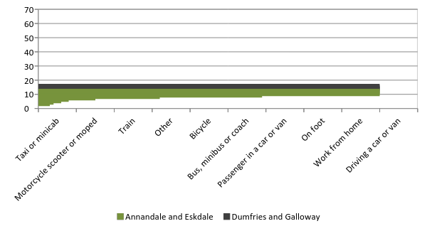

Source: Census 2011

Note: Aged 16-74, excludes full-time students

**Car Travel**

Reliance on private transport also varies within the area. As illustrated in the chart below, looking at the main settlements within the area, car or van use is lowest amongst people living in Langholm, and highest in Eaglesfield.

**Figure 11.2: % of People Driving a Car or Van to Work**

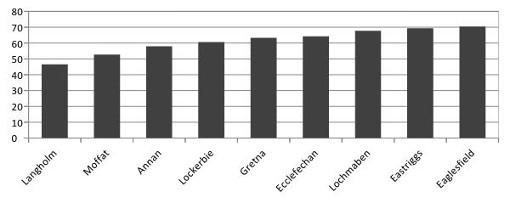

Source: Census

Note: Aged 16-74, excludes full-time students

The Census also asks about the number of cars in each household. The level of car ownership in the area is slightly higher than both the regional and national averages.

**Figure 11.3: Number of Cars or Vans per Household**

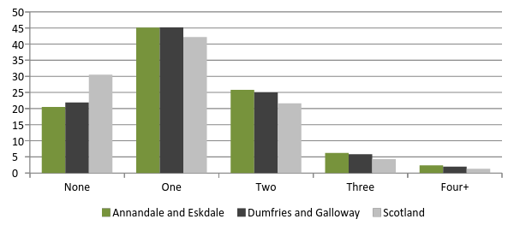

Source: Census 2011

One of the indicators included in the calculation of the Scottish Index for Multiple Deprivation is a measure of ‘geographic access’ to services. As illustrated below, the average time that it takes to drive to the nearest GP, Post Office or primary school is higher in Annandale and Eskdale than the regional average – but the time to the nearest petrol station, secondary school or retail centre is lower.. Average drive time is highest to the closest Secondary School – as would be expected as there are only four across the area.

**Figure 11.4: Drive Time (in minutes) to Local Services**

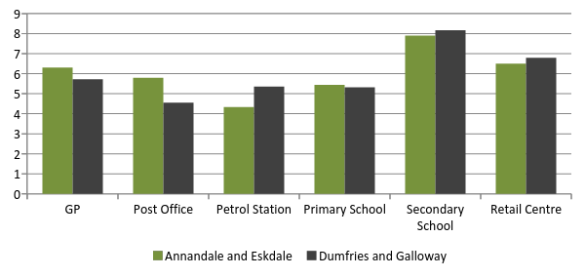

Source: SIMD

Note: Average of Datazones

The Scottish Fire and Rescue Service attended 22 road traffic collisions in Annandale and Eskdale in the period April-September 2013. Of these collisions, 12 took place on the M74.[73]

**Public Transport**

Looking at public transport, Annandale and Eskdale is served by a number of bus services, as shown below.

**Figure 11.5: Bus Routes in Annandale and Eskdale**

|  |  |  |  |
| --- | --- | --- | --- |
| **Number** | **Route** | **Operator** | **Usage** |
| X74 | Dumfries – Moffat - Glasgow | Stagecoach |  |
| 74/114 |  |  |  |
| 79 | Dumfries – Annan - Carlisle | Stagecoach |  |
| 557 |  |  |  |
| 505 |  |  |  |
| 502 |  |  |  |
| 503 |  |  |  |
| 501 |  |  |  |
| 515 |  |  |  |
| 516 |  |  |  |
| 555 |  |  |  |

Source:

Usage data requested from SWESTrans

The chart below shows the number of passengers (entries and exits) using each of the three train stations in Annandale and Eskdale. As discussed earlier, Lockerbie is on the West Coast Main line connecting Scotland and England, which is likely to account for the high number of passengers using the station.

**Figure 11.6: Usage of Rail Stations in Annandale and Eskdale**

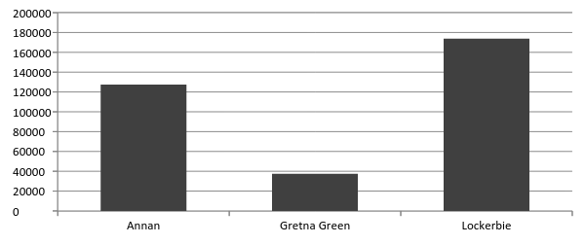

Source: Office of the Rail Regulator (2014) Station Usage Estimates 2012/13

In addition to the time taken to drive to local services, the time taken by public transport is also factored in to the calculation of overall deprivation in the SIMD. Average travel times by public transport to the nearest GP (17 mins) and Post Office (13 mins) are higher in Annandale and Eskdale than the average for Dumfries and Galloway. The travel time to the nearest retail centre is in line with the regional average. However, there will also be other factors – such as the frequency, timings and cost of services – that will influence how easy it is for people to access local services using public transport.

**Figure 11.7: Public Transport Time (in minutes) to Local Services**

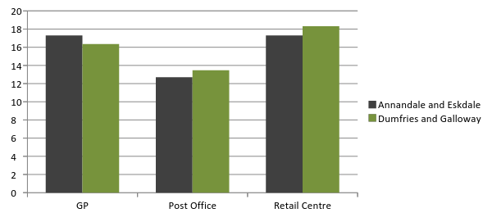

Source: SIMD 2012

Note: Average of Datazones

***Rural Transport Solutions***

Rural Transport Solutions is an innovative partnership model that brings together the local transport commissioning bodies Dumfries and Galloway Council, SWestrans, NHS Dumfries and Galloway, and the Scottish Ambulance Service to seek solutions to transport issues for communities using community transport operators as delivery partners. Following a pilot in Wigtownshire, the initiative is now being rolled out across Dumfries and Galloway. This will operate in Annandale and Eskdale based around joint working with the Annandale Transport Initiative.

# 12. COMMUNITY SAFETY AND RESILIENCE

**Police and Crime**

The area is covered by Police Scotland’s Annandale and Eskdale Area Command, part of the Dumfries and Galloway Division. Police stations are located in:

* Annan
* Gretna
* Langholm
* Lockerbie
* Moffat

The Scottish Index of Multiple Deprivation includes a ‘crime’ domain, which is based on the incidence of a number of types of offences:

* Domestic housebreaking
* Crimes of violence
* Common assault
* Sexual offences
* Drugs offences
* Vandalism

There were 1,054 of these crimes recorded in Annandale and Eskdale in 2010/11 – this was a fall from the 1,304 recorded in 2007/08.[74]

In common with the other domains used to compile the SIMD, every datazone in Scotland is ranked from 1 (the most deprived) to 6505 (least deprived) based on the prevalence of these criminal offences. Annandale and Eskdale has 5 datazones (in Kirkcudbright) in Scotland’s 20% most ‘crime’ deprived datazones, and a further 6 datazones in the 20-40% most deprived.

**Figure 12.1: Most ‘Crime’ Deprived Datazones in Annandale and Eskdale**

|  |  |  |  |  |  |  |
| --- | --- | --- | --- | --- | --- | --- |
| **Datazone** | **Area** | **Crime Deprivation** | | | **Overall Deprivation** | |
| **Rank** | **Quintile** | **Rank** | | **Quintile** |
| S01000962 | Annan South | 170 | 1 | 2637 | | 3 |
| S01000970 | Gretna and Eastriggs | 772 | 1 | 2321 | | 2 |
| S01001055 | Lockerbie and Mid Annandale | 980 | 1 | 3368 | | 3 |
| S01000965 | Annan North | 1113 | 1 | 692 | | 1 |
| S01001058 | Lockerbie and Mid Annandale | 1300 | 1 | 3554 | | 3 |
| S01000969 | Annan North | 1337 | 2 | 2184 | | 2 |
| S01000958 | Gretna and Eastriggs | 1520 | 2 | 1919 | | 2 |
| S01000967 | Annan North | 1562 | 2 | 1758 | | 2 |
| S01000971 | Annan North | 1681 | 2 | 1505 | | 2 |
| S01001082 | Moffat and Eskdalemuir | 2481 | 2 | 4457 | | 4 |
| S01001059 | Lockerbie and Mid Annandale | 2573 | 2 | 2222 | | 2 |

Source: SIMD

Police Scotland provide figures for the number of crimes and offences of various categories that are recorded in the Annandale and Eskdale Area Command.[75]

**Figure 12.2: Crimes Recorded in Annandale and Eskdale, April-September 2013**

|  |  |
| --- | --- |
|  | **Annandale and Eskdale** |
| **Crimes of Violence** | 26 |
| **Murder** | 1 |
| **Attempted Murder** | 2 |
| **Culpable Homicide** | 0 |
| **Serious Assault** | 7 |
| **Robbery** | 2 |
| **Petty Assault** | 178 |
| **Drugs Suppy/Production** | 22 |
| **Theft by Housebreaking** | 32 |
| **Theft by Shoplifting** | 39 |
| **Vandalism/Malicious Mischief** | 151 |
| **Consuming Alcohol in a Designated Place** | 7 |
| **Crimes of Indecency** | 32 |
| **Rape** | 7 |

Source: Police Scotland

**Fire**

Dumfries and Galloway is part of the West Service Delivery Area for the Scottish Fire and Rescue Service. There are 5 fire stations in Annandale and Eskdale:

* Annan
* Gretna
* Langholm
* Lockerbie
* Moffat

There were 63 fires recorded in Annandale and Eskdale in 2012/13. This number has stayed reasonably constant since 2009/10.

**Figure 12.3: Number of Fires in Annandale and Eskdale**

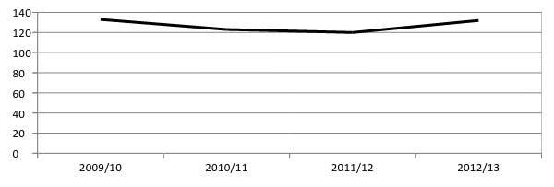

Source: Scottish Neighbourhood Statistics

As illustrated in Figure 13.4 below, however, the incidence of both accidental dwelling fires and deliberate fires in the area is slightly higher than the regional average.

**Figure 12.4: Fires per 100,000 People, 2012/13**

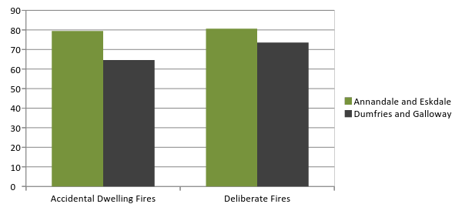

Source: Scottish Neighbourhood Statistics

The Scottish Fire and Rescue Service received 388 emergency calls in Annandale and Eskdale in 2012/13, and attended 323 incidents.[76] As is illustrated below, a high proportion of the incidents that SFRS attends in the area are due to automatic false alarm calls.

**Figure 12.5: Incidents attended by reason**

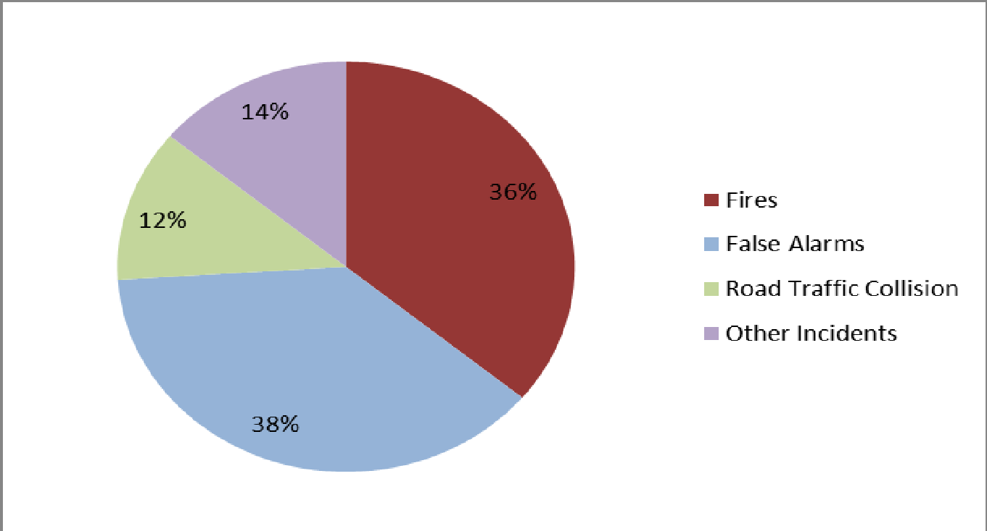

Source: Scottish Fire and Rescue Service – Performance Report April-September 2013 (Annandale and Eskdale)

**Child Protection**

As of March 2014, there were 74 looked after children in Annandale and Eskdale – this accounted for 20% of the total across the region. During the period April-September 2013, there were 1.0 looked after children per 1,000 in Annandale and Eskdale. This is below the national average rate of 1.6 per 1,000. 16.7% of looked after children had 3 or more different placements – this is an issue as there is evidence that stable placements contribute to better outcomes for children.[77]

**Community Resilience Plans**

The aim of Community Resilience Plans is to increase resilience within the local community through the development of robust co-ordinated arrangements that complement those of responding agencies.

As of March 2014, two community councils in Annandale and Eskdale – Royal Four Towns and Johnstone – have completed and submitted their Community Resilience Plans, while Eastriggs, Dornock & Creca, Kirtle and Eaglesfield, Moffat and District and Langholm, Ewes and Westerkirk Community Councils’ plans were being developed.[78]

# 13. ENVIRONMENT

**Scenic Areas**

There 2 Regional Scenic Areas that lie at least within the Annandale and Eskdale.[79]

* The Moffat Hills, which includes the upper Annan and Moffat glens as far as the ridge lines, and the outward facing ends of the ridges which are important to the views into and along the glens, plus the unspoilt borders town of Moffat at the junction of the two glens. To the north the area abuts a Special Landscape Area within the Scottish Borders.
* The Langholm Hills, which covers the areas of upland glen and other attractive valley landscapes of Eskdale and the Ewes Water valley, and the adjacent Southern Uplands. It also includes the town of Langholm itself.

**Flooding**

The proportion of homes identified as being at risk of flooding (i.e. with at least a 0.5% chance of being flooded in any given year) is substantially lower in Annandale and Eskdale than the regional or national average. Only 5 datazones in the area have any homes at risk. However, it is worth noting that this data is based on SEPA flood maps from 2006, so the likelihood of flooding may have changed in some areas since then.

**Figure 13.1: % of Dwellings at Risk of Flooding**

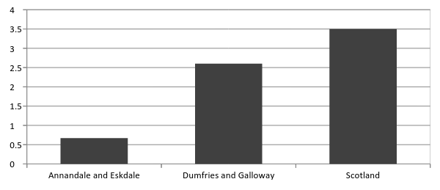

Source: Scottish Neighbourhood Statistics

Note: Fluvial or coastal flooding

Data from 2006

**Windfarm Developments**

The table below shows a list of current and planned windfarm developments in Annandale and Eskdale.

**Figure 13.2: Current Status of Wind Projects, Annandale and Eskdale**

|  |  |  |  |
| --- | --- | --- | --- |
| **Development** | **Location** | **No. of Turbines** | **Status** |
| Craig Wind Farm | Langholm | 4 | Operational |
| Craig Wind Farm Extension | Langholm | 1 | Approved |
| Ewe Hill | Lockerbie | 6 | Approved |
| Harestanes | Forest of Ae, Moffat | 71 | Under Construction |
| Minsca Farm | Waterbeck, Lockerbie | 16 | Operational |

Source: Renewables UK website

1. Dumfries and Galloway Council (2013). Proposed Local Development Plan and NHS Dumfries and Galloway (2014) Census Release, November 2013
2. Health Intelligence Unit, NHS D&G. (2014) Census Release, November 2013
3. GROS (2013) Total Migration To or From an Area
4. Equality and Human Rights Commission Scotland (2013). Equality Act 2010: Technical Guidance on the Public Sector Equality Duty Scotland
5. Health Intelligence Unit, NHS D&G. (2014) Census Release, November 2013
6. Health Intelligence Unit, NHS D&G. (2014) Census Release, November 2013
7. Health Intelligence Unit, NHS D&G. (2014) Census Release, November 2013
8. Scottish Neighbourhood Statistics
9. Scottish Government (2013) Scottish Household Survey 2012
10. Consult Sterling Ltd (2010). Using Equality Evidence to Inform Policy: Dumfries and Galloway Council Equality and Diversity Regional Mapping
11. Health Intelligence Unit, NHS D&G. (2014) Census Release, November 2013
12. NOMIS – Claimant Count
13. Health Intelligence Unit, NHS D&G. (2014) Census Release, November 2013
14. Scottish Government (2012) Scottish Index of Multiple Deprivation
15. NOMIS – Business Counts
16. Scottish Enterprise (2013). Local Report on Activity: Dumfries and Galloway, April-September 2013
17. DGC Planning and Environment Services (2013) Performance Reporting (Annandale and Eskdale) – December 2013
18. DGC Planning and Environment Services (2013). Performance Reporting (Annandale and Eskdale), December 2013
19. DGC Planning and Environment Services (2013) Performance Reporting (Annandale and Eskdale) – December 2013
20. DGC Community and Customer Services (2014). Community Facilities Review
21. The definition of sustainable tourism represents the SIC07 industry classifications for tourism used within the Scottish Government’s growth sector.
22. Tourism in Scotland’s Regions 2012, Visit Scotland - September 2013
23. Health Intelligence Unit, NHS D&G. (2014) Census Release, November 2013
24. Dumfries & Galloway Council: [Tourism Business Confidence Monitor 2012](http://www.dgtourism4business.co.uk/images/Downloads/Business%20Confidence%20Monitor_2012.pdf)
25. Tourism in Scotland’s Regions 2012, Visit Scotland - September 2013
26.
27. Tourism in Scotland’s Regions 2012, Visit Scotland - September 2013
28. Dumfries & Galloway Council: [Tourism Business Confidence Monitor 2012](http://www.dgtourism4business.co.uk/images/Downloads/Business%20Confidence%20Monitor_2012.pdf)
29. Dumfries & Galloway Council: [Tourism Business Confidence Monitor 2012](http://www.dgtourism4business.co.uk/images/Downloads/Business%20Confidence%20Monitor_2012.pdf)
30. Dumfries & Galloway Council: [Tourism Business Confidence Monitor 2012](http://www.dgtourism4business.co.uk/images/Downloads/Business%20Confidence%20Monitor_2012.pdf)
31. <http://www.visitscotland.com/destinations-maps/dumfries-galloway/area-overview>
32. <http://www.visitscotland.com/destinations-maps/dumfries-galloway/area-overview>
33. DGC Community and Customer Services (2014) Annandale and Eskdale Area Committee Report, January 2014
34. <http://www.visitscotland.com/see-do/attractions/churches-cathedrals-abbeys/dumfries-galloway/><http://www.visitscotland.com/see-do/attractions/historic-sites/dumfries-galloway/>
35. Dumfries and Galloway Council (2014). Dumfries and Galloway Major Festivals and Events Strategy 2014-17
36. Destination Dumfries and Galloway, Audit of Tourism Accommodation Sector (supply and demand); October 2011
37. Scottish Government (2012) Scottish Index of Multiple Deprivation
38. NOMIS – Annual Survey of Hours and Earnings
39. Scottish Neighbourhood Statistics
40. Scottish Government (2012) Scottish Index of Multiple Deprivation
41. Scottish Government (2014). *Scottish Welfare Fund Statistics*
42. Scottish Parliament (2013). The Impact of Welfare Reform on Scotland
43. DWP Stat-Xplore
44. Scottish Government (2014). Discretionary Housing Payments in Scotland
45. Dumfries and Galloway Council (2013) Schools Cluster Working Review
46. Scottish Government (2012) Scottish Index of Multiple Deprivation
47. ISD (2013). Births in Scottish Hospitals
48. ISD (2012). Breastfeeding Statistics
49. Census 2011
50. Scottish Neighbourhood Statistics
51. ScotPHO (2010). Children and Young People Health and Wellbeing Profiles 2010: Dumfries and Galloway CHP
52. ScotPHO (2013). Tobacco Control Profiles 2013: Dumfries and Galloway CHP
53. ScotPHO (2014). Health and Wellbeing Profiles 2014: Dumfries and Galloway
54. ScotPHO (2010). Children and Young People Health and Wellbeing Profiles 2010: Dumfries and Galloway CHP
55. Police Scotland (2014) Area Committee Performance Reporting – Annandale and Eskdale
56. ScotPHO (2014) Health and Wellbeing Profile 2014 (Dumfries and Galloway)
57. Cox, D. and Ajetunmobi, O. (2007). Whit Fettle? The Dumfries and Galloway Wellbeing and Lifestyle Survey 2007
58. ScotPHO (2014) Health and Wellbeing Profile 2014 (Dumfries and Galloway)
59. Dumfries and Galloway Council website
60. Scottish Government (2012) Scottish Index of Multiple Deprivation
61. NHS Dumfries and Galloway website
62. NHS Dumfries and Galloway website
63. Putting You First (2013) 2012/13 Annual Report
64. Scottish Government (2013) Scotland Performs: NHSScotland Performance
65. Alzeimers Scotland (2014) Statistics: Number of People with Dementia in Scotland 2014
66. Dumfries & Galloway Joint Strategic Plan for Older People 2012-2022
67. Dumfries & Galloway Joint Strategic Plan for Older People 2012-2022
68. <http://www.gro-scotland.gov.uk/statistics/theme/households/projections/2010-based/index.html>
69. Dumfries and Galloway Council, Housing Needs and Demands Assessment, 2009
70. Dumfries and Galloway Local Housing Strategy 2011 -2016
71. Dumfries and Galloway Local Housing Strategy 2011 -2016
72. Dumfries and Galloway Local Housing Strategy 2011 -2016
73. Scottish Fire and Rescue Service (2014). Performance Report April-September 2013 (Annandale and Eskdale))
74. Scottish Neighbourhood Statistics
75. Police Scotland (2014) Area Committee Performance Reporting – Annandale and Eskdale
76. Scottish Fire and Rescue Service (2014). Performance Report April-September 2013 (Annandale and Eskdale)
77. Dumfries and Galloway Council Social Work (2014). Performance Report, Annandale and Eskdale Area, April-September 2013
78. DGC Community and Customer Services (2014) Performance Indicator Exception Report, Annandale and Eskdale
79. Dumfries and Galloway Council (2013). *Proposed Local Development Plan Technical Paper: Regional Scenic Areas*