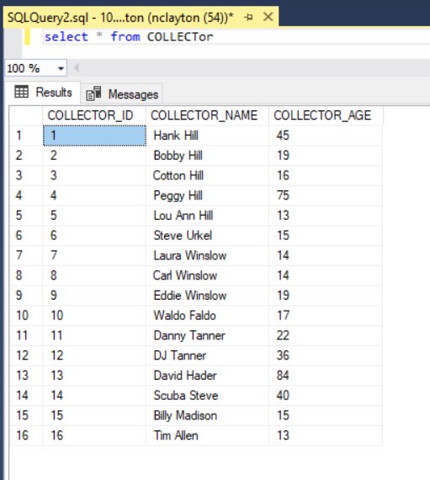

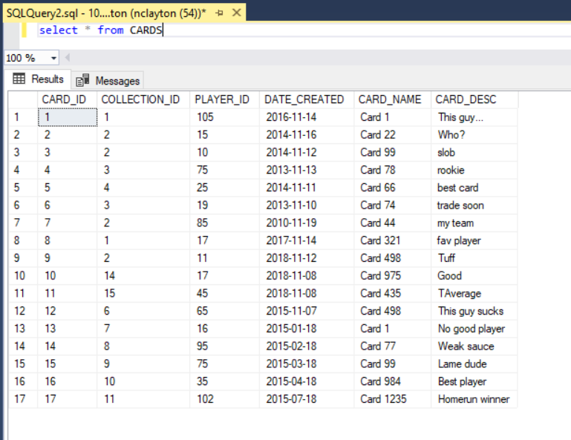

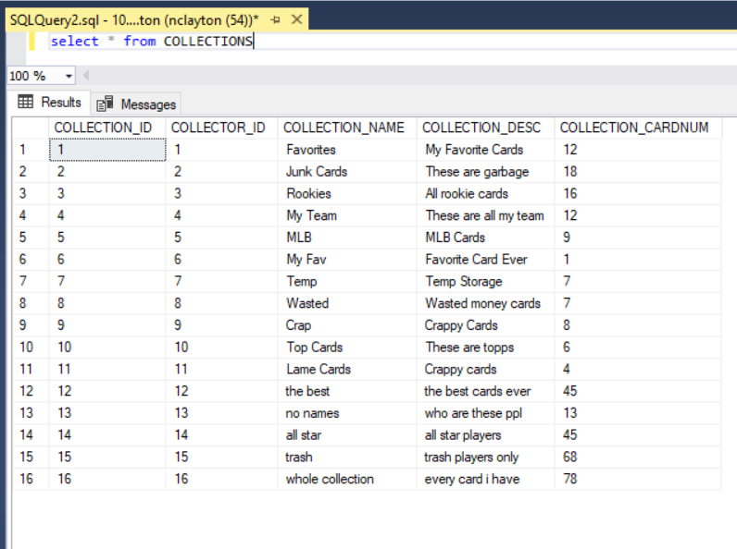

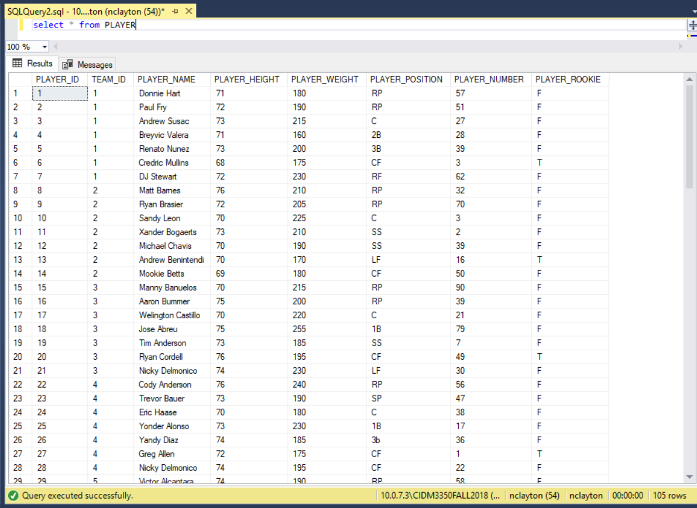

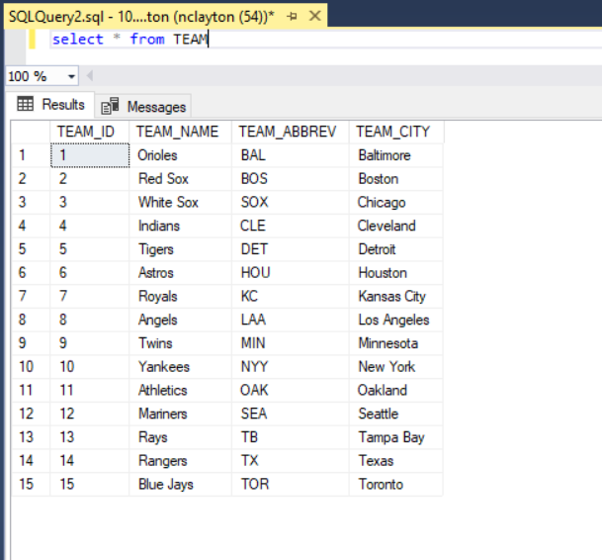

USE CASE # 1: Display player name, height, and team name of all players over 6ft 3in tall.

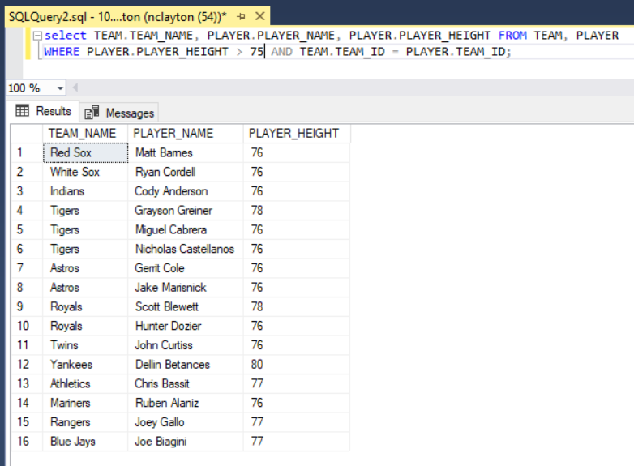

Use Case # 2: Display all cards of players who are over 240lbs.

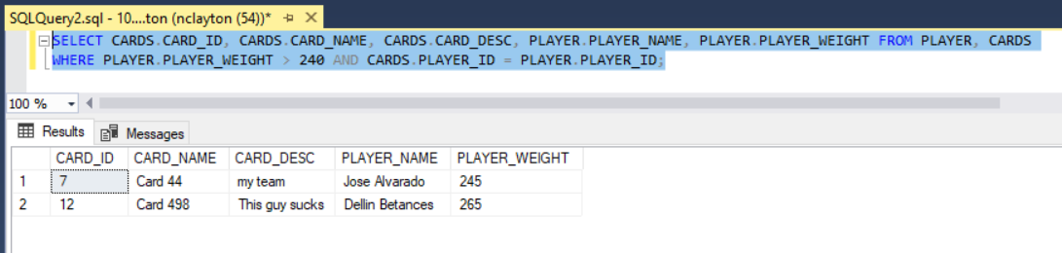

Use Case # 3: Display all collections owned by a collector under the age of 15.

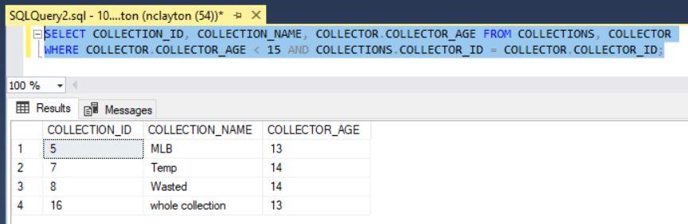

Use Case # 4: Display all catchers who are over 225lb and their team name.

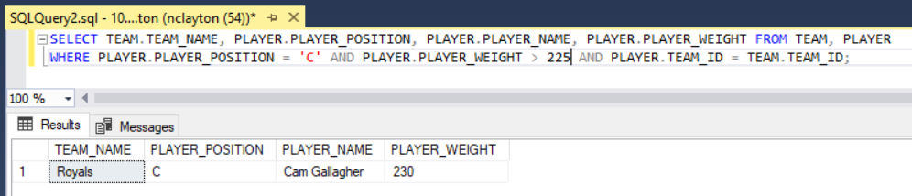

Use Case # 5: Display all cards and the collections the card belongs to of players who are 6’6 or taller.

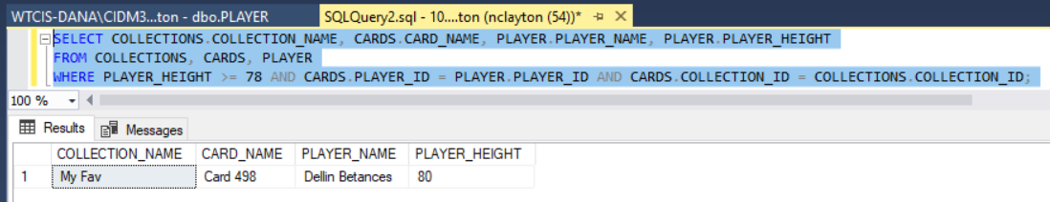

Use Case #6: Display all player’s names and positions who play for the Texas Rangers.

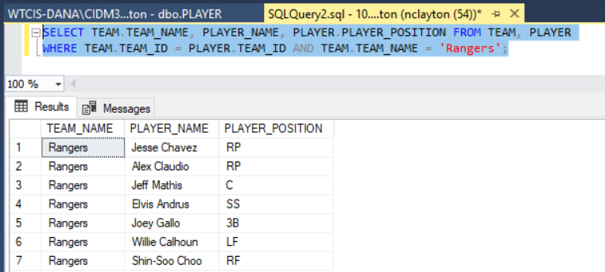

Use Case #7: Display all cards of players who are rookies.

