## Non-Functional Requirements

While the functional requirements detail the functions which the system can perform, the non-functional requirements describe characteristics of the system. These characteristics typically apply to the entire system.

### Design Constraints (DC)

DC1: This application is to be developed using MySQL, PHP, HTML, Javascript and Jquery.

DC2: It must be easy to change the value of the metric goal. A programmer should only need to change the code in one place, and all reports will be generated using the new metric goal.

DC3: When a faculty member logs into Stout, a list of the course offerings the faculty member is teaching or has taught shall be displayed in reverse chronological order by semester. If the faculty member is not assigned to teach any offerings and has never taught any offerings, the system shall state this clearly. Administrative functions shall be accessible from this Faculty View, but with less prominence.

DC4: When an administrator logs into Stout the Administrative functions shall be d.

DC5: C.O.R.E. Report shall appear similar to the following:

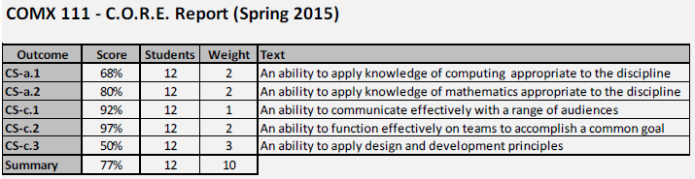

DC6: Course PC Report shall appear similar to the following:

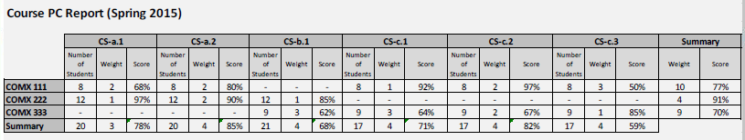

DC7: PC Semester Report shall appear similar to the following:

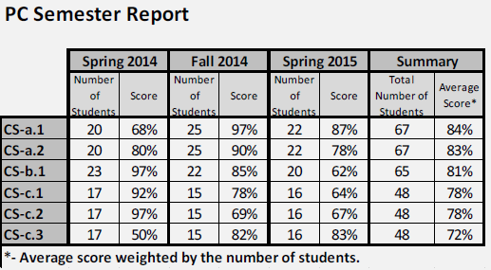

DC8: Matrix Report shall appear similar to the following:

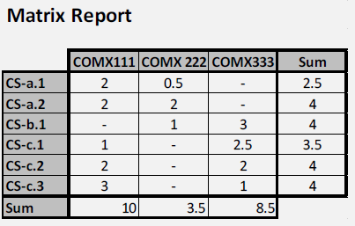

DC9: Outcome Report shall appear similar to the following:

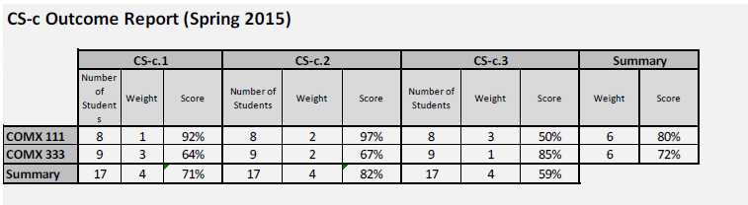

### Human Factors (HF)

No provisions related to human factors are required by this application.

### External Interface Requirements (XI)

#### Hardware (HW)

HW1: The application is accessible on any hardware connected to the Internet which supports one or more of the browsers listed below (SW1).

#### Software (SW)

SW1:The system should be able to run on all of the commonly used browsers.(Fire Fox, Chrome, Safari)

#### Communications (CM)

CM1: Connection to CAS is required.

### Security (SC)

SC1: The application shall only be accessible to MTECHs users within the Stout system.

SC2: The application shall not contain Montana Tech student numbers. It may contain student names and will contain assignment, project and/or test question scores.

SC3: Stout must comply with FERPA regulations.

### Development Environment (DV)

No provisions related to the development environment are required by this application.

### Standards (ST)

ST1: All HTML code adheres to XHTML 1.0 Strict.

ST2: All CSS code adheres to CSS level 2.1

ST3: A set of coding standards will be used so that the format and character of the code is consistent. These coding standards shall include the W3C standards (<http://www.w3.org/standards/>) for web-content development.

### Delivery Environment (DL)

#### Site (SI)

No site requirements are placed on the application.