1) No errors or warnings were present when I first opened the page.

5) I would create an object that stores the position, color, width, and other aspects of each line

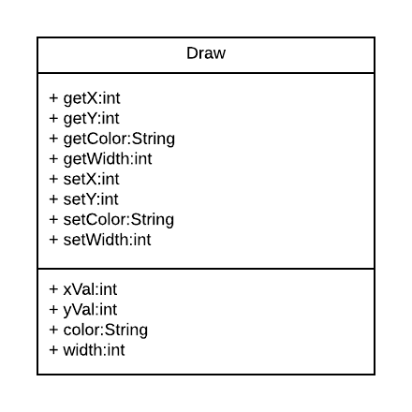

6)The redraw function could be redone to only redraw only the newest line every time. Done by only drawing the last position line in the array or object.

7) It does comply with the idea of progressive enhancement because of its layout and design. The page is designed into 3 layers, a presentation layer using CSS, a structure layer in HTML and a behavior layer using JavaScript. The layers are separable, making it possible to run the page with solely the HTML file, however doing so would limit prevent the functions and designs of the page from working properly.