Microscopic model of carbonaceous nanoporous molecular sieves – anomalous transport in molecularly confined spaces

Piotr Kowalczyk

Applied Physics, RMIT University, GPO Box 2476V, Victoria 3001, Australia

Abstract

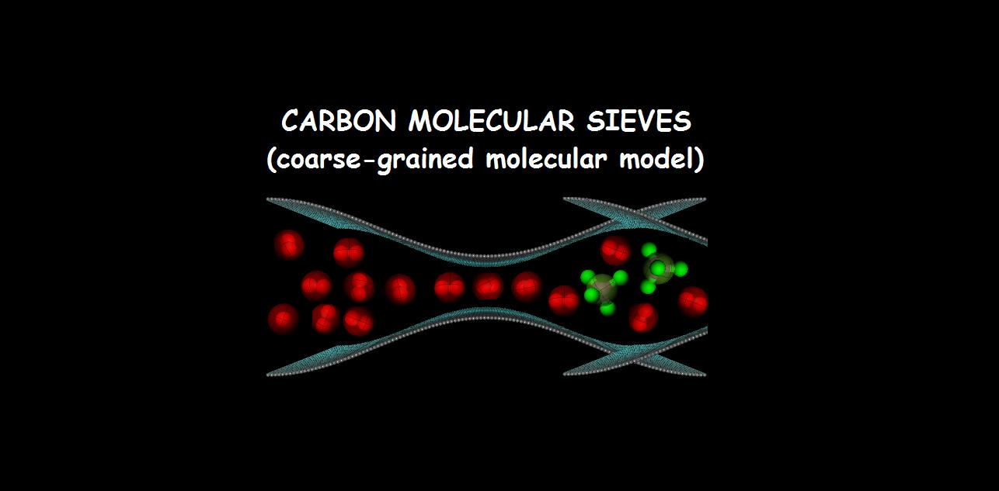
To model the equilibrium and transport properties of carbonaceous molecular sieves (CMS) the new microscopic turbostratic carbon pore model (TCPM) is developed. Analysis of experimental Gibbs excess of methane adsorption on Shirasagi CMS 3K-161 at 298 K indicates that investigated CMS is structurally heterogeneousss material (i.e., it is composed of slit-shaped and turbostratic carbon nanopores of different sizes). Predicted absolute methane isotherm, total pore volume of 0.22 cm³ g⁻¹, enthalpy of methane adsorption of 17.5-18.6 kJ mol⁻¹ on Shirasagi CMS 3K-161 at 298 K are in good agreement with existing experimental and theoretical data. Applying TCPM, we model the equilibrium and kinetic separation of hydrogen and methane mixtures adsorbed in CMS turbostratic carbon nanopores at infinite dilution and 194.7, 293.2, 313.2, 423.2, and 573.2 K. We found that near ambient temperatures one can reach equilibrium selectivity of methane over hydrogen (CH₄/H₂) of 10² in the turbostratic carbon nanopores having effective cage sizes of  Å. Lowering an operating temperature down to the dry ice one, increases the equilibrium CH₄/H₂ selectivity in these nanopores up to 10³. The kinetic selectivity of hydrogen over several investigated fluids, including: methane, argon, xenon, nitrogen, and carbon dioxide at studied operating conditions does not depend on the size of the carbon nanopore cage. This simply means that kinetic separation factor is controlled by the size of the carbon nanopore constriction. Taking this into account, we predicted the effective size of the carbon nanopore constriction of real CMS from the experimentally measured kinetic H₂/CH₄ selectivities at infinite dilution. The high kinetic H₂/CH₄ selectivity of 10²-10³ corresponds to the effective size of the carbon nanopore constriction of  2.958 Å (i.e., lower or equal to the collision diameter of hydrogen molecule). However, decreasing/increasing of the effective size of the carbon nanopore constriction by  Å exponentially increases/decreases kinetic H₂/CH₄ separation factor.

