Kinetic Monte Carlo Modelling of Pt on Au (111) in Bimetallic Catalysis
P. Zoontjens¹, G.Grochola, S.Russo, I.Snook
Applied Physics, School of Applied Sciences, RMIT University, Melbourne, Australia.

Catalytically active nanoparticles play significant roles in electrocatalysis [1]. Pt is of considerable interest as it catalyses the oxidation of methanol, which is a very promising fuel cell reaction [2]. Also, Pt is a catalyst for many other technologically important reactions [3].
It has recently been shown that Pt-decorated Au nanoparticles can act as efficient nano-catalysts for formic acid oxidation [4]. Furthermore, bimetallic PtAu nanoparticles have been shown to function as electrocatalysts for the oxygen reduction reaction [5]. Nanoparticles such as these have potential applications in fuel cells with the advantage of minimising the amount of Pt required.
In view of these results we are led to consider other Pt on Au nanostructures as possible nano catalysts. We investigate by simulation, the creation of extended Pt nanostructures on an Au surface via a physical deposition process. Extended structures maximise the surface area of the deposited Pt which is positively correlated with catalytic activity.
The low energy and low flux deposition of Pt adatoms onto an Au (111) surface, which incorporated a mono layer Au island, was studied. The Au island acts as a template for the organisation of extended structures composed of the deposited Pt atoms, which are trapped by the island edge. These structures form as a result of long time scale diffusion processes, which are impractical to simulate with Molecular Dynamics (MD). Consequently we use the Kinetic Monte Carlo (KMC) method to study the development of Pt nanostructures on Au. The ability to alter the morphology of the Pt nanostructures by varying the readily controlled parameters of temperature and deposition rate was studied.
The graphic shows Pt atoms (silver) forming a 2D nanostructure extending from the Au (gold) island edge. There are also some Pt atoms embedded in the Au island edge.
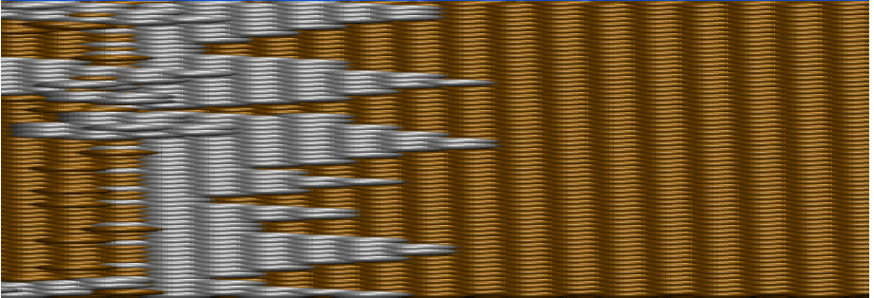

References
[1] M L Satter and P N Ross. Ultramicroscopy, 20 21, (1986).
[2] K R Williams. An Introduction to Fuel Cells, Elsevier, (1966).
[3] J M Chapuzet, A Laisa and J Lessard. Electrocatalysis, Wiley-VCH, (1998).
[4] N Kristian, Y Yan and X Wang. Chem. Comm., 353-355, (2008).
[5] P Hernandez-Fernandez, S Rojas, P Ocon, J L Gomez de la Fuente and J San Fabian.
J. Phys. Chem. C, 111(7), 2913-2923, (2007).

¹ peter.zoontjens@rmit.edu.au

