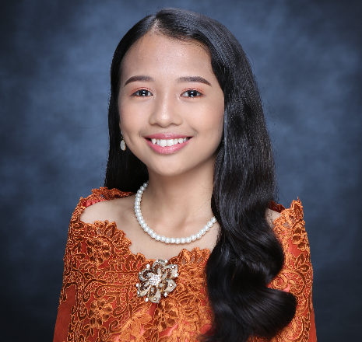**NICOLE M. PALWA**

Address: Banlasan, Tubigon, Bohol

Contact: +63909 903 9623

Email: [palwanicole@gmail.com](mailto:palwanicole@gmail.com)

**OBJECTIVE**

To contribute to an organization while gaining valuable industry experience that helps boost my skills and expertise in computer programming.

**PERSONAL INFORMATION**

Age: **20 years old**

Sex: **Female**

Birth Date: **July 21, 2002**

Civil Status: **Single**

Height: **4’11**

Weight: **38 kg.**

Religion: **Roman Catholic**

Nationality: **Filipino**

Languages/Dialect Spoken: **Cebuano, Filipino, and English**

**QUALIFICATIONS**

* Hardworking
* Competent
* Reliable
* Adaptive and Flexible
* Can work under pressure

**EDUCATION**

**Elementary** **Banlasan Elementary School**

3rd Honorable Mention

March 2014

**Junior High** **Holy Cross Academy**

GSP Awardee, and with Honor

March 2018

**Senior High** **Holy Cross Academy**

ICT – Technical Drafting

Best in Research Output, and With Honor

March 2020

**College** **Bohol Island State University- Calape Campus**

Bachelor of Science in Computer Science

2020 – Present

**EXPERIENCE**

**Work Immersion Training RHU Tubigon**

Pooc Oriental, Tubigon, Bohol

March 2020

**SEMINARS**

* **Basic Things to Know About Cybersecurity**

Zoom Meeting

July 29, 2022

* **Natural Language Processing**

BISU Calape Student Activity Center

March 27, 2023

**SKILLS**

* Oriented in C Programming
* Oriented in Java Language
* Oriented in Mobile Application
* Oriented in Web Development
* Oriented in mySQL Database

**CHARACTER REFERENCE**:

Mr. Gardson Binasbas

ICT Chairperson

09655660067

Mr. Jomari Orillosa

OJT Coordinator

09666626458

Dr. Samuel J. Gulayan

Campus Director

09209181332

**DECLARATION**

I hereby certify that the above-mentioned information is true and correct to the best of my knowledge.

NICOLE M. PALWA

Applicant