# Sea Cucumber RAD Library Prep Protocol, Part 2Macintosh HD:Users:natalielowell:Desktop:Screen Shot 2016-11-29 at 3.59.53 PM.png

## Step 4: Shear Libraries

1. Aliquot 2 uL of each library into a strip tube for checking shearing efficiency

For **high quality** DNA,

1. Set water bath and ensure stabilization at 4 C, turn on sonicator
2. Run libraries in sonicator for 3 cycles, power setting low, 30 sec on & 59 sec off
3. Invert libraries several times and spin down
4. Repeat steps 2 & 3 for a total of 9 shearing cycles
5. Set aside 2 uL of each sublibrary into the strip tube and compare on a gel with the before-sharing sample
6. If more shearing cycles are required[1], do one at a time and check each on a gel

For **low quality degraded** DNA,

1. Set water bath and ensure stabilization at 4 C, turn on sonicator
2. Run libraries in sonicator for 1-2 cycles, power setting low, 30 sec on & 59 sec off
3. Invert libraries several times and spin down
4. If more shearing cycles are required, do one at a time and check each on a gel

For **very degraded DNA**, consider not shearing.

|  |  |
| --- | --- |
| **STEP 4 - REMAINING VOLUME AFTER SHEARING** | |
|  |  |
| **Final Volume** | 156 |

## Step 5: Bead Clean-up, 1X

1. Ensure beads are at room temperature & homogenized and fresh 80% ethanol
2. Add the volume of beads from the table below to each sublibrary, and mix by pipetting carefully 10 times. If you find liquid on the wall of the tube, then spin down for only a second[2]

|  |  |
| --- | --- |
| **STEP 5 - BEAD CLEAN-UP** | |
|  |  |
| **Library Volume** | 156 |
| **1X Bead Volume** | 156 |

1. Incubate at room temperature for 5 minutes
2. Place tubes on magnetic plate for 2 minutes or until the supernatant clears
3. Aspirate and discard supernatant
4. Wash beads with 200 uL 80% ethanol, rinse by pipetting
5. Incubate for 30 seconds
6. Aspirate ethanol and discard
7. Repeat steps 6,7, & 8 for a second wash
8. Use a P10 to remove any remaining drops of ethanol
9. Air dry for ~5 minutes[3], until all ethanol has disappeared; while waiting, label clean tubes for each sublibrary
10. Add 22 uL elution buffer and mix by pipetting until beads fully resuspended
11. Incubate for 2 minutes in a regular tube rack
12. Place back on magnetic rack for 2 minutes or until supernatant clears
13. Transfer 20 uL supernatant to clean labeled tubes



## Step 6: Gel Extraction

1. Run all 20uL for each sublibrary on a gel, leaving an empty lane between each well
2. While gel is running, label a clean 1.5mL tube for each sublibrary
3. Remove plastic edges with a spatula and cut the band[4] with a sterile razor and place in tube
4. Purify with MinElute Gel Purification Kit
   1. Assume the gel slice weighs 100 mg
   2. Add 300 uL Buffer QG
   3. Warm with your hands and mix by inversion or light vortexing until gel is fully dissolved (should take about 10 minutes)
   4. Check that the color is yellow like Buffer QG[5]
   5. Add 1 gel volume (100 uL) isopropanol to the sample and mix by inversion; do not spin at this step
   6. Prepare columns and catch tubes
   7. Transfer sample to column, spin for 1 minute at max speed, & discard flow-through
   8. Add 500 uL Buffer QG, spin for 1 minute at max speed, & discard flow-through
   9. Wash with 750 uL Buffer PE, incubate for 5 minutes, then spin for 1 minute at max speed and discard flow-through
   10. Dry spin for 1 minute at max speed
   11. Place column in a clean 1.5 mL tube
   12. Elute DNA in 22 uL Elution Buffer, incubate for 1 minute, and spin for 1 minute at max speed
5. Run 2 uL on a gel to confirm right size (optional; can only have 20uL for next step)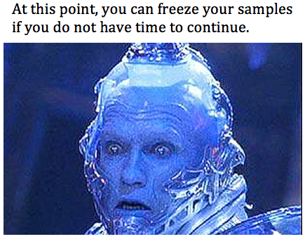



1. You want the brightest portion of the smear in the 250-500bp range for single end reads and 200-400 bp range for paired end reads
2. Do not centrifuge samples with magnetic beads unless there is obvious sample on the sides of the tube. Only spin for a second.
3. Any remaining ethanol can inhibit downstream reactions, particularly PCR. Make sure all ethanol has dried. This can take closer to 15-20 minutes.
4. For paired end, 250-550bp, and for single read 350-550bp. Range should not exceed 250-300bp!
5. If not yellow, add 10 uL 3M sodium acetate pH 5 or 1 uL mild HCl.