Logo



Color Palette URL: https://coolors.co/38707d-4a5b0b-566b1c-72a4a8-d9e0ea

* primary-color #38707D
* secondary-color #4A6B0B
* accent1-color #566B1C
* accent2-color #72A4A8
* accent3-color #D9E0EA

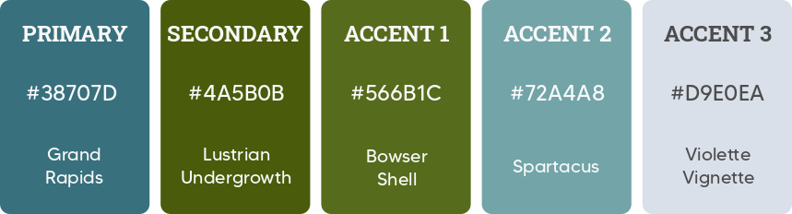

Typography

heading-font: Roboto Slab

text-font: Roboto