📱 09 · Low-Fidelity & High-Level (Hi-Fi) Interactive Prototypes
ReRouteHer — AI-Powered Skill Readiness & Career Re-entry Platform
Course / Team Code: 5120-TM07
Figma Canvas: https://www.figma.com/design/wwl5kUAg2RJF8anRURdf1n/5120-TM07
Live Interactive Prototype: https://prototype.curl.my/
GitHub Repositories: ryus0006/rerouteher-ui & ncm233/reroutehers-prototype

1. Executive Summary & Prototyping Objectives
Returning to formal employment after a prolonged caregiving career break is fraught with severe emotional and cognitive hurdles: returners frequently experience imposter syndrome, struggle to articulate their transferable capabilities, and encounter a "wall of 20+ overwhelming job requirements" on traditional job boards.
ReRouteHer addresses this gap through an empathy-led, data-backed career re-entry readiness engine. The prototyping phase followed an iterative double-diamond design lifecycle, progressing from conceptual low-fidelity (Lo-Fi) structural wireframes to a high-level, interactive high-fidelity (Hi-Fi) prototype.
2. Low-Fidelity (Lo-Fi) Prototypes & Wireframe Architecture
2.1 Design Rationale & Information Hierarchy
The initial low-fidelity wireframes established the foundational four-step sequential journey, deliberately stripping away visual embellishments to validate three core design hypotheses:
- Zero-Friction Intake: Eliminating multi-page tedious questionnaires in favor of an automated 2-step input (CV document parsing + natural language career break description).
- Reflective vs. Exploratory Separation: Separating the historical baseline (Skill Snapshot — where she is coming from) from the aspirational target (Target Role & Gap — where she wants to aim).
- Anti-Overwhelm Focus: Guaranteeing a strict maximum cap of 3 actionable focus areas, replacing demoralizing comprehensive requirement checklists.

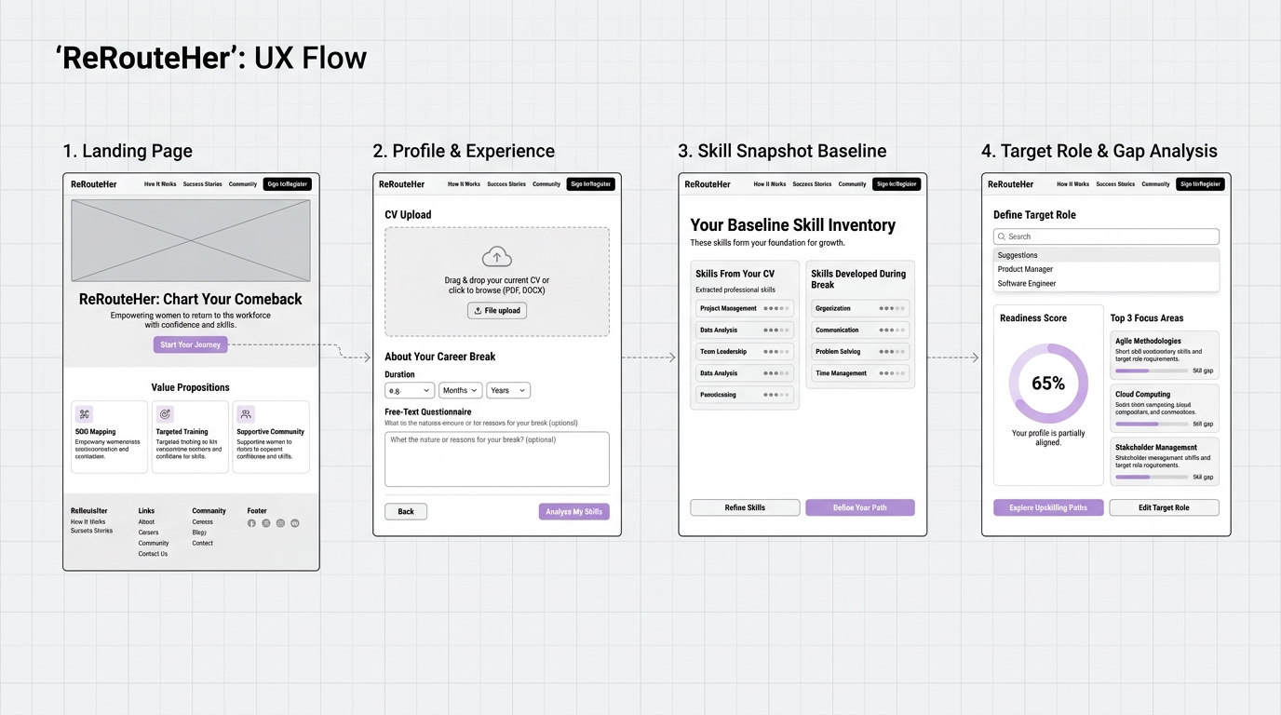
Figure 1: ReRouteHer Low-Fidelity (Lo-Fi) Wireframe Architecture Board (4-Step Sequential UX Flow)
2.2 Screen-by-Screen Lo-Fi Breakdown
Stage | Lo-Fi Screen Name | Key Functional Modules & Layout Strategy | User Experience Intent
01 | Landing Page | • Minimalist top navigation with brand mark  • Hero header with bold value proposition  • Prominent primary CTA button ('Start Your Journey')  • 3-column value cards (Break Experience, Weighted Score, Top 3 Focus) | Instills immediate confidence and sets clear expectations of zero manual friction.
02 | Profile & Experience Intake | • Drag-and-drop CV upload dropzone (PDF/DOCX)  • Duration selector (0.5 to 15 years)  • Free-text multi-line textarea with example suggestion chips | Bypasses repetitive form fields, allowing returners to express real-world experiences in their own words.
03 | Baseline Skill Snapshot | • Non-locking 'Background Baseline' header  • Two-column skill container: Extracted CV Skills vs. Reframed Break Skills  • O*NET crosswalk indicator badge | Validates both professional achievements and caregiving competencies on an equal footing.
04 | Target Role & Gap Analysis | • Interactive target role selector tabs  • Semicircular readiness gauge displaying current baseline %  • Capped Top 3 focus areas with projected readiness boost tags  • 'Explore Upskilling Paths' CTA | Replaces failure anxiety with an actionable, bite-sized growth plan.

3. High-Fidelity (Hi-Fi) Interactive Prototype
The high-fidelity prototype transforms the validated wireframes into a soothing, empowering, state-of-the-art interactive web application built with modern glassmorphism aesthetics and data-backed O*NET taxonomic mapping.

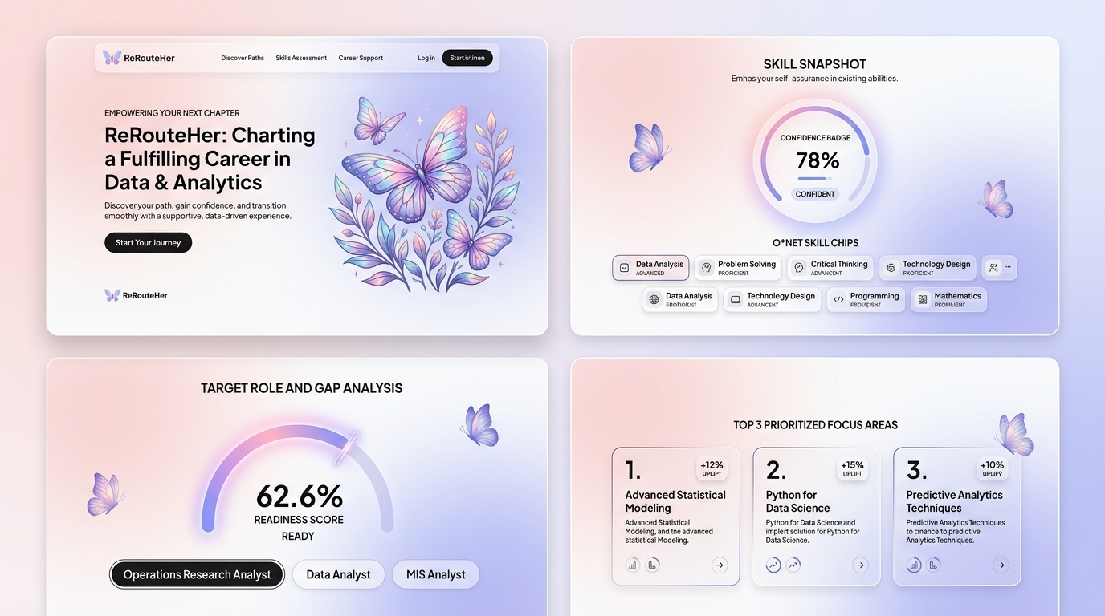
Figure 2: ReRouteHer High-Fidelity (Hi-Fi) UI Showcase (Ethereal Butterfly Theme & Glassmorphism System)
3.1 Design System & Visual Language
Token Name | Hex Code | Tailwind / CSS Var | Semantics & Psychological Function
Primary Blush Pink | #DE8BA8 | --pink-500 | Metamorphosis, empathy, primary gradient CTA button
Soft Lavender | #B4A2D4 | --violet-400 | Transmutation, cognitive calming, ethereal depth
Periwinkle Blue | #7E92CA | --blue-600 | Trust, professional stability, technical skill tags
Mint Green | #337857 | --mint-600 | O*NET validated break achievements, high confidence badge
Amber Gold | #96540D | --amber-700 | Priority focus area uplift badges (+% gain)
Midnight Ink | #262B4A | --ink | High-contrast primary typography & UI structure
Frosted Canvas | #FCF8FA | --grad-soft | Multi-stop ethereal soft gradient page background

3.2 Detailed Screen-by-Screen Hi-Fi Specifications
Screen 1 · Landing Page (E1)
- Hero Artwork: Ethereal multi-layered butterfly oil painting with radial alpha-mask gradient blending (85% opacity).
- Journey Rail: 3-step interactive visual progress stepper (Upload CV ➔ Describe Break ➔ See Fit & Top Gaps).
- Parallax Dynamics: Smooth GSAP & ScrollTrigger orbital physics and soft floating star highlights.
Screen 2 · Two-Stage Intake Flow (E2a & E2b)
- Stage 1 (CV Dropzone): Client-side validated file dropzone (.pdf/.docx, <=10MB) with sample resume fast-loaders.
- Stage 2 (Career Break NLP): Dual-input system featuring a duration slider (0.5 to 15 years) and a natural language textarea with instant suggestion chips (+Childcare, +Budgeting, +Volunteering, +Self-study).
Screen 3 · Read-Only Skill Snapshot (E3)
- Occupation Baseline Card: Displays classifier-matched role (e.g. 'Operation Research Analyst') with a 'High confidence match' mint badge, emphasizing a non-binding historical reflection.
- Two-Column Skill Inventory: Compact pill chips ('SkillChip') displaying Extracted CV Skills (with hover evidence tooltips and >12 collapse toggle) alongside Reframed Break Skills (mint green O*NET verified tags).
- Crosswalk Bridge Banner: Interactive banner detailing how natural language break inputs map directly into standard O*NET competency taxonomies.
Screen 4 · Target Role & Readiness Gap Diagnostic Engine (E4)
- Interactive Role Selector: Pill tabs enabling instantaneous switching between target roles (Operation Research Analyst, Data Analyst, MIS Analyst, UX/UI).
- 210° Arc Readiness Gauge: Animated SVG sweep gauge indicating '62.6% READY TODAY' paired with a high-visibility summary: '62.6% today → 84.3% after your focus areas'.
- Prioritized Top 3 Focus Areas: Ranked high-impact requirements (e.g. 1. Mathematics +6.7%, 2. AI Assistants +7.5%, 3. Verify AI Output +7.5%) with guaranteed role-skill vs AI-literacy balancing.
- Transparent Weighting Card: Explains why the percentage score is importance-weighted rather than a raw ratio count, building genuine trust.

4. Usability Testing & Iterative Design Refinement Log
Iteration Phase | Identified User Pain Point / Feedback | Implemented Design Solution in Hi-Fi Prototype
Lo-Fi Concept | Generic role selection felt restrictive and forced returners into boxes prematurely. | Introduced the Read-Only Skill Snapshot step as a reflective baseline before prompting role selection.
Initial Hi-Fi (v1.0) | AI literacy skills flooded the focus list, crowding out essential domain technical skills. | Engineered the pickFocusAreas algorithm: guarantees 1 AI-literacy slot and reserves remaining slots for core domain role skills.
User Feedback (v1.1) | Long CV skill lists created vertical scrolling clutter and cognitive fatigue. | Created compact pill chips ('SkillChip') with hover evidence tooltips and a 'Show all / Show fewer' collapse toggle.
Team Review (v2.0) | Perceived disconnect between raw skill count (e.g. 7 of 10) and percentage readiness (62.6%). | Added the Importance-Weighted Formula Card, clearly explaining weighting factors and O*NET skill benchmarks.

5. Deliverable Links & Interactive Prototype Access
🌐 Live Deployed Prototype URL: https://prototype.curl.my/
🎨 Figma Interactive Design Canvas: https://www.figma.com/design/wwl5kUAg2RJF8anRURdf1n/5120-TM07?node-id=0-1&t=8vvvEvjkLIAUzMhL-1
💻 Local Development & Execution Commands:
• Install dependencies: npm install
• Start development server: npm run dev (http://localhost:5173)
• Run unit test suite: npm run test:unit (26 passing tests)

