Title of the paper (Times New Roman, 12 pt, Bold, Centered)
(1 empty line)
First Author¹, Second Author² (Times New Roman, 10 point, Bold, Centered)
(1 empty line)
¹ Affiliation of author, including city, email address (Times New Roman, 9 point, Centered)
² Affiliation of author, including city, email address (Times New Roman, 9 point, Centered)
(1 empty line)
Abstract
Please follow the instruction to insure the uniformity in appearance of the papers in the Conference Proceedings.
Keywords: Three to five keywords should be typed here.
(1 empty line)
1. Introduction
Papers must be submitted no later than 20th February, 2019. The full paper must be submitted in PDF file format through the link https://easychair.org/conferences/?conf=ncmdao2
(1 empty line)
2. Typing
The manuscript must be typed on A4 sheets (length: 297mm; width: 210mm). The left and right margins should be 25mm, the top and bottom margins are 25mm and 30mm, respectively. The typing area of each page is 242x160mm.
The text should be typed in BLACK color, using Times New Roman, or, if not possible, a similar font. The use of 10-point font and single line space for main text of paper is mandatory. Type the title on the top of the first page. There is one empty line space between the title of the paper and the author(s), one empty line between the author(s) and the affiliation(s) of author(s), and one empty line space above the main headings. Do not leave empty line space between two paragraphs. Please note there is a limitation of 1500 words or 4 pages per paper.
(1 empty line)
2.1. Title
The title of the paper should be typed in Title Case with 12 point bold typeface. The title should be centered.
(1 empty line)
2.2. Author's Name
Type the author's name(s) with 10-point bold typeface and in the order of first, middle and last name. There is one empty line above and below the name(s) of the author(s). The author's name(s) should be centered. Presenter’s name should be underlined.
(1 empty line)
2.3. Affiliation
The affiliation(s) of the author(s) (including city and email address) should be typed below the list of authors. The affiliation(s) should be centered and typed with 9-point plane typeface.
(1 empty line)
2.4. Abstract
Do not have references or displayed equations in the abstract. There is one empty line between the abstract and the affiliation(s) of author(s).
(1 empty line)
2.5. Keywords
Keywords are necessary. Try to keep the number of keywords within five. There is one empty line below the keywords.
(1 empty line)
2.6. Heading
The main headings (starting from Introduction) should be numbered as 1., 2., 3., and typed in Title Case with 10-point bold typeface and start from left end of the line. A main heading should have one line space above it. The secondary headings, if necessary, should be typed in Title Case with 10 point normal typeface. The secondary headings should be numbered as 1.1, 1.2, 1.3. There is one line space above the secondary heading but no space below it.
(1 empty line)
2.7. Equations
Equations must be consecutively numbered. Refer to equations in the text as Eq.(1), Eq.(2). All equations should be centered. Displayed equations should be numbered simply as (1), (2), (3). The numbers should appear at the extreme right of the line in parentheses.
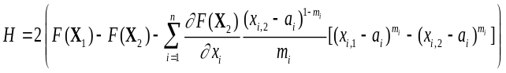 (1)
(1 empty line)
2.8. Tables and Figures
Tables and figures should be consecutively numbered. Place table caption above the table and figure caption below the figure. Table and figure captions should be centered. Allow one line space between the table and its caption and between the figure and its caption. Allow one line of space between the table or figure and the adjacent text.

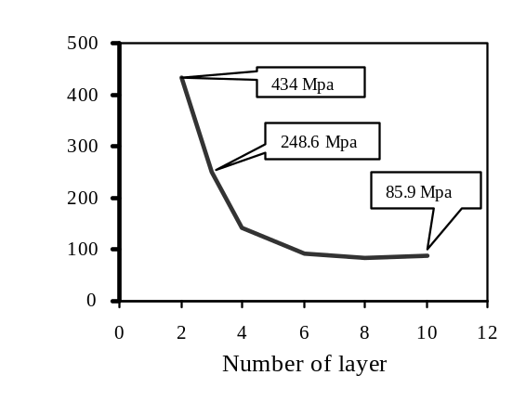

Figure 1: Circumferential stress

Table 1: Material properties

T / mm |  | Fraction | E1 / MPA | E2 / MPA | G12 / MPA
10 | -0.3038 | 0.1458 | 7087.03 | 103.81 | 41.3
20 | -0.9977 | 0.2848 | 14462.00 | 645.08 | 275.96
30 | -2.4270 | 0.2848 | 22456.00 | 1905.70 | 934.38
40 | -5.1850 | 0.5696 | 31842.00 | 3955.00 | 2306.10

3. Acknowledgements

4. References
References should be listed at the end of the paper and consecutively numbered. Refer to references in the text with reference number in brackets as [1]. Style the reference list according to the following examples.

[1] S. Missoum, P. Ramu and R.T. Haftka, A convex hull approach for the reliability-based design optimization of nonlinear transient dynamic problems, Computer methods in applied mechanics and engineering, 196 (29), 2895-2906, 2007.
[2] G.K. Ananthasuresh, K.J. Vinoy, S. Gopalakrishnan, K.N. Bhat and V.K. Aatre, Micro and Smart Systems, Wiley, New York, 2012.
[3] R. Ruben, J. Folgado and P.R. Fernandes, A Three-Dimensional Model for Shape Optimization of Hip Prostheses Using a Multi-Criteria Formulation, 6th World Congress on Structural and Multidisciplinary Optimization, J. Herskovits, S. Mazorche, A. Canelas (Eds.), ISSMO, Rio de Janeiro, Brazil, 2005 (ISBN: 85–285–0070–5).

