# Title (Arial, Bold, 14 pt, centered)

[1]Author’s Name and Surname1, Author’s Name and Surname2 (Arial, 11 pt, centered)

1Affiliation, E-mail (Arial, 10 pt, centered)

2Affiliation, E-mail

Abstract

The abstract should be written with 11 font size, Arial, and single line spacing.

**Keywords:** *This section should contain a maximum of 5 words written with Arial, and Italic separated by commas.*

Introduction/Background (Arial, Bold, 11 pt)

Please explain clearly the purpose of your study here. It should contain more than two lines. Page format should be A4 page size with margins 2,5 cm wide from the top, and 2 cm wide from the right left, and bottom. Pages should not be numbered. **The manuscript should not exceed 2 pages for Short paper submission (Posters) and 8 pages for Long papers**.

Submitted manuscripts must not have been published anywhere before and should not be entered into the evaluation process for publication elsewhere. The scientific responsibility of the manuscript belongs to the author(s).

Materials and Methods (Design/methodology/approach)

It should contain information about the materials and the methods adopted to carry out the research work.

Results and Discussion (Findings)

Summarize in this section the objective, method, and findings in an understandable way. Also, the method which you used for your study should be compared with the other methods (if they exist).

Conclusion

This should state clearly the main conclusions of the research and give a clear explanation of their importance and relevance.

Figures and Tables

It is essential that all illustrations are as clear and as legible as possible. Figures are to be numbered and to have a caption which should always be positioned under the figures, in contrast to the caption belonging to a table, which should always appear above the table. Captions are set in 9-point type.

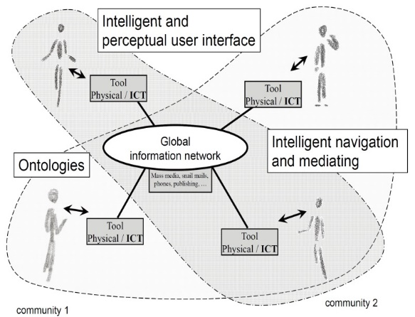

**Fig. 1.** Artifacts empowered by Artificial Intelligence (Source: LNCS 5640, p. 115)

References

References should be arranged alphabetically at the end of the paper. The author-year notation system is required; do not use numbered notation. For detailed information, you can check APA 6 Style guide.

1. Corresponding Author (should be signed with star).