Built-in Types of Data
100 – What are the 4 built-in data types in Python?
string, float, integer, and boolean.
200 – Upon executing the following Python program, review1.py...
import stdio
import sys
n = sys.argv[1]
stdio.writeln(n)
Which class of error will be thrown if no command line arguments are passed?
run-time error.
300 – DAILY DOUBLE
What type of type conversion is demonstrated in the Python program review2.py? What is the type of the expression in stdio.writeln() once the program has finished executing?
Explicit type conversion, float.
400 – What is the value of result after the following Python program is executed?
import stdio
result = 10 // 4
stdio.writeln(result)
2
500 – What is the value of x after the following Python program is executed?
import stdio
result = 5 * (2 + 3) % 3
stdio.writeln(result)
1
Conditionals
100 – What is the value of expression after the following Python program is executed?
import stdio
expression = True and not False
stdio.writeln(expression)
True.
200 – This term describes Python’s behavior of stopping evaluation in an if-elif-else chain once a true condition is found, avoiding further checks.
Short Circuiting.
300 – What is the value of expression after the following Python program is executed?
import random
import stdio
expression = (random.randrange(0,1) == 1)
stdio.writeln(expression)
False.
400 – Given the following Python program, what is number?
import stdio
number = 1854
if number % 2 == 0:
stdio.writeln("number is something")
else:
stdio.writeln("number is something else")
number is even (divisible by 2).
500 – What is the value of expressionValue after the following Python program executes?
import stdio
import math
expressionValue = not(5 >= 5 + 3) and 3.14 == math.pi
stdio.writeln(expressionValue)
False.
Loops
100 – The shorthand version of the following programming statement in Python...
i = i * 1
i *= 1
5`5r5`r
for loop
300 – What type of expression does a while loop expect in Python?
Boolean expression.
400 – DAILY DOUBLE
What does the following Python program do? What is the value of value when the program is finished executing?
import stdio
array = [1, 2, 3, 4, 5, 6, 7, 8]
numberSum

=

0

F
O
R

N
U
M
B
E
R

I
N

A
R
R
A
Y
:

N
U
M
B
E
R
S
U
M

+
=

N
U
M
B
E
R

V
A
L
U
E

=

N
U
M
B
E
R
S
U
M

/

L
E
N
(
A
R
R
A
Y
)

S
T
D
I
O
.
W
R
I
T
E
L
N
(
V
A
L
U
E
)

C
A
L
C
U
L
A
T
E
S

T
H
E

A
V
E
R
A
G
E

V
A
L
U
E

O
F

T
H
E

A
R
R
A
Y

A
,

4
.
5
.

5
0
0

–

W
H
A
T

I
S

T
H
E

V
A
L
U
E

O
F

E
X
P
R
E
S
S
I
O
N
V
A
L
U
E

A
F
T
E
R

T
H
E

F
O
L
L

O
W
I
N
G
Python program executes?
import stdio
import math
expressionValue = not(5 >= 5 + 3) and 3.14 == math.pi
stdio.writeln(expressionValue)
False.
Arrays
100 – Python's built-in implementation of the array data structure.
list
200 – If a and b are both list types, what is the following called?
a = b[:]
Array copying or array splicing.
300 – If a and b are both list types, what is the following called?
a = b
Array aliasing.
400 – What is the value of x after the following Python program is executed?
import stdio
a = [8, 9, 10]
x = a[-1]
stdio.writeln(x)
10
500 – What does the following Python program do? What is the value of C after execution?
import stdio
A = [[1, 0], [0, 1]]
B = [[0, 1], [1, 0]]
C = [[0, 0], [0, 0]]
for i in range(len(A)):
for j in range(len(B[-1])):
C[i][j] = A[i][j] + B[i][j]
stdio.writeln(C)
Adds two matrices together and C = [[1,1], [1,1]]
Tie It All Together
100 –
2^10 = 1000, 2^20 = 1000000 what is 2^30 approximately?
200 - Binary Numbers
The binary representation of 13 i.e., executing python binary.py 13 (what is the output)?
1101
……..
300 –
What is the dot product (defined below) of u and v?
import stdio
u = [0, 1]
v = [1,0]55t5t5t5t5t5t5tdotProduct = 0
for x in range(len(u)):
dotProduct += u[x] * v[x]
stdio.writeln(dotProduct)
400 –
The current price for a single Bitcoin is 67976.76!
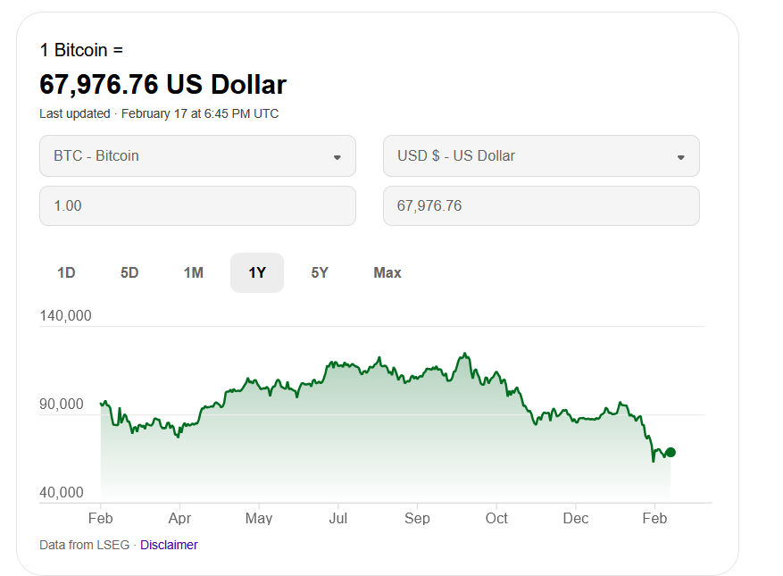
Consider the following Python program, bitcoin.py...
import sys
import stdio
THRESHOLD = 50000
SELL = 120000
bitcoinPrice = float(sys.argv[1])
message = ""
if bitcoinPrice < THRESHOLD:
message = "BUY"
elif bitcoinPrice == THRESHOLD:
message = "HOLD"
else: # greater than.
if bitcoinPrice >= SELL:
message = "SELL"
else:
message = "HODL"
stdio.writeln(message)
What is the value of message after bitcoin.py is executed? i.e., I type
python bitcoin.py 67976.76
into the command line.
500 –
What is the value of deckLength after the following Python program has been executed?
import stdio
colors = ["red", "yellow", "green", "blue"]
numbers = ["1", "2", "3", "4", "5", "6", "7", "8", "9"]
actionCards = ["skip", "reverse", "draw two"]
deck = []
# Add one 0 per color
for color in colors:
deck.append("0 of " + color)
# Add two of each 1–9 per color
for color in colors:
for number in numbers:
deck.append(number + " of " + color)
deck.append(number + " of " + color)
# Add two of each action card per color
for color in colors:
for action in actionCards:
deck.append(action + " of " + color)
deck.append(action + " of " + color)
# Add wild cards (no color)
for i in range(4):
deck.append("wild")
deck.append("wild draw four")
# Print the length of the deck
deckLength = len(deck)
stdio.writeln(deckLength)
108

https://jeopardylabs.com/play/csci-151-midterm-exam-1-review-jeopardy

