CSCI 151 – Interdisciplinary Computer Science I, Lab 1
- Continuously Compounded Interest
Write a Python program that computes the value of an investment with continuously compounded interest.
Your program should take three command-line arguments:
- P – the initial principal (a float)
- r – the annual interest rate as a decimal (e.g., 0.05 for 5%)
- t – the number of years the money is invested (a float)
The final amount is given by the formula:
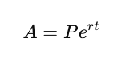
The program should print the resulting value using Python’s default floating-point representation.
Example usage:
python interest.py 1000 0.05 10
Example output:
1648.7212707001282

- Gaussian Random Numbers
Write a Python program that generates and prints a single standard Gaussian random number using the Box–Muller formula:
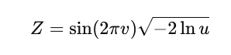
where u and v are independent real numbers uniformly distributed between 0 and 1.
Your program should:
- Use random.random() to generate u and v
- Compute Z using the formula above
- Print the resulting value using Python’s default floating-point representation
Example usage:
python gaussian.py
Example output:
-0.473812654109
(Note: Your output will differ each time the program is run.)

- Mercator Projection
The Mercator projection is a conformal (angle-preserving) map projection that maps latitude φ and longitude λ to rectangular coordinates ( (x, y) ).
The projection is defined by the equations:
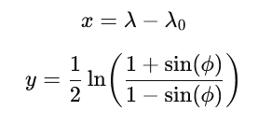
where λ0 is the longitude of the point at the center of the map.
Write a Python program that takes three command-line arguments:
- λ0 – longitude of the map center
- φ – latitude of the point
- λ – longitude of the point
All values are real numbers.
Your program should compute the projected coordinates (x, y) and print them using Python’s default floating-point representation, separated by a space.
Hint: The trigonometric functions in Python expect angles in radians. The input values are given in degrees.
Example usage:
python mercator.py -75.0 40.0 -73.5
Example output:
1.5 0.7629096520666107

- Color Conversion (RGB → CMYK)
Several different formats are used to represent color. The RGB format specifies the level of red (R), green (G), and blue (B) as integers between 0 and 255. The CMYK format specifies the level of cyan (C), magenta (M), yellow (Y), and black (K) as real numbers between 0.0 and 1.0.
Write a Python program that converts RGB values to CMYK.
Your program should take three command-line arguments:
- r – red component (integer, 0–255)
- g – green component (integer, 0–255)
- b – blue component (integer, 0–255)
If r = g = b = 0, then:
- c = 0.0
- m = 0.0
- y = 0.0
- k = 1.0
Otherwise, compute the CMYK values using the formulas:
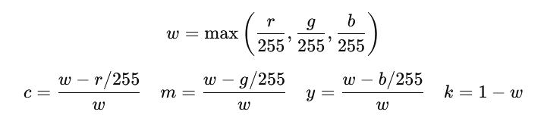
Print the CMYK values using Python’s default floating-point representation, one per line, in the following format:
cyan = <value>
magenta = <value>
yellow = <value>
black = <value>

Example usage:
python rgbtocmyk.py 75 0 130
Example output:
cyan = 0.4230769230769229
magenta = 1.0
yellow = 0.0
black = 0.4901960784313726

