Project status report

Niall Collins

Student Number: A00144538

Mobile: 0852733270

# All workings to date

Everything that is done to date from software to write-ups can be found on the GitHub repository at;

<https://github.com/ncollins89/Msc_AppProject>

# Android Studio Installation

The Android studio I downloaded on my AMD processor machine can be found at the link below;

<https://developer.android.com/studio/archive.html>

when you access this page you click on;

* show stable only

scroll down to;

* Android Studio 3.0.1

And then click on;

* the .exe link if it’s a standard 64bit machine or scroll down further to get the zip file for the 32bit machine

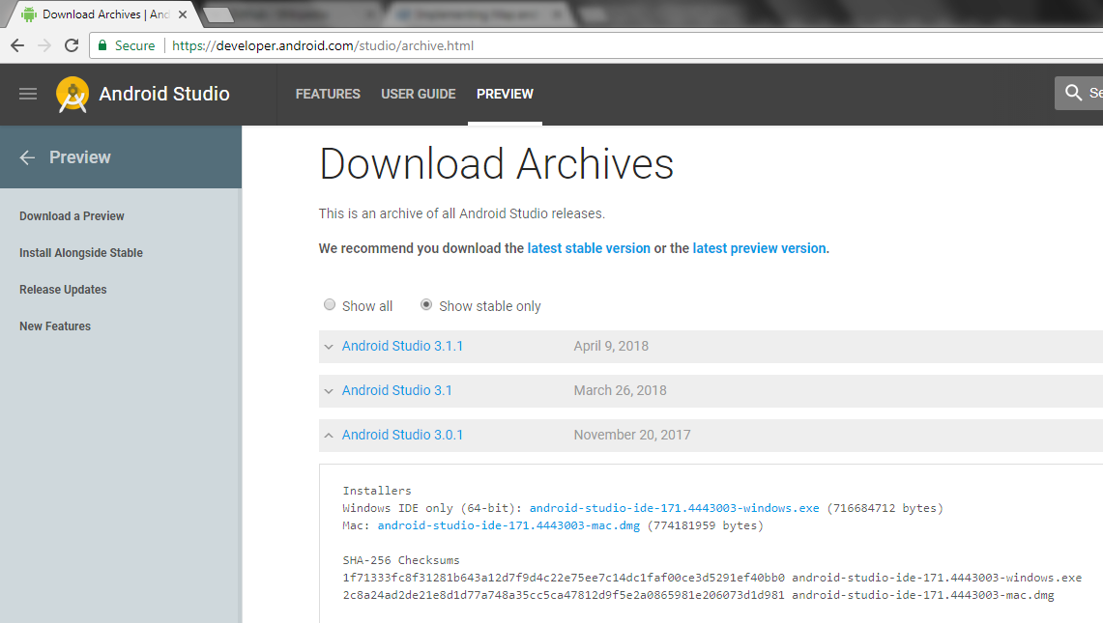

# Android Studio Working Enviroment

Up to this point the implimentation and testing of the working enviroment is slower then expected and slightly behind schedule, as mentioned above the machine been used to write the code on is an AMD processor machine whereas the default for android studio is Intel even when an emulator is set up to be used on an AMD machine what is actually does is it takes that code into the emulator and tries to migrate it back to Intel HAXM which is where then the emulator is timing itself out or restarting, I have over the past number of weeks tried to problem solve this by changing settings, downloading external emulators such as GenyMotion and Visual studio emulators for Android but these also gave me no joy even when I did create new project “Hello World”, but after some digging I found settings that made the emulator show some signs of working beyond the blank screen I was previously getting but this also has reached a dead end as it was taking far too long to load the code onto the emulator which either made it timeout or start loading again(screenshots below). Going forward from here it will be my intentions to borrow and use an Intel machine as I feel I can not waste any more time on the emulator.

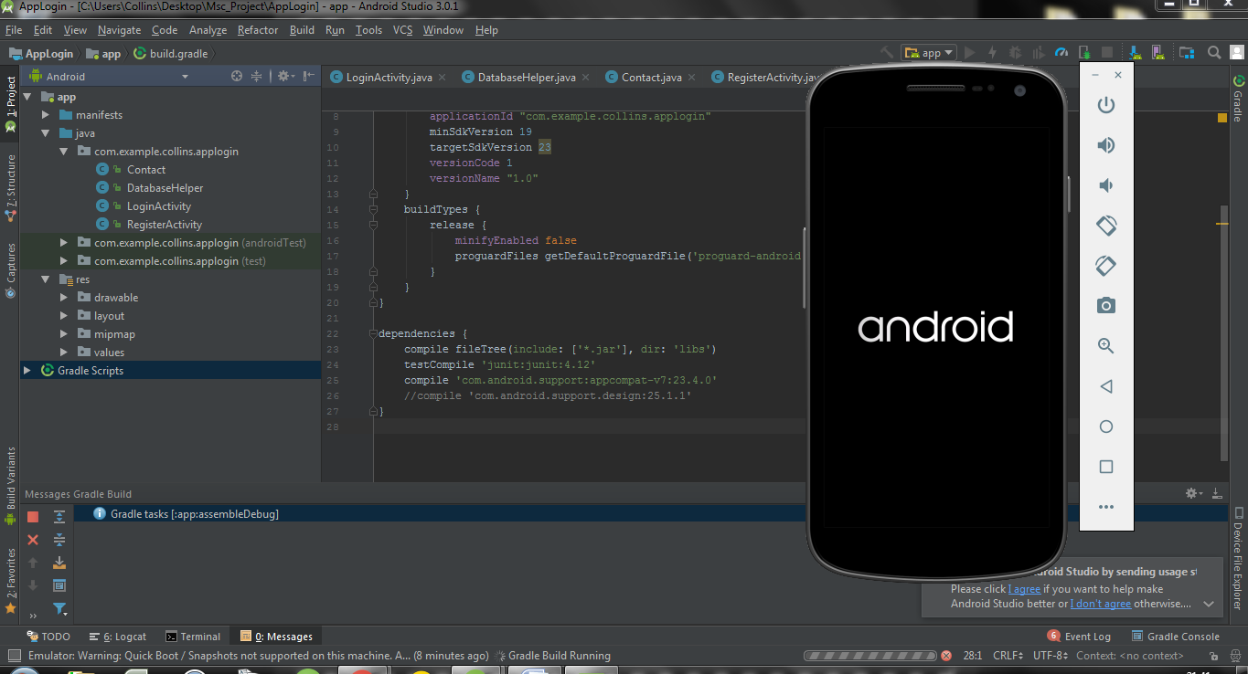

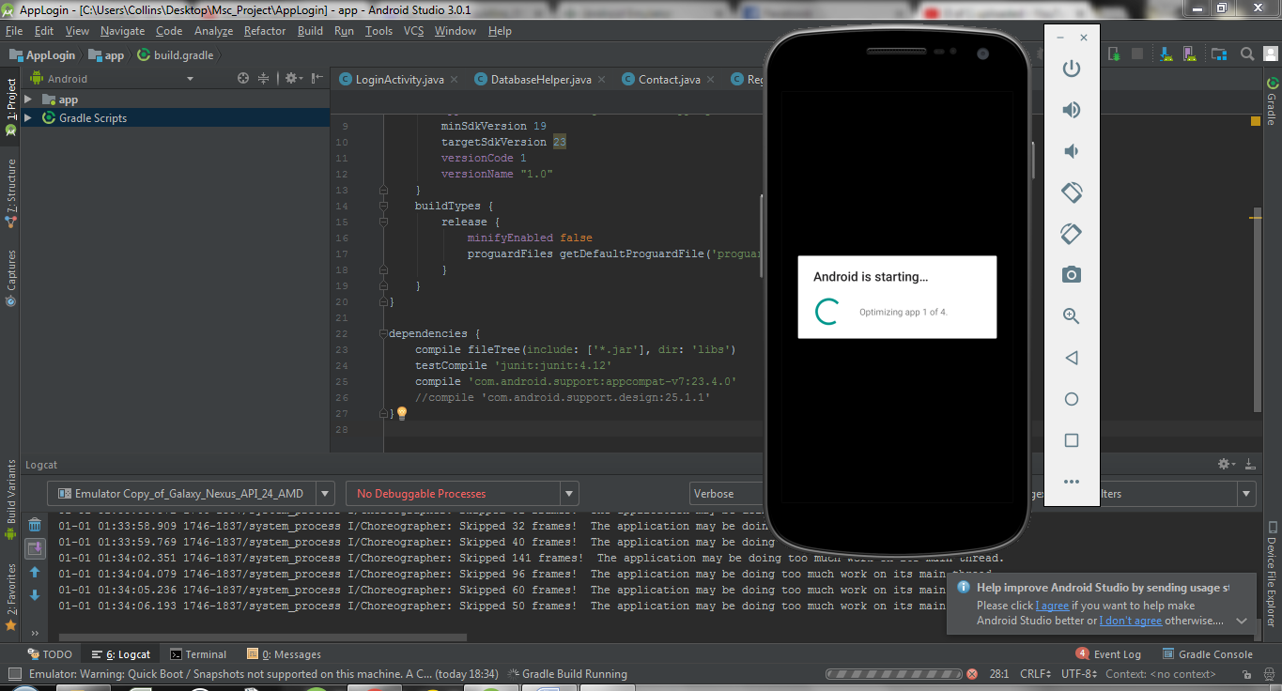

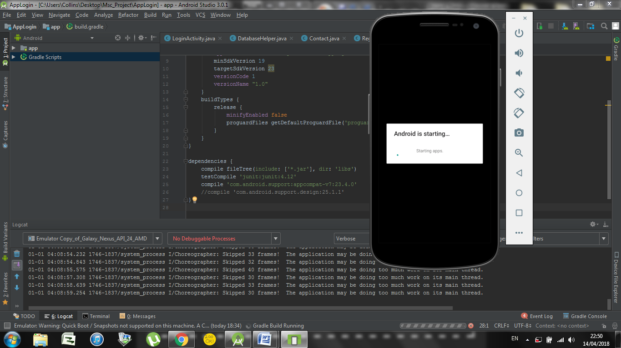

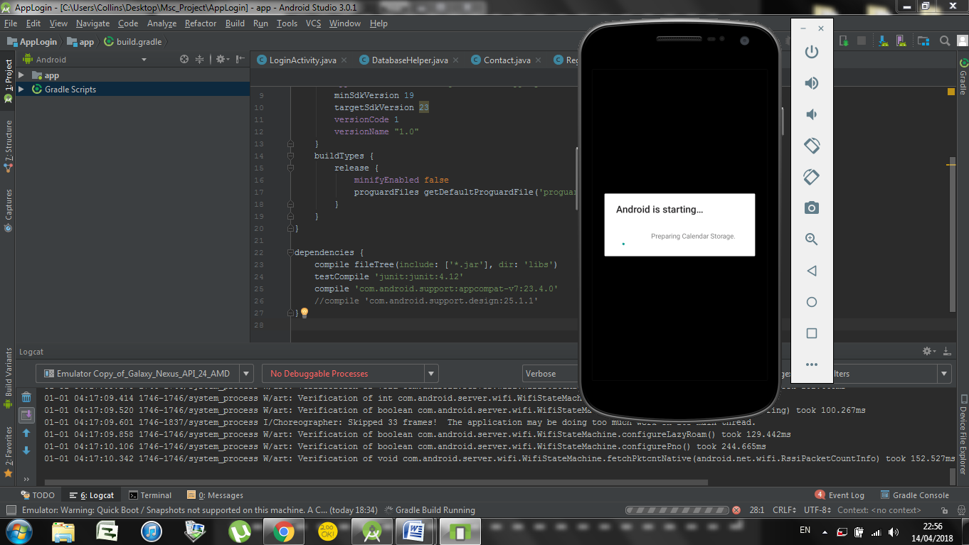

It was then after this point it would go back and load from the start again just displaying “Android” across the screen.

# Write-up

This left it to where only the writeup could be started and worked on a good bit so that time wasn’t fully wasted most of the chapters have been touched on with just some extra content to be added as the time draws near, chapters that have not yet been started are the ones waiting on code examples and testing from the software itself, all of this can be seen in the documents attached.