# IBM Engagement Guide for IBM Tririga Customers

## 

## Client Information – <CUSTOMERNAME>

|  |  |
| --- | --- |
| Support Item | Value |
| Passport Advantage Contract Number / Site | Agreement –  Site Number –  Program Type – Passport Advantage |
| IBM Customer Number |  |
| IBM Support phone number | 800-426-7378 |
| Customer location |  |
| Primary Contact who can download IBM software | |  | | --- | | Name: | | e-mail: | | Phone: | |
| Site Technical Contact who can approve new authorized users to access IBM’s technical support system | |  |  | | --- | --- | | Name: |  | | e-mail: |  | | Phone: |  | |

## Your IBM account team

|  |  |  |  |
| --- | --- | --- | --- |
| **Role** | **Name** | **Email** | **Phone** |
| **Brand Sales Specialist** |  |  |  |
| **Brand Technical Sales Specialist** |  |  |  |
| **Brand Technical Sales Specialist Manager** |  |  |  |
| **Customer Success Manager** |  |  |  |
| **Technical Account Manager** |  |  |  |
| **Business Partner** |  |  |  |

## Opening a Support Case

* The **quickest** way to contact IBM technical support is by opening a Case through the IBM Support Community website <https://www.ibm.com/mysupport/>) online. Please see the FAQs on [how to get started with support](https://www.ibm.com/mysupport/s/article/Getting-Started-Guide?language=en_US).
* This requires an IBMid and password which you can create [here](http://www-01.ibm.com/support/docview.wss?uid=swg21414792) .
* [How to Open a Case](https://www.ibm.com/mysupport/s/article/How-to-open-a-case) (<https://www.ibm.com/mysupport/s/article/How-to-open-a-case>) will guide you on the options of opening cases.
* Contact IBM support through the Support number 800-426-7378

All that is needed to open a Case is the IBM Customer Number (from above)

## Case Severity and response goals

The following table indicates how to determine the severity and response times:

|  |  |  |  |
| --- | --- | --- | --- |
| **Severity** | **Business Impact** | **Detailed description** | **Response Time** |
| 1 | Critical | **System or Service Down** Business critical functionality is inoperable or a critical interface has failed. This usually applies to a production environment and indicates an inability to access products or services resulting in a critical impact on operations. This condition requires an immediate solution. **Note:** We will work with you **24 hours a day, seven days a week** to resolve Severity 1 problems provided you have a technical resource available to work during those hours. You must reasonably assist IBM with any problem diagnosis and resolution.  For IBM Cloud services, you must log a Service Down case within 24 hours of first becoming aware that there is a critical business impact and the Cloud service is not available. | 2 hours |
| 2 | Significant | A product, service, business feature, or function of the product or service is severely restricted in its use, or you are in jeopardy of missing business deadlines. | 2 hours |
| 3 | Some | The product, service or functionality is usable and the issue does not represent a significant impact on operations. | 2 hours |
| 4 | Minimal | An inquiry or non-technical request. | 2 hours |

## Official 5-Step case escalation procedure

*Here is a link to the latest version of* *[IBM Support Guide](https://www.ibm.com/support/pages/node/733923), https://www.ibm.com/support/pages/node/733923 (see paragraph “Escalate a case”)*

We believe IBM Support is "Best of Breed." If at any point in our service process, you feel we are not meeting our commitments to you, as outlined in this IBM Support Guide, you may call our attention to this problem by doing one or all of the following:

1. Be certain to explain the business impact of your problem to the service representative
2. Raise the Severity Level of the problem
3. Ask to speak to the person's manager - Escalations to an IBM manager will receive prompt attention and management focus.  If needed, you can find contact numbers for your geographic area in the [IBM Directory of worldwide contacts](http://www.ibm.com/planetwide/) (https://www.ibm.com/planetwide/).
4. Ask for a **"Duty Manager"** - The Duty Manager or field manager will work with our technical staff to ensure your request is being handled appropriately.
5. After allowing the Duty Manager time to make an impact, if further escalation is required then open a Complaint or nominate as a Critical Situation ("CritSit"), if warranted, by asking any member of your IBM Client team to do so on your behalf.
6. **Appendix**
   1. **Additional useful resources**

|  |  |  |
| --- | --- | --- |
| Request for Enhancement Community | Here you can collaborate with development teams and other product users through your ability to search, view, comment on, vote for, watch, submit, and track product requests for enhancement (RFEs) for IBM Maximo products in the Internet of Things brand. | [IBM Developerworks Request for Enhancement Community](https://www.ibm.com/developerworks/rfe/%20) |
| Software Compatibility reports | The Software Product Compatibility Reports is an innovative new tool designed to allow you to easily generate custom reports about compatible IBM software combinations. Using this tool, you may create reports about a product's compatibility with operating systems, prerequisite software or virtualization environments. Lastly, you may use these reports to tailor-make graphical reports about a set of products' end-of-service dates. | [IBM Software Product Compatibility Reports](https://www.ibm.com/software/reports/compatibility/clarity/index.html%20) |
| Support Handbook | More details about the support process and how to effectively work with the IBM support model. | [IBM Support Guide](https://www.ibm.com/support/pages/node/733923) |
| Getting Started with your IBM Software Purchase | How to access your Passport Advantage account for software downloads, how to access your IBM Rational software license keys, definition of terms, and important links. | [Getting Started with Your IBM Software Purchase](https://www.ibm.com/support/pages/sites/default/files/inline-files/$FILE/GettingStartedEnglish_0.pdf) |
| IBM Knowledge Center and Libraries | Master list of all IBM Products. Search by your product name to find documentation, how-to guides, online help, and product support. | [IBM Knowledge Center](https://www.ibm.com/support/knowledgecenter/products/#software) |
| IFIX schedule and plans | Find all generally available fixes at [Fix Central](https://www-945.ibm.com/support/fixcentral/) | <https://www.ibm.com/support/fixcentral/> |
| Subscribe to Notifications | Subscribe to notifications on IBM products: security bulletins, flashes, news, downloads, fixes, troubleshooting, product publications, and Webcasts. | [Notifications Portal](https://www-945.ibm.com/systems/support/myview/subscription/css.wss/#/) |
| TRIRIGA Specific Support Resources | The IBM TRIRIGA Information and Support Resources page is a collection of links and other resources that provides information and assistance for IBM TRIRIGA products. | [TRIRIGA Information and Support Resources](https://www.ibm.com/support/pages/ibm-tririga-information-and-support-resources) |

* 1. **Self-Enablement Resources**

The following lists a variety of ancillary sources of information for to enable the “self learner”

|  |  |  |
| --- | --- | --- |
| YouTube | Walkthroughs for Common Demos and TRIRIGA features | [TRIRIGA Online Demos](https://www.youtube.com/channel/UC3jTZSxxEixcP3JOs3Ofv4A/featured) |
| IoT TRIRIGA Community | Join the Internet of Things TRIRIGA Community for Groups, Discussions, and Blogs, information on product support updates, product releases, and IBM supported events. | [IoT TRIRIGA Community](https://community.ibm.com/community/user/iot/communities/tririga-home) |
| Other portals that offers information on IBM products and documentation | * IBM Demo (Product demos) * IBM Training and Skills Solutions (Training and certification) * Knowledge Center (Product documentation) * IBM Cloud (Cloud product documentation) * IBM Developer (Developer focused portal) * IBM Redbooks (Solutions and how-tos) | * [IBM Product Demos](https://www.ibm.com/demos/) * [IBM Training and Skills Gateway](https://www.ibm.com/training) * [IBM Knowledge Center and Product Documentation](https://www.ibm.com/docs/en/tap) * [IBM Cloud Documentation](https://cloud.ibm.com/docs) * [IBM Developer Portal](https://developer.ibm.com/) * [IBM Redbooks Solutions & How-tos](http://www.redbooks.ibm.com/) |

* 1. **IBM Support Community: Requesting access and managing authorized support contacts**

**Support Community Videos**:

You will find a video course that has short videos on the following topics

- Create an IBM ID  
- Requesting access to your company's IBM Support account  
- Administrators: Managing your IBM Customer Number (ICN)  
- Introducing the IBM Support Community: Open and manage cases  
- Introducing the IBM Support Community: Search  
- Introducing the IBM Support Community: Forums

On: <https://www.onlinedigitallearning.com/course/view.php?id=4720>

As we transition to the new IBM Support Community at https://www.ibm.com/mysupport you might have questions about the different capabilities available to users in the community and how their access to those capabilities can be managed.

The good news is that your own organization can manage your users and their level of access using self-service capabilities built right in to the community.

**User role capability matrix**

* 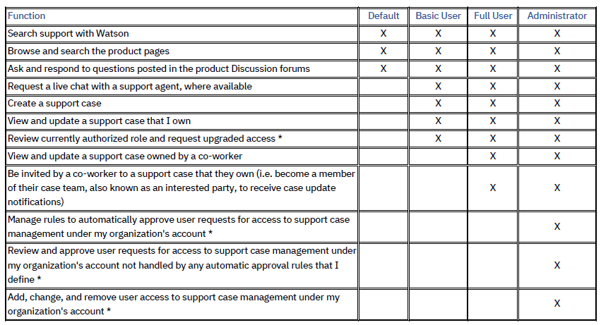

* These functions are accessible within the IBM Support Community from the User administration option under the user's profile menu.

**Default role**

Without requesting or being assigned a role by an authorized Administrator any user who signs in to the IBM Support Community will automatically be assigned the Default role.

**Other roles**

Authorization to the Basic User, Full User, or Administrator role for your organization’s support agreements with IBM is managed by your Site Technical Contact (STC) and any Secondary Site Technical Contacts (SSTC) that your STC has authorized. Your STC and SSTCs have the Administrator role.

There are two routes to becoming authorized to the Basic User, Full User, or Administrator role:

* Request access through self-nomination
  + - Your request will often be immediately approved by a rule that the Administrators have defined, especially if you are requesting Basic User access.
    - If your request is not automatically approved the Administrators will be notified by email that there is a user request for access to support pending their review and approval.
* Being manually added to the list of authorized support contacts by an Administrator, or having an existing role changed by an Administrator.

**Request access through self-nomination**

When you sign in to the IBM Support Community for the first time and have not been pre-assigned a level of access by one of your account’s Administrators you will be given Default access and prompted to register a product or service. For many of the products or services that you can select you will then be prompted for your site’s IBM Customer Number (ICN) and the country where it is registered. Your co-workers who already have access, or your IT or project staff, can provide this information. When you add the selected product or service a request for Basic User access will be submitted. If your sign in matches a rule that your account’s Administrators have defined your Basic User access will be activated immediately – if not, they will be notified that your request is pending their review and approval.



To request access to another account, or to request a higher level of access to an existing account, sign in to the IBM Support Community and select the

User administration option under your profile menu. Your profile menu is accessed by clicking the user icon next to the Marketplace button in the upper right corner of each page (*see right*).

If you want to request access to another account you will need the IBM Customer Number (ICN) and country for that site. Again, your co-workers who already have access, or your IT or project staff, can provide this information.

To request a higher level of access for an account, scroll down the User administration window until you see your existing approved access. There will be hyperlink next to each entry to quickly request the next level of access for that account.

Once approved – either automatically by a rule, or manually after review by one of the account’s Administrators – your new role will take immediate effect in the IBM Support Community. If you don’t see the expected capabilities, please clear your web browser’s cache (the keyboard shortcut is usually Ctrl+F5) and try again. If you still don’t see the expected capabilities then please contact the community support team by using the Get help – report an issue with this website link found near the bottom of each page in the community.

**Administrator access**

If you are an Administrator, you can also access the User administration option under your profile menu when signed in to the IBM Support Community. You will have full access to the capabilities of this function, including:

• Review all your existing authorized support contacts, change their role, or remove their access.

• Add a new support contact and grant them a role (you need to know their IBMid, usually their email address).

• Maintain rules to automatically approve self-nomination requests from users with an email address in a specific internet domain.

• Review pending requests not automatically approved and decide whether to grant or reject the user’s request.