GitHub Assignment: Create a GitHub repository for Solve Project 7

**Assignment Description:** Now that you understand how to use GitHub, create a repository for Solve Project 7. The repository should include your file for Solve Project 7. The file will be under the master branch.

1. your GitHub account name: nconnol1

2) a screenshot of your GitHub repository

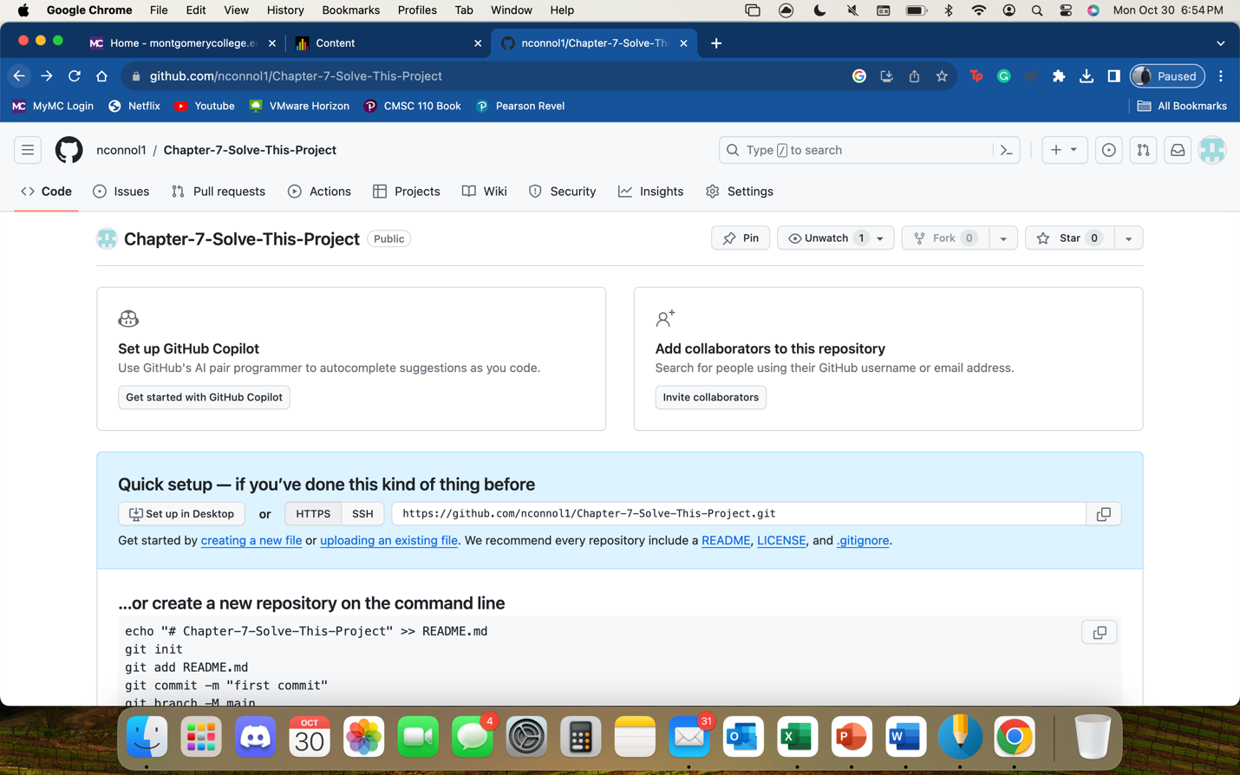

Create a Repository

Log into GitHub.com and **select “New repository”** to create Solve Project 7 repository.

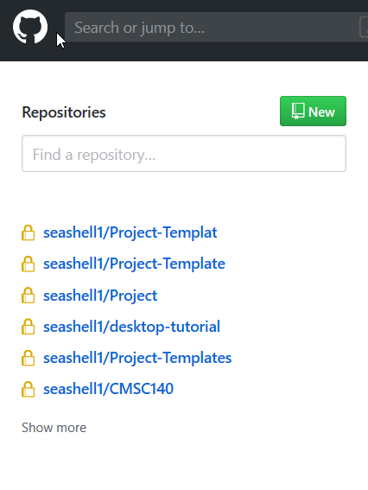

**Name your repository Solve Project7(or something similar).** Add a description so that collaborators know what the repository’s purpose is. The description will also show in README, so make sure to check the initialize repo with a README. Click ***“create repository.”***

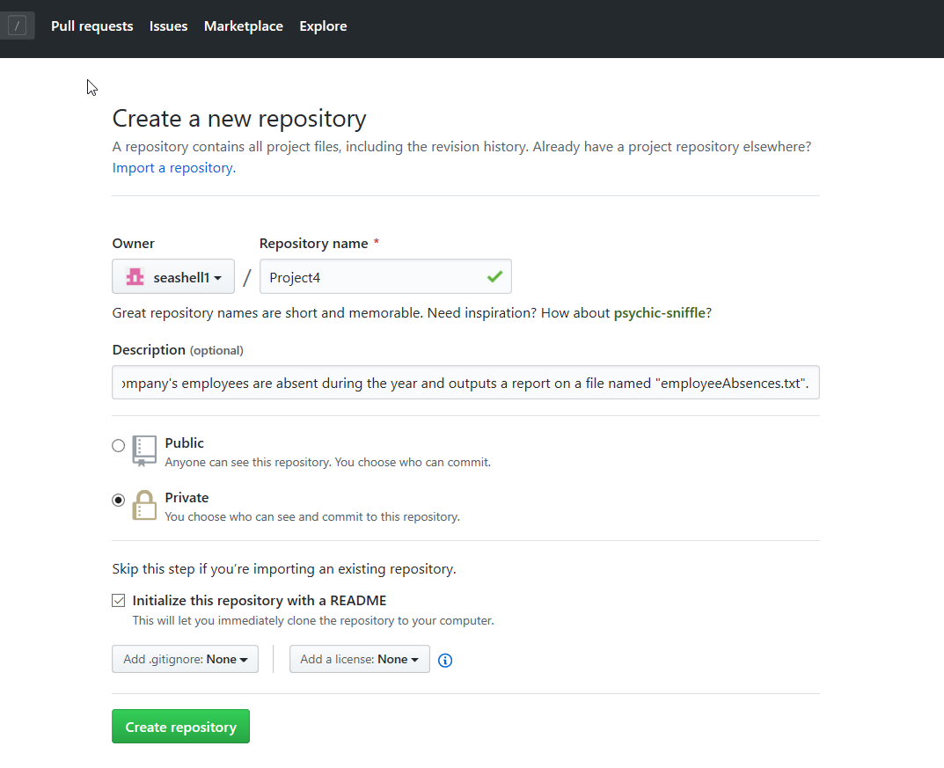

You have successfully created a private repository for your Project 7. Next, you must clone your repository so that a local path to it will appear on your computer.

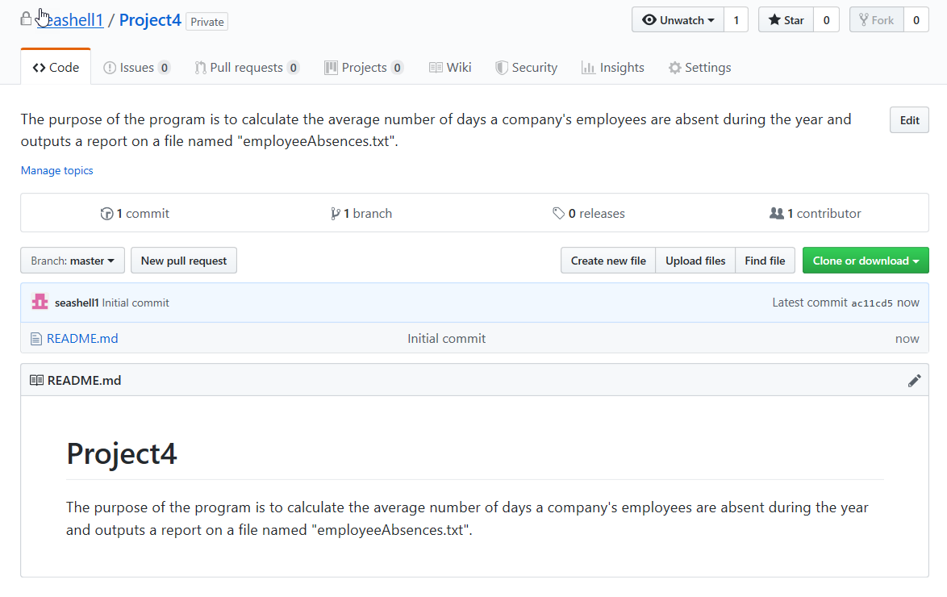

In order to create a local path on your computer, **click the green button “Clone or download”** in your Project7 repository on GitHub.com (see screenshot above).

Even though you can manually download the repo. as .zip or clone using the terminal. We will be using the GitHub desktop to clone the repo.

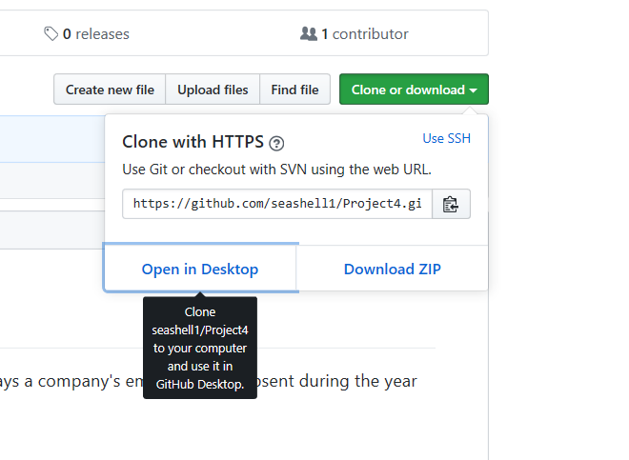

**Open GitHub Desktop :**

Select the Repo. Choose local path on your computer and click “Clone”

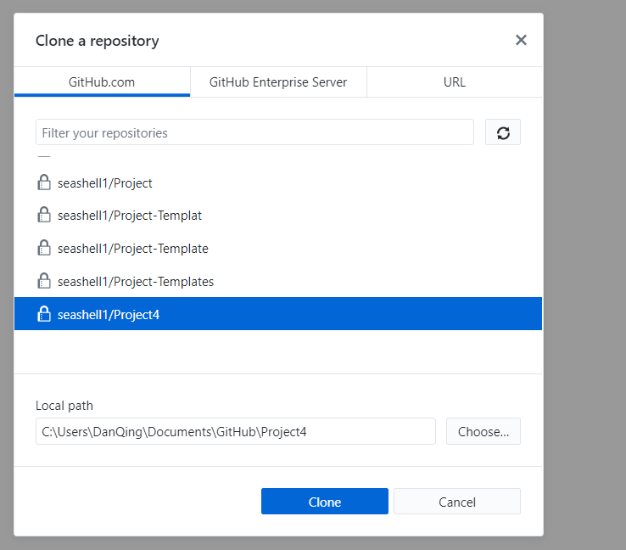

Click “fetch origin” to git pull (all information from GitHub.com

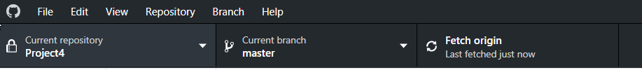

Now located the local path you chose and open it

In the folder, you should see the Readme.md file.

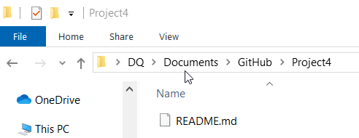

Open the Readme.md file and write down the objects of this project.

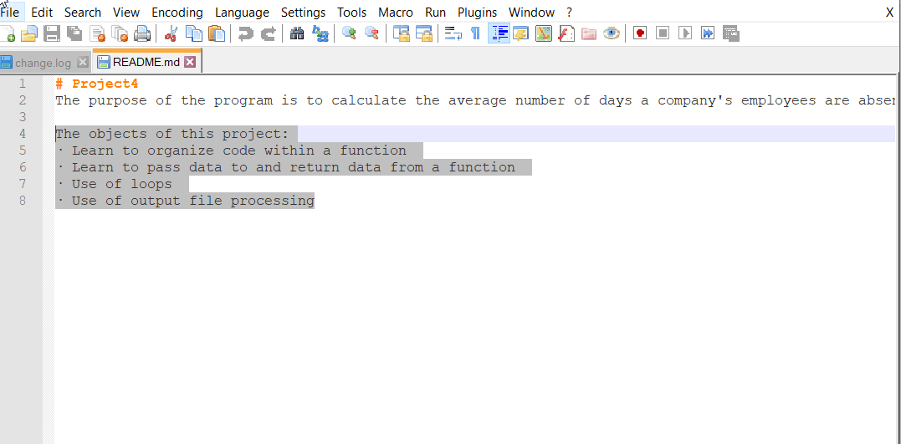

Now **copy your project 7 program** (for example here is Hello.cpp instead) on in the folder.

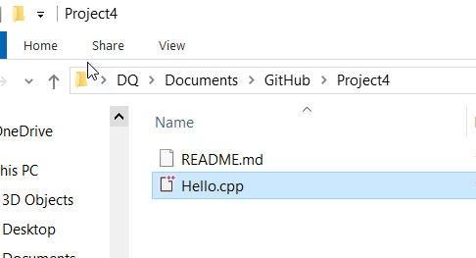

Now go back to GitHub desktop app and you should see the changes

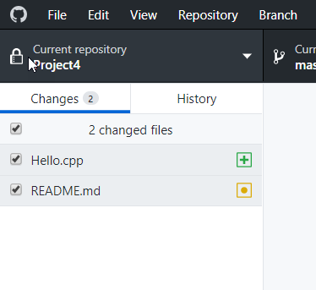

Add a summary of what was changed (a message)

You can add a description but it is not necessary

Click “Commit to [branch]”

Select “Push Origin” to push changes to GitHub.com

**Submission**

Complete GitHub Homework and submit a Word Document with your GitHub account name and a screenshot of your GitHub repository here.