34eeeeeeeeeeeeeee23

C:\Users\Jasley\AppData\Local\Microsoft\Windows\Temporary Internet Files\Content.IE5\KM10U47F\MC900357901[1].wmf

**STOCKPORT & DISTRICT**

**JUNIOR BADMINTON**

**TOURNAMENT**

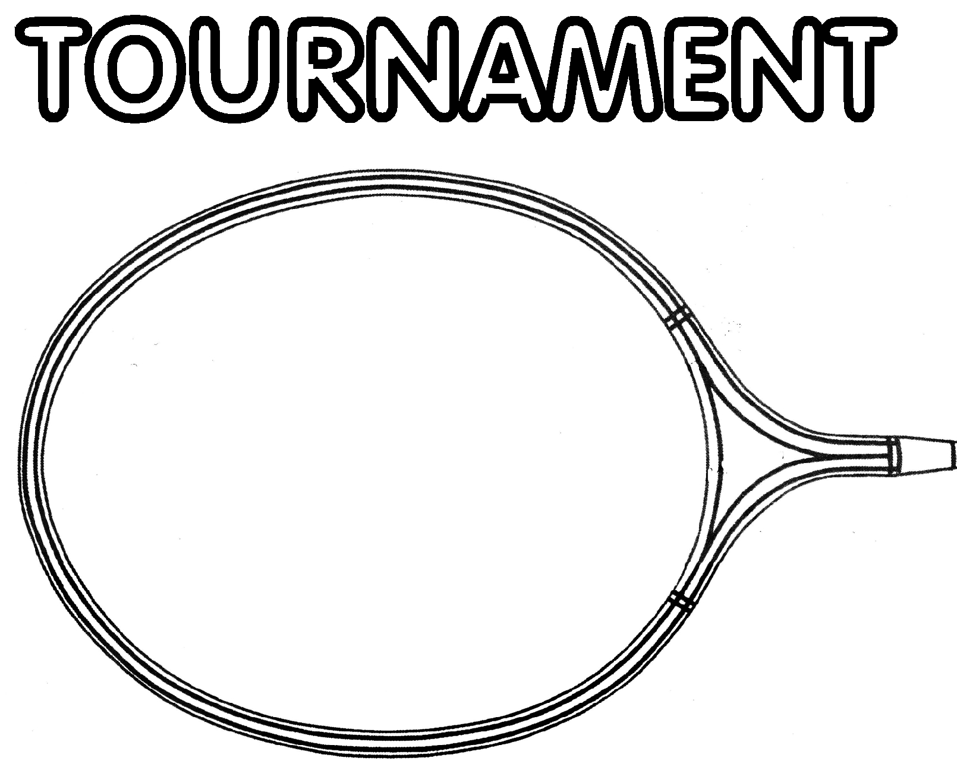

**Singles and Doubles**

**Under 12, Under 15 and Under 18**

**Saturday, 16 March 2019**

**Poynton Leisure Centre**

**Yew Tree Lane, Poynton**

**Cheshire SK12 1PU**

**Closing Date for Entries:**

**2 March 2019**

**(send entries to Irene Nottingham**

**19 Thistlewood Drive**

**Wilmslow. SK9 2RF)**

**CONDITIONS OF ENTRY**

1. A separate entry form must be completed by each competitor.
2. The completed form together with the correct entry fee must be sent to the Tournament Secretary by 2 March 2019. Entries are not acknowledged.
3. Cheques must be made payable to Stockport Badminton League.
4. Late entries will only be accepted at the Referee’s discretion and if numbers permit.
5. If you have no partner and would like to enter the doubles event, please write ‘Partner required’ in the space for Partner’s Name. The Referee will make every effort to find you a partner but cannot guarantee to do so.  
     
   **Acceptances: A list of accepted competitors and their start times will be emailed to each competitor (PLEASE WRITE YOUR EMAIL CLEARLY) approximately 3 days prior to the tournament date.**

**TOURNAMENT REGULATIONS**

1. The Tournament is open to all players who play in Stockport and local districts.
2. Players must have been born in the year 2007 or later (under 12), 2004 or later (under 15) or 2001 or later (under 18). Competitors may play in a higher age group but will not be permitted to play in more than one age group.
3. **The entry fee is £7.50 per person, per event, i.e. £7.50 for singles event, £7.50 for doubles event, per person. Entry fees will be forfeited if competitors fail to arrive without prior notification.** Entries without payment will not be accepted.
4. **START TIME will be approximately 9.00 a.m. and the tournament will end by 5.00 pm.** **Doubles events will start in the afternoon. AS START TIMES DO NOT ALWAYS RUN TO PLAN, PLEASE BE AVAILABLE ON THE CONTACT NUMBER YOU SUPPLY SO WE CAN CONTACT YOU ON THE DAY SHOULD YOUR SCHEDULED START TIME CHANGE.**
5. The Tournament Organisers reserve the right to refuse entry without giving reason, and to modify the anticipated programme of events in any way they see fit. The Referee’s decision is final.
6. Early stages of the events will be played in groups if possible. The format of the later stages will be at the discretion of the Referee. **Please do not leave the event without first notifying the Referee.**
7. Acceptable badminton clothing (shorts and T shirts) and footwear are to be worn.
8. Feather shuttlecocks will be used.
9. The winners and runners-up in each event will receive medals or trophies.
10. Refreshments will be available during the day.

**SEND ENTRY FORM TO**

**Tournament Secretary: Irene Nottingham**

**19, Thistlewood Drive, Wilmslow, Cheshire SK9 2RF**

**Tel: 01625 535540 – email aim@talktalk.net**

Surname: .............................................................................................................................

Forename: ...........................................................................................................................

Male / Female: (delete as necessary)

Date of birth: .......................................................................................................................

Address: ...............................................................................................................................

..............................................................................................................................................

Email:...................................................................................................................................

Telephone No: .....................................................................................................................

**ENTRY DETAILS**

**Venue**

**Poynton Leisure Centre**

**Yew Tree Lane, Poynton**

|  |  |  |  |
| --- | --- | --- | --- |
| **Event** | **Under 12** | **Under 15** | **Under 18** |
| **(please tick)** | Born on or after | Born on or after | Born on or after |
|  | 1 January 2007 | 1 January 2004 | 1 January 2001 |
| Boys’ Singles |  |  |  |
|  |  |  |  |
| Girls’ Singles |  |  |  |
|  |  |  |  |
| Boys’ Doubles |  |  |  |
| (partner’s name) |  |  |  |
|  |  |  |  |
| Girls’ Doubles  (partner’s name) |  |  |  |
|  |  |  |  |

Signed by player (or parent/guardian): ................................................. Date: ...................