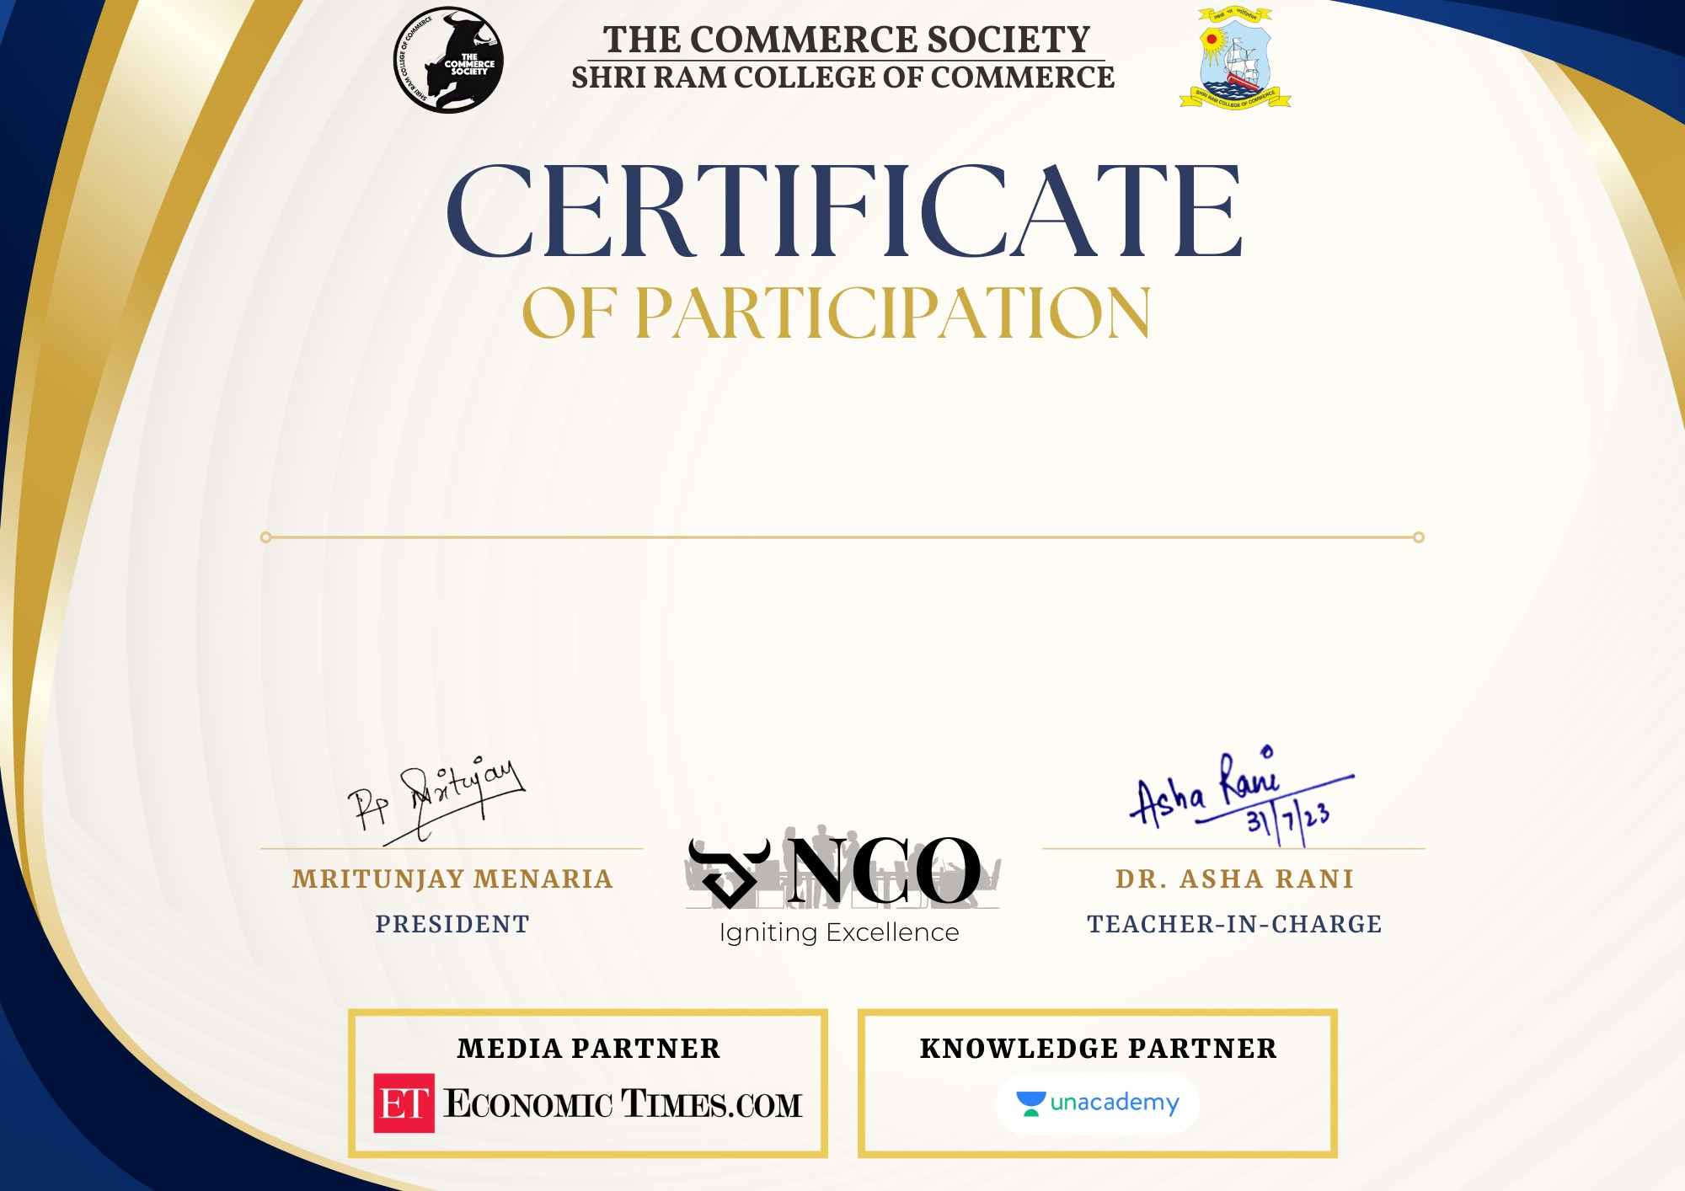

This certificate is proudly presented to

*{name_place}*

for successfully participating in the National Commerce Olympiad, 2023 in the {category_place} category, organized by The Commerce Society, SRCC