Leaf quantity outweighs vertical arrangement in simulated understorey microclimate buffering: a LiDAR–MuSICA attribution in a temperate oak forest
A preliminary version of this work was presented at the Microclimate Ecology and Biogeography (MEB) conference (Montpellier, France, June 2026).
Keywords: Microclimate buffering, Understorey temperature, Leaf area density profile, Airborne LiDAR, Multilayer canopy model, Sensitivity analysis, Temperate deciduous forest

Key message
Airborne laser scanning coupled to a multilayer canopy model shows that the amount of foliage, more than its vertical arrangement, controls the simulated temperature buffering of a temperate oak understorey. The vertical profile has an effect in the model, but measured canopies span too narrow a range of shapes for it to change the buffering between plots.

Abstract
Context Forest understoreys buffer their occupants from macroclimatic extremes. Which dimension of canopy structure controls that buffering is not settled. Airborne laser scanning (ALS) resolves the vertical dimension. Canopy variables covary in real stands, so observational models cannot attribute the effect to one of them.
Aims We ask which dimension controls the simulated buffering, leaf quantity or vertical arrangement, and whether the leaf-area-density profile adds anything once leaf area, height and cover are fixed.
Methods We coupled four ALS-derived variables to the multilayer model MuSICA: leaf area index, maximum height, fractional cover and the vertical leaf-area-density (LAD) profile. We perturbed each around the real canopy of 400 plots in a temperate oak forest (Blois, France; summer 2021). We selected the plots by conditioned Latin hypercube sampling.
Results Leaf area and cover together dominate the sensitivity of the simulated daytime maximum-temperature offset ΔT_{max}, and maximum height is negligible. In the most open stands every effect is below 0.03 °C, too small to rank, and maximum height is negligible (at most 0.001 °C per metre). The vertical profile has a second-order effect. Outside the most open stands, the real-versus-uniform contrast stays at or below the cover step. Its rank against the leaf-area step depends on the response metric and the summary statistic. A controlled sweep identifies the vertical spread of the profile, not its peak height, as the stronger axis over most of the leaf-area range. Real profiles vary too little in either axis to exercise this mechanism, so the realised effect is about 0.05 °C.
Conclusions Along the Blois canopy gradient, leaf quantity dominates the between-plot sensitivity of the simulated buffering, and the vertical LAD profile adds little to it. This result bounds what the vertical detail of ALS can contribute to mapping forest microclimate.

1. Introduction
Beneath a forest canopy the climate experienced by organisms departs from the conditions recorded by standard weather stations. Daytime maxima are attenuated and the diurnal range is compressed relative to the open (De Frenne et al., 2019; Zellweger et al., 2020). This decoupling is termed microclimatic buffering. It controls the distribution and persistence of understorey plant communities (De Pauw et al., 2022; Haesen et al., 2023), the success of tree regeneration (Meeussen et al., 2022), and the capacity of forests to act as thermal microrefugia under macroclimatic warming (Kemppinen et al., 2024; Lenoir et al., 2017). Accounting for vegetation-driven microclimatic variation reduces the climate velocities species must track and alters their direction, at least in tropical forests (Soifer et al., 2026). Forest maximum temperatures average 4.1 °C cooler than the open across 98 sites on five continents, and the offset grows as temperatures become more extreme (De Frenne et al., 2019). Dedicated sensor networks and gridded sub-canopy temperature products now quantify it at continental scale (Haesen et al., 2021; Lembrechts & Lenoir, 2020).
Canopy structure is the first-order control on buffering. Denser and more closed canopies intercept more radiation and decouple the understorey further (Díaz-Calafat et al., 2023; Zellweger et al., 2019). Dense old-growth or well-covered stands buffer thermal extremes the most (De Lombaerde et al., 2022; Frey et al., 2016). Airborne laser scanning (ALS, airborne LiDAR) resolves the full vertical distribution of vegetation (Bouvier et al., 2015). ALS-derived structural metrics predict sub-canopy temperature across landscapes (Atkins et al., 2023; Jucker et al., 2018) and have been used to map the summer temperature offset (Vandewiele et al., 2023). Simulations with the multilayer canopy model MuSICA across stand types have identified a canopy-density threshold in buffering (Bouwen, 2025). That study left open which variable drives the effect, and it imposed a generic profile shape for lack of measured leaf-area-density profiles. We address both gaps here.
LAI is the established correlate of sub-canopy temperature (Hardwick et al., 2015). The height at which the foliage concentrates sets where radiation is intercepted and where the canopy’s heat sources and sinks lie (Parker et al., 2004). Two canopies of equal leaf quantity (leaf area and cover) but different vertical arrangement could therefore buffer the understorey by different amounts. This mechanism has rarely been tested under controlled conditions. Whether the vertical arrangement itself controls the buffering, or only covaries with leaf area and cover, is not settled. Observational models face two difficulties. Canopy variables are collinear in real stands, so the coefficients of a site-fitted model are unstable under concurvity and the contribution of each variable is not identifiable (Greiser et al., 2018). Such models cannot separate the role of leaf quantity from that of arrangement. They also predict poorly outside their calibration range (Maclean et al., 2017).
A mechanistic model addresses both difficulties. MuSICA is a one-dimensional multilayer soil-vegetation-atmosphere model that solves the coupled energy, radiative and turbulent balance (Ogée et al., 2003). It can be driven with controlled combinations of canopy variables. Each variable’s contribution is then isolated by construction rather than inferred from correlated observations. Such models have been used to predict and map forest microclimate (Brusse et al., 2024; Zellweger et al., 2024), but rarely to attribute it to individual canopy variables. Because the model is mechanistic, its parameters are not fitted to one site and should transfer to another. Other mechanistic microclimate models share this property (Kolstela et al., 2024; Maclean & Klinges, 2021). We coupled ALS-derived canopy variables to MuSICA to isolate each variable’s contribution to summer understorey buffering in a temperate deciduous oak forest. The 400-plot design samples the canopies the forest contains.
This study asks two questions. (1) Which dimension of canopy structure controls the simulated understorey buffering: the quantity of foliage, or its vertical arrangement? (2) Does the vertical leaf-area-density profile add anything to the buffering once leaf area, height and cover are fixed?
We hypothesise (H1) that vertical structure modulates radiative and turbulent transfer, so that the leaf-area-density (LAD) profile is a controlling input of the simulated microclimate. We hypothesise (H2) that at fixed leaf area, height and cover, top-heavy profiles attenuate the diurnal cycle more strongly, because radiation is then intercepted higher and the canopy heat source shifts upward. We tested these hypotheses in three steps. We derived a structural typology of the LAD profile. We perturbed each variable around every plot’s real canopy with MuSICA and computed the local sensitivity of the daytime maximum-temperature offset ΔT_{max} in each structural type. For the profile, we contrasted the real vertical profile with a uniform one. We prescribed a Gaussian profile and swept its peak height and vertical spread at fixed leaf area, height and cover. We repeated the sweep over the leaf-area range the forest occupies. That sweep tests the direction H2 asserts and adds the spread of the foliage as a second profile axis.
The perturbation separates the dimensions, because leaf area and vertical arrangement enter the model by different pathways even though they covary in real stands. Two outcomes would count against the hypotheses. H1 fails if the real-versus-uniform contrast does not move the simulated buffering, whatever the between-plot range of measured profiles. H2 fails if raising the peak height at fixed leaf area does not cool the understorey further. We report the size of each mechanism separately from the range real stands span in each variable, because a mechanism can be large in the model while its variable varies little between stands.

2. Material and methods

2.1 Study site
Blois is a temperate lowland deciduous forest in the central Loire region of France (about 47.6° N, 1.3° E), almost entirely sessile oak (Quercus petraea). Elevation spans 94 to 141 m, so topographic forcing of the microclimate is at most 0.31 °C by lapse rate (Section 2.5).

2.1.1 Airborne LiDAR acquisition
Canopy structure was characterised from a leaf-on ALS survey flown on 17 June 2021 (Gril et al., 2023). The platform, scanner, flight parameters and return density are given in Appendix D. The provider filtered and classified the cloud (vegetation, ground, other) and height-normalised it against the ground returns. The LAD profiles and scalar variables used downstream were derived from this normalised cloud (Section 2.2).

2.2 LiDAR canopy structure and variables
We reconstructed vertical leaf-area-density (LAD) profiles by foliage-profile inversion of the vertical return distributions (Bouvier et al., 2015; Kamoske et al., 2019; MacArthur & Horn, 1969). From them we derived the leaf area index (LAI), maximum canopy height (H_{max}), fractional cover (fCover) and the vertical complexity index (VCI). LAI is the vertically integrated one-sided LAD, an effective plant area index. The MacArthur–Horn inversion assumes a spherical leaf-angle distribution with the conventional extinction coefficient k = 0.5 and no foliage-clumping correction, so the value is a proxy for true leaf area. We retained k = 0.5 and corrected every profile for beam scan angle (Appendix D).
Fractional cover is the fraction of returns above a 2 m height threshold within the 20 m cell. All four variables and the LAD profile were computed on the 20 m grid directly from the returns in each cell, not aggregated from a finer product. LAD was binned at 1 m resolution from 1.5 m above ground. ALS retrieves plant area in heterogeneous canopies at least as accurately as in-situ optical sensors (Vincent et al., 2017), so we took the ALS retrieval as the structural reference.
VCI is the normalised Shannon entropy of the vertical distribution of returns above ground (Van Ewijk et al., 2011). It summarises the evenness of that distribution rather than the shape of the LAD profile. We report it only as a descriptor of structural complexity (Fig. 1) and never use it as a model input. Appendix C gives its formula and Section 4.1 discusses what it tracks. We characterised profile shape by a functional decomposition instead (Section 2.3).

2.3 Forest structural typology
To separate architecture from quantity, we applied a functional principal component analysis (FPCA) to the LAD profiles, on a B-spline basis whose dimension was selected by generalised cross-validation (Ramsay & Silverman, 1997). Each profile was first double-normalised, rescaled to z/H_{max} in height and to unit integral in density. FPC1 to FPC3 capture about 92% of the profile-shape variance. They serve only to define the typology and are not interpreted individually.
We clustered the plots by K-means on six z-standardised ALS metrics: LAI, H_{max}, fCover and FPC1 to FPC3. We fixed four archetypes for interpretability and tractability. The within-cluster sum of squares flattens beyond four groups, and the average silhouette width is 0.27 at four clusters (Rousseeuw, 1987). The four archetypes are labelled P1 to P4 by increasing canopy density and were frozen before any simulation. Figure 1 summarises them by their mean LAD profiles. The typology only groups the plots; every perturbation is applied per plot.
Within each archetype we selected 100 plots by conditioned Latin hypercube sampling (cLHS, Minasny & McBratney, 2006), implemented in the clhs R package (Roudier, 2012). The sampler ran 10,000 iterations at a fixed seed. Fractional cover was floored at 0.5, the floor the model applies to its cover input. cLHS selects among the existing 20 m LiDAR grid cells and does not generate variable values. Each of the 400 plots perturbed in Section 2.4 is an observed 20 m cell, with its own measured LAD profile and variable combination. The design reproduces each archetype’s variable marginals and correlations and covers the full range, including the rare open, low-density stands a random draw would miss (Appendix C). The descriptive statistics of Table 1 and Figure 1 are means. Because the design over-represents the open extremes, we report every effect size as a median over plots, with a bootstrap interval (Table 2, Table E1). The design also probes height independently of density, with the widest height spread in the open archetype P1 (Appendix C).
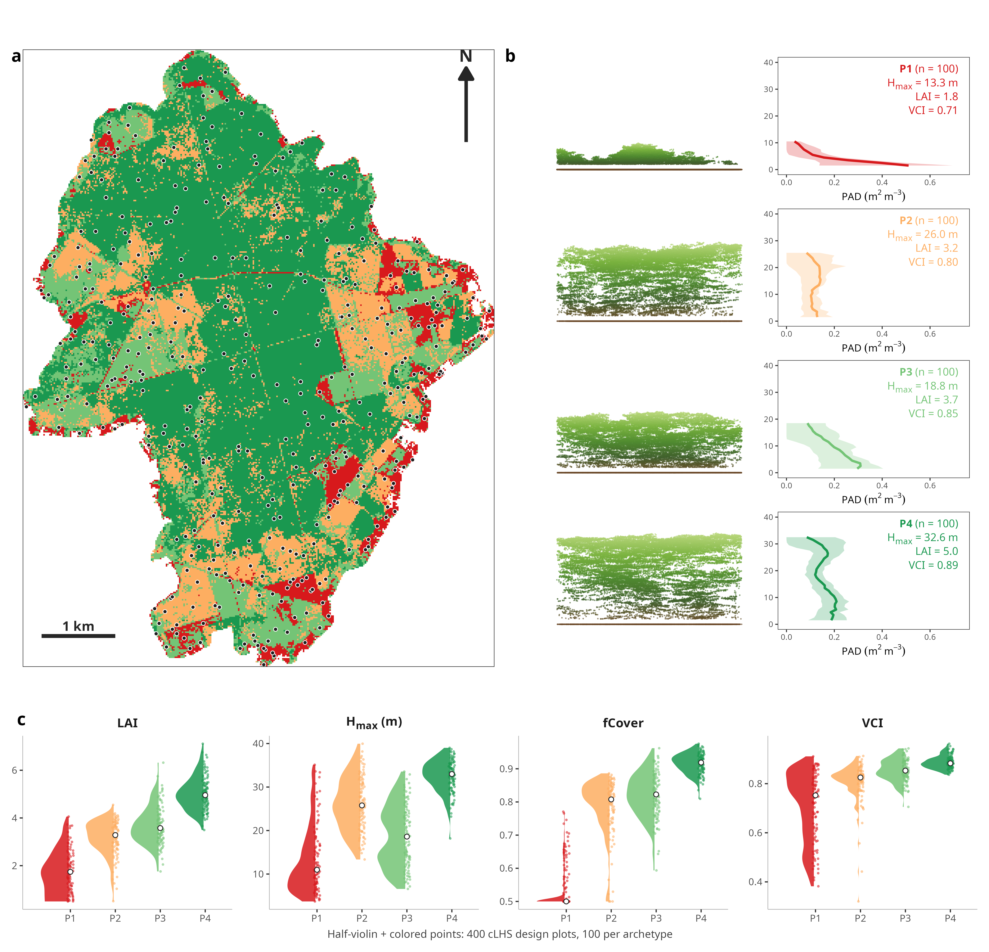
Figure 1 Structural typology of the Blois oak forest. (a) Forest map coloured by archetype (P1 open to P4 dense) with the 400 cLHS design plots as dots. (b) Per archetype, one representative ALS point cloud on a common 0 to 40 m scale, and the mean LAD profile of its 100 design plots with its interquartile band, cut at the median maximum height. The panel labels the profile PAD; annotated H_{max}, one-sided LAI and VCI are archetype means. (c) Per-archetype half-violins of one-sided LAI, H_{max}, fractional cover and VCI over the 400 design plots, median in white.
The complete workflow is summarised in Figure 2.
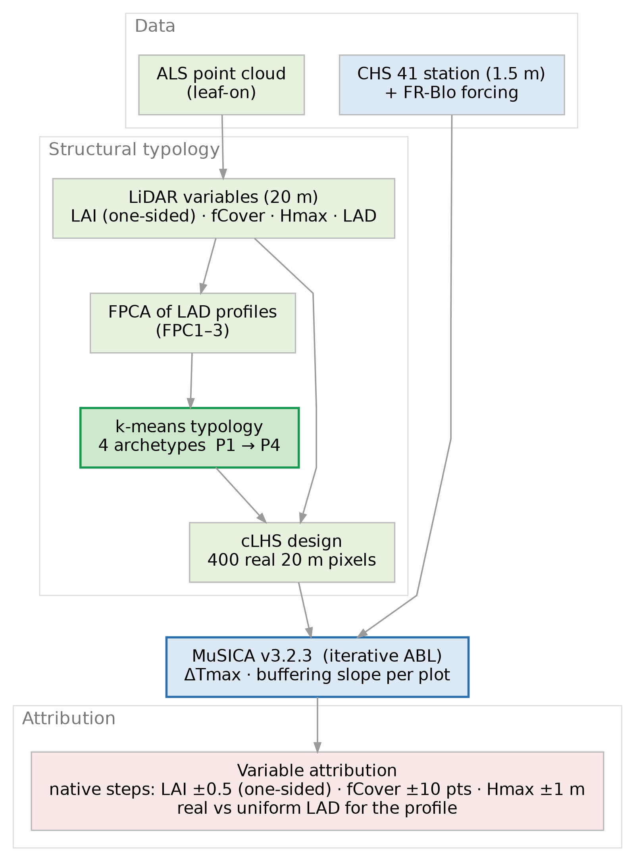
Figure 2 Analysis pipeline. ALS yields four canopy variables at 20 m (LAI, fractional cover, maximum height and the LAD profile); a functional PCA of the profiles feeds a K-means typology of four archetypes and a cLHS design of 400 plots. MuSICA, forced by the CHS 41 station and ERA5 (Section 2.4), simulates ΔT_{max} and the micro-macro slope per plot; each scalar variable is perturbed in fixed native steps and the profile by a real-versus-uniform contrast.

2.4 MuSICA model and simulation design
MuSICA is a multilayer, multileaf biophysical canopy model. It solves the coupled radiative, energy and turbulent balance through a vertically discretised canopy (Ogée et al., 2003). Radiation is attenuated layer by layer following Beer–Lambert extinction theory (Baldocchi et al., 1984; Campbell, 1986). Appendix F gives its full configuration. Every simulation ran the whole of 2021 at an hourly time step, so the analysis window, 1 June to 30 September, is preceded by five months of within-year spin-up (Appendix F). Each structural variable enters MuSICA by its own pathway. LAI enters as two-sided leaf area distributed across the layers, and the LAD profile sets how that leaf area is distributed with height. The LiDAR LAI is one-sided (projected) whereas MuSICA expects the total, two-sided leaf area, so LAI is doubled before input (a units convention, not a clumping correction). Fractional cover enters as the canopy clumping factor. It leaves the leaf area in the column unchanged and sets how efficiently that leaf area intercepts radiation, so a closed canopy of a given LAI shades more than a clumped one. Maximum height enters twice: it sets the depth over which the LAD profile is distributed and places the forcing level 2 m above the canopy top.
Canopy structure also alters the meteorology just above the canopy (Bouwen et al., 2026), so one fixed forcing applied to every structural scenario ignores that feedback. We therefore ran MuSICA version 3.2.3 (v3.2.3) with its atmospheric boundary-layer coupling in iterative (“yoyo”) mode (Bouwen, 2025), so that canopy structure feeds back on the meteorology above. The blending height of that coupling is a prescribed input, not derived internally (Appendix F). The coupling represents the canopy-atmosphere feedback that a fixed forcing omits (Bonan et al., 2018), at the cost of one extra forcing series, the boundary-layer height.
The forcing combines the local CHS 41 station (altitude 127 m) with ERA5 reanalysis (Hersbach et al., 2020). The station is the same open-field reference at 1.5 m used for the offset (Section 2.5). Air temperature, humidity and precipitation come from the station; shortwave and longwave radiation, wind and surface pressure come from ERA5. We took temperature from the station because the reanalysis has a warm bias against it that varies with the time of day over the summer window (Appendix A). The surface-boundary-layer height the yoyo coupling requires is the hourly MERRA-2 boundary-layer height for the Blois grid cell (Gelaro et al., 2017), median 550 m. It is archived in the same forcing file (Appendix F).
The ERA5 wind is the 10 m open-field value. All simulations reported here use it as delivered, without correction. MuSICA needs the wind just above each canopy, and a neutral logarithmic profile applied at each plot’s canopy height would multiply the 10 m value by about 0.41 to 0.48. We treated that correction as a sensitivity test (Appendix A). Because the same wind series drives every plot and every step, perturbing H_{max} moves the LAD depth and the forcing level but not the wind speed delivered there. The height step therefore tests the radiative and geometric pathway of height, not its aerodynamic one, so it is a lower bound on the full height effect.
Every analysis ran on the 400-plot cLHS design (Section 2.3), around each plot’s own measured canopy rather than a synthetic or archetype-mean one. For each plot we ran a reference at its measured variables. We then perturbed one variable at a time by a fixed step in its own native unit, with the other three at their measured values. We also contrasted the real LAD profile against a uniform one. Both are specified in Section 2.6, and all perturbations used the same v3.2.3 configuration. We perturbed per plot rather than the four mean profiles because MuSICA is nonlinear, so f(mean) ≠ mean(f). Aggregating per-plot effects then recovers both the archetype mean and its within-archetype spread, without the unobserved variable combinations a global baseline would impose.

2.5 Microclimate metric extraction
Every metric is read at 1 m, the standard sub-canopy measurement height, by vertical interpolation of the simulated profile.
(a) Absolute offsets (ΔT_{max}, ΔVPD_{max}). ΔT_{max} = T_{max,micro} − T_{max,macro} is the offset between the sub-canopy and the open-field reference at the daily maximum. Negative values denote buffering (a cooler understorey) and positive values amplification. The two maxima are matched in time. For each day we located the hour of the macroclimatic maximum and read the sub-canopy temperature at that same hour (Bouwen, 2025). ΔVPD_{max} is defined identically for vapour-pressure deficit.
The macroclimatic reference is the local open-field station that also drives the model (CHS 41, air temperature at 1.5 m; Section 2.4), not the free-air reanalysis aloft. The same station was the open-field reference in the earlier LiDAR-microclimate mapping of this forest (Gril et al., 2023). The offset and the driving meteorology share one baseline. We did not elevation-correct it across plots. Over the 94 to 141 m relief, a lapse-rate correction at 6.5 K km⁻¹ would reach at most 0.31 °C. A per-plot offset of this kind cancels in the within-plot perturbation differences that define every effect here.
(b) Micro-macro slope. The offset measures how much the understorey is cooled. The slope measures how strongly it tracks the macroclimate. We obtained it by regressing the hourly 1 m sub-canopy temperature on the station temperature at the same clock hour, over all hours of the analysis window. A slope below one means the understorey damps the macroclimatic range and buffers; a slope above one means it amplifies.
Only the vertical-gradient illustrations depart from this 1 m readout and use the full set of 15 air layers (Fig. B1).

2.6 Variable-perturbation sensitivity analysis
From the perturbed simulations (Section 2.4) we computed each variable’s effect on the two response metrics of Section 2.5, ΔT_{max} and the micro-macro slope. Each was computed over the full summer and over the hottest 10% of days, the 13 days of the window with the highest station daily maximum. For scalar variables the sensitivity is the metric change a fixed native step produces at the plot’s operating point; for the profile it is the real-versus-uniform contrast. The analysis is local and one-at-a-time (Pianosi et al., 2016; Saltelli et al., 2007).
We report the profile contrast raw, as the real-versus-uniform change in ΔT_{max}. We did not rescale it by VCI or per standard deviation, because a given VCI corresponds to infinitely many profiles. Uniform is the neutral reference, with no preferred direction. The controlled sweep of the profile addresses the height at which the foliage is concentrated (Hypothesis H2, below). The contrast is an upper bound on the profile’s effect, because it takes the profile to a uniform limit that real canopies reach only in part.
Each scalar variable was moved by a fixed step in its own native unit: leaf area by ±0.5 (one-sided), fractional cover by ±10 points and maximum height by ±1 m. The upward and the downward step are reported separately, never averaged, so any curvature in the response is visible. Each variable was bounded to the range the stand can physically occupy: leaf area at a floor of 0.1, fractional cover between 0.5 and 1, and maximum height between 2 and 40 m. Where a step would cross a bound it was truncated. The change plotted is then the one simulated, without rescaling to the nominal step, so an effect near a bound is understated, never inflated.
The leaf-area and height steps preserve profile shape by construction (Appendix F). The uniform reference is a constant density from 1 m to the canopy top with the plot’s own leaf area, maximum height and cover, so it differs from the real profile in shape alone. The profile has no fixed step of this kind. It is reported as the full contrast, which is not commensurable with the scalar steps. We keep every effect’s sign throughout, and report each for both metrics and both periods.
Table 1 gives each archetype’s variable means and within-archetype standard deviations, so each fixed step can be compared with the size of the variable itself.
Table 1 Structural variables and fixed steps per archetype. Within-archetype mean and standard deviation (SD) of each scalar variable, in native units (one-sided LAI; fractional cover; maximum height in m). The fifth column gives each fixed step (LAI ±0.5, cover ±10 points, height ±1 m) as a percentage of the archetype mean. Leaf area and cover are stepped by 10 to 28% of their means, height by 3 to 8%. In P4 cover is 0.92 ± 0.03 against a ceiling of 1, so the cover step is truncated to about 8 points.
Archetype | LAI (mean ± SD) | fCover (mean ± SD) | H_{max}, m (mean ± SD) | fixed step, % of the archetype mean (LAI · cover · height)
P1 (open) | 1.80 ± 0.86 | 0.56 ± 0.08 | 13.3 ± 7.8 | 28% · 18% · 8%
P2 | 3.15 ± 0.74 | 0.78 ± 0.09 | 26.0 ± 6.0 | 16% · 13% · 4%
P3 | 3.69 ± 0.81 | 0.82 ± 0.07 | 18.8 ± 7.1 | 14% · 12% · 5%
P4 (dense) | 5.03 ± 0.71 | 0.92 ± 0.03 | 32.6 ± 3.7 | 10% · 11% · 3%
One qualification applies to the most collinear pair, leaf area and fractional cover (r = 0.94 across the 400 cLHS plots). Moving one while the other is held fixed leaves their observed joint distribution. The model’s split between leaf area and cover is therefore a model-only attribution the field cannot confirm (Section 4.1). The profile contrast keeps leaf area, height and cover fixed by construction, so it is not exposed to that collinearity. Vapour-pressure-deficit sensitivities are model-internal results, since no sub-canopy humidity measurement is available for comparison.
Controlled test of H2. The real-versus-uniform contrast measures whether the profile departs from a uniform one, but not how the foliage is arranged. To test Hypothesis H2 directly we prescribed a Gaussian LAD profile and swept its two shape parameters, μ and σ. The same (μ, σ) parameterisation describes vertical canopy profiles in Sentinel-2 sensitivity studies (Fujiwara et al., 2026). The peak height μ sets the dominant canopy height. The width σ sets the vertical spread of the foliage. Both are fractions of H_{max}, and each profile is renormalised to preserve leaf area. We crossed five values of μ from 0.30 to 0.70 with five of σ from 0.12 to 0.36, at five one-sided leaf-area levels (LAI 2 to 6), a grid of 125 simulations. Cover was fixed at 0.87 and maximum height at 25 m. MuSICA re-bins the profile onto ten vegetation layers, so σ below about 0.10 H_{max} is not resolved, and the swept σ values stay above it. The sparse levels do not correspond to observed stands. A one-sided LAI of 2 under a cover of 0.87 has no counterpart in the open P1 (cover 0.56, height 13.3 m; Table 1). The Gaussian is unimodal, so bimodal real profiles lie outside the sweep.

3. Results

3.1 Structural typology
The FPCA and K-means typology partitioned the plots into four architectural archetypes, from the open, sparse P1 to the dense, closed P4 (Fig. 1). The types order monotonically along a canopy-density and leaf-area gradient (Table 1). The clustering builds that ordering in (Section 2.3).
The typology did not depend on VCI. A principal component analysis of the four variables recovered the same four groups along a single dominant density-closure axis with and without VCI (Fig. 3).
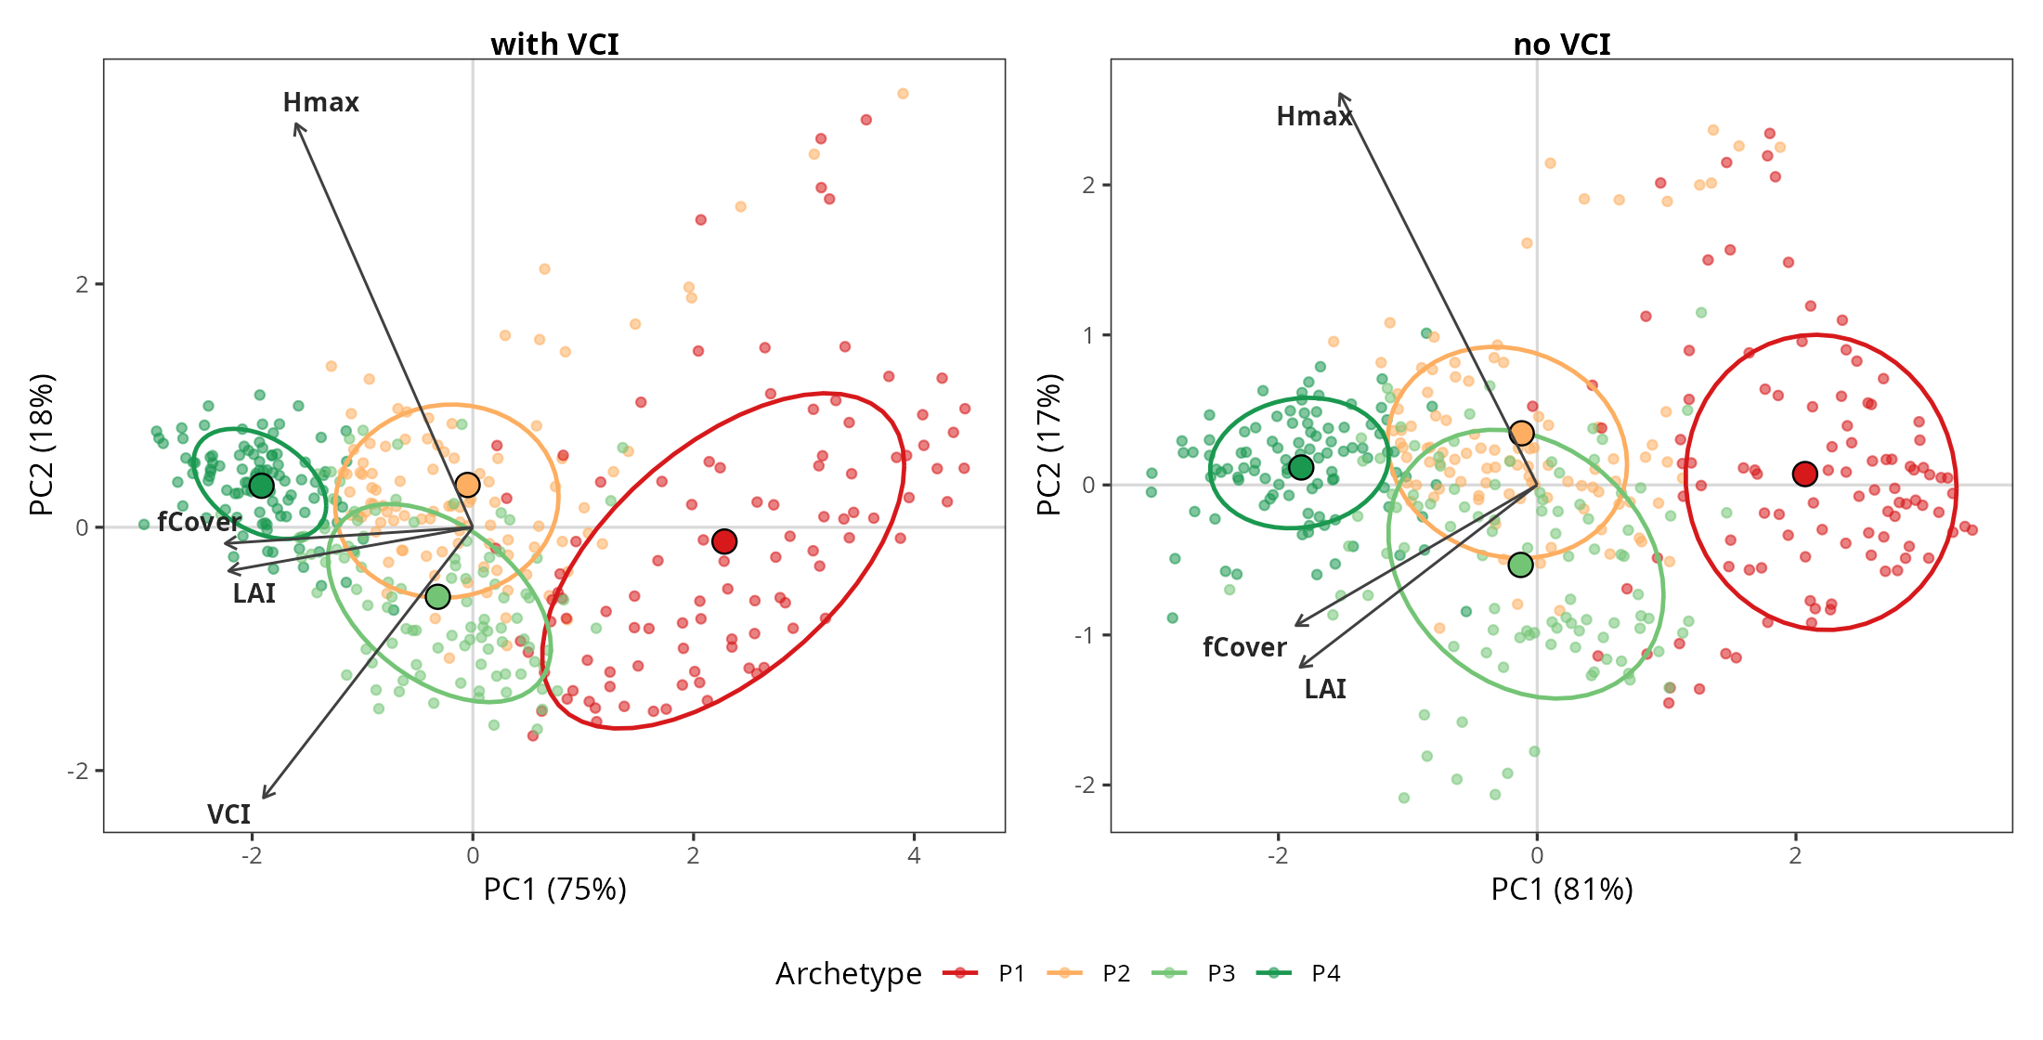
Figure 3 Principal component analysis of the canopy variables with VCI (LAI, fCover, H_{max}, VCI) and without VCI (LAI, fCover, H_{max}), points coloured by archetype. VCI’s loading splits between the first two components instead of aligning with the density axis (Appendix C). The archetypes separate equally with and without it, so VCI is collinear with the density variables.

3.2 Sensitivity of ΔT_{max} to each canopy variable, per archetype
Leaf quantity dominated from the intermediate to the closed archetypes and was largest in the closed P4 (Fig. 4, Table 2). In the densest archetype P4, adding 0.5 of leaf area cooled the understorey by 0.205 °C and the cover step cooled it by 0.265 °C. In the open P1 the same steps gave +0.027 °C, a warming, and −0.015 °C. The two steps are not commensurable, and the cover step is truncated at the cover ceiling in P4 (Table 1), so we do not rank leaf area against cover. Maximum height was negligible in every archetype, |effect| ≤ 0.001 °C per metre.
We keep the open P1 in the attribution. Real profiles are most bottom-heavy there, with an LAD centroid at 0.40 of H_{max}, the lowest of the four archetypes (Section 4.1). P1 is therefore the regime that most tests the vertical dimension. Every effect was small there: 0.027 °C for the leaf-area step, 0.015 °C for the cover step, 0.016 °C for the full profile contrast and 0.001 °C per metre or less for height. Including P1 does not change the ordering found in P4.
The real-versus-uniform profile contrast, at fixed leaf area, cover and height, was a second-order effect throughout. It moved ΔT_{max} by a median of 0.016 °C in P1, 0.052 °C in P2 and 0.065 °C in P3, cooling in each. In P4 it moved by +0.104 °C, where the real profile warmed the understorey relative to a uniform one. From P2 to P4 the contrast stayed at or below the cover step (0.052 against 0.069, 0.065 against 0.068, 0.104 against 0.265 °C). In the open P1 all four effects were below 0.03 °C, and we do not order them. The contrast’s rank against the leaf-area step depended on the summary statistic. In P2 and P3 the contrast fell below that step under the mean and reached or exceeded it under the median, so we leave the two unordered. Per plot, the contrast exceeded the leaf-area step in 47% of the 400 plots and the cover step in 42%.
The full contrast is an upper bound. It takes the canopy to the uniform limit, a range real canopies span only in part. Because the clusters are defined partly on the profile components FPC1 to FPC3, most profile-shape variance lies between archetypes. Within a type the profile varies little (Section 4.1). Replacing each plot’s real profile by its archetype’s mean shape moved ΔT_{max} by a median of 0.011 °C in P1, 0.027 °C in P2, 0.055 °C in P3 and 0.071 °C in P4. These values are below the cover step in every archetype.
Table 2 gives each effect’s median and 95% bootstrap interval over the plots within each archetype. Leaf area and cover both strengthened towards the dense end: the cover step cooled by 0.015 °C in P1 and by 0.265 °C in P4. Maximum height stayed within 0.001 °C per metre of zero in every archetype and in both directions, and its widest interval bound was 0.003 °C. The two directions of the leaf-area step were not mirror images in P4 (0.205 against 0.172 °C), so the effect steepens as the canopy closes. Cover was asymmetric in the same sense (0.265 against 0.224 °C). The leaf-area and profile intervals are disjoint in P1 and P4, overlapping in P2 and nearly touching in P3. Leaf area exceeded the profile contrast in P4 (0.205 against 0.104 °C); in P1 every effect was below 0.03 °C.
Table 2 Median change in ΔT_{max} (°C) per archetype for each fixed step (LAI one-sided), with 95% bootstrap interval over the plots within each archetype. Both directions are expressed as the change per increase of the variable, the downward step being sign-reversed, so two equal rows mean a symmetric response. The profile is the full real − uniform contrast. Steps are truncated at the variable bounds, so an effect near a bound is understated rather than inflated. Truncation also removes plots. Every row rests on all 100 plots of its archetype except cover −10 points, which uses 47 plots in P1 and 97 in P2, because cover there is already at or near the 0.5 floor.
Effect | P1 | P2 | P3 | P4
LAI +0.5 | +0.027 (+0.024, +0.030) | −0.052 (−0.063, −0.044) | −0.044 (−0.054, −0.034) | −0.205 (−0.223, −0.191)
LAI −0.5 | +0.023 (+0.019, +0.028) | −0.033 (−0.040, −0.026) | −0.030 (−0.039, −0.021) | −0.172 (−0.196, −0.158)
fCover +10 pts | −0.015 (−0.018, −0.012) | −0.069 (−0.081, −0.057) | −0.068 (−0.077, −0.059) | −0.265 (−0.281, −0.243)
fCover −10 pts | −0.026 (−0.030, −0.017) | −0.054 (−0.063, −0.045) | −0.054 (−0.066, −0.050) | −0.224 (−0.264, −0.210)
H_{max} +1 m | −0.000 (−0.001, +0.000) | −0.000 (−0.000, +0.000) | −0.001 (−0.003, −0.000) | +0.000 (−0.001, +0.001)
H_{max} −1 m | +0.000 (−0.001, +0.001) | +0.001 (+0.001, +0.001) | −0.001 (−0.003, −0.000) | −0.001 (−0.002, −0.001)
profile (full contrast) | −0.016 (−0.033, −0.010) | −0.052 (−0.063, −0.035) | −0.065 (−0.075, −0.053) | +0.104 (+0.072, +0.143)
On the buffering slope, maximum height stayed negligible everywhere, leaf area and cover remained the two largest scalar sensitivities, and the leaf-area effect was again largest in the dense P4. The profile’s rank against the leaf-area step differed on the slope. Its contrast was +0.002 in P1, −0.002 in P2, +0.008 in P3 and +0.027 in P4 (dimensionless). It matched the leaf-area step in P3 and exceeded it in the dense P4, with the opposite sign, while staying at or below the cover step in every archetype (Appendix E, Table E1).
Over the hottest 10% of days the ordering was preserved and most effects strengthened. The profile contrast grew in the intermediate archetypes, its median ΔT_{max} moving from −0.052 to −0.078 °C in P2 and from −0.065 to −0.121 °C in P3. In P4 the leaf-area step moved from −0.205 to −0.268 °C, a factor of 1.31, and the cover step from −0.265 to −0.284 °C (Fig. S1).
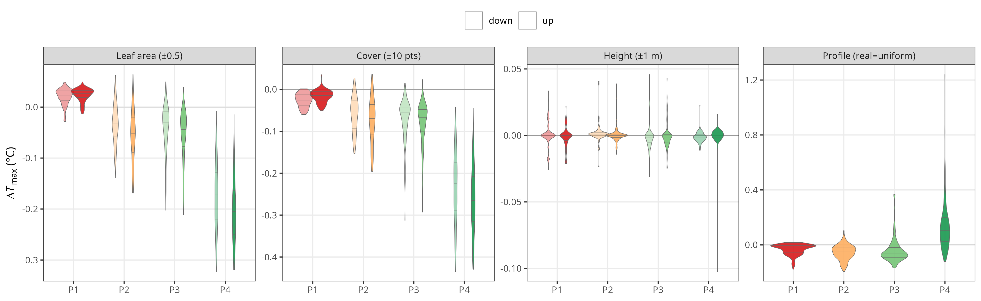
Figure 4 Sensitivity of ΔT_{max} to each canopy variable per archetype (P1 open to P4 dense) over the full summer: leaf area (±0.5, one-sided), fractional cover (±10 points) and maximum height (±1 m), with upward (dark) and downward (pale) steps, and the profile as the full real − uniform contrast at fixed leaf area, cover and height. Violins are the per-plot distributions, with median and interquartile range in white. Panels do not share a y-axis and the steps are not commensurable (Table 1), so panel heights are not a ranking.
Rescaled to one full one-sided unit of leaf area, the median leaf-area effect was +0.054 °C in the open P1, a warming. It was −0.105 °C in P2, −0.088 °C in P3 and −0.410 °C in the dense P4.
The per-archetype sensitivities did not depend on the clustering. When all 400 plots are pooled without labels, each sensitivity is a smooth function of its own operating point. The archetypes are bins along that function, and the sensitivities cross the boundaries without a step (Fig. 5). A variance partition agrees. The continuous operating point explained more of the leaf-area and cover sensitivities than the label did: R² = 0.75 against 0.74 for leaf area and 0.74 against 0.72 for cover. For the profile the order reversed: the label explained 0.33 and the operating point 0.28. Neither predictor explained the height sensitivity (R² = 0.00 for both).
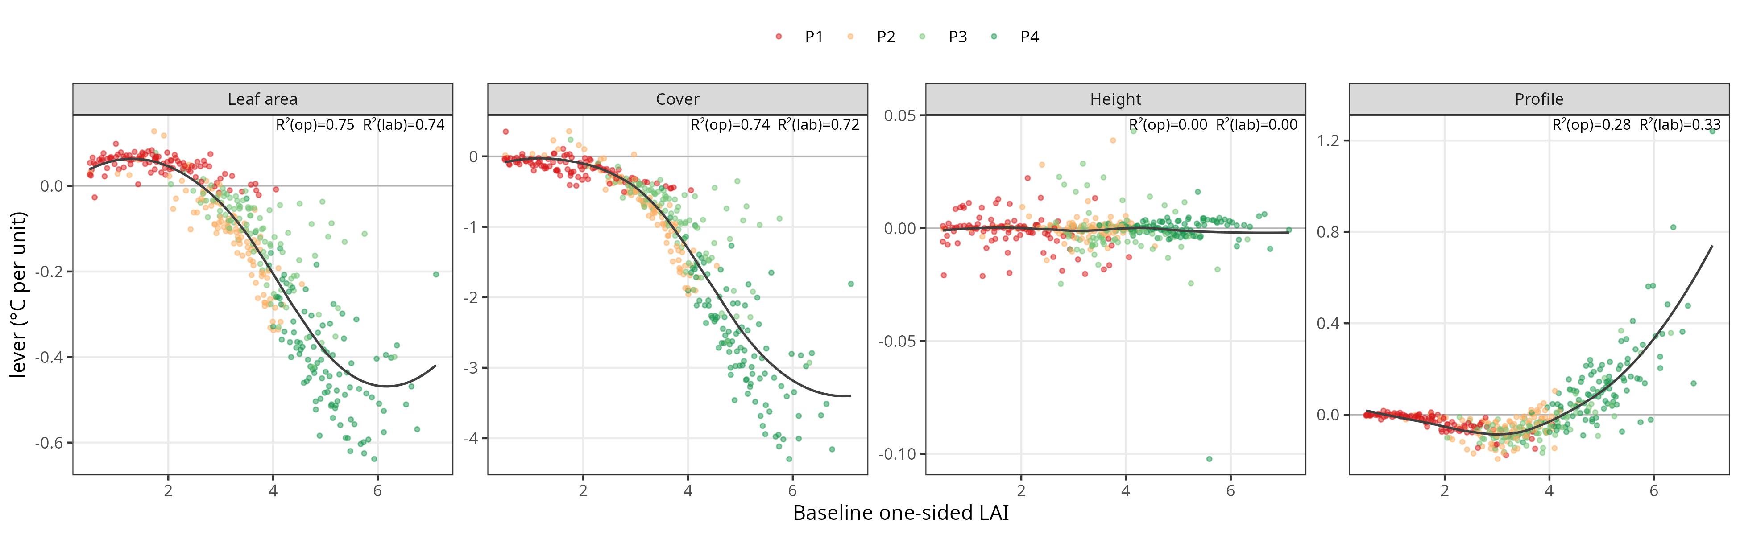
Figure 5 Sensitivity of ΔT_{max} to each variable against its baseline operating point over the 400 cLHS plots, coloured by archetype with a robust-loess smooth: (a) leaf-area step, (c) cover step (plots at the 0.5 cover floor excluded) and (d) real − uniform profile contrast, all against baseline one-sided LAI, and (b) height step against baseline H_{max}. Each panel gives the R² of the sensitivity against the continuous operating point and against the cluster label. The operating point explains more for leaf area and cover, the label more for the profile (0.33 against 0.28).

3.3 Controlled test of the vertical arrangement (H2)
At fixed leaf area, height and cover, two axes of the profile moved ΔT_{max} (Fig. 6). The peak height μ tests Hypothesis H2 directly. The vertical spread σ is a second axis the hypothesis does not name. The stand amplified the open-field maximum at one-sided LAI 2 to 3, by up to +0.27 °C. It crossed zero near LAI 4 and buffered the understorey at LAI 5 to 6, down to −0.78 °C.
Raising the peak cooled the understorey at every level, the direction H2 asserts. The effect grew with leaf area, from 0.05 °C at LAI 2 to 0.25 °C at LAI 6. At the dense end it was not monotone: a mid-upper peak (μ = 0.6) buffered most, and the top-heavy shape less.
The vertical spread moved ΔT_{max} more than the peak over most of the range. At fixed peak height it spanned 0.18 to 0.20 °C at LAI 2, 3 and 5, against 0.05 to 0.17 °C for the peak. A more diffuse profile warmed the sparse stands and cooled the dense ones. Foliage spread lower feeds the shallow warm layer when the canopy is open, and shades the sub-canopy when it is closed. At LAI 4, the level nearest the median stand of 3.48, the peak was instead the larger axis (0.12 against 0.08 °C). At one-sided LAI 6 the spread moved ΔT_{max} by 0.61 °C, three times its value at LAI 5. This is the dense end of the range, above the median stand.
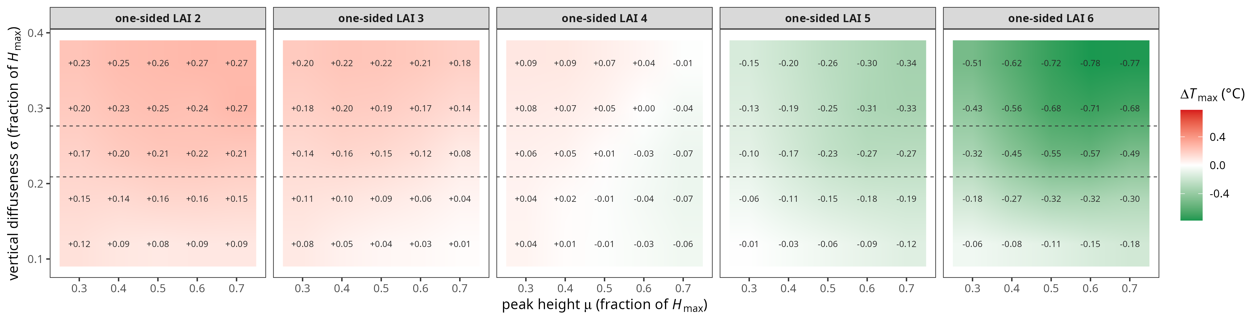
Figure 6 Controlled test of H2: simulated ΔT_{max} over the peak height μ (x-axis) and vertical spread σ (y-axis) of a Gaussian LAD profile, both as fractions of H_{max}, at five one-sided leaf-area levels (LAI 2 to 6; design median 3.48), with cover 0.87 and maximum height 25 m fixed. Red amplifies the open-field maximum and green buffers it; dashed lines mark the middle half of the spread of real profiles (σ 0.21 to 0.28). Raising the peak cools the understorey, and the spread moves ΔT_{max} more than the peak over most of the range; σ below 0.10 H_{max} is not resolved by the ten-layer grid.

4. Discussion

4.1 Leaf quantity as the dominant control and the realised range of the vertical profile
The quantity of foliage controls the simulated buffering, and its vertical arrangement adds little once leaf area, cover and height are fixed. In tree-diversity experiments, the buffering gained with species richness was likewise mediated by higher canopy density (Schnabel et al., 2025). In a young plantation, diverse mixtures that raised canopy cover damped daily vapour-pressure-deficit swings (Park et al., 2026). We hypothesised that the vertical profile is a controlling input of the microclimate (H1) and that shifting foliage upward buffers more (H2). Both mechanisms exist in the model, but over the range real stands span their realised effect is second-order. As a real-versus-uniform contrast, the profile moved ΔT_{max} by a median of 0.02 to 0.07 °C in the three sparser archetypes and by +0.10 °C in the dense P4. There the real profile warmed relative to a uniform one. The contrast stayed at or below the cover step in P2 to P4, and its rank against the leaf-area step depends on the response metric and the summary statistic. The contrast is an upper bound. Measured profiles are nearly invariant within a structural type, and replacing each real profile by its archetype’s mean shape moved ΔT_{max} by 0.01 to 0.07 °C (Section 3.2). The between-stand variation of real profiles is too small to express the mechanism (H1).
The controlled test supports the direction of H2 and adds a second axis. It swept two axes of the profile at fixed leaf area, height and cover, over the leaf-area range the forest occupies (Section 3.3, Fig. 6). Raising the peak cooled the understorey at every level, so H2 holds in direction. Its effect was the smaller of the two axes over most of the range, 0.05 to 0.17 °C. The larger axis was the vertical spread, which H2 did not name. At fixed peak height it moved ΔT_{max} by 0.18 to 0.20 °C at LAI 2, 3 and 5. At LAI 4, nearest the median stand, the peak was the larger axis instead. A more diffuse profile warmed the sparse stands and cooled the dense ones. Both axes steepened with leaf area and reached their widest range at one-sided LAI 6, the dense end above the median stand of 3.48.
Real stands vary little along either axis. The middle half of measured spreads is σ 0.21 to 0.28, within a swept range of 0.12 to 0.36. Denser stands are both more diffuse and buffer more, so spread and density cannot be separated. Over that realised spread the axis moves ΔT_{max} by about 0.05 °C, the same order as the contrast in the sparser archetypes (Table 2). The centroid range is as narrow: real profiles span a middle half of 0.44 to 0.55 of H_{max}, and the open P1 is lower, at 0.40. The vertical arrangement is therefore a real control in the model but a second-order one in these stands. This controlled test does not support a controlling role of the vertical dimension beyond leaf quantity, the question left open in Section 1.
The simulated within-canopy temperature profiles show why the profile contrast stays small at the readout height (Fig. 7). For each archetype, the real LAD profile and a uniform profile of the same LAI, H_{max} and cover give temperature profiles that diverge inside the canopy and converge towards the ground. At 1 m the gap is at most 0.09 °C. This is a 10:00 to 16:00 average, not the hour-of-maximum ΔT_{max} contrast of Table 2. The two agree in size, both near 0.1 °C in the dense P4. The profile shape redistributes the heat source within the canopy, and little of that redistribution reaches the 1 m air temperature.
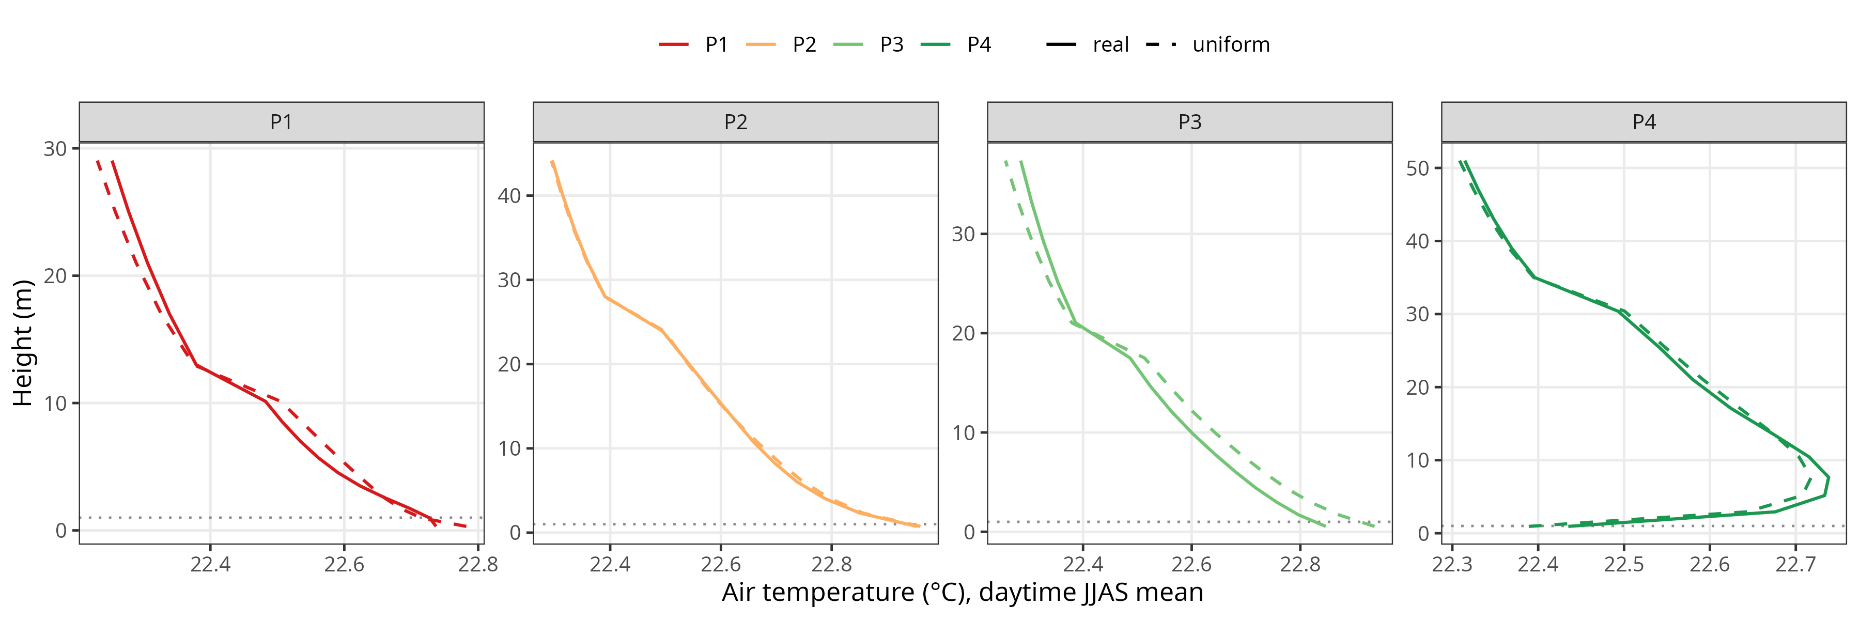
Figure 7 Simulated vertical profile of air temperature per archetype (P1 open to P4 dense), for the real LAD profile (solid) and a uniform profile of the same LAI, H_{max} and cover (dashed), June to September, 10:00 to 16:00. The two profiles diverge inside the canopy and converge at the 1 m readout, where the gap is at most 0.09 °C.
The archetypes differ in VCI, and their simulated within-canopy temperature profiles differ by type (Fig. 7). Both differences follow density. The four archetypes are recovered the same way with and without VCI in the input (Fig. 3). VCI co-varies with leaf area and cover (Appendix C). Because VCI tracks density, a correlation between VCI and buffering does not show that arrangement matters.
The two ends of the gradient respond in opposite ways. In the open P1, added leaf area warms the sub-canopy air. With a sparse canopy the ground and the foliage both absorb radiation into a shallow, poorly mixed layer, and the warm surfaces heat the air faster than the extra foliage shades it. In the dense P4 the same increment acts through shading and the redistribution of radiation down the profile, so it cools. The sign flip is consistent with the mechanism, and the ±0.01 control rules out a solver artefact (Appendix E). One caveat qualifies any comparison across archetypes. The nominal variable values differ between them by construction (Table 1), so a per-unit sensitivity is read at a different operating point in each type. In the dense P4 cover is 0.92 ± 0.03 against a ceiling of one, so its step is truncated to about 8 points and the effect is read close to saturation. Truncation understates the P4 cover effect. In the open P1 the same fixed steps are large fractions of small variables, 28% of the mean leaf area against 10% in P4. The open effect is read where the relative perturbation is largest. Saturation and truncation compress the dense end and do not inflate it.
Leaf area and cover dominate the simulated buffering from the intermediate to the closed archetypes. Their effect is largest in the closed canopy, where buffering is deepest. The profile remains a second-order effect of inconsistent sign. In observational data, canopy openness dominates the diurnal temperature range and vertical stratification adds little (Ehbrecht et al., 2019). This ranking rests on the full contrast, an upper bound. The leaf-quantity control is the variable-level counterpart of the canopy-density control on the offset reported from observational gradients (Kovács et al., 2017). A sensor that measures leaf quantity accurately, without three-dimensional detail, may therefore resolve the controlling structural information (Section 4.3).
One split remains model-internal: leaf area and fractional cover are too collinear to separate empirically (r = 0.94 across the design). The perturbation supplies that split because the two variables enter MuSICA by distinct radiative pathways (Section 2.4), but no observation in this study can confirm or refute it. We therefore read leaf area and cover together as leaf quantity throughout, and never rank one against the other.
The nearest comparable study agrees in part with this ordering (Bouwen, 2025). It imposed a generic beta distribution for the vertical profile, for lack of measured leaf-area-density profiles. The per-plot profiles here supply measured shapes, and the contrast they produce is 0.02 to 0.10 °C over the range real stands span. That study finds maximum height a poor predictor, as we do. Where it reports vertical complexity correlating with buffering, our test suggests why: the index tracks leaf quantity (Appendix C). The two studies differ on saturation. That study finds the deciduous offset insensitive to leaf area above about 4 to 6 m² m⁻², and set by cover beyond it. Here the leaf-area effect is largest in the dense P4, at −0.41 °C per unit of one-sided LAI around a mean LAI of 5.0, and the cover effect is largest there too. The two studies agree on which variables matter, and not on the range over which leaf area acts. Whether the non-saturating leaf-area effect seen here reflects the leaf-area scale and parameterisation of this canopy remains to be tested in stands of other density and leaf habit.

4.2 Scope of the per-plot perturbation
The variable-perturbation sensitivity analysis resolves the two difficulties of observational microclimate models (Section 1). It measures a local partial response at the observed canopies, and it attributes the effect to physical variables instead of concurvity-confounded coefficients. Two limits come with it. Local sensitivities do not sum to the total as an additive budget, but they avoid the baseline-choice and off-manifold ambiguities such a decomposition incurs under strong collinearity. Each sensitivity is also conditional. It is read at the operating point of its archetype, so the ranking mixes a variable’s local effect with the archetype’s position on the manifold. The density dependence of the sensitivities is a result and not an artefact of that conditioning (Fig. 5). The vertical profile is the one input that admits no scalar step, so its effect is a contrast against a uniform reference shape that preserves the plot’s own leaf area, height and cover. The per-plot design also avoids the bias of reading a nonlinear response at the mean profile (Jensen’s inequality).
We chose a mechanistic over a statistical model for inference. A model that solves the energy balance attributes buffering to physical variables. Because it is process-based and not fitted to a site, it supports extrapolation where a fitted sensitivity or equilibrium model only describes (Maclean et al., 2017; Maclean & Klinges, 2021). Such models can be applied outside the conditions they were built in, as when a land surface model is used to project whether understorey buffering persists under future warming (Hes et al., 2024).
We represent vertical structure by the LAD profile itself and add no further indices. The LAD profile is a physical input to MuSICA: it sets the leaf-area density of each of the ten vegetation layers over which the radiative and turbulent balance is solved. VCI and any other index of the profile are summaries of that same profile. Adding them as perturbed variables would feed MuSICA nothing new and would reintroduce the collinearity that rules out regression (Section 1).
At this same site, Gril et al. (2023) mapped the buffering slope statistically from three collinear ALS metrics: maximum height, plant area index and VCI. That model reached R² = 0.91 at a 5 m radius. Its authors note that it cannot say which dimension drives the slope. Coupling the same airborne structure to MuSICA, we find that leaf area and cover drive the slope. The vertical arrangement, resolved by the complexity index and the profile, is a second-order term that opposes the buffering at the dense end (Table E1). The two approaches are complementary: the statistical model maps where the forest buffers, and this one attributes the buffering to leaf quantity.

4.3 Scope and limits
The attribution is a sensitivity analysis internal to MuSICA. It rests on the model’s physical parameterisation (Appendix F) and on the 400-plot cLHS design. It has no independent field validation: no understorey temperature measurement enters this chapter. The coupled model is evaluated against sub-canopy measurements in the companion microclimate-forcing study (Corroyez et al., 2026a, in preparation). One model-internal check rules out numerical noise: a leaf-area control of ±0.01 shows the solver deterministic at the scale of the weakest effects (Appendix E). The attribution does not depend on the typology. A principal component analysis of the variables recovers the archetypes at the 1 m vertical binning with and without VCI (Fig. 3). The ranking does not depend on the archetype label (Fig. 5).
The four types could be read as developmental stages, but height does not order with density (Table 1). P1 is shortest on average and most variable in height (H_{max} 13.3 ± 7.8 m). The intermediate types invert, P2 tall at 26.0 m and P3 shorter at 18.8 m. P4 is both tallest and most closed. P1 is therefore a heterogeneous open class, and its height spread suggests a mix of sparse plots and opened crowns of older stands. A testable reading orders the types from open, light-rich canopies, whether young regeneration or thinned mature stands, to tall closed stands. Linking structural type to developmental stage and management, including the slow recovery of buffering after harvest (Aalto et al., 2023; Starck et al., 2025), needs inventory data this study lacks.
The dominance of leaf quantity has a silvicultural corollary. Thinning and shelterwood cuts lower both leaf area and cover, the two controlling variables, and so weaken the buffer directly. The vertical arrangement of foliage is the weaker control in the measured stands but stays relevant, because thinning from below and thinning from above shift the vertical arrangement in opposite directions. The controlled test moves ΔT_{max} by up to 0.20 °C over the swept profile range at the leaf-area levels these stands occupy, and by more at the dense end (Section 3.3, Fig. 6). Stands here do not differ enough in arrangement for the effect to appear, though a cut could create that difference. Because the open-canopy behaviour of a one-dimensional column is weakly constrained here (Section 3.2) and is tested in the companion study (Corroyez et al., 2026a, in preparation), this corollary holds as a direction, without a quantitative prescription. The design compounds the limit: the cLHS sample floors fractional cover at 0.5, so the attribution has no design points in the regime a heavy cut would create. The corollary restates the trade-off between opening the canopy for regeneration light and keeping a cool understorey. Buffering lost to harvest returns only as leaf area and cover rebuild, on the slow post-harvest timescale (Starck et al., 2025).
The study covers a single site, one leaf-on summer season and one species, and the analysis is internal to MuSICA, so the conclusions are mechanistic and not a landscape prediction. Composition affects the offset: mixing tree species can enlarge the offset in young plantations (Zhang et al., 2022). The leaf-quantity control is nonetheless found beyond temperate oak. In a historically degraded tropical forest, loss of canopy density likewise raises understorey temperature (Marsh et al., 2022).
The response metric is the daytime maximum offset ΔT_{max}. This 1 m offset understates the between-type contrast at the soil surface. Across the four archetype canopies the simulated daytime-mean soil-surface temperature spans 7.4 °C from the open to the dense type, against 0.5 °C for the daytime-mean air temperature at 1 m (not shown). Night-time buffering, controlled by longwave trapping, is a distinct mechanism we do not examine. We claim the mechanistic ordering, not the exact magnitudes.
The result could depend on the forcing and on the leaf-area retrieval. Two corrections leave the variable ranking unchanged: the canopy-height wind correction (Appendix A) and the scan-angle correction (Appendix D).
The 20 m analysis footprint does not drive the result. We re-clipped each plot in circular footprints of 5 to 50 m radius and read every quantity as the shift from the 20 m footprint (Fig. 8). The two response metrics stay within 0.03 °C for ΔT_{max} and 0.004 for the slope. Of the four structural inputs, only maximum height moves with the footprint, by about 2 m, because the highest return in the footprint rises with the area sampled. That variable is thermally negligible (Section 3.2).
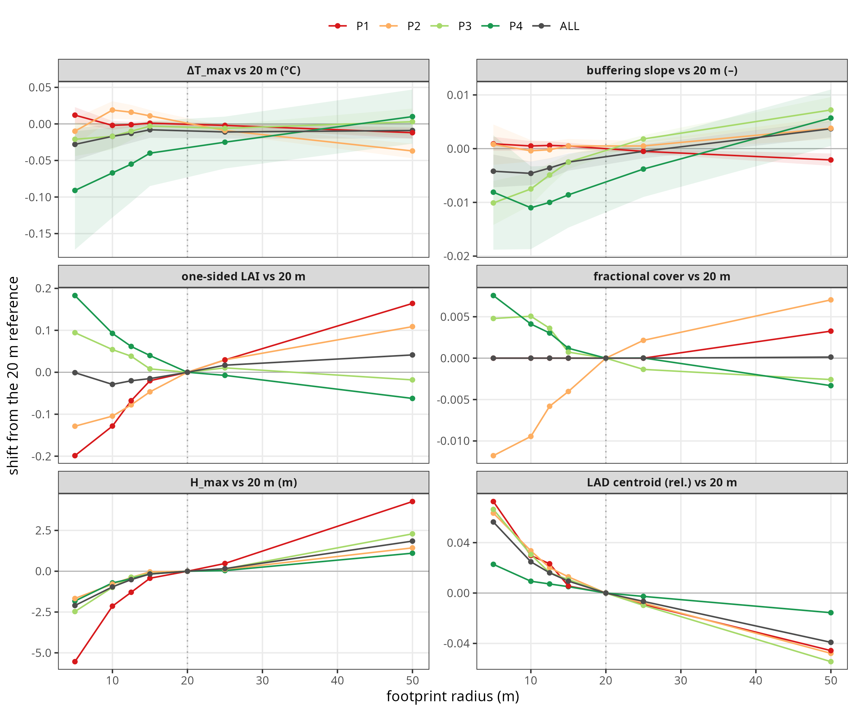
Figure 8 Shift of the canopy inputs and the two response metrics from their 20 m value, for circular footprints of 5 to 50 m radius, pooled over the 400 cLHS plots by archetype. Top row: the two MuSICA responses with 95% intervals. Lower rows: the four structural inputs, of which only maximum height shifts, by about 2 m.
The remaining dependences are properties of the leaf-area input. One assumption links the retrieval to the model. Leaf area is inverted under a spherical leaf-angle distribution with k = 0.5 (Section 2.2), and MuSICA then attenuates radiation under an ellipsoidal one (Appendix F). The two distributions are not identical, and the leaf-area scale is not freely adjustable (Appendix D), so they remain to be reconciled.
A property of the leaf-area input itself is harder to bound. The ALS retrieval returns an effective plant area (Section 2.2) and does not separate woody from foliar surface, so trunks and branches are counted within it. We neither quantify that fraction nor bound its consequence. The scale is also unvalidated. We have no independent ground measurement of leaf area at these plots, so we anchor the retrieval on the published inversion alone. Because the absolute coupling is conditional on that unmeasured scale (Appendix D), we report the variable ranking as the result, and not the absolute coupling.
Because leaf quantity controls the simulated buffering, the next step is to drive the same coupling with a two-dimensional optical proxy of leaf area, for example from Sentinel-2, in place of ALS. The test is whether it resolves the controlling structural information or saturates before it can (Aklilu Tesfaye & Gessesse Awoke, 2021). At this same site, optical and radar predictors already recover part of the microclimate signal a LiDAR model captures (Laslier et al., 2023). A uniform 23% reduction in retrieved leaf area follows from the optimised extinction coefficient of Appendix D. That shift alone changes the simulated coupling, as the companion forcing study measures against sub-canopy observations (Corroyez et al., 2026a, in preparation). An optical proxy should therefore keep its leaf-area error below 23% wherever the absolute coupling matters, although the between-plot ranking survives a shift of that size. Optical indices tend to saturate in dense canopy before reaching such accuracy.

5. Conclusion
Over the Blois canopy gradient, leaf quantity dominates the between-plot sensitivity of the simulated buffering, and its effect is strongest in the closed canopy where buffering is deepest. As a full real-versus-uniform contrast, the vertical LAD profile moves the offset by a median of 0.02 to 0.07 °C in the three sparser archetypes, and by +0.10 °C in the densest. In P2 to P4 it stays at or below the cover step. Replacing each real profile by its archetype mean moves ΔT_{max} by 0.01 to 0.07 °C, so over the design gradient the profile is a real but second-order control (H1).
Shifting foliage upward buffers the understorey more, the direction H2 asserts. The controlled test finds the vertical spread of the profile a stronger axis than its peak height over most of the range, up to 0.20 °C at the leaf-area levels these stands occupy. Real stands vary too little in either axis to reach that effect, so H2 holds in direction but the profile’s realised effect is second-order.
Because leaf quantity controls the simulated buffering, forest management and remote sensing need to track leaf area and cover in these deciduous oak stands. A two-dimensional measure of leaf area and cover may suffice to map buffering. Section 4.3 gives the accuracy such a measure must reach. A companion study tests whether Sentinel-2 resolves that information or saturates before it can (Corroyez et al., 2026b, in revision).

Appendix A. Forcing: station temperature, and a canopy-height wind sensitivity test
The model is driven by the CHS 41 station for air temperature, humidity and precipitation, and by ERA5 reanalysis for the radiative and aerodynamic variables (Section 2.4). Pooled over all hours, ERA5 is 0.96 °C too warm (RMSE 2.06 °C, r = 0.92; Fig. A1a). The bias depends on the time of day: it peaks near +3.6 °C in the early morning, around 06:00 to 09:00 UTC, falls through the day, and turns slightly negative in the evening (Fig. A1b). A forcing with this diurnal bias would distort the simulated within-canopy diurnal cycle and the daytime offset ΔT_{max} the study targets. Only the radiative and aerodynamic variables, less exposed to this near-surface bias, are taken from ERA5. Gaps in the station record are filled from the reanalysis, so the driving series stays continuous and the station series is used wherever it is available.
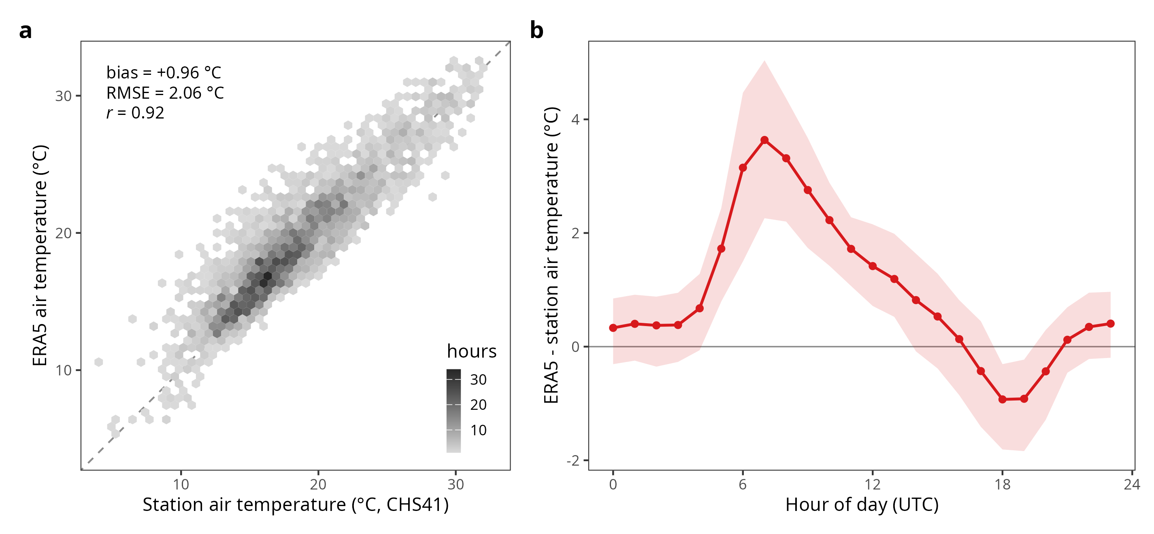
Figure A1 Bias of ERA5 air temperature against the CHS 41 open-field station, summer 2021. (a) Hourly ERA5 versus station temperature (bias +0.96 °C, RMSE 2.06 °C, r = 0.92). (b) Mean diurnal cycle of the bias, ERA5 minus station, with the interquartile range; it peaks near +3.6 °C in the early morning and turns negative in the evening.
The baseline drives every simulation with the ERA5 10 m open-field wind as delivered (Section 2.4). MuSICA needs the wind just above each canopy, so we tested what a height correction would change. Under a neutral surface layer, a logarithmic wind profile maps the open-field 10 m wind to the wind at h + 2 m above a canopy of height h. The correction factor is U(h+2m) / U(10m) = [ln(2 + h − d) − ln(z₀)] / [ln(10) − ln(z_{0,ERA})]. The zero-plane displacement is d = 0.7h and the canopy roughness length z₀ = 0.1h. The ERA5 surface roughness for the Blois grid cell, taken from the reanalysis forecast-surface-roughness field, is 0.44 m and nearly constant over the summer window (0.438 to 0.443 m from June to September). Open grassland has a roughness of about 0.01 m and closed forest about 1 m, so the Blois value lies between them. At that roughness the correction factor is about 0.41 to 0.48 across the 13 to 33 m archetype canopy heights (Fig. A2). The baseline ERA5 10 m wind is then roughly 2.1 to 2.4 times the corrected estimate just above the canopy. As a sensitivity test, we reran the attribution with the corrected wind applied offline per plot at its canopy height, on a subset of eight plots of the CHS 41 configuration, two per archetype, each rerun with and without the correction. Per unit of leaf area, the leaf-area effect is −0.42 °C in P4 with the correction against −0.41 °C without. It is −0.15 against −0.09 °C in P3, −0.12 against −0.11 °C in P2, and about +0.09 against +0.05 °C in P1. P4 stays the largest and P1 the only warming. P2 and P3 differ by at most 0.03 °C in both runs and swap order. The variable ranking is unchanged (Section 4.3).
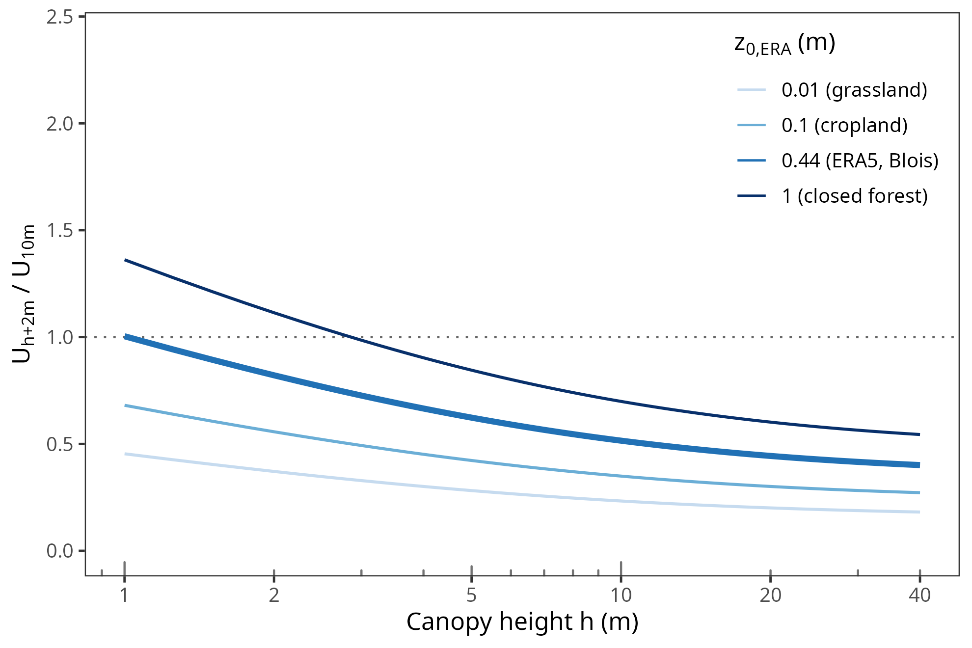
Figure A2 Neutral log-profile correction factor U(h+2m) / U(10m) from the ERA5 10 m open-field wind to the wind just above a canopy of height h, with displacement d = 0.7h and canopy roughness z₀ = 0.1h. The four curves are reanalysis roughness lengths z_{0,ERA} from 0.01 m (grassland) to 1 m (closed forest), with the Blois value of 0.44 m in bold; at that value the factor is 0.41 to 0.48 over the 13 to 33 m canopy heights of this study. The correction is used only in the sensitivity test of this appendix, not in the baseline simulations.

Appendix B. The within-canopy gradient, per variable
Microclimate, leaf temperature and gas exchange all vary across forest strata (Vinod et al., 2023), so the vertical dimension matters ecologically even where it moves our 1 m response metric little. Figure 7 shows the within-canopy temperature profile for the real and the uniform LAD profile per archetype. Figure B1 extends the same analysis to each variable separately, on each archetype’s median canopy, for temperature, wind, humidity and vapour-pressure deficit. Each archetype’s median canopy was perturbed by the fixed native steps of Section 2.6. Profiles were interpolated onto a common relative-height grid before averaging, and the axis stops at 1.4 because not all per-plot grids extend above it. Because the model’s layers scale with canopy height, each run was normalised by its own H_{max} (the perturbed run by H_{max} + 1 m). Every difference is taken at a matched fraction of canopy height, so the height step is read at constant relative height. Figure 4 reads it at a fixed 1 m and finds |effect| ≤ 0.001 °C per metre. These within-canopy profiles are model constructs, with no multi-height measurement to anchor them.
Among the three scalar steps the ordering is that of the main attribution: leaf area and cover exceed maximum height in every archetype. On the 10:00 to 16:00 mean, the leaf-area step warms the sub-canopy air by 0.055 °C in P1 and cools it by 0.227 °C in P4. This mean is a different measure from ΔT_{max}. The wind response to the leaf-area step is negative throughout, as expected when foliage is added. On wind the profile contrast exceeds the scalar steps, but a full real-versus-uniform contrast and a fixed step are not commensurable. These representative-canopy panels are consistent with the full-contrast effect of Section 3.2 but do not establish it independently. Figure 4 remains the per-plot result.
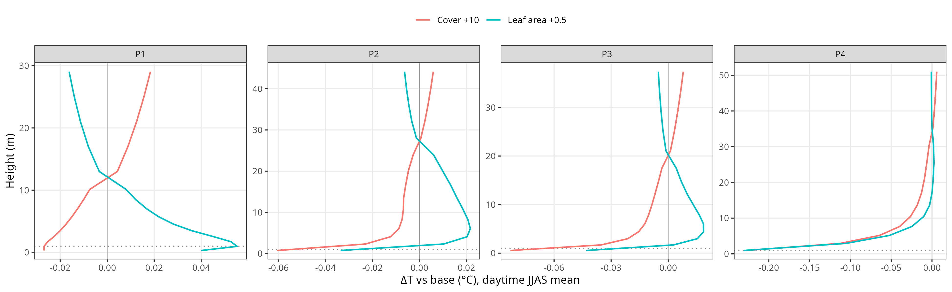
Figure B1 Mean within-canopy response of air temperature, wind, relative humidity and vapour-pressure deficit (rows) to each perturbation (coloured lines) per archetype, averaged over June to September and 10:00 to 16:00 on the forcing clock. The dashed line marks no effect, and ΔLAD is the real − uniform profile contrast, not a step.

Appendix C. Variable correlation structure, per archetype and overall
We report the pairwise Pearson correlations among the canopy variables over all 400 cLHS plots and within each archetype (Fig. C1). The variables are LAI, fractional cover and maximum height as scalars, and the vertical complexity index VCI as a scalar descriptor of structural complexity. Over the cLHS design the variables are intercorrelated (LAI-fCover r = 0.94, LAI-VCI r = 0.73). A single regression therefore cannot attribute the thermal effect to one variable. We used a per-archetype variable-perturbation sensitivity analysis instead, around each plot’s own measured canopy (Section 2.4).
This collinearity persists within each archetype. The within-archetype LAI-fCover correlation is weakest in the open P1, r = 0.79. It is 0.97 in P2, 0.93 in P3 and 0.95 in P4.
The per-archetype perturbation does not rely on the variables being decorrelated within an archetype. It isolates each variable’s partial response by moving that variable a small step while the others are held at their real values. Because LAI and fractional cover enter the canopy scheme as separate inputs with distinct mechanisms, the model assigns each a distinct sensitivity (Table 2). Their relative size depends on the choice of steps and is not interpreted as a ranking (Section 3.2). The split between leaf area and cover is a model construct the collinear field data cannot confirm (Section 4.1). Where they are most collinear, the single-variable step also departs most from the joint distribution the canopy follows. The leaf-quantity-versus-arrangement contrast is different in kind: it is a contrast of profile shape at the plot’s own leaf area, height and cover. Leaf area is held by construction, not by statistical control.
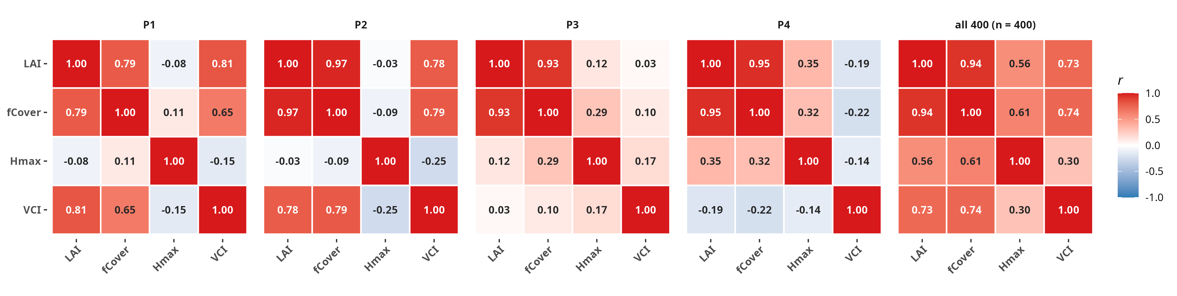
Figure C1 Pearson correlation matrices among LAI, fCover, H_{max} and VCI (structural-complexity scalar), within each archetype P1 to P4 and over all 400 cLHS points. LAI-fCover reaches r = 0.97 in P2, 0.93 in P3 and 0.95 in P4, and 0.79 at its weakest, in the open P1.
The design’s dispersion reproduces real variability. One-sided LAI disperses comparably across archetypes and fractional cover saturates towards one in the dense types. Height behaves differently. In the open P1 height is decoupled from cover (within-archetype Pearson r = 0.11). It spans 4 to 35 m there, almost the whole forest height range. In the dense archetypes height and cover are correlated. In P1 the design therefore probes height independently of density, and H_{max} dispersion is largest there.
VCI is defined as the Shannon entropy of the vertical distribution of returns above ground, normalised to range from zero to one (Van Ewijk et al., 2011),
$$VCI=−\frac{\sum_{i=1}^{HB}{p_{i}}lnp_{i}}{ln(HB)},$$
where $p_{i}$ is the proportion of returns in height bin $i$ and $HB$ the number of 1 m height bins spanning the canopy. The bins are in absolute metres above ground, so VCI is computed on the metric profile and not rescaled by maximum height. It is distinct from the height-normalised (z/H_{max}) LAD profile used to build the typology (Section 2.3).
To make the redundancy of VCI explicit, we ran a principal component analysis on the four scalar variables with and without VCI and asked whether the four archetypes are recovered either way (Fig. 3). Including VCI changes little. Leaf area and fractional cover load together on the first component, the density axis (loadings −0.55 and −0.56). PC1 explains about 75% of the variance. VCI loads on both components (PC1 −0.47, PC2 −0.55). The case for the redundancy of VCI rests on two other facts. VCI correlates with leaf area and cover (r = 0.73 and 0.74; Fig. C1), and the plots separate into the four archetypes the same way with and without it. VCI adds no independent structural dimension to the typology: it is a scalar summary of the density gradient the other variables already describe. The vertical profile therefore enters the model as the full LAD profile (Section 2.4) and not as VCI.

Appendix D. LiDAR scan-angle correction of leaf area
Correcting the LiDAR leaf area for beam scan angle lowers it by about 5% and leaves the variable ranking unchanged. The foliage-profile inversion (Section 2.2) counts returns per height layer and converts them to leaf-area density assuming the beams travel vertically, so the path length through a layer equals the layer thickness. Off-nadir beams travel a longer path, l = dz · ⟨sec θ⟩, where θ is the scan angle. The path-corrected leaf-area density is then the vertical estimate divided by the mean secant of the scan angles over the returns. Scan geometry biases area-based LiDAR metrics (Dayal et al., 2023), and consistent estimates of light attenuation across airborne sensors require intercalibration (Vincent et al., 2023).
The survey was flown by ALTOA with a RIEGL VQ-780i near-infrared scanner (Partenavia P68 at 900 m altitude, 2000 kHz pulse frequency, ±30° nominal scan angle). The mean point density was 72.6 pts m⁻² (9.7 ground returns m⁻²) at 4.5 cm vertical precision (Gril et al., 2023).
At Blois the return scan angles run from −32° to +33°, just beyond the ±30° nominal field of view. The excess comes from aircraft roll. The median angle magnitude is 16° and the 95th percentile 29°. This gives ⟨sec θ⟩ ≈ 1.05 and a leaf-area reduction of about 5%, nearly uniform across plots (standard deviation 1.5%; Fig. D1). We applied this correction to all leaf areas reported here. Like the wind sensitivity test (Appendix A), it leaves the variable ranking unchanged. We verified this by re-running the attribution. A near-uniform 5% rescaling moves every plot’s leaf area by the same fraction, so it shifts the absolute magnitudes without reordering the sensitivities.
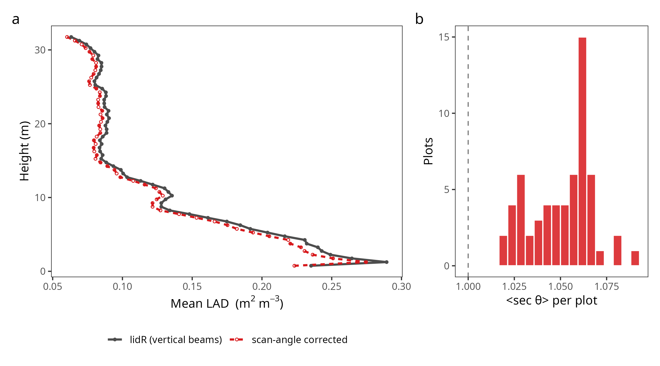
Figure D1 Scan-angle correction of leaf-area density, characterised on a 53-plot ALS sample at Blois and applied to all 400 design plots. (a) Mean leaf-area-density profile from the standard lidR inversion (grey) and after the scan-angle correction (red dashed); the corrected profile lies about 5% below at every height. (b) Per-plot ⟨sec θ⟩ factor: all values lie between 1.02 and 1.09.
We also considered the extinction coefficient itself. An optimised value k = 0.65 was obtained for this ALS product in our companion Sentinel-2/LiDAR retrieval study (Corroyez et al., 2026b, in revision). It maximises inter-sensor consistency of the leaf area but reduces the leaf area by a further 23%. The leaf area most consistent between sensors is therefore not guaranteed to be the one that best couples to the microclimate. We kept the conventional k = 0.5 for the coupling rather than import a coefficient optimised for a different objective. The consequence of the 23% rescaling for the simulated coupling is assessed in the companion microclimate-forcing study (Corroyez et al., 2026a, in preparation). There a shift of that size changes the simulated coupling, so the leaf-area scale is not freely adjustable. A 23% shift in retrieved leaf area is within the range of clumping and extinction-coefficient uncertainty, so the absolute coupling is not demonstrated to transfer. At a site whose leaf area departs from the k = 0.5 proxy, the absolute effects would not hold. Only the variable ranking, which the near-uniform corrections leave intact, transfers beyond this dataset.

Appendix E. Uncertainty of the variable effects
Each plot contributes both directions of every scalar step, so the data give both the sign and the curvature of each effect. Table 2 of the main text gives the ΔT_{max} effects with their intervals. Table E1 gives the same design on the buffering slope and shows which of those patterns depend on the response metric. Maximum height stays at or below 0.001 per metre. Leaf area and cover keep both their sign and their strengthening towards the dense end. The three scalar sensitivities therefore transfer to the slope. The profile contrast is small in the open and intermediate archetypes (+0.002 in P1, −0.002 in P2, +0.008 in P3) and largest in the dense P4 (+0.027). In magnitude it matches the leaf-area step in P3 and exceeds it in P4 (0.027 against 0.022), with the opposite sign. It stays at or below the cover step in both (0.012 and 0.030 in magnitude). Its positive sign in P3 and P4 means the real profile weakens buffering relative to the uniform one.
A separate control rules out numerical noise behind the small effects. Perturbing leaf area on the CHS 41 forcing by a physically negligible ±0.01, a step of 0.02 in total, moved ΔT_{max} by a median of 0.003 °C over 40 plots. That response is consistent with the linear extrapolation of the ±0.5 step and keeps the archetype-specific sign, warming by 0.001 °C in the open P1 and cooling by 0.007 °C in the dense P4. In P4 the 0.007 °C matches the 0.008 °C predicted by proportion from the 0.5-step effect (0.205 °C, Section 3.2). MuSICA is therefore deterministic at this scale, and no numerical floor masks the weak effects. The same control calibrates the height effect. At 0.001 °C per metre or less, moving maximum height by a whole metre shifts ΔT_{max} less than moving leaf area by two hundredths of a unit.
Table E1. Median change in the micro-macro buffering slope (dimensionless) per archetype for each fixed step, with 95% bootstrap confidence interval, on the same design and the same plots as Table 2. Unlike Table 2, each step direction is reported with its own raw sign, so the up and down rows of a monotonic response carry opposite signs.
Effect | P1 | P2 | P3 | P4
LAI +0.5 | +0.002 (+0.001, +0.002) | −0.012 (−0.013, −0.011) | −0.008 (−0.009, −0.007) | −0.022 (−0.024, −0.021)
LAI −0.5 | −0.002 (−0.002, −0.002) | +0.011 (+0.010, +0.012) | +0.007 (+0.006, +0.008) | +0.020 (+0.019, +0.021)
fCover +10 pts | −0.002 (−0.003, −0.002) | −0.016 (−0.017, −0.014) | −0.012 (−0.013, −0.011) | −0.030 (−0.032, −0.029)
fCover −10 pts | +0.003 (+0.003, +0.004) | +0.015 (+0.014, +0.016) | +0.012 (+0.010, +0.013) | +0.029 (+0.027, +0.030)
H_{max} +1 m | −0.000 (−0.000, −0.000) | −0.000 (−0.000, −0.000) | −0.001 (−0.001, −0.001) | −0.000 (−0.000, +0.000)
H_{max} −1 m | +0.000 (+0.000, +0.000) | +0.001 (+0.001, +0.001) | +0.001 (+0.001, +0.001) | +0.001 (+0.000, +0.001)
profile (full contrast) | +0.002 (+0.002, +0.003) | −0.002 (−0.005, +0.000) | +0.008 (+0.004, +0.015) | +0.027 (+0.023, +0.031)

Appendix F. MuSICA model configuration
We simulated stand microclimate with MuSICA v3.2.3, a multilayer soil-vegetation-atmosphere transfer model (Ogée et al., 2003), using the official binary released under the EUPL. The model ran for a single broadleaf deciduous species, sessile oak (Q. petraea), over the whole of 2021 at an hourly time step. The forcing file is MuSICA_in_CHS41-Blois_2021-station-hsbl-Rmerge.nc. The four-month analysis window, 1 June to 30 September, is preceded by five months of spin-up. The atmosphere is coupled in iterative surface-boundary-layer mode (“yoyo”). The vertical domain comprises 15 air layers and 10 vegetation layers, both fixed by air_resolution_level = 2 and not chosen here. The LiDAR LAD profile is mapped onto the 10 vegetation layers. Within each time step the model reconciles the canopy-atmosphere fluxes with the atmosphere up to a blending height. Above that height the flow no longer responds to landscape heterogeneity (Garratt, 1994). The model takes that blending height as a prescribed input and does not derive it internally. The surface-boundary-layer height the yoyo requires is an hourly series archived in the site forcing file, which the model reads directly as the blending height. We took that series from the MERRA-2 reanalysis for the Blois grid cell (Gelaro et al., 2017); its median is 550 m. Bouwen (2025) instead derived that height from ERA5, following the reanalysis boundary-layer-height climatology of Seidel et al. (2012).
The soil is resolved on an irregular grid to 1.6 m depth with van Genuchten retention. Phenology follows a parametric deciduous scheme with a single leaf cohort scaled to each plot’s leaf area. The leaf energy balance is solved separately for sunlit and shaded and for wet and dry leaf fractions. The vertical leaf-area-density profile is the per-plot LiDAR profile, or its uniform counterpart for the profile contrast; no parametric default is used.
The scalar perturbations of Section 2.6 preserve that profile’s shape by construction. A change in leaf area rescales the whole density profile by a single factor, so every layer keeps its share. A change in maximum height stretches the profile in relative height, z/H_{max}, before it is re-interpolated onto the 1 m grid. Neither redistributes foliage vertically.
The main settings are given in Table F1 and the soil-hydraulic and leaf parameters in Table F2; the complete namelist files are archived with the code.
Table F1. MuSICA v3.2.3 configuration, identical for every simulation reported here, for the 400 cLHS design plots of the variable perturbation at Blois (central Loire, France) in 2021. Only the leaf-area-density profile, leaf area index, fractional cover and maximum height vary between plots; they are the per-plot LiDAR inputs. Soil-hydraulic and leaf parameters are in Table F2.
Component | Setting
Model and version | MuSICA v3.2.3 (Ogée et al., 2003), INRAE, EUPL-licensed, official binary
Atmosphere coupling | Iterative surface-boundary-layer mode (“yoyo”, ABL_flag = ‘iter’): near-surface scalars computed up to the surface-boundary-layer height, then recomputed at the reference height
Boundary-layer height | Hourly surface-boundary-layer height (h_sbl) from MERRA-2 (Gelaro et al., 2017), archived in the forcing file (median 550 m), the input the yoyo requires
Forcing file | MuSICA_in_CHS41-Blois_2021-station-hsbl-Rmerge.nc, hourly
Forcing sources | Air temperature, relative humidity and precipitation from the CHS 41 station (Blois); incoming shortwave and longwave radiation, 10 m wind speed (as delivered, no height correction; Appendix A), and surface pressure from ERA5; surface-boundary-layer height from MERRA-2, archived in the same file
Simulation period | Full year 2021 (analysis window 1 June to 30 September)
Time step | Hourly (3600 s)
Vertical grid | 15 air layers and 10 vegetation layers, both set by air_resolution_level = 2 and not tuned (the LiDAR leaf-area-density profile is mapped onto the 10 vegetation layers); one leaf-age class
Leaf energy balance | Solved separately for sunlit and shaded, and wet and dry leaf fractions
Radiation, extinction | Leaf-inclination (ellipsoidal) distribution, leaf inclination index 0.63; LiDAR leaf area entered two-sided (one-sided LAI doubled before input)
Canopy clumping | CLUMPING_FACTOR, set per plot to the LiDAR fractional cover (Section 2.4); the namelist default is not used
Radiation, soil | Soil albedo 0.15 (visible) and 0.28 (near-infrared); soil emissivity 0.97
Soil, grid | Irregular vertical grid (15 layers) to 1.6 m depth; depth-dependent parameters at 4 nodes (0.04, 0.14, 0.28, 0.8 m)
Soil, hydraulics | van Genuchten retention; θ_{sat} 0.54 m³ m⁻³ at the surface grading to 0.47 m³ m⁻³ at depth; residual water content 0.02 m³ m⁻³
Soil, initialisation | Initialised on 1 January at 0.40 m³ m⁻³ and 283 K at the surface grading to 278 K at depth, then integrated forward with no multi-year spin-up, so the four-month analysis window is preceded by five months of model time
Phenology | Parametric deciduous scheme; budburst on day-of-year 115; single leaf cohort with maximum leaf area set to each plot’s two-sided leaf area (the vertical distribution is set by the LiDAR profile, not the parametric default)
Stand | Single broadleaf deciduous species, sessile oak (Q. petraea)
LiDAR | Extinction coefficient k = 0.5 (Appendix D)
Table F2. Additional soil-hydraulic and leaf parameters as set in the run namelists, identical across plots. Where a parameter is depth-dependent, the four values are the soil nodes of Table F1 in order (0.04, 0.14, 0.28 and 0.8 m depth). Units follow the namelist convention (UNITS FOR h_{s} AND K_{sat} TO BE SUPPLIED).
Parameter | Value
Soil retention model | van Genuchten (RETENTION_CURVE_MODEL_FLAG = 3), with van Genuchten hydraulic conductivity (HYDRAULIC_COND_MODEL_FLAG = 2)
Air-entry parameter h_{s} (by depth) | 1.48, 2.17, 2.81, 2.81
Retention shape parameter n | 1.05 (all depths)
Exponent m | 0.5 (all depths); not used under this flag combination, since the retention model fixes its exponent internally to 1 and m enters only the Brooks and Corey conductivity branch
Saturated hydraulic conductivity K_{sat} (by depth) | 0.106, 0.041, 0.013, 0.001
Leaf characteristic dimension | 0.05 m
Leaf mass per area (canopy top) | 0.1 kg m⁻²
Leaf inclination index (radiation scheme) | 0.63
Stomatal conductance | slope g₁ = 10, intercept g₀ = 0.001 mol m⁻² s⁻¹, hypostomatous
Stomatal water-potential limitation | half-response at leaf xylem potential −1.3 MPa, shape 2.6
J_{max} temperature response | optimum 38 °C, curvature θ = 0.7
Photosynthetic capacity (V_{cmax25}, J_{max25}) | MuSICA v3.2.3 default broadleaf parameterisation

Supplementary figures
The main figures are computed over all summer days. We repeated the analyses over the hottest 10% of days (13 days, ranked by the station daily maximum), because buffering matters most during heat extremes. The result is unchanged: leaf quantity controls the buffering on hot days as over the full summer. Most effects are larger under heat, and so is their spread. The per-plot dispersion of the leaf-area effect widens by a factor of about 1.4 to 1.7 relative to the full summer, so we interpret the hot-day medians as a direction only.
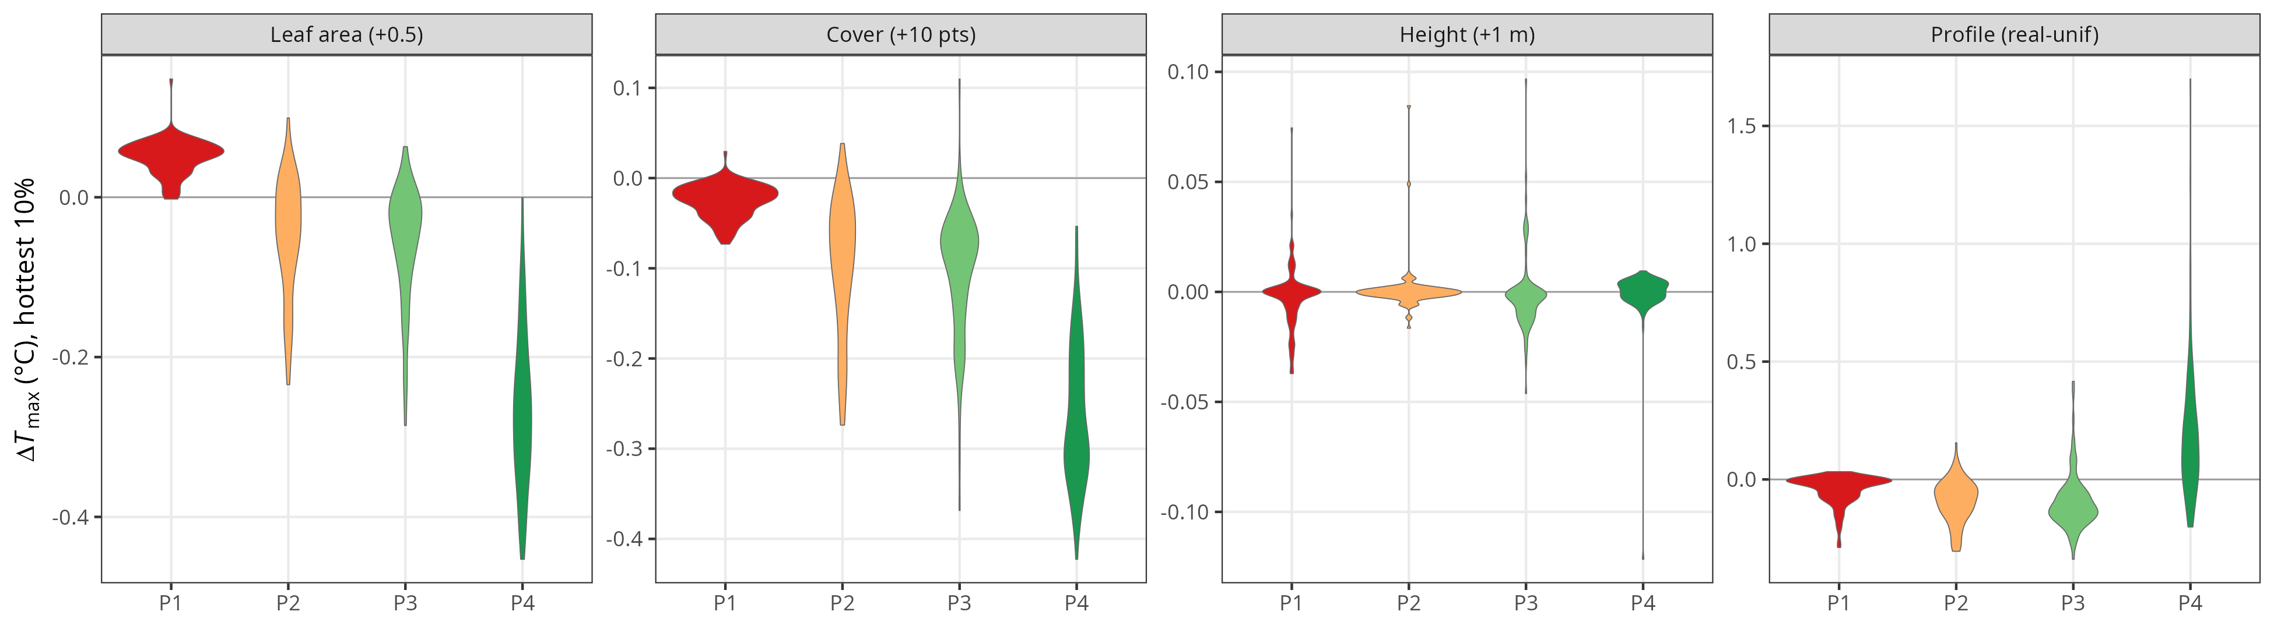
Figure S1 Variable attribution as in Figure 4 over the hottest 10% of days. Leaf quantity remains dominant in the dense P4 (leaf area +0.5 giving −0.268 °C, cover +10 points −0.284 °C). The full-contrast profile effect grows in magnitude in the intermediate archetypes P2 and P3 (−0.078 and −0.121 °C, against −0.052 and −0.065 °C over the full summer), and maximum height stays negligible.

Declarations

Ethics approval and consent to participate
Not applicable. This study involves no human participants, human data, human tissue, or animals.

Consent for publication
Not applicable. This manuscript contains no data from any individual person.

Availability of data and materials
The analysis is implemented as a staged pipeline (run_chapter1.R) that regenerates every figure, table and number reported here from the archived simulation outputs, in a few minutes and without re-running the model. Regenerating the archived outputs themselves requires MuSICA and the raw airborne laser scanning data, and takes far longer. The pipeline, the MuSICA run namelists of Appendix F, and the derived variable, design and simulation products are archived at (REPOSITORY AND DOI TO BE SUPPLIED). MuSICA v3.2.3 (Ogée et al., 2003) is distributed by INRAE under the EUPL (DISTRIBUTION SOURCE TO BE SUPPLIED). The ERA5 reanalysis (Hersbach et al., 2020) is publicly available from the Copernicus Climate Data Store. The airborne laser scanning point cloud and the CHS 41 station record are available on request, subject to the agreements under which they were obtained (PROVENANCE AND CONTACT TO BE CONFIRMED). Software versions used for the retrieval, typology, design and statistical analysis are to be listed here (R AND PACKAGE VERSIONS TO BE SUPPLIED).

Competing interests
(TO BE COMPLETED BY THE AUTHORS. If none: “The authors declare that they have no competing interests.”)

Funding
(TO BE COMPLETED BY THE AUTHORS: all sources of funding for the reported research, and whether any funder had a role in conceptualisation, design, data collection, analysis, the decision to publish, or manuscript preparation.)

Authors’ contributions
(TO BE COMPLETED BY THE AUTHORS, using author initials, e.g. “NC designed the study, ran the simulations and wrote the manuscript. All authors read and approved the final manuscript.”)

Acknowledgements
(TO BE COMPLETED BY THE AUTHORS: anyone who contributed but does not meet the authorship criteria. Permission to acknowledge must be obtained from those named. If none, write “Not applicable”.)

References
Aalto, I., Aalto, J., Hancock, S., Valkonen, S., & Maeda, E. E. (2023). Quantifying the impact of management on the three-dimensional structure of boreal forests. Forest Ecology and Management, 535, 120885. https://doi.org/10.1016/j.foreco.2023.120885
Aklilu Tesfaye, A., & Gessesse Awoke, B. (2021). Evaluation of the saturation property of vegetation indices derived from sentinel-2 in mixed crop-forest ecosystem. Spatial Information Research, 29(1), 109–121. https://doi.org/10.1007/s41324-020-00339-5
Atkins, J. W., Shiklomanov, A., Mathes, K. C., Bond-Lamberty, B., & Gough, C. M. (2023). Effects of forest structural and compositional change on forest microclimates across a gradient of disturbance severity. Agricultural and Forest Meteorology, 339, 109566. https://doi.org/10.1016/j.agrformet.2023.109566
Baldocchi, D., Matt, D., Hutchison, B., & Mcmillen, R. (1984). Solar radiation within an oak—hickory forest: An evaluation of the extinction coefficients for several radiation components during fully-leafed and leafless periods. Agricultural and Forest Meteorology, 32(3-4), 307–322. https://doi.org/10.1016/0168-1923(84)90056-X
Bonan, G. B., Patton, E. G., Harman, I. N., Oleson, K. W., Finnigan, J. J., Lu, Y., & Burakowski, E. A. (2018). Modeling canopy-induced turbulence in the Earth system: A unified parameterization of turbulent exchange within plant canopies and the roughness sublayer (CLM-ml V0). Geoscientific Model Development, 11(4), 1467–1496. https://doi.org/10.5194/gmd-11-1467-2018
Bouvier, M., Durrieu, S., Fournier, R. A., & Renaud, J.-P. (2015). 7_Generalizing predictive models of forest inventory attributes using an area-based approach with airborne LiDAR data. Remote Sensing of Environment, 156, 322–334. https://doi.org/10.1016/j.rse.2014.10.004
Bouwen, K. (2025). Interactions entre la structure de la canopée et le microclimat du sous-étage : implications pour la régénération des forêts [PhD thesis]. Université de Bordeaux.
Bouwen, K., Brunet, Y., Lafont, S., Domec, J.-C., Charru, M., Chipeaux, C., Berveiller, D., Cuntz, M., Simioni, G., Kolari, P., Krol, M., Van Der Molen, M., Klosterhalfen, A., Knohl, A., & Ogée, J. (2026). Microclimate variations in the roughness sublayer above European forests: Assessing theories using ICOS network data. Agricultural and Forest Meteorology, 389, 111442. https://doi.org/10.1016/j.agrformet.2026.111442
Brusse, T., Lenoir, J., Boisset, N., Spicher, F., Dubois, F., Caro, G., & Marrec, R. (2024). Mechanistically mapping near-surface temperature in the understory of temperate forests: A validation of the microclima R package against empirical observations. Agricultural and Forest Meteorology, 346, 109894. https://doi.org/10.1016/j.agrformet.2024.109894
Campbell, G. S. (1986). Extinction coefficients for radiation in plant canopies calculated using an ellipsoidal inclination angle distribution. Agricultural and Forest Meteorology, 36(4), 317–321. https://doi.org/10.1016/0168-1923(86)90010-9
Dayal, K. R., Durrieu, S., Lahssini, K., Ienco, D., & Monnet, J.-M. (2023). Enhancing Forest Attribute Prediction by Considering Terrain and Scan Angles From Lidar Point Clouds: A Neural Network Approach. IEEE Journal of Selected Topics in Applied Earth Observations and Remote Sensing, 16, 3531–3544. https://doi.org/10.1109/JSTARS.2023.3263595
De Frenne, P., Zellweger, F., Rodríguez-Sánchez, F., Scheffers, B. R., Hylander, K., Luoto, M., Vellend, M., Verheyen, K., & Lenoir, J. (2019). Global buffering of temperatures under forest canopies. Nature Ecology & Evolution, 3(5), 744–749. https://doi.org/10.1038/s41559-019-0842-1
De Lombaerde, E., Vangansbeke, P., Lenoir, J., Van Meerbeek, K., Lembrechts, J., Rodríguez-Sánchez, F., Luoto, M., Scheffers, B., Haesen, S., Aalto, J., Christiansen, D. M., De Pauw, K., Depauw, L., Govaert, S., Greiser, C., Hampe, A., Hylander, K., Klinges, D., Koelemeijer, I., … De Frenne, P. (2022). Maintaining forest cover to enhance temperature buffering under future climate change. Science of The Total Environment, 810, 151338. https://doi.org/10.1016/j.scitotenv.2021.151338
De Pauw, K., Sanczuk, P., Meeussen, C., Depauw, L., De Lombaerde, E., Govaert, S., Vanneste, T., Brunet, J., Cousins, S. A. O., Gasperini, C., Hedwall, P.-O., Iacopetti, G., Lenoir, J., Plue, J., Selvi, F., Spicher, F., Uria-Diez, J., Verheyen, K., Vangansbeke, P., & De Frenne, P. (2022). Forest understorey communities respond strongly to light in interaction with forest structure, but not to microclimate warming. New Phytologist, 233(1), 219–235. https://doi.org/10.1111/nph.17803
Díaz-Calafat, J., Uria-Diez, J., Brunet, J., De Frenne, P., Vangansbeke, P., Felton, A., Öckinger, E., Cousins, S. A. O., Bauhus, J., Ponette, Q., & Hedwall, P.-O. (2023). From broadleaves to conifers: The effect of tree composition and density on understory microclimate across latitudes. Agricultural and Forest Meteorology, 341, 109684. https://doi.org/10.1016/j.agrformet.2023.109684
Ehbrecht, M., Schall, P., Ammer, C., Fischer, M., & Seidel, D. (2019). Effects of structural heterogeneity on the diurnal temperature range in temperate forest ecosystems. Forest Ecology and Management, 432, 860–867. https://doi.org/10.1016/j.foreco.2018.10.008
Frey, S. J. K., Hadley, A. S., Johnson, S. L., Schulze, M., Jones, J. A., & Betts, M. G. (2016). Spatial models reveal the microclimatic buffering capacity of old-growth forests. Science Advances, 2(4), e1501392. https://doi.org/10.1126/sciadv.1501392
Fujiwara, T., Marod, D., Thinkamphaeng, S., Phumphuang, W., Nakmuenwai, P., Kamyo, T., Brede, B., Naito, H., & Hosoi, F. (2026). Evaluating the sensitivity of Sentinel-2 reflectance to vertical canopy profiles using a voxel-based point density proxy framework. International Journal of Remote Sensing, 1–24. https://doi.org/10.1080/01431161.2026.2720316
Garratt, J. (1994). Review: The atmospheric boundary layer. Earth-Science Reviews, 37(1-2), 89–134. https://doi.org/10.1016/0012-8252(94)90026-4
Gelaro, R., McCarty, W., Suárez, M. J., Todling, R., Molod, A., Takacs, L., Randles, C. A., Darmenov, A., Bosilovich, M. G., Reichle, R., Wargan, K., Coy, L., Cullather, R., Draper, C., Akella, S., Buchard, V., Conaty, A., Da Silva, A. M., Gu, W., … Zhao, B. (2017). The Modern-Era Retrospective Analysis for Research and Applications, Version 2 (MERRA-2). Journal of Climate, 30(14), 5419–5454. https://doi.org/10.1175/JCLI-D-16-0758.1
Greiser, C., Meineri, E., Luoto, M., Ehrlén, J., & Hylander, K. (2018). Monthly microclimate models in a managed boreal forest landscape. Agricultural and Forest Meteorology, 250–251, 147–158. https://doi.org/10.1016/j.agrformet.2017.12.252
Gril, E., Laslier, M., Gallet-Moron, E., Durrieu, S., Spicher, F., Le Roux, V., Brasseur, B., Haesen, S., Van Meerbeek, K., Decocq, G., Marrec, R., & Lenoir, J. (2023). Using airborne LiDAR to map forest microclimate temperature buffering or amplification. Remote Sensing of Environment, 298, 113820. https://doi.org/10.1016/j.rse.2023.113820
Haesen, S., Lembrechts, J. J., De Frenne, P., Lenoir, J., Aalto, J., Ashcroft, M. B., Kopecký, M., Luoto, M., Maclean, I., Nijs, I., Niittynen, P., Van Den Hoogen, J., Arriga, N., Brůna, J., Buchmann, N., Čiliak, M., Collalti, A., De Lombaerde, E., Descombes, P., … Van Meerbeek, K. (2021). ForestTemp – Sub-canopy microclimate temperatures of European forests. Global Change Biology, 27(23), 6307–6319. https://doi.org/10.1111/gcb.15892
Haesen, S., Lenoir, J., Gril, E., De Frenne, P., Lembrechts, J. J., Kopecký, M., Macek, M., Man, M., Wild, J., & Van Meerbeek, K. (2023). Microclimate reveals the true thermal niche of forest plant species. Ecology Letters, 26(12), 2043–2055. https://doi.org/10.1111/ele.14312
Hardwick, S. R., Toumi, R., Pfeifer, M., Turner, E. C., Nilus, R., & Ewers, R. M. (2015). The relationship between leaf area index and microclimate in tropical forest and oil palm plantation: Forest disturbance drives changes in microclimate. Agricultural and Forest Meteorology, 201, 187–195. https://doi.org/10.1016/j.agrformet.2014.11.010
Hersbach, H., Bell, B., Berrisford, P., Hirahara, S., Horányi, A., Muñoz-Sabater, J., Nicolas, J., Peubey, C., Radu, R., Schepers, D., Simmons, A., Soci, C., Abdalla, S., Abellan, X., Balsamo, G., Bechtold, P., Biavati, G., Bidlot, J., Bonavita, M., … Thépaut, J.-N. (2020). The ERA5 global reanalysis. Quarterly Journal of the Royal Meteorological Society, 146(730), 1999–2049. https://doi.org/10.1002/qj.3803
Hes, G., Vanderkelen, I., Fisher, R., Chave, J., Ogée, J., & L Davin, E. (2024). Projecting future forest microclimate using a land surface model. Environmental Research Letters, 19(2), 024030. https://doi.org/10.1088/1748-9326/ad1f04
Jucker, T., Hardwick, S. R., Both, S., Elias, D. M. O., Ewers, R. M., Milodowski, D. T., Swinfield, T., & Coomes, D. A. (2018). Canopy structure and topography jointly constrain the microclimate of human-modified tropical landscapes. Global Change Biology, 24(11), 5243–5258. https://doi.org/10.1111/gcb.14415
Kamoske, A. G., Dahlin, K. M., Stark, S. C., & Serbin, S. P. (2019). Leaf area density from airborne LiDAR: Comparing sensors and resolutions in a temperate broadleaf forest ecosystem. Forest Ecology and Management, 433, 364–375. https://doi.org/10.1016/j.foreco.2018.11.017
Kemppinen, J., Lembrechts, J. J., Van Meerbeek, K., Carnicer, J., Chardon, N. I., Kardol, P., Lenoir, J., Liu, D., Maclean, I., Pergl, J., Saccone, P., Senior, R. A., Shen, T., Słowińska, S., Vandvik, V., Von Oppen, J., Aalto, J., Ayalew, B., Bates, O., … De Frenne, P. (2024). Microclimate, an important part of ecology and biogeography. Global Ecology and Biogeography, 33(6), e13834. https://doi.org/10.1111/geb.13834
Kolstela, J., Aakala, T., Maclean, I., Niittynen, P., Kemppinen, J., Luoto, M., Rissanen, T., Tyystjärvi, V., Gregow, H., Vapalahti, O., & Aalto, J. (2024). Revealing fine-scale variability in boreal forest temperatures using a mechanistic microclimate model. Agricultural and Forest Meteorology, 350, 109995. https://doi.org/10.1016/j.agrformet.2024.109995
Kovács, B., Tinya, F., & Ódor, P. (2017). Stand structural drivers of microclimate in mature temperate mixed forests. Agricultural and Forest Meteorology, 234–235, 11–21. https://doi.org/10.1016/j.agrformet.2016.11.268
Laslier, M., Lalechere, E., Gril, E., Ferrer, N., & Lenoir, J. (2023). Mapping forest microclimates using Sentinel 1 Radar data: Insights and complementarity with LiDAR and optical data. In C. M. Neale & A. Maltese (Eds.), Remote Sensing for Agriculture, Ecosystems, and Hydrology XXV (p. 12). SPIE. https://doi.org/10.1117/12.2679400
Lembrechts, J. J., & Lenoir, J. (2020). Microclimatic conditions anywhere at any time! Global Change Biology, 26(2), 337–339. https://doi.org/10.1111/gcb.14942
Lenoir, J., Hattab, T., & Pierre, G. (2017). Climatic microrefugia under anthropogenic climate change: Implications for species redistribution. Ecography, 40(2), 253–266. https://doi.org/10.1111/ecog.02788
MacArthur, R. H., & Horn, H. S. (1969). Foliage Profile by Vertical Measurements. Ecology, 50(5), 802–804. https://doi.org/10.2307/1933693
Maclean, I. M. D., & Klinges, D. H. (2021). Microclimc: A mechanistic model of above, below and within-canopy microclimate. Ecological Modelling, 451, 109567. https://doi.org/10.1016/j.ecolmodel.2021.109567
Maclean, I. M. D., Suggitt, A. J., Wilson, R. J., Duffy, J. P., & Bennie, J. J. (2017). Fine-scale climate change: Modelling spatial variation in biologically meaningful rates of warming. Global Change Biology, 23(1), 256–268. https://doi.org/10.1111/gcb.13343
Marsh, C. D., Hill, R. A., Nowak, M. G., Hankinson, E., Abdullah, A., Gillingham, P., & Korstjens, A. H. (2022). Measuring and modelling microclimatic air temperature in a historically degraded tropical forest. International Journal of Biometeorology, 66(6), 1283–1295. https://doi.org/10.1007/s00484-022-02276-4
Meeussen, C., De Pauw, K., Sanczuk, P., Brunet, J., Cousins, S. A. O., Gasperini, C., Hedwall, P.-O., Iacopetti, G., Lenoir, J., Plue, J., Selvi, F., Spicher, F., Uria Diez, J., Verheyen, K., Vangansbeke, P., & De Frenne, P. (2022). Initial oak regeneration responses to experimental warming along microclimatic and macroclimatic gradients. Plant Biology, 24(5), 745–757. https://doi.org/10.1111/plb.13412
Minasny, B., & McBratney, A. B. (2006). A conditioned Latin hypercube method for sampling in the presence of ancillary information. Computers & Geosciences, 32(9), 1378–1388. https://doi.org/10.1016/j.cageo.2005.12.009
Ogée, J., Brunet, Y., Loustau, D., Berbigier, P., & Delzon, S. (2003). MuSICA , a CO₂ , water and energy multilayer, multileaf pine forest model: Evaluation from hourly to yearly time scales and sensitivity analysis. Global Change Biology, 9(5), 697–717. https://doi.org/10.1046/j.1365-2486.2003.00628.x
Park, M. H., Guzmán Q., J. A., Dyalsingh, H., Scott, A., & Cavender-Bares, J. (2026). Forest composition and diversity buffer microclimates and enhance productivity. Journal of Ecology, 114(5), e70347. https://doi.org/10.1111/1365-2745.70347
Parker, G. G., Harmon, M. E., Lefsky, M. A., Chen, J., Pelt, R. V., Weis, S. B., Thomas, S. C., Winner, W. E., Shaw, D. C., & Frankling, J. F. (2004). Three-dimensional Structure of an Old-growth Pseudotsuga-Tsuga Canopy and Its Implications for Radiation Balance, Microclimate, and Gas Exchange. Ecosystems, 7(5). https://doi.org/10.1007/s10021-004-0136-5
Pianosi, F., Beven, K., Freer, J., Hall, J. W., Rougier, J., Stephenson, D. B., & Wagener, T. (2016). Sensitivity analysis of environmental models: A systematic review with practical workflow. Environmental Modelling & Software, 79, 214–232. https://doi.org/10.1016/j.envsoft.2016.02.008
Ramsay, J. O., & Silverman, B. W. (1997). Functional Data Analysis. Springer New York. https://doi.org/10.1007/978-1-4757-7107-7
Roudier, P. (2012). Clhs: Conditioned Latin Hypercube Sampling (p. 0.9.2). Comprehensive R Archive Network. https://doi.org/10.32614/CRAN.package.clhs
Rousseeuw, P. J. (1987). Silhouettes: A graphical aid to the interpretation and validation of cluster analysis. Journal of Computational and Applied Mathematics, 20, 53–65. https://doi.org/10.1016/0377-0427(87)90125-7
Saltelli, A., Ratto, M., Andres, T., Campolongo, F., Cariboni, J., Gatelli, D., Saisana, M., & Tarantola, S. (2007). Global Sensitivity Analysis. The Primer (1st ed.). Wiley. https://doi.org/10.1002/9780470725184
Schnabel, F., Beugnon, R., Yang, B., Richter, R., Eisenhauer, N., Huang, Y., Liu, X., Wirth, C., Cesarz, S., Fichtner, A., Perles-Garcia, M. D., Hähn, G. J. A., Härdtle, W., Kunz, M., Castro Izaguirre, N. C., Niklaus, P. A., Von Oheimb, G., Schmid, B., Trogisch, S., … Bruelheide, H. (2025). Tree Diversity Increases Forest Temperature Buffering via Enhancing Canopy Density and Structural Diversity. Ecology Letters, 28(3), e70096. https://doi.org/10.1111/ele.70096
Seidel, D. J., Zhang, Y., Beljaars, A., Golaz, J.-C., Jacobson, A. R., & Medeiros, B. (2012). Climatology of the planetary boundary layer over the continental United States and Europe. Journal of Geophysical Research: Atmospheres, 117(D17), 2012JD018143. https://doi.org/10.1029/2012JD018143
Soifer, L. G., Ball, J., Asmath, H., Maclean, I. M. D., & Coomes, D. (2026). Microclimates slow and alter the direction of climate velocities in tropical forests. Nature Climate Change, 16(1), 95–101. https://doi.org/10.1038/s41558-025-02496-7
Starck, I., Aalto, J., Hancock, S., Valkonen, S., Kalliovirta, L., & Maeda, E. (2025). Slow recovery of microclimate temperature buffering capacity after clear-cuts in boreal forests. Agricultural and Forest Meteorology, 363, 110434. https://doi.org/10.1016/j.agrformet.2025.110434
Van Ewijk, K. Y., Treitz, P. M., & Scott, N. A. (2011). Characterizing Forest Succession in Central Ontario using Lidar-derived Indices. Photogrammetric Engineering & Remote Sensing, 77(3), 261–269. https://doi.org/10.14358/PERS.77.3.261
Vandewiele, M., Geres, L., Lotz, A., Mandl, L., Richter, T., Seibold, S., Seidl, R., & Senf, C. (2023). Mapping spatial microclimate patterns in mountain forests from LiDAR. Agricultural and Forest Meteorology, 341, 109662. https://doi.org/10.1016/j.agrformet.2023.109662
Vincent, G., Antin, C., Laurans, M., Heurtebize, J., Durrieu, S., Lavalley, C., & Dauzat, J. (2017). 6_Mapping plant area index of tropical evergreen forest by airborne laser scanning. A cross-validation study using LAI2200 optical sensor. Remote Sensing of Environment, 198, 254–266. https://doi.org/10.1016/j.rse.2017.05.034
Vincent, G., Verley, P., Brede, B., Delaitre, G., Maurent, E., Ball, J., Clocher, I., & Barbier, N. (2023). Multi-sensor airborne lidar requires intercalibration for consistent estimation of light attenuation and plant area density. Remote Sensing of Environment, 286, 113442. https://doi.org/10.1016/j.rse.2022.113442
Vinod, N., Slot, M., McGregor, I. R., Ordway, E. M., Smith, M. N., Taylor, T. C., Sack, L., Buckley, T. N., & Anderson-Teixeira, K. J. (2023). Thermal sensitivity across forest vertical profiles: Patterns, mechanisms, and ecological implications. New Phytologist, 237(1), 22–47. https://doi.org/10.1111/nph.18539
Zellweger, F., Coomes, D., Lenoir, J., Depauw, L., Maes, S. L., Wulf, M., Kirby, K. J., Brunet, J., Kopecký, M., Máliš, F., Schmidt, W., Heinrichs, S., Den Ouden, J., Jaroszewicz, B., Buyse, G., Spicher, F., Verheyen, K., & De Frenne, P. (2019). Seasonal drivers of understorey temperature buffering in temperate deciduous forests across Europe. Global Ecology and Biogeography, 28(12), 1774–1786. https://doi.org/10.1111/geb.12991
Zellweger, F., De Frenne, P., Lenoir, J., Vangansbeke, P., Verheyen, K., Bernhardt-Römermann, M., Baeten, L., Hédl, R., Berki, I., Brunet, J., Van Calster, H., Chudomelová, M., Decocq, G., Dirnböck, T., Durak, T., Heinken, T., Jaroszewicz, B., Kopecký, M., Máliš, F., … Coomes, D. (2020). Forest microclimate dynamics drive plant responses to warming. Science, 368(6492), 772–775. https://doi.org/10.1126/science.aba6880
Zellweger, F., Sulmoni, E., Malle, J. T., Baltensweiler, A., Jonas, T., Zimmermann, N. E., Ginzler, C., Karger, D. N., De Frenne, P., Frey, D., & Webster, C. (2024). Microclimate mapping using novel radiative transfer modelling. Biogeosciences, 21(2), 605–623. https://doi.org/10.5194/bg-21-605-2024
Zhang, S., Landuyt, D., Verheyen, K., & De Frenne, P. (2022). Tree species mixing can amplify microclimate offsets in young forest plantations. Journal of Applied Ecology, 59(6), 1428–1439. https://doi.org/10.1111/1365-2664.14158

