Working title: Leaf quantity, not its vertical arrangement, governs summer understory buffering, except where the canopy saturates: a LiDAR-driven MuSICA sensitivity analysis.
Preliminary version presented orally ( https://sdrive.cnrs.fr/s/r5ftQXMKECm3BJw?dir=/3-Talks/3-6%20-%20afternoon_forest%20ecology&editing=false&openfile=true ) at the Microclimate Ecology and Biogeography (MEB) conference (Montpellier, France, June 2026). https://meb-network.com/meb-2026/

Abstract
- Forest understories buffer macroclimatic extremes; buffering attributed to canopy structure.
- Open question: which dimension of structure, total leaf quantity (LAI/cover) or 3-D vertical arrangement (LAD)?
- Hard because (i) canopy variables are strongly collinear, (ii) ALS (best at the vertical dimension) rarely coupled to a process test.
- Approach: ALS variables (LAI, Hmax, fCover, LAD profile) + MuSICA → sensitivity of ΔTmax to each variable; 400 cLHS plots in 4 archetypes (P1 open→P4 dense); validated vs 53 HOBO.

1. Introduction
- Microclimatic buffering matters.
  - Sub-canopy climate departs from weather-station conditions: attenuated maxima, compressed diurnal range, dampened extremes (De Frenne et al. 2019; Zellweger et al. 2020).
  - It is the climate that filters ecological processes: understory communities (De Pauw et al. 2022; Haesen et al. 2023; Lembrechts et al. 2019), regeneration (Meeussen et al. 2022), thermal microrefugia under warming (Lenoir et al. 2017; De Frenne et al. 2021; Kemppinen et al. 2024; Potter et al. 2013).
  - Macro-grid vs experienced-climate mismatch can reach several °C → central to forest ecology under change (Lembrechts and Lenoir 2020; Haesen et al. 2021).
- Canopy structure is the first-order control.
  - Denser/taller/closed canopies intercept more radiation, decouple more (Zellweger et al. 2019; Kovács et al. 2017; Díaz-Calafat et al. 2023); old-growth/closed buffer extremes most (Frey et al. 2016; De Lombaerde et al. 2022).
  - Structure now retrievable wall-to-wall by remote sensing; ALS resolves the full 3-D vegetation distribution, not a 2-D projection (Bouvier et al. 2015; Parker et al. 2004).
  - ALS structure used in microclimate studies/models (Jucker et al. 2018; Ehbrecht et al. 2017; Atkins et al. 2023; Pierick, 2025); neighbouring LiDAR-MuSICA work found a canopy-density threshold in conifers (Bouwen), but not which variable drives it, nor whether it holds in broadleaf canopies.
- The open question. Among ALS variables, which drives buffering? Vertical arrangement is assumed decisive (LiDAR’s selling point), but never cleanly separated from total leaf quantity (LAI) and cover (Hardwick et al. 2015).
  - Mechanistic rationale: where foliage sits sets the height of radiation interception and of the heat sources/sinks → equal-LAI canopies with different arrangement could, in principle, buffer differently.
- Why it is hard.
    - Variables strongly collinear in real stands → observational/statistical models (offset regressions, GAMMs) give unstable coefficients under concurvity; individual contributions not identifiable (Greiser et al. 2018; Maclean et al. 2017).
    - Such models are descriptive/site-fitted → cannot separate radiative vs turbulent roles of quantity vs arrangement.
- Mechanistic alternative. A multilayer SVAT (MuSICA (Ogée et al. 2003)) driven with controlled variable combinations isolates each contribution by construction; process-based → transferable in principle (Maclean and Klinges 2021; Maclean, n.d.; Kolstela et al. 2024; Gril, Spicher, et al. 2023). Such models are widely used to predict/map microclimate, but seldom to attribute it to individual variables, the gap addressed here.
- This study. Couple ALS variables + MuSICA; controlled variable-perturbation sensitivity analysis (move each variable around each plot’s real canopy); validate vs 53 loggers; quantify LAI vs vertical-arrangement contribution in a temperate oak forest.
- Hypotheses. H1: vertical structure modulates transfer → LAD a key parameter. H2: at fixed LAI/height, top-heavy profiles attenuate the diurnal cycle more.
- Foreshadow. Density-dependent: leaf quantity governs throughout, lead erodes as canopy closes, vertical profile co-leads only in dense (by saturation, not magnitude); vertical = small absolute lever everywhere. Reconciles divided literature; sets up Ch.2 optical-saturation.

2. Materials and Methods
- 2.1 Site. Blois, central Loire (≈47.6° N, 1.3° E), near-pure sessile oak (Quercus petraea); low relief (limits topographic forcing). Buffering quantified by ΔTmax (defined in §2.5).
  - 2.1.1 Loggers. Summer 2021 (1 Jun–30 Sep); 53 HOBO spatially dispersed across the massif along a structure gradient; air sensor at 1 m, north-facing white PVC shield (Zellweger design); hourly; Trimble GPS (Gril, Laslier, et al. 2023). Soil sensors not used.
  - 2.1.2 ALS. Dedicated leaf-on flight (ALTOA, 17 Jun 2021), RIEGL VQ-780i, 900 m, 72.6 pts m⁻² (9.7 ground), vertical precision 4.5 cm; provider-classified; height-normalized against ground.
- 2.2 LiDAR variables. LAD profiles by foliage-profile inversion of return distributions (MacArthur and Horn 1969; Bouvier et al. 2015; Kamoske et al. 2019; Hosoi and Omasa 2006). Four variables: LAI (integrated LAD, one-sided), Hmax (upper height percentile), fCover (footprint fraction with a canopy return above a low threshold), VCI; 20 m grid, LAD binned 1 m from 1.5 m up; logger runs use finer 0.5 m (down to 0.75 m). Footprint-insensitive 5–50 m (App C). VCI = van Ewijk normalized Shannon entropy of the return height distribution (1 m bins, per-pixel zmax), on ground-normalized heights. VCI kept as descriptor (Supp.), shape handled by FPCA.
- 2.3 Typology. FPCA on normalized LAD profiles (both H and LAD) → FPC1–3 (~87% variance explained) (Ramsay and Silverman 2005). K-means on {LAI, Hmax, fCover, FPC1–3} → 4 archetypes P1–P4 (by density); frozen before sims. cLHS within each archetype: selects 100 real existing 20 m LiDAR pixels (not synthetic) → 400 real plots; per-archetype dispersion = real variability (Minasny and McBratney 2006). Height decoupled from cover in open P1 (probes height lever where density frees it).
- 2.4 MuSICA & design. Multilayer/multileaf; solves coupled radiative/energy/turbulent balance (Ogée et al. 2003), radiation attenuated by canopy-extinction theory (Baldocchi et al. 1984; Campbell 1986). LAI×2 = total two-sided leaf area MuSICA expects (units, not clumping). v3.2.3 with ABL coupling in iterative “yoyo” mode: near-surface meteorology responds to surface fluxes via a slab boundary layer (Bonan et al. 2018). Forcing = local CHS 41 station (same 1.5 m reference as ΔTmax), gap-filled with reanalysis (ERA5/SAFRAN). Design: per plot, perturb one variable around its real canopy (LAI ±1, fCover ±0.1, Hmax ±5 m); vertical profile = real-vs-uniform contrast (preserves LAI & height). Per-plot (not mean-profile) → avoids Jensen bias.
- 2.5 Metric extraction. Read at fixed 1 m (vertical interpolation). (a) ΔTmax = T_max,micro − T_max,macro (daily max micro − macro); negative = buffering, positive = amplification; ΔVPDmax identically; vs station daily max; (b) micro-macro slope (hourly regression, no shift); log-slope <0 buffer, >0 amplify. Reference = open-field station (1.5 m); forcing-vs-reanalysis offset documented separately; HOBO 1 m vs station 1.5 m mismatch noted.
- 2.6 Sensitivity analysis. Local, one-at-a-time perturbation at each plot’s operating point (Saltelli et al. 2007; Pianosi et al. 2016). Headline readout (Figs 2–3): Δmetric per +1 within-archetype SD of each variable (slope × dispersion), signed, for ΔTmax and the log buffering slope (§2.5b convention); LAD scaled per SD of (1−VCI). Appendix A: native per-unit sensitivity (physical units, up/down separate for asymmetry) + intrinsic potency. No baseline/coalition (unlike a Shapley-style decomposition) → immune to off-manifold/credit-share ambiguity under collinearity. - What 1 SD is, by archetype (native units; the “+1 SD” step of Figs 2–3):
Arch | LAI (mean±SD) | fCover (mean±SD) | Hmax m (mean±SD) | VCI SD
P1 | 1.18±0.70 | 0.55±0.07 | 20.7±10.7 | 0.26
P2 | 3.02±0.76 | 0.96±0.07 | 14.8±4.8 | 0.06
P3 | 3.86±0.62 | 0.96±0.06 | 28.5±4.2 | 0.07
P4 | 5.40±0.64 | 1.00±0.01 | 33.7±3.4 | 0.04
- 2.7 Validation & residual. Sim at reference canopy vs 53 loggers (ΔTmax + slope), per-logger MuSICA run (0.5 m LAD); forward-inclusion validation (add variables in sensitivity order). Residual decomposed by OLS vs terrain/heterogeneity (elevation, slope, TWI, northness, CH sd, rumple, gap fraction); justified by the spatially-dispersed gradient sampling (no spatial clustering → no spatial-error term). VPD computed, not validated (loggers = Temperature only).

3. Results (condensed)
- 3.1 Typology. 4 reproducible archetypes P1 (open) → P4 (dense) (Fig 1); built on profile shape yet order along density/LAI; lets sensitivity be read along density.
Figure 1 : site + typology (cLHS+HOBO map, mean LAD profiles, VCI per archetype). 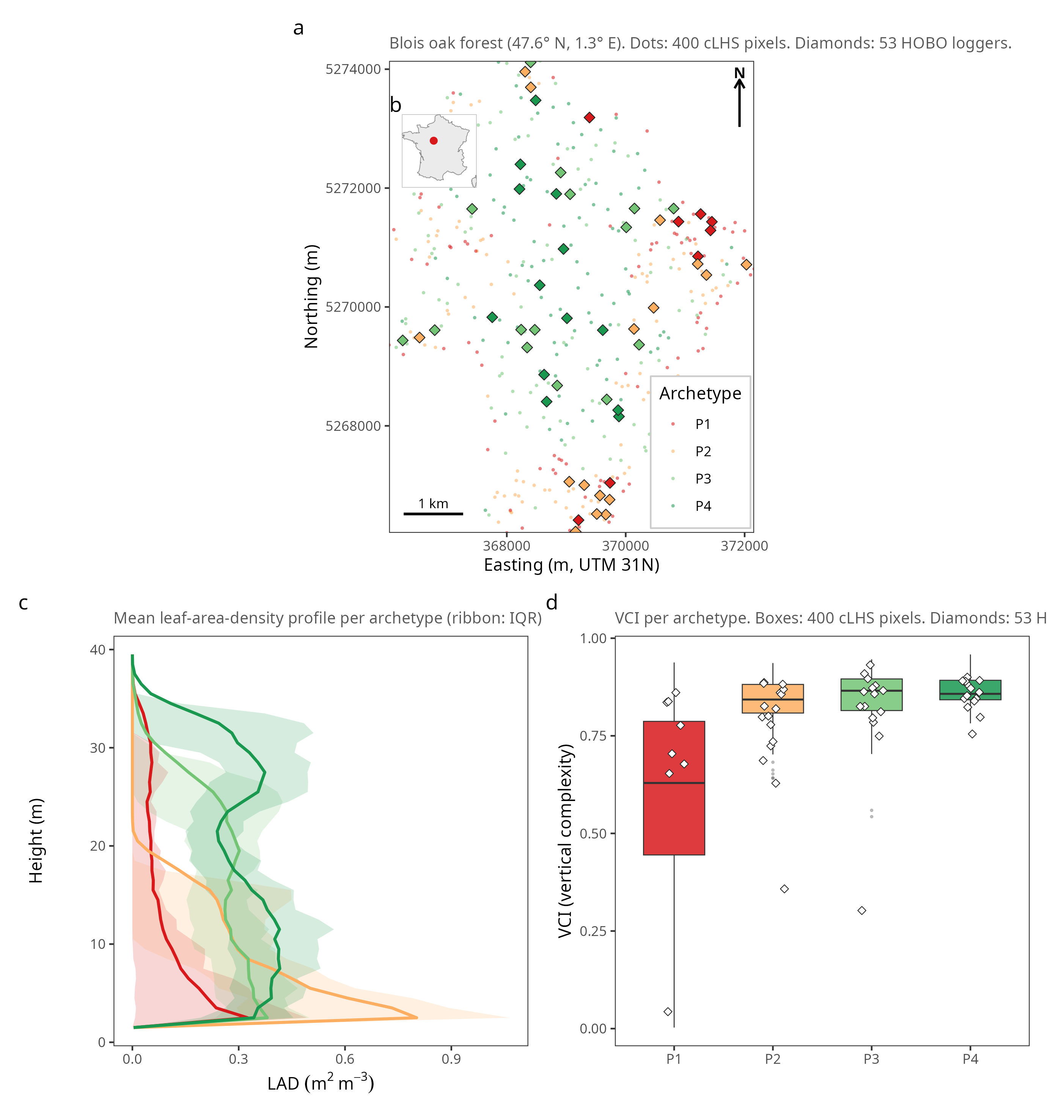 -
- 3.2 Leaf quantity dominates, density-dependent (core). (Figs 2–3, per +1 within-archetype SD.) - Open P1: LAI ≈0.57 °C ≫ cover 0.24, height 0.18 (range artifact), profile 0.02. - Dense P4: LAI erodes to ≈0.12, profile rises to ≈0.11 (co-lead), overtaking cover (~0.01) and height (~0.01). - Native per-unit (App A): +1 LAI cools ≈0.47 °C (open) → ≈0.17 (dense); asymmetric (removal > addition). Same ordering on ΔTmax and the slope. Maps onto Bouwen density threshold (Bouwen, n.d.). - Model-free cross-check (App F): observed buffering ~ LAI+cover (64% of explained var, R²=0.87), profile adds ~0 once quantity controlled (partial r ≈ 0).
Figure 2 : Δmetric/Δvariable per +1 within-archetype SD, per archetype (ΔTmax +log slope). 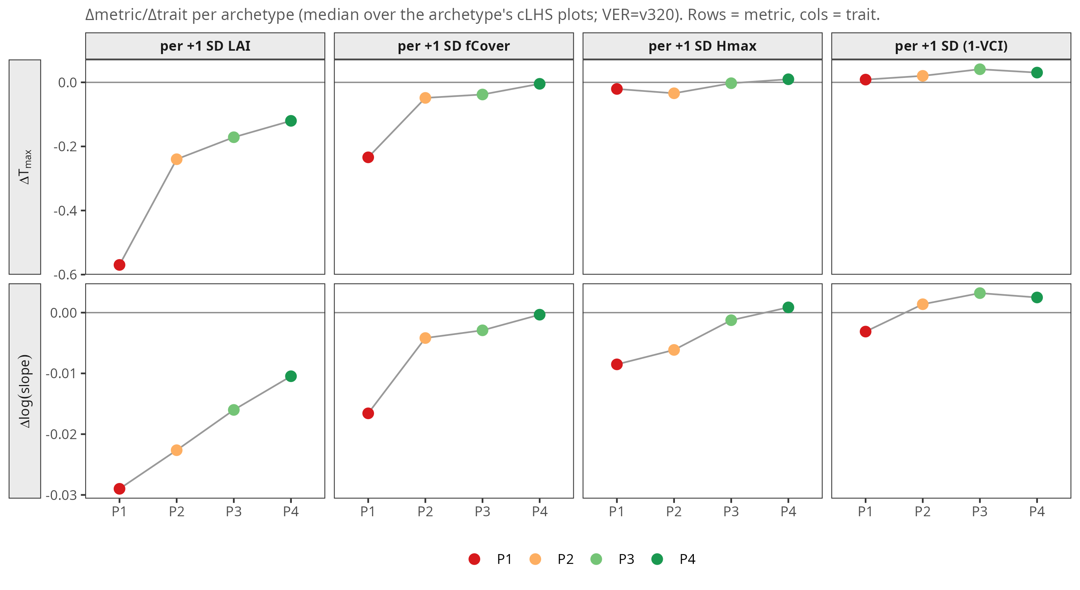
Figure 3 : idem, per-plot distribution. 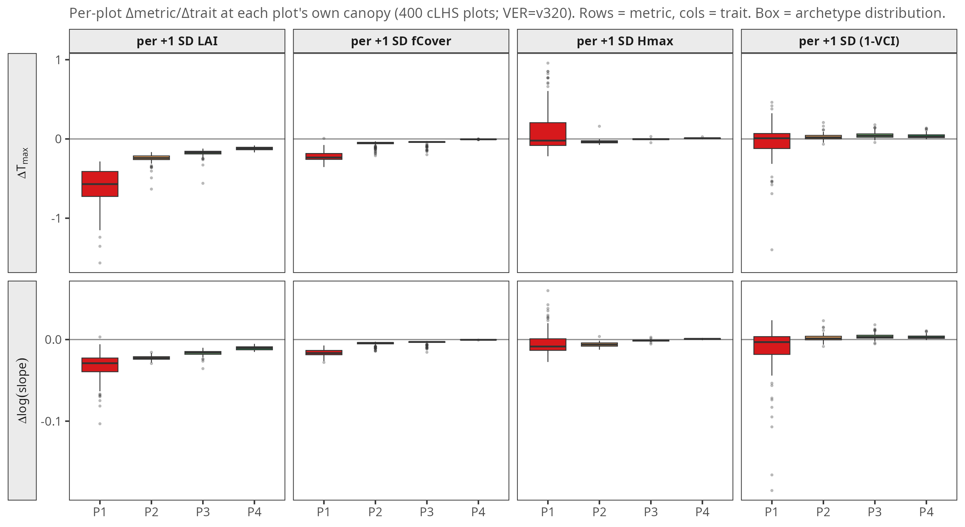 -
- 3.3 Glass ceiling. Ranking captured (r ≈ 0.93; Fig 4), warm bias +0.9 °C, slope compressed (0.95 vs 0.86), buffer/amplify split 44/9 vs 45/8. Forward inclusion (Fig 5): LAI first everywhere (r ≈ 0.84–0.98), 2nd variable = fCover (open) / profile (dense P3–P4: 0.86→0.90). Residual ~ sub-pixel gap fraction (adj R²=0.62; amplifiers are gappiest 0.52 vs 0.01), not vertical heterogeneity.
Figure 4 : validation vs 53 HOBOs 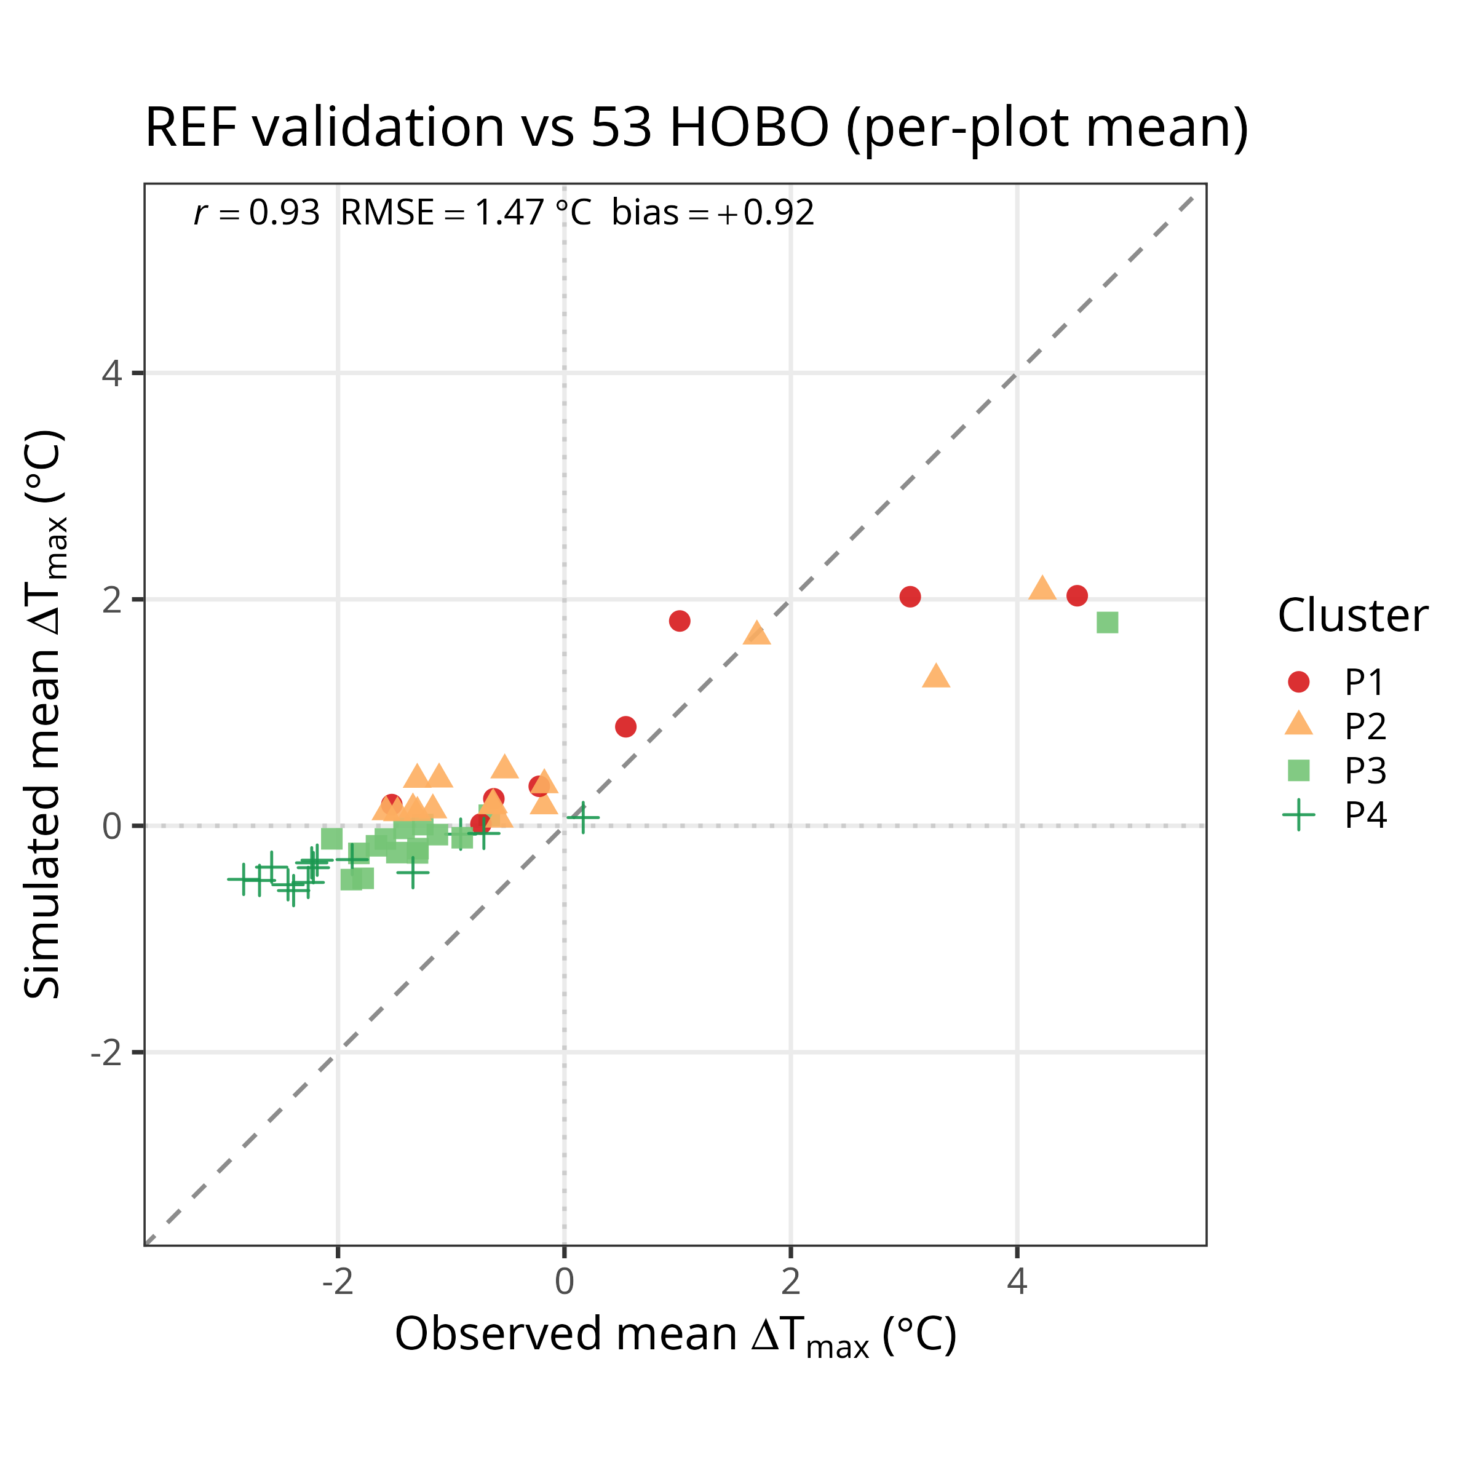
Figure 5 : forward inclusion: cumulative r vs variables added (LAI first; cover open / LAD dense).
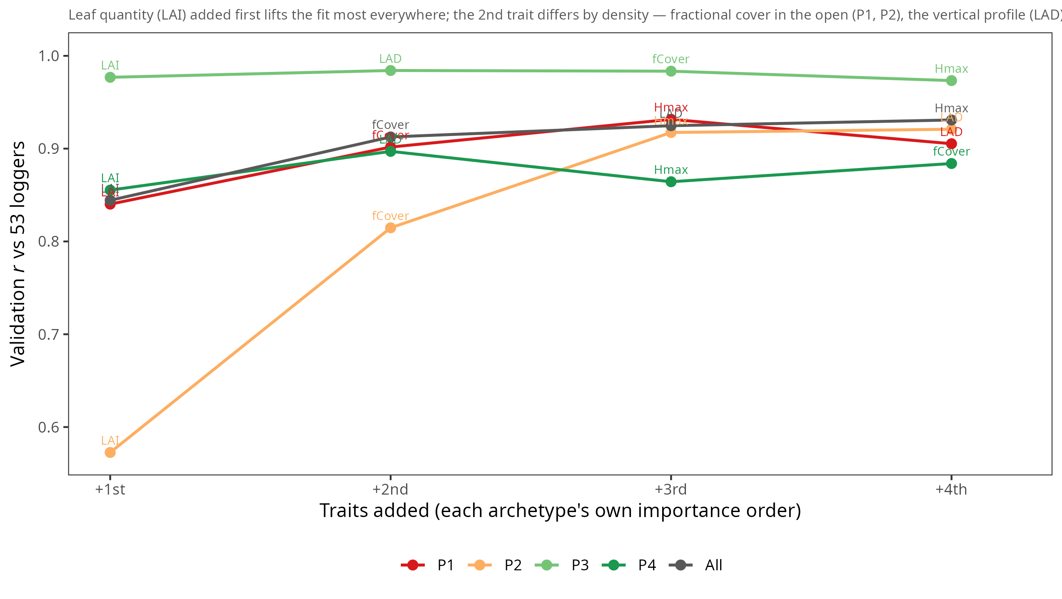
Figure 6: simulated vertical gradient (T, wind, RH, VPD) by archetype (mechanistic illustration). 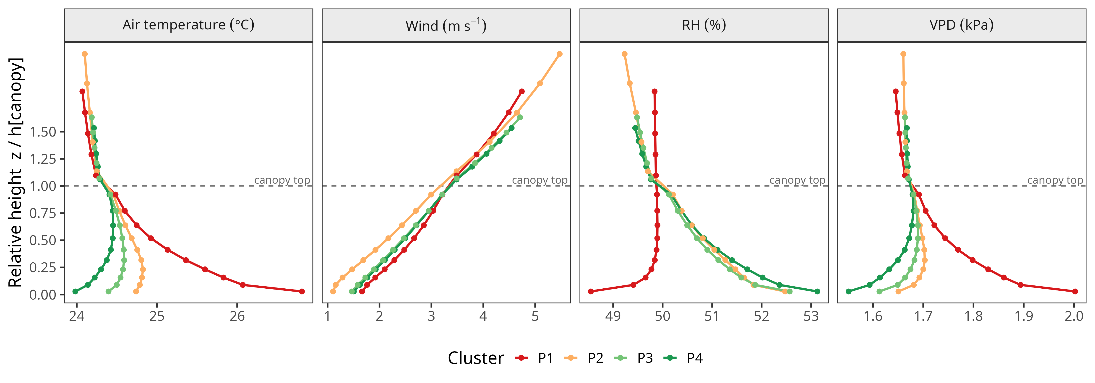 - 2.5

4. Discussion (condensed)
- 4.1 Density-dependent control. H1 not supported in strong form (profile weakest lever across most of gradient; comparable to LAI in dense only by saturation). H2 supported but 2nd-order (top-heavy cools slightly more, saturates with LAI). Leaf quantity leads throughout; reconciles total-leaf-area vs 3-D-complexity literature (Kovács et al. 2017; Ehbrecht et al. 2017; Atkins et al. 2023; Pierick, n.d.; Park et al. 2026). Why landscape average reads “vertical ≈ 0”.
- 4.2 Glass ceiling. Warm bias mostly canopy-scheme (1-D under-buffering) + out-of-scope gap/topographic amplification; sensitivity unaffected (held fixed under perturbation). Field cannot adjudicate the dense co-lead (variables collinear r 0.75–0.86) → model result, not logger-established.
- 4.3 Methodological contribution. On-manifold local sensitivity vs concurvity-confounded regression and off-manifold interventional decomposition; LAD = functional input (full profile), not a scalar index (VCI/rumple/canopy-ratio are deterministic functions of it → would re-add collinearity); canopy ratio adds nothing beyond LAI (Starck et al. 2025).
- 4.4 Limits & perspectives. Typology ecologically real (PCA recovers it, PC1 ≈64%; measured ΔTmax separates types). Archetypes ≈ developmental stages (caveat: height non-monotonic; P1 heterogeneous open). Single site/year/species; ΔTmax daytime only (ΔTmin distinct). Robust to model version & to 0.5 m vs 1 m LAD (understory loads onto LAI; r=0.93 preserved). Next: S2 optical proxy vs ALS (Menge et al. 2023; De Lombaerde et al. 2022).

5. Conclusion (condensed)
- Leaf quantity governs throughout; dominance density-dependent. Open: outright. Dense (saturated): lead erodes, vertical profile co-leads (overtaking cover & height). Vertical = small absolute lever everywhere; prominence in dense = saturation, not magnitude. Nuances “3-D indispensable”; explains landscape “vertical ≈ 0”. Model earns credibility on ranking; plateaus on absolute level (glass ceiling). Density-dependent control ties to the canopy-density threshold; frames Ch.2 optical-saturation.

Annex figures
A1a/b Local sensitivity. 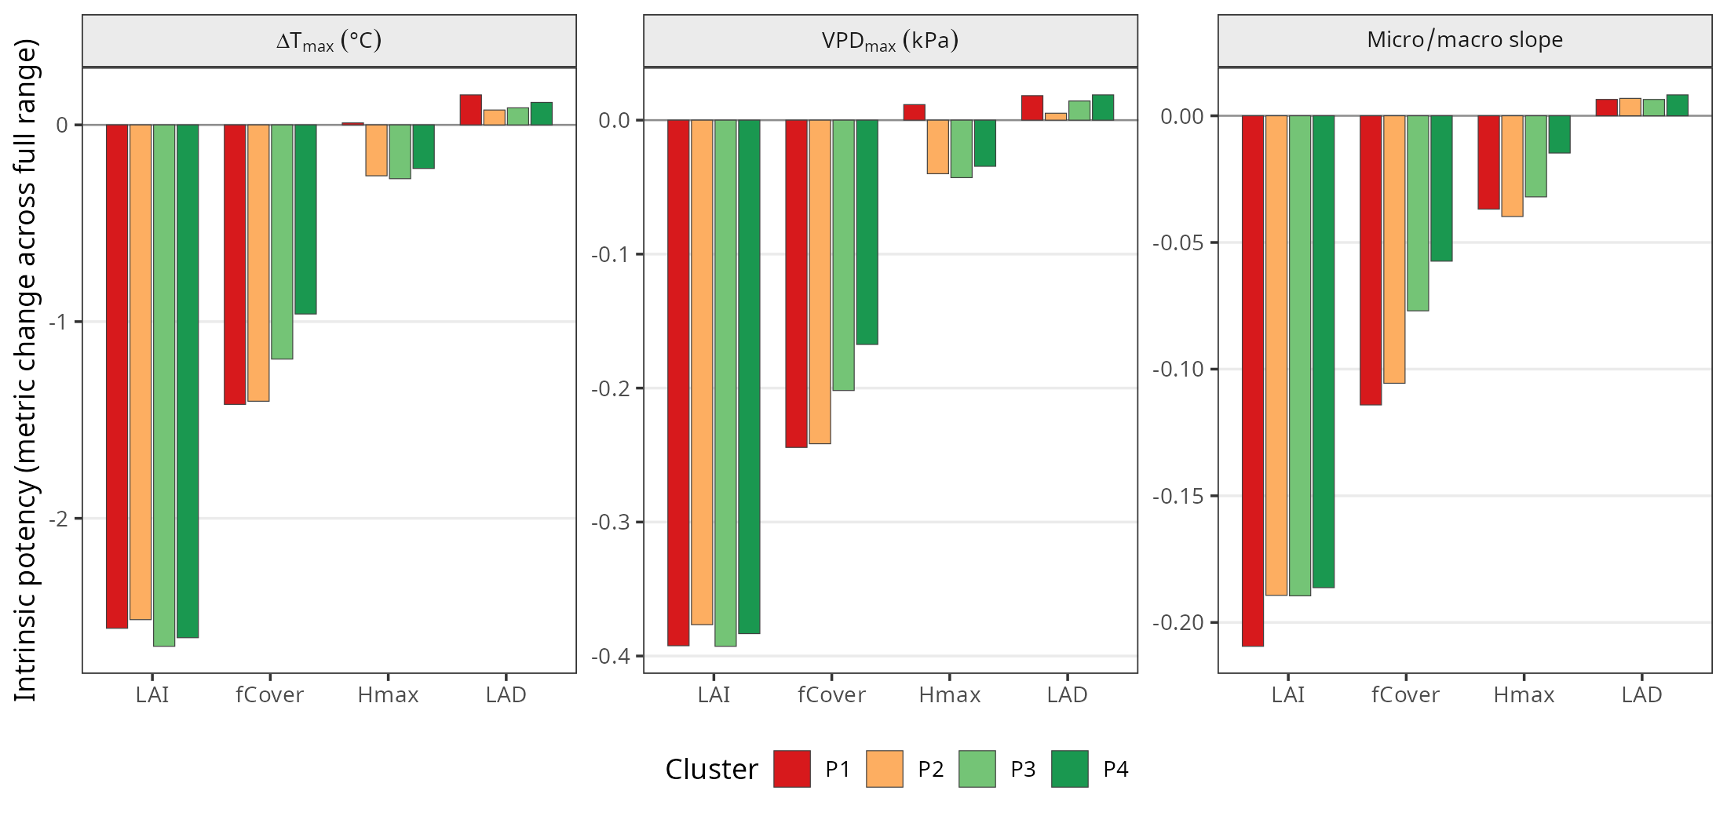 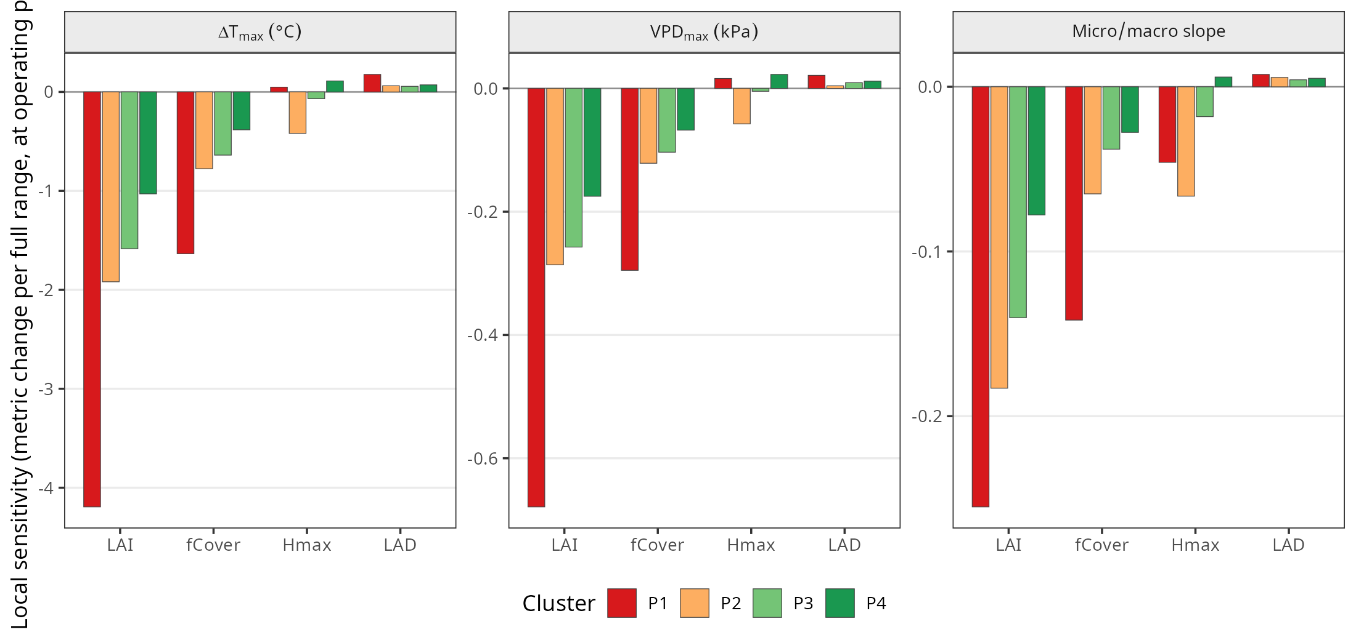
A1e/f hot-days; A1g/h native per-unit (Δmetric/Δvariable. 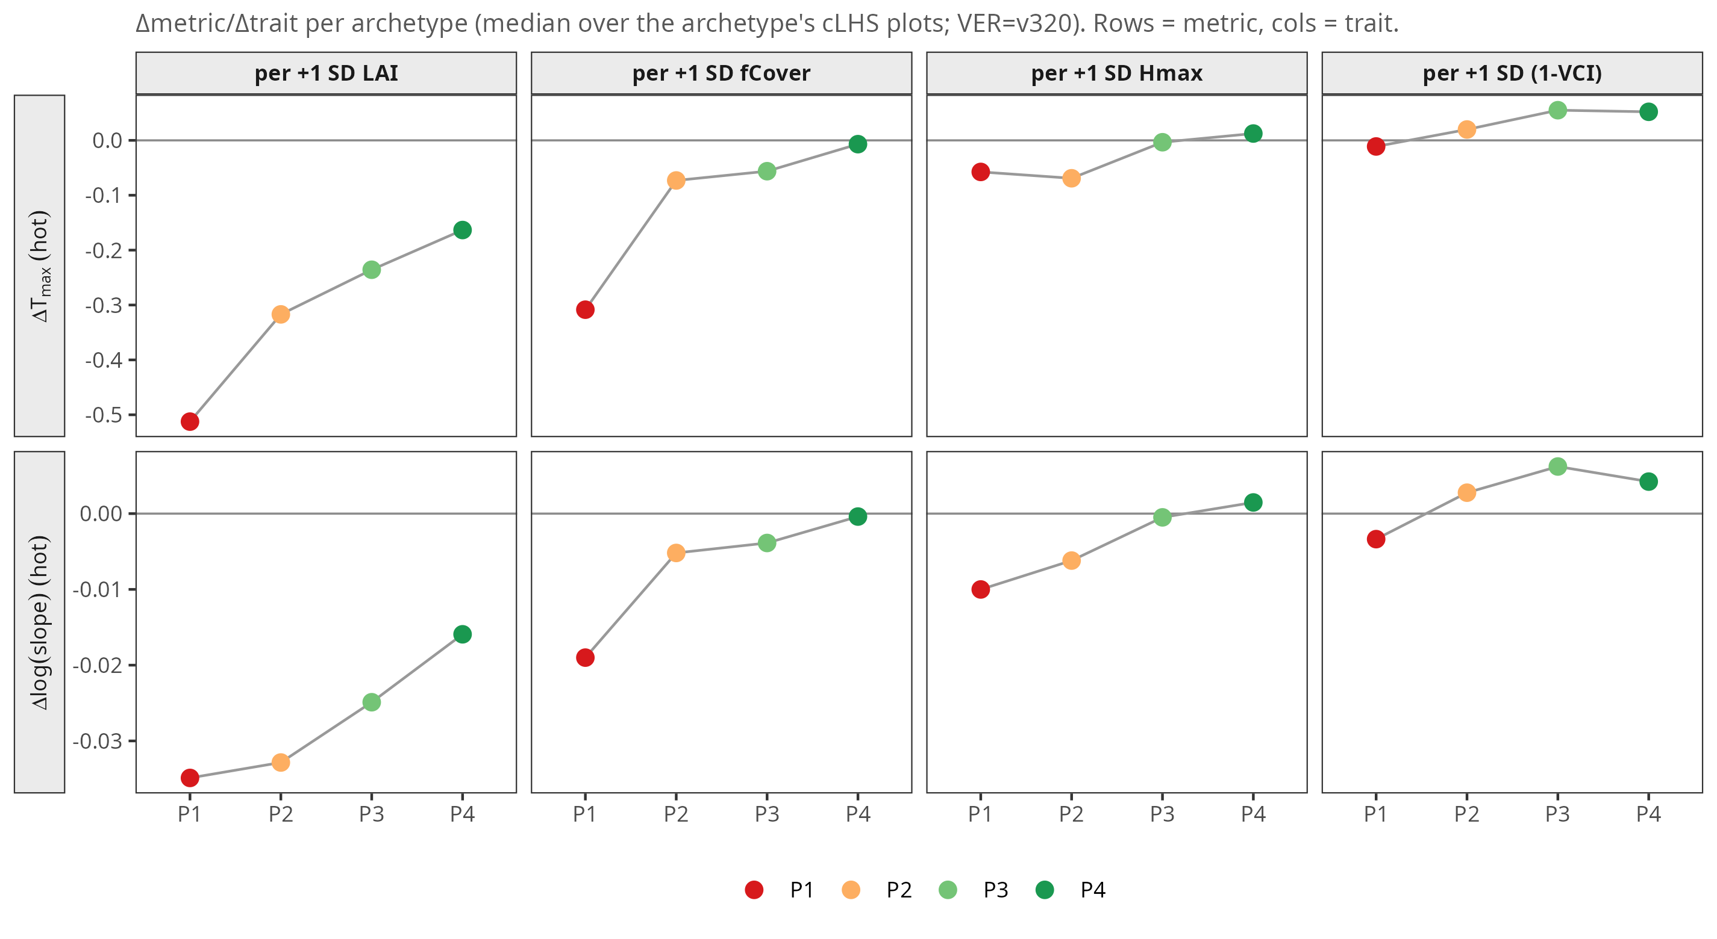 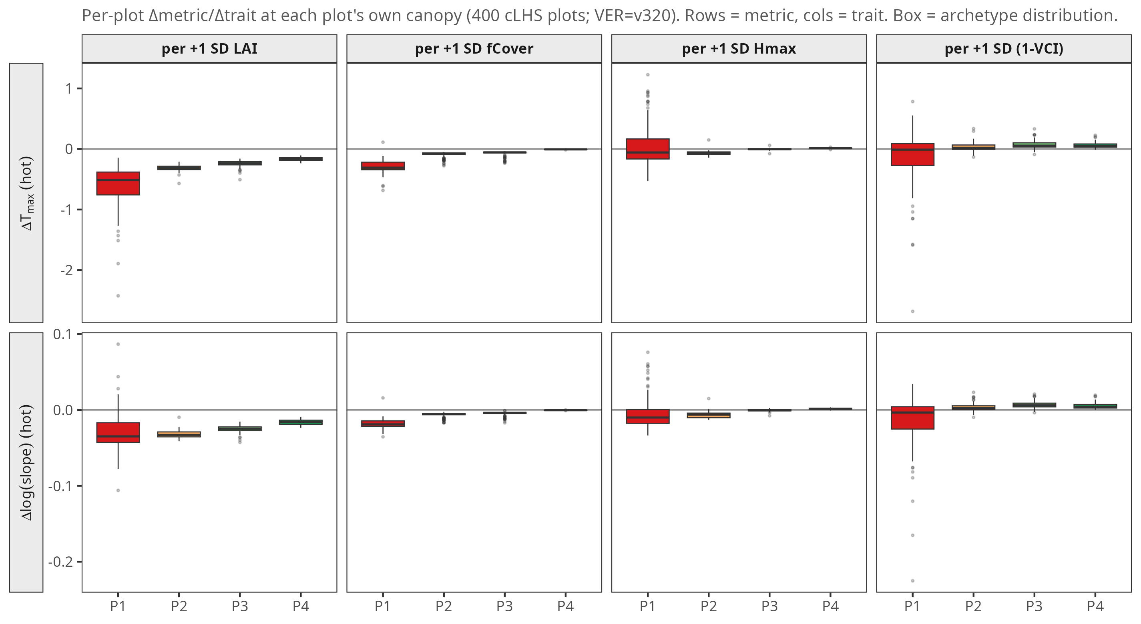 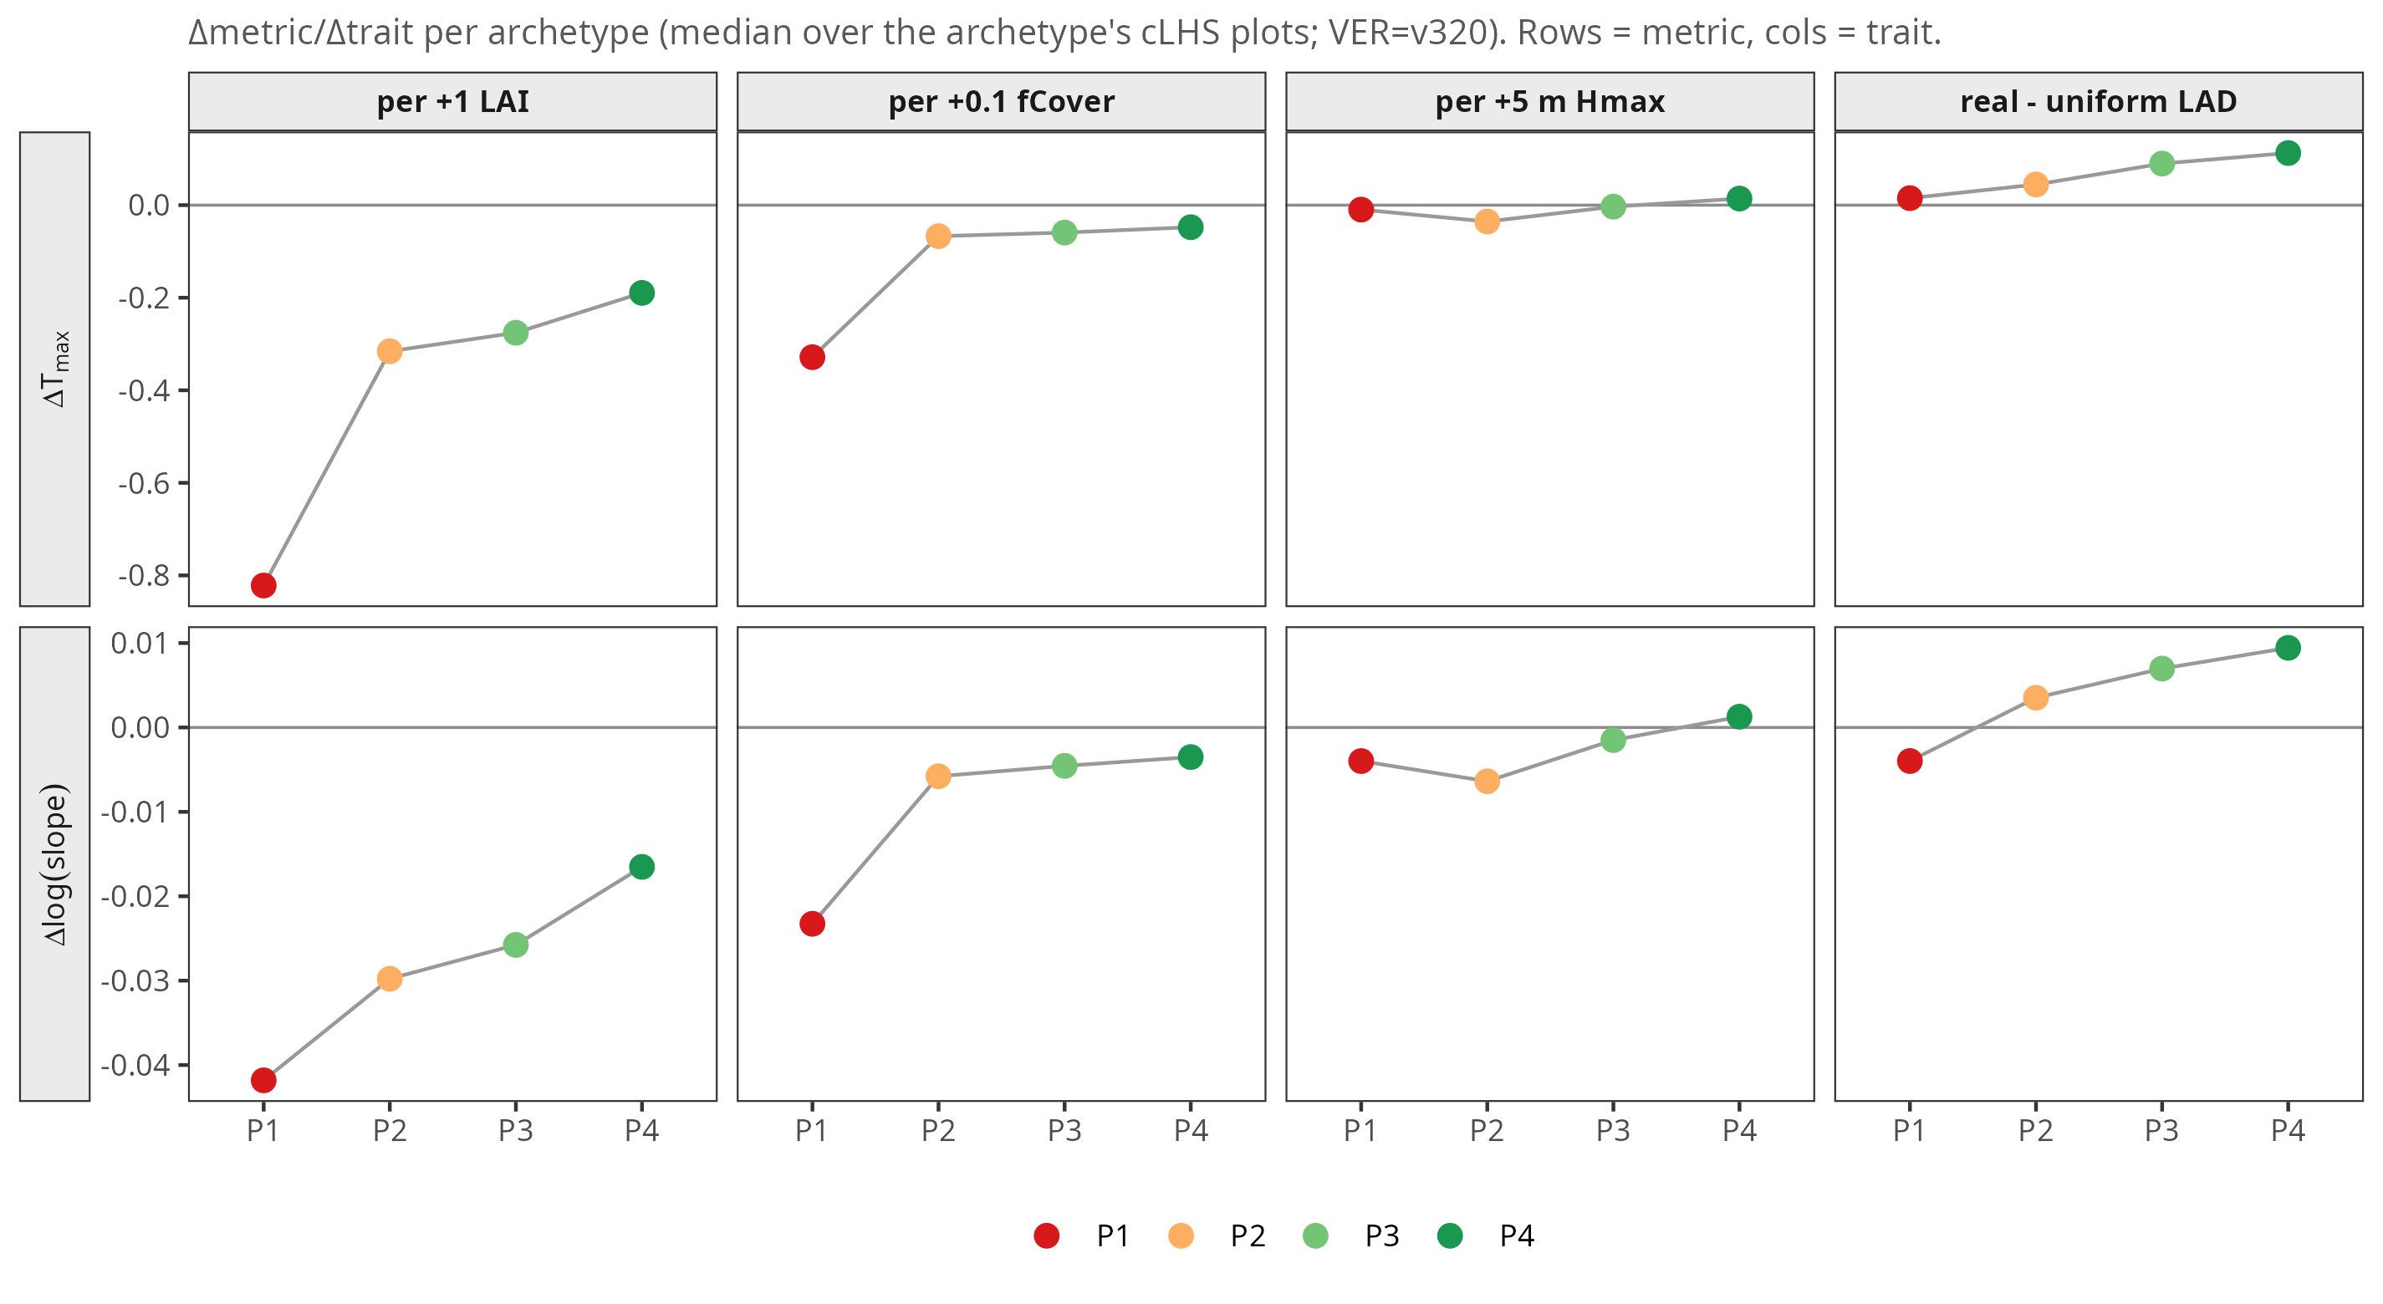 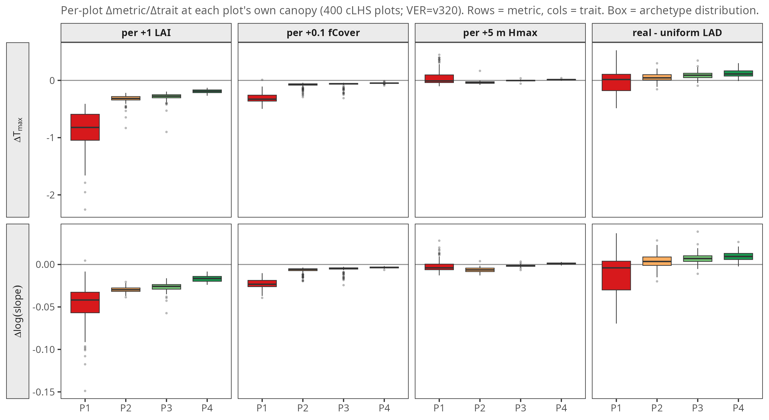
A2 LAD~(1−VCI); B1 residual~topo; C1 footprint; D1 dispersion. 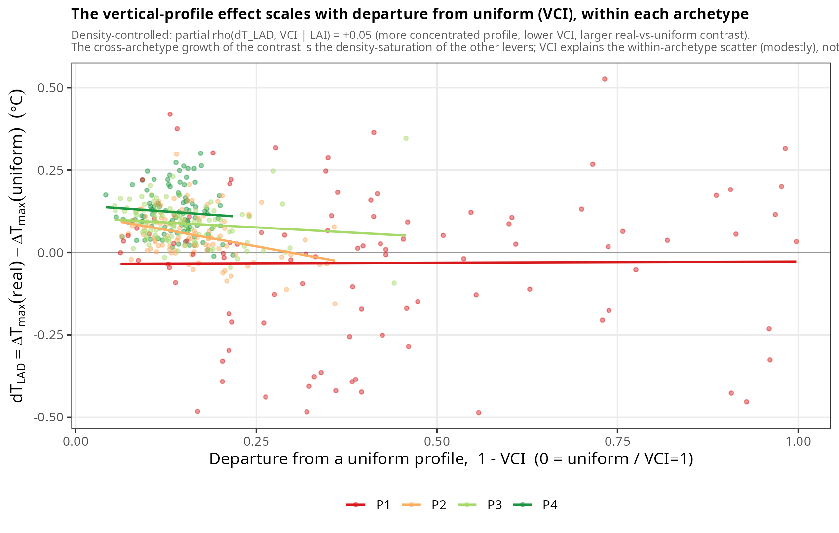 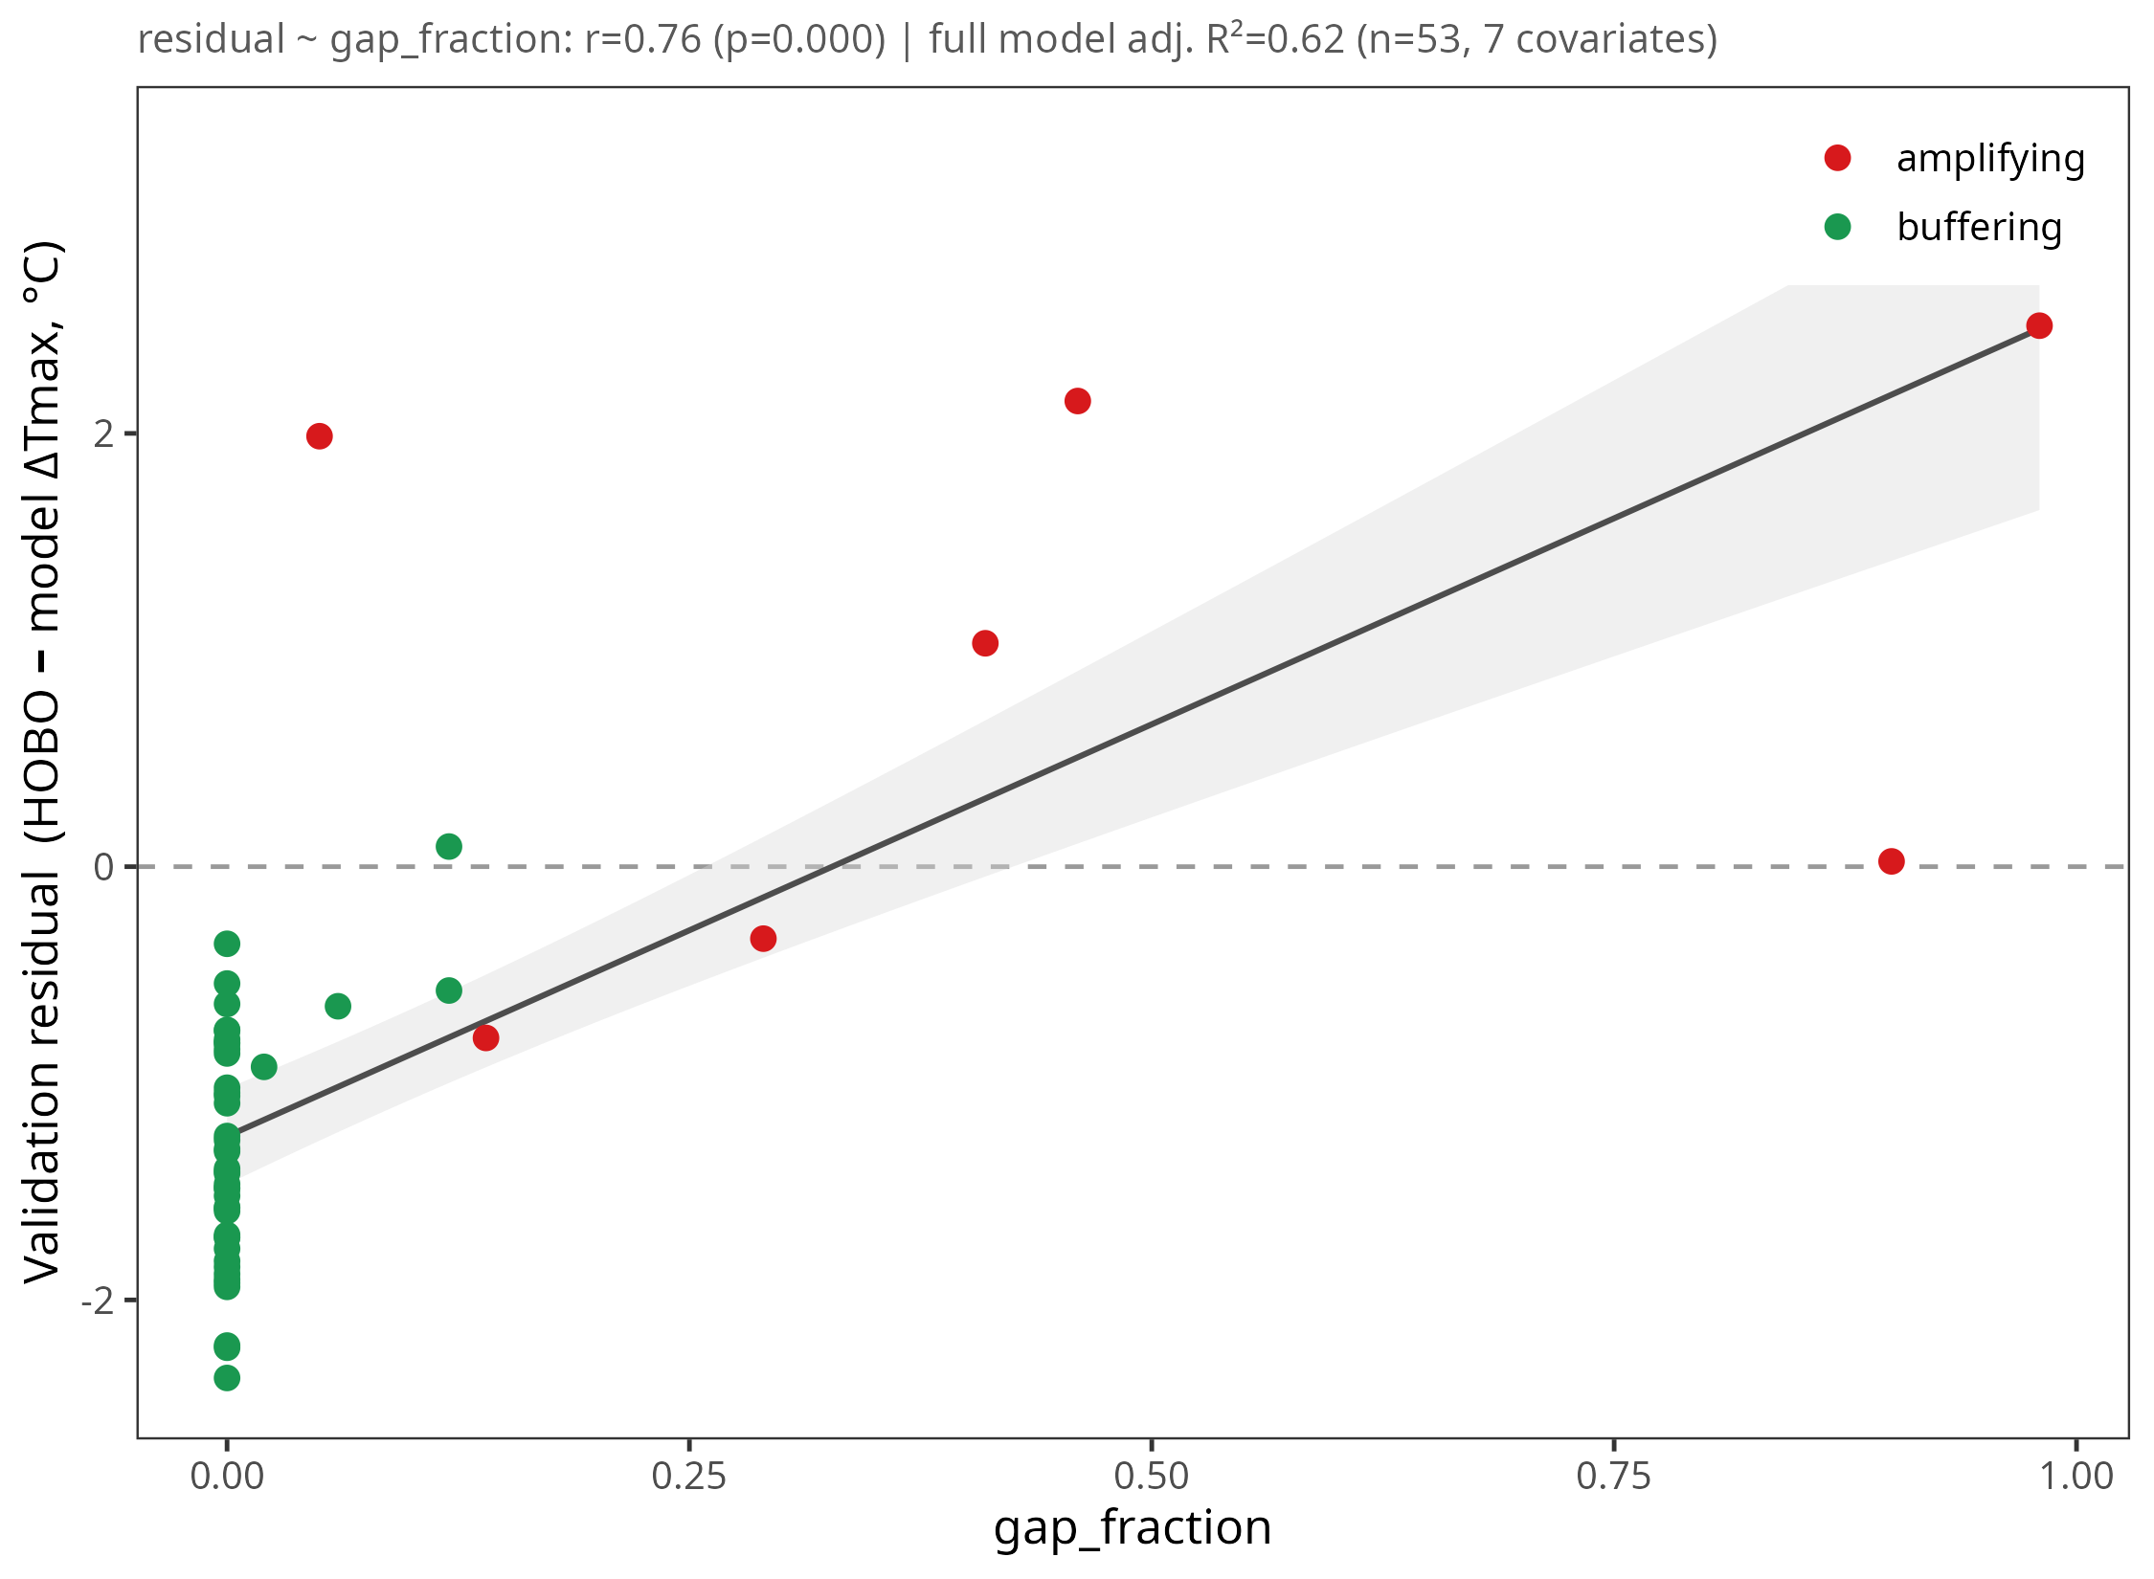 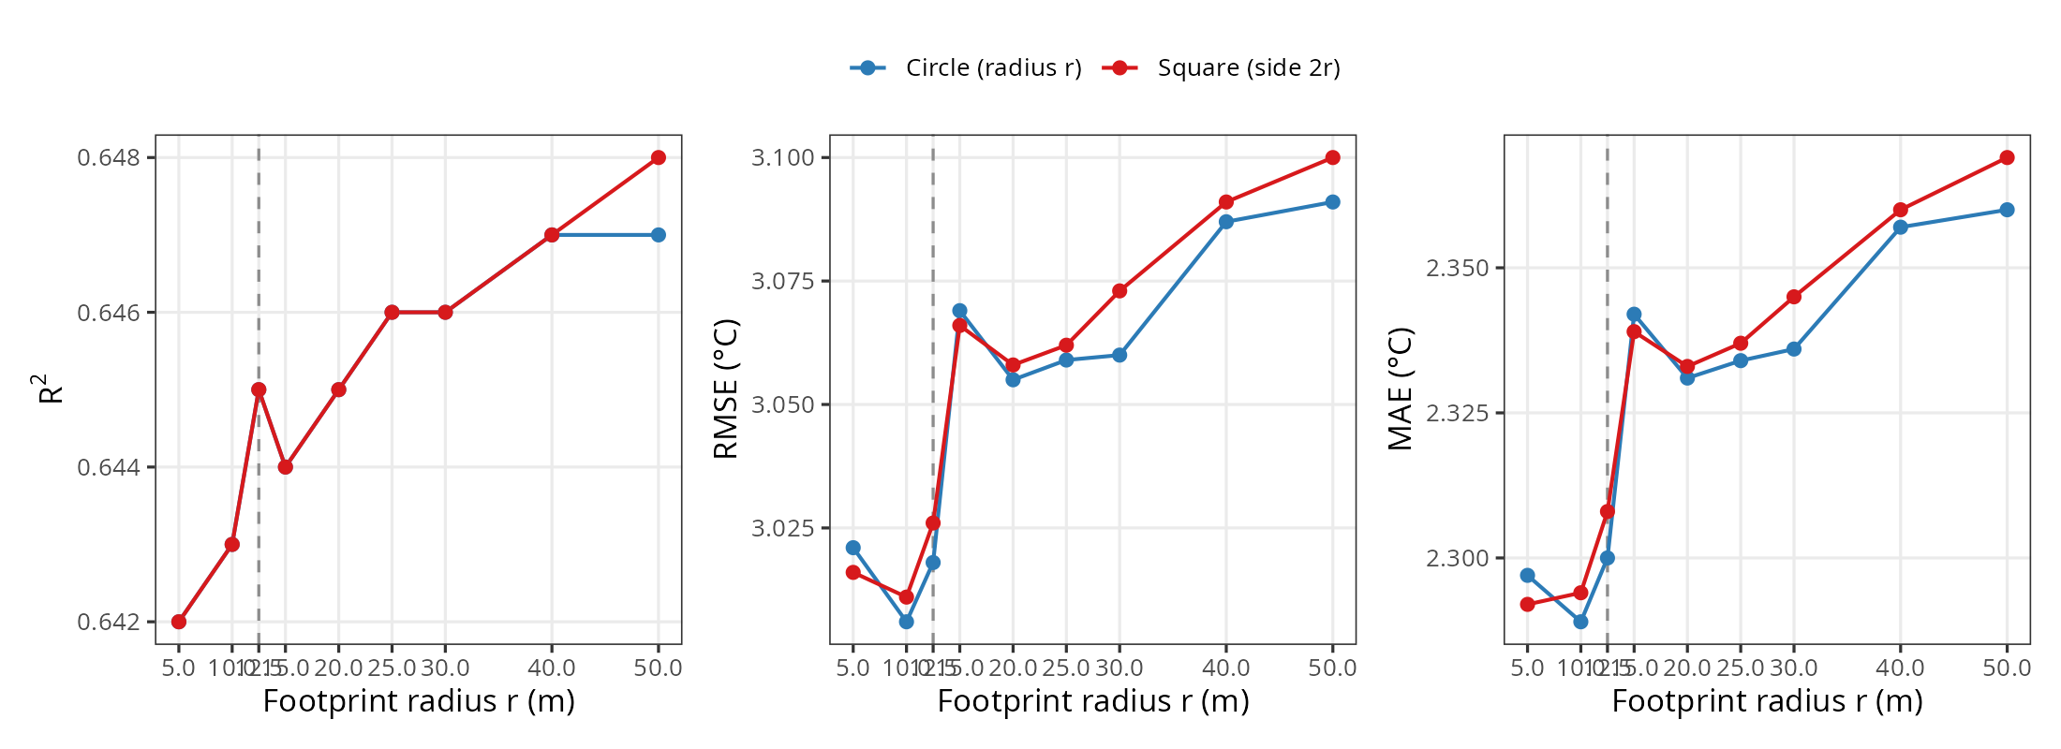 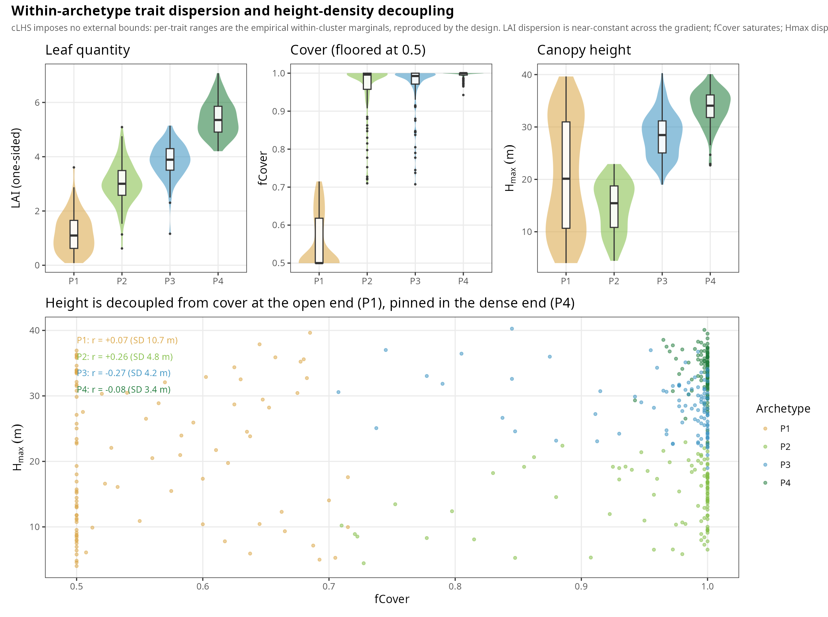
E1/E2 collinearity; E3 PCA ±VCI. 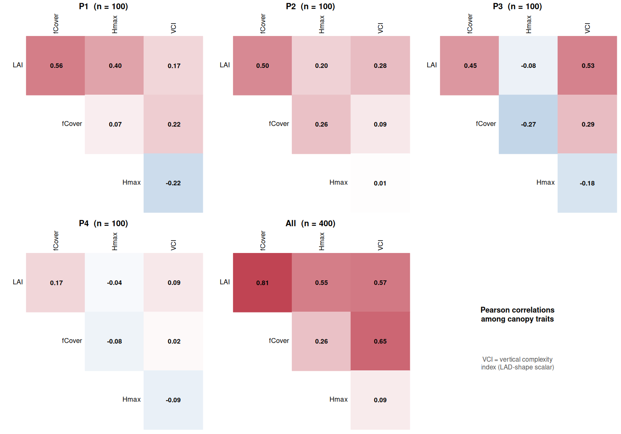 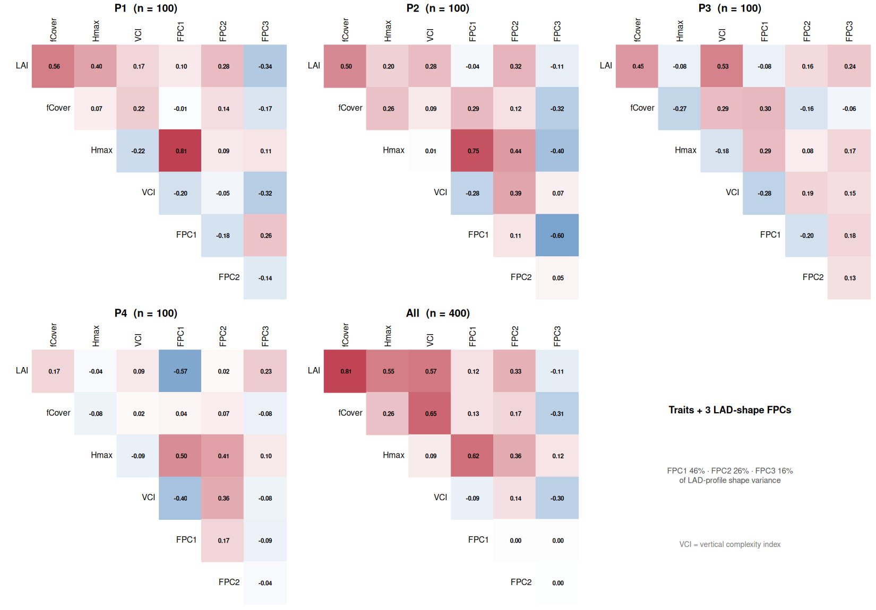 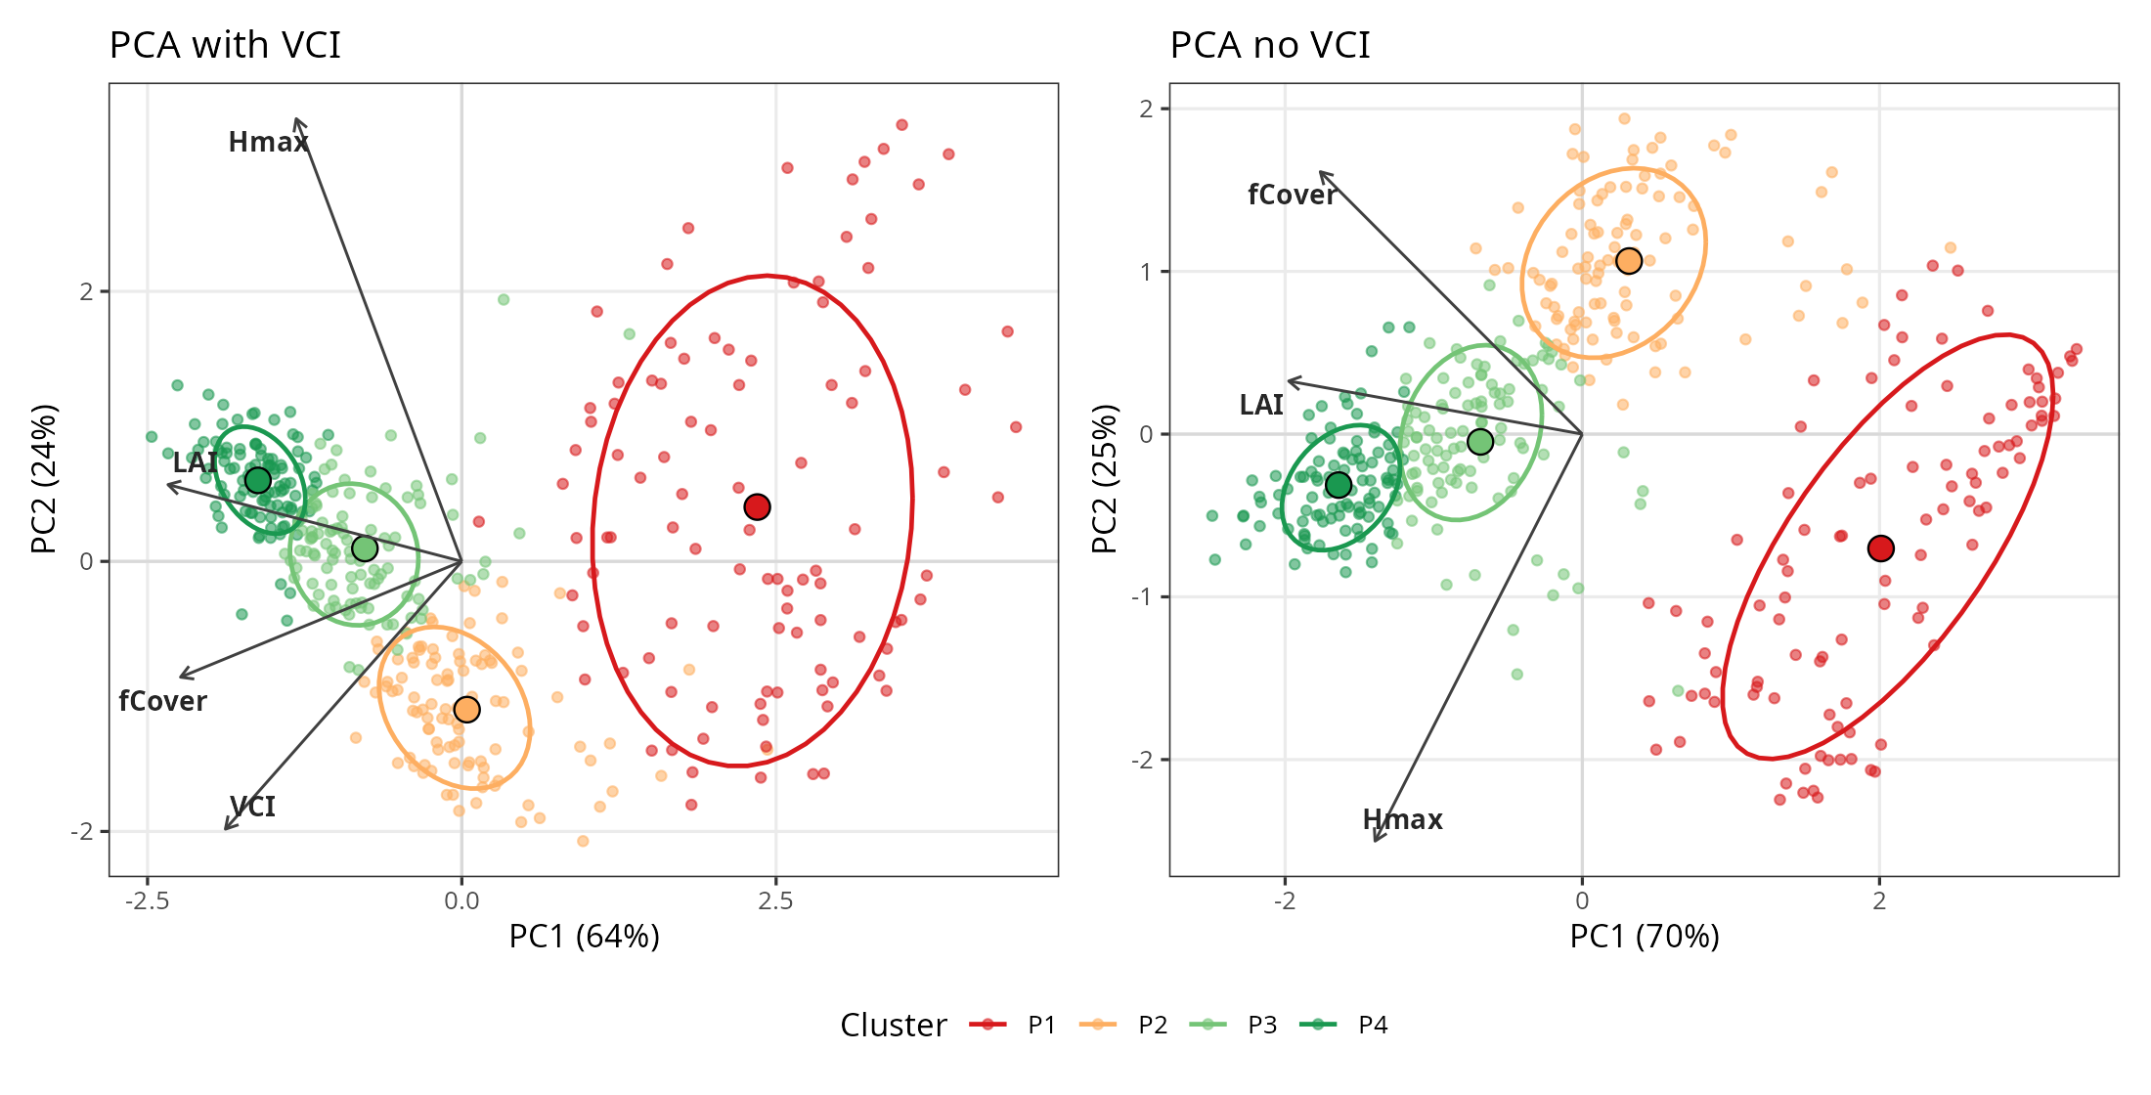
F1/F2 obs attribution; F3 coverage; F4 LAI/fCover separability. 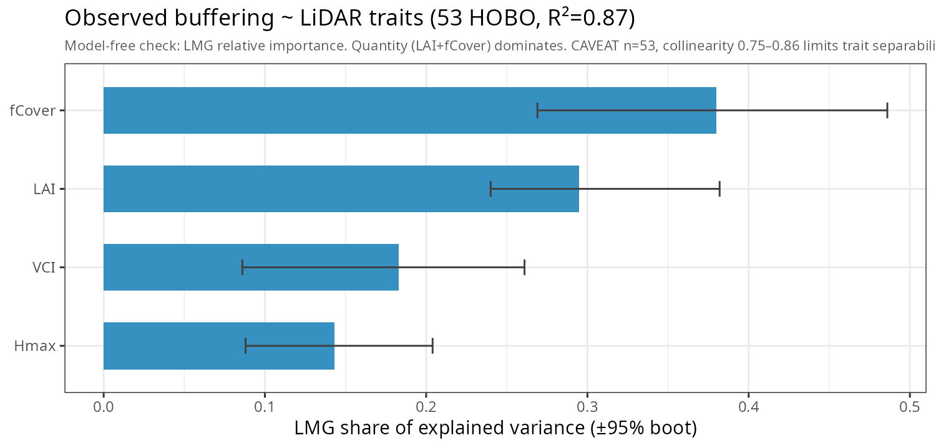 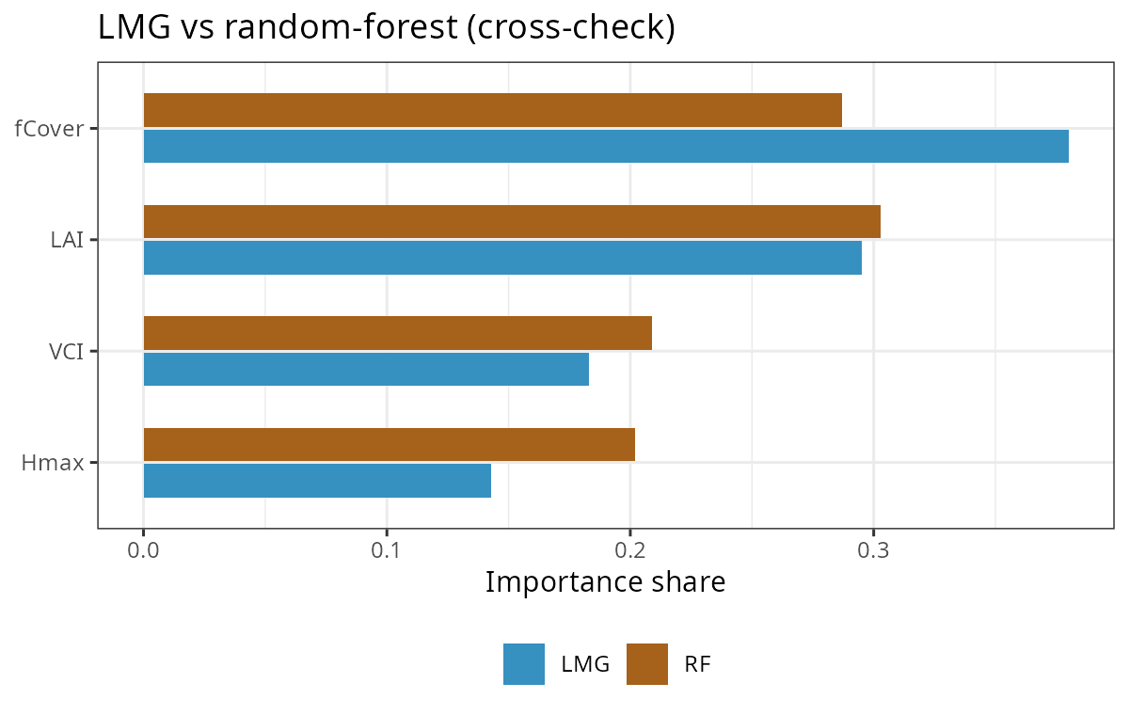 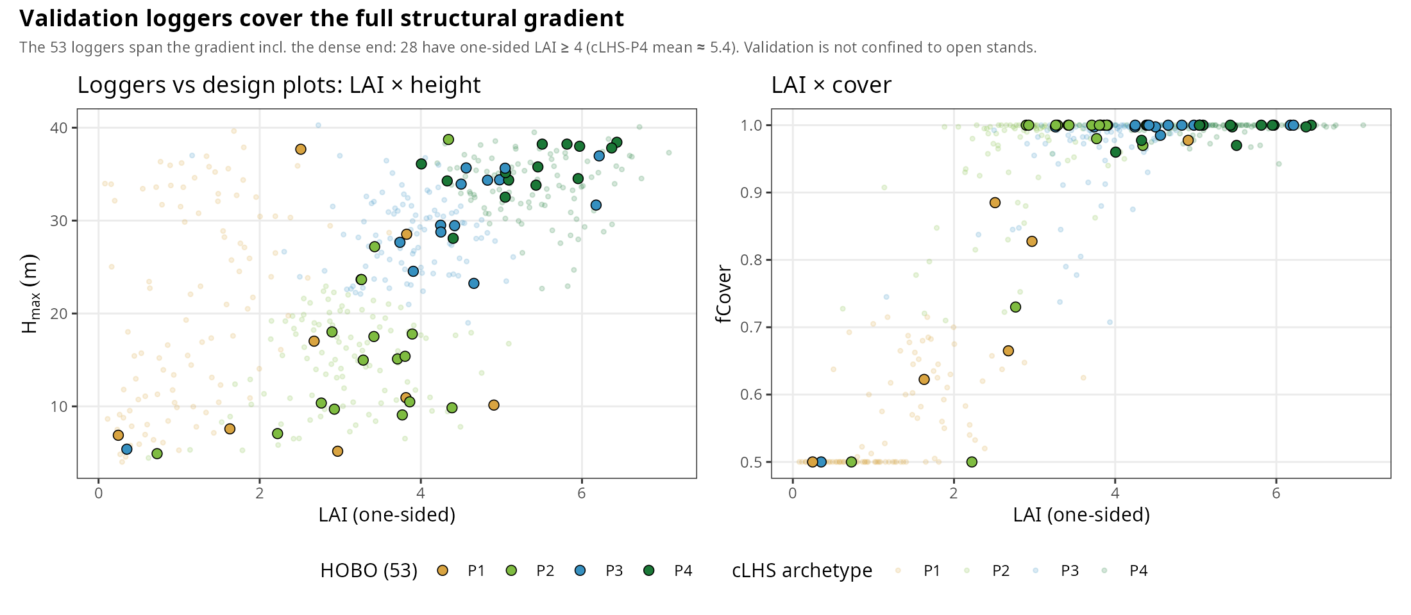 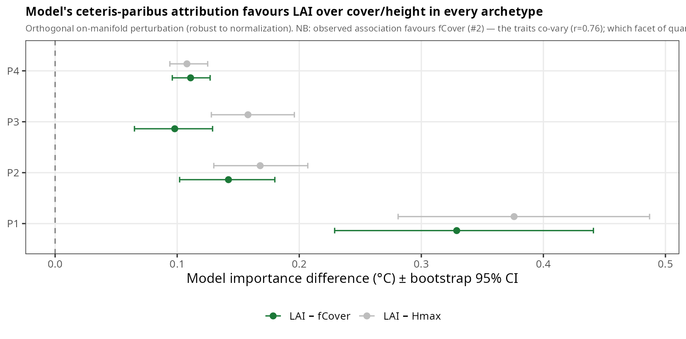
Atkins, Jeff W., Alexey Shiklomanov, Kayla C. Mathes, Ben Bond-Lamberty, and Christopher M. Gough. 2023. “Effects of Forest Structural and Compositional Change on Forest Microclimates Across a Gradient of Disturbance Severity.” Agricultural and Forest Meteorology 339 (August): 109566. https://doi.org/10.1016/j.agrformet.2023.109566.
Baldocchi, D, D Matt, B Hutchison, and R Mcmillen. 1984. “Solar Radiation Within an Oak-Hickory Forest: An Evaluation of the Extinction Coefficients for Several Radiation Components During Fully-Leafed and Leafless Periods.” Agricultural and Forest Meteorology 32 (3-4): 307–22. https://doi.org/10.1016/0168-1923(84)90056-X.
Bonan, Gordon B., Edward G. Patton, Ian N. Harman, et al. 2018. “Modeling Canopy-Induced Turbulence in the Earth System: A Unified Parameterization of Turbulent Exchange Within Plant Canopies and the Roughness Sublayer (CLM-ml V0).” Geoscientific Model Development 11 (4): 1467–96. https://doi.org/10.5194/gmd-11-1467-2018.
Bouvier, Marc, Sylvie Durrieu, Richard A. Fournier, and Jean-Pierre Renaud. 2015. “7_Generalizing Predictive Models of Forest Inventory Attributes Using an Area-Based Approach with Airborne LiDAR Data.” Remote Sensing of Environment 156 (January): 322–34. https://doi.org/10.1016/j.rse.2014.10.004.
Bouwen, Par Klara. n.d. Interactions entre la structure de la canopée et le microclimat du sous-étage : implications pour la régénération des forêts.
Campbell, G. S. 1986. “Extinction Coefficients for Radiation in Plant Canopies Calculated Using an Ellipsoidal Inclination Angle Distribution.” Agricultural and Forest Meteorology 36 (4): 317–21. https://doi.org/10.1016/0168-1923(86)90010-9.
De Frenne, Pieter, Jonathan Lenoir, Miska Luoto, et al. 2021. “Forest Microclimates and Climate Change: Importance, Drivers and Future Research Agenda.” Global Change Biology 27 (11): 2279–97. https://doi.org/10.1111/gcb.15569.
De Frenne, Pieter, Florian Zellweger, Francisco Rodríguez-Sánchez, et al. 2019. “Global Buffering of Temperatures Under Forest Canopies.” Nature Ecology & Evolution 3 (5): 744–49. https://doi.org/10.1038/s41559-019-0842-1.
De Lombaerde, Emiel, Pieter Vangansbeke, Jonathan Lenoir, et al. 2022. “Maintaining Forest Cover to Enhance Temperature Buffering Under Future Climate Change.” Science of The Total Environment 810 (March): 151338. https://doi.org/10.1016/j.scitotenv.2021.151338.
De Pauw, Karen, Pieter Sanczuk, Camille Meeussen, et al. 2022. “Forest Understorey Communities Respond Strongly to Light in Interaction with Forest Structure, but Not to Microclimate Warming.” New Phytologist 233 (1): 219–35. https://doi.org/10.1111/nph.17803.
Díaz-Calafat, Joan, Jaime Uria-Diez, Jörg Brunet, et al. 2023. “From Broadleaves to Conifers: The Effect of Tree Composition and Density on Understory Microclimate Across Latitudes.” Agricultural and Forest Meteorology 341 (October): 109684. https://doi.org/10.1016/j.agrformet.2023.109684.
Ehbrecht, Martin, Peter Schall, Christian Ammer, and Dominik Seidel. 2017. “Quantifying Stand Structural Complexity and Its Relationship with Forest Management, Tree Species Diversity and Microclimate.” Agricultural and Forest Meteorology 242 (August): 1–9. https://doi.org/10.1016/j.agrformet.2017.04.012.
Frey, Sarah J. K., Adam S. Hadley, Sherri L. Johnson, Mark Schulze, Julia A. Jones, and Matthew G. Betts. 2016. “Spatial Models Reveal the Microclimatic Buffering Capacity of Old-Growth Forests.” Science Advances 2 (4): e1501392. https://doi.org/10.1126/sciadv.1501392.
Greiser, Caroline, Eric Meineri, Miska Luoto, Johan Ehrlén, and Kristoffer Hylander. 2018. “Monthly Microclimate Models in a Managed Boreal Forest Landscape.” Agricultural and Forest Meteorology 250–251 (March): 147–58. https://doi.org/10.1016/j.agrformet.2017.12.252.
Gril, Eva, Marianne Laslier, Emilie Gallet-Moron, et al. 2023. “Using Airborne LiDAR to Map Forest Microclimate Temperature Buffering or Amplification.” Remote Sensing of Environment 298 (December): 113820. https://doi.org/10.1016/j.rse.2023.113820.
Gril, Eva, Fabien Spicher, Caroline Greiser, et al. 2023. “Slope and Equilibrium: A Parsimonious and Flexible Approach to Model Microclimate.” Methods in Ecology and Evolution 14 (3): 885–97. https://doi.org/10.1111/2041-210X.14048.
Haesen, Stef, Jonas J. Lembrechts, Pieter De Frenne, et al. 2021. “ForestTemp – Sub-Canopy Microclimate Temperatures of European Forests.” Global Change Biology 27 (23): 6307–19. https://doi.org/10.1111/gcb.15892.
Haesen, Stef, Jonathan Lenoir, Eva Gril, et al. 2023. “Microclimate Reveals the True Thermal Niche of Forest Plant Species.” Ecology Letters 26 (12): 2043–55. https://doi.org/10.1111/ele.14312.
Hardwick, Stephen R., Ralf Toumi, Marion Pfeifer, Edgar C. Turner, Reuben Nilus, and Robert M. Ewers. 2015. “The Relationship Between Leaf Area Index and Microclimate in Tropical Forest and Oil Palm Plantation: Forest Disturbance Drives Changes in Microclimate.” Agricultural and Forest Meteorology 201 (February): 187–95. https://doi.org/10.1016/j.agrformet.2014.11.010.
Hosoi, Fumiki, and Kenji Omasa. 2006. “Voxel-Based 3-D Modeling of Individual Trees for Estimating Leaf Area Density Using High-Resolution Portable Scanning Lidar.” IEEE Transactions on Geoscience and Remote Sensing 44 (12): 3610–18. https://doi.org/10.1109/TGRS.2006.881743.
Jucker, Tommaso, Stephen R. Hardwick, Sabine Both, et al. 2018. “Canopy Structure and Topography Jointly Constrain the Microclimate of Human-Modified Tropical Landscapes.” Global Change Biology 24 (11): 5243–58. https://doi.org/10.1111/gcb.14415.
Kamoske, Aaron G., Kyla M. Dahlin, Scott C. Stark, and Shawn P. Serbin. 2019. “Leaf Area Density from Airborne LiDAR: Comparing Sensors and Resolutions in a Temperate Broadleaf Forest Ecosystem.” Forest Ecology and Management 433 (February): 364–75. https://doi.org/10.1016/j.foreco.2018.11.017.
Kemppinen, Julia, Jonas J. Lembrechts, Koenraad Van Meerbeek, et al. 2024. “Microclimate, an Important Part of Ecology and Biogeography.” Global Ecology and Biogeography 33 (6): e13834. https://doi.org/10.1111/geb.13834.
Kolstela, Joonas, Tuomas Aakala, Ilya Maclean, et al. 2024. “Revealing Fine-Scale Variability in Boreal Forest Temperatures Using a Mechanistic Microclimate Model.” Agricultural and Forest Meteorology 350 (May): 109995. https://doi.org/10.1016/j.agrformet.2024.109995.
Kovács, B., F. Tinya, and P. Ódor. 2017. “Stand Structural Drivers of Microclimate in Mature Temperate Mixed Forests.” Agricultural and Forest Meteorology 234–235 (March): 11–21. https://doi.org/10.1016/j.agrformet.2016.11.268.
Lembrechts, Jonas J., and Jonathan Lenoir. 2020. “Microclimatic Conditions Anywhere at Any Time!” Global Change Biology 26 (2): 337–39. https://doi.org/10.1111/gcb.14942.
Lembrechts, Jonas J., Ivan Nijs, and Jonathan Lenoir. 2019. “Incorporating Microclimate into Species Distribution Models.” Ecography 42 (7): 1267–79. https://doi.org/10.1111/ecog.03947.
Lenoir, Jonathan, Tarek Hattab, and Guillaume Pierre. 2017. “Climatic Microrefugia Under Anthropogenic Climate Change: Implications for Species Redistribution.” Ecography 40 (2): 253–66. https://doi.org/10.1111/ecog.02788.
MacArthur, Robert H., and Henry S. Horn. 1969. “Foliage Profile by Vertical Measurements.” Ecology 50 (5): 802–4. https://doi.org/10.2307/1933693.
Maclean, Ilya M D. n.d. Microclimf: Fast Modelling of Microclimate Across Real Landscapes in R.
Maclean, Ilya M. D., and David H. Klinges. 2021. “Microclimc: A Mechanistic Model of Above, Below and Within-Canopy Microclimate.” Ecological Modelling 451 (July): 109567. https://doi.org/10.1016/j.ecolmodel.2021.109567.
Maclean, Ilya M. D., Andrew J. Suggitt, Robert J. Wilson, James P. Duffy, and Jonathan J. Bennie. 2017. “Fine-Scale Climate Change: Modelling Spatial Variation in Biologically Meaningful Rates of Warming.” Global Change Biology 23 (1): 256–68. https://doi.org/10.1111/gcb.13343.
Meeussen, C., K. De Pauw, P. Sanczuk, et al. 2022. “Initial Oak Regeneration Responses to Experimental Warming Along Microclimatic and Macroclimatic Gradients.” Plant Biology 24 (5): 745–57. https://doi.org/10.1111/plb.13412.
Menge, Joscha H., Paul Magdon, Stephan Wöllauer, and Martin Ehbrecht. 2023. “Impacts of Forest Management on Stand and Landscape-Level Microclimate Heterogeneity of European Beech Forests.” Landscape Ecology 38 (4): 903–17. https://doi.org/10.1007/s10980-023-01596-z.
Minasny, Budiman, and Alex B. McBratney. 2006. “A Conditioned Latin Hypercube Method for Sampling in the Presence of Ancillary Information.” Computers & Geosciences 32 (9): 1378–88. https://doi.org/10.1016/j.cageo.2005.12.009.
Ogée, J., Y. Brunet, D. Loustau, P. Berbigier, and S. Delzon. 2003. “MuSICA , a CO₂ , Water and Energy Multilayer, Multileaf Pine Forest Model: Evaluation from Hourly to Yearly Time Scales and Sensitivity Analysis.” Global Change Biology 9 (5): 697–717. https://doi.org/10.1046/j.1365-2486.2003.00628.x.
Park, Maria H., J. Antonio Guzmán Q., Hannah Dyalsingh, Allison Scott, and Jeannine Cavender-Bares. 2026. “Forest Composition and Diversity Buffer Microclimates and Enhance Productivity.” Journal of Ecology 114 (5): e70347. https://doi.org/10.1111/1365-2745.70347.
Parker, Geoffrey G., Mark E. Harmon, Michael A. Lefsky, et al. 2004. “Three-Dimensional Structure of an Old-growth Pseudotsuga-Tsuga Canopy and Its Implications for Radiation Balance, Microclimate, and Gas Exchange.” Ecosystems 7 (5). https://doi.org/10.1007/s10021-004-0136-5.
Pianosi, Francesca, Keith Beven, Jim Freer, et al. 2016. “Sensitivity Analysis of Environmental Models: A Systematic Review with Practical Workflow.” Environmental Modelling & Software 79 (May): 214–32. https://doi.org/10.1016/j.envsoft.2016.02.008.
Pierick, Kerstin. n.d. Microclimatic Heterogeneity Is Associated with Forest Structural Complexity and Biodiversity.
Potter, Kristen A., H. Arthur Woods, and Sylvain Pincebourde. 2013. “Microclimatic Challenges in Global Change Biology.” Global Change Biology 19 (10): 2932–39. https://doi.org/10.1111/gcb.12257.
Ramsay, James O., and Bernard W. Silverman. 2005. Functional Data Analysis. 2nd ed. Springer.
Saltelli, Andrea, Marco Ratto, Terry Andres, et al. 2007. Global Sensitivity Analysis. The Primer. 1st ed. Wiley. https://doi.org/10.1002/9780470725184.
Starck, Iris, Juha Aalto, Steven Hancock, Sauli Valkonen, Leena Kalliovirta, and Eduardo Maeda. 2025. “Slow Recovery of Microclimate Temperature Buffering Capacity After Clear-Cuts in Boreal Forests.” Agricultural and Forest Meteorology 363 (March): 110434. https://doi.org/10.1016/j.agrformet.2025.110434.
Zellweger, Florian, David Coomes, Jonathan Lenoir, et al. 2019. “Seasonal Drivers of Understorey Temperature Buffering in Temperate Deciduous Forests Across Europe.” Global Ecology and Biogeography 28 (12): 1774–86. https://doi.org/10.1111/geb.12991.
Zellweger, Florian, Pieter De Frenne, Jonathan Lenoir, et al. 2020. “Forest Microclimate Dynamics Drive Plant Responses to Warming.” Science 368 (6492): 772–75. https://doi.org/10.1126/science.aba6880.

