Leaf quantity governs understory microclimate buffering, with the vertical leaf-area profile becoming a comparable driver of the microclimate where the canopy saturates: a LiDAR-driven MuSICA sensitivity analysis

Abstract
Forest understories buffer their occupants from macroclimatic extremes, and this buffering is widely attributed to canopy structure. Which dimension of that structure matters most remains unresolved: the total quantity of foliage, or its three-dimensional vertical arrangement. The question is hard for two reasons. Canopy traits are strongly intercorrelated, and the remote-sensing instrument best able to resolve the vertical dimension (airborne laser scanning, ALS) has rarely been coupled to a process-based test of which trait actually drives the thermal effect. We combine ALS-derived canopy traits (leaf area index LAI, maximum height H_{max}, fractional cover fCover, and the vertical leaf-area-density [LAD] profile) with the multilayer biophysical canopy model MuSICA to quantify how the simulated summer understory thermal offset (ΔT_{max}, the diurnal micro-macro maximum-temperature difference) responds to each trait at a temperate deciduous oak forest (Blois, France; summer 2021), validated against 53 in-situ temperature loggers. Across 400 LiDAR plots stratified into four structural archetypes (P1 open to P4 dense), we ran a controlled trait-perturbation sensitivity analysis: each trait was moved a small, native step around every plot’s own realistic canopy, and the vertical profile was contrasted against a leaf-area- and height-preserving uniform profile. The dominant driver is leaf quantity (LAI) throughout, but its lead is density-dependent. In open canopy, leaf quantity governs by a wide margin (within-archetype importance 0.57 °C of ΔT_{max}, against 0.24 °C for cover, 0.18 °C for height and 0.02 °C for the profile). As the canopy closes and leaf quantity saturates, its importance erodes (to 0.12 °C in the dense archetype) until the vertical profile becomes a comparable-magnitude lever on the microclimate (0.11 °C), having already overtaken cover and height. This vertical effect is directional and modest: relative to a leaf-area- and height-preserving uniform profile, the realistic profile buffers the understory slightly less, a small effect that grows with density, so the profile co-leads the microclimate in the dense canopy without exceeding leaf quantity. It is a small absolute lever everywhere, becoming comparable to leaf quantity only because the alternatives saturate, not because it is large. MuSICA reproduces the between-plot buffering ranking well (r = 0.93) but plateaus on the absolute thermal offset (+0.9 °C warm bias) and compresses the buffering magnitude, with the residual deviations tracing chiefly to sub-pixel canopy gaps (adjusted R² = 0.62) that a one-dimensional model does not represent. This density-dependent control reconciles the conflicting literature on canopy structure and microclimate and motivates the optical-saturation analysis of the following chapter.

1. Introduction
Beneath a forest canopy the climate experienced by organisms departs systematically from the conditions recorded by standard weather stations: daytime maxima are attenuated, the diurnal range is compressed, and extremes are dampened relative to the open (De Frenne et al. 2019; Zellweger et al. 2020). This decoupling, termed microclimatic buffering, is not a second-order detail. It is the climate that actually filters demographic and ecological processes. It governs the distribution and persistence of understory plant communities (De Pauw et al. 2022), the success of tree regeneration, and the capacity of forests to act as thermal microrefugia under macroclimatic warming (Lenoir et al. 2017; De Frenne et al. 2021). Because the mismatch between coarse macroclimatic grids and the conditions organisms experience can reach several degrees, quantifying buffering and understanding what controls it has become central to forest ecology under climate change (Lembrechts and Lenoir 2020; Haesen et al. 2021).
The first-order control on buffering is canopy structure. Denser, taller, more closed canopies intercept more radiation and decouple the understory more strongly (Zellweger et al. 2019; Kovács et al. 2017). Structure was historically characterized from field inventories, but it can now be retrieved over continuous landscapes from remote sensing. Airborne laser scanning (ALS/LiDAR) is especially valuable here, because it resolves the full three-dimensional distribution of vegetation rather than a two-dimensional projection (Bouvier et al. 2015). ALS-derived structure has accordingly been incorporated into microclimate studies and models (Jucker et al. 2018; Ehbrecht et al. 2017; Atkins et al. 2023). In directly neighbouring work, the LiDAR-MuSICA coupling was used to identify a canopy-density threshold on buffering in conifer stands (Bouwen, n.d.).
A more fundamental question is left open: among the structural variables that ALS delivers, which contributes most to buffering? LiDAR is valued precisely because it resolves the vertical profile, and the vertical arrangement of foliage is widely assumed to be decisive. Yet whether the vertical dimension itself governs the thermal regime, or merely co-varies with the total quantity of leaves (LAI) and their horizontal cover, has never been cleanly disentangled. The difficulty is twofold. First, canopy traits are strongly collinear in real stands, so observational and statistical microclimate models (linear sensitivity or offset regressions, generalized additive mixed models) cannot uniquely attribute the effect to one trait: their coefficients are unstable under concurvity and individual contributions are not identifiable (Greiser et al. 2018; Maclean et al. 2017). Second, such models are descriptive and site-fitted, and cannot in principle separate the radiative and turbulent roles of quantity from those of arrangement.
A physics-based, mechanistic alternative addresses both difficulties. A multilayer soil-vegetation-atmosphere model that solves the coupled energy, radiative and turbulent balance, here MuSICA (Ogée et al. 2003), can be driven with controlled combinations of canopy traits. The contribution of each trait is then isolated by construction rather than inferred from correlated observations. Being process-based, its parameters are in principle transferable rather than fitted to one site (Maclean and Klinges 2021). In this study we couple ALS-derived canopy traits with MuSICA and run a controlled trait-perturbation sensitivity analysis, moving each trait around the realistic canopy of each plot rather than inferring its effect from correlated observations, validated against 53 in-situ loggers, to quantify the relative contribution of leaf quantity versus vertical arrangement to summer understory buffering in a temperate deciduous oak forest.
We hypothesized that (H1) vertical structure modulates radiative and turbulent transfer, so that the LAD profile is a key parameter for a faithful microclimate simulation; and (H2) at fixed leaf area and height, top-heavy profiles, with biomass concentrated high in the canopy, attenuate the diurnal cycle more strongly, because radiation is intercepted higher and the canopy heat source is shifted upward. To test these hypotheses, we (1) derived a structural typology of the LAD profile, (2) perturbed each trait around every plot’s realistic canopy with MuSICA and measured the local sensitivity of ΔT_{max} within each structural type, contrasting the real vertical profile against a uniform one, and (3) validated the simulated buffering against the logger network and decomposed its residual against terrain and heterogeneity covariates the model cannot represent. As a perspective toward the following chapter, we further ask whether a two-dimensional optical proxy (Sentinel-2) can substitute for LiDAR-derived structure, or whether it merely yields an optical illusion of buffering.

2. Materials and Methods

2.1 Study site
Blois is a temperate lowland deciduous forest in the central Loire region of France (about 47.6° N, 1.3° E), almost entirely composed of sessile oak (Quercus petraea). The terrain is of low relief, which limits topographic forcing of the microclimate at the landscape scale. Throughout, buffering is quantified by the diurnal maximum-temperature offset ΔT_{max} = T_{max,micro} − T_{max,macro}, computed at daily resolution against an open-field regional macroclimate reference; negative values denote buffering (a cooler understory) and positive values amplification.

2.1.1 Field data: HOBO loggers
During the summer of 2021 (1 June to 30 September), 53 HOBO loggers distributed along a gradient of canopy openness and structure recorded air temperature hourly (GMT+0). Each air sensor was fixed 1 m above the ground on a tree trunk or wooden pole and, to limit radiative overheating, oriented northward inside a white homemade PVC radiation shield (10 × 15 cm), following the design of Zellweger et al. (2019). Co-located soil sensors (buried 8 cm) were recorded but are not used here, this chapter addressing only above-ground air temperature. The loggers were Onset HOBO Pendant data loggers (model UA-001-64; manufacturer-reported accuracy ±0.53 °C over 0–50 °C, resolution 0.14 °C at 25 °C), logging hourly, and were georeferenced with a Trimble Geo 7X differential GPS (Gril et al. 2023).

2.1.2 Remote sensing data: Airborne LiDAR acquisition
Canopy structure was characterized from an airborne laser scanning (ALS) survey of the site acquired under leaf-on conditions. The survey was a dedicated high-density acquisition flown by the company ALTOA on 17 June 2021, with a RIEGL VQ-780i near-infrared scanner on a Partenavia P68 aircraft at 900 m altitude (2000 kHz pulse frequency, ±30° scan angle), yielding a mean point density of 72.6 pts m⁻² (9.7 ground returns m⁻²) with a vertical precision of 4.5 cm (Gril et al. 2023). The provider performed point-cloud filtering and classification (vegetation, ground, other); the classified cloud was height-normalized against the ground returns, from which the vertical leaf-area-density (LAD) profiles and the scalar canopy traits used downstream were derived (Section 2.2).

2.2 LiDAR canopy structure and variables
Every structural variable derives from the leaf-on ALS point cloud (Section 2.1.2). From it we reconstructed vertical leaf-area-density (LAD) profiles by the foliage-profile inversion of vertical return distributions (MacArthur and Horn 1969; Bouvier et al. 2015). Four canopy variables follow: leaf area index (LAI), maximum canopy height (H_{max}), fractional cover (fCover), and the vertical complexity index (VCI). We aggregated them to a 20 m pixel grid at each plot, the LAD profile being binned at 1 m vertical resolution over this gridded product. The logger-validation runs use a finer, understory-aware 0.5 m reconstruction instead (Section 2.7); the two resolutions are not merged. Footprint choice does not drive the result: the simulated fit is insensitive to both footprint size and geometry from 5 to 50 m (Appendix C). ALS-based leaf-area retrieval in heterogeneous canopies is, moreover, comparable to and can exceed that of in-situ optical sensors (Vincent et al. 2017), which justifies treating these LiDAR variables as the structural reference.
VCI is a useful descriptor of overall structural complexity. It carries no direct information on the shape of the LAD profile, however, so we keep it in Supplementary Material only and characterize shape through a functional decomposition instead (Section 2.3).

2.3 Forest structural typology
Architecture and quantity must be separated before they can be compared. We therefore applied a functional principal component analysis (FPCA) to the LAD profiles, after double normalization in both height and density, so that the analyzed object is pure profile shape, scale-free with respect to LAI and H_{max} (Ramsay and Silverman 2005). Three components sufficed: FPC1 to FPC3 captured about 87% of the profile-shape variance.
We then clustered the plots by K-means on six ALS metrics, the three scalar traits (LAI, H_{max}, fCover) together with the three shape components (FPC1 to FPC3). This yielded four structural archetypes, labeled P1 to P4 by increasing canopy density, each summarized by its mean LAD profile. The clustering was frozen before any simulation. Because it combines leaf quantity, height, cover and profile shape, the typology orders plots along the full structural and density gradient; it organizes the sensitivity analysis along that gradient without driving it, since every perturbation is applied per plot, around that plot’s own realistic canopy.
Within each archetype we then drew 100 plots by conditioned Latin hypercube sampling [cLHS; Minasny and McBratney (2006)]. The result is a balanced design of 400 plots. It spans the realized trait space evenly across the four structural types and feeds the simulations of Section 2.4.

2.4 MuSICA model and simulation design
MuSICA is a multilayer, multileaf biophysical canopy model. It solves the coupled radiative, energy and turbulent balance through a vertically discretized canopy (Ogée et al. 2003). Two inputs carry the structure we test: LAI enters as two-sided leaf area distributed across layers, and the LAD profile sets the vertical discretization of that leaf area. The contrast between leaf quantity and vertical arrangement thus maps onto distinct model inputs. Because the LiDAR-derived LAI is a one-sided (projected) quantity whereas MuSICA expects the total, two-sided leaf area, LAI was doubled before being passed to the model; this is a units convention, not a clumping correction.
On the 400-plot cLHS design (Section 2.3) the analysis is built around each plot’s own realistic canopy rather than around a common reference, so that the model is never evaluated off the data manifold. For each plot we ran a reference simulation at its measured traits, then perturbed one trait at a time around that operating point: LAI by ±1 (one-sided) unit, fractional cover by ±0.1, and H_{max} by ±5 m, holding the other three traits at their real values. The vertical profile, being a function rather than a scalar, is treated by a categorical contrast: we replaced the real LAD profile with a vertically uniform one that preserves both LAI and H_{max} (the total leaf area and the canopy depth) and flattens only the shape. This isolates vertical arrangement while holding leaf quantity and height fixed. All simulations use the legacy MuSICA binary (v3.2.0).
We perturb per plot, around its real canopy, rather than perturbing the four mean profiles, for a concrete reason. MuSICA is nonlinear, so f(mean) ≠ mean(f); a per-plot analysis aggregated afterwards is unbiased and, as a bonus, yields the within-archetype distribution of each effect. Because every perturbation starts from a realistic canopy and moves a single trait a small, native step, each effect is a local partial response on the data manifold, free of the chimeric, off-manifold canopies that a global-baseline decomposition would impose on atypical stands.

2.5 Microclimate metric extraction
Every metric is read at the same fixed height of 1 m, by vertical interpolation of the simulated profile, so that simulation and loggers are compared at the height the loggers occupy.
(a) Absolute offsets (ΔT_{max}, ΔVPDmax). ΔT_{max} is the difference between the daily maximum of the simulated 1 m micro temperature and the daily maximum of the macro forcing, each maximum taken over its own diurnal cycle; ΔVPDmax is defined identically for vapour-pressure deficit. The simulated series is shifted by −2 h before daily aggregation, which aligns the simulated and observed diurnal peaks for comparison with the loggers.
(b) Micro-macro slope. We regress the hourly 1 m sub-canopy temperature on the above-canopy forcing at the same clock hour, with no time shift, since both share the model clock. The slope summarizes buffering. On the log scale, a slope below one, log(slope) < 0, means the understory damps the macroclimatic range and buffers; a slope above one, log(slope) > 0, means it amplifies. The sign of log(slope) is what partitions the plots into buffering and amplifying.
Only the vertical-gradient illustration (Fig. 6) departs from this 1 m readout, using the full set of 15 canopy layers.

2.6 Trait-perturbation sensitivity analysis
From the perturbed simulations (Section 2.4) we read each trait’s effect on three response metrics, each over the full summer and over the hottest 10% of days: the daily maximum-temperature offset ΔT_{max}, the micro-macro buffering slope, and ΔVPDmax. For the scalar traits the local sensitivity is the change in the metric per native unit at the plot’s own operating point, taken as the average of the upward and downward perturbations; for the vertical profile it is the real-minus-uniform contrast. The three scalar perturbations are genuine small moves along the data manifold, with each trait’s correlated partners held at their real values, so they answer a contribution question directly, without the unstable, mutually confounded coefficients of a regression. The vertical profile is the one exception: it is a function rather than a scalar, so isolating its effect requires a reference shape, for which we use the vertically uniform profile that preserves the plot’s own leaf area and height, the minimal neutral shape. This reference is not arbitrary: a uniform profile is the limit of maximal vertical evenness, the point at which the vertical complexity index VCI equals one, so the contrast is naturally read as moving the profile from its real complexity (its measured VCI) to the uniform limit, and the per-plot effect can be expressed per unit of the departure from uniform, 1 − VCI. We use the uniform shape rather than a directional alternative (a top- or bottom-heavy reference) deliberately: uniform is the unique neutral reference, with no preferred vertical direction, so the contrast measures whether and by how much arrangement matters at all, without conflating that magnitude with the choice of one particular alternative shape. The complementary, directional question, where in the canopy the mass should sit, is then addressed separately and explicitly by the controlled top-heavy experiment (Hypothesis H2, Section 3.2). We are explicit that a perfectly uniform profile is itself an idealization rather than an observed canopy; what the contrast buys, in exchange, is a clean separation of arrangement from quantity and height that a scalar shape index alone cannot deliver, the VCI serving here to interpret and scale the contrast rather than as a model input.
We report three complementary readouts. First, the local per-unit sensitivity itself, in physical units (°C per LAI unit, per 0.1 cover, per metre of height, and the real-versus-uniform contrast for the profile), with the upward and downward directions kept separate, because saturation makes a trait’s effect asymmetric (adding leaf area to an already closed canopy does little, removing it does much). Second, a within-archetype importance, to rank the traits by how much each actually drives plot-to-plot variation inside a structural type: for the scalar traits this is the magnitude of the local per-unit sensitivity multiplied by the trait’s realized within-archetype dispersion (so a potent trait with little realized spread, such as cover in closed canopy, correctly scores low), and for the vertical profile it is the magnitude of the real-versus-uniform contrast. These are two genuinely distinct quantities, a slope-times-spread and a shape contrast, reported side by side exactly as the question frames them. Third, to separate a trait’s universal physical strength from the margin locally available to it, we also report an intrinsic potency, the full-range sensitivity computed with the partner traits held at the archetype mean, alongside the local sensitivity normalized by each trait’s full-sample range so the four traits are comparable in common units.
For the scalar traits this design needs no reference baseline and no coalition enumeration, so it raises none of the off-manifold or shared-credit ambiguities of an interventional decomposition under correlated inputs: each trait is moved a small step from a real canopy with its correlated partners held at their real values, a partial response evaluated where the data actually live. The vertical-profile contrast is the single categorical exception that does use a reference shape (uniform), but a minimal, leaf-area- and height-preserving one, so it still isolates arrangement alone rather than confounding it with the other traits.

2.7 Validation and residual decomposition
Simulated buffering at the reference (full-canopy) configuration was compared with the 53 loggers, on the daily ΔT_{max} and on the micro-macro regression slope. The model value at each logger comes from a dedicated MuSICA run at that logger’s own location, not from an interpolation of the cLHS design plots, so “observed minus modeled” is defined logger by logger.
For these logger runs the LAD profiles were rebuilt at a finer 0.5 m resolution, directly from the raw, leaf-on point cloud, height-normalized on the fly against the classified ground returns. This matters near the ground. The site’s archived pre-normalized cloud had been filtered about 1.5 m above ground, so it discarded the lowest returns. Rebuilt from the raw cloud, with returns below 0.5 m treated as ground and excluded, the profiles recover the understory stratum below about 2 m, which carries roughly 15% of the leaf area in this stand. Resolving that stratum is what lets the simulated profile meet the loggers at the 1 m height they occupy. The sensitivity analysis (Sections 2.2 to 2.6) keeps the coarser 1 m gridded product, because the perturbations act on the shape of the profile and on the scalar traits rather than on the absolute understory density.
We then ran a forward-inclusion validation. Starting from each type’s baseline canopy, the LiDAR variables were added cumulatively in that type’s own sensitivity-importance order (Section 2.6, for ΔT_{max}). At each step, the simulated mean ΔT_{max} at 1 m across that type’s loggers was correlated with their observed means. The correlation is therefore computed across loggers (n = 8, 16, 15 and 14 for P1 to P4; 53 for the pooled “All” group, which uses the order pooled over the 400 plots). The loggers are unevenly distributed across types, so the per-type correlations are indicative rather than precise, particularly for the small open type P1 (n = 8).
The spatial autocorrelation of the observed and modeled fields, and of the validation residual, was assessed with Moran’s I (k = 8 nearest-neighbor, row-standardized weights; 999 Monte-Carlo permutations). The residual carries no material spatial structure (I = 0.03 to 0.16 across weightings, significant under none to one of them), so it was decomposed by ordinary least squares without a spatial-error term. Vapor-pressure-deficit sensitivities are computed but not validated, the loggers recording air temperature only, so VPD results are model-internal.
Finally, to characterize what the one-dimensional, plot-scale model structurally cannot capture, the per-logger validation residual (observed minus modeled ΔT_{max}, n = 53) was regressed on terrain and canopy-heterogeneity metrics derived from LiDAR over the site: elevation, slope, topographic wetness index, northness, canopy-height standard deviation, rumple, and canopy gap fraction. We report the adjusted R² given the number of predictors. These metrics describe terrain context and within-footprint heterogeneity that a homogeneous, one-dimensional plot model represents only through its mean structural inputs. To separate a forcing-inherited warm bias from a canopy-scheme error, we further compared the ERA5 forcing aloft against an independent open-field reference, the RENECOFOR CHS41 sessile-oak meteorological station (Loir-et-Cher), at the daily maximum over the summer window.

3. Results

3.1 A four-archetype structural typology
The FPCA and K-means typology resolved four reproducible architectural archetypes spanning the structural gradient from an open, sparse canopy (P1) to a dense, closed one (P4) (Fig. 1). The typology is built purely on profile shape, yet the archetypes order along a canopy-density and LAI gradient, which is what allows the subsequent sensitivity analysis to be read as a function of stand density. The typology is therefore a presentation device for the sensitivity gradient, not its engine: every perturbation is applied per plot.

3.2 The dominant driver is leaf quantity, but its lead is density-dependent
Leaf quantity is the leading driver of plot-to-plot variation in ΔT_{max} in every structural type, but the size of its lead falls systematically as the canopy closes (Fig. 2). In the open archetype P1, leaf quantity dominates by a wide margin (within-archetype importance 0.57 °C of ΔT_{max}), ahead of fractional cover (0.24 °C), height and the vertical profile (height’s apparent 0.18 °C reflects this archetype’s exceptionally wide ±10.7 m height range rather than any per-metre sensitivity, which is negligible everywhere; the profile contributes 0.02 °C); this is the most variable structural type. In the intermediate archetypes P2 and P3, leaf quantity still leads (0.24 and 0.17 °C) while the vertical profile rises to second place by P3 (0.09 °C, overtaking cover and height). In the dense archetype P4, the importance of leaf quantity has eroded to 0.12 °C and that of the vertical profile has grown to 0.11 °C: the two are now comparable, and the profile has clearly overtaken cover (0.01 °C) and height (0.01 °C). Leaf quantity thus governs the open end of the density gradient outright and co-leads with the vertical profile at the dense end, where its own leverage has saturated. Three independent lines support this dense-canopy co-lead, so it does not hang on a single metric: the within-archetype importance above; the forward-inclusion validation, in which leaf quantity added first in the dense archetype reaches r ≈ 0.86 and the vertical profile added second lifts the field fit to r ≈ 0.90 (Section 3.3); and the monotonic rise of the per-plot real-versus-uniform profile contrast from the open to the dense archetype (Fig. 3). This density-dependent erosion maps onto the canopy-density threshold reported for neighbouring stands (Bouwen, n.d.): below it, quantity governs; above it, quantity and arrangement matter alike.
The mechanism is visible directly in the per-unit sensitivities, in physical units (Fig. 3). At each plot’s own operating point, adding one (one-sided) unit of leaf area cools ΔT_{max} by about 0.47 °C in the open archetype but only 0.17 °C in the dense one, and ten points of cover by 0.27 °C falling to 0.09 °C: the marginal cooling power of quantity falls about three-fold as the canopy saturates (and about four-fold once normalized over the trait’s full range, Appendix A). The effect is also strongly asymmetric in the open canopy, where the response is far from saturated: removing one unit of leaf area from a sparse stand warms it by +1.18 °C, whereas adding one cools it by only −0.47 °C (a factor of about 2.5), so in the open, losing foliage costs far more than densifying gains. In the dense canopy both directions are small and nearly symmetric (−0.17 and +0.21 °C). Height is a negligible lever throughout, below 0.07 °C even at ±5 m. The vertical-profile contrast runs in the opposite, buffering-reducing direction: relative to a uniform profile of the same leaf area and height, the realistic profile buffers the 1 m understory slightly less, raising ΔT_{max} by about +0.02 °C in the open archetype and +0.11 °C in the dense one. The contrast grows precisely as the quantity levers fade, so the profile’s influence on the understory microclimate increases toward the dense end even though, in absolute terms, it only mildly opposes the buffering that leaf quantity provides. Within each archetype the contrast scales with the profile’s departure from a uniform shape: the further the real profile is from vertical evenness (the lower its VCI), the larger the real-versus-uniform contrast (partial Spearman ρ = −0.33 controlling for leaf area, clearest in the open and dense archetypes; Appendix A, Fig. A2). The bulk centre of mass, by contrast, sits close to mid-canopy in every archetype (0.51 to 0.54 of H_{max}) and does not track the effect, so it is the profile’s evenness, not its top-versus-bottom balance, that the contrast responds to. The cross-archetype growth of the contrast is a separate matter, set by the density-saturation of the other levers rather than by any trend in profile shape (VCI in fact rises toward the dense end, where the contrast is largest).
The pattern is not specific to the daytime temperature offset. The same local sensitivities computed for the micro/macro buffering slope and for ΔVPDmax, over the full summer and over the hottest 10% of days, show the same density-dependent erosion of the quantity levers and the same relative rise of the vertical profile in the dense end (normalized local sensitivities, Appendix A). The hottest days sharpen rather than alter it: every trait’s sensitivity grows in absolute terms, so the dense-canopy regime in which arrangement becomes comparable is most pronounced precisely when buffering is most consequential.
That leaf quantity leads everywhere, yet its lead erodes, reflects two distinct facts that the analysis separates (Appendix A). Intrinsically, the physical potency of the traits is universal: with partner traits held at the archetype mean, the full-range sensitivity ranks leaf quantity far ahead of cover, height and the profile in every archetype, so leaf quantity never loses its physical primacy. What changes with density is the margin locally available to each trait. In closed canopy, leaf area is radiatively saturated and cover is pinned near one, so neither can move the microclimate much regardless of its intrinsic potency, whereas the vertical profile still has room to act. The leading trait in each archetype is therefore the product of a universal physical strength and a locally realizable range, which is exactly why a per-archetype, on-manifold sensitivity analysis, rather than a single landscape ranking, is needed to see the regime structure at all.
The prominence of the vertical profile in dense canopy is a relative, not an absolute, effect. The vertical dimension is a small lever everywhere (its real-versus-uniform contrast ≤ 0.11 °C across all archetypes). Two separate lines show that vertical arrangement is a real but second-order lever. The real-versus-uniform contrast establishes its magnitude and that it grows with density, and that magnitude is captured, within each archetype, by the profile’s departure from a uniform shape (its VCI; Appendix A); independently, a controlled experiment that holds leaf area and height fixed while varying only the profile shape (Hypothesis H2, below) shows that shifting foliage upward attenuates the canopy diurnal cycle more strongly, and that this effect too is second-order and saturates with leaf area. The two probe different facets of arrangement, how evenly the leaf area is spread (VCI) and where its mass sits (H2), which is exactly why neither a single scalar nor a single contrast replaces the full profile, and why the typology is built on the complete profile by FPCA. Over the architectural variability available in real stands the vertical effect is an order of magnitude below the between-plot signal and undetectable on the field data once quantity traits are controlled. The vertical profile becomes comparable to leaf quantity in dense canopy only because quantity and cover have collapsed to near-zero leverage there. It is small-but-co-leading in magnitude, not large, and it never overtakes leaf quantity.
This density-dependent erosion is a property of the canopy physics, not of how the trait space was sampled. The within-archetype importance combines a trait’s local sensitivity with its realized dispersion, so a narrower LAI range in the dense archetype could in principle mimic a loss of importance. It does not: the within-archetype standard deviation of one-sided LAI is essentially constant across the gradient (0.70, 0.76, 0.62 and 0.64 from P1 to P4; Appendix D), so the four-fold collapse of the LAI sensitivity itself, not a narrower design, drives the erosion of its importance. Cover is different: its importance collapse is reinforced by genuine saturation, its dispersion narrowing as fCover approaches one in closed canopy, which is itself a physical, not a sampling, effect. The cleanest, dispersion-free statement on the vertical profile is the controlled experiment of H2: holding LAI and H_{max} fixed and varying only the profile shape, top-heavy profiles attenuate the canopy diurnal cycle more strongly, but the effect is second-order and saturates with leaf area, consistent with the small, saturating role the per-archetype sensitivity assigns the profile.

3.3 The model distributes the variance, but meets a glass ceiling against the field
The 53 loggers are the field anchor of this study. The sensitivity analysis is internal to MuSICA, so the loggers do not test the per-plot sensitivities directly. They do three other things. They confirm the buffering and amplifying partition the model produces, they set the absolute level the model cannot reach, and, through the forward-inclusion experiment, they show that the trait leading the sensitivity analysis is also the trait that recovers the observed field first. The first two anchor the model in reality; the third is the only bridge back to the sensitivity result, and it holds.
Compared with the 53 loggers, MuSICA reproduces the between-plot ranking of buffering well (r = 0.93; Fig. 4) but not its absolute level. It shows a warm bias of about +0.9 °C. At the common 1 m height the model recovers the buffering/amplifying partition well (44 buffering and 9 amplifying plots, against 45 and 8 observed), but it compresses the micro-macro slope toward unity (median 0.95 versus 0.86 observed), so it under-expresses the magnitude of both buffering and amplification rather than mis-counting the plots.
This spatial skill is built by the very traits the sensitivity analysis identifies. Adding the LiDAR traits cumulatively to each archetype’s baseline canopy, in that archetype’s own sensitivity-importance order, recovers the observed field step by step (Fig. 5). Leaf quantity is added first in every archetype and carries most of the fit on its own (r ≈ 0.84 in the open archetype P1, 0.98 in P3, 0.86 in the dense archetype P4). The second trait added differs by archetype exactly as the sensitivity analysis predicts: cover in the open and intermediate types, the vertical profile (LAD) in the dense types P3 and P4. In P4, where leaf quantity alone reaches r ≈ 0.86, adding the vertical profile second lifts the fit to r ≈ 0.90, the field signature of the profile’s growing role once leaf quantity has saturated. The full model reaches r = 0.88 to 0.97 across archetypes (0.93 pooled). The forward order therefore mirrors the density-dependent sensitivity result: leaf quantity leads the recovery of the field everywhere, and the vertical profile contributes a real secondary increment precisely where the analysis shows it co-leading.
The residual of this validation is not noise but structure that a one-dimensional, plot-scale model cannot see. It is explained mostly by sub-pixel canopy gap fraction (adjusted R² = 0.62 over all 53 loggers; the amplifying plots are the gappiest, mean gap fraction 0.52 versus 0.01; Appendix B), not by vertical structural heterogeneity. The validation residual is itself only weakly spatially autocorrelated (Moran’s I = 0.03 to 0.16 across weightings, significant under none to one of them), so per-plot inference is not materially inflated by spatial clustering.

4. Discussion

4.1 A density-dependent control: leaf quantity throughout, the vertical profile rising to co-lead in the dense
This outcome revises the expectation we started from. We had hypothesized that the vertical dimension would lead: that the LAD profile would be a key parameter for a faithful microclimate simulation (H1), and that top-heavy profiles would buffer markedly more (H2). Neither holds in its strong form. H1 is not supported: the profile is the weakest of the four levers across most of the gradient and becomes comparable to leaf quantity only in the dense archetype, and only because the quantity levers saturate there, not because its own effect is large. H2 is supported but second-order: shifting foliage upward does attenuate the diurnal cycle more, yet the effect is small and itself saturates with leaf area. The leading control, against our prior, is leaf quantity throughout. Far from weakening the chapter, this is its contribution: by quantifying the vertical effect on the data manifold rather than assuming it, we show that the widely held primacy of three-dimensional arrangement survives only as a saturation phenomenon in the densest stands.
Our central result is that leaf quantity is the dominant structural control on understory microclimate everywhere, but the size of that dominance is density-dependent. In open canopy, radiation interception is far from saturated, so adding leaf area still changes the radiative and turbulent regime, and total leaf quantity sets the microclimate by a wide margin. As the canopy closes, interception and extinction saturate. Additional leaf area and cover move ΔT_{max} progressively less, the cooling power of an extra unit of leaf area falling several-fold from the open to the dense end, and the residual variation is increasingly governed by where the foliage sits, that is, by the vertical profile. The profile never overtakes leaf quantity, but it rises from a negligible lever in the open canopy to one comparable to leaf quantity in the dense canopy, having overtaken cover and height along the way. This is the trait-level expression of the canopy-density threshold reported in neighbouring conifer stands (Bouwen, n.d.): below the threshold, quantity governs outright; above it, quantity and arrangement matter alike. It also reconciles a literature that has variously emphasized total leaf area and three-dimensional complexity (Kovács et al. 2017; Ehbrecht et al. 2017; Atkins et al. 2023): both are right, in different density regimes. The result does not resurrect the view that 3-D structure is everything. The vertical effect is small in absolute terms everywhere, and it becomes comparable to quantity in dense canopy by saturation of the alternatives, not by being large. This is precisely why a landscape average reads “vertical ≈ 0”, and why the realistic, per-archetype, on-manifold sensitivity analysis is needed to see the regime structure at all.
An observation-only relative-importance analysis independently corroborates the central result without invoking MuSICA (Appendix F). Regressed on the four LiDAR traits, the observed buffering at the 53 loggers is governed by leaf quantity (LAI and fCover together account for about 64% of the explained variance, R² = 0.87), while the vertical profile adds little once quantity is controlled (partial r ≈ 0). Which facet of quantity ranks first is method-dependent — observational association favours cover, whereas the model’s ceteris-paribus attribution favours LAI in every archetype — because the two co-vary in the field (r = 0.76). Isolating the marginal effect of leaf area is precisely what the controlled, on-manifold perturbation provides and an observational fit cannot, and this is the methodological justification for the modelled attribution.

4.2 The glass ceiling and what a one-dimensional model cannot see
The model captures the spatial ranking of buffering but plateaus on its absolute level. We tested the origin of the +0.9 °C warm bias directly. Against an independent open-field station (RENECOFOR CHS41, sessile oak, Loir-et-Cher), the ERA5 forcing aloft (Hersbach et al. 2020) runs only +0.2 °C warm at the daily maximum (95% CI −1.6 to +2.4 °C over 122 summer days), and slightly cooler on the hottest days. The reanalysis forcing therefore accounts for at most a quarter of the bias; the remaining ~0.7 °C is generated within the one-dimensional canopy scheme, which under-buffers the sub-canopy air, consistent with the validation residual being structured by sub-pixel canopy gap fraction (Section 3.3). Soil-moisture state and logger radiative error remain secondary candidates (Greiser et al. 2024). More fundamentally, MuSICA is a one-dimensional, plot-scale model: slope, aspect, cold-air pooling, lateral advection, edge effects and sub-pixel canopy gaps are not inputs and cannot be simulated (Meeussen et al. 2021). These omissions do not bias the sensitivity analysis. They are held fixed under every perturbation, so the sensitivities remain valid within the model’s world. They are confined to the validation residual, which is exactly why that residual is structured by canopy gap fraction (Section 3.3). The perturbed cover is a plot-mean scalar, whereas the residual gap fraction is within-pixel heterogeneity that a single mean cannot represent, so these are distinct variables and the sensitivity analysis is not leaking back into its own validation. The honest reading is therefore a two-part ceiling: a genuine, modest structural under-buffering on closed-canopy plots, and an out-of-scope inability to reproduce topographically and gap-driven amplification. The latter is a scope limitation of a 1-D model, not a failure of the canopy physics.
A second limitation concerns what the field can adjudicate. The loggers span the full gradient, dense stands included, but the canopy traits are collinear there as everywhere (pairwise r = 0.75 to 0.86), so the vertical profile’s independent contribution cannot be isolated observationally at any density (Appendix F). The dense-canopy co-lead of the profile is therefore a model result that the collinear field data can neither confirm nor refute, rather than a finding the loggers establish on their own. Disentangling it would require either stands in which arrangement and quantity are naturally decoupled or an experimental manipulation of the profile.

4.3 Methodological contribution
The controlled trait-perturbation sensitivity analysis over MuSICA resolves the two obstacles that defeat observational microclimate models. By moving each trait a small, native step around each plot’s own realistic canopy, with its correlated partners held at their real values, it measures a local partial response evaluated where the data actually live: it attributes the thermal effect to physical traits rather than to unstable, concurvity-confounded regression coefficients, and, unlike an interventional decomposition against a common reference, the three scalar traits are never evaluated on the chimeric, off-manifold canopies that toggling correlated traits to a shared baseline would force (a landscape-mean dense canopy imposed on a sparse-tree plot, and the like). For them there is no reference baseline to choose and no coalition to enumerate, so each contribution is read directly as the trait’s sensitivity at the operating point where the stand actually sits, in interpretable physical units. The vertical profile is the one necessary exception: a functional input cannot be moved by a scalar step, so its effect is a contrast against a uniform reference shape, chosen to preserve the plot’s own leaf area and height so that it isolates arrangement and nothing else. The trade-off is deliberate: local sensitivities are not an exact additive budget that sums to the total canopy effect, as a Shapley-style decomposition would be; in exchange they are immune to the baseline-choice and off-manifold ambiguities that such a decomposition incurs under strong trait collinearity, and they report the concrete marginal effect of a unit change rather than an average of contributions that no single intervention realizes. The rationale for a mechanistic model over a statistical one is not a predictive horse-race but a question of inference. A model that solves the energy balance lets us attribute buffering to physical canopy traits, and, being process-based rather than site-fitted, it supports extrapolation in principle, where a fitted sensitivity slope or equilibrium model only describes (Maclean and Klinges 2021; Maclean et al. 2017). The analysis is model-internal but spatially validated, and the per-plot, per-archetype design removes the Jensen bias that a mean-profile analysis would silently incur.
A second choice concerns how we represented vertical structure. We used the leaf-area-density profile itself, and we deliberately did not add further structural indices. The reason is mechanistic, not statistical. The LAD profile is a physical input to MuSICA: it sets the vertical discretization of leaf area over which the radiative and turbulent balance is solved, so it enters the model directly. A structural index does not. Descriptors such as the vertical complexity index (VCI), rumple, or the canopy ratio are summaries computed from that same profile and the height field. Adding them as further perturbed traits in the sensitivity analysis would feed MuSICA nothing the profile does not already carry, and it would reintroduce the very collinearity we abandoned regression to escape, because each is a deterministic function of the LAD profile. This is distinct from our use of the VCI to interpret and scale the profile contrast (Section 2.6, Appendix A): there the VCI labels how far a real profile sits from the uniform reference and quantifies the within-archetype gradient of the contrast, but the effect itself is always computed by MuSICA from the full profile, never by feeding it a scalar. A scalar index is a useful descriptor of an effect, not a substitute for the functional input that generates it. The empirical test agrees. The canopy ratio, a height-percentile descriptor of how foliage is partitioned between understory and overstory (Starck et al. 2025), correlates with observed buffering on its own (Spearman ρ = −0.46, p < 0.001), but it adds no explanatory power once leaf quantity is known (ΔR² = 0.3%, p = 0.30 above LAI). In this closed deciduous oak canopy, where the foliage sits is largely redundant once its total quantity is known. That is the trait-level echo of the density-dependent result, and it contrasts with the expectation that such descriptors should matter most in tall, uneven-aged or sparse stands (Bouwen, n.d.).

4.4 Limitations and perspectives
The four archetypes are ecologically real, not a mathematical abstraction, and this holds at the 1 m resolution used for the attribution. Two independent checks validate the typology. First, an unsupervised principal component analysis of the scalar traits (LAI, fractional cover, H_{max}) together with the vertical complexity index recovers the same four clusters along a dominant density–closure axis (PC1 ≈ 75% of the variance). Second, and more tellingly, the measured understory microclimate separates them: across the 53 loggers the observed ΔT_{max} orders the types from amplifying in the open archetype to buffering in the dense ones (Kruskal–Wallis p ≈ 7 × 10⁻⁵ for ΔT_{max} and ≈ 3 × 10⁻⁷ for the buffering slope; Supplementary Material). A typology built purely from 1 m LiDAR profiles therefore predicts the thermal regime actually experienced on the ground, so its ecological meaning is established at the 1 m resolution and does not require the finer 0.5 m reconstruction.
It is then tempting to read the four types as stages of stand development, and here the trait values caution against a simple reading. From P1 to P4, leaf quantity rises monotonically (one-sided LAI 1.2, 3.0, 3.9 and 5.4) and the canopy closes (fCover 0.55 to 1.0), but height does not order with density. The open archetype P1 is tall on average yet highly variable (H_{max} 20.7 ± 10.7 m), the second type P2 is the shortest (14.8 m), and the dense archetype P4 is both tallest and most closed (33.7 m). P1 is therefore not a young stand but a heterogeneous open class, mixing genuinely sparse plots with the opened crowns of older stands. A loose and testable reading is that the gradient runs from open, light-rich canopies, whether young regeneration or thinned and gap-rich mature stands, toward tall closed stands where the canopy has fully developed. We do not have the stand-age or management records to confirm this, and the high within-type height dispersion shows that one archetype can hold several silvicultural histories. Linking structural type to developmental stage and to management, including the slow recovery of buffering capacity after harvest (Starck et al. 2025; Aalto et al. 2023), is a clear next step, but it needs inventory data this study does not include.
The study is confined to a single site, year and species, and the sensitivity analysis is internal to MuSICA’s representation of the canopy, so the conclusions should be read as mechanistic rather than as a landscape prediction. Two further bounds follow. The response metric is the daytime maximum offset ΔT_{max}; nighttime buffering (ΔT_{min}), governed by longwave radiative trapping rather than by daytime shading, is a distinct mechanism we do not examine, and the trait controls need not be the same at night. And while a process-based model is in principle transferable rather than site-fitted, we rest that transferability on the model’s physics rather than demonstrate it: a single site and year cannot test it, and confirming it would require a multi-site, multi-species application. The trait ranking is robust to the model version. It is also robust to the vertical resolution of the LAD profile. Rebuilding the profiles at 0.5 m on the 53 loggers, so that the sub-1.5 m understory is captured, does not promote the vertical profile: the recovered understory loads almost entirely onto leaf quantity, its sensitivity roughly doubling, while the buffering ranking and the field validation are preserved (r = 0.93). The coarser 1 m sensitivity analysis is therefore conservative with respect to the density-dependent result, not an artifact of missing the understory. The cLHS design points are not co-located with the loggers, so validation is a separate, stand-level statement of model credibility rather than a point-by-point check of the sensitivities, as is intrinsic to any synthetic-design sensitivity analysis. Looking forward, the same coupling driven by a two-dimensional optical proxy (Sentinel-2 leaf area) rather than ALS provides a direct test of whether the optical signal carries the structural information that governs buffering, or merely saturates into an illusion of it. This is the subject of the following chapter.

5. Conclusion
Leaf quantity governs the understory microclimate throughout, but the size of its dominance is density-dependent. It drives the variation outright in open canopy, while in dense canopy, where quantity saturates, its lead erodes until the vertical profile rises to co-lead with it, having overtaken cover and height. The vertical dimension is a small absolute lever throughout, and its prominence in dense stands is a saturation effect, not a large effect: it becomes comparable to leaf quantity, but never exceeds it. This nuances the view that three-dimensional structure is indispensable, and explains why a landscape average reads “vertical ≈ 0”. Against our starting hypotheses, the vertical profile is therefore not the key control (H1); it is a secondary lever that becomes comparable to leaf quantity only where quantity saturates, and concentrating foliage high in the canopy attenuates the diurnal cycle only modestly (H2). The biophysical model reproduces the between-plot ranking of buffering well, and the buffering/amplifying partition at the common 1 m height, but plateaus on the absolute level and compresses the slope magnitude, the residual tracing to topographic and sub-pixel canopy-gap heterogeneity, an honest glass ceiling that delimits what a one-dimensional canopy model can and cannot deliver. The density-dependent control connects the trait-level sensitivity to the canopy-density threshold of neighbouring work and frames the optical-saturation question taken up next.

Figures
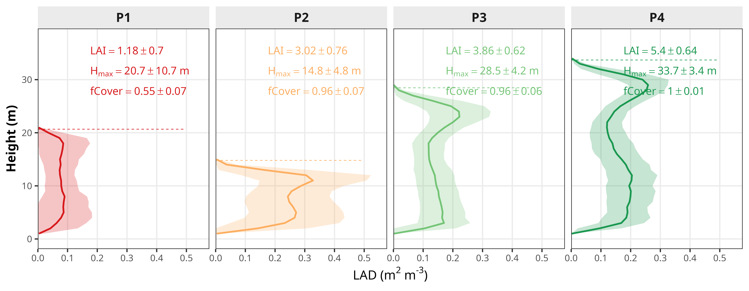
Figure 1. Four LiDAR-derived structural archetypes, from open (P1) to dense (P4): mean leaf-area-density profiles, each rescaled to its archetype’s mean H_{max} by homothety before averaging so the mean shape is undistorted and ends at the dashed mean height. LAI is shown one-sided.
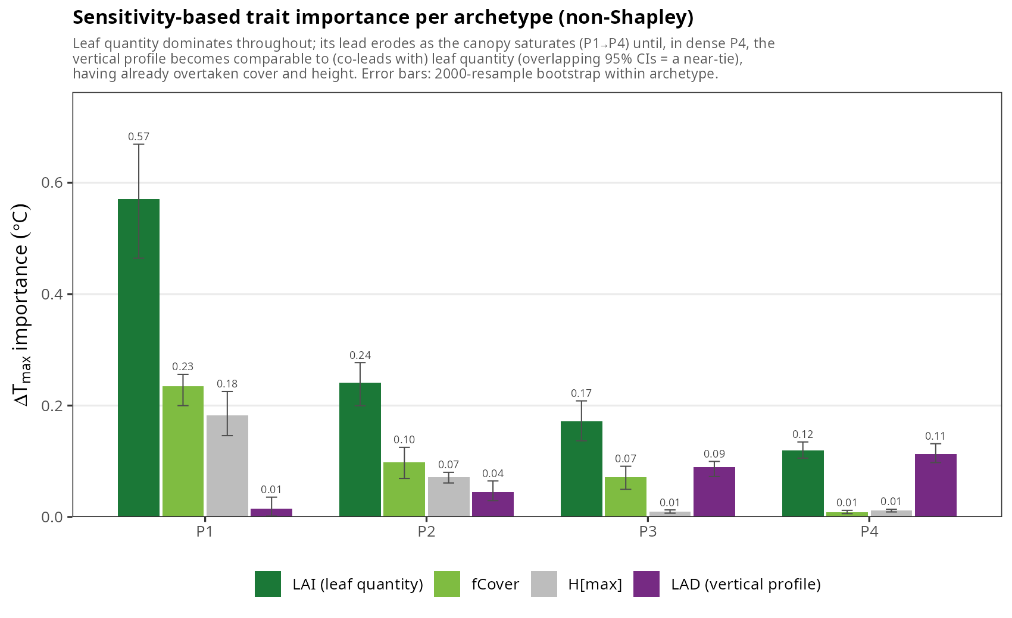
Figure 2. Sensitivity-based trait importance for ΔT_{max} within each archetype (100 cLHS plots per archetype): for the scalar traits, the magnitude of the local per-unit sensitivity times the realized within-archetype dispersion; for the vertical profile (LAD), the magnitude of the real-versus-uniform contrast. Leaf quantity (LAI) dominates throughout; its lead erodes as the canopy saturates (P1→P4) until the vertical profile becomes comparable to it in the dense archetype P4, having already overtaken cover and height. Error bars are 95% confidence intervals from a 2000-resample within-archetype bootstrap; in P4 the LAI and LAD intervals overlap, so the dense co-lead is a statistical near-tie rather than a separation.
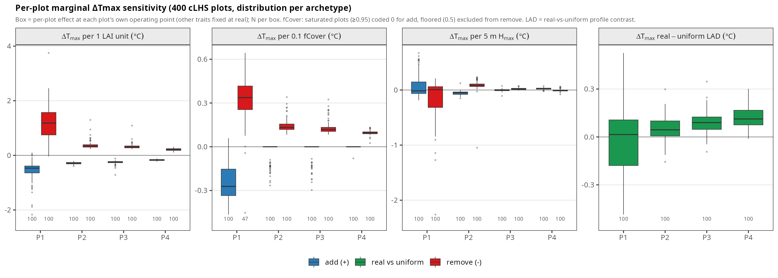
Figure 3. Per-plot local sensitivities in physical units, as distributions over the 400 cLHS plots by archetype: ΔT_{max} change per one-sided LAI unit, per 0.1 fractional cover and per 5 m of height (upward and downward perturbations shown separately), and the real-minus-uniform contrast for the vertical profile (LAD). The cooling power of leaf quantity collapses several-fold from open to dense and is strongly asymmetric in the open canopy (removing leaf area costs more than adding it), while the real profile’s real-minus-uniform contrast grows toward the dense end.
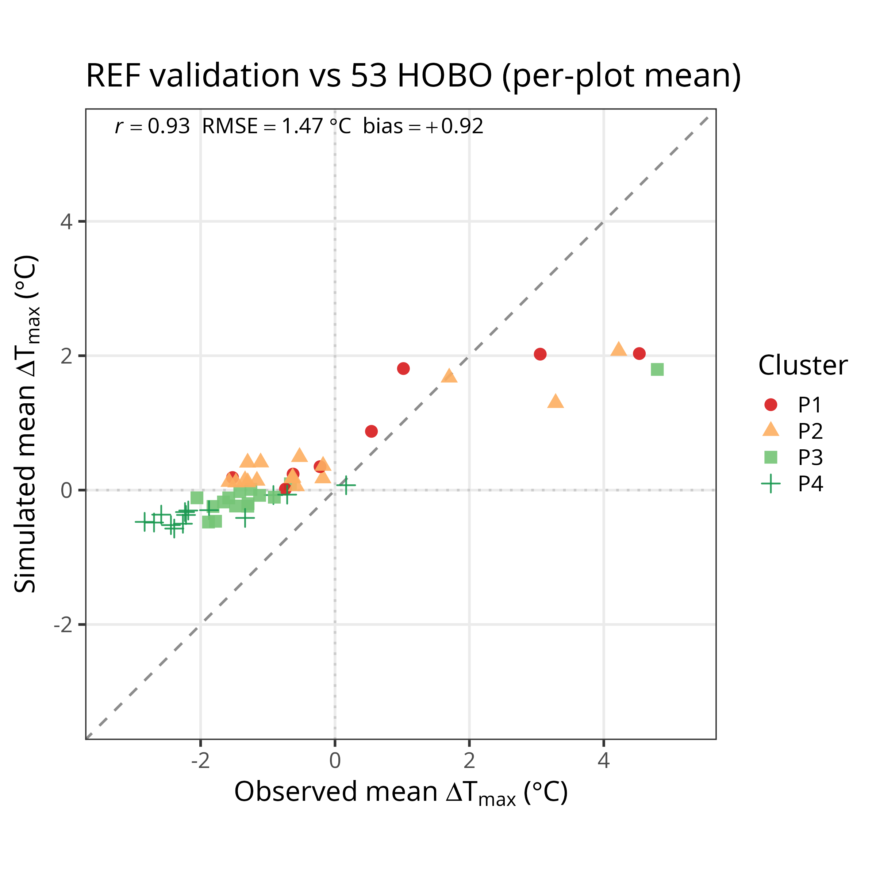
Figure 4. Validation against 53 HOBO loggers: simulated versus observed ΔT_{max} per plot. The between-plot ranking is captured (r = 0.93) with a warm bias; the model under-buffers and does not reproduce the amplifying plots, the glass ceiling.
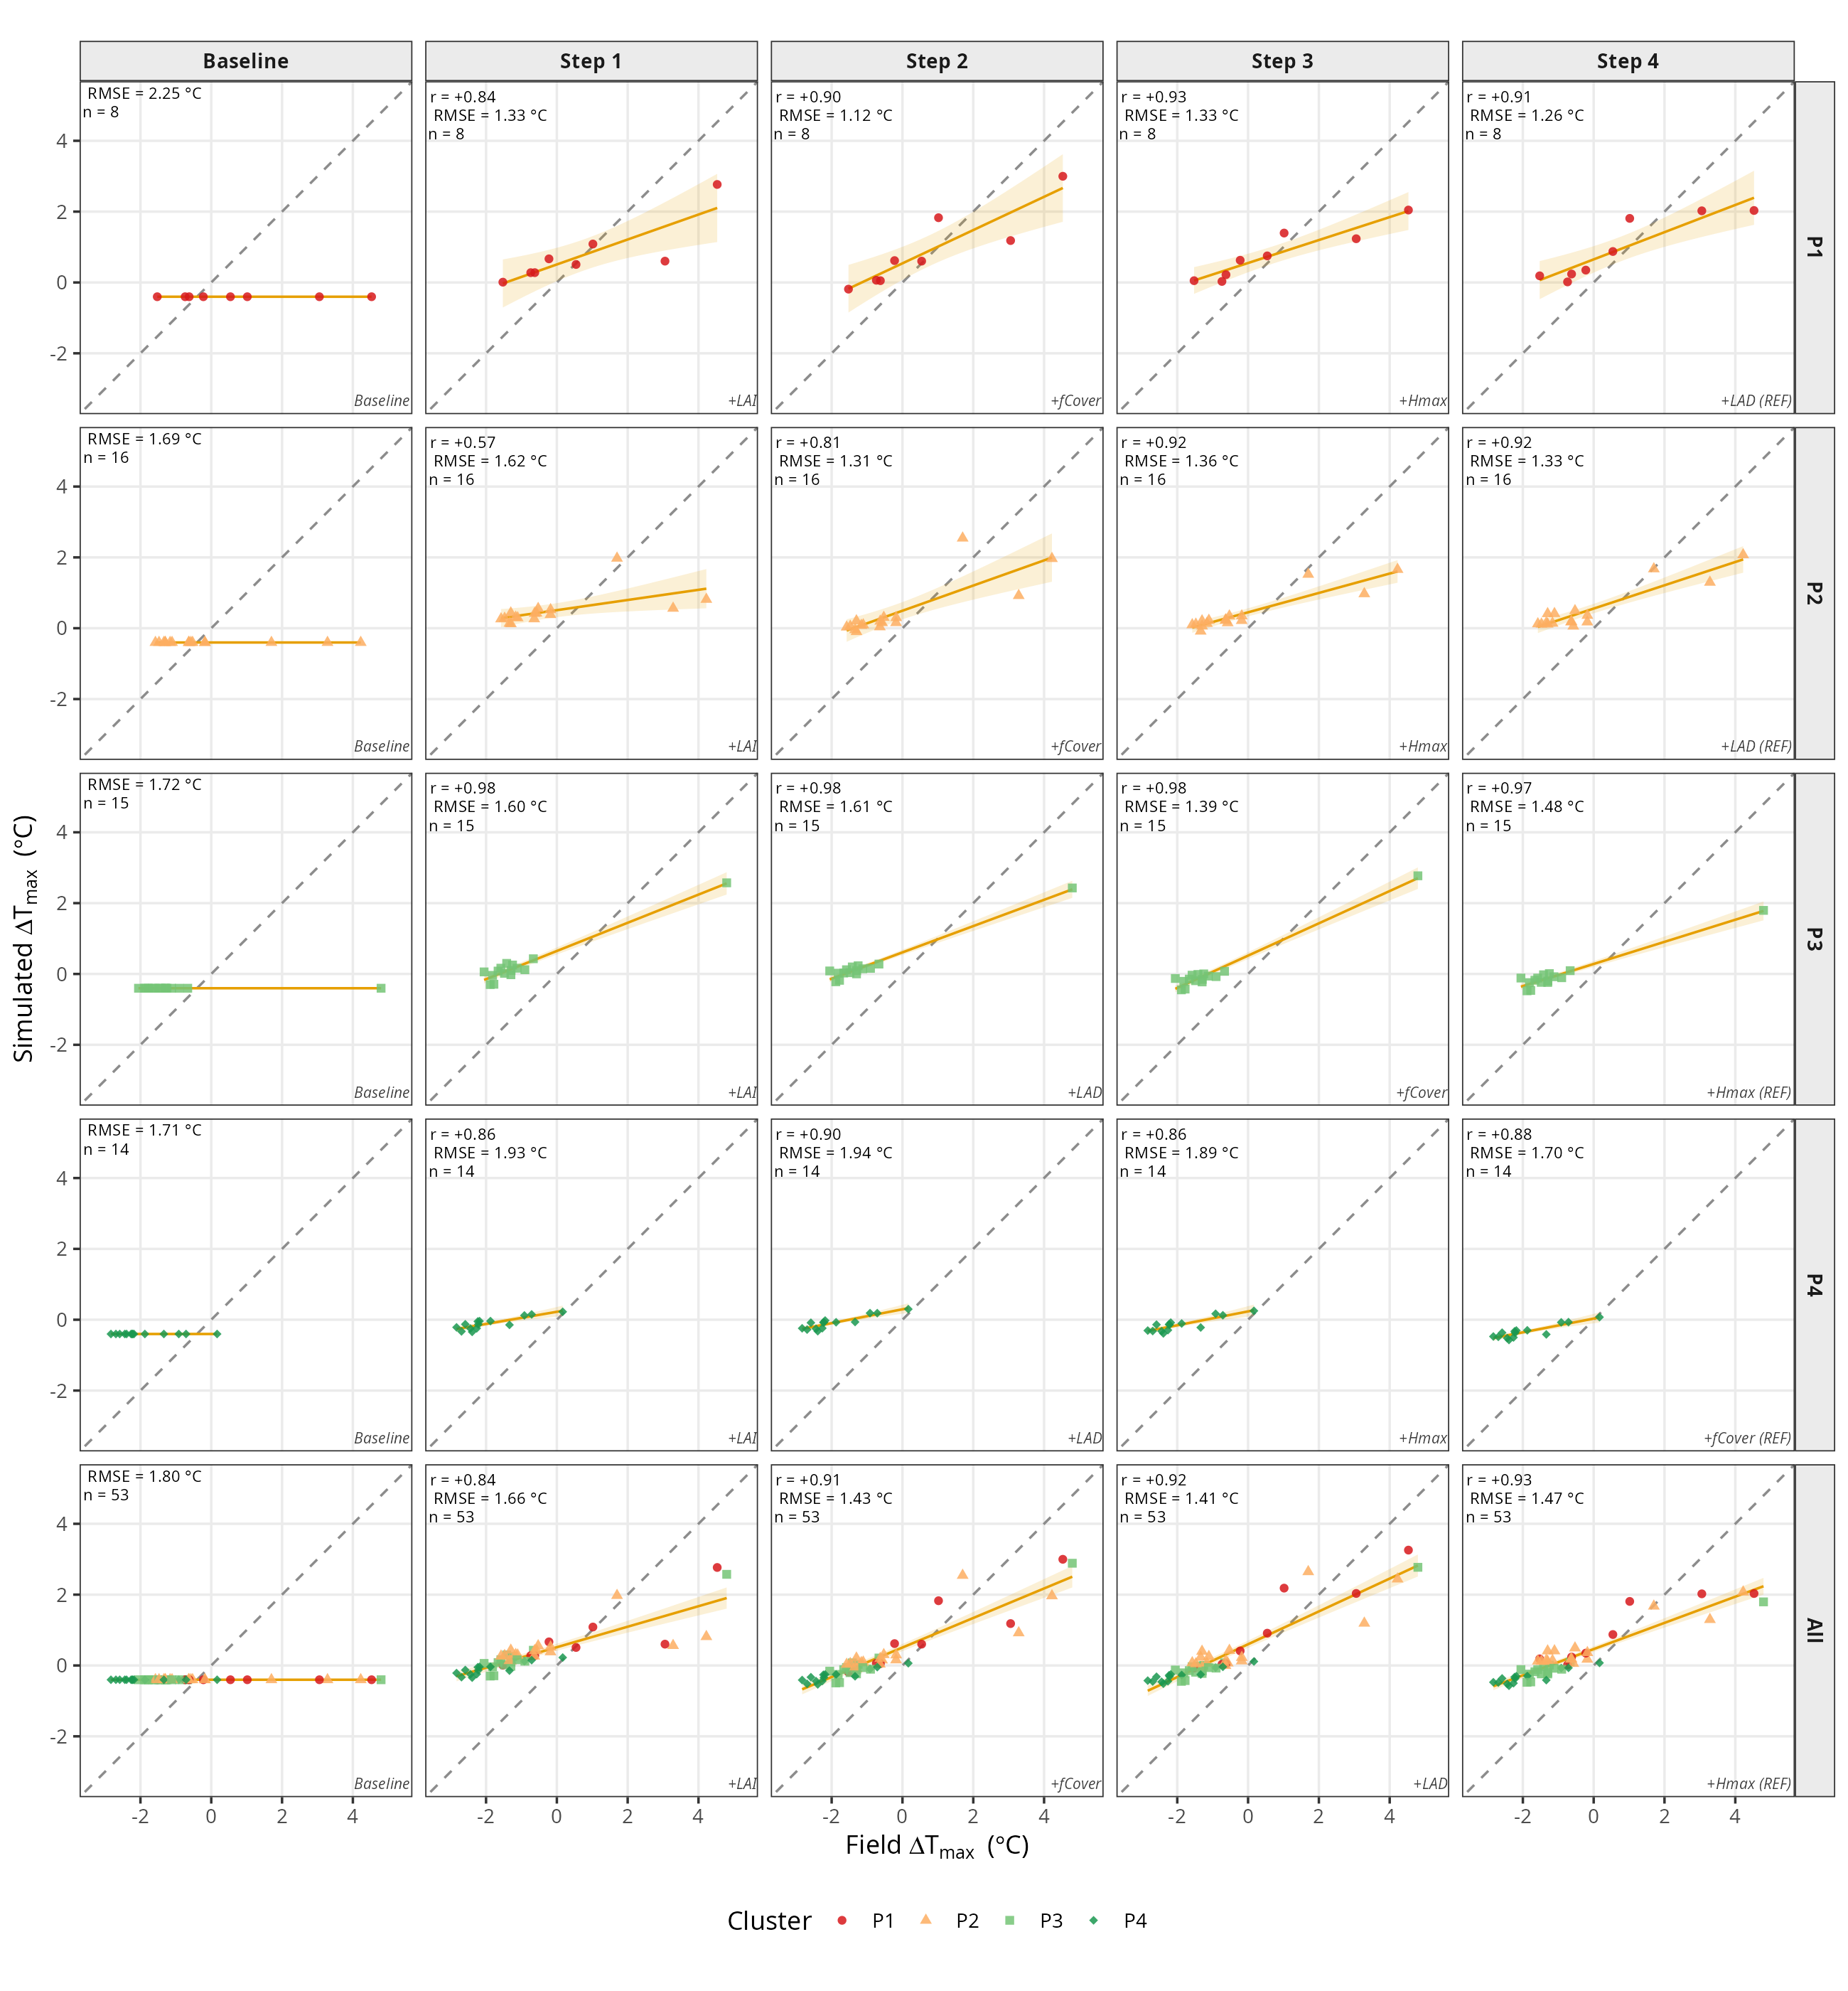
Figure 5. Forward validation against the 53 loggers, per archetype (rows P1 to P4, and All) and with traits added cumulatively in each archetype’s own sensitivity-importance order (columns: baseline, then steps 1 to 4). Each cell plots simulated versus observed mean ΔT_{max} at 1 m (1:1 dashed, orange least-squares fit, r and RMSE annotated; points colored by archetype). Leaf quantity (LAI) is added first in every archetype and carries most of the spatial fit; the vertical profile (LAD) is added second in the dense archetypes P3 and P4, where in P4 it lifts the fit from r ≈ 0.86 to 0.90.
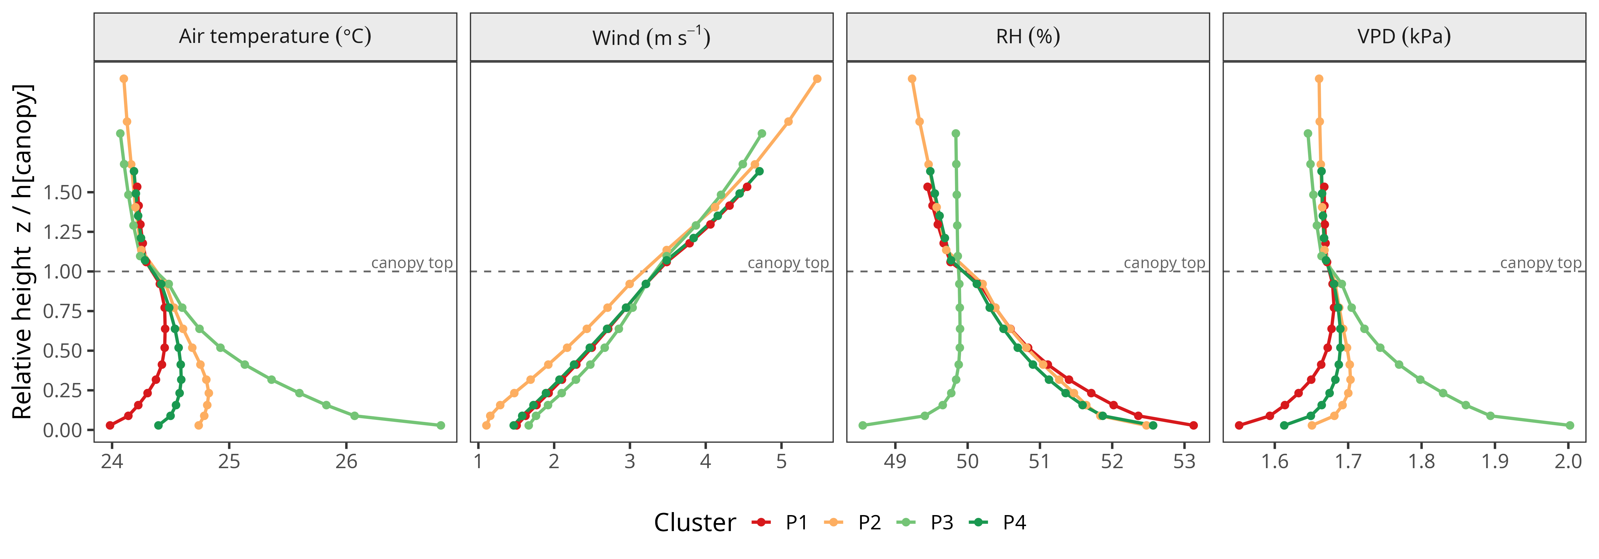
Figure 6. Simulated vertical profiles of air temperature, wind, relative humidity and VPD, by archetype (mechanistic illustration; no vertical field reference).

Appendix A. Intrinsic potency, local sensitivity, and the VCI reading of the vertical-profile contrast
The leading trait in each archetype (Section 3.2) is the product of two distinct quantities, which the sensitivity analysis separates: a trait’s universal physical strength, and the margin locally available to it inside a given structural type. We report each.
The intrinsic potency is the full-range sensitivity of a metric to each trait, computed with the partner traits held at the archetype mean, so it measures the physical strength a trait would have if it could vary over its full landscape range. It is essentially cluster-invariant and ranks the traits the same way in every archetype: leaf quantity is far the most potent (about −2.6 °C of ΔT_{max} over its range), ahead of cover (−1.2 °C), height (−0.25 °C) and the vertical profile (+0.1 °C; Fig. A1, left). Leaf quantity therefore never loses its physical primacy.
The local sensitivity is instead the slope evaluated within each archetype’s own realized window (the within-archetype 10th-to-90th-percentile range of each trait), normalized by the trait’s full-sample range so the four traits are comparable in common units. This is where saturation appears: the local sensitivity of ΔT_{max} to leaf quantity collapses about four-fold from the open to the dense archetype (≈ −4.2 °C in P1 to ≈ −1.0 °C in P4 in normalized units), and cover follows the same gradient (−1.6 to −0.4 °C), while height and the vertical profile stay small (Fig. A1, right). The same erosion holds for the micro/macro buffering slope and for ΔVPDmax, over the full summer and the hottest 10% of days. A trait can thus be intrinsically potent yet have little local leverage, because in closed canopy leaf area is radiatively saturated and cover is pinned near one; this is the physical condition that lets the vertical profile rise to co-lead in the dense archetype even though its intrinsic potency is the smallest of the four. The combination of a universal potency and a density-varying local margin is exactly why a per-archetype, on-manifold sensitivity analysis, rather than a single landscape ranking, is required.
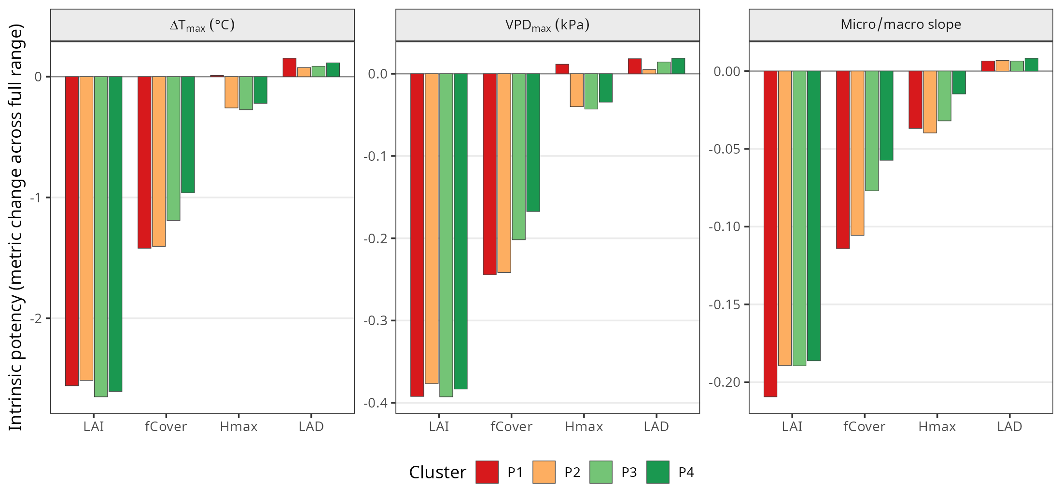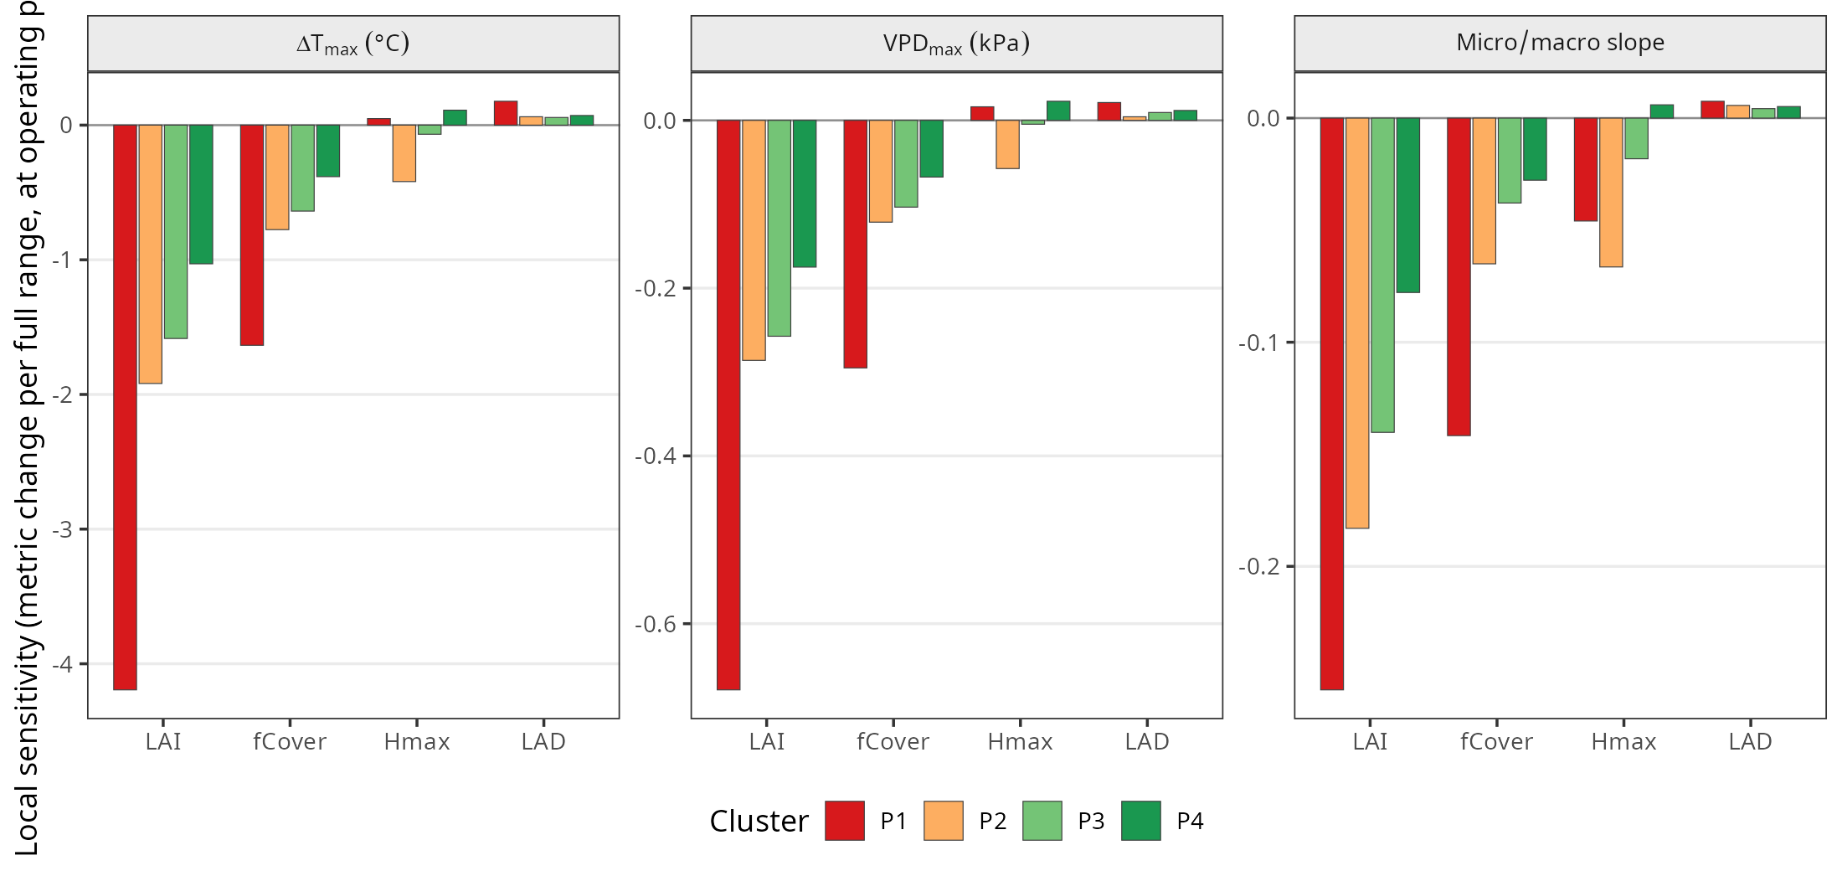
The direction of the vertical-profile contrast has a clean scalar interpretation through the vertical complexity index. Because a uniform profile is the limit of maximal vertical evenness (VCI = 1), the real-versus-uniform contrast is the effect of closing the gap from the profile’s measured VCI to that limit. Within each archetype, the contrast scales with the departure from uniform, 1 − VCI: more concentrated profiles (lower VCI) produce a larger real-versus-uniform contrast (partial Spearman ρ = −0.33 controlling for leaf area, clearest in the open P1 and dense P4 archetypes; Fig. A2). This is the scalar handle the bulk centre of mass failed to provide (the centre of mass is near mid-canopy, 0.51–0.54 of H_{max}, in every archetype and does not track the contrast). The VCI is, however, used here only to interpret and scale the contrast, not as a model input or an added player: it is a deterministic summary of the same profile MuSICA already ingests, it is strongly collinear with leaf quantity across the landscape (ρ = 0.86, hence the density control above), and as a scalar it is one-to-many with shape (it measures how evenly leaf area is spread, not where), which is precisely why the typology is built on the full profile (FPCA) rather than on the VCI. The cross-archetype growth of the contrast is not a VCI trend — VCI in fact rises toward the dense end — but the density-saturation of the competing levers.
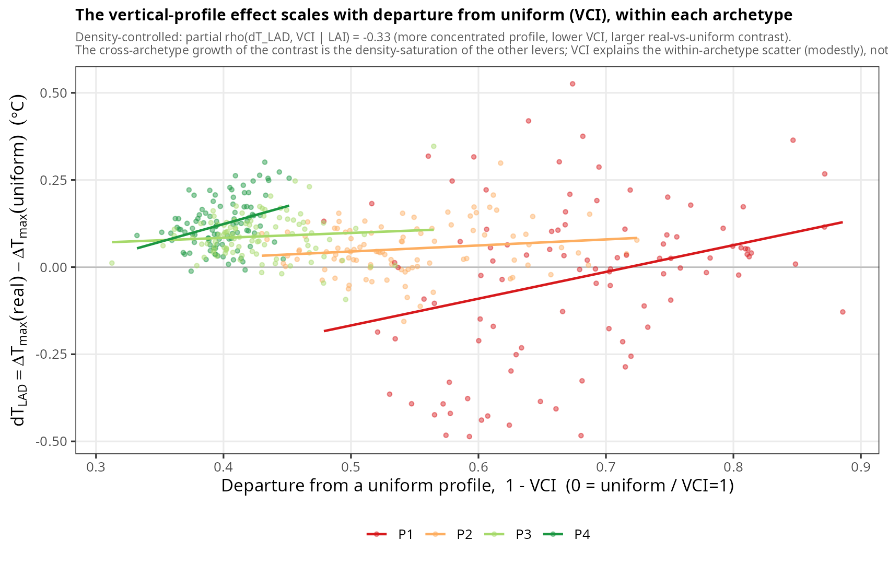
Fig. A2. The vertical-profile contrast (dT_{LAD} = ΔT_{max} real − ΔT_{max} uniform) against the profile’s departure from uniform (1 − VCI), per archetype, with per-archetype linear fits. Within each archetype a more concentrated profile (lower VCI, larger 1 − VCI) gives a larger real-versus-uniform contrast; the density-controlled partial correlation is ρ = −0.33 between the contrast and VCI. The pooled raw association reverses sign because VCI is collinear with density (VCI rises toward the dense archetypes, where the contrast is largest for a separate, saturation reason).

Appendix B. Residual decomposition against terrain and heterogeneity
To characterize what the one-dimensional, plot-scale model structurally cannot represent, the per-plot validation residual (observed minus modelled ΔT_{max}, all 53 loggers) was regressed on terrain and canopy-heterogeneity covariates derived from an external LiDAR dataset: elevation, slope, topographic wetness index, northness, canopy-height standard deviation, rumple, and canopy gap fraction. None of these is an input to a homogeneous plot-scale model. The decomposition explains most of the residual (adjusted R² = 0.62, n = 53), overwhelmingly dominated by canopy gap fraction (r = 0.76; partial p < 0.001), with only marginal secondary contributions from topographic exposure (elevation and northness, p ≈ 0.05; slope not significant). The amplifying plots are precisely the gappiest ones (mean gap fraction 0.52 versus 0.01 on the buffering plots, p = 0.006; Fig. B1). They are also structurally simpler (lower height standard deviation and rumple), but these covary with openness and add nothing independent once gap fraction is included, so the residual is governed by horizontal canopy openness, not by vertical structural heterogeneity.
Moran’s I (k = 8 nearest neighbours, 999 permutations) shows the observed buffering field is moderately spatially structured (I = 0.10, p = 0.04) and the modelled field is in fact more strongly autocorrelated than the observations (I = 0.23, p = 0.001): driven by spatially smooth LiDAR structure, the model produces a field smoother than reality, because it cannot reproduce the localized, gap-driven deviations that roughen the observed field. Those deviations land in the residual, which is itself only weakly spatially autocorrelated (I = 0.03 to 0.16 across weightings, significant under none to one of them), so per-plot inference is not materially inflated by spatial clustering.
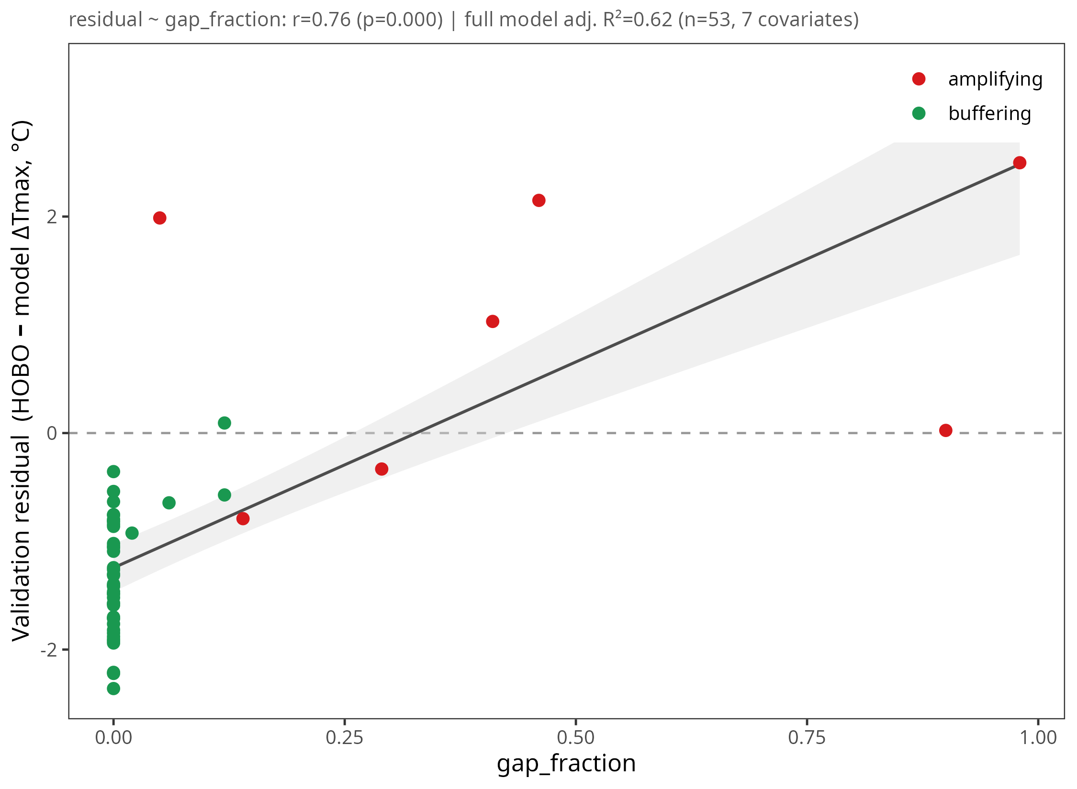
Fig. B1. Decomposition of the per-plot validation residual (observed minus modelled ΔT_{max}, all 53 loggers) against terrain and heterogeneity covariates (adjusted R² = 0.62): the residual is overwhelmingly structured by canopy gap fraction (r = 0.76), the amplifying plots (red) being the gappiest, not by vertical structural heterogeneity.

Appendix C. Footprint radius and geometry sensitivity
The structural traits feeding MuSICA are extracted from the LiDAR point cloud within a fixed footprint centered on each logger, so the chosen footprint size and shape could in principle influence the fit. We tested this directly. For each of the 53 loggers we re-extracted the traits and re-ran MuSICA for nine footprint radii (5, 10, 12.5, 15, 20, 25, 30, 40, 50 m) and for two footprint geometries (a circle of radius r and a square of side 2r), then scored the hourly simulated air temperature at 1 m against the logger record (R², RMSE, MAE; Fig. C1).
The fit is remarkably insensitive to the footprint. Across the full 5 to 50 m range R² stays within 0.642 to 0.648 and the two geometries are indistinguishable (curves overlap within about 0.01 °C at every radius), so footprint shape does not matter. The error metrics are minimized at small footprints: RMSE and MAE reach their lowest values near 10 to 12.5 m (RMSE ≈ 3.01 °C, MAE ≈ 2.29 °C) and degrade slowly toward the largest radii (RMSE ≈ 3.10 °C, MAE ≈ 2.37 °C at 50 m). A small footprint keeps the extracted structure local to the logger; enlarging it averages over more heterogeneous canopy and dilutes that local match. Our 12.5 m radius (a 25 m extent) sits in this optimal region while still enclosing enough returns for a stable trait estimate, which justifies the choice.
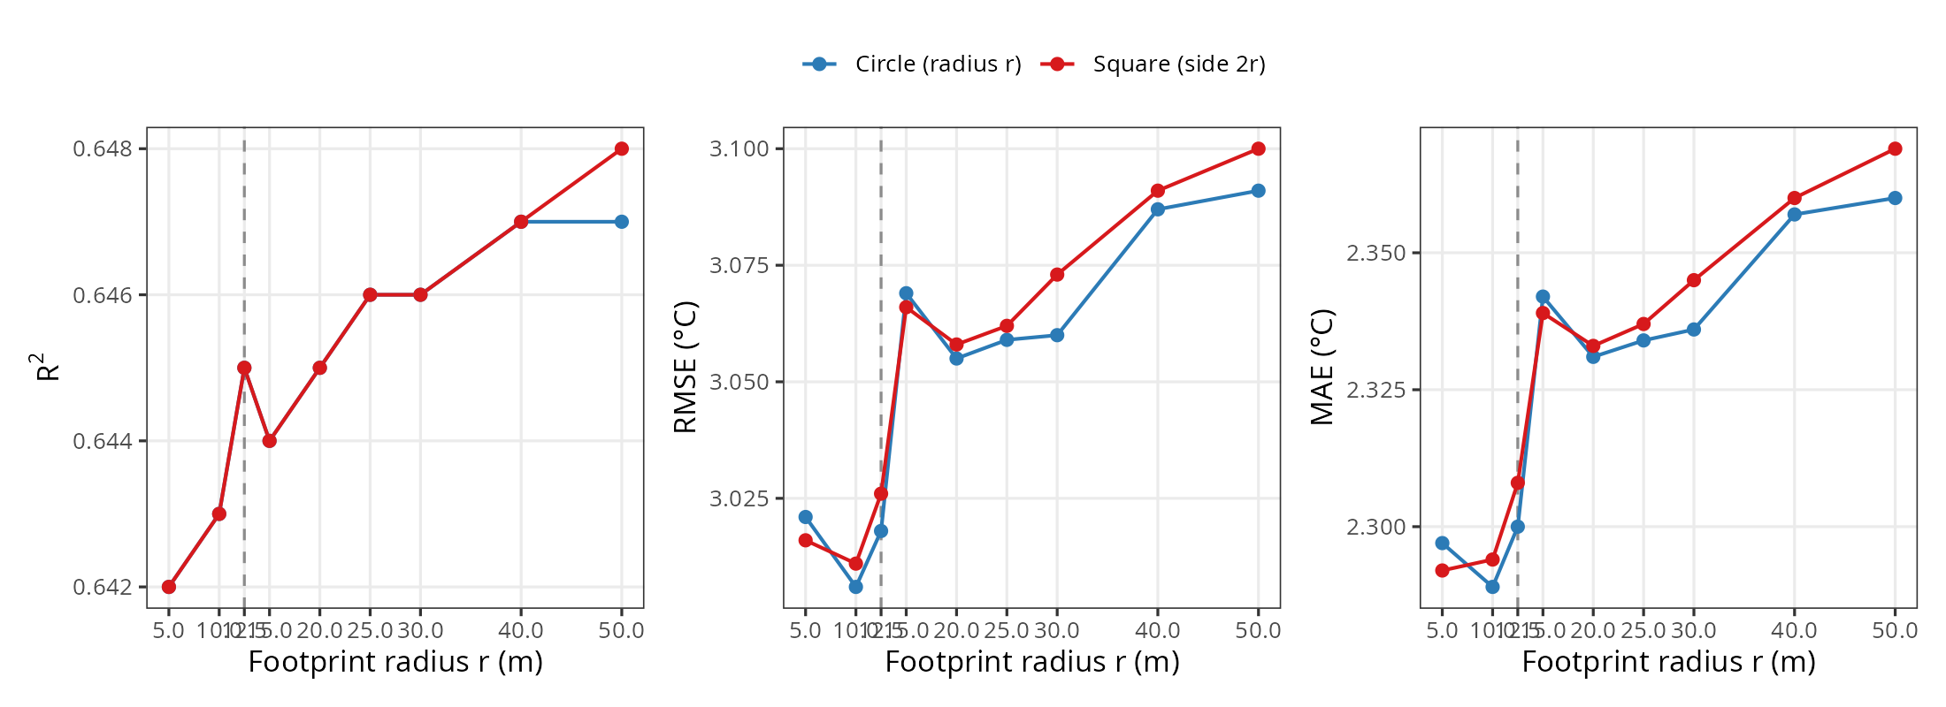
Fig. C1. Footprint sensitivity of the MuSICA fit to the 53 loggers (hourly air temperature at 1 m): R² (left), RMSE (center) and MAE (right) as a function of footprint radius, for a circular footprint (blue) and a square footprint of side 2r (red). The dashed line marks the chosen 12.5 m radius. The two geometries are indistinguishable and R² is essentially flat; the error is lowest at small footprints.

Appendix D. Within-archetype trait dispersion
Because the within-archetype importance readout (Section 2.6) scales with the realized dispersion of a trait as well as with its physical sensitivity, we report the per-archetype mean and standard deviation of the three scalar traits across the 100 cLHS plots of each archetype (Table D1). The standard deviation of one-sided LAI is essentially constant across the density gradient (0.62 to 0.76), so the density-dependent collapse of LAI importance cannot be a sampling-range artefact and reflects the four-fold collapse of the LAI sensitivity itself. Fractional cover saturates toward one in the dense archetypes and its dispersion narrows accordingly, consistent with genuine physical saturation.
Table D1. Within-archetype trait dispersion (mean ± SD; 100 cLHS plots per archetype). LAI is one-sided.
Archetype | LAI (mean ± SD) | fCover (mean ± SD) | H_{max} (mean ± SD)
P1 (open) | 1.18 ± 0.70 | 0.55 ± 0.07 | 20.7 ± 10.7
P2 | 3.02 ± 0.76 | 0.96 ± 0.07 | 14.8 ± 4.8
P3 | 3.86 ± 0.62 | 0.96 ± 0.06 | 28.5 ± 4.2
P4 (dense) | 5.40 ± 0.64 | 1.00 ± 0.01 | 33.7 ± 3.4

Appendix E. Trait correlation structure, per archetype and overall
Disentangling collinear traits is the central difficulty this study addresses, so we report the pairwise Pearson correlations among the canopy traits, both over all 400 cLHS plots and within each archetype (Fig. E1; LAI, fractional cover and maximum height as scalars, and the vertical complexity index VCI as a scalar summary of the LAD profile shape). Across the whole landscape the traits are strongly intercorrelated (LAI-fCover r = 0.81, LAI-VCI r = 0.87), which is precisely why a single regression cannot uniquely attribute the thermal effect and why a per-archetype, on-manifold trait-perturbation sensitivity analysis is used instead.
The correlation structure is itself density-dependent. It is strongest in the open and intermediate archetypes and collapses in the dense archetype P4, where LAI-fCover falls to r = 0.17 and LAI-VCI to r = −0.08: once the canopy closes, leaf quantity, cover and profile shape vary nearly independently. This is the same saturation that drives the density-dependent sensitivity result, seen here in the trait covariance rather than in the sensitivities, and it confirms that the within-archetype sensitivity analysis is comparing traits that are not redundant inside each archetype.
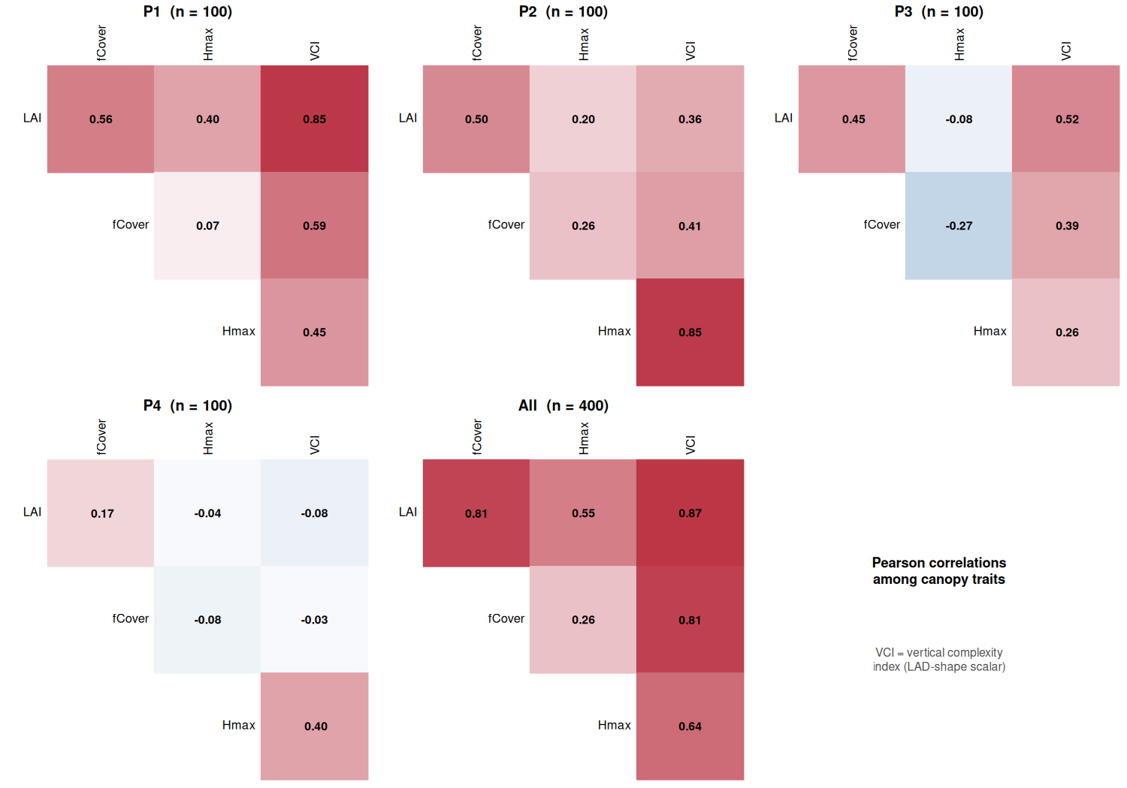
Fig. E1. Pearson correlation matrices among the canopy traits (LAI, fCover, H_{max}, and VCI as a LAD-shape scalar), within each archetype P1 to P4 and over all 400 cLHS points. Collinearity is strong across the landscape but collapses in the dense archetype P4.
We also add the three leading functional principal components of the LAD profile (FPC1 to FPC3, capturing 46, 26 and 16% of the profile-shape variance), computed on the 400 cLHS profiles with the same double-normalized FPCA as the typology (Fig. E2). Two points stand out. The FPCs carry information largely complementary to the scalar traits: their correlations with LAI, fCover and H_{max} are low to moderate (the strongest being FPC1-H_{max} = 0.62 across the landscape, as the dominant shape mode tracks canopy height), which is exactly why the LAD profile is treated as a distinct model input rather than folded into the scalar traits. And, as for the scalars, the profile-shape associations restructure with density: in the dense archetype P4, FPC1 becomes strongly and negatively tied to LAI (r = −0.57), the signature of the profile reorganizing once leaf quantity saturates.
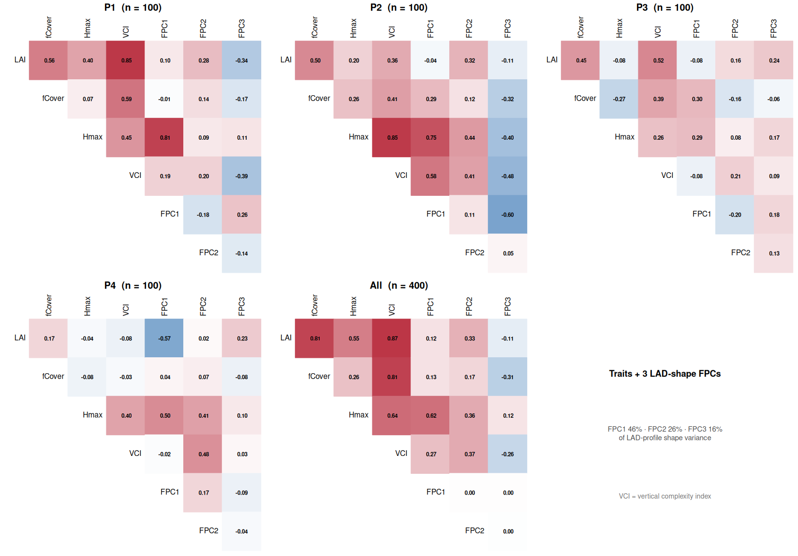
Fig. E2. As Fig. E1 but with the three leading LAD-profile FPCs added (FPC1 to FPC3, 46/26/16% of profile-shape variance). The FPCs are orthogonal by construction over all 400 points and only weakly to moderately correlated with the scalar traits, confirming the vertical profile is a largely independent structural axis.

Appendix F. Model-free observational triangulation of the attribution
To test whether the attribution exists in the data and not only inside MuSICA, we regressed the observed buffering (−ΔT_{max}) at the 53 loggers directly on the four LiDAR traits (LAI, fCover, H_{max}, VCI). We report LMG relative-importance shares (Lindeman-Merenda-Gold, averaging R² over all predictor orderings, the standard estimator under correlated predictors), with a random-forest permutation importance as a non-linear cross-check, and simple and partial Pearson correlations. The full model reaches R² = 0.87. Leaf quantity dominates: LAI and fCover together carry about 64% of the explained variance, while the vertical profile (VCI) adds little once quantity is controlled (partial r ≈ −0.16). Which facet of quantity ranks first is method-dependent — the observational association favours fCover (LMG 0.36 versus 0.28; partial r 0.65 versus 0.49; random forest ties them), whereas the model’s ceteris-paribus attribution favours LAI in every archetype (Fig. F2) — a divergence that follows directly from the field collinearity of the two traits (r = 0.76). Two caveats bound this triangulation. First, n = 53. Second, the traits are strongly collinear (pairwise r = 0.75 to 0.86, VCI 0.82 to 0.86 with all others), so the partial terms are unstable and the profile’s independent role cannot be isolated observationally at any density; for the same reason we report only the full-sample importance and not a per-archetype decomposition, which is degenerate at roughly a dozen loggers per stratum. The loggers do span the dense end of the gradient (one-sided LAI up to about 6.4, matching the dense archetype’s mean of about 5.4; Fig. F3), so the limitation is the trait confound, not the absence of dense stands: the model’s dense co-lead is a result that the collinear observations can neither confirm nor refute. This is therefore independent support for quantity-dominance, not a standalone attribution.
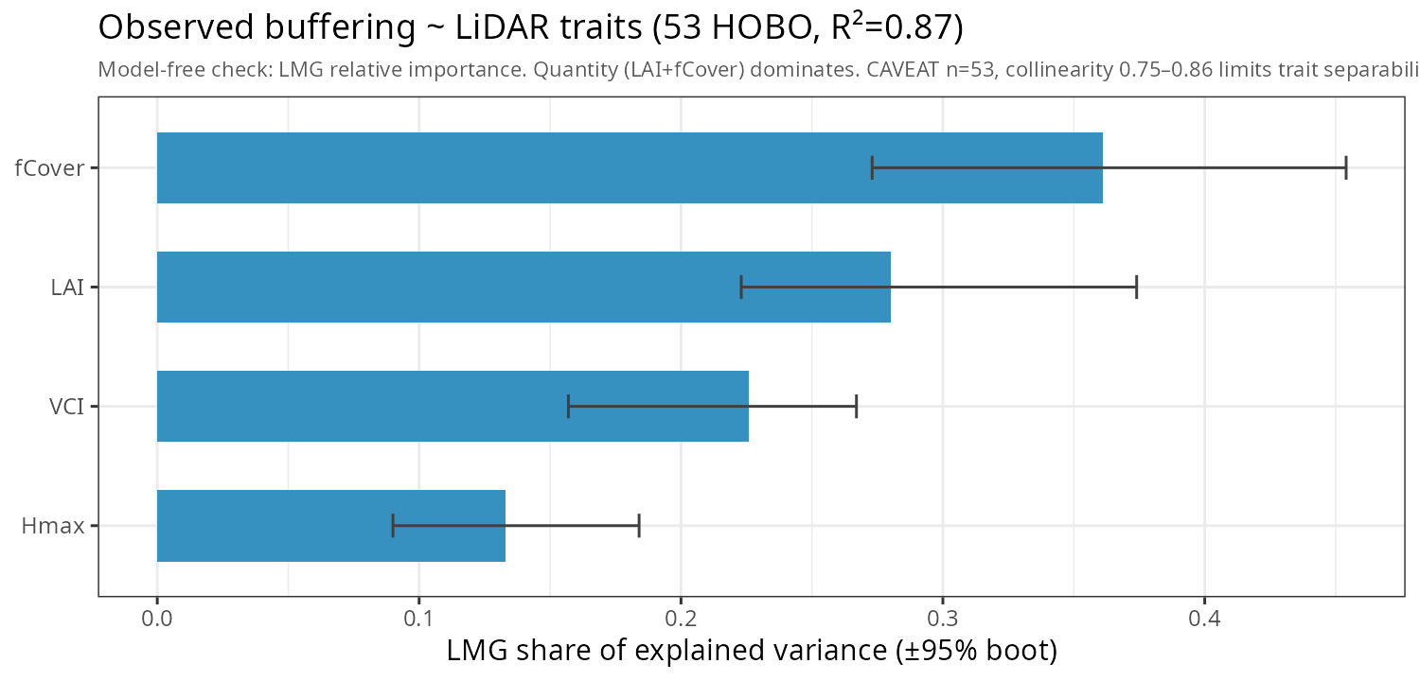
Fig. F1. Model-free relative importance of the four LiDAR traits for the observed buffering at the 53 loggers (LMG shares of explained variance, R² = 0.87, with bootstrap 95% intervals). Leaf quantity (LAI plus fCover) dominates; the vertical profile (VCI) adds little once quantity is controlled. Caveats: n = 53, trait collinearity 0.75 to 0.86, no P4 plots.
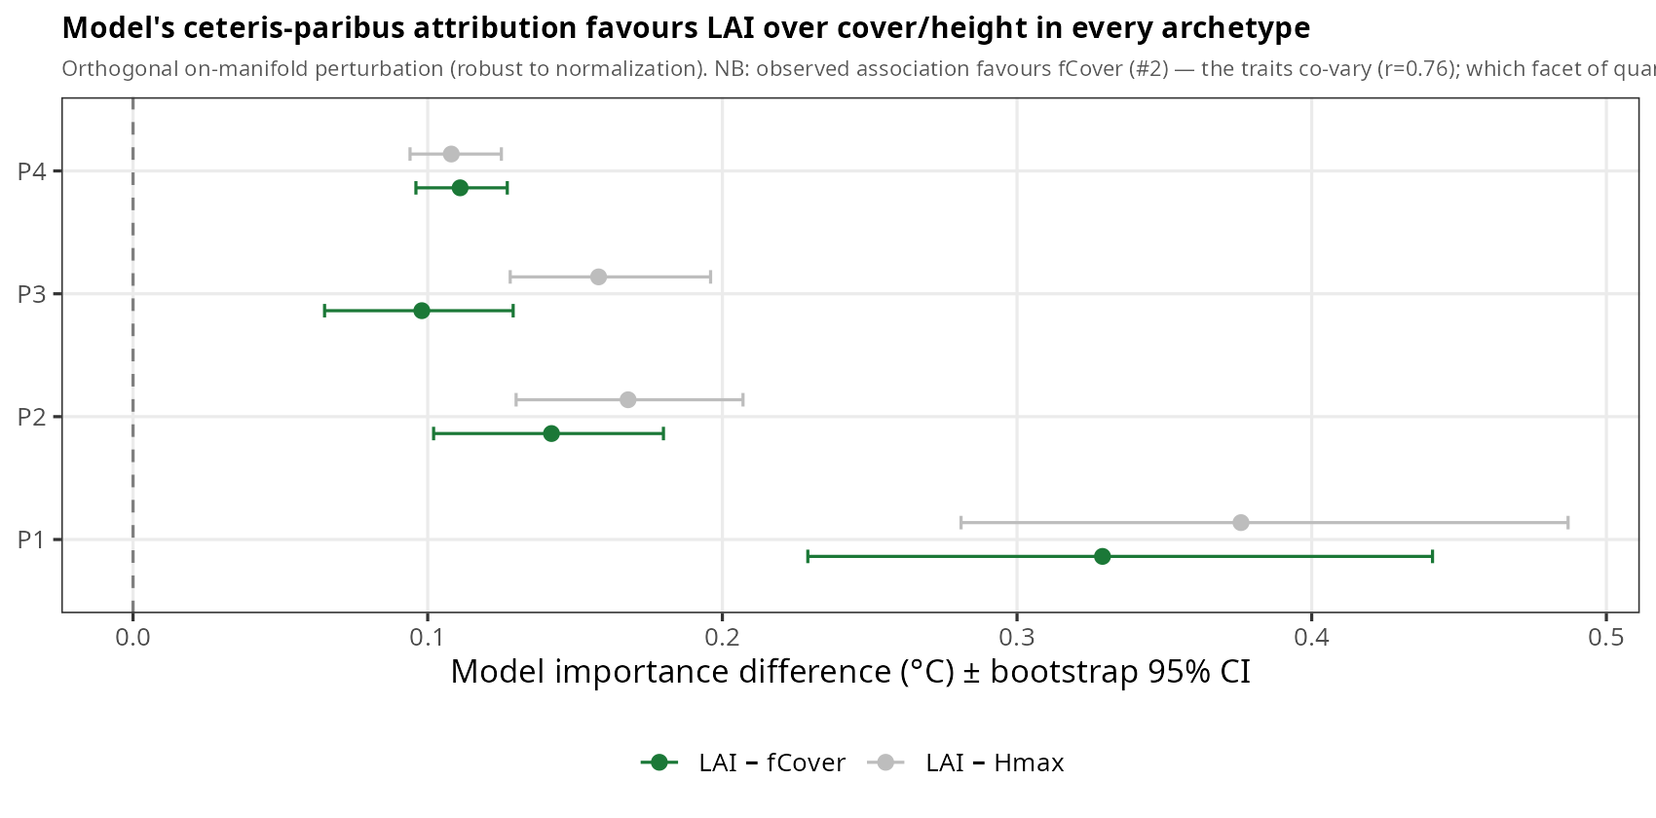
Fig. F2. Model-side importance differences (LAI minus fCover, LAI minus H_{max}) per archetype, with bootstrap 95% intervals, from the controlled on-manifold perturbation that moves each trait orthogonally to its partners. The model’s ceteris-paribus attribution favours LAI over cover and height in every archetype, robust to the importance normalization. The field cannot make this separation because LAI and fCover co-vary (r = 0.76).
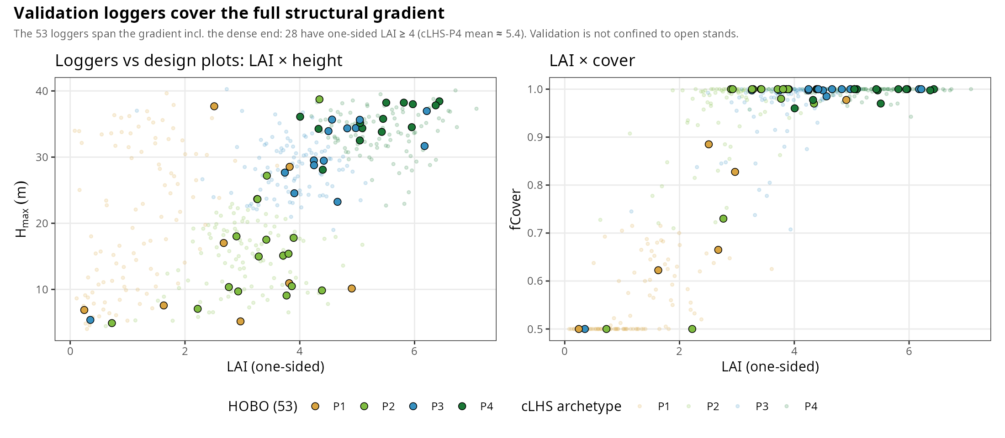
Fig. F3. Coverage of the structural gradient by the 53 validation loggers (filled, outlined points, coloured by their canonical archetype) against the 400 cLHS design plots (faint background), in LAI × height (left) and LAI × cover (right); LAI on a common one-sided scale. The loggers span the full gradient including the dense end: 28 of 53 have one-sided LAI ≥ 4, matching the dense archetype P4 (mean ≈ 5.4). The validation is therefore not confined to open stands; what the field cannot do is separate the collinear traits, not sample the dense regime.

References
Aalto, Iris, Juha Aalto, Steven Hancock, Sauli Valkonen, and Eduardo Eiji Maeda. 2023. “Quantifying the Impact of Management on the Three-Dimensional Structure of Boreal Forests.” Forest Ecology and Management 535 (May): 120885. https://doi.org/10.1016/j.foreco.2023.120885.
Atkins, Jeff W., Alexey Shiklomanov, Kayla C. Mathes, Ben Bond-Lamberty, and Christopher M. Gough. 2023. “Effects of Forest Structural and Compositional Change on Forest Microclimates Across a Gradient of Disturbance Severity.” Agricultural and Forest Meteorology 339 (August): 109566. https://doi.org/10.1016/j.agrformet.2023.109566.
Bouvier, Marc, Sylvie Durrieu, Richard A. Fournier, and Jean-Pierre Renaud. 2015. “7_Generalizing Predictive Models of Forest Inventory Attributes Using an Area-Based Approach with Airborne LiDAR Data.” Remote Sensing of Environment 156 (January): 322–34. https://doi.org/10.1016/j.rse.2014.10.004.
Bouwen, Par Klara. n.d. Interactions entre la structure de la canopée et le microclimat du sous-étage : implications pour la régénération des forêts.
De Frenne, Pieter, Jonathan Lenoir, Miska Luoto, et al. 2021. “Forest Microclimates and Climate Change: Importance, Drivers and Future Research Agenda.” Global Change Biology 27 (11): 2279–97. https://doi.org/10.1111/gcb.15569.
De Frenne, Pieter, Florian Zellweger, Francisco Rodríguez-Sánchez, et al. 2019. “Global Buffering of Temperatures Under Forest Canopies.” Nature Ecology & Evolution 3 (5): 744–49. https://doi.org/10.1038/s41559-019-0842-1.
De Pauw, Karen, Pieter Sanczuk, Camille Meeussen, et al. 2022. “Forest Understorey Communities Respond Strongly to Light in Interaction with Forest Structure, but Not to Microclimate Warming.” New Phytologist 233 (1): 219–35. https://doi.org/10.1111/nph.17803.
Ehbrecht, Martin, Peter Schall, Christian Ammer, and Dominik Seidel. 2017. “Quantifying Stand Structural Complexity and Its Relationship with Forest Management, Tree Species Diversity and Microclimate.” Agricultural and Forest Meteorology 242 (August): 1–9. https://doi.org/10.1016/j.agrformet.2017.04.012.
Greiser, Caroline, Lucia Hederová, Giulia Vico, Jan Wild, Martin Macek, and Martin Kopecký. 2024. “Higher Soil Moisture Increases Microclimate Temperature Buffering in Temperate Broadleaf Forests.” Agricultural and Forest Meteorology 345 (February): 109828. https://doi.org/10.1016/j.agrformet.2023.109828.
Greiser, Caroline, Eric Meineri, Miska Luoto, Johan Ehrlén, and Kristoffer Hylander. 2018. “Monthly Microclimate Models in a Managed Boreal Forest Landscape.” Agricultural and Forest Meteorology 250–251 (March): 147–58. https://doi.org/10.1016/j.agrformet.2017.12.252.
Gril, Eva, Marianne Laslier, Emilie Gallet-Moron, et al. 2023. “Using Airborne LiDAR to Map Forest Microclimate Temperature Buffering or Amplification.” Remote Sensing of Environment 298 (December): 113820. https://doi.org/10.1016/j.rse.2023.113820.
Haesen, Stef, Jonas J. Lembrechts, Pieter De Frenne, et al. 2021. “ForestTemp – Sub-Canopy Microclimate Temperatures of European Forests.” Global Change Biology 27 (23): 6307–19. https://doi.org/10.1111/gcb.15892.
Hersbach, Hans, Bill Bell, Paul Berrisford, et al. 2020. “The ERA5 Global Reanalysis.” Quarterly Journal of the Royal Meteorological Society 146 (730): 1999–2049. https://doi.org/10.1002/qj.3803.
Jucker, Tommaso, Stephen R. Hardwick, Sabine Both, et al. 2018. “Canopy Structure and Topography Jointly Constrain the Microclimate of Human-Modified Tropical Landscapes.” Global Change Biology 24 (11): 5243–58. https://doi.org/10.1111/gcb.14415.
Kovács, B., F. Tinya, and P. Ódor. 2017. “Stand Structural Drivers of Microclimate in Mature Temperate Mixed Forests.” Agricultural and Forest Meteorology 234–235 (March): 11–21. https://doi.org/10.1016/j.agrformet.2016.11.268.
Lembrechts, Jonas J., and Jonathan Lenoir. 2020. “Microclimatic Conditions Anywhere at Any Time!” Global Change Biology 26 (2): 337–39. https://doi.org/10.1111/gcb.14942.
Lenoir, Jonathan, Tarek Hattab, and Guillaume Pierre. 2017. “Climatic Microrefugia Under Anthropogenic Climate Change: Implications for Species Redistribution.” Ecography 40 (2): 253–66. https://doi.org/10.1111/ecog.02788.
MacArthur, Robert H., and Henry S. Horn. 1969. “Foliage Profile by Vertical Measurements.” Ecology 50 (5): 802–4. https://doi.org/10.2307/1933693.
Maclean, Ilya M. D., and David H. Klinges. 2021. “Microclimc: A Mechanistic Model of Above, Below and Within-Canopy Microclimate.” Ecological Modelling 451 (July): 109567. https://doi.org/10.1016/j.ecolmodel.2021.109567.
Maclean, Ilya M. D., Andrew J. Suggitt, Robert J. Wilson, James P. Duffy, and Jonathan J. Bennie. 2017. “Fine-Scale Climate Change: Modelling Spatial Variation in Biologically Meaningful Rates of Warming.” Global Change Biology 23 (1): 256–68. https://doi.org/10.1111/gcb.13343.
Meeussen, Camille, Sanne Govaert, Thomas Vanneste, et al. 2021. “Microclimatic Edge-to-Interior Gradients of European Deciduous Forests.” Agricultural and Forest Meteorology 311 (December): 108699. https://doi.org/10.1016/j.agrformet.2021.108699.
Minasny, Budiman, and Alex B. McBratney. 2006. “A Conditioned Latin Hypercube Method for Sampling in the Presence of Ancillary Information.” Computers & Geosciences 32 (9): 1378–88. https://doi.org/10.1016/j.cageo.2005.12.009.
Ogée, J., Y. Brunet, D. Loustau, P. Berbigier, and S. Delzon. 2003. “MuSICA , a CO₂ , Water and Energy Multilayer, Multileaf Pine Forest Model: Evaluation from Hourly to Yearly Time Scales and Sensitivity Analysis.” Global Change Biology 9 (5): 697–717. https://doi.org/10.1046/j.1365-2486.2003.00628.x.
Ramsay, J. O., and B. W. Silverman. 2005. Functional Data Analysis. 2nd ed. Springer Series in Statistics. Springer. https://doi.org/10.1007/b98888.
Starck, Iris, Juha Aalto, Steven Hancock, Sauli Valkonen, Leena Kalliovirta, and Eduardo Maeda. 2025. “Slow Recovery of Microclimate Temperature Buffering Capacity After Clear-Cuts in Boreal Forests.” Agricultural and Forest Meteorology 363 (March): 110434. https://doi.org/10.1016/j.agrformet.2025.110434.
Vincent, Grégoire, Cécile Antin, Marilyne Laurans, et al. 2017. “6_Mapping Plant Area Index of Tropical Evergreen Forest by Airborne Laser Scanning. A Cross-Validation Study Using LAI2200 Optical Sensor.” Remote Sensing of Environment 198 (September): 254–66. https://doi.org/10.1016/j.rse.2017.05.034.
Zellweger, Florian, David Coomes, Jonathan Lenoir, et al. 2019. “Seasonal Drivers of Understorey Temperature Buffering in Temperate Deciduous Forests Across Europe.” Global Ecology and Biogeography 28 (12): 1774–86. https://doi.org/10.1111/geb.12991.
Zellweger, Florian, Pieter De Frenne, Jonathan Lenoir, et al. 2020. “Forest Microclimate Dynamics Drive Plant Responses to Warming.” Science 368 (6492): 772–75. https://doi.org/10.1126/science.aba6880.

