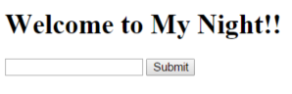

Once the application is up and running, when hitting the its entry point (http://localhost:8080/assign1/). The above dialog will be presented, prompting the user to enter a location.

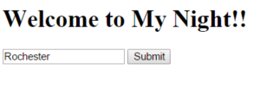

Once a location is entered and submitted, the application will utilize the Eventful API, and the Yelp API to get a collection of events and restaurants. These restaurants and events will then become selectable on the next page which can be seen below.

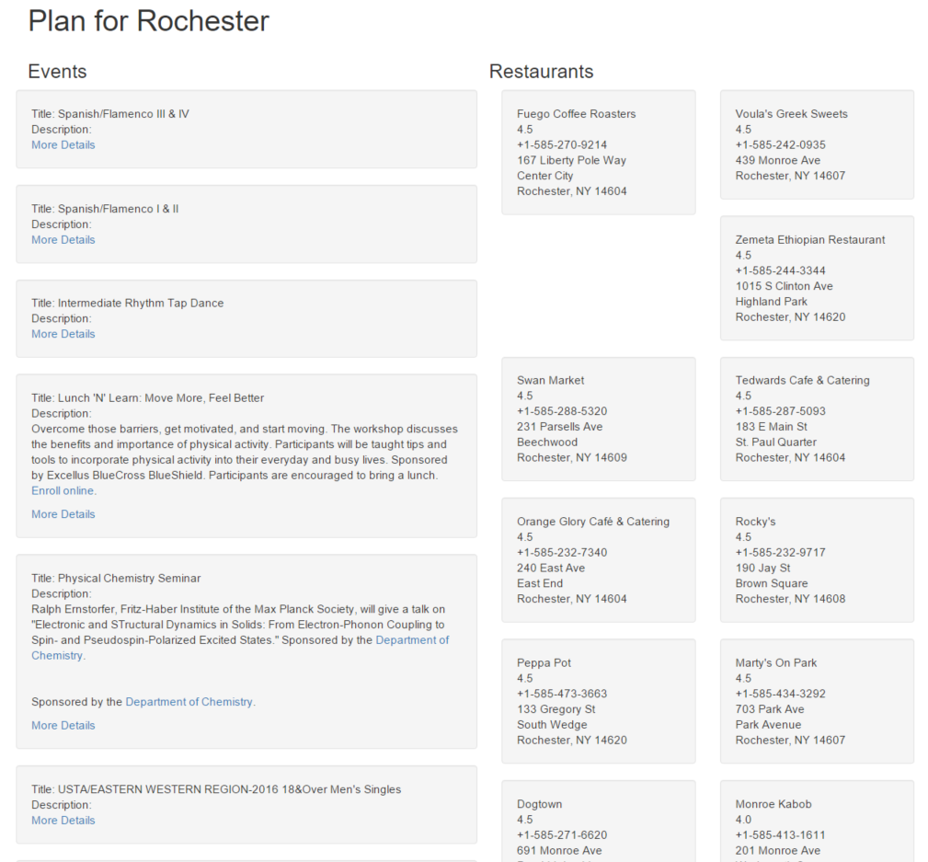

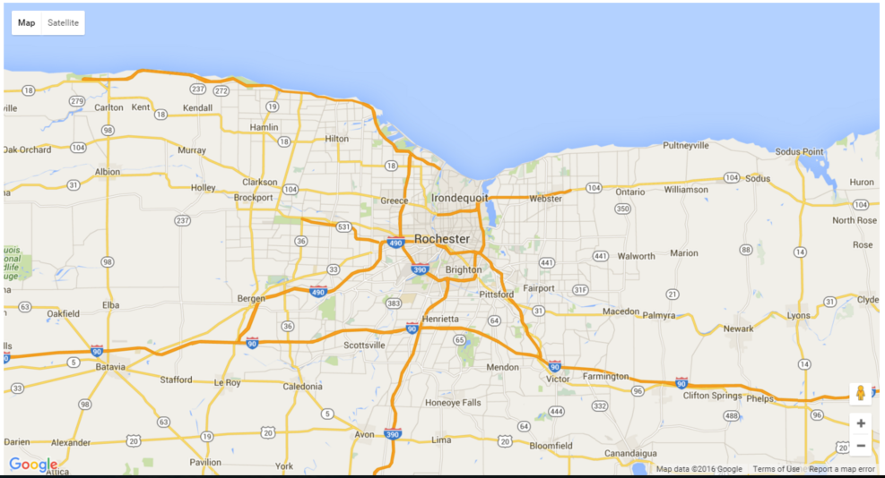

Once both an event and a restaurant have been selected, the Google maps API will make a call its directions service, to fill out the map; the (A) location being the selected event, and the (B) location being the selected restaurant. When a different event or restaurant is selected the map will be updated accordingly.