Loading from Version Control

**If you weren’t able to use version control for the lab:**

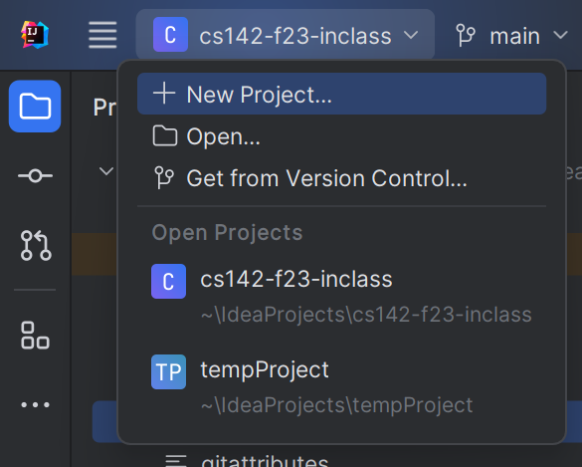

Start IntelliJ. In the top-left corner of the screen, click the project dropdown and choose “Get from Version Control.” Alternately, you can select File -> New -> Project from Version Control  
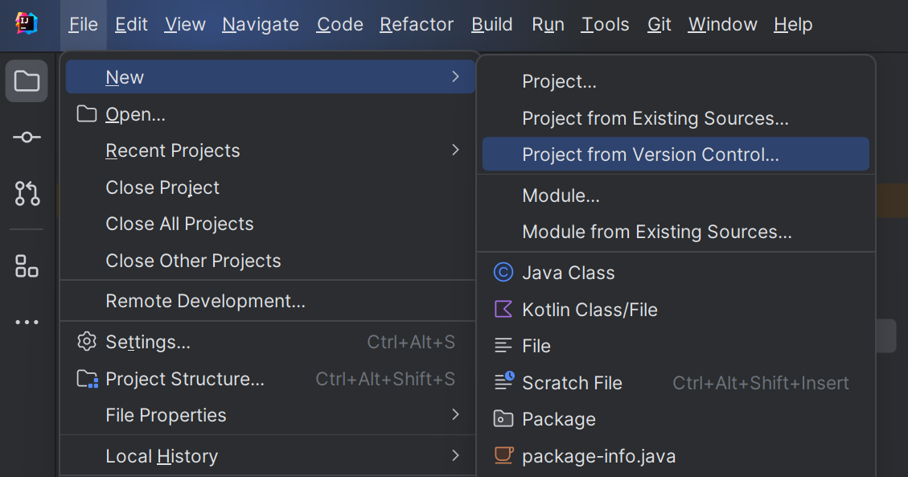

We will make a new project to store all of our labs and code that I want to distribute to the whole class. (This will copy my code from online into a new project-I recommend you put this in a directory with the other COMP 142 projects. Intellij should automatically set this to the directory you’ve used most recently.)

On the next screen, copy and paste in the following URL in the box that says “URL”:

https://github.com/ncp38/cs142-f23-inclass

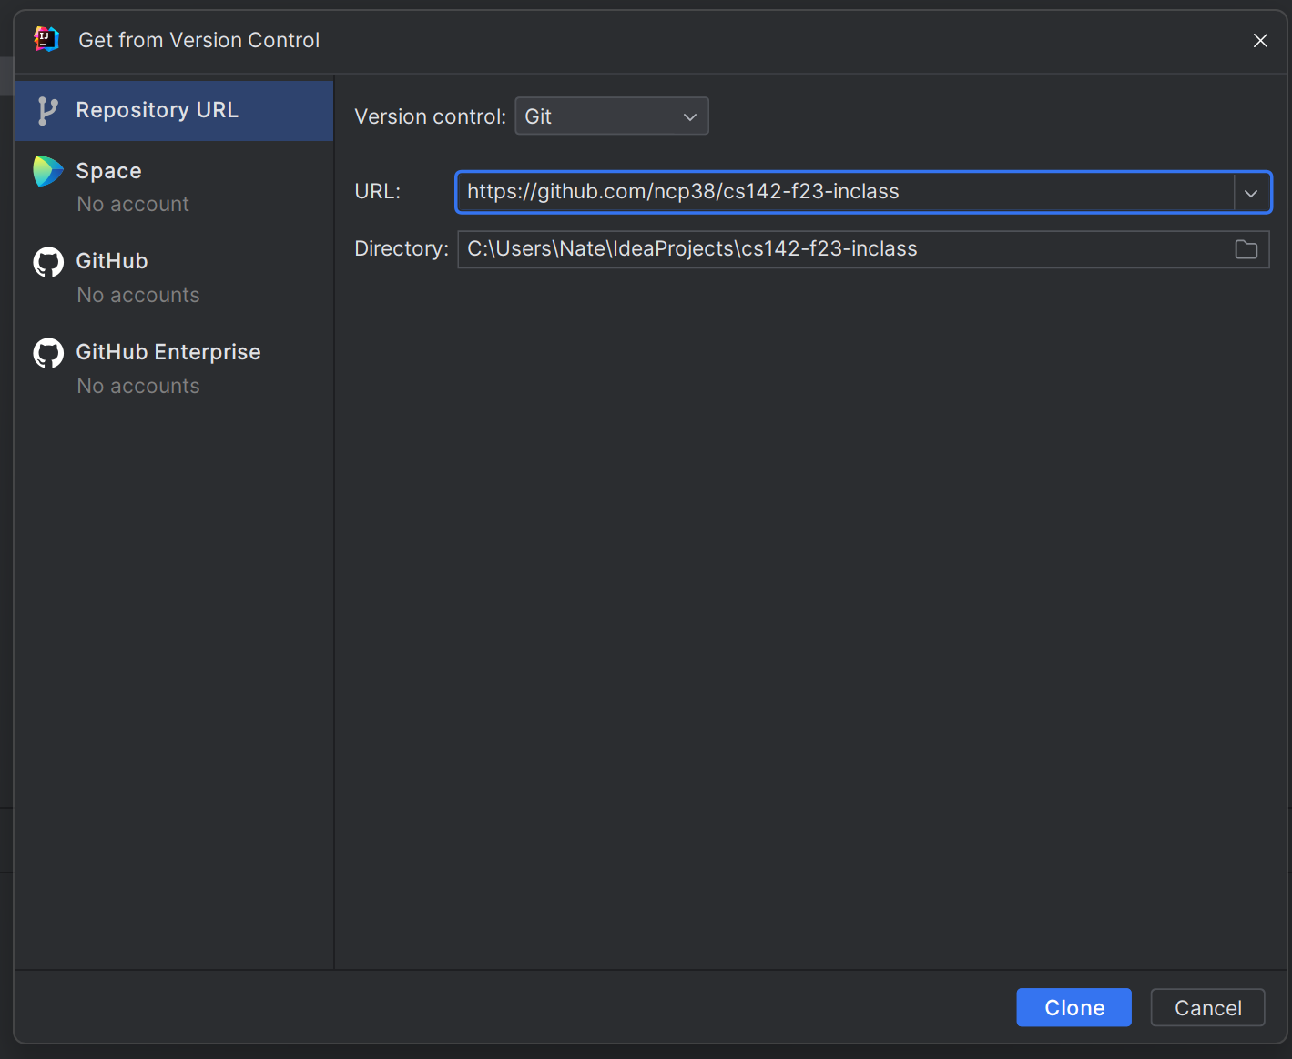

In the “Directory” box, double-check that the folder listed is the right place for new projects to be stored (a subfolder of your main cs142 projects). If something is off, you can click the folder icon at the far right of the text area and make a new folder for this class work.

In the left-hand panel, expand the oop1 folder to see the code we’ll be working with in class.

**For folks who were having trouble with version control:**

-Make sure Git is installed on your computer.

-Restart intellij after installing Git.  
-If you’re still running into issues, you can download the files for this class through a browser window-however, come see me after class/in office hours. We’ll keep using this method, so it’ll be helpful to get this resolved on your personal machines!

**To pull new files into the project** (**warning**-this will delete any work you may have done!! Be sure you’ve backed up any of your work in the project before updating):

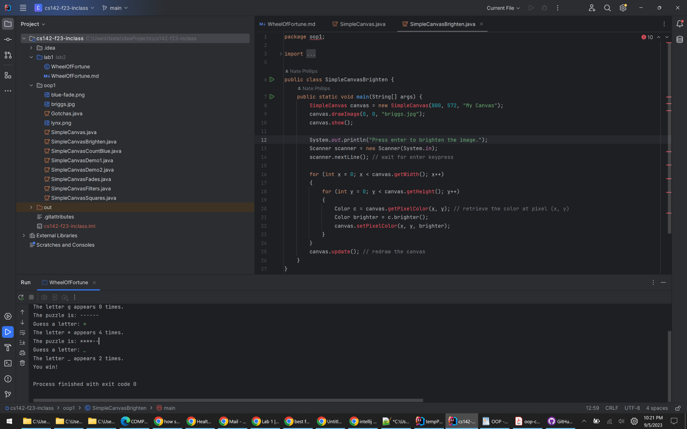

Right click and select Git -> Pull:

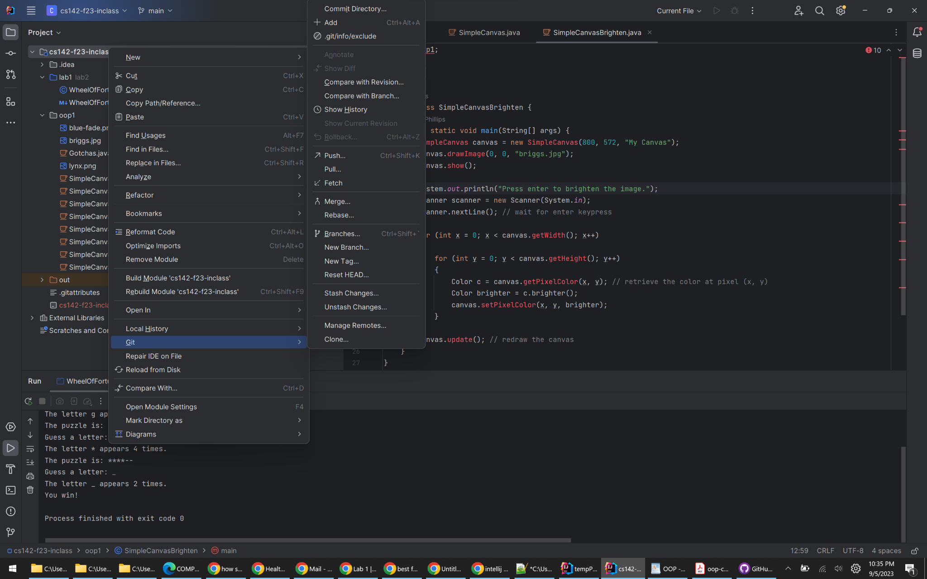

You should get a directory that looks something like this (notice how src is highlighted in blue and its subfolders in gray):  
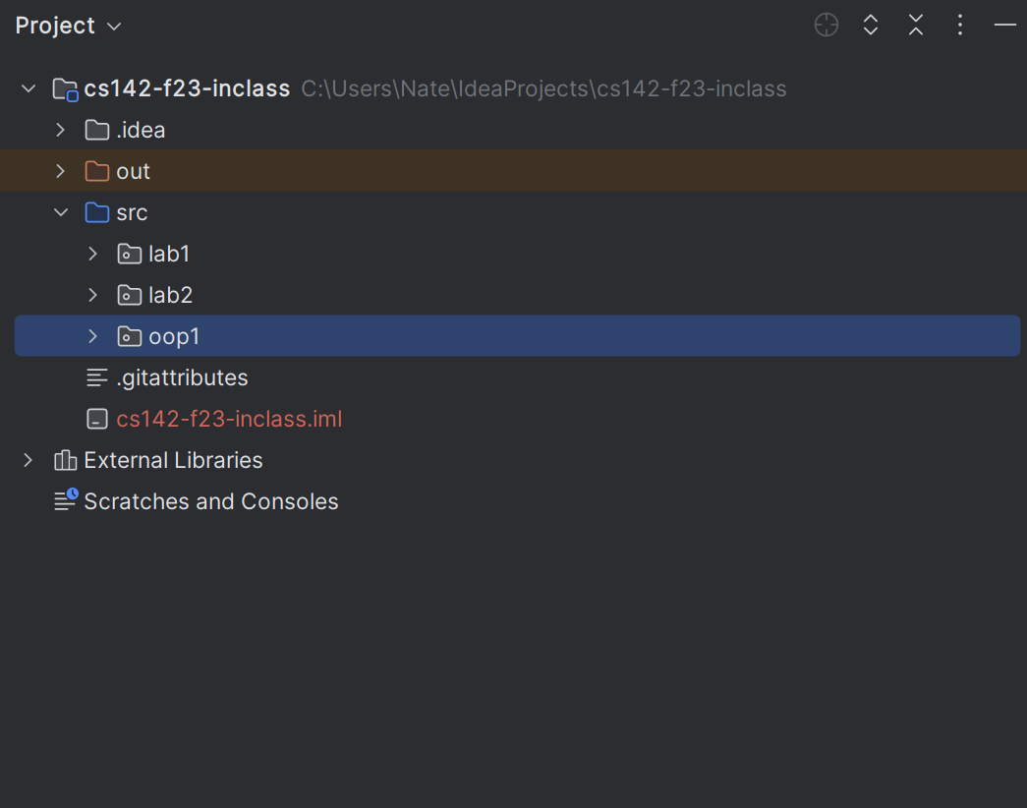

If you notice unexpected errors in your program (as you see below), that might be because the wrong folder is set to the sources root:

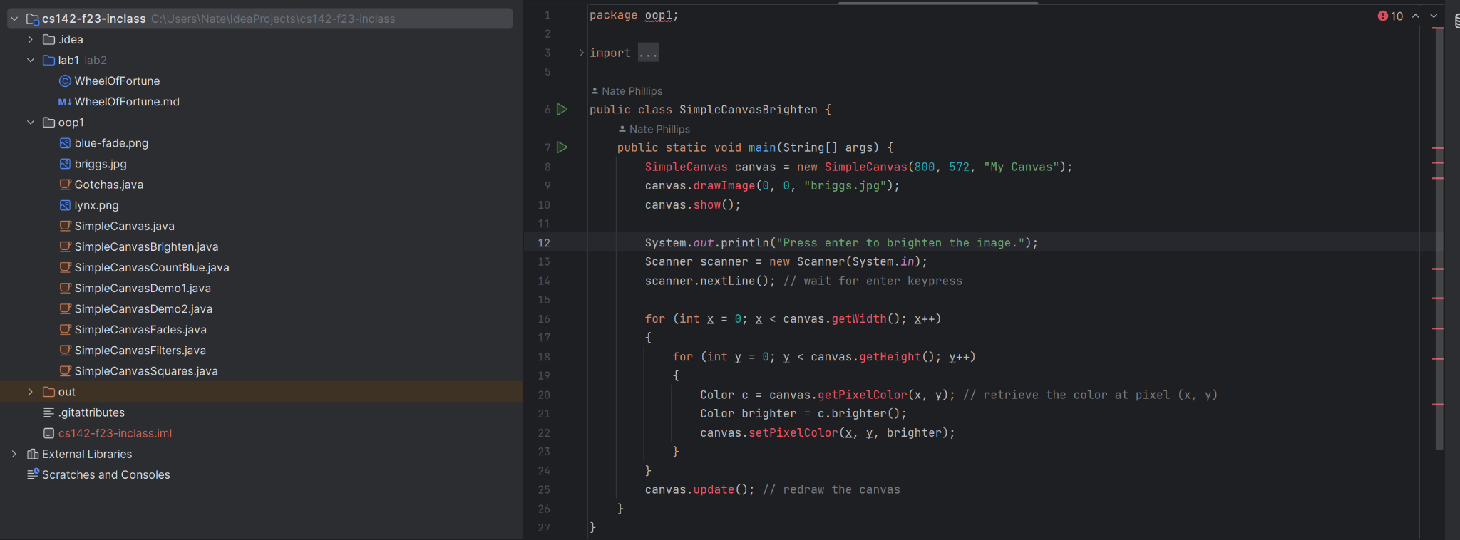

To fix these errors, we have to set the appropriate folder as the source root…To do this, right-click src and select Mark Directory as -> Sources Root

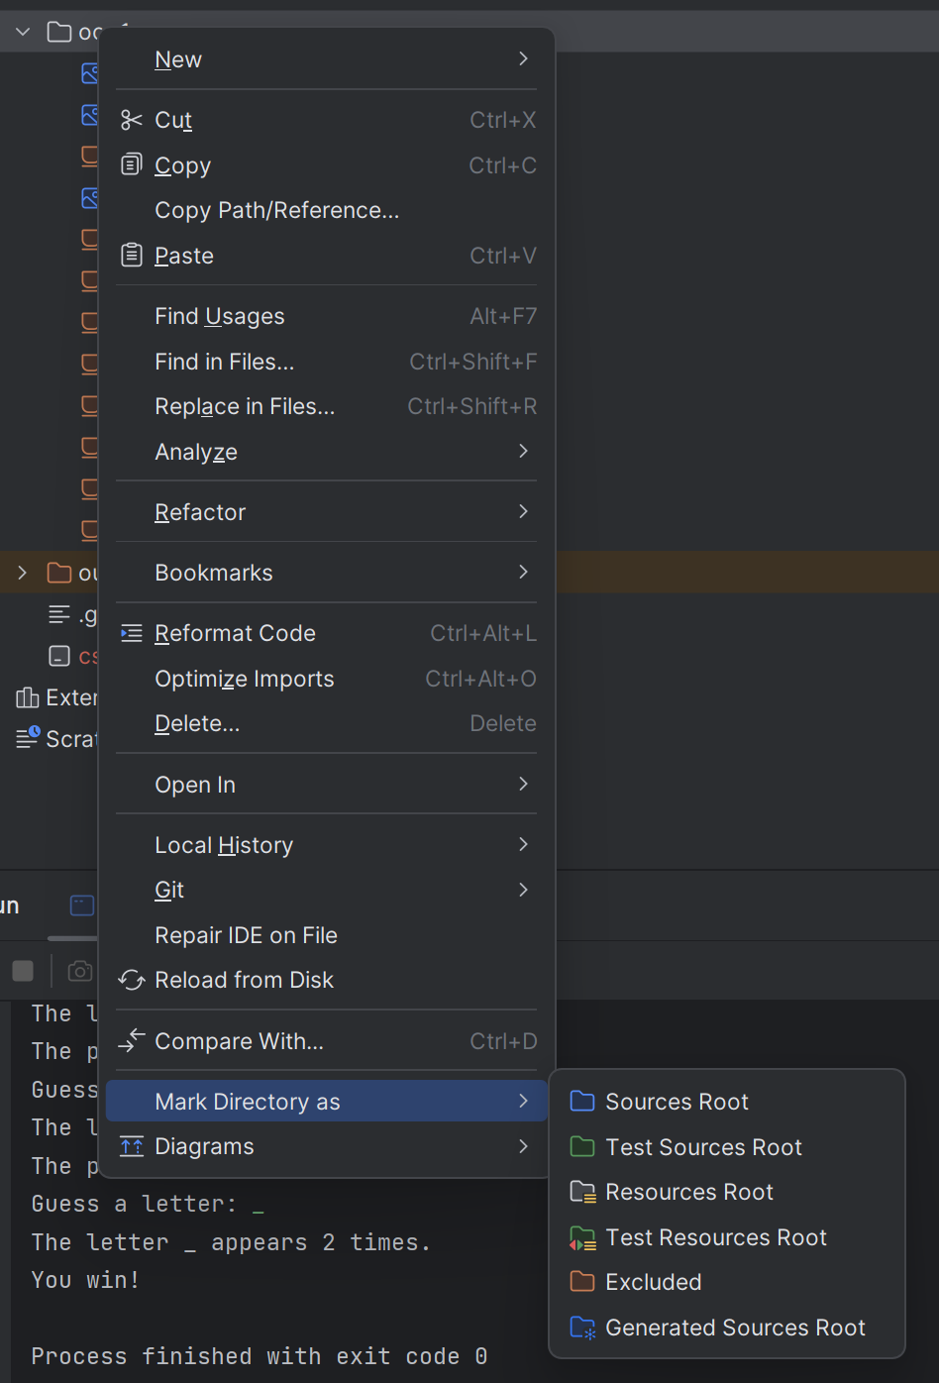

If you do this and find only the excluded option available, there may be some other issues going on…Check your file directory on the left and see if there are two iml files. If there are, delete the file named className1.iml.  
  
The other option you have for setting what the source directory is: In the top-left of the screen, click on file -> Project Properties. From the window that pops up, select modules on the left. From there, you’ll need to make sure src is the only thing set as the source directory. Click the x for any item on the right that isn’t src and then select the src folder in the middle and choose “sources folder.” If this doesn’t fix your problems, let me know, and we’ll try and find a solution!