Loading from Version Control

**To create a new project for in-class work:**

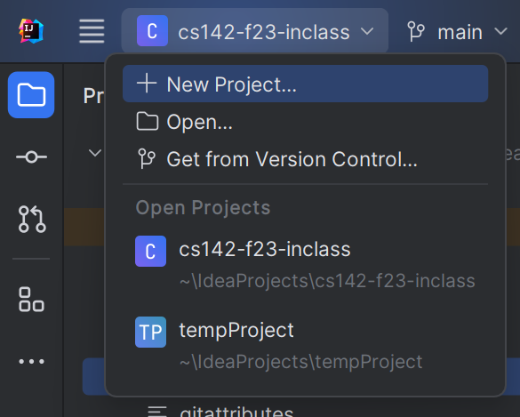

Start IntelliJ. In the top-left corner of the screen, click the project dropdown and choose “Get from Version Control.” Alternately, you can select File -> New -> Project from Version Control  
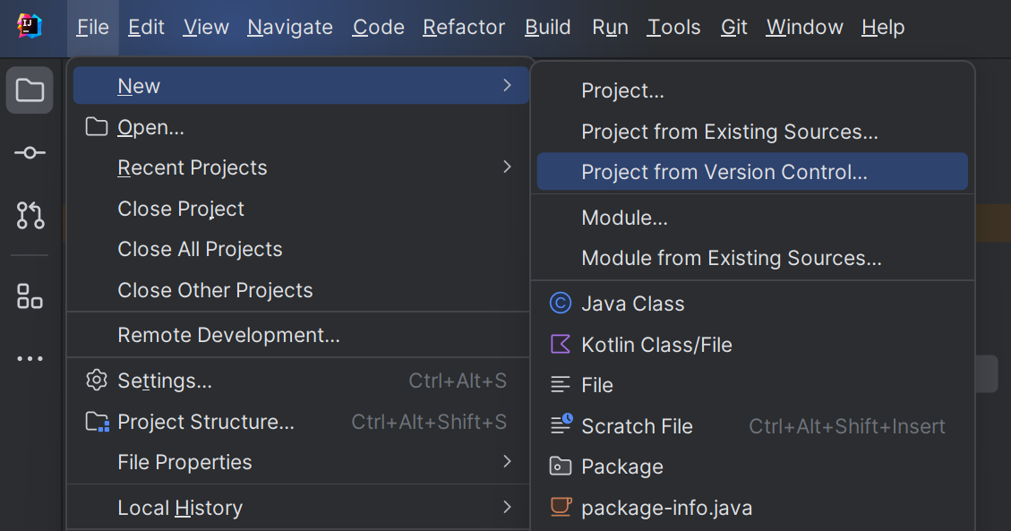

We will make a new project to store all of our labs and code that I want to distribute to the whole class. (This will copy my code from online into a new project-I recommend you put this in a directory with the other COMP 142 projects. Intellij should automatically set this to the directory you’ve used most recently.)

On the next screen, copy and paste in the following URL in the box that says “URL”:

https://github.com/ncp38/cs142-s24-inclass

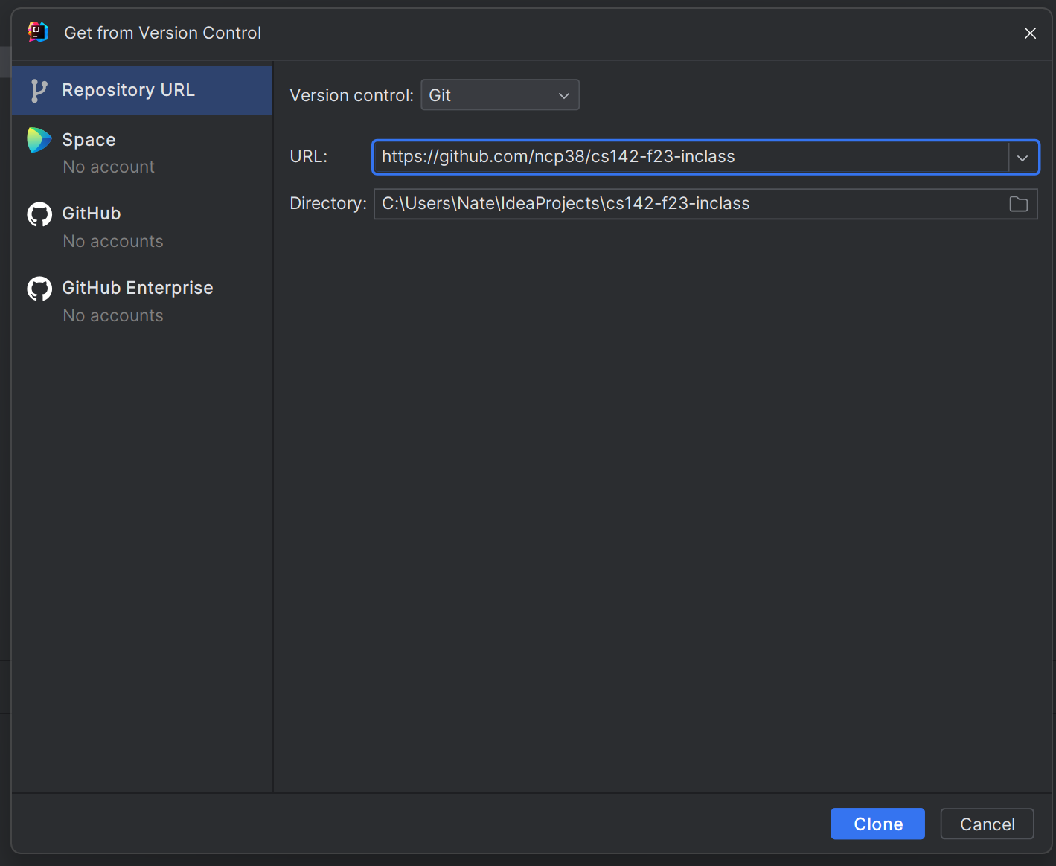

In the “Directory” box, double-check that the folder listed is where you want your project to be stored (a subfolder of your main cs142 projects). If something is off, you can right-click the location where you want to add a new folder or select the new folder button above:

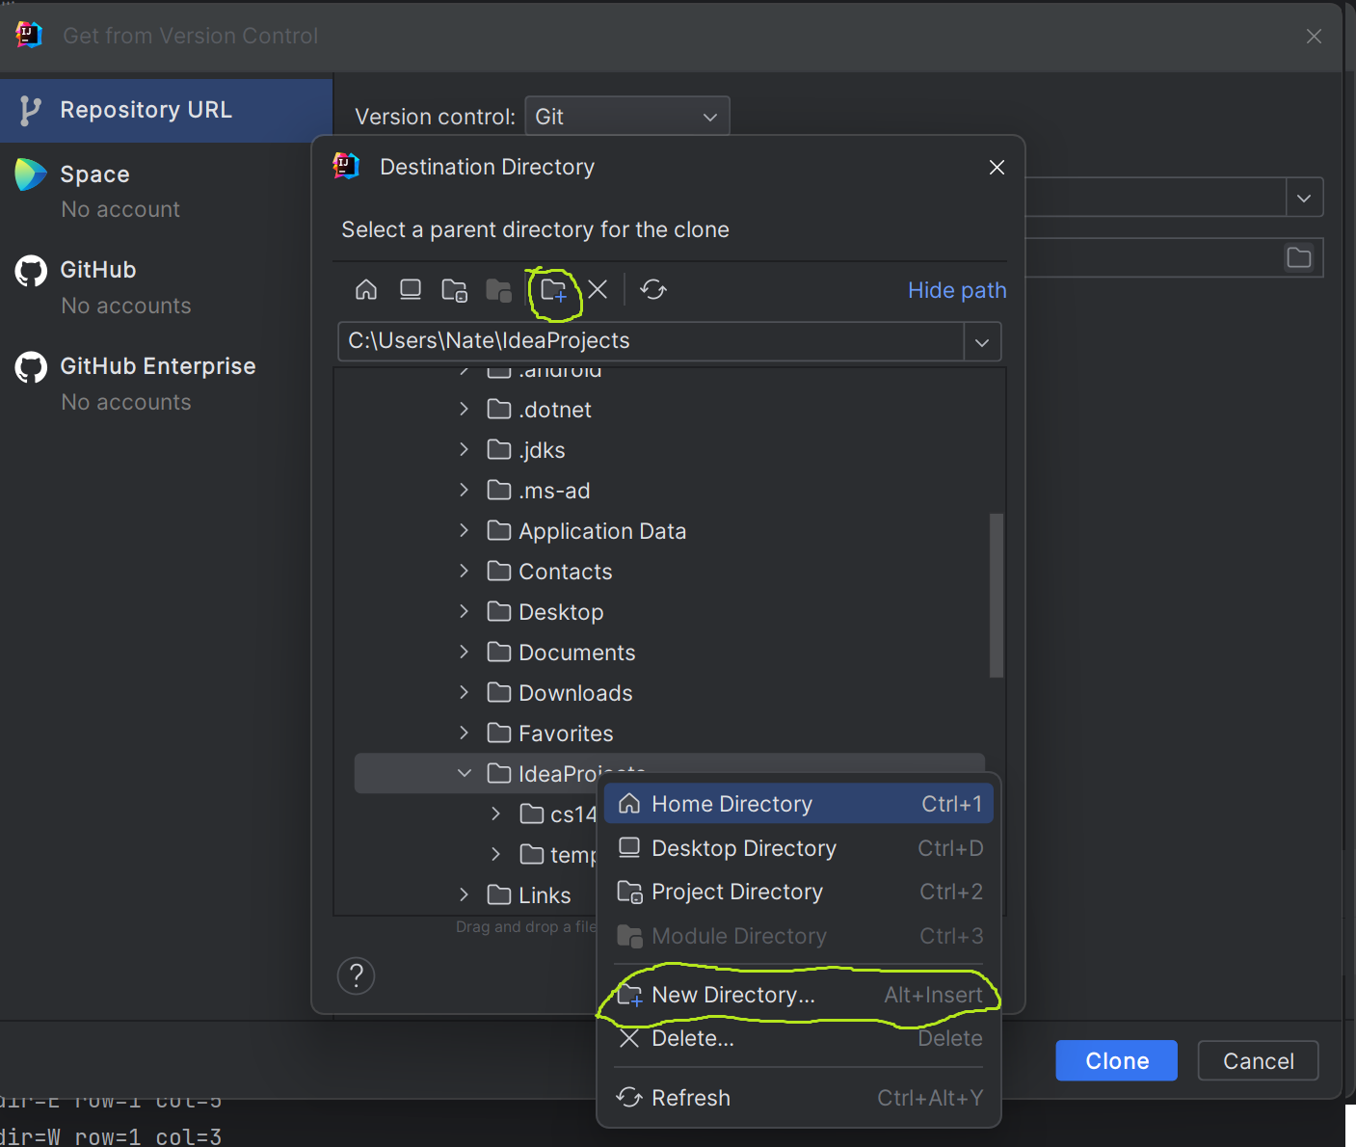

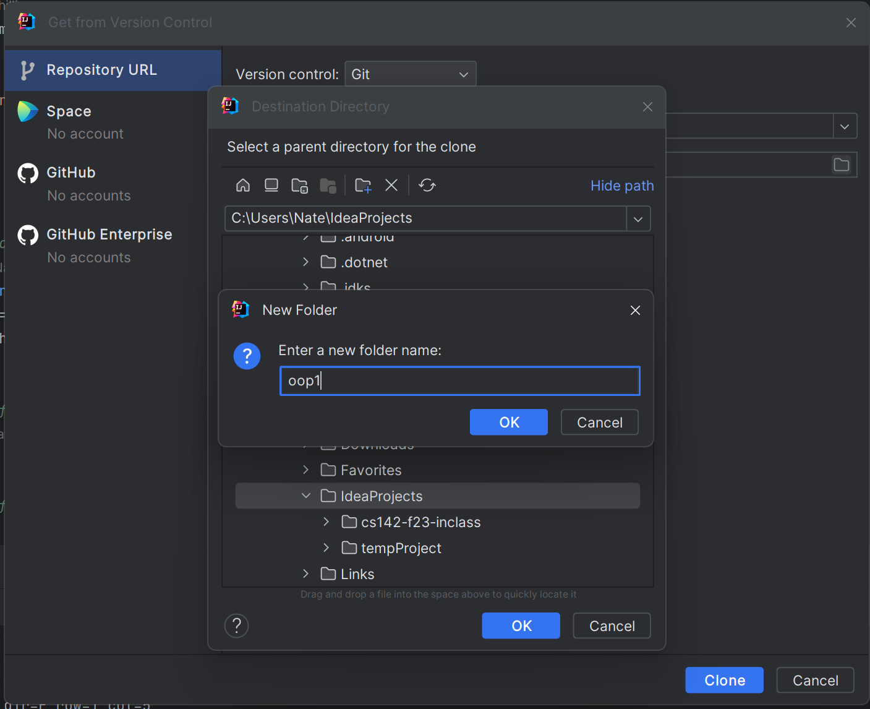

In the left panel, expand the src folder to see the code we’ll be working with in class.

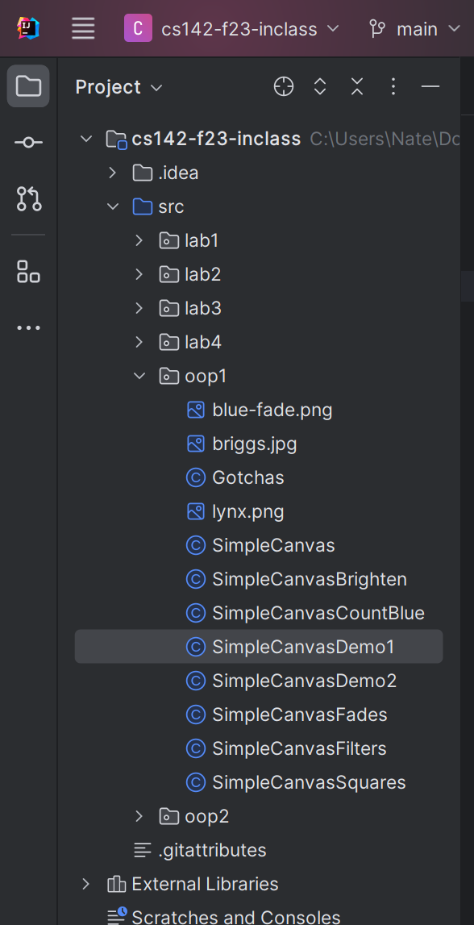

**For folks who were having trouble with version control:**

-Make sure Git is installed on your computer.

-Restart intellij after installing Git.  
-If you’re still running into issues, you can download the files for this class through a browser window-however, come see me after class/in office hours. We’ll keep using this method, so it’ll be helpful to get this resolved on your personal machines!