COMP 241Review

Topics:

* This exam is cumulative and covers previous concepts like Java programming, the n^2 sorting algorithms, abstract data types, interface vs implementation, and especially big O analysis. Arrays, linkedLists, stacks, queues, trees, hashtables, sets, and maps are also covered by the exam.
* Graphs
* Heaps
* Priority queues
* Quicksort, merge sort, and heap sort
* Dijkstra’s Algorithm
* Breadth-first search, depth first search

1. Which of the below are valid min heaps?  
     
   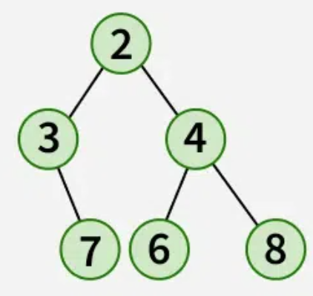

* For each of the heaps that are incorrect, why are they not a heap?
* What steps would you follow to apply heapsort to any of the heaps above?
* For the last heap pictured here, if this heap was stored in an array, what element would index 3 be? (That is, array[3].)

1. For the graph below, in what order would the vertices be visited in a breadth-first search? What about a depth-first search? The starting position is v0, and lower numbered nodes should be expanded first in case of a tie.

What is the big O running time of this algorithm?

1. Using Dijkstra’s Algorithm, find the cheapest path between D and B. Show your work!  
     
   A diagram of a network

   Description automatically generated
2. Given an input of 4, 3, 1, 5, 8, 11, 2, 7, show the steps to sort this input using merge sort. Next, show the steps to sort the same array using quicksort.