Autonomous Emergency Response Robot

Wani Hakim
Lindsey Hodges
Nate Phillips

April 20, 2011

Table of Contents: Page
Abstract 2
Project Scope 3
Project Design Specifications 4
The Project 5 – 9
Sensor Design 10 – 16
Program Design 17
Prototype Cost 18
Sustainability 18
Summary 19
References 19

Abstract:
Natural disasters such as the recent earthquakes on the island of Haiti and in Chili motivate engineers to use modern technology to help save lives. Urgent emergency response is critical for preventing further crisis and saving victims. The theme of IEEE SoutheastCon 2011 hardware competition is to design and implement an autonomous robot that can assist with the response to natural disasters. The objective is to locate the victims trapped in a building, determine their status, sense hazards, and report this information to the emergency responders.
The project includes the design and implementation of an autonomous emergency response robot that can safely evaluate the situation and relay vital information to emergency response teams. The robot includes electronic hardware for wall following, internal navigation, obstacle detection and avoidance, electromagnetic field detection, and light intensity detection. The robot reports information to the emergency responders through visual display and audio output.

Project Scope:
The scope of this project includes the design and implementation of an autonomous emergency response robot that can safely evaluate the situation and relay vital information to emergency response teams and includes:
- Design and implementation of an autonomous emergency response robot that can accurately locate victims placed randomly throughout a specified course.
- The robot must determine the status of the victim and report this information by audio and visual display to the emergency responders. A green LED represents the health status of each victim. Conscious victims have a LED that blinks at a rate of 2 Hz with a 50% duty cycle, unconscious victims have a LED that is always on, and dead victims have a LED that is always off.
- Sensors located on the robot must distinguish between obstacles, victims, and hazards. Victims emit a low frequency electromagnetic field of 33 kHz and hazards emit a low frequency electromagnetic field of 44 kHz.

Project Design Specifications:
- The detection system must include sensors to detect the following:
  - low frequency electromagnetic field (33 kHz and 44 kHz)
  - light-emitting diode (LED)
  - purple walls as navigational aid
  - white obstacles and victims throughout the course
- The robot must be autonomous and include a battery source.
- There is a time limit of 4 minutes to complete all tasks.
- Upon locating the victim, the robot must speak and display the room, position, and health status of the victim.

Table 1: Project Requirements and Resolutions
NEEDS | METRIC | Electromagnetic field detector | Infrared sensors | Audio synthesizer | Digital display | Light emitting diode | Microcontroller | Motor and Wheels
Completely autonomous actions |  |  |  |  |  |  | X
Obstacle detection |  |  | X
Accurate maneuvering |  |  | X |  |  |  | X | X
Electromagnetic field detection |  | X
Light sensing |  |  | X |  |  | X
Proximity detection |  |  | X |  |  |  | X
Output information accurately |  |  |  | X | X

The Project:
Construction of the robot included designing and building the components needed in testing the robot. These devices included 9-volt battery operated circuits, such as the blinking LED at 2 Hz with 50% duty cycle using the 555 timer and the constantly on LED. The electromagnetic field generator with a frequency of 44 kHz was also constructed. A generated sine wave travels through an inductor connected to a battery to create the electromagnetic field. The resulting frequency transmitted is 44 kHz. Construction of the robot also required building the specified course layout for the competition.
Figure 1: Front and Top View of Robot
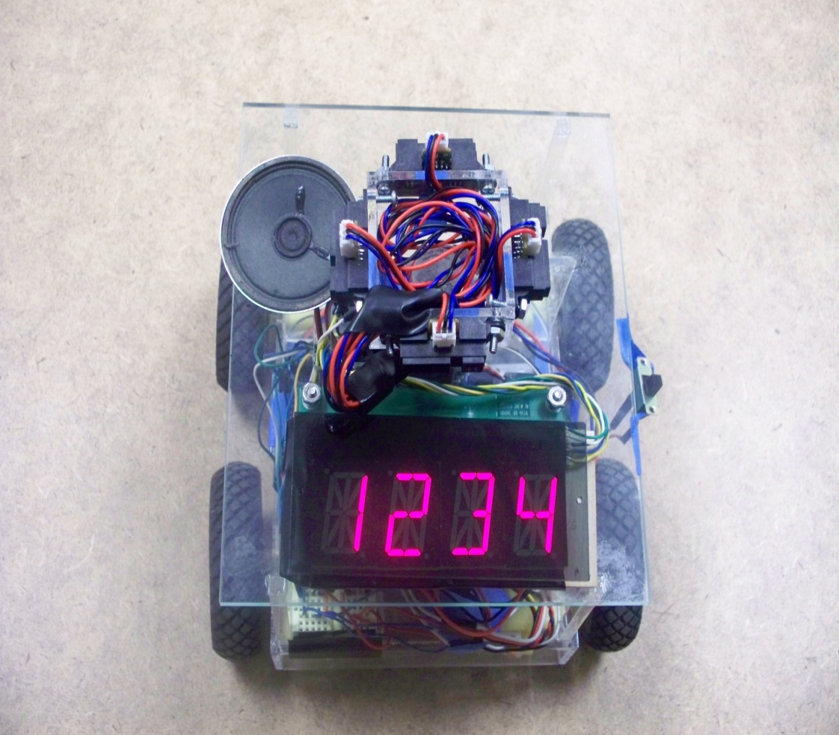
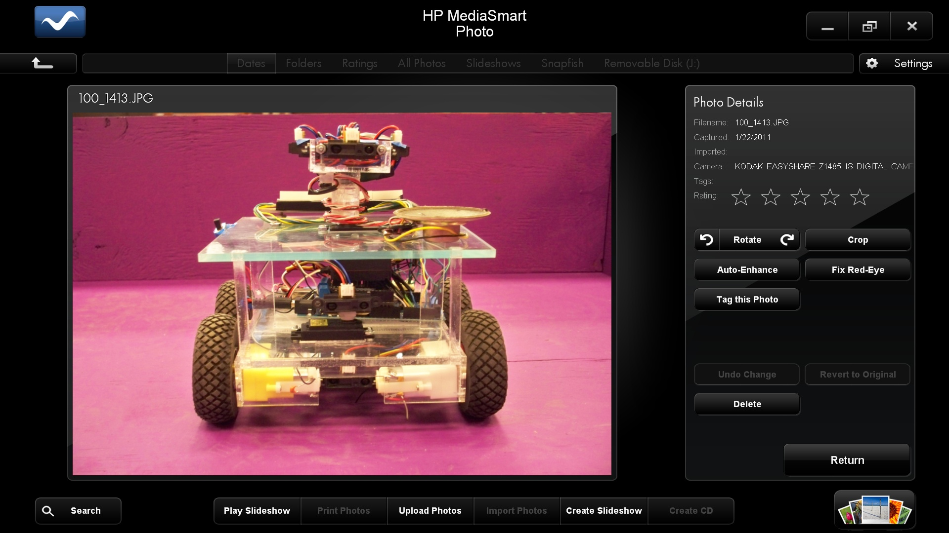

The victims’ LED can be either ON, OFF, or blinking based on the specified health status. The LED mounts in the center of an 8 cm diameter PVC drain cap so that the top of the LED is completely level with the top ridge of the PVC drain cap. Figure 2 shows the LED mounted in the drain cap.
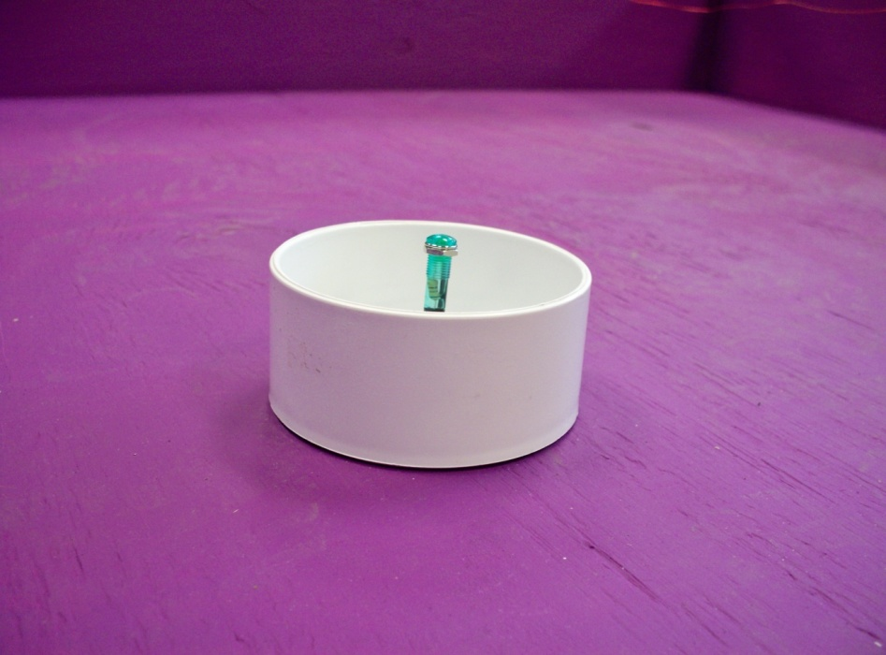
Figure 2: Victim Represented by LED

The LED without battery connections generates the OFF status, while the LED connected to a battery and a resistor generates the ON status as shown below in Figure 2.
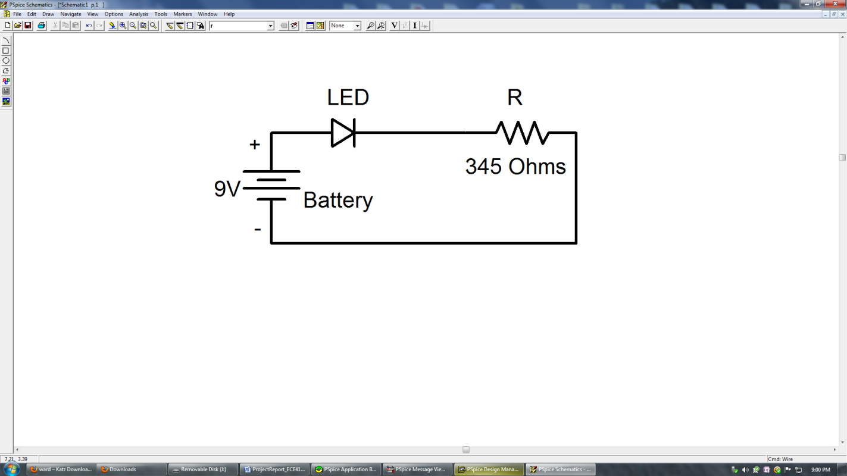
Figure 3: Circuit Diagram for ON LED

The equation used for finding the value of the resistor was:
$$R1= \frac{power supply (Vs)-LED voltage drop (Vd)}{LED current rating}$$
The LED current rating for the green LED was 20 milliamps and the LED voltage drop was 2.1 volts.
$$R= \frac{9V-2.1V}{20 mA}=345 Ω$$
The blinking LED at 2 Hz with 50% duty cycle using the 555 timer had a schematic diagram as shown below.
Figure 4: Circuit Diagram for BLINKING LED
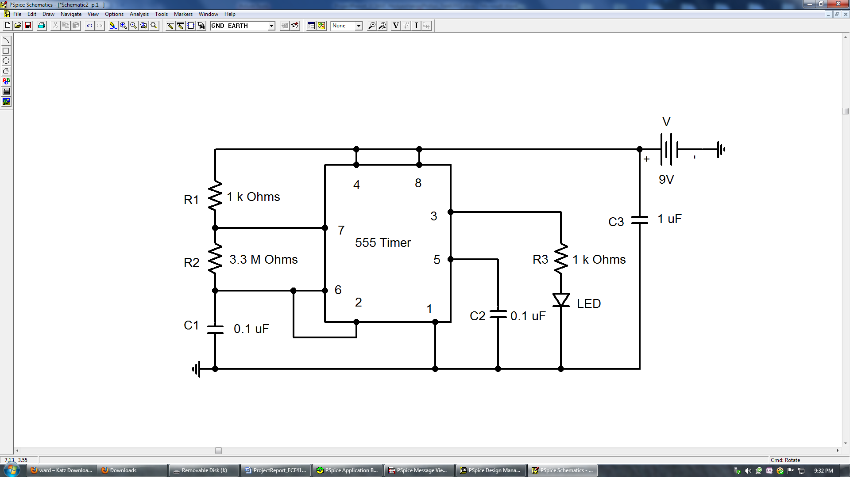
For the 50% duty cycle, the following formula determines the value$R2:$
$$f=\frac{1}{\ln\left(2\right)*C1*(R1+2R2)}$$
Where$C1$ was chosen to be $0.1 uF$and$R1$ was chosen to be$1 kΩ$.

The next phase of the construction was building the course layout specified for the competition. Four 4 by 8 foot sheets of plywood were required for the course. Two sheets were nailed together to create the base and nailed onto the frame of 2 by 4 pieces. Then one sheet cut into four individual sheets created the outer walls. The last sheet cut into five long sheets created the inner walls. All walls ended up with a height of 23.5 centimeters. The images below are the original specified course layout and the resulting course.
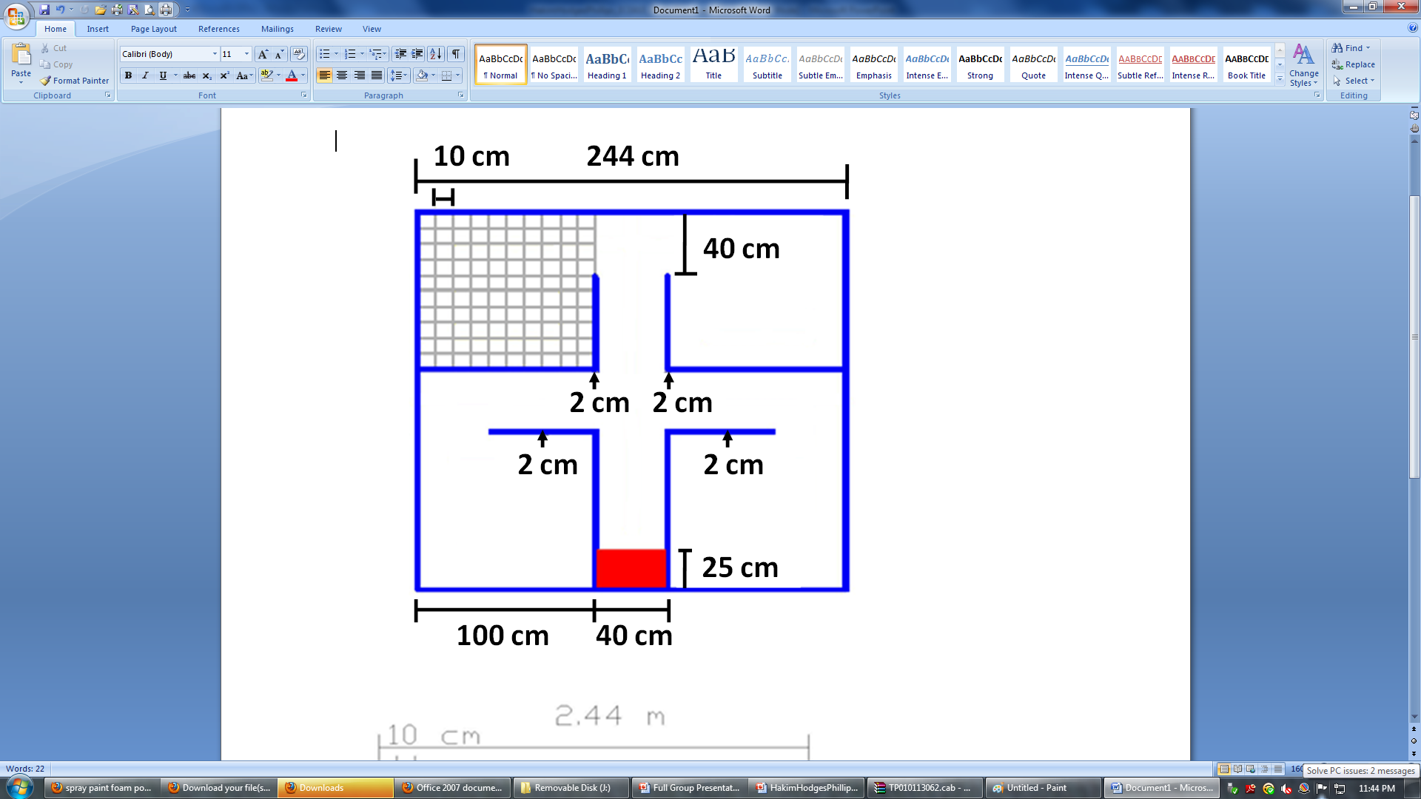
Figure 5: Specified Course Layout and Resulting Test Course

The final phase of construction was to design the electromagnetic fields to represent the hazards and victims. Copper wire wraps around a coreless 40 cm by 40 cm square wood frame to create the hazard electromagnetic field. A 44 kHz signal generates through the coil with 10 mA RMS turns. The image below shows the red copper wire wrapped around the wood frame. The coil connects to the function generator to generate the signal.
Figure 6: Hazard Generator and Receiver
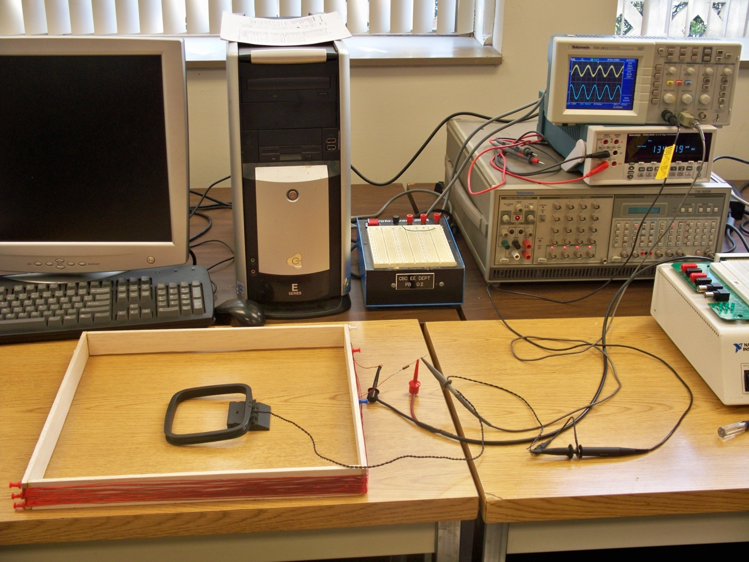
The other electromagnetic field generates using a function generator and by wrapping copper wire around a coreless cylinder with an 8 cm diameter and a height of 3 cm. A signal of 33 kHz generates through the coil with 10 mA RMS turns. The coil mounts 2 cm to 3 cm above the course directly over the 8 cm diameter PVC drain cap of the victim.
The Arduino Mega microcontroller acts as the brain of the robot to control the eight infrared sensors and numerous digital components. At least six analog input pins and thirteen digital pins were required for the robot. The Arduino Mega has 16 analog input pins and 54 digital I/O pins, including 14 PWM (pulse width modulation) pins, which were required for controlling the Servo motors.

Sensor Design:
The design of the emergency response robot requires sensors for maneuvering around the course and detecting objects. For navigating through the course, infrared detectors determine where walls end. The walls are purple and contrast with the white objects within the course. The infrared detector contains an infrared source, infrared phototransistor, and two resistors. The microcontroller inputs the measured voltage level (0 – 5 volts) across one of the resistors and calculates the proximity of the walls based on the measurements.
Figure 7: Robot Infrared Range Sensors
Servo

Infrared Sensor

Wall
Obstacle
Obstacle
Victim
Robot

The infrared detectors are located at the levels as shown in Figure 7. The highest level measures the distance between the walls and the robot, and consists of four infrared sensors on a platform facing in four directions. As the robot navigates through the course, the sensors will measure the distances between the walls so that the robot can recall the exact grid coordinate of its location when required to output the victim or hazard location.

The hallways are 40 cm wide. Figure 8 shows a top view of the robot that demonstrates how the robot calculates its location in the course. The platform mounted on a continuous rotation servo motor changes angle based on when the distance of DA + DB + DC becomes greater than 40 cm. The servo will determine which direction to adjust based on the direction the robot body is turning. The value DB is the distance between sensors A and C and the distance between sensors B and D. The value DB will remain constant throughout the course. The same method works for all four infrared sensors. For example, when the robot reaches the center of the course, all four sensors will measure the same value because they will all be the same distance from the walls.
Figure 8: Top View of Robot Showing Infrared Sensors Mounted on Servo
Infrared B

Infrared C
Infrared A

Infrared D
DC
DB
Wall
Wall
DA

The infrared sensors will also notify the robot when it has reached the entrance to a room. For example, if the robot is entering the southwest corner room, sensor D will spike to a larger distance reading (from 15 cm to 100 cm) and sensor B will be a very long distance reading (> 200 cm).
The middle level of the robot contains a Sharp GP12D20 infrared sensor with the range 3 cm to 30 cm. The infrared sensor mounted on a servo rotates between 30° and 150°. The servo rotates as the sensor scans the area for 9 cm tall obstacles. The values returned are distance measurements such as listed in Table 2. The value indicates how close the object is to the robot and the position indicates the angle of the servo motor. From these values there is an obstacle 2 cm directly in front of the robot. The program will analyze the values and decide whether the robot can fit around the obstacle or if it needs to try a different route.
Table 2: Measurements Taken from Sharp Infrared Sensor on Servo
Value (cm) | 121 | 83 | 78 | 2 | 2 | 2 | 2 | 85 | 141
Position (°) | 30 | 45 | 60 | 75 | 90 | 105 | 120 | 135 | 150

Figure 9: Sharp GP12D20 Input Compared to Object Placement
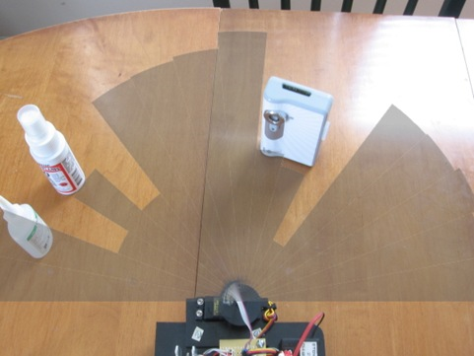
The image above shows how the infrared sensor input to the microcontroller when mounted on a servo motor matches the actual placement of the obstacles.
The lowest level of the robot will also contain a Sharp GP12D20 infrared sensor in the range 3 cm to 30 cm. The sensor will be low enough to detect the 4 cm tall victims. If the lowest level and the middle level infrared sensor detect an obstacle the same distance away, then the object is a 9 cm obstacle and the robot will avoid it.

Figure 10: Output Voltage vs. Distance to Object

Figure 10 shows the output voltage versus distance to reflected object. To prevent the measurement error between 0 cm and 8 cm, the infrared sensors are located 4 cm from the edge of the robot frame. The two equations used in the program to calibrate the sensors were:
float volts = analogRead(IRpin)*5/1024;
float distance = 28*pow(volts, -1.0);
The sensors have a voltage range of 0 to 5V. The 5V divided by 1024 gives a value per step. The slope of 28 near the center of the exponential curve multiplied by the inverse of the measured volts converts the distance measurement to centimeters.
When the robot enters one of the four rooms, the microcontroller will turn on the electromagnetic field detector and test for the field emitted by a hazard. The electromagnetic field detector is a probe inserted into an analog input to the microcontroller. The detector circuit tunes to the hazard’s frequency of 44 kHz using an LC circuit. The voltage input increases as the probe gets closer and the electromagnetic field strength increases. If the field is strong enough, the robot will report that the hazard is located inside the room and the location is in the center of the room.
To detect the green LED of the victim, a separate green LED mounts on the robot and angles down toward the victim LED. The robot LED connects to two bidirectional I/O digital pins of the microcontroller. The pins drive the robot LED with current in the forward direction, which causes the robot LED to light up. Then the pins drive the robot LED with current in the reverse-bias direction. The robot LED inhibits the flow of current and the inherent capacitor is charged. The pins are set to high-impedance CMOS input mode and the LED leaks current at a rate proportional to the incident light received from the green LED of the victim. The microcontroller measures the time taken for the leakage current to discharge the LED's inherent capacitor. This measurement indicates whether the victim’s LED is ON, OFF, or BLINKING. The robot LED detector must be less than 7cm from the victim’s LED and at a 30° angle from the ground for accurate measurement.
The microcontroller outputs the room number, location, and health status of the victim using an audio synthesizer built into the microcontroller and a digital display connected to the microcontroller. The audio synthesizer connected to the microcontroller connects to an 8-Ω speaker. The microcontroller sends code to the synthesizer to determine the information the speaker outputs. If the electromagnetic field detected from the coil is from the hazard and not the victim, the robot must output through audio and digital display the hazard’s location.
The audio synthesizer is the model V8600A designed by RC systems. The audio synthesizer only requires six pins to function.
The microcontroller simply inputs the line voice.println(“Room number 1”); to send the message to the audio synthesizer. The baude rate of the microcontroller and the audio synthesizer must be the same rate in order to produce understandable words.
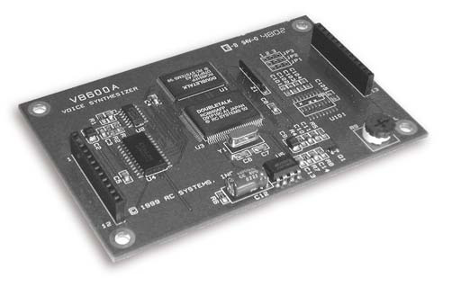
Figure 11: V8600A Voice Synthesizer and 8Ω Speaker
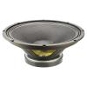

The display must report the same information as the audio output. The LED display consists of four 2.5 cm tall alphanumeric numbers controlled with stackable serial drivers. An antiglare material covers the top of the display to increase readability from a longer distance away.
Figure 12 shows the LED display mounted on the top of the middle tier of the robot. The four numbers represent the room number, grid coordinate, and health status of the victim. If the numbers display [ 3 7 6 2], the victim would be in room 3, located at grid coordinate (7,6), and have a health status of 2, which represents the ON LED and the victim is conscious.
Figure 12: Digital Display

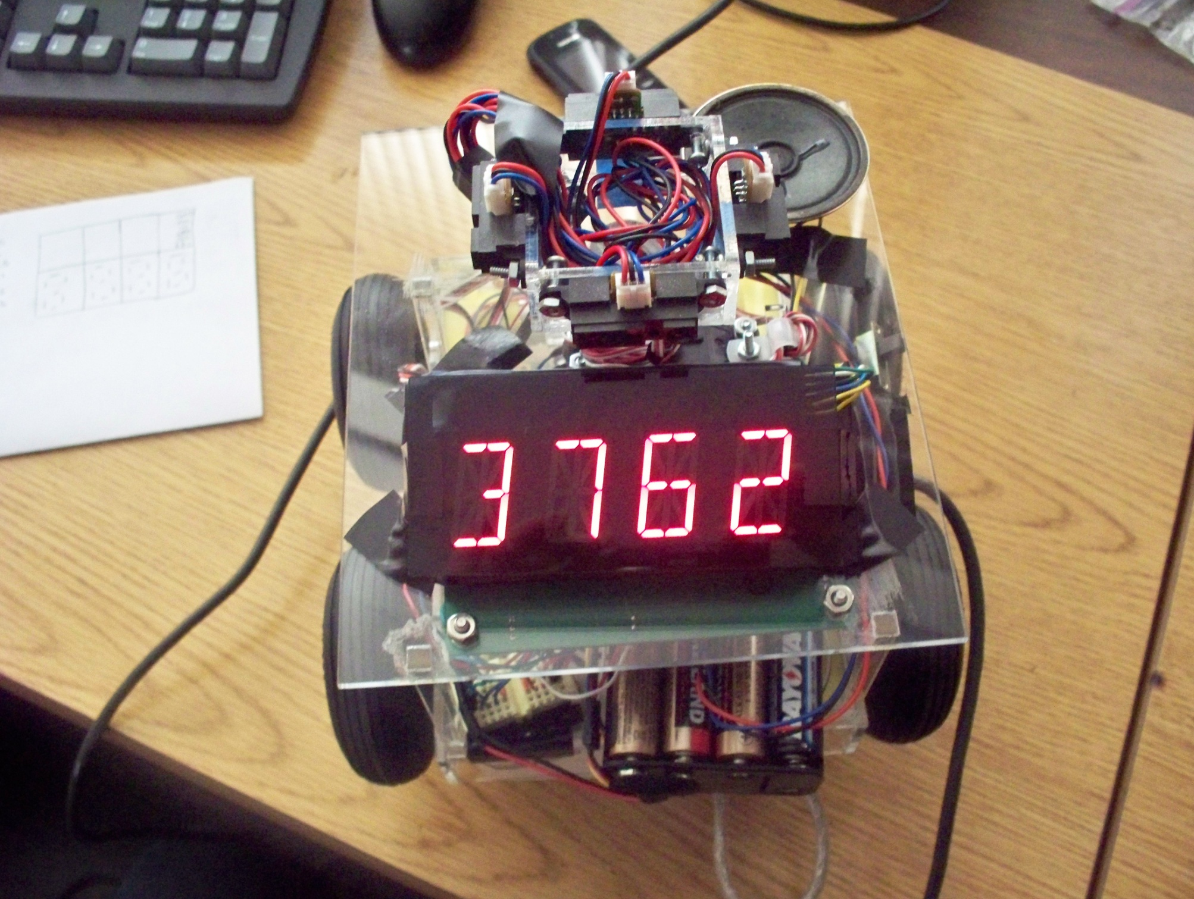

The robot body was designed using clear acrylic for a robust and lightweight frame. Figure 14 shows a bottom view of the robot. There were four micro DC geared motors used to control the wheels of the robot. The microcontroller controls the motors using a varying voltage from 6 V to 12 V. They each weigh 45 g, have a torque of 1.92 Kg-cm, and have a gear ratio of 1:120. A parallel capacitor across each motor reduces voltage spikes.
Figure 13: Bottom Image of Robot Frame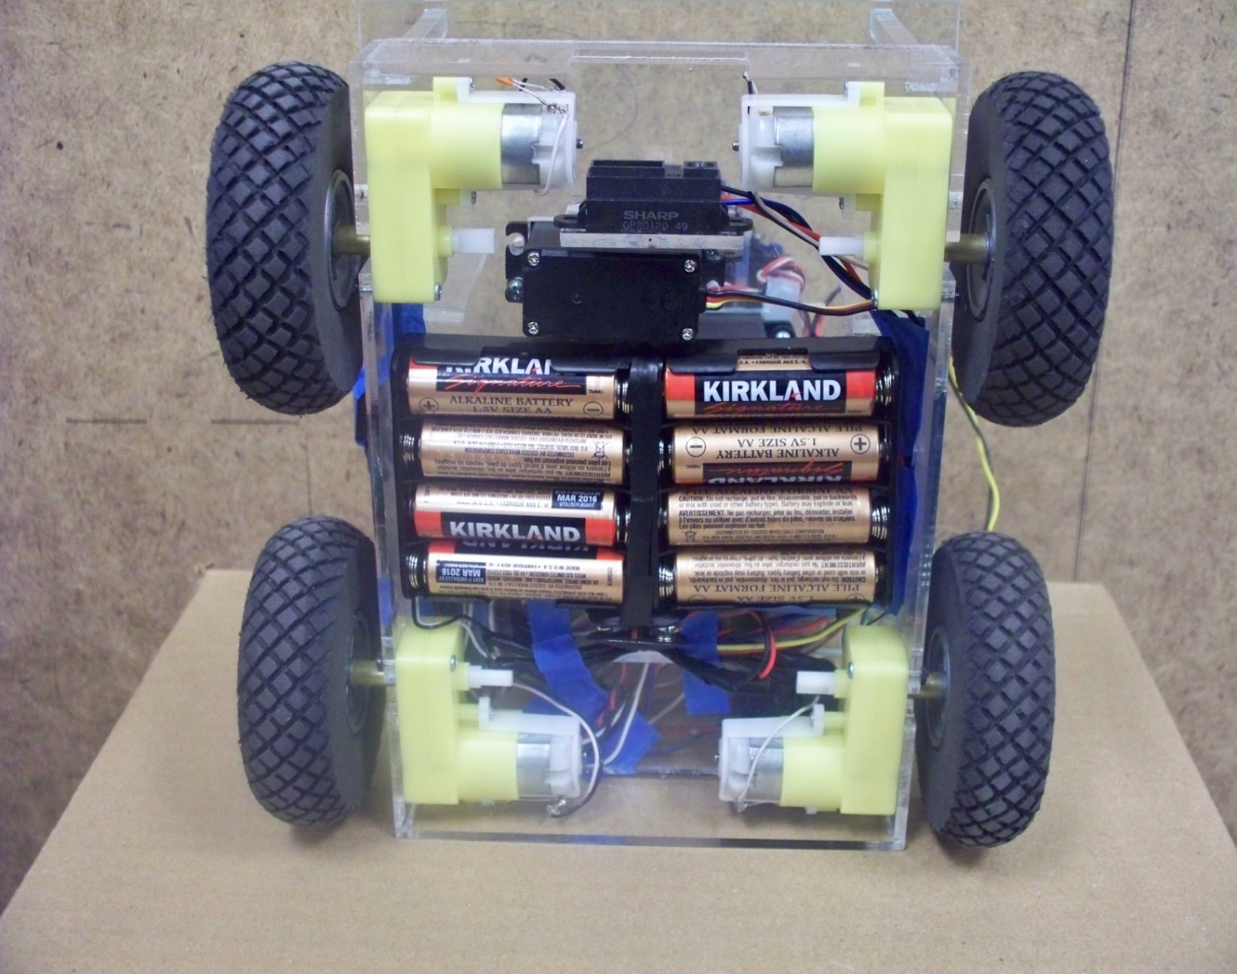

The robot uses 8 cm diameter diamond-tread wheels. The battery pack mounts to the bottom of the robot to save space. The robot requires eight AA batteries with a nominal voltage of 12V. The motor shield developed by DFRobot inserts into the Arduino microcontroller. The motor shield drives four 6-12V DC motors with a maximum current of 2A.

Program Design:
The following is a block diagram of the overall program design. The robot will repeat the right side of the block diagram for all four rooms or until the time limit of four minutes has elapsed.
Figure 14: Program Design

Prototype Cost:
Many of the components used to build the robot came from older robots or resulted in excess left over from older projects. Ignoring the cost of the materials used to create the course, the total prototype cost was $361.30.
Table 3: Bill of Materials
Part | Cost
Wiring | $10.00
SHARP Infrared Sensors (6) | $24.00
Electromagnetic Field Detector | $10.00
Green LEDs | $2.00
V8600A Audio Synthesizer | $100.00
LED Digital Display | $30.00
Batteries | $35.00
360 full rotation servo motor | $13.50
180 servo motor | $15.60
Robot Body and Motors | $49.20
Arduino Mega Microcontroller | $55.00
DFRobot 2A Motor Controller | $17.00
4 x 8 sheets of plywood | $120.00
1 gallon of purple matte paint | $30.00
TOTAL | $511.30

Sustainability:
The goal of this project is to produce one fully functioning, autonomous robot. There are no stated needs beyond successful performance at one competition. All of the components screw to the surface of the acrylic base or lightly glue to the surface of the acrylic so that future teams may reuse the components.
Summary:
The project includes the design and implementation of an autonomous emergency response robot that can safely evaluate the situation and relay vital information to emergency response teams. The robot includes electronic hardware for wall following, internal navigation, obstacle detection and avoidance, electromagnetic field detection, and light intensity detection. The robot reports information to the emergency responders through visual display and audio output.
The cost of the robot was relatively low because the majority of the components salvaged from previous projects made up for the high cost of core components, such as the microcontroller and LED display. The robot was safe to work with because it required low voltage ratings of no more than twelve volts and current ratings of no more than two amperes.
Given a random set of obstacles, victims, and a hazard, the robot can maneuver through the course, locate victims, and report information through visual display and audio output. The robot competed in the IEEE Southeast Conference 2011 Student Hardware Competition. The robot team competed against thirty-five teams and tied for fifth place in the preliminary rounds.

References:
“Southeast Conference 2011 Student Hardware Competition Rules – Revision 1.0”
http://orgs.tntech.edu/ieee/SECON2011/rules.pdf
“Society of Robots – Member Written Tutorials”
http://www.societyofrobots.com/member_tutorials/node/71
“Robotics – Infrared Sensors”
http://www.acroname.com/robotics/info/articles/sharp/sharp.html
“Visualizing Sensor Date and Processing”
http://www.uchobby.com/index.php/2009/03/visualizing-sensor-with-arduino-and-processing/

