Software Engineering PR280

Nick Leslie

Iteration 1

## Plan/Goal

To complete the first problem in Appendix Two, using VueJS.

*“Write a program to play a number guessing game. The program shall generate a random number*

*between 0 and 99. The USER inputs his/her guess, and the program shall response with "Try*

*higher", "Try lower" or "You got it in n trials" if the guess is correct.”*

## Design Level Class Diagram

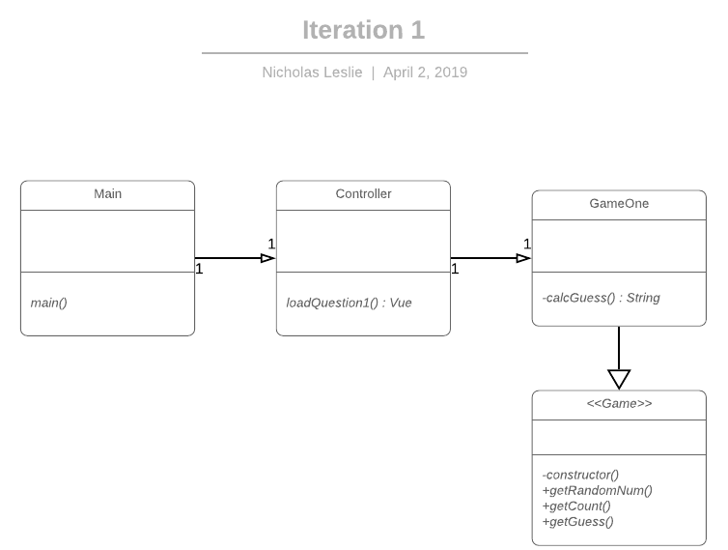

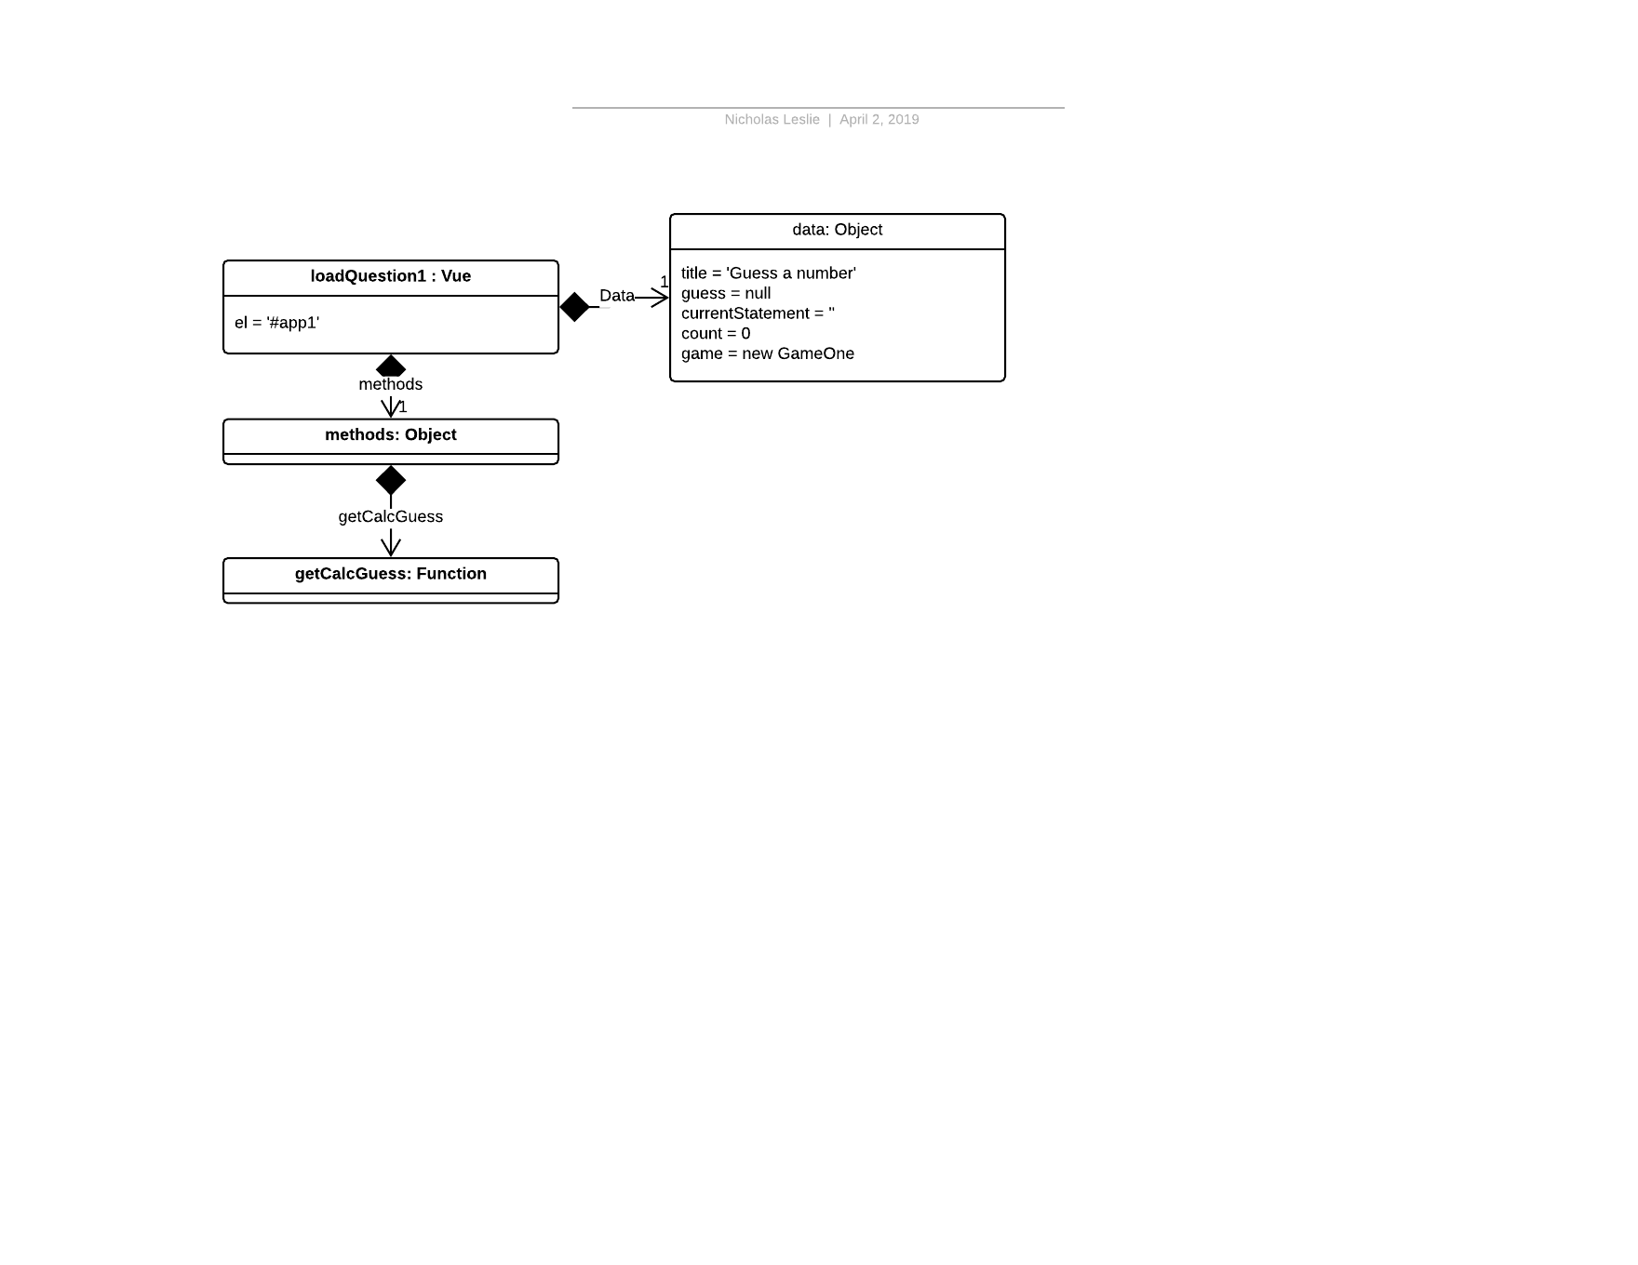

## Plan for how the program feature of an iteration you are working will work

### Spike Solution

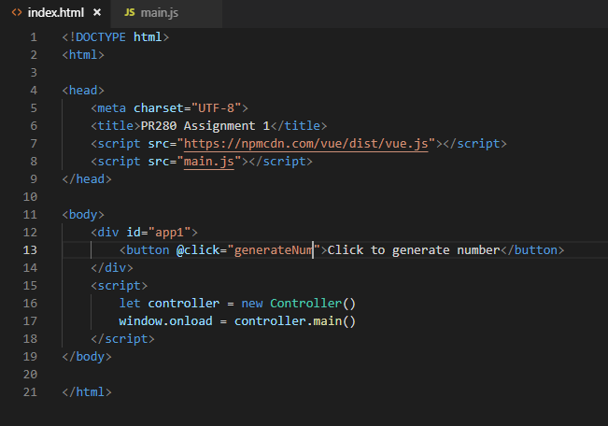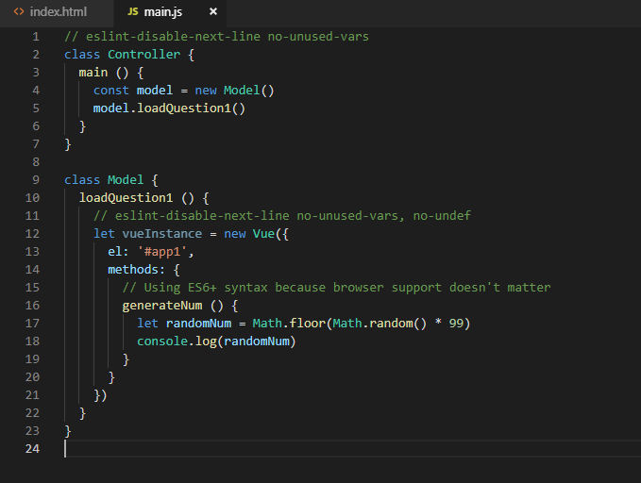Using VueJS, create a random number, and display it (console.log()), on page load