Software Engineering PR280

Nick Leslie

Iteration 2

## Plan/Goal

1. To complete the second problem in Appendix Two, using VueJS.

Add Bootstrap to website to ensure HTML doesn’t get cluttered

Add some testing using Jasmine

|  |  |  |  |
| --- | --- | --- | --- |
| Student | Nick Leslie | Date | 3/04/2019 |
| Program | Number Guessing Game | Program # | 2 |
| Instructor | Amit / Luofeng | Language | JavaScript/Vue |

|  |  |  |  |  |  |  |  |  |  |  |  |
| --- | --- | --- | --- | --- | --- | --- | --- | --- | --- | --- | --- |
| **Summary** | **Plan** | | |  | **Actual** | | |  | **To Date** | | |
| LOC/Hour | **100** | | |  |  | | |  |  | | |
| Planned Time | **120** | | |  |  | | |  |  | | |
| Actual Time |  | | |  |  | | |  | **190** | | |
| ~~% Reused~~ |  | | |  |  | | |  |  | | |
| ~~% New Reused~~ |  | | |  |  | | |  |  | | |
|  | | | | | | | | | | | |
|  |  | | |  |  | | |  |  | | |
| **Program Size (LOC)** | **Plan** | | |  | **Actual** | | |  | **To Date** | | |
| Base (B) | 100 | | |  | 76+24 | | |  |  | | |
|  | (Measured) | | |  | (Measured) | | |  |  | | |
| Deleted (D) | 10 | | |  | 0 | | |  |  | | |
|  | (Estimated) | | |  | (Counted) | | |  |  | | |
| Modified (M) | 50 | | |  | 10 | | |  |  | | |
|  | (Estimated) | | |  | (Counted) | | |  |  | | |
| Added (A) | 100 | | |  | 94 | | |  |  | | |
|  | (A + M - M) | | |  | (T − B + D − R) | | |  |  | | |
| Reused (R) | 90 | | |  | 7 | | |  |  | | |
|  | (Estimated) | | |  | (Counted) | | |  |  | | |
| Added and Modified (A + M) | 150 | | |  | 104 | | |  |  | | |
|  | (Projected) | | |  | (A + M) | | |  |  | | |
| Total Size (T) | 200 | | |  | 194 | | |  | 194 | | |
|  | (A +M + B - M – D + R) | | |  | (Measured) | | |  |  | | |
| Total New Reusable | 200 | | |  | 194 | | |  | 194 | | |
|  | | | | | | | | | | | |
| **Time in Phase (min.)** | **Plan** |  | **Actual** | | |  | **To Date** | | |  | **To Date %** |
| Planning | 20 |  | 1:00 | | |  | 31:00 | | |  |  |
| Design | 40 |  | 16:57 | | |  | 1:16:57 | | |  |  |
| Coding | 60 |  | 1:0:38 | | |  | 2:00:38 | | |  |  |
| Compile | 0 |  | 0 | | |  | 0 | | |  |  |
| Test | 10 |  | 17:08 | | |  | 27:08 | | |  |  |
| Postmortem | 10 |  | 0 | | |  | 10:00 | | |  |  |
| Total | 160 |  | 1:36:0 | | |  | 4:06:00 | | |  |  |
|  | | | | | | | | | | | |
| **Defects Injected** |  |  | **Actual** | | |  | **To Date** | | |  | **To Date %** |
| Planning |  |  | 0 | | |  | 0 | | |  |  |
| Design |  |  | 0 | | |  | 0 | | |  |  |
| Code |  |  | 5 | | |  | 10 | | |  |  |
| Compile |  |  | 0 | | |  | 0 | | |  |  |
| Test |  |  | 0 | | |  | 0 | | |  |  |
| Total Development |  |  | 0 | | |  | 0 | | |  |  |
|  | | | | | | | | | | | |
| **Defects Removed** |  |  | **Actual** | | |  | **To Date** | | |  | **To Date %** |
| Planning |  |  | 0 | | |  | 0 | | |  |  |
| Design |  |  | 0 | | |  | 0 | | |  |  |
| Code |  |  | 5 | | |  | 10 | | |  |  |
| Compile |  |  | 0 | | |  | 0 | | |  |  |
| Test |  |  | 0 | | |  | 0 | | |  |  |
| Total Development |  |  |  | | |  |  | | |  |  |
| After Development |  |  |  | | |  |  | | |  |  |

c. Time log on Toggl

## Design Level Class Diagram

## Plan for how the program feature of an iteration you are working will work

Wireframe:

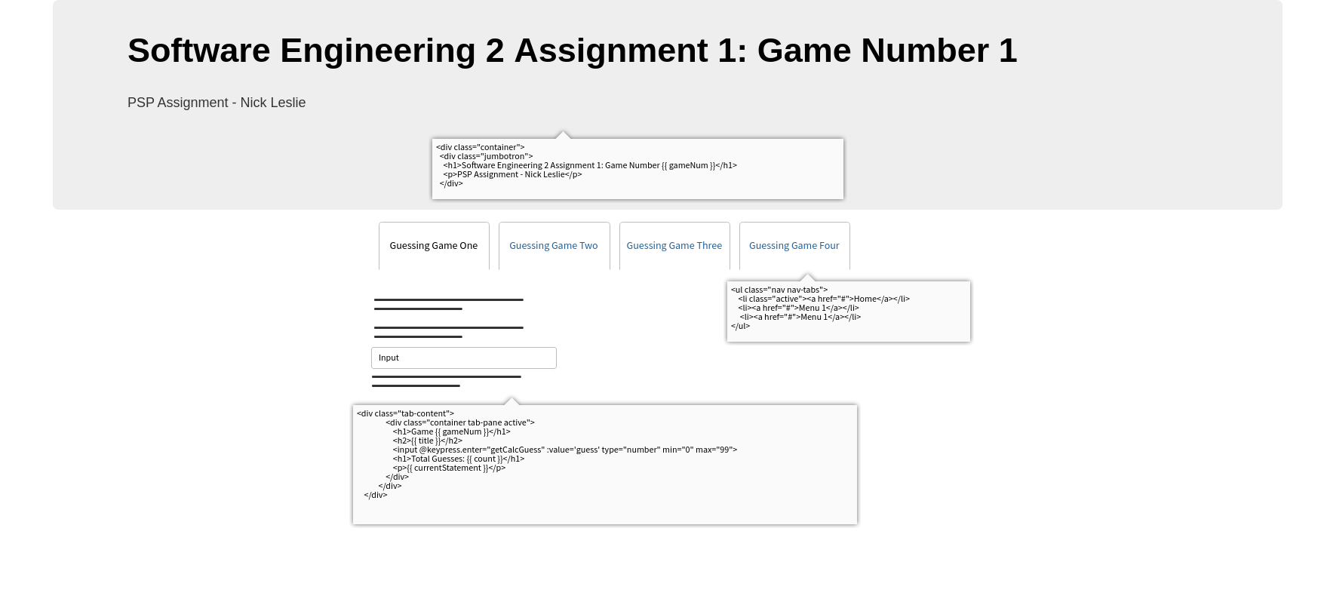

# Testing Planning

|  |  |  |  |
| --- | --- | --- | --- |
| Student | Nick Leslie | Date | 03/04/2019 |
| Program | Guessing Game | Program # | 2 |
| Instructor | Amit / Luofeng | Language | JavaScript |

|  |  |
| --- | --- |
| Test Name/Number | Test 1 |
| Test Objective | Determine if “COLD” if guess is greater than 40 away |
|  |  |
| Test Description | User inputs value: 1 |
|  |  |
|  |  |
|  |  |
|  |  |
| Test Conditions | Static Number value: 50 |
|  |  |
|  |  |
|  |  |
|  |  |
| Expected Results | Program says “COOL” |
|  |  |
|  |  |
|  |  |
| Actual Results | Pass |
|  |  |
|  |  |
|  |  |
|  |  |
| Test Name/Number | Test 2 |
| Test Objective | Determine if you receive “COOL” if guess is within 20-39 away from target |
|  |  |
| Test Description | User inputs value: 25 |
|  |  |
|  |  |
|  |  |
|  |  |
| Test Conditions | Static Number value: 50 |
|  |  |
|  |  |
|  |  |
|  |  |
| Expected Results | Program says “COOL” |
|  |  |
|  |  |
|  |  |
| Actual Results | Pass |
|  |  |
|  |  |
|  |  |
|  |  |
| Test Name/Number | Test 3 |
| Test Objective | Determine if you receive “WARM” if guess is within 10-19 away from target |
|  |  |
| Test Description | User inputs value: 35 |
|  |  |
|  |  |
|  |  |
|  |  |
| Test Conditions | Static Number value: 50 |
|  |  |
|  |  |
|  |  |
|  |  |
| Expected Results | Program displays “WARM” |
|  |  |
|  |  |
|  |  |
| Actual Results | Pass |
|  |  |
|  |  |
|  |  |
|  |  |
| Test Name/Number | Test 4 |
| Test Objective | Determine if you receive “HOT” if guess is within 1-9 away from target |
|  |  |
| Test Description | User inputs value: 49 |
|  |  |
|  |  |
|  |  |
|  |  |
| Test Conditions | Static Number value: 50 |
|  |  |
|  |  |
|  |  |
|  |  |
| Expected Results | Program displays “HOT” |
|  |  |
|  |  |
|  |  |
| Actual Results | Pass |
|  |  |
|  |  |
|  |  |
|  |  |
| Test Name/Number | Test 5 |
| Test Objective | Determine if you receive “You got it in n trials” if guess is correct |
|  |  |
| Test Description | User inputs value: 50 |
|  |  |
|  |  |
|  |  |
|  |  |
| Test Conditions | Static number value: 50 |
|  |  |
|  |  |
|  |  |
|  |  |
| Expected Results | Program displays “You got it in 1 trials” |
|  |  |
|  |  |
|  |  |
| Actual Results | Pass |
|  |  |
|  |  |
|  |  |
|  |  |
| Test Name/Number | Test 6 |
| Test Objective | Determine if system works with randomly generated numbers |
|  |  |
| Test Description | User inputs value: 50 then narrows in on final number |
|  |  |
|  |  |
|  |  |
|  |  |
| Test Conditions | Random number generated |
|  |  |
|  |  |
|  |  |
|  |  |
| Expected Results | Similar results to tests 1-5 |
|  |  |
|  |  |
|  |  |
| Actual Results | Pass |
|  |  |
|  |  |
|  |  |
|  |  |

# StandardJS report

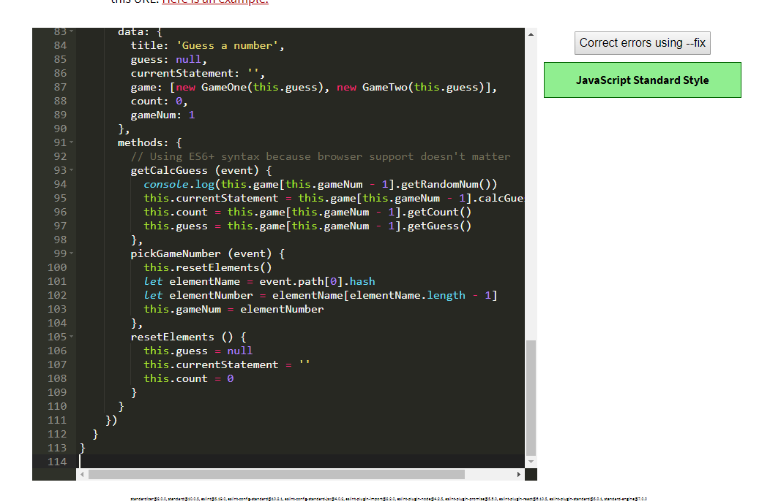

# Run the tests

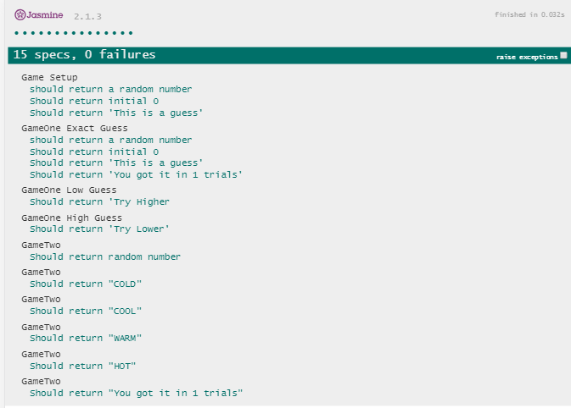

# Error Log (With at least 5 errors)

|  |  |  |  |  |  |  |  |
| --- | --- | --- | --- | --- | --- | --- | --- |
| 12/04/2019 | 6 | 20 | Code | Compile | 1 | 6 | <> wrong way round |
| 12/04/2019 | 7 | 20 | Code | Compile | 1 | 7 | Error in v-on handler: "TypeError: Cannot read property 'getRandomNum' of undefined" in getCalcGuess(). Fixed by putting -1 on array |
| 12/04/2019 | 8 | 60 | Code | Compile | 1 | 8 | User could input number less than 1. Changed all numbers less than 1 to be 1 |
| 12/04/2019 | 9 | 20 | Code | Compile | 1 | 9 | Error in v-on handler: "TypeError: Cannot read property 'getRandomNum' of undefined" in pickGameNumber(). -1 added to fix this |
| 12/04/2019 | 10 | 70 | Code | Compile | 1 | 10 | Data/state remained the same for all games. Added reset function to clear data/state |

# Process Improvement Proposal (With at least 5 PIPs)

PSP Process Improvement Proposal (PIP)

|  |  |  |  |
| --- | --- | --- | --- |
| Student | Nick Leslie | Date | 12/04/2019 |
| Program | Guessing Game | Program # | 2 |
| Instructor | Amit / Luofeng | Language | JavaScript |

|  |
| --- |
| Problem Description |
| Briefly describe the problems that you encountered. |
| 1. Repeated code (On index.html) |
| 1. Not advanced enough (Pretty basic, so far) |
| 1. Moving data/state around will become a nightmare unless I improve it |
|  |
|  |
|  |
|  |
|  |
| Proposal Description |
| Briefly describe the process improvements that you propose. |
| 1. Move to Vue-CLI |
| 1. Use components |
| 1. Use Bootstrap-Vue |
| 1. Use a global event bus for data/state? |
| 1. Programmatically display tabs depending on how many game types there are |
|  |
|  |
|  |
|  |
|  |
| Other Notes and Comments |
| Note any other comments or observations that describe your experiences or improvement ideas. |
|  |
|  |
|  |
|  |
|  |
|  |
|  |
|  |
|  |
|  |
|  |