Software Engineering PR280

Nick Leslie

Iteration 3

## Plan/Goal

1. Plan: To use Vue components and Vue-CLI to further extend the system I current have. This iteration will cover requirements One and Two (Previously completed in the past two iterations)

Add Bootstrap-Vue to replace standard Bootstrap

PSP0.1 Project Plan Summary Iteration 3

|  |  |  |  |
| --- | --- | --- | --- |
| Student | Nick Leslie | Date | 18/04/2019 |
| Program | Number Guessing Game | Program # | 3 |
| Instructor | Amit / Luofeng | Language | JavaScript/Vue |

|  |  |  |  |  |  |  |  |  |  |  |  |
| --- | --- | --- | --- | --- | --- | --- | --- | --- | --- | --- | --- |
| **Summary** | **Plan** | | |  | **Actual** | | |  | **To Date** | | |
| LOC/Hour | **100** | | |  | **45** | | |  |  | | |
| Planned Time | **120** | | |  |  | | |  |  | | |
| Actual Time | 4:47:53 | | |  |  | | |  | **190** | | |
| ~~% Reused~~ |  | | |  |  | | |  |  | | |
| ~~% New Reused~~ |  | | |  |  | | |  |  | | |
|  | | | | | | | | | | | |
|  |  | | |  |  | | |  |  | | |
| **Program Size (LOC)** | **Plan** | | |  | **Actual** | | |  | **To Date** | | |
| Base (B) | 194 | | |  | 194 | | |  |  | | |
|  | (Measured) | | |  | (Measured) | | |  |  | | |
| Deleted (D) | 50 | | |  | 10 | | |  |  | | |
|  | (Estimated) | | |  | (Counted) | | |  |  | | |
| Modified (M) | 50 | | |  | 5 | | |  |  | | |
|  | (Estimated) | | |  | (Counted) | | |  |  | | |
| Added (A) | 200 | | |  | 82 | | |  |  | | |
|  | (A + M - M) | | |  | (T − B + D − R) | | |  |  | | |
| Reused (R) | 100 | | |  | 123 | | |  |  | | |
|  | (Estimated) | | |  | (Counted) | | |  |  | | |
| Added and Modified (A + M) | 250 | | |  | 87 | | |  |  | | |
|  | (Projected) | | |  | (A + M) | | |  |  | | |
| Total Size (T) | 400 | | |  | 276 | | |  | 276 | | |
|  | (A +M + B - M – D + R) | | |  | (Measured) | | |  |  | | |
| Total New Reusable | 444 | | |  | 195 | | |  | 195 | | |
|  | | | | | | | | | | | |
| **Time in Phase (min.)** | **Plan** |  | **Actual** | | |  | **To Date** | | |  | **To Date %** |
| Planning | 20 |  | 13:04 | | |  | 44:04 | | |  |  |
| Design | 40 |  | 19:00 | | |  | 1:16:57 | | |  |  |
| Coding | 60 |  | 1:57:46 | | |  | 3:58:24 | | |  |  |
| Compile | 0 |  | 0 | | |  | 0 | | |  |  |
| Test | 10 |  | 2:18:07 | | |  | 2:45:15 | | |  |  |
| Postmortem | 10 |  | 0 | | |  | 10:00 | | |  |  |
| Total | 160 |  | 4:47:53 | | |  | 8:54:42 | | |  |  |
|  | | | | | | | | | | | |
| **Defects Injected** |  |  | **Actual** | | |  | **To Date** | | |  | **To Date %** |
| Planning |  |  | 0 | | |  | 0 | | |  |  |
| Design |  |  | 0 | | |  | 0 | | |  |  |
| Code |  |  | 5 | | |  | 15 | | |  |  |
| Compile |  |  | 0 | | |  | 0 | | |  |  |
| Test |  |  | 0 | | |  | 0 | | |  |  |
| Total Development |  |  | 0 | | |  | 0 | | |  |  |
|  | | | | | | | | | | | |
| **Defects Removed** |  |  | **Actual** | | |  | **To Date** | | |  | **To Date %** |
| Planning |  |  | 0 | | |  | 0 | | |  |  |
| Design |  |  | 0 | | |  | 0 | | |  |  |
| Code |  |  | 5 | | |  | 15 | | |  |  |
| Compile |  |  | 0 | | |  | 0 | | |  |  |
| Test |  |  | 0 | | |  | 0 | | |  |  |
| Total Development |  |  |  | | |  |  | | |  |  |
| After Development |  |  |  | | |  |  | | |  |  |

c. Time log on Toggl

## Design Level Class Diagram

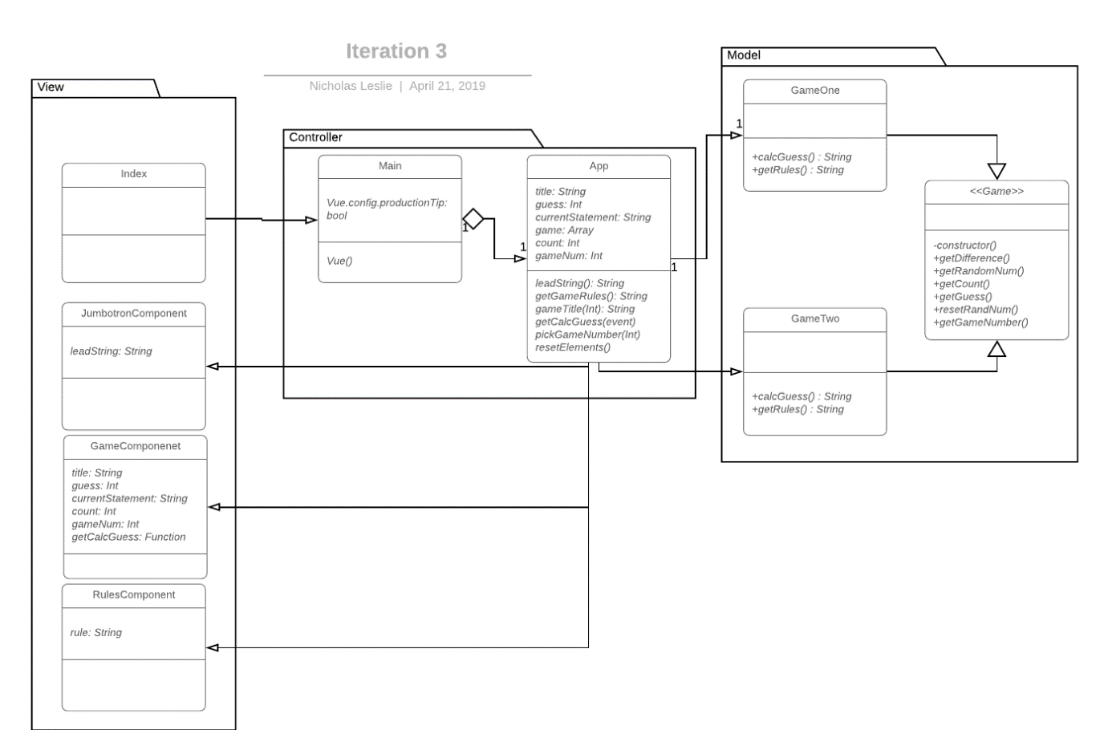

## Plan for how the program feature of an iteration you are working will work

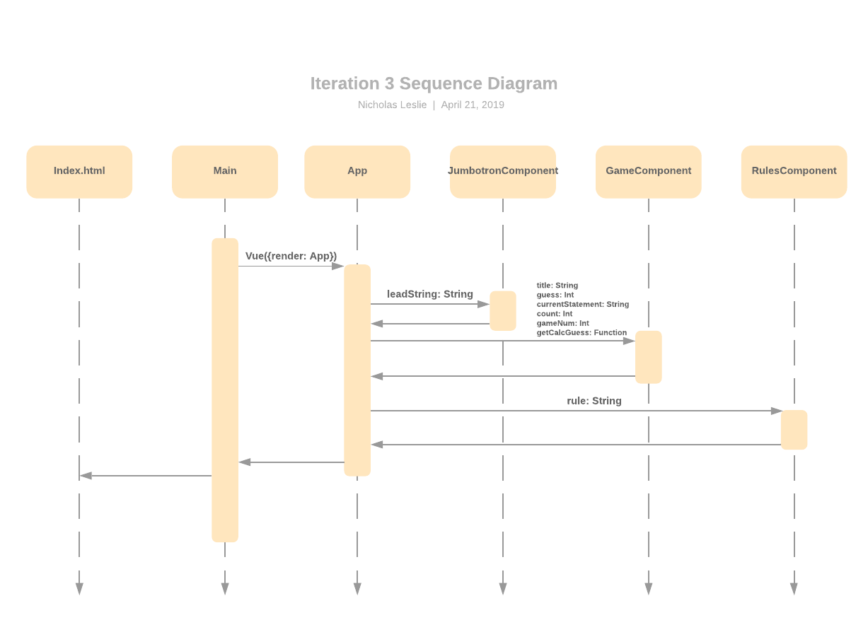

# Testing Planning

1. Test Report Template

|  |  |  |  |
| --- | --- | --- | --- |
| Student | Nick Leslie | Date | 18/04/2019 |
| Program | Guessing Game | Program # | 3 |
| Instructor | Amit / Luofeng | Language | JavaScript |

|  |  |
| --- | --- |
| Test Name/Number | Test 1 |
| Test Objective | Determine if “COLD” if guess is greater than 40 away |
|  |  |
| Test Description | User inputs value: 1 |
|  |  |
|  |  |
|  |  |
|  |  |
| Test Conditions | Static Number value: 50 |
|  |  |
|  |  |
|  |  |
|  |  |
| Expected Results | Program says “COOL” |
|  |  |
|  |  |
|  |  |
| Actual Results | Pass |
|  |  |
|  |  |
|  |  |
|  |  |
| Test Name/Number | Test 2 |
| Test Objective | Determine if you receive “COOL” if guess is within 20-39 away from target |
|  |  |
| Test Description | User inputs value: 25 |
|  |  |
|  |  |
|  |  |
|  |  |
| Test Conditions | Static Number value: 50 |
|  |  |
|  |  |
|  |  |
|  |  |
| Expected Results | Program says “COOL” |
|  |  |
|  |  |
|  |  |
| Actual Results | Pass |
|  |  |
|  |  |
|  |  |
|  |  |
| Test Name/Number | Test 3 |
| Test Objective | Determine if you receive “WARM” if guess is within 10-19 away from target |
|  |  |
| Test Description | User inputs value: 35 |
|  |  |
|  |  |
|  |  |
|  |  |
| Test Conditions | Static Number value: 50 |
|  |  |
|  |  |
|  |  |
|  |  |
| Expected Results | Program displays “WARM” |
|  |  |
|  |  |
|  |  |
| Actual Results | Pass |
|  |  |
|  |  |
|  |  |
|  |  |
| Test Name/Number | Test 4 |
| Test Objective | Determine if you receive “HOT” if guess is within 1-9 away from target |
|  |  |
| Test Description | User inputs value: 49 |
|  |  |
|  |  |
|  |  |
|  |  |
| Test Conditions | Static Number value: 50 |
|  |  |
|  |  |
|  |  |
|  |  |
| Expected Results | Program displays “HOT” |
|  |  |
|  |  |
|  |  |
| Actual Results | Pass |
|  |  |
|  |  |
|  |  |
|  |  |
| Test Name/Number | Test 5 |
| Test Objective | Determine if you receive “You got it in n trials” if guess is correct |
|  |  |
| Test Description | User inputs value: 50 |
|  |  |
|  |  |
|  |  |
|  |  |
| Test Conditions | Static number value: 50 |
|  |  |
|  |  |
|  |  |
|  |  |
| Expected Results | Program displays “You got it in 1 trials” |
|  |  |
|  |  |
|  |  |
| Actual Results | Pass |
|  |  |
|  |  |
|  |  |
|  |  |
| Test Name/Number | Test 6 |
| Test Objective | Determine if system works with randomly generated numbers |
|  |  |
| Test Description | User inputs value: 50 then narrows in on final number |
|  |  |
|  |  |
|  |  |
|  |  |
| Test Conditions | Random number generated |
|  |  |
|  |  |
|  |  |
|  |  |
| Expected Results | Similar results to tests 1-5 |
|  |  |
|  |  |
|  |  |
| Actual Results | Pass |
|  |  |
|  |  |
|  |  |
|  |  |
|  |  |
| Test Name/Number | Test 7 |
| Test Objective | Determine if two games are loaded |
|  |  |
| Test Description | User clicks on a new tab |
|  |  |
|  |  |
|  |  |
|  |  |
| Test Conditions |  |
|  |  |
|  |  |
|  |  |
|  |  |
| Expected Results | Game will change |
|  |  |
|  |  |
|  |  |
| Actual Results | Pass |
|  |  |
|  |  |
|  |  |
|  |  |
|  |  |
| Test Name/Number | Test 8 |
| Test Objective | Jumbotron component displays string |
|  |  |
| Test Description | Pass string to props |
|  |  |
|  |  |
|  |  |
|  |  |
| Test Conditions | String = This is a message |
|  |  |
|  |  |
|  |  |
|  |  |
| Expected Results | leadString will equal String |
|  |  |
|  |  |
|  |  |
| Actual Results | Pass |
|  |  |
|  |  |
|  |  |
|  |  |
| Test Name/Number | Test 9 |
| Test Objective | Game Component will display its relevant info |
|  |  |
| Test Description | Pass strings and numbers to props |
|  |  |
|  |  |
|  |  |
|  |  |
| Test Conditions | String = This is a message. Num = 1 |
|  |  |
|  |  |
|  |  |
|  |  |
| Expected Results | Title, currentStatement will equal String. Guess, count, gameNum will equal Num |
|  |  |
|  |  |
|  |  |
| Actual Results | Pass |
|  |  |
|  |  |
|  |  |
|  |  |
| Test Name/Number | Test 10 |
| Test Objective | Rules Component will display its relevant info |
|  |  |
| Test Description | Pass strings to props |
|  |  |
|  |  |
|  |  |
|  |  |
| Test Conditions | String = This is a message |
|  |  |
|  |  |
|  |  |
|  |  |
| Expected Results | Rule will equal String. |
|  |  |
|  |  |
|  |  |
| Actual Results | Pass |
|  |  |
|  |  |
|  |  |
|  |  |

# StandardJS report

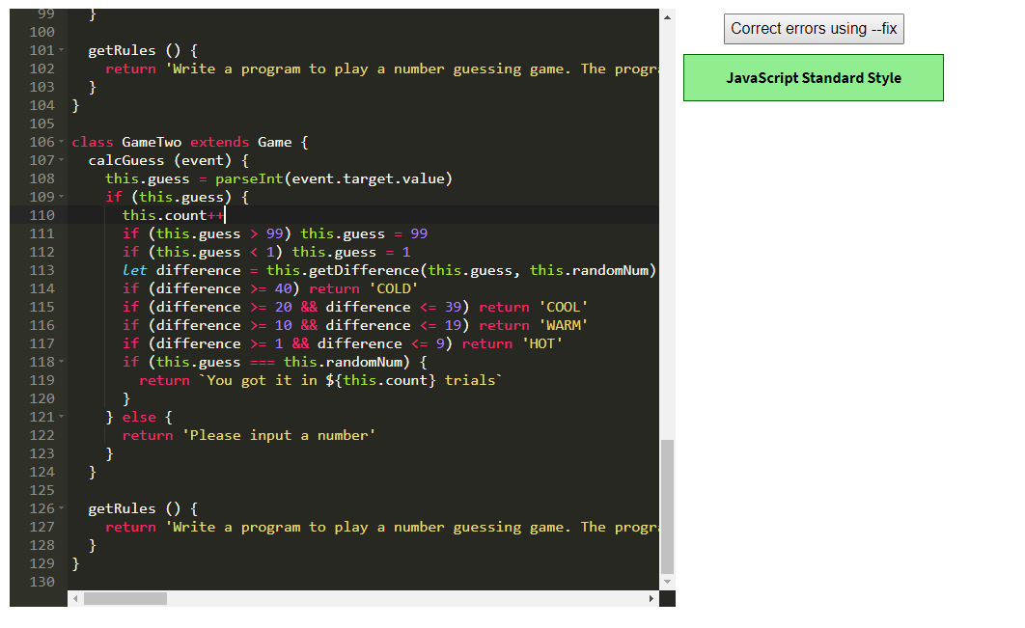

# Run the tests

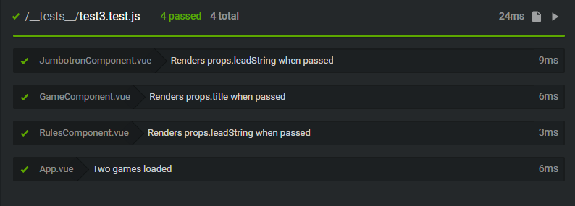

# Error Log (With at least 5 errors)

|  |  |  |  |  |  |  |  |
| --- | --- | --- | --- | --- | --- | --- | --- |
| 21/04/2019 | 11 | 20 | Code | Compile | 1 | 11 | "Error compiling template" - failed to wrap templates in <div> |
| 21/04/2019 | 12 | 80 | Code | Compile | 1 | 12 | "Unknown custom Element: <RulesComponent>" - Failed to declare component in vue.components |
| 21/04/2019 | 13 | 20 | Code | Compile | 1 | 13 | [Vue warn]: Invalid prop: type check failed for prop "rule" - getGameRules changed to getGameRules() |
| 21/04/2019 | 14 | 80 | Code | Compile | 1 | 14 | [Vue warn]: Unknown custom element: <b-jumbotron> - fixed with Vue.use(BootstrapVue) |
| 21/04/2019 | 15 | 20 | Code | Compile | 1 | 15 | <b-tab v-for="aGame in game">: componenet lists rendered with v-for should have explicit keys - ":key="aGame.getGameNumber()"" |

# Process Improvement Proposal (With at least 5 PIPs)