Software Engineering PR280

Nick Leslie

Iteration 5

Code can be found:

# Plan/Goal

* Complete Appendix Two, Task 4
* “Write a program to play a number guessing game. The USER mentally selects a number between 0 and 99 and the computer ties to guess it. The computer outputs its guess, and the User response with "COLD" if the guess is more than 40 from the target number, "COOL" if the guess is within 20-39 of the target number, “WARM” if the guess is within 10-19 of the target number, “HOT” if the guess is within 1-9 of the target number or “correct”. The computer should keep count of the number of guesses. The computer should complain if the USER has lied.”
* Split code up to its own files
* Use Trello for better organisation <https://trello.com/b/UeT6imOH/iteration5>

PSP0.1 Project Plan Summary Iteration 5

|  |  |  |  |
| --- | --- | --- | --- |
| Student | Nick Leslie | Date | 1/05/2019 |
| Program | Number Guessing Game | Program # | 5 |
| Instructor | Amit / Luofeng | Language | JavaScript/Vue |

|  |  |  |  |  |  |  |  |  |  |  |  |
| --- | --- | --- | --- | --- | --- | --- | --- | --- | --- | --- | --- |
| **Summary** | **Plan** | | |  | **Actual** | | |  | **To Date** | | |
| LOC/Hour | **100** | | |  |  | | |  |  | | |
| Planned Time | **120** | | |  |  | | |  |  | | |
| Actual Time |  | | |  |  | | |  |  | | |
| ~~% Reused~~ |  | | |  |  | | |  |  | | |
| ~~% New Reused~~ |  | | |  |  | | |  |  | | |
|  | | | | | | | | | | | |
|  |  | | |  |  | | |  |  | | |
| **Program Size (LOC)** | **Plan** | | |  | **Actual** | | |  | **To Date** | | |
| Base (B) | 364 | | |  | 364 | | |  |  | | |
|  | (Measured) | | |  | (Measured) | | |  |  | | |
| Deleted (D) | 0 | | |  | 0 | | |  |  | | |
|  | (Estimated) | | |  | (Counted) | | |  |  | | |
| Modified (M) | 10 | | |  | 0 | | |  |  | | |
|  | (Estimated) | | |  | (Counted) | | |  |  | | |
| Added (A) | 50 | | |  | 120 | | |  |  | | |
|  | (A + M - M) | | |  | (T − B + D − R) | | |  |  | | |
| Reused (R) | 10 | | |  | 0 | | |  |  | | |
|  | (Estimated) | | |  | (Counted) | | |  |  | | |
| Added and Modified (A + M) | 60 | | |  | 120 | | |  |  | | |
|  | (Projected) | | |  | (A + M) | | |  |  | | |
| Total Size (T) | 400 | | |  | 468 | | |  |  | | |
|  | (A +M + B - M – D + R) | | |  | (Measured) | | |  |  | | |
| Total New Reusable |  | | |  | 468 | | |  |  | | |
|  | | | | | | | | | | | |
| **Time in Phase (min.)** | **Plan** |  | **Actual** | | |  | **To Date** | | |  | **To Date %** |
| Planning | 20 |  | 10:29 | | |  | 1:13:47 | | |  |  |
| Design | 40 |  | 27:43 | | |  | 2:07:09 | | |  |  |
| Coding | 60 |  | 2:13:31 | | |  | 9:09:25 | | |  |  |
| Compile | 0 |  | 0 | | |  | 0 | | |  |  |
| Test | 60 |  | 51:08 | | |  | 4:11:31 | | |  |  |
| Postmortem | 10 |  | 11:10 | | |  | 24:14 | | |  |  |
| Total | 160 |  | 3:44:01 | | |  | 17:04:08 | | |  |  |
|  | | | | | | | | | | | |
| **Defects Injected** |  |  | **Actual** | | |  | **To Date** | | |  | **To Date %** |
| Planning |  |  | 0 | | |  | 0 | | |  |  |
| Design |  |  | 0 | | |  | 0 | | |  |  |
| Code |  |  | 5 | | |  | 25 | | |  |  |
| Compile |  |  | 0 | | |  | 0 | | |  |  |
| Test |  |  | 0 | | |  | 0 | | |  |  |
| Total Development |  |  | 0 | | |  | 0 | | |  |  |
|  | | | | | | | | | | | |
| **Defects Removed** |  |  | **Actual** | | |  | **To Date** | | |  | **To Date %** |
| Planning |  |  | 0 | | |  | 0 | | |  |  |
| Design |  |  | 0 | | |  | 0 | | |  |  |
| Code |  |  | 5 | | |  | 25 | | |  |  |
| Compile |  |  | 0 | | |  | 0 | | |  |  |
| Test |  |  | 0 | | |  | 0 | | |  |  |

# Design Level Class Diagram

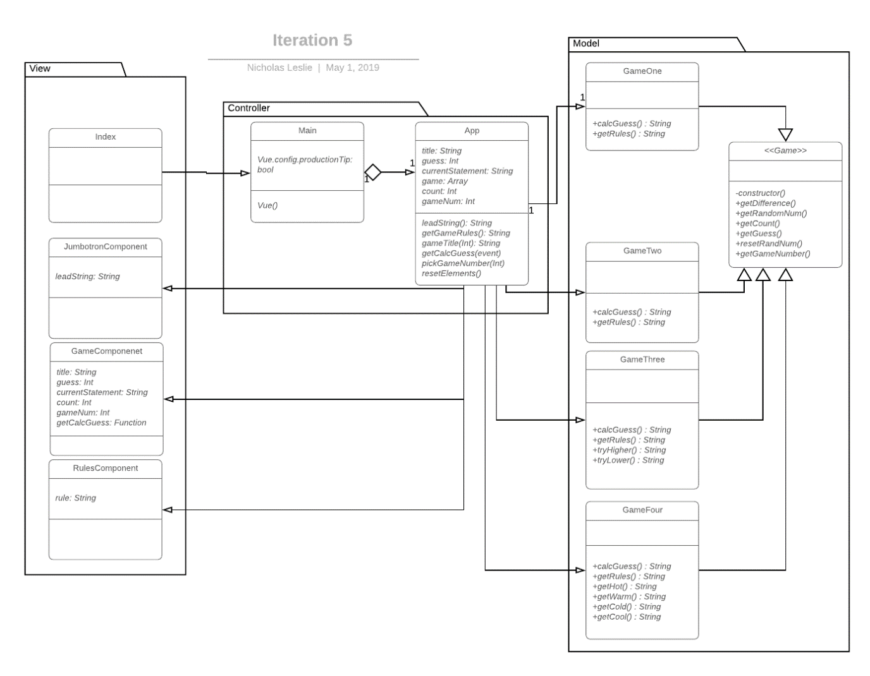

# Plan for how the program feature of an iteration you are working will work

Pseudocode

Start game

Return random number

Add number to array

If user picks cold, cool, warm, or hot, set state to that

New Number equals Random number between previous number minus different and previous number plus difference

If newly generated number is in array, generate new number

Else add number to array

Return new random number

# Testing Planning

|  |  |  |  |
| --- | --- | --- | --- |
| Student | Nick Leslie | Date | 29/04/2019 |
| Program | Guessing Game | Program # | 5 |
| Instructor | Amit / Luofeng | Language | JavaScript |

|  |  |
| --- | --- |
| Test Name/Number | Test 1 - Automated |
| Test Objective | Check if 5 buttons are rendered |
|  |  |
| Test Description | If currentStatement = True then it will display 5 buttons |
|  |  |
|  |  |
|  |  |
|  |  |
| Test Conditions | gameNum = 4. CurrentStatement = “A string” |
|  |  |
|  |  |
|  |  |
|  |  |
| Expected Results | 5 buttons will be displayed |
|  |  |
|  |  |
|  |  |
| Actual Results | Pass |
|  |  |
|  |  |
|  |  |
|  |  |
| Test Name/Number | Test 2 - Automated |
| Test Objective | Check if start button is rendered |
|  |  |
| Test Description | If currentStatement = False then it will display 1 button |
|  |  |
|  |  |
|  |  |
|  |  |
| Test Conditions | gameNum = 4. currentStatement = “” |
|  |  |
|  |  |
|  |  |
|  |  |
| Expected Results | Start button will be displayed |
|  |  |
|  |  |
|  |  |
| Actual Results | Pass |
|  |  |
|  |  |
|  |  |
|  |  |
| Test Name/Number | Test 3 - Manual |
| Test Objective | Clicking Start will return a random number |
|  |  |
| Test Description | If the user clicks “Start” it will return a random number |
|  |  |
|  |  |
|  |  |
|  |  |
| Test Conditions | gameNum = 4. User clicks start |
|  |  |
|  |  |
|  |  |
|  |  |
| Expected Results | Random number will be returned |
|  |  |
|  |  |
|  |  |
| Actual Results | Pass |
|  |  |
|  |  |
|  |  |
|  |  |
| Test Name/Number | Test 4 |
| Test Objective | User clicks hot and gets a number back |
|  |  |
| Test Description | If the user clicks start, then Hot, it will return a number between -9 or +9 of randomNum generated at Start |
|  |  |
|  |  |
|  |  |
|  |  |
| Test Conditions | gameNum = 4 |
|  |  |
|  |  |
|  |  |
|  |  |
| Expected Results | Get a random number back that is + or – 9 that previous random number |
|  |  |
|  |  |
|  |  |
| Actual Results | Pass |
|  |  |
|  |  |
|  |  |
|  |  |

# StandardJS report

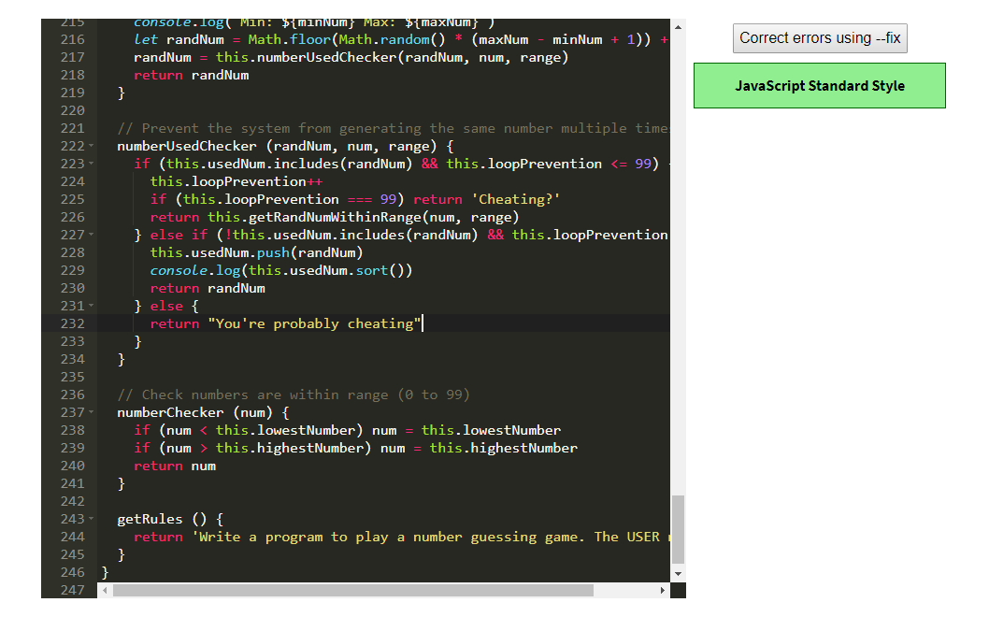

# Run the tests

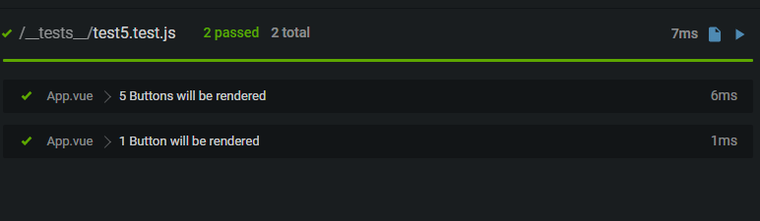

# Error Log (With at least 5 errors)

|  |  |  |  |  |  |  |  |  |
| --- | --- | --- | --- | --- | --- | --- | --- | --- |
| 1/05/2019 | 21 |  | 20 | Code | Compile | 2 | 21 | [Vue warn]: Error in data(): "TypeError: _model.GameOne is not a constructor" - Need to export class |
| 1/05/2019 | 22 |  | 60 | Code | Compile | 1 | 22 | [Vue warn]: Invalid prop: type check failed for prop "guess". Expected Number with value NaN, got String with value "Cheating?". - String check (typeof/instanceof String) |
| 1/05/2019 | 23 |  | 80 | Code | Compile | 1 | 23 | [Vue warn]: Error in v-on handler: "TypeError: Cannot read property 'toString' of undefined" - Extra else statement needed to return string |
| 1/05/2019 | 24 |  | 70 | Code | Compile | 1 | 24 | [Vue warn]: Error in render: "TypeError: Cannot read property 'toString' of undefined" - Needed super(newGuess, gameNumber) |
| 1/05/2019 | 25 |  | 60 | Code | Compile | 5 | 25 | Endless Loop. Crashed browser. When check if number had been used before, if all numbers had been used then it would crash the browser. - Added check to prevent this |

# Process Improvement Proposal (With at least 5 PIPs)

PSP Process Improvement Proposal (PIP)

|  |  |  |  |
| --- | --- | --- | --- |
| Student | Nick Leslie | Date | 01/05/2019 |
| Program | Guessing Game | Program # | 5 |
| Instructor | Amit / Luofeng | Language | JavaScript |

|  |
| --- |
| Problem Description |
| Briefly describe the problems that you encountered. |
| Advanced testing became too complicated when trying to interact with child components |
| Old iteration code could do with a reformat |
|  |
|  |
|  |
| Proposal Description |
| Briefly describe the process improvements that you propose. |
| 1. Learn how to test child components |
| 1. Refactor all code |
| 1. Improve random number generation (like I have done for iteration 5) to reduce the generation of repeated numbers |
| 1. Improved TDD |
| 1. Reduce coding time by have more pseudocode plans |
|  |
|  |
|  |
|  |
|  |