**Due date: 18.12.2020**

**CENG 113 – Programming Basics**

**Homework 02**

Travel time calculator

In this homework, you will implement a program which is able to estimate **approximate travel time** according to flight distances.

Similarly to HW01, submissions will be mostly **graded automatically** therefore outputs must be the same as for all example runs (don't forget to use the new line character “\n” as you see in the outputs). User inputs outlined in orange and others in black.

**Example run #1:**

Departure province:

**Izmir**

Arrival province:

**Ankara**

Enter travel type:

**Car**

I am calculating the distance between IZMIR and ANKARA ...

Distance: 591.91 km

Approximate travel time with CAR: 6 hours 34 minutes

Recommended places close to IZMIR:AYDIN,BALIKESIR,MANISA

**Rules:**

* We assume that the operations are based on flight distance, so the calculations (distance, time) are approximate (not precise calculation).
* All user inputs are **case-insensitive** (e.g. users may enter such things as “*AnKaRa*”, “*ANKara*”, “*ankara*”).
* Although the actual province names contain Turkish characters, we assume that users can not enter **non-English characters** (e.g. users have to write such as “*Izmir*”, “*Gumushane*”, “*Duzce*”, instead of writing “*İzmir*”, “*Gümüşhane*”, “*Düzce*”).
* We assume that the user has entered at **least one character**, you do not need to check empty values.
* The text file (provinces.txt) contains province names, their locations as latitude and longitude in a format given below. All data are separated by **commas**.

*ProvinceName,Latitude,Longitude*

* First of all, you should read the file then store the data in an **appropriate data structure** (e.g. dictionary).
* After the user enters the departure and arrival province, you will **check** whether the province exists in the data (i.e. check from relevant data structure).
* If the province does not exist, user may have entered some missing letters such as “*An*”, you will suggest all possible provinces (e.g. ANKARA, ANTALYA) then province name will be asked again as shown in the **Example run #2**. Possible provinces are printed in **alphabetical order**.
* However, if it is still not found (e.g. user entered “*X*”), print “*Province not found!*” message then province name will be asked again as shown in the **Example run #2**.
* If the arrival province is the same with departure province, you should notify to the user, then ask again as shown in the **Example run #3**.
* Travel types can be CAR, MOTORCYCLE or BICYCLE, you should check if the travel type is valid. In the case the travel type is invalid, you should ask until get the correct information as shown in the **Example run #4**.
* The **distance** will be calculated according to thePythagorean theorem as stated in the document then it will be printed with two decimal point values rounded (e.g. the value of 591.916123 will be 591.92). Basically, you will use latitude and longitude values.
* In order to calculate **travel time**, you should use speed values according to travel type (e.g. if the user entered travel type as “*Bicycle*”, speed value will be 25). After the distance and speed are obtained, travel time can be calculated with a well-known formula specified in the document.

|  |  |
| --- | --- |
| Travel Type | Speed |
| Car | 90 km/h |
| Motorcycle | 80 km/h |
| Bicycle | 25 km/h |

* **Recommended** places should be listed in **alphabetical order** as shown at the end of the outputs. These places are the **three closest** provinces to the departure province **according to distances**.
* You cannot import any module, just use the features you learned in the lessons and labs.

**Example run #2:**

Departure province:

**An**

Province not found!

Possible provinces:ANKARA,ANTALYA

Departure province:

**X**

Province not found!

Departure province:

**Ankara**

Arrival province:

**Iz**

Province not found!

Possible province:IZMIR

Arrival province:

**Izmir**

Enter travel type:

**Car**

I am calculating the distance between ANKARA and IZMIR ...

Distance: 591.91 km

Approximate travel time with CAR: 6 hours 34 minutes

Recommended places close to ANKARA:CANKIRI,KARABUK,KIRIKKALE

**Example run #3:**

Departure province:

**Izmir**

Arrival province:

**IZMIR**

Enter a different province!

Arrival province:

**Ankara**

Enter travel type:

**Car**

I am calculating the distance between IZMIR and ANKARA ...

Distance: 591.91 km

Approximate travel time with CAR: 6 hours 34 minutes

Recommended places close to IZMIR:AYDIN,BALIKESIR,MANISA

**Example run #4:**

Departure province:

**Izmir**

Arrival province:

**Ankara**

Enter travel type:

**C**

Enter travel type:

**A**

Enter travel type:

**CAR**

I am calculating the distance between IZMIR and ANKARA ...

Distance: 591.91 km

Approximate travel time with CAR: 6 hours 34 minutes

Recommended places close to IZMIR:AYDIN,BALIKESIR,MANISA

**Calculation of the distance and travel time:**

* The two basic axes are horizontal (x) and vertical (y), the position of any point can be defined as corresponding to x and y values (x, y).
* Latitude and longitude values can be defined as x and y, respectively.
* A line defined by two points in a plane. The distance (line length) between two points can be obtained with the Pythagorean theorem.
* We assume that a straight line is drawn from one point to another as shown in the image below.

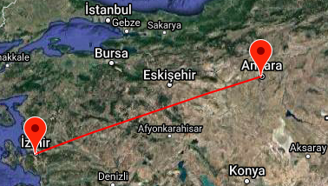

* Based on this information, the distance can be calculated as follows:

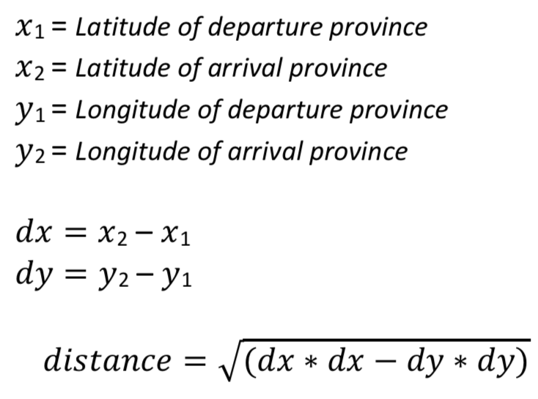





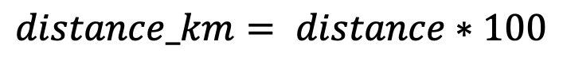

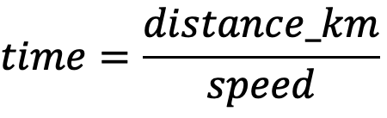

* After obtaining the distance value, multiply it by hundred to calculate it in terms of **kilometers (km)**.
* The travel time will be calculated using speed and distance, moreover **the speed varies** according to the travel type.
* The time value is a float value, take the integer part as hour, subtract hours from the time value, then multiply by sixty, take the integer part to get the minutes as follows:

Time = 6.576788057908049

Hours = 6

Minutes = (Time - Hours)*60 = 34

**Hint:** Do not round the minutes even if it is 34.60, just get the integer part.

**Submission:**

* Submit your solution through Microsoft Teams until the deadline, **18.12.2020 23:59**.
* The file name should be named as **ceng113_hw2_ID.py**. You must write your **student ID** in the ID section, otherwise the grader will not be able to read the file among other student files.
* Cheating is prohibited, you will lose points when any cheating is detected.
* Instead of sending private messages to asistans, ask your questions from the assistant section.