**30.12.2020**

**CENG113**

**Programming Basics**

**HOMEWORK #4**

**DUE DATE: 10.01.2018 - 23:59**

You are expected to write a Python program for a game about an ancient hero that is half-god. In order to become immortal, he is challenged to complete 5 tasks.

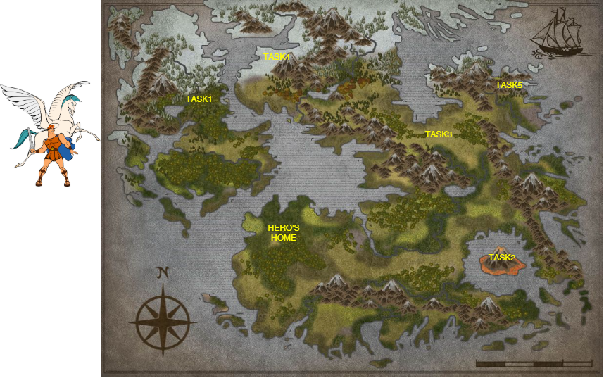

**Figure 1:** The map of the world

In Figure 1, you can see the map of the game world. At the beginning of the game, the hero starts his journey from his home. He also has a pegasus companion with whom he can travel to the given task’s destinations.

In the given TaskList.txt, you can find each task’s distance from his home by foot,by pegasus and the needed HP to kill the monster of the task. TaskList.txt is structured as shown below:

| **TaskName** | **DistanceByFoot** | **DistanceByPegasus** | **HPToKill** |
| --- | --- | --- | --- |
| Task1 | -1 | 350 | 50 |
| Task2 | -1 | 400 | 100 |
| Task3 | 600 | 500 | 75 |
| Task4 | 1000 | 500 | 50 |
| Task5 | 900 | 700 | 75 |

You have to read TaskList.txt, and create a nested list named task_list that has each task as a list:

task_list = [[Task1,0,350,50],[Task2,0,400,100]....]

As you can see from the TaskList file, if there is no route to go to the given task by foot, the distance is given as -1. Therefore, you have to use Pegasus in order to reach these destinations.

In the beginning of the game, **the hero has 3000HP, while the pegasus has 550HP.**

The hero can walk at the speed of **20km/hour**. The pegasus can fly at the speed of **50km/hour.** For each hour of the journey, the hero loses **10HP,** while the pegasus loses **15HP**.

At the end of each task, the hero must return to his home and continue from there.

After completing each task, the program should **remove that task** from the task list.

At each turn, the program should display **the remaining tasks** and their distances from the hero’s home, and ask for the hero’s next move.

* You should write **remove_task(task_list)** and **print_remaining_tasks(task_list)** in **a recursive manner.**

The program finishes when there is **no task left (“**Congratulations, you have completed the task.**” message is printed)**, or the **HP of the hero is not enough to kill the monster of the task** or the **HP of the hero and pegasus is not enough to travel to the given destination (“**Game Over**” is printed).**

If the user succeeds the game, you have to ask his/her name and the time the game takes to finish. Also, you have to show the Hall of Fame at the end of each successful game that shows the best 3 results.

**IMPORTANT NOTES:**

* User inputs are case insensitive.
* Be careful about **invalid** inputs! Ask each question over and over again until a valid input is entered.

**Submission Rules:**

STUDENTS WHO DO NOT FOLLOW THESE RULES WILL BE GRADED AS 0.

1. You should submit your assignments through Microsoft Teams until the due date.

2. Your homework should be named as **CENG113_hw4_studentID.py** (ie:

CENG113_hw4_123456789).

3. Use comments in your code, otherwise you will **lose** some points.

4. Write your **student ID** as a comment **at the beginning of your code**.

5. Instead of sending private messages to assistants, ask your questions from the assistant section.

**Note:** Violation of any submission rule may end up with point deduction up to 100 points. Any kind of cheating including teamwork will be penalized.

**An example scenario for the game world (user inputs are given in bold):**

Welcome to Hero’s 5 Labors!  
Remaining HP for Hero : 3000

Remaining HP for Pegasus: 550  
Here are the tasks left that hero needs to complete:

--------------------------------------------------------  
| TaskName | ByFootDistance | ByPegasus | HPNeeded |  
--------------------------------------------------------  
| Task1 | 0 km | 400 km | 50 |  
| Task2 | 0 km | 500 km | 100 |  
| Task3 | 600 km | 500 km | 75 |  
| Task4 | 1000 km | 500 km | 50 |  
| Task5 | 900 km | 700 km | 80 |  
--------------------------------------------------------

Where should Hero go next? **Task1**

How do you want to travel?(Foot/Pegasus)**foot**

You cannot go there by foot.

How do you want to travel?(Foot/Pegasus)**pegasus**  
Hero defeated the monster.

Time passed : 8 hour

Remaining HP for Hero : 2950

Remaining HP for Pegasus: 430

How do you want to go home?(Foot/Pegasus)**Pega**

Invalid input

How do you want to go home?(Foot/Pegasus)**Pegasus**

Hero arrived home.

Time passed : 16 hour

Remaining HP for Hero : 2950

Remaining HP for Pegasus: 310

Here are the tasks left that hero needs to complete:

--------------------------------------------------------  
| TaskName | ByFootDistance | ByPegasus | HPNeeded |  
--------------------------------------------------------  
| Task2 | 0 km | 500 km | 100 |  
| Task3 | 600 km | 500 km | 75 |  
| Task4 | 1000 km | 500 km | 50 |  
| Task5 | 900 km | 700 km | 80 |  
--------------------------------------------------------  
Where should Hero go next? **Task2**

How do you want to travel?(Foot/Pegasus)**foot**

You cannot go there by foot.

How do you want to travel?(Foot/Pegasus)**pegasus**  
Hero defeated the monster.

Time passed : 26 hour

Remaining HP for Hero : 2850

Remaining HP for Pegasus: 160

How do you want to go home?(Foot/Pegasus)**foot**

You cannot go there by foot.

How do you want to go home?(Foot/Pegasus)**pegasus**

Hero arrived home.

Time passed : 36 hour

Remaining HP for Hero : 2850

Remaining HP for Pegasus: 10

Here are the tasks left that hero needs to complete:

--------------------------------------------------------  
| TaskName | ByFootDistance | ByPegasus | HPNeeded |  
--------------------------------------------------------  
| Task3 | 600 km | 500 km | 75 |  
| Task4 | 1000 km | 500 km | 50 |  
| Task5 | 900 km | 700 km | 80 |  
--------------------------------------------------------  
Where should Hero go next? **Task3**

How do you want to travel?(Foot/Pegasus)**pegasus**

Pegasus does not have enough HP.

How do you want to travel?(Foot/Pegasus)**foot**

Hero defeated the monster.

Time passed : 66 hour

Remaining HP for Hero : 2475

Remaining HP for Pegasus: 10

How do you want to go home?(Foot/Pegasus)**foot**

Hero arrived home.

Time passed : 96 hour

Remaining HP for Hero : 2175

Remaining HP for Pegasus: 10

Here are the tasks left that hero needs to complete:

--------------------------------------------------------  
| TaskName | ByFootDistance | ByPegasus | HPNeeded |  
--------------------------------------------------------  
| Task4 | 1000 km | 500 km | 50 |  
| Task5 | 900 km | 700 km | 80 |  
--------------------------------------------------------

Where should Hero go next? **Task5**

How do you want to travel?(Foot/Pegasus)**pegasus**

Pegasus does not have enough HP.

How do you want to travel?(Foot/Pegasus)**foot**

Hero defeated the monster.

Time passed : 141 hour

Remaining HP for Hero : 1675

Remaining HP for Pegasus: 10

How do you want to go home?(Foot/Pegasus)**foot**

Hero arrived home.

Time passed : 186 hour

Remaining HP for Hero : 1225

Remaining HP for Pegasus: 10

Here are the tasks left that hero needs to complete:

--------------------------------------------------------  
| TaskName | ByFootDistance | ByPegasus | HPNeeded |  
--------------------------------------------------------  
| Task4 | 1000 km | 500 km | 50 |  
--------------------------------------------------------

Where should Hero go next? **Task1**

Invalid input

Where should Hero go next? **Task4**

How do you want to travel?(Foot/Pegasus)**foot**

Hero defeated the monster.

Time passed : 196 hour

Remaining HP for Hero : 675

Remaining HP for Pegasus: 10

How do you want to go home?(Foot/Pegasus)**foot**

Hero arrived home.

Time passed : 246 hour

Congratulations, you have completed the task.

What is your name : **Damla**

Hall Of Fame

--------------------------  
| Name | Finish Time |  
--------------------------

| Damla | 246 hour |  
--------------------------