How to set router to serve on port 3000

Ensure local port is set to 3000, remote is set to 80
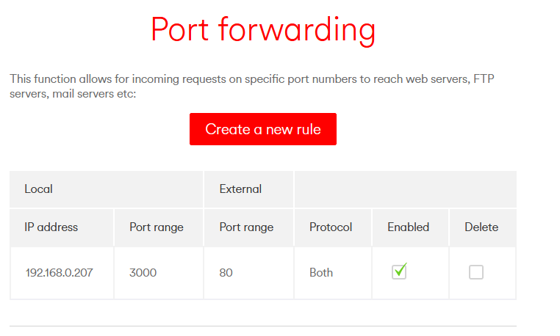

Turn off Firewall
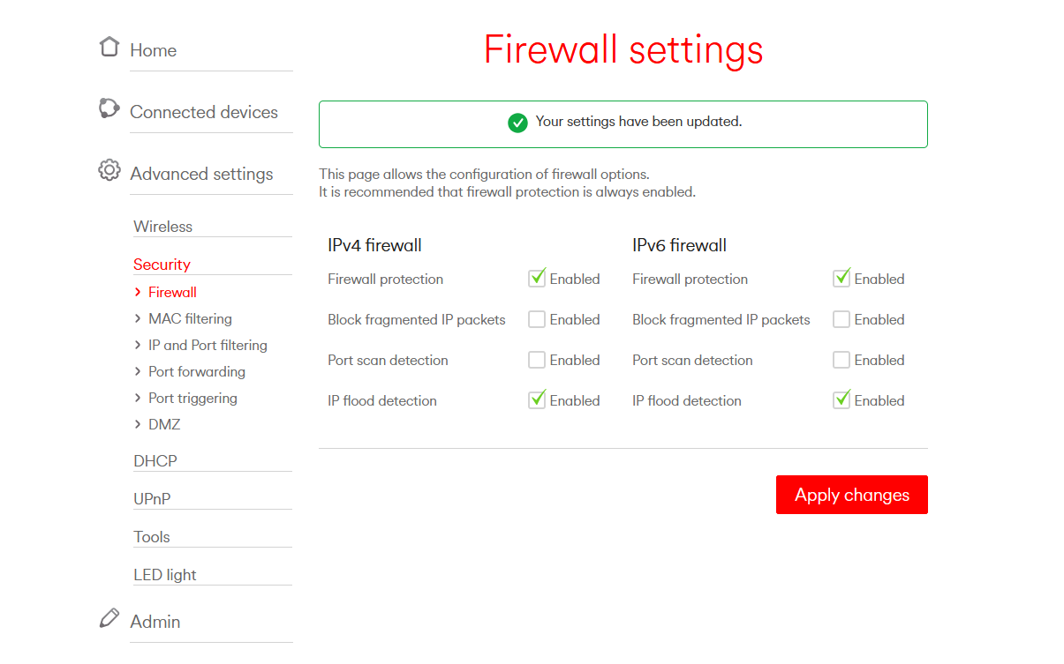
Reboot router
Check service:
http://86.4.208.162/docs?id=zone1

Reapply firewall

