RPA API User Guide

Introduction

The purpose of this user guide is to help understand the RPA Authenticated API. This guide supplements the official IBM RPA documentation here:
https://www.ibm.com/docs/en/rpa/21.0?topic=automation-rpa-api-reference

API Overview

To run a bot using the RPA API, you follow a journey. The journey starts with finding a host and ends with getting the bot result. The flow diagram below describes each step in the journey.

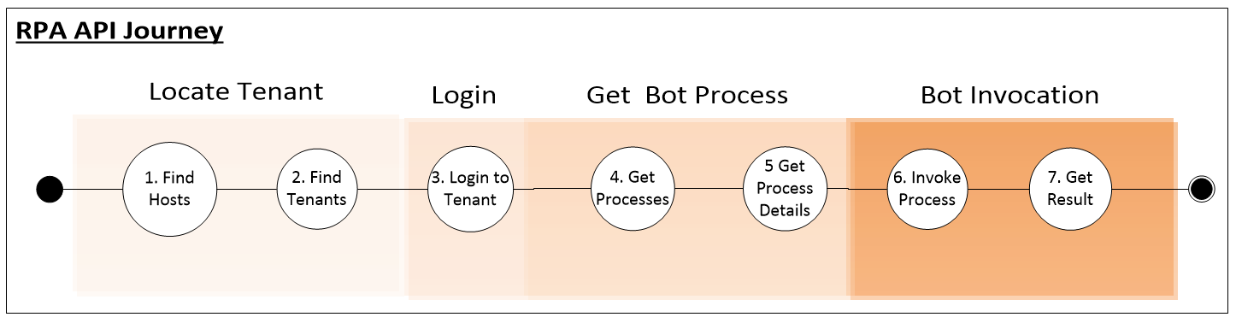
The API is invoked against the RPA tenant. The tenant authenticates the caller, locates the process in which the bot resides and then permits invocation of the bot. It is at this point that the RPA tenant finds the designated computer and invokes the internal synchronous API to run the bot. See below:
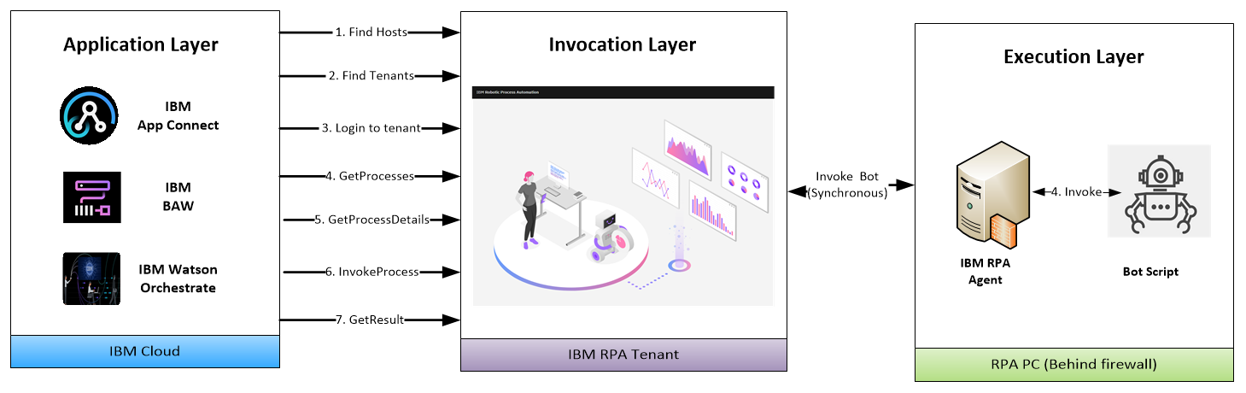
The next section examines each of the steps in more detail.

RPA API Methods

Find Host Regions

Description

Finds all available regions where RPA SaaS servers are deployed.

Input
None
Output
A list of SaaS hosts
Example
curl --location --request GET https://br1api.wdgautomation.com/v2.0/configuration/regions

Find tenants

Description

Return the tenants in each region

Input
REGION – the location of the SaaS tenant. The SaaS tenants are determined in step 1.
USERNAME - Tenant username
Output
The TENANT_ID
Example
curl --location --request GET 'https://[REGION]api.wdgautomation.com/v1.0/en-US/account/tenant?username=[USERNAME]' --data-raw ''

Login to tenant

Description
Login to the tenant using tenant credentials
Input
REGION – the location of the SaaS tenant determined in Step 1.
TENANT_ID - the tenant identifier determined in Step 2.
USERNAME - Tenant username
PASSWORD - Tenant password
Output
BEARER_TOKEN - the access token that allows you to perform the subsequent steps. Valid for 24 hours only.
Example
curl --location --request POST 'https://[REGION]api.wdgautomation.com/v1.0/token' --header 'tenantId: [TENANT_ID]' --header 'Content-Type: application/x-www-form-urlencoded' --data-urlencode 'grant_type=password' --data-urlencode 'username=[USERNAME]' --data-urlencode 'password=[PASSWORD] --data-urlencode 'culture=en-US'

4 - Get Processes

Description
Get the processes defined in the tenant
Input
REGION – the location of the SaaS tenant determined in Step 1.
TENANT_ID - the tenant identifier determined in Step 2.
BEARER_TOKEN - the access token determined in Step 3.
Output
PROCESSES - a list of processes
Example
curl --location --request GET 'https://[REGION]api.wdgautomation.com/v2.0/workspace/[TENANT_ID]/process?lang=en-US' --header 'Authorization: Bearer [BEARER_TOKEN]'' --data-raw ''

5 - Get process details
Description
Get the input / output schema of the process. This is extrapolated from the bot parameters.
Input
REGION – the location of the SaaS tenant determined in Step 1.
TENANT_ID - the tenant identifier determined in Step 2.
BEARER_TOKEN - the access token determined in Step 3.
PROCESS_ID – the process id selected in Step 4.
Output
PROCESSES - a list of processes with associated process id
Example
curl --location --request GET 'https://[REGION]api.wdgautomation.com/v2.0/workspace/[TENANT_ID]/process/[PROCESS_ID]' --header 'Authorization: Bearer [BEARER_TOKEN]'' --data-raw ''

6 - Invoke Process

Description
Invoke the process
Input
REGION – the location of the SaaS tenant determined in Step 1.
TENANT_ID - the tenant identifier determined in Step 2.
BEARER_TOKEN - the access token determined in Step 3.
PROCESS_ID – the process id selected in Step 4.
JSON_PAYLOAD – the JSON payload corresponding to the Bot input parameters
Output
INSTANCE_ID – the instance id of the invoked process
Example
curl --location --request POST 'https://[REGION]api.wdgautomation.com/v2.0/workspace/[TENANT_ID]/process/[PROCESS_ID]/instance?lang=en-US' --header 'Authorization: Bearer [BEARER_TOKEN] --data-raw [JSON_PAYLOAD]

7 - Get result

Description
Get the invocation result
Input
REGION – the location of the SaaS tenant determined in Step 1.
TENANT_ID - the tenant identifier determined in Step 2.
BEARER_TOKEN - the access token determined in Step 3.
PROCESS_ID – the process id selected in Step 4.
Output
JSON_RESULT – the JSON response of the bot execution
Example
curl --location --request GET 'https://[REGION]api.wdgautomation.com/v2.0/workspace/[TENANT_ID]/process/[PROCESS_ID]/instance/[INSTANCE_ID]' --header 'Authorization: Bearer [BEARER_TOKEN]''

Appendix A: Test suites

This appendix lists popular format suites to test the RPA API

Powershell

https://github.com/ncrowther/BotApiGenerator/blob/main/testApi.ps1

SoapUI

Postman

