RPA API User Guide

The purpose of this user guide is to help understand the RPA Authenticated API. This guide supplements the official IBM RPA documentation here:
https://www.ibm.com/docs/en/rpa/21.0?topic=automation-rpa-api-reference

API Overview

To use the RPA API, you follow a journey. The journey begins with finding a tenant and ends with successfully running a process. The flow diagram below describes the steps in the journey.

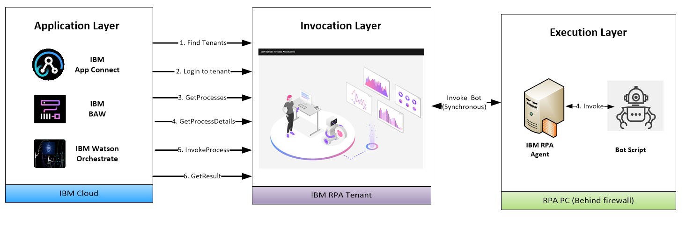
The next section examines each of the steps in more detail. Curl is used for example REST invocations

RPA API Methods

Find tenants

Description

Get tenant information

Input
REGION – the location of the SaaS tenant. AP1, UK1, EU1
USERNAME - Tenant username
Output
The TENANT_ID
Example
curl --location --request GET 'https://[REGION]api.wdgautomation.com/v1.0/en-US/account/tenant?username=[USERNAME]' --data-raw ''

Login to tenant

Description
Login to the tenant using tenant credentials
Input
REGION – the location of the SaaS tenant.
USERNAME - Tenant username
PASSWORD - Tenant password
TENANT_ID - the tenant identifier determined in Step 1.
Output
BEARER_TOKEN - the access token that allows you to perform the subsequent steps. Valid for 24 hours only.
Example
curl --location --request POST 'https://[REGION]api.wdgautomation.com/v1.0/token' --header 'tenantId: [TENANT_ID]' --header 'Content-Type: application/x-www-form-urlencoded' --data-urlencode 'grant_type=password' --data-urlencode 'username=[USERNAME]' --data-urlencode 'password=[PASSWORD] --data-urlencode 'culture=en-US'

3 - Get Processes

Description
Get the processes defined in the tenant
Input
REGION – the location of the SaaS tenant.
TENANT_ID - the tenant identifier determined in Step 1.
BEARER_TOKEN - the access token determined in Step 2
Output
PROCESSES - a list of processes with process ids
Example
curl --location --request GET 'https://[REGION]api.wdgautomation.com/v2.0/workspace/[TENANT_ID]/process?lang=en-US' --header 'Authorization: Bearer [BEARER_TOKEN]'' --data-raw ''

4 - Get process details
Description
Get the input / output schema of the process. This is extrapolated from the bot parameters.
Input
REGION – the location of the SaaS tenant.
BEARER_TOKEN - the access token
TENANT_ID - the tenant identifier determined in Step 1.
PROCESS_ID – the process id selected in Step 3.
Output
PROCESSES - a list of processes with associated process id
Example
curl --location --request GET 'https://[REGION]api.wdgautomation.com/v2.0/workspace/[TENANT_ID]/process/[PROCESS_ID]' --header 'Authorization: Bearer [BEARER_TOKEN]'' --data-raw ''

5 - Invoke Process

Description
Invoke the process
Input
REGION – the location of the SaaS tenant.
BEARER_TOKEN - the access token
TENANT_ID - the tenant identifier determined in Step 1.
PROCESS_ID – the process id selected in Step 3.
Output
INSTANCE_ID – the instance id of the invoked process
Example
curl --location --request POST 'https://[REGION]api.wdgautomation.com/v2.0/workspace/[TENANT_ID]/process/[PROCESS_ID]/instance?lang=en-US' --header 'Authorization: Bearer [BEARER_TOKEN]'' --data-raw ''
"payload": {
"in_region": "328328"
}
}'

6 - Get result

Description
Get the invocation result
Input
REGION – the location of the SaaS tenant.
BEARER_TOKEN - the access token
TENANT_ID - the tenant identifier determined in Step 1.
PROCESS_ID – the process id selected in Step 3.
Output
INSTANCE_ID – the instance id of the invoked process
Example
curl --location --request GET 'https://[REGION]api.wdgautomation.com/v2.0/workspace/[TENANT_ID]/process/[PROCESS_ID]/instance/[INSTANCE_ID]' --header 'Authorization: Bearer [BEARER_TOKEN]'' --data-raw ''

Testing the API from Postman

Testing the API from SoapUI

Testing the API from PowerShell

